A MULTI-AGENT FRAMEWORK FOR INTELLIGENT
WEBSITE DESIGN AND DEVELOPMENT
A PROJECT REPORT SUBMITTED TO
SRM INSTITUTE OF SCIENCE & TECHNOLOGY
IN PARTIAL FULFILMENT OF THE REQUIREMENTS FOR THE
AWARD OF THE DEGREE OF
MASTER OF COMPUTER APPLICATIONS
BY

MATHESHWARAN R (RA2532241010311)
SUHAS C (RA2532241010312)
NITHYASHREE K(RA2532241010329)
DEVANANDA E (RA2532241010332)

UNDER THE GUIDANCE OF Dr. V.NISHA


DEPARTMENT OF COMPUTER APPLICATIONS
FACULTY OF SCIENCE AND HUMANITIES
SRM INSTITUTE OF SCIENCE & TECHNOLOGY
Kattankulathur – 603 203
Chennai, Tamilnadu

OCTOBER - 2026

BONAFIDE CERTIFICATE

This is to certify that the project report titled “A MULTI-AGENT
FRAMEWORK FOR INTELLIGENT WEBSITE DESIGN AND DEVELOPMENT” is a bonafide work carried out by Jenin Shalomon P.J (RA2532241010304) under my supervision for the award of the Degree of Master of Computer Applications. To my knowledge the work reported herein is the original work done by the student.

Dr. V.Nisha Dr.P.J.Arul Leena Rose
Assistant Professor Professor & Head,
Department of Computer Applications Department of Computer Applications
(GUIDE)

INTERNAL EXAMINER EXTERNAL EXAMINER

ACKNOWLEDGEMENT
With profound gratitude to the ALMIGHTY, I take this chance to thank the people who helped me to complete this project.
We take this as a right opportunity to say THANKS to my parents who are there to stand with me always with the words “YOU CAN”.
We are thankful to Dr.T.R.Paarivendhar, Chancellor, SRM Institute of Science & Technology who gave us the platform to establish me to reach greater heights.
We earnestly thank Dr.A.Duraisamy, Dean, Faculty of Science and Humanities, SRM Institute of Science & Technology who always encourage us to do novel things.
A great note of gratitude to Dr. S. Albert Antony Raj, Deputy Dean, Faculty of Science and Humanities for his valuable guidance and constant Support to do this Project.
We express our sincere thanks to Dr. P.J.Arul Leena Rose, Professor & Head for her support to execute all incline in learning.
It is our delight to thank our project guide Dr. V.Nisha, Assistant Professor
Department of Computer Applications for her help, support, encouragement, suggestions, and guidance throughout the development phases of the project.
We convey our gratitude to all the faculty members of the department who extended their support through valuable comments and suggestions during the reviews.
Our gratitude to friends and people who are known and unknown to me who helped in carrying out this project work a successful one.
JENIN SHALOMON P.J

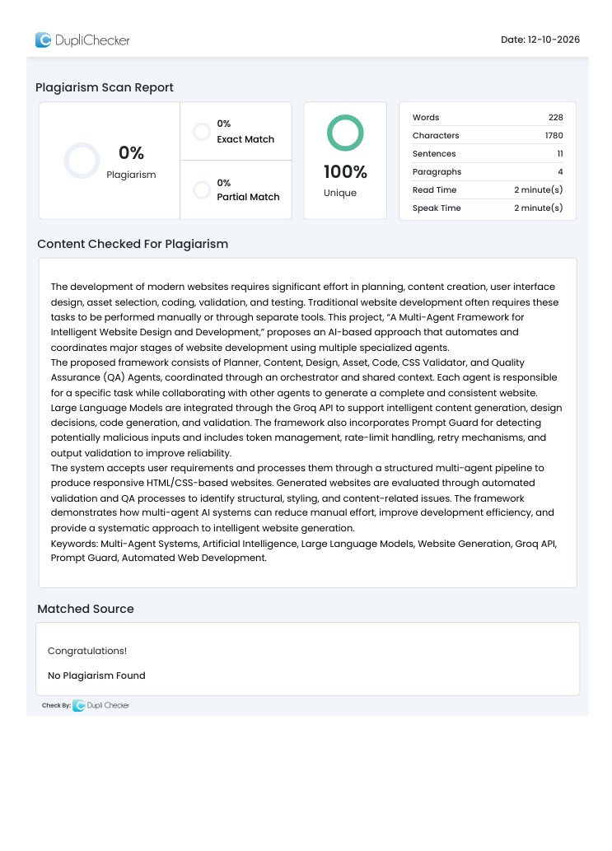

TABLES OF CONTENTS
1.Introduction 1
1.1 Background 1
1.2 Problem Statement 2
1.3 Objectives and Scope 3
2.Literature Survey 5
2.1 AI-Assisted Website Development 5
2.2 Large Language Models 5
2.3 Multi-Agent Systems 5
2.4 Research Gap 6
3.System Analysis 7
3.1 Existing System 7
3.2 Proposed System 7
3.3 Functional and Non-Functional Requirements 8
3.3.1 Functional Requirements 8
3.3.2 Non-Functional Requirements 8
3.4 Advantages of the Proposed System 9
4.System Architecture and Design 10
4.1 Overall Architecture 10
4.2 Multi-Agent Workflow 11
4.3 Data Flow Diagram 13
4.4 System Components 14
4.5 Technology Stack 15
4.6 System Design Summary 15
4.7 Orchestrator Coordination and Workflow Control 16
4.8 Shared Context and Intermediate Data Management 17
4.9 Validation, Error Handling, and Recovery 17
5.Multi-Agent Framework 19
5.1 Planner Agent 19
5.2 Content Agent 19
5.3 Design Agent 20
5.4 Asset Agent 20
5.5 Code Agent 20
5.6 CSS Validator Agent 21
5.7 QA Agent 21
5.8 Orchestrator and Shared Context 22
6.LLM and API Integration 23
6.1 Groq API and LLM Models 23
6.2 Prompt Guard Integration 23
6.3 Token and Rate-Limit Management 24
6.4 Error and Retry Handling 24
7.System Implementation 25
7.1 Project Structure 25
7.1.1 Website Generation Workflow 25
7.1.2 Shared Context and State Management 25
7.1.3 API Integration and Error Handling 26
7.2 Website Generation Pipeline 27
7.3 HTML and CSS Generation 29
7.4 Validation and Logging 29
8.Testing and Results 31
8.1 Testing Methodology 31
8.2 Agent and Integration Testing 31
8.3 Website Validation 32
8.4 Results and Performance Analysis 34
8.5 Detailed Testing Procedures 35
8.6 Functional Test Cases 36
8.7 Analysis of Quality Assurance Results 37
8.8 Limitations of the Testing Approach 38
9.Conclusion and Future Enhancements 39
9.1 Conclusion 39
9.2 Future Enhancements 39
10.References 40
11.Appendices 41
11.1 Source Code 41
11.1.1 orchestrator.py 41
11.2 Generated Website Screenshots 55
11.2.1 Website Generation Result 55
11.2.2 Generated Home Page 56
11.2.3 Generated Menu Section 56
11.2.4 Generated Contact Page 57
11.3 Test Results and Logs 57
11.3.1 Agent Pipeline Execution 57
11.3.2 Per-Page QA Results 58
11.3.3 API Usage and Performance Results 59
11.3.4 Overall Test Result 59

ABSTRACT

The development of modern websites requires significant effort in planning, content creation, user interface design, asset selection, coding, validation, and testing. Traditional website development often requires these tasks to be performed manually or through separate tools. This project, “A Multi-Agent Framework for Intelligent Website Design and Development,” proposes an AI-based approach that automates and coordinates major stages of website development using multiple specialized agents.
The proposed framework consists of Planner, Content, Design, Asset, Code, CSS Validator, and Quality Assurance (QA) Agents, coordinated through an orchestrator and shared context. Each agent is responsible for a specific task while collaborating with other agents to generate a complete and consistent website. Large Language Models are integrated through the Groq API to support intelligent content generation, design decisions, code generation, and validation. The framework also incorporates Prompt Guard for detecting potentially malicious inputs and includes token management, ratelimit handling, retry mechanisms, and output validation to improve reliability.
The system accepts user requirements and processes them through a structured multiagent pipeline to produce responsive HTML/CSS-based websites. Generated websites are evaluated through automated validation and QA processes to identify structural, styling, and content-related issues. The framework demonstrates how multi-agent AI systems can reduce manual effort, improve development efficiency, and provide a systematic approach to intelligent website generation.
Keywords: Multi-Agent Systems, Artificial Intelligence, Large Language Models, Website Generation, Groq API, Prompt Guard, Automated Web Development.

LIST OF TABLES

Table 4.1: System Components.................................................................................. [14]
Table 4.2: Technology Stack...................................................................................... [15]
Table 6.1: LLM Models and Their Purpose................................................................ [23]
Table 8.1: Testing Methodology................................................................................. [31]
Table 8.2: Test Cases and Results............................................................................... [32]
Table 8.3: Validation Check........................................................................................ [33]
Table 8.4: Performance Analysis................................................................................ [35]
Table 8.5: Functional Test Cases................................................................................ [36]
Table 11.1: Final Test Summary................................................................................. [60]

LIST OF FIGURES

Figure 4.1: System Architecture................................................................................. [11]
Figure 4.2: Multi-Agent Workflow............................................................................ [12]
Figure 4.3: Data Flow Diagram.................................................................................. [13]
Figure 7.1: Project Structure....................................................................................... [27]
Figure 7.2: Pipeline..................................................................................................... [28]
Figure 7.3: Validation Process.................................................................................... [30]
Figure 8.1: Testing and Validation Workflow............................................................ [34]
Figure 11.1: Generated Website Build Result............................................................ [55]
Figure 11.2: Generated Home Page............................................................................ [56]
Figure 11.3: Generated Menu Section........................................................................ [56]
Figure 11.4: Generated Contact Page......................................................................... [57]
Figure 11.5: Agent Pipeline Execution....................................................................... [58] Figure 11.6: Per-Page QA Results ............................................................................. [58]

1. INTRODUCTION

1.1 Background
The rapid growth of the internet has made websites an essential part of modern businesses, educational institutions, organizations, service providers, and individuals. A website provides an effective platform for presenting information, communicating with users, promoting services, and delivering digital experiences. As the demand for websites continues to increase, there is a growing need for development methods that can produce websites efficiently while maintaining good design, functionality, usability, and quality.
Traditional website development involves several stages, including requirement analysis, planning, content preparation, user interface design, asset selection, coding, testing, and deployment. These activities are generally performed by developers and designers using different tools and workflows. Although this approach provides flexibility and control, it can require considerable time and technical knowledge. Changes in requirements may also require repeated modifications across different stages of development.
The advancement of Artificial Intelligence (AI) and Large Language Models (LLMs) has introduced new possibilities for automating software development tasks. LLMs are capable of understanding natural-language requirements and generating text, code, design suggestions, and other forms of digital content. This capability can be applied to website development, allowing users to describe their requirements in natural language and obtain a website generated with the assistance of AI.
However, relying on a single AI model to perform the entire website development process can create several challenges. Website development consists of multiple specialized tasks, and each task may require different types of reasoning and validation. For example, generating suitable website content is different from designing the user interface, selecting assets, writing HTML and CSS, or checking the generated code for errors. A single model handling all these tasks may produce inconsistent results, overlook errors, or fail to maintain consistency between different parts of the website.
A multi-agent system provides an approach to address these limitations. In a multiagent framework, multiple specialized AI agents collaborate to accomplish a larger objective. Each agent can be assigned a specific responsibility while sharing relevant information with other agents. This allows the overall process to be divided into smaller and more manageable tasks.
The proposed project, “A Multi-Agent Framework for Intelligent Website Design and Development,” applies this concept to automated website generation. The framework divides the website development process among several specialized agents. The Planner Agent analyses the requirements and prepares the development plan. The Content Agent generates website content, while the Design Agent determines suitable design and layout decisions. The Asset Agent handles the selection and organization of website assets. The Code Agent generates the required HTML and CSS code. The CSS Validator Agent checks styling-related issues, and the QA Agent evaluates the generated website for possible problems.
An Orchestrator coordinates the activities of these agents and manages the overall workflow. A shared context allows relevant information to be passed between agents so that the generated website remains consistent with the original requirements. This collaborative architecture enables the system to approach website development as a sequence of coordinated tasks rather than treating it as a single generation problem.
The project also integrates LLMs through the Groq API to provide the intelligence required by the agents. Different models can be used for different requirements, while mechanisms for token management, rate-limit handling, retry operations, and output processing improve the reliability of the system. Prompt Guard is also incorporated to identify potentially malicious prompt-based inputs before they are processed by the system.
The proposed framework aims to demonstrate how AI and multi-agent collaboration can be used to automate significant portions of the website development lifecycle. Instead of requiring users to manually perform every development activity, the system accepts requirements in a structured or natural-language form and coordinates multiple AI agents to produce a functional website.
The project therefore combines concepts from Artificial Intelligence, Large Language Models, Multi-Agent Systems, Web Development, Automated Code Generation, and Software Testing to create an intelligent website development framework.

1.2 Problem Statement
Website development traditionally requires coordination between several activities such as requirement analysis, content creation, interface design, asset selection, programming, validation, and testing. Performing these activities manually can be time-consuming and may require knowledge of multiple technologies. Small organizations, individuals, and users without extensive technical expertise may find it difficult to develop a complete and professionally structured website.
Although AI-based website generation tools can reduce development effort, many approaches depend primarily on a single AI model or a single generation step. Such approaches may face difficulties when dealing with complex requirements involving multiple pages, different content sections, design consistency, reusable components, and validation. A generated website may contain incomplete content, inconsistent styling, invalid HTML/CSS, or other issues that require additional manual correction.
Another challenge is the coordination of different development tasks. Content generation, design planning, code generation, asset management, and quality assurance are different activities with different objectives. Treating all of these tasks as one generation problem can reduce the ability of the system to specialize in each task and verify its output.
Therefore, there is a need for an intelligent framework that can divide website development into specialized tasks, assign those tasks to dedicated AI agents, coordinate their activities, maintain shared project information, and validate the final output.
The problem addressed by this project is:
How can a multi-agent AI framework be designed and implemented to automate the major stages of website design and development while maintaining consistency, reliability, and quality of the generated website?
The proposed system addresses this problem by introducing a coordinated collection of specialized agents that work together through an orchestrated workflow.

1.3 Objectives and Scope

1.3.1 Objectives
The primary objective of this project is to develop a multi-agent AI framework for intelligent website design and development that can automate major stages of the website generation process.
The specific objectives are:
- To design a multi-agent architecture for automated website development.
- To develop specialized agents for planning, content generation, design, asset management, code generation, CSS validation, and quality assurance.
- To implement an orchestrator that coordinates the activities of different agents.
- To provide a shared context mechanism for maintaining consistency of information between agents.
- To integrate Large Language Models through the Groq API for intelligent content and code generation.
- To generate responsive HTML/CSS-based websites from user requirements.
- To implement automated validation mechanisms for identifying structural, styling, and quality-related issues.
- To incorporate Prompt Guard for detecting potentially malicious prompt inputs.
- To implement token management, rate-limit handling, retry mechanisms, and error handling for reliable LLM interaction.
- To evaluate the generated websites using testing and quality assurance procedures.
- To reduce the amount of manual effort required in the website development process.

1.3.2 Scope of the Project
The scope of the project covers the automated generation of websites using a coordinated multi-agent architecture. The system focuses on the stages involved in transforming user requirements into a structured and functional website.
The framework includes requirement planning, content generation, design planning, asset handling, HTML/CSS code generation, CSS validation, and quality assurance. The agents communicate through the orchestrator and shared project context to maintain consistency throughout the generation process.
The system uses LLMs to interpret requirements and generate the required website components. It can generate content and code for different sections and pages based on the provided requirements. The generated output can then be checked through validation and QA processes.
The project also covers API-level reliability features such as rate-limit management, token usage tracking, retry handling, and response processing. Prompt Guard is included as an additional security mechanism for identifying potentially malicious inputs.
The scope does not attempt to completely replace professional web developers or designers. Instead, the framework is intended to automate repetitive and time-consuming development activities and provide an efficient starting point for website creation. Human review can still be applied when highly specialized design, business logic, accessibility, security, or deployment requirements are involved.
Overall, the project demonstrates the practical application of multi-agent artificial intelligence to automated website development, with emphasis on modular agent responsibilities, coordinated generation, validation, and quality improvement.

2. LITERATURE SURVEY

2.1 AI-Assisted Website Development
Artificial Intelligence has increasingly been applied to software and web development to automate tasks that traditionally require considerable human effort. AI-based development systems can assist with requirement understanding, content generation, code generation, interface design, and error detection. Recent advances in Large Language Models have further improved the ability of AI systems to interpret natural-language instructions and generate programming code and structured content.
AI-assisted website development allows users to describe their desired website using natural language rather than manually writing every component. Based on the provided requirements, an AI system can generate webpage structures, textual content, styling, and programming code. This reduces the initial development effort and allows users with limited programming knowledge to create functional web applications.
However, automated website generation can face challenges such as inconsistent design, incomplete content, invalid code, and lack of systematic testing. These limitations indicate the need for a more structured architecture where different AI components can specialize in different website development tasks.

2.2 Large Language Models
Large Language Models are advanced AI models trained on large collections of textual and programming data. They are capable of understanding natural-language instructions and generating human-like text and programming code. Models based on the Transformer architecture have significantly improved the performance of natural-language processing and code-generation applications.
LLMs can be used in website development for several purposes, including generating website content, creating HTML and CSS code, understanding user requirements, suggesting design structures, and identifying possible errors. Their ability to process contextual information makes them suitable for applications where multiple development tasks need to be performed based on a common set of requirements.
In the proposed framework, LLMs serve as the intelligence layer for the different agents. Instead of using the model for a single task, the system assigns specific responsibilities to different agents. This allows the same underlying AI capability to be applied in a structured and modular manner.

2.3 Multi-Agent Systems
A multi-agent system consists of multiple autonomous or semi-autonomous agents that cooperate to achieve a common objective. Each agent can have a specific role, responsibility, or area of expertise. Communication and coordination between agents allow complex tasks to be divided into smaller tasks and processed systematically.
Multi-agent approaches have become increasingly relevant with the development of LLM-based agents. An agent can use an LLM to reason about a task, generate an output, evaluate information, and communicate results to other agents. This approach is particularly useful for complex applications where a single AI model may have to handle several unrelated responsibilities simultaneously.
For website development, different agents can specialize in planning, content creation, design, asset management, coding, validation, and quality assurance. Such specialization can improve modularity and make it easier to identify and correct errors during the development process.
The proposed framework applies this concept by assigning specific responsibilities to the Planner, Content, Design, Asset, Code, CSS Validator, and QA Agents. The agents are coordinated by an orchestrator and use shared project information to maintain consistency.

2.4 Research Gap
Existing AI-assisted development approaches demonstrate that LLMs can significantly reduce the effort required for code and content generation. However, generating an entire website involves multiple interconnected activities rather than a single generation task. A system that focuses only on code generation may not adequately address content consistency, design decisions, asset selection, or quality assurance.
Another limitation is the lack of structured coordination between specialized AI tasks. When multiple development activities are performed independently, inconsistencies may occur between the website's content, design, and generated code. Furthermore, generated outputs may require additional validation before they can be considered suitable for use.
The proposed project addresses this gap by introducing a coordinated multi-agent framework specifically designed for website design and development. Each agent performs a specialized task while the orchestrator manages the overall workflow. A shared context mechanism enables information to be passed between agents, while validation and QA agents provide additional checks on the generated output.
The framework also addresses practical challenges associated with LLM-based applications through Prompt Guard, token management, rate-limit handling, retry mechanisms, and output validation. Therefore, the project extends the concept of AI-assisted website generation from simple content or code generation toward a more structured and collaborative development pipeline.

Summary of Literature Survey
The literature indicates that AI, LLMs, and multi-agent systems provide strong foundations for automating software development tasks. However, a complete website requires coordination across several specialized activities. The proposed framework combines these concepts into a unified system where multiple AI agents collaborate to generate, validate, and improve website components. This provides the foundation for the system architecture and implementation discussed in the following chapters.

3. SYSTEM ANALYSIS

3.1 Existing System
Traditional website development is generally performed through a sequence of manual activities such as requirement analysis, content preparation, interface design, asset selection, programming, testing, and deployment. Developers and designers use different tools and technologies to complete these activities. Each stage may require specialized technical knowledge and considerable development time.
Several AI-based website generation tools have been introduced to reduce manual effort. These systems can generate webpage layouts, content, and source code based on user instructions. Large Language Models can also assist developers by generating HTML, CSS, JavaScript, and textual content.
However, many existing approaches rely primarily on a single AI model or a limited generation workflow. The model may be required to perform multiple tasks simultaneously, such as understanding requirements, designing the interface, generating content, writing code, and checking the generated output. This can result in inconsistent design decisions, incomplete content, coding errors, or insufficient validation.

Limitations of the Existing System
The major limitations include:
- High dependence on manual development and technical knowledge.
- Separate tools may be required for different development tasks.
- Single-model approaches may struggle with complex multi-stage requirements.
- Generated content and design may become inconsistent across pages.
- Generated code may contain structural or styling errors.
- Limited automated quality assurance.
- Repeated manual correction may be required.
- API limitations and rate limits can affect AI-based generation. • Security risks may arise from untrusted user prompts.
These limitations create the need for a more organized and collaborative approach to AIassisted website development.

3.2 Proposed System
The proposed system is a Multi-Agent Framework for Intelligent Website Design and Development that uses multiple specialized AI agents to automate different stages of website creation.
Instead of assigning the complete website generation task to a single AI model, the proposed framework divides the process into specialized responsibilities. Each agent receives the information required for its task and produces an output that can be used by other agents.

The major agents in the proposed system are:
- Planner Agent – analyses user requirements and prepares the website development plan.
- Content Agent – generates suitable textual content for the website.
- Design Agent – determines layout, styling, visual structure, and design requirements.
- Asset Agent – manages and selects required website assets.
- Code Agent – generates the HTML and CSS implementation.
- CSS Validator Agent – checks the generated styling and identifies CSS-related issues. • QA Agent – evaluates the generated website and identifies potential problems.
An Orchestrator coordinates the complete workflow and controls the interaction between the agents. A Shared Context is used to maintain important project information and allow agents to work with consistent requirements and outputs.
The system uses Large Language Models through the Groq API. Prompt Guard is integrated to identify potentially malicious inputs. The framework also includes rate-limit management, token tracking, retry mechanisms, error handling, and output cleaning to improve the reliability of the generation process.
The overall process begins with user requirements and proceeds through planning, content generation, design, asset management, code generation, validation, and quality assurance. The final result is a structured website containing the required pages and components.

3.3 Functional and Non-Functional Requirements

3.3.1 Functional Requirements
The functional requirements describe the operations that the proposed system must perform.
- The system shall accept website requirements from the user.
- The system shall analyze and organize the requirements using the Planner Agent.
- The system shall generate website content using the Content Agent.
- The system shall generate design specifications using the Design Agent.
- The system shall manage required assets through the Asset Agent.
- The system shall generate HTML and CSS using the Code Agent.
- The system shall validate generated CSS using the CSS Validator Agent.
- The system shall perform quality assurance using the QA Agent.
- The system shall coordinate agents through the Orchestrator.
- The system shall maintain shared information between agents.
- The system shall generate the final website output.
- The system shall handle LLM API errors and rate limits.
- The system shall detect potentially malicious prompts using Prompt Guard.
- The system shall maintain logs related to API usage, generation, validation, and testing.

3.3.2 Non-Functional Requirements
The non-functional requirements define the quality and operational characteristics of the system.
- Usability: The system should allow users to provide website requirements with minimal technical knowledge.
- Reliability: The framework should handle API failures, rate limits, and temporary errors appropriately.
- Scalability: The modular agent architecture should allow additional agents or capabilities to be added in the future.
- Maintainability: Individual agents should be independently maintainable and modifiable.
- Performance: The system should efficiently coordinate LLM calls and avoid unnecessary API requests.
- Security: Untrusted prompts should be checked using an appropriate prompt security mechanism.
- Consistency: Information shared between agents should remain consistent throughout the generation process.
- Extensibility: The framework should support the integration of different LLM models and additional website-generation capabilities.

3.4 Advantages of the Proposed System
The proposed multi-agent framework provides several advantages over traditional and single-agent approaches:
- Task Specialization – Each agent focuses on a specific website development task.
- Reduced Manual Effort – Major development activities can be automated.
- Improved Coordination – The orchestrator manages communication between different agents.
- Better Consistency – Shared context helps maintain consistent requirements and design decisions.
- Automated Validation – Generated code and website components can be checked automatically.
- Improved Reliability – Retry mechanisms and rate-limit handling improve API reliability.
- Security Support – Prompt Guard provides an additional layer for detecting malicious inputs.
- Modular Architecture – Individual agents can be improved or replaced without redesigning the entire system.
- Faster Development – Automated generation can reduce the time required to create an initial website.
- Future Extensibility – New agents and AI capabilities can be incorporated as the framework evolves.
Overall, the proposed system provides a structured approach to AI-assisted website development by combining LLMs, specialized agents, orchestration, validation, and automated quality assurance into a single framework.

4. SYSTEM ARCHITECTURE AND DESIGN

4.1 Overall Architecture
The proposed system follows a multi-agent architecture designed to automate the major stages of website design and development. The system accepts website requirements from the user and processes them through a sequence of specialized AI agents. Each agent performs a specific task and contributes its output to the overall website generation process.
The system consists of the user interface, orchestrator, specialized AI agents, shared context, LLM/API layer, validation components, and output management. The Orchestrator acts as the central coordination component and manages the execution of the different agents. The agents communicate through the shared project context, which maintains important information generated during the workflow.
The framework contains seven major agents: Planner Agent, Content Agent, Design Agent, Asset Agent, Code Agent, CSS Validator Agent, and QA Agent. The Planner Agent analyses the requirements and creates the website plan. The Content and Design Agents generate content and design specifications, while the Asset Agent handles the required website assets. The Code Agent converts the requirements and generated information into HTML/CSS code. The CSS Validator Agent checks the styling implementation, and the QA Agent performs overall quality verification.
The LLM Client provides communication between the agents and the selected Large Language Models through the Groq API. The system also includes Prompt Guard for detecting potentially malicious prompts and incorporates rate-limit management, retry mechanisms, token tracking, and output processing.

Figure 4.1 System Architecture
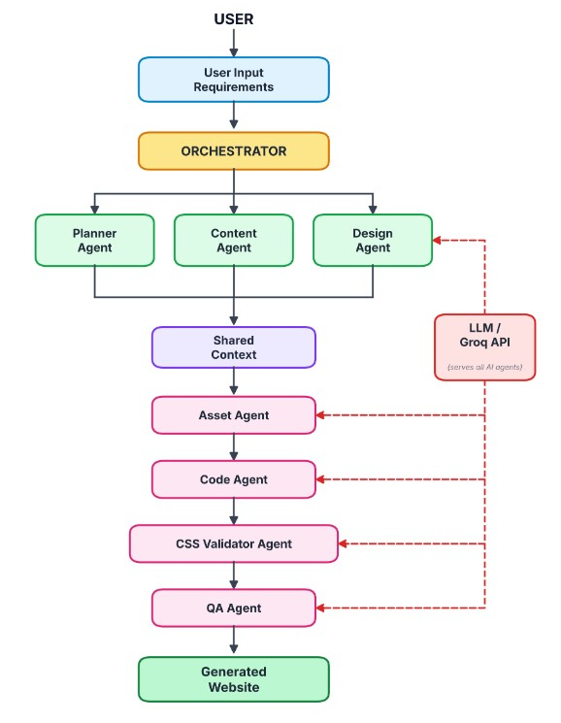

4.2 Multi-Agent Workflow
The proposed framework divides website development into several specialized tasks. The workflow starts when the user provides the requirements of the website. The Orchestrator receives these requirements and initiates the appropriate agents.
The Planner Agent first analyzes the requirements and determines the website structure, pages, sections, and required features. The generated plan is stored in the shared context and used by subsequent agents.
The Content Agent generates textual content based on the planned website structure. The Design Agent determines the visual design, layout, styling, and user interface requirements. The Asset Agent manages the assets required for the website.
After the planning and generation stages, the Code Agent uses the available information to generate the HTML and CSS implementation. The generated code is then checked by the CSS Validator Agent for styling-related issues.
The QA Agent performs the final quality assessment of the generated website. It checks whether the website satisfies the requirements and identifies potential problems. The Orchestrator coordinates these operations and ensures that information generated by one agent is available to other agents through the shared context.

Figure 4.2 Multi-Agent Workflow
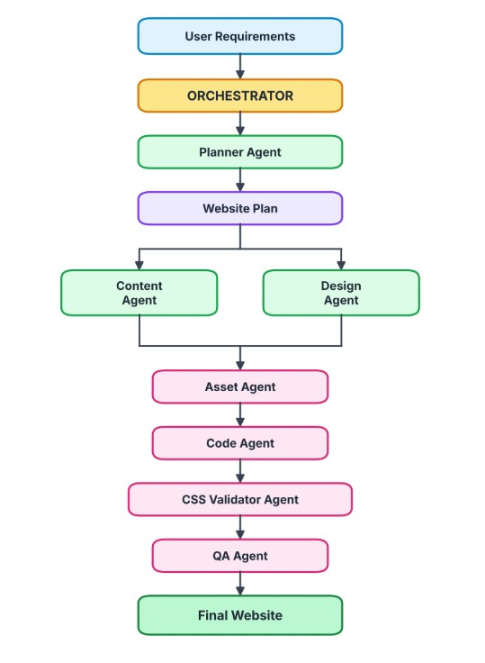

4.3 Data Flow Diagram
The Data Flow Diagram represents the movement of information through the proposed website generation framework. The user provides website requirements as the primary input. These requirements are processed by the Orchestrator and passed to the Planner Agent.
The Planner Agent produces a structured website plan containing information about pages, sections, content requirements, design requirements, and other relevant features. This information is stored in the shared context.
The Content, Design, and Asset Agents use the shared information to generate their respective outputs. These outputs are then used by the Code Agent to generate the website implementation.
The generated website is passed through CSS validation and quality assurance. Any detected issues can be used during the correction process. After successful validation, the final website is stored in the generated website output directory.

Figure 4.3 Data Flow Diagram
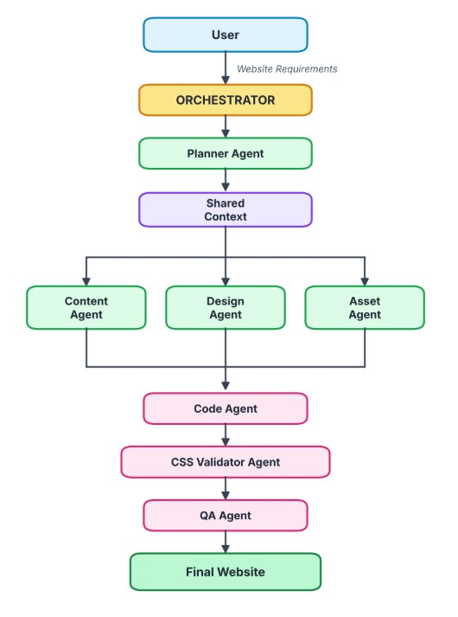

4.4 System Components
The proposed system is implemented using multiple Python modules and directories. Each component performs a specific role in the website generation process.
The Orchestrator coordinates the overall workflow, while the individual agents perform specialized operations. The shared_context.py module provides a mechanism for maintaining information between different stages. The llm_client.py module manages communication with the Groq API and provides common LLM-related functionality.
The project also contains output and logging directories that store generated websites, API usage information, validation results, QA results, and other execution information.

Table 4.1 System Components
Component | Project File / Directory | Purpose
Orchestrator | orchestrator.py | Coordinates the overall agent workflow
Planner Agent | agents/planner_agent.py | Creates the website development plan
Content Agent | agents/content_agent.py | Generates website content
Design Agent | agents/design_agent.py | Defines website design and layout
Asset Agent | agents/asset_agent.py | Handles website assets
Code Agent | agents/code_agent.py | Generates HTML/CSS code
CSS Validator Agent | agents/css_validator_agent.py | Validates CSS implementation
QA Agent | agents/qa_agent.py | Performs quality assurance
Shared Context | shared_context.py | Maintains information shared between agents
LLM Client | utils/llm_client.py | Handles LLM/API communication
Output Directory | outputs/ | Stores generated websites and execution results

4.5 Technology Stack
The framework combines programming technologies, AI services, web technologies, and supporting libraries to implement the automated website development process.
Python is used as the primary programming language for implementing the application, agents, orchestration, and supporting utilities. The Groq API provides access to the Large Language Models used by the system. HTML and CSS are used to construct and style the generated websites.
Prompt Guard is incorporated to provide an additional security layer for detecting potentially malicious prompts. JSON is used extensively for structured data, logs, configurations, and generated results.

Table 4.2 Technology Stack
Technology | Purpose
Python | Core application and agent development
Flask | Web application and user interface
Groq API | LLM integration
GPT-OSS Models | AI-based generation and reasoning
Prompt Guard | Prompt attack detection
HTML | Website structure
CSS | Website styling
JSON | Structured data and logging
python-dotenv | Environment variable management
Regular Expressions | Output processing and text cleaning

4.6 System Design Summary
The proposed system is designed as a modular multi-agent framework in which each agent is responsible for a specific stage of website development. The architecture separates planning, content generation, design, asset management, code generation, validation, and quality assurance into independent components.
The Orchestrator provides centralized coordination, while the Shared Context enables information to be maintained across different stages. The LLM Client provides a common interface for communicating with the selected language models and handles API-related operations.
The architecture also incorporates security and reliability mechanisms such as Prompt Guard, token management, rate-limit handling, retry operations, and output cleaning. These mechanisms are particularly important because the framework depends on external LLM APIs for several stages of website generation.
The modular design makes the framework easier to maintain and extend. Additional agents or capabilities can be introduced without requiring major changes to the entire system. The architecture therefore provides a structured foundation for implementing an intelligent and automated website development system.

4.7 Orchestrator Coordination and Workflow Control
The Orchestrator is the central control component of the proposed multi-agent website development framework. Its primary responsibility is to coordinate the execution of the specialized agents in the correct sequence and ensure that the output produced by one stage is available to the next stage. Instead of allowing each agent to operate independently without coordination, the Orchestrator manages the complete workflow from the initial user requirements to the final website output.
The process begins when the user submits a website description through the application interface. The Orchestrator receives the brief and initiates the website generation pipeline. The Planner Agent processes the brief and prepares a structured website specification. This specification provides the basic information required for subsequent operations, including the website type, pages, content requirements, and design preferences.
After planning, the framework invokes the Content Agent and Design Agent to prepare the textual and visual specifications. The Asset Agent manages the required image assets, while the Code Agent uses the available specifications and generated content to construct the website files. The CSS Validator Agent then checks the generated styling, and the QA Agent evaluates the resulting website against defined quality checks.
The Orchestrator also controls the correction process when quality problems are detected. The QA results are used to identify issues that may require another generation attempt. The workflow can repeat the relevant correction stage within the configured retry limit. This mechanism reduces the need to restart the entire process whenever a correctable issue is found.
Another important responsibility of the Orchestrator is to manage the overall execution state. It coordinates the order of operations, uses the shared context to access intermediate results, and supports the preparation of the final execution report. This centralized approach makes the workflow easier to understand, monitor, and maintain.

4.8 Shared Context and Intermediate Data Management
The Shared Context is an important component of the system because website generation requires information to pass through multiple agents. Each agent produces a specific output, and later stages depend on information generated earlier. The shared context provides a common structure for maintaining these intermediate results throughout the pipeline.
The shared_context.py module is responsible for maintaining the project's shared information. Depending on the processing stage, this information includes the original website brief, the structured website specification, generated content, design information, assets, generated code, quality assurance results, retry information, and final report details.
The Planner Agent's output is particularly important because it establishes the basic structure of the website. The Content Agent uses this specification to prepare relevant text, while the Design Agent uses it to define the visual presentation. The Asset Agent and Code Agent then use the available information to support asset selection and website generation. As a result, the agents work with a common representation of the project rather than relying only on separate, disconnected outputs.
The shared context also supports the correction process. When the QA Agent identifies an issue, the corresponding report can be used by the Orchestrator to determine whether another generation attempt is required. Maintaining the previous outputs and quality information helps the workflow preserve useful information during correction.
Structured data is important when information is exchanged between agents. JSONbased specifications and outputs can be processed programmatically and checked for expected fields. Normalization and validation help reduce inconsistencies, such as missing values or unexpected response formats, before the information reaches a later stage.
The shared context therefore acts as the information coordination layer of the framework. It does not replace the responsibilities of individual agents; instead, it allows each agent to perform its specialized task using the information produced by other stages.

4.9 Validation, Error Handling, and Recovery
The proposed framework includes validation and error-handling mechanisms because the website generation process depends on external language models and automatically generated code. Model responses may be incomplete, incorrectly formatted, or unsuitable for direct use. Similarly, generated HTML and CSS may contain structural or styling problems. Validation is therefore required at different stages of the pipeline.
At the input stage, Prompt Guard provides an additional security check for potentially malicious prompts. The Planner Agent then prepares and normalizes the website specification so that downstream components receive structured information. These checks help reduce the risk of invalid input being passed through the complete workflow.
During communication with the language model service, the LLM Client and supporting API utilities manage API-related operations. The project includes mechanisms for handling rate limits, retrying certain failed operations, tracking API usage, and processing model outputs. These mechanisms help the application respond to temporary service errors and unsuitable responses, although they cannot guarantee that every request will succeed.
After code generation, the CSS Validator Agent checks styling-related issues. The QA
Agent performs additional checks on the generated website. These include checks for important HTML elements, page metadata, navigation, image sources and alternative text, duplicate identifiers, footer presence, CSS class usage, and other structural or presentation-related requirements implemented in the project.
When a problem is detected, the framework records the relevant result and uses the available correction mechanism where applicable. The configured retry limit prevents the generation process from repeating indefinitely. If an issue remains unresolved after the available attempts, the final report should retain the actual outcome instead of treating the website as fully validated.
The validation process improves the visibility of problems and provides useful information for further development. However, automated checks have limitations. Passing structural checks does not necessarily prove that every page is visually correct, fully accessible, secure, or compatible with every browser and device. Additional manual review and broader testing are therefore important before deploying a generated website in a production environment.
Overall, the combination of centralized orchestration, shared context, API error handling, CSS validation, and quality assurance provides a structured method for managing the complexity of automated website development.

5. Multi-Agent Framework
The proposed system uses a multi-agent framework in which different agents are assigned specific responsibilities in the website development process. Instead of depending on a single AI model to perform planning, content generation, design, coding, and testing, the system divides these tasks among specialized agents. This improves modularity, consistency, validation, and overall website quality.
The framework consists of the Planner Agent, Content Agent, Design Agent, Asset Agent, Code Agent, CSS Validator Agent, and QA Agent. An Orchestrator coordinates these agents, while a Shared Context acts as the common storage area for the information generated during the development process.

5.1 Planner Agent
The Planner Agent is responsible for understanding the user's website requirements and converting them into a structured website specification. It receives the user's natural-language brief and uses the LLM to identify important website characteristics such as the site title, site type, business category, tone, target audience, pricing requirements, physical location, required pages, and colour mood.
The generated specification is returned in JSON format so that it can be easily processed by the other agents. The Planner Agent validates the generated response to ensure that all required fields are available and that the website type belongs to the supported categories.
The agent also performs normalization of the generated specification. Boolean values are converted into proper Boolean types, missing page information is replaced with a default structure, and the selected currency is converted into a standard currency code and symbol.
The Planner Agent also uses Prompt Guard to check the user input before processing it. If an unsafe prompt attack is detected, the request is blocked. Invalid or incomplete LLM responses are handled using a retry mechanism.

5.2 Content Agent
The Content Agent is responsible for generating the textual content required for the website. It uses the structured specification produced by the Planner Agent and generates content for each page and its individual sections.
The generated content may include headings, descriptions, call-to-action text, services, products, testimonials, pricing information, and other relevant website information. The content is stored in a structured JSON format so that it can be directly used by the Code Agent during website generation.
The Content Agent also performs several validation and normalization operations. Duplicate headings are detected and modified to prevent repeated headings from appearing on the same page. Pricing information is validated and formatted according to the selected currency. Missing fields are also normalized so that downstream agents receive a consistent content structure.
This approach reduces the possibility of malformed or inconsistent content being passed to the website generation stage.

5.3 Design Agent
The Design Agent is responsible for creating the visual design system of the website. It converts the website specification into design information that can be used by the Code Agent while generating the HTML and CSS structure.
The design system includes colour selection, typography, spacing, layout, accessibility, responsive behaviour, visual effects, and animations. This allows the generated website to maintain a consistent visual appearance across different pages.
The Design Agent also contains deterministic validation mechanisms for colour and typography. The system checks whether the selected primary and secondary colours are visually harmonious. If incompatible colours are detected, a suitable secondary colour is automatically generated.
Similarly, the agent verifies the heading and body font pairing. If fonts are missing or identical, the system selects a suitable predefined font combination based on the tone and colour mood.

5.4 Asset Agent
The Asset Agent is responsible for selecting suitable visual assets for the generated website. The current implementation uses the Pexels API to search for relevant images based on the website subject and section requirements.
The agent first identifies the main subject of the website and generates suitable search queries for different sections. It then retrieves images from Pexels and associates them with the corresponding website sections.
The Asset Agent includes caching to avoid repeatedly requesting the same imagesearch results. It also supports concurrent image retrieval to improve the efficiency of multiple searches.
API failures and rate-limit responses are handled using retry and backoff mechanisms. The agent also prevents the same image from being unnecessarily reused across different sections. Alternative text is provided for images to improve accessibility, with fallback text generated when the image provider does not supply suitable alt text.

5.5 Code Agent
The Code Agent is responsible for generating the actual website pages using the outputs produced by the Planner, Content, Design, and Asset Agents.
The agent generates individual HTML pages and creates the required navigation links between them. The Home page is generated as index.html, while other pages are assigned filenames based on their page names.
The Code Agent uses the generated content and image assets and applies the design system to maintain consistent colours, typography, layouts, and responsive behaviour.
The agent distinguishes between sections containing multiple items and sections containing a single topic. Item-based sections are structured using cards and grids, while singletopic sections are generated using appropriate text and image layouts.
The Code Agent also includes mechanisms to correct common structural problems such as duplicate headers, footers, navigation buttons, and incorrect active navigation states. It works together with the QA Agent through a feedback loop to improve generated pages when problems are detected.

5.6 CSS Validator Agent
The CSS Validator Agent is responsible for checking whether the generated website follows the defined design and styling requirements.
The validator checks the use of design colours and CSS variables, responsive media queries, keyboard focus styles, footer styling, and other important CSS properties. It ensures that the design system generated by the Design Agent is properly represented in the final stylesheet.
The agent also performs page-level checks such as verifying the presence of a single main heading, checking image alternative text, detecting unused or orphaned CSS classes, and validating interactive navigation controls.
Site-wide CSS validation is performed separately from page-level validation. This allows common CSS problems to be identified before individual pages are generated.

5.7 QA Agent
The QA Agent performs quality assurance on the generated website pages. It checks both the structural correctness and the overall quality of each generated page.
The agent performs static checks such as verifying the HTML document type, responsive viewport metadata, title element, heading structure, navigation, header, duplicate IDs, and image sources. It also checks for structural problems that could affect the appearance or usability of the website.
The QA Agent performs additional checks related to accessibility and styling. It detects inappropriate inline focus styles and checks whether required elements are correctly placed within their expected HTML structure.
The agent can also perform an LLM-based review of the generated page. Issues identified during QA are passed back to the Code Agent, allowing the page to be corrected and tested again. This creates a feedback loop between code generation and quality assurance.

5.8 Orchestrator and Shared Context
The Orchestrator acts as the central controller of the multi-agent framework. It manages the execution order of the different agents and ensures that the output of one stage is available to the next stage.
The overall workflow begins with the user brief and proceeds through planning, content generation, design generation, site-wide CSS validation, asset selection, code generation, and quality assurance. After all stages are completed successfully, the generated website and final report are stored in the output directory.
The Orchestrator also supports resuming previously completed work. A context snapshot is stored during the pipeline, allowing completed stages to be skipped when the same website generation task is resumed. This reduces unnecessary processing and API usage.

Shared Context
The Shared Context acts as a common data store for all agents. It maintains the user brief, website specification, generated content, design information, selected assets, generated code, QA report, retry information, and final report path.

6. LLM and API Integration

6.1 Groq API and LLM Models
The proposed multi-agent website generation framework uses the Groq API to provide Large Language Model capabilities to the different agents. The LLM is responsible for understanding user requirements, generating structured information, creating website content, developing page code, and supporting quality analysis.
The main model used in the project is openai/gpt-oss-120b. The system also defines lighter models such as openai/gpt-oss-20b and qwen/qwen3.8-27b for tasks where a smaller model can be used. This allows the framework to manage computational requirements and API usage more efficiently.
The LLM interaction is centralized through the utils/llm_client.py module. Instead of allowing every agent to communicate with the API independently, the agents use the common LLM client. This provides a consistent method for model selection, token management, error handling, and response processing.
Model | Purpose
openai/gpt-oss-120b | Main LLM for complex generation tasks
openai/gpt-oss-20b | Lightweight LLM tasks
qwen/qwen3.8-27b | Intermediate model tasks
meta-llama/llama-prompt-guard-2-22m | Input prompt security
meta-llama/llama-prompt-guard-2-86m | Output security

6.2 Prompt Guard Integration
Prompt Guard is integrated into the framework to improve the security of interactions with the Large Language Models. It is used to identify potentially malicious or unsafe prompts before they are processed by the main LLM. The framework uses separate Prompt Guard models for input and output checking.
The input prompt is scanned before sending it to the main LLM. The generated output can also be checked before it is passed to the next stage of the website generation pipeline. This helps reduce the risk of prompt injection and unsafe generated content.

Working Process
User Input → Input Prompt Guard → Main LLM → Output Prompt Guard → Next Agent

6.3 Token and Rate-Limit Management
The framework includes token and rate-limit management to control API usage during website generation. Since multiple agents communicate with the LLM, several API calls may be made during a single generation process. The system therefore tracks API usage and applies delays when necessary.
The api_budget.py module records API calls and usage metrics, while the LLM client checks available token headroom before making a request. Different minimum delays are also maintained for the models to reduce the possibility of exceeding API limits.

Working
Prompt → Estimate Tokens → Check API Limit → Wait if Required → Send Request → Record Usage

6.4 Error and Retry Handling
The framework includes error and retry handling to improve the reliability of API communication. LLM requests may fail because of rate limits, temporary API errors, unavailable models, or other network-related problems. The llm_client.py module detects these conditions and applies suitable handling.
When a rate-limit error occurs, the system determines the required waiting time and delays the next request. The system also limits the retry wait time to avoid excessive delays. This allows the multi-agent pipeline to continue working when temporary API problems occur.
Retry Process
API Request → Error Detection → Determine Wait Time → Wait → Retry Request

7. System Implementation

7.1 Project Structure

7.1.1 Website Generation Workflow
The implementation of the proposed framework follows a structured sequence of operations that converts the user's website requirements into a generated website. The application uses Python for the main processing logic, Flask for the web interface, specialized agents for individual development tasks, and the Groq API for language model integration.
The process begins when the user enters a description of the required website through the application interface. The input may specify the type of website, intended audience, required pages, preferred visual style, content requirements, and other relevant details. The application passes these requirements to the Orchestrator, which coordinates the execution of the generation pipeline.
The Planner Agent analyses the input and prepares a structured specification. This specification acts as the foundation for subsequent stages. The Content Agent generates the textual material, and the Design Agent prepares the visual design information. The Asset Agent manages the required visual assets, while the Code Agent uses the collected information to generate the website implementation.
After code generation, the CSS Validator Agent examines the styling implementation. The generated pages are then processed by the QA Agent, which checks for structural and quality-related issues. If the available checks identify problems, the framework can use the configured correction and retry mechanism. The Orchestrator coordinates these operations and prepares the final execution report.
The generated website files and related execution information are stored in the project's output directories. This organization separates the application logic from generated results and makes it easier to inspect the website, review logs, and examine the outcome of an execution.

7.1.2 Shared Context and State Management
The website generation process involves multiple stages, and each stage depends on information produced by earlier stages. To support this requirement, the framework uses the Shared Context implemented in _{shared_context.py}. It provides a common structure for maintaining the data required by the different agents.
The shared information includes the user's original brief, the website specification, generated content, design details, asset information, generated code, QA results, retry information, and final report details. The exact information available at any point depends on how far the pipeline has progressed.
When the Planner Agent completes its task, the resulting specification becomes available to subsequent agents. The Content Agent and Design Agent use this information to prepare their respective outputs. The Asset Agent and Code Agent then use the accumulated project information to support website construction. This arrangement reduces the need to repeatedly reconstruct the original requirements at every stage.
State management is also important during error recovery. When quality checks identify a problem, the Orchestrator can use the available QA information to guide another attempt within the configured retry limit. Maintaining the execution state provides a clearer record of the workflow and supports the preparation of the final report.
The Shared Context therefore acts as a common information layer rather than an independent website-generation agent. It allows the framework to maintain continuity between specialized tasks and provides the Orchestrator with access to intermediate results.

7.1.3 API Integration and Error Handling
The framework relies on external language models to perform several AI-based generation tasks. Communication with these models is handled through the project's LLM client and supporting API utilities. The Groq API provides access to the configured language models, while supporting modules handle API-related operations.
The API integration layer is important because the agents require model responses in a form that can be processed by the application. Depending on the task, the response may contain a website specification, page content, design information, or generated code. The application must process these responses before passing the information to the next stage.
External API calls may encounter rate limits, temporary service failures, incomplete responses, or output-format problems. The project includes mechanisms for rate-limit handling, retries for applicable failures, API usage tracking, and output processing. These mechanisms help the application manage some common errors, although they cannot eliminate every possible failure.
The project also uses environment-variable management to support configuration of sensitive settings such as API credentials. Keeping credentials outside the main source code is a useful security practice because it reduces the risk of accidentally exposing them when sharing or maintaining the project.
Prompt Guard provides an additional check for potentially malicious input. This security measure complements the normal generation workflow but should not be considered a complete security solution. Generated websites and user inputs still require appropriate validation and review.
Overall, the API integration and error-handling components support communication between the specialized agents and the external model service. Their role is to improve the reliability and manageability of the generation process while making API usage and execution outcomes easier to inspect.

Figure 7.1 Project Structure
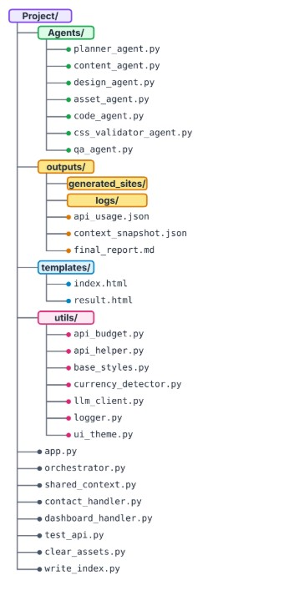

7.2 Website Generation Pipeline
The website generation process follows a sequential multi-agent pipeline. The user first provides a website requirement through the application interface. The Orchestrator receives the requirement and coordinates the different agents.
The Planner Agent converts the user requirement into a structured website specification. The Content Agent then generates the required website content, while the Design Agent defines the visual style, colours, typography, and layout. The Asset Agent selects suitable images and other visual resources.
The Code Agent uses the specification, content, design information, and selected assets to generate the website pages. The CSS Validator checks the generated styling, and the QA Agent performs structural and quality checks. If validation problems are detected, the system can perform corrections before producing the final website.

Figure 7.2 Pipeline
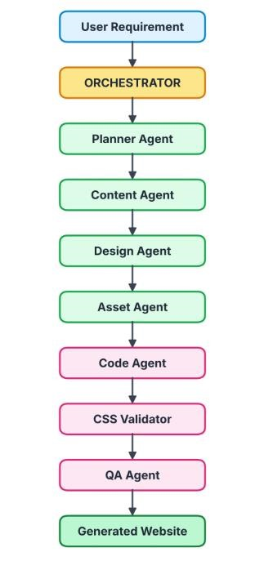

7.3 HTML and CSS Generation
The Code Agent generates the HTML structure and styling information required for each website page. It receives the website specification, generated content, design information, selected assets, and navigation links from the previous stages.
Images are included with appropriate alternative text, navigation links are connected between pages, and different section layouts are selected according to the content requirements.
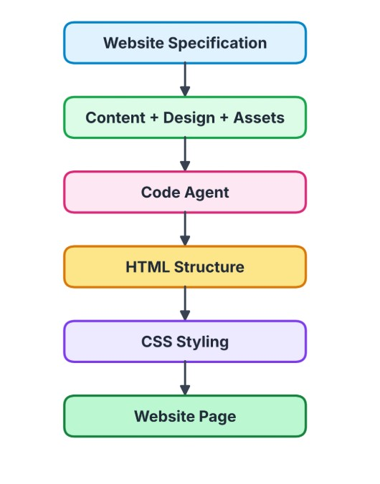

7.4 Validation and Logging
The generated website is validated before the final output is produced. The QA Agent performs static checks on the generated HTML and verifies important website elements such as the document type, viewport configuration, page title, heading structure, navigation, images, and duplicate IDs.
The framework also maintains logs for the different stages of the generation process. These logs help track agent execution, API usage, validation results, and errors. The generated context can also be saved so that the system can resume or inspect previous generation stages.

Figure 7.3 Validation Process:

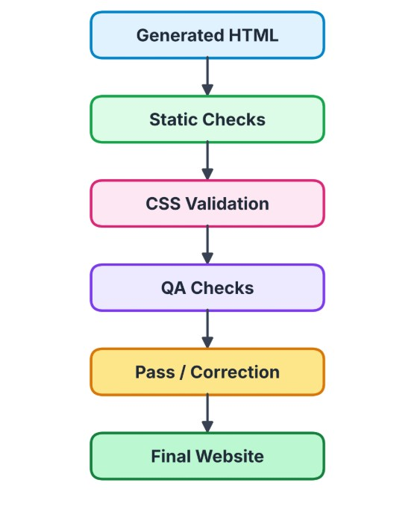

8.Testing and Results

8.1 Testing Methodology
Testing is performed to verify that the multi-agent website generation framework works correctly and produces valid website output. The testing process covers individual agents, communication between agents, website generation, CSS validation, and final quality assurance.
The system uses both agent-level testing and integration testing. Agent-level testing checks the individual functions of each agent, while integration testing verifies that the complete pipeline works correctly from user input to the final generated website.

Table 8.1 Testing Methodology
Testing Type | Purpose
Agent Testing | Verify individual agent functions
Integration Testing | Verify communication between agents
Input Validation | Check user requirements and generated specifications
HTML Validation | Verify generated HTML structure
CSS Validation | Check styling and responsive rules
QA Testing | Identify structural and content-related issues
Output Testing | Verify the final generated website

8.2 Agent and Integration Testing
Agent and integration testing is performed to verify that each agent performs its assigned task correctly and that the agents work together as a complete website generation pipeline.
Each agent receives the output from the previous stage through the shared context. The
Planner Agent produces the website specification, which is used by the Content and Design Agents. The Asset Agent uses the generated requirements to select suitable assets, while the Code Agent combines the generated information to create the website pages. The CSS Validator and QA Agent then validate the generated output.

Table 8.2 Test Cases and Results
Test Case | Expected Result |  | Result
User enters valid website  requirement | Website specification is generated |  | Pass
Planner generates specification | Valid structured specification is produced |  | Pass
Content Agent generates content | Required page content is generated |  | Pass
Design Agent generates design | Colours, typography and layout generated | are | Pass
Asset Agent selects images | Suitable image assets are selected |  | Pass
Code Agent generates pages | Valid HTML pages are generated |  | Pass
CSS Validator checks styles | CSS issues are detected |  | Pass - 1 issue detected
QA Agent checks website | Structural issues are detected |  | Issues detected 0/2 pages passed all QA checks
Complete pipeline execution | Final website is generated |  | Pass — QA issues remain

8.3 Website Validation
The generated website is validated before it is considered complete. The QA Agent checks the structure and important elements of each generated HTML page. The validation process checks whether the page contains a valid document type, viewport configuration, page title, correct heading structure, navigation elements, images, and other required components.
CSS-related checks are also performed to identify issues such as missing responsive rules, focus states, and incorrect styling. If an issue is detected, the generated page can be corrected and checked again before the final website is produced.

Table 8.3 Validation Checks

Validation Check | Purpose
DOCTYPE Check | Verifies valid HTML document declaration
Viewport Check | Ensures responsive display configuration
Title Check | Verifies the page contains a title
H1 Check | Ensures correct main heading structure
Navigation Check | Verifies navigation elements
Image Check | Detects missing or broken image references
Duplicate ID Check | Identifies duplicate HTML IDs
CSS Check | Verifies important CSS rules
Footer Check | Ensures required footer structure

Figure 8.1 Testing and Validation Workflow

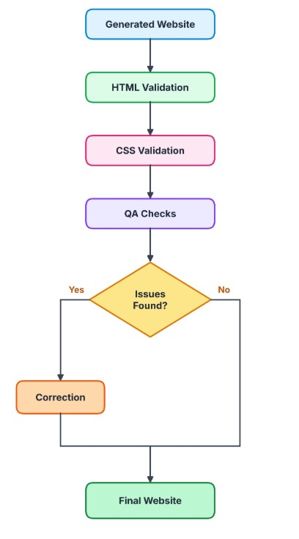

8.4 Results and Performance Analysis
The developed multi-agent framework successfully generates complete websites from user requirements through a sequence of specialized agents. The system coordinates planning, content generation, design selection, asset selection, code generation, CSS validation, and quality assurance.
Testing showed that the individual agents were able to perform their assigned tasks and that the complete pipeline could transfer information between agents using the shared context. The generated websites were checked for important HTML and CSS requirements before being accepted as final outputs.

Table 8.4 Performance Analysis
Parameter | Result
Website Specification Generation | Successful
Content Generation | Successful
Design Generation | Successful
Asset Selection | Successful
HTML Generation | Generated
CSS Validation | 1 issue detected
QA Validation | Issues detected and correction attempted
Multi-Agent Coordination | Successful
Final Website Generation | Completed

Result Summary
The testing results demonstrate that the proposed framework can automate major stages of website development. The specialized agents successfully performed their respective tasks and coordinated through the shared context. The QA process identified structural and accessibility issues in the generated pages and initiated correction attempts. The final execution generated the requested website, although the recorded QA result was best-effort with 0 out of 2 pages passing all QA checks. These results demonstrate the importance of automated validation and quality assurance in AI-generated websites.

8.5 Detailed Testing Procedures
Testing is an important part of the proposed multi-agent website development framework because the system combines user input processing, language model integration, code generation, styling validation, and automated quality assurance. Each stage must be examined to determine whether it performs its intended function and whether its output can be used by the next stage.
The testing process begins with input validation. The application receives a website brief from the user, and the Planner Agent processes the input to prepare a structured specification. The generated specification should contain the information required by later stages. Incomplete or incorrectly formatted responses must be identified and handled according to the validation and retry mechanisms implemented in the application.
The next stage examines the interaction between agents. The outputs generated by the Planner, Content, Design, and Asset Agents should be available to the subsequent stages through the shared context. The Code Agent should use the available project information to generate the website files. These checks help identify problems caused by missing data, inconsistent output structures, or incomplete processing between agents.
Code and styling validation is performed after website generation. The CSS Validator Agent checks for styling-related issues, while the QA Agent examines the generated pages for defined structural and quality requirements. The checks implemented in the project include the presence of important HTML elements, page titles, headings, navigation elements, image information, footer elements, duplicate identifiers, and CSS-related issues.
The final stage involves reviewing the generated website and the execution records. The generated pages can be inspected to determine whether the content and layout correspond to the original requirements. Logs and QA reports provide additional information about the execution sequence, detected issues, and correction attempts. These records are useful for understanding the outcome of a test and identifying areas that require further improvement.

8.6 Functional Test Cases
Functional testing verifies whether the major components of the framework perform their intended tasks. The following table describes the principal test areas for the proposed system. The expected behaviour represents the intended result; the actual outcome must be recorded from the corresponding execution evidence.
Table 8.5 Functional Test Cases
Test Case | Testing Activity | Expected Behaviour | Evidence to Review
TC01 | Submit website  requirements | The application accepts the brief and initiates processing | Application output or  execution log
TC02 | Generate website  specification | The Planner Agent produces  structured website information | Specification output
TC03 | Generate website content | The Content Agent prepares  content for the planned pages | Generated content data
TC04 | Prepare design  information | The Design Agent produces design information for website  construction | Design output
TC05 | Generate website  files | The Code Agent creates the required website implementation | Generated HTML and CSS files
TC06 | Validate styling | The CSS Validator identifies styling-related problems where present | CSS validation report
Test Case | Testing Activity | Expected Behaviour | Evidence to Review
TC07 | Perform quality checks | The QA Agent checks the generated pages against  implemented rules | QA report or dashboard
TC08 | Handle detected  issues | The configured correction mechanism processes eligible  issues within the retry limit | Retry logs and final QA output
TC09 | Record execution  results | The framework stores relevant logs and final report information | Output directory and report
TC10 | Review generated pages | The website can be inspected for structure, content, and visual presentation | Screenshots of generated pages

The expected behaviour listed above should not automatically be interpreted as a successful test result. A test should be marked as passed only when the corresponding output or execution evidence confirms that the expected behaviour occurred. If the available evidence is incomplete, the result should be recorded as inconclusive or not verified.

8.7 Analysis of Quality Assurance Results
The QA stage is designed to identify structural and presentation-related issues in the generated website. The automated checks help detect problems that may not be obvious from the existence of the generated files alone. Examples include missing required HTML elements, duplicate identifiers, missing image alternative text, broken or missing image sources, and unused CSS classes.
The execution evidence included in the project report indicates that the validation process identified issues requiring attention. The recorded CSS validation output reported one issue, and the recorded per-page QA result showed that zero out of two pages passed all the configured QA checks. This result indicates that the generated pages did not satisfy every implemented QA requirement during that recorded run.
These findings are important because they distinguish successful code generation from successful quality validation. A website may be generated and displayed while still containing structural, styling, or content-related issues. Therefore, the generation of website files alone is not sufficient evidence that the framework has produced a fully validated result.
The recorded results also demonstrate the usefulness of automated testing. By identifying issues in a structured report, the framework provides information that can guide debugging and subsequent correction attempts. However, the presence of a retry mechanism does not guarantee that every issue will be resolved. The final outcome must be evaluated using the actual results recorded after the available attempts.
The current test evidence should consequently be interpreted as a demonstration of the framework's generation and validation workflow, rather than proof that all generated pages passed every quality requirement. Further testing with different website briefs, page structures, and input conditions would help evaluate the consistency of the framework and identify additional improvements.

8.8 Limitations of the Testing Approach
Although automated validation provides useful feedback, it cannot evaluate every aspect of website quality. Structural checks can identify specific HTML and CSS issues, but they may not fully assess the visual balance, usefulness, readability, or overall user experience of a generated page.
The results may also vary depending on the input brief, model response, selected assets, and availability of the external API. A successful execution with one website brief does not establish that the same quality will be achieved for every type of website. Testing should therefore include multiple representative inputs and repeated executions where appropriate.
Additional evaluation could include manual visual inspection, responsive layout testing across different screen sizes, browser compatibility checks, accessibility assessment, and performance measurements. The results should be documented using consistent criteria so that different executions can be compared fairly.
These limitations provide directions for improving the testing process. Combining automated structural checks with manual review and broader test coverage would provide a more complete assessment of the proposed framework.

9. Conclusion and Future Enhancements

9.1 Conclusion
The project A Multi-Agent Framework for Intelligent Website Design and Development presents an AI-based approach for automating major stages of website development. The framework uses multiple specialized agents, with each agent responsible for a specific task such as planning, content generation, design creation, asset selection, code generation, CSS validation, and quality assurance.
The Orchestrator coordinates these agents and maintains their information through a shared context. The integration of the Groq API and Large Language Models enables the system to understand user requirements and generate website components automatically. Prompt Guard provides an additional security layer, while token management, rate-limit handling, validation, and logging improve the reliability of the system.
The testing process demonstrated that the individual agents and the complete generation pipeline can work together to produce website pages from user requirements. The generated output is further checked using CSS validation and QA processes before being finalized.
Overall, the proposed framework demonstrates how multi-agent artificial intelligence can reduce manual effort in website development and provide a structured approach for automated website generation.

9.2 Future Enhancements
The framework can be further improved by introducing additional capabilities and expanding the existing agents. Possible future enhancements include:
- Advanced UI Generation
The system can be extended to generate more sophisticated user interfaces with advanced layouts, animations, and interactive components.
- Improved Design Intelligence
The Design Agent can be enhanced to provide context-aware colour schemes, typography, spacing, and responsive layouts.
- More Asset Sources
Additional image and media providers can be integrated to offer a wider range of assets.
- Enhanced Testing
Automated browser-based testing can be added to verify the behaviour and responsiveness of generated websites.
- Database Integration
Database support can be introduced to store user projects, generated websites, configurations, and previous generations.
- Deployment Automation
The framework can be extended to deploy generated websites automatically to cloud hosting platforms.
- User Feedback and Regeneration
Users can be given options to request changes to specific sections and regenerate only the required components.

10. References
- Flask, Flask Documentation, Pallets.
- GitHub, GitHub Documentation, GitHub.
- Groq, Groq API Documentation, Groq Inc.
- Jinja, Jinja Template Documentation, Pallets.
- LangChain, LangChain Documentation.
- Meta, Llama Prompt Guard Documentation, Meta AI.
- Mozilla, MDN Web Docs: HTML, CSS, and JavaScript, Mozilla.
- OpenAI, GPT-OSS Model Documentation, OpenAI.
- Pexels, Pexels API Documentation.
- Python Software Foundation, Python Documentation.
- Russell, Stuart J., and Peter Norvig, Artificial Intelligence: A Modern Approach, 4th Edition, Pearson, 2020.
- Wooldridge, Michael, An Introduction to MultiAgent Systems, 2nd Edition, John Wiley & Sons, 2009.

11. Appendices
The appendices contain the supporting materials and complete implementation details of the proposed multi-agent website generation framework. They include the complete source code, sample input and outputs, screenshots of the generated websites, and testing results.

11.1 Source Code
This section contains the main source code of the project, orchestrator.py, which coordinates the execution of the specialized agents and manages the overall website generation workflow.

11.1.1 orchestrator.py
import os import json import shutil import logging import datetime from shared_context import SharedContext from agents.planner_agent import run_planner from agents.content_agent import run_content_agent from agents.design_agent import run_design_agent from agents.asset_agent import run_asset_agent from agents.code_agent import generate_multi_page_site_with_qa from agents.css_validator_agent import run_sitewide_css_validation from utils.logger import save_agent_log from utils.api_budget import estimate_and_warn

logger = logging.getLogger("orchestrator")

SNAPSHOT_PATH = "outputs/context_snapshot.json"
GENERATED_SITES_DIR = "outputs/generated_sites"
DEFAULT_PAGE_COUNT_ESTIMATE = 4 # used only before a spec exists to give an early rough warning

def build_final_report(brief, spec, content, design, assets, result, sitewide_css_report=None): def _fenced_json(data, limit=None): text = json.dumps(data, indent=2) if limit and len(text) > limit:
return text[:limit] + f"\n... [truncated, {len(text) - limit} more characters]" return text

lines = [
"# Website Generation Report",
"",
f"**Generated:** {datetime.datetime.now().isoformat()}", f"**User Brief:** {brief}",
"",
"## 1. Planner Agent Output",
"```json", _fenced_json(spec), "```",
"",
"## 2. Content Agent Output",
"```json", _fenced_json(content, limit=2000), "```",
"",
"## 3. Design Agent Output",
"```json", _fenced_json(design), "```",
"",
"## 4. Asset Agent Output",
"```json", _fenced_json(assets, limit=2000), "```",
"",
]

if sitewide_css_report is not None:
lines.append("## 5. Site-Wide CSS Validation (runs once, before page generation)") status = "PASSED ✅" if sitewide_css_report["passed"] else "FAILED ⚠️" lines.append(f"- Status: {status}") if sitewide_css_report["issues"]:
lines.append("Issues (fix these in base_styles.py / design_agent.py, not per page):") for issue in sitewide_css_report["issues"]:
lines.append(f" - {issue}") lines.append("")

lines.append("## 6. Code Agent + Per-Page QA Loop-Back Summary") lines.append("")

for filename, page_log in result["summary"]["pages"].items():
status = "PASSED ✅" if page_log["passed"] else "FAILED ⚠️ (best effort returned)" lines.append(f"### Page: {filename}") lines.append(f"- Status: {status}") lines.append(f"- Total attempts: {page_log['total_attempts']}")
lines.append("")

for attempt in page_log["attempts"]:
lines.append(f"**Attempt {attempt['attempt_number']}** — Passed:
{attempt['passed']}") if attempt["issues"]:
lines.append("Issues found:") for issue in attempt["issues"]: lines.append(f" - {issue}") else:
lines.append("No issues found.") lines.append("")

lines.append("## 7. Final Generated Pages") for filename, path in result["generated_files"].items():
lines.append(f"- `{filename}` → `{path}`")

report_path = "outputs/final_report.md" with open(report_path, "w", encoding="utf-8") as f:
f.write("\n".join(lines))

return report_path

def get_multiline_brief() -> str:
print("Describe the website you want (paste multiple lines, blank lines are OK).") print("When done, type END on its own line and press Enter:\n")
lines = [] while True: line = input() if line.strip().upper() == "END":
break lines.append(line) return "\n".join(lines)

def clear_generated_sites():
"""Wipes the generated_sites folder so old pages from a different brief can never leak into a new run (filenames like index.html, contact.html are common across almost every site).""" if os.path.exists(GENERATED_SITES_DIR): shutil.rmtree(GENERATED_SITES_DIR) os.makedirs(GENERATED_SITES_DIR, exist_ok=True)

def _qa_summary_all_passed(qa_summary: dict) -> bool: """True only if there's at least one page and every page's QA loop reported passed=True. Empty/missing summaries are treated as NOT passed, so an interrupted run (e.g. zero pages generated before a crash) is correctly re-attempted rather than skipped.""" pages = (qa_summary or {}).get("pages", {})
return bool(pages) and all(p.get("passed") for p in pages.values())

def run_pipeline(user_brief: str, resume: bool = True, strict_sitewide_css: bool = False, currency: str = "USD"):
"""
strict_sitewide_css: when True, the pipeline stops immediately after site-wide CSS validation fails, instead of continuing into page generation. Site-wide issues (missing breakpoints, missing focus states, etc.) apply identically to EVERY page and, per the validator's own design, cannot be fixed by the per-page QA retry loop — letting the pipeline continue anyway means burning a full multi-attempt QA budget on every page for a problem none of those attempts can solve.
Defaults to False to preserve prior behavior (warn and continue).

currency: user-selected currency code (e.g. "USD", "INR", "GBP", "EUR"), forwarded to the Planner Agent, which stamps it onto the spec as currency_code/currency_symbol (see planner_agent.normalize_spec).
Defaults to "USD" for CLI/legacy callers that don't pass one.

NOTE: if a previous spec is resumed from a snapshot (resume=True and a matching snapshot exists), the Planner step — and therefore this currency argument — is skipped, and whatever currency was baked into the cached spec is reused instead.
"""
ctx = SharedContext()

if resume and os.path.exists(SNAPSHOT_PATH): with open(SNAPSHOT_PATH, "r") as f:
saved_data = json.load(f)

if saved_data.get("brief") == user_brief and saved_data.get("spec"):
logger.info("📂 Found previous progress for this exact brief — resuming where possible.\n") ctx.data = saved_data else:
logger.info("🆕 New or changed brief detected — starting fresh (previous progress ignored).\n") clear_generated_sites() elif not resume:
logger.info("🆕 Fresh run requested — clearing any leftover generated files.\n") clear_generated_sites() else:
# resume=True but no snapshot exists at all — e.g. context_snapshot.json
# was deleted/never written but generated_sites/ still has files from
# some earlier, now-untraceable run. Without a snapshot there's no way
# to confirm those files correspond to this (or any known) brief, so
# treat this the same as a fresh run rather than silently reusing # (and skipping regeneration of) files with unknown provenance. logger.info("🆕 No previous snapshot found — starting fresh.\n") clear_generated_sites()

ctx.update("brief", user_brief) ctx.save_to_file()

# Step 1: Planning if not ctx.get("spec"):
logger.info("🧠 Running Planner Agent...") spec = run_planner(user_brief, currency=currency)
if not spec:
logger.error("❌ Planning failed (likely rate limited). Run again later to resume.") return False ctx.update("spec", spec) ctx.save_to_file() save_agent_log("planner_log", spec) logger.info("✅ Spec ready.\n")
else:
logger.info("🧠 Skipping Planner (already completed).\n") spec = ctx.get("spec")

# Budget estimate: moved here (rather than before the planner ran) so it
# uses the ACTUAL number of pages from the spec instead of a hardcoded
# guess — a landing page and an 8-page e-commerce site have very # different cost profiles, and a fixed number under- or over-warns for
# almost every real brief.
num_pages = len(spec.get("pages", [])) or DEFAULT_PAGE_COUNT_ESTIMATE estimate_and_warn(num_pages=num_pages, max_retries=3)

# Step 2: Content if not ctx.get("content"):
logger.info("✍️ Running Content Agent...") content = run_content_agent(spec) if not content:
logger.error("❌ Content generation failed (likely rate limited). Run again later to resume.")
return False ctx.update("content", content) ctx.save_to_file() save_agent_log("content_log", content) logger.info("✅ Content ready.\n")
else:
logger.info("🧠 Skipping Content (already completed).\n") content = ctx.get("content")

# Step 3: Design if not ctx.get("design"):
logger.info("🎨 Running Design Agent...") design = run_design_agent(spec) if not design:
logger.error("❌ Design generation failed (likely rate limited). Run again later to resume.")
return False
ctx.update("design", design) ctx.save_to_file() save_agent_log("design_log", design) logger.info("✅ Design system ready.\n")
else:
logger.info("🧠 Skipping Design (already completed).\n") design = ctx.get("design")

# Step 3.5: Site-wide CSS validation — runs ONCE, against the deterministic
# base CSS generator, before any pages exist. This catches missing
# breakpoints/focus-states/footer-styling at the source (base_styles.py /
# design schema) instead of letting the per-page QA loop re-discover the
# same unfixable issue on every page, every attempt. logger.info("🧠 Running site-wide CSS validation...") sitewide_css_report = run_sitewide_css_validation(design) save_agent_log("css_validator_sitewide", sitewide_css_report) if sitewide_css_report["passed"]:
logger.info("✅ Site-wide CSS passed all deterministic checks.\n")
else:
logger.warning(
"⚠️ Site-wide CSS has %d issue(s) (these apply to EVERY page and must be fixed in "
"base_styles.py or the design schema, not by the per-page retry loop):", len(sitewide_css_report["issues"]),
)
for issue in sitewide_css_report["issues"]:
logger.warning(" - %s", issue)

if strict_sitewide_css:
logger.error(
"❌ Stopping (strict_sitewide_css=True): fix the issues above and rerun. "
"Progress so far (spec/content/design) is saved and will be reused on resume."
) return False logger.info("")

# Step 4: Assets if not ctx.get("assets"):
logger.info("🖼️ Running Asset Agent...") assets = run_asset_agent(spec, content) if not assets:
# FIX: every other stage checks for a falsy return and aborts
# with a clear message; this one previously didn't. A failed
# asset generation call would silently store None/{} and the # pipeline would continue straight into page generation with
# no images and no warning to the operator.
logger.error("❌ Asset generation failed (likely rate limited). Run again later to resume.")
return False ctx.update("assets", assets) ctx.save_to_file() save_agent_log("asset_log", assets) logger.info("✅ Assets ready.\n")
else:
logger.info("🧠 Skipping Assets (already completed).\n") assets = ctx.get("assets")

# Step 5: Code generation with per-page QA loop-back
# FIX: previously ran unconditionally on every invocation, even a full
# resume where every page already passed QA in a prior run — wasting an
# entire per-page QA/fix LLM budget for nothing. Now mirrors the same
# "skip if already completed" pattern used by every earlier step. cached_summary = ctx.get("qa_report") if ctx.get("code") and _qa_summary_all_passed(cached_summary):
logger.info("🧠 Skipping Code Agent + QA loop (already completed, all pages previously passed).\n") result = {"generated_files": ctx.get("code"), "summary": cached_summary}
else:
logger.info("💻 Handing off to Code Agent (multi-page, with per-page QA loop-back)...") result = generate_multi_page_site_with_qa(spec, content, design, assets, max_retries=3)

# FIX: every other stage calls save_agent_log() right after it
# finishes, but this one never did. The dashboard's last pipeline
# card ("Code Agent + Per-Page QA Loop") and the whole "Per-Page QA
# Loop" section read from outputs/logs/multi_page_qa_summary.json, so
# without this write that card stayed on "pending" forever, even
# after the run fully completed in the terminal.
save_agent_log("multi_page_qa_summary", result["summary"])

ctx.update("code", result["generated_files"]) ctx.update("qa_report", result["summary"]) ctx.save_to_file()

logger.info("\n📄 Pages generated:") for filename, path in result["generated_files"].items():
page_passed = result["summary"]["pages"][filename]["passed"] status = "✅ PASSED" if page_passed else "⚠️ best-effort" logger.info(" - %s: %s (%s)", filename, status, path)

# Step 6: Final report
report_path = build_final_report(user_brief, spec, content, design, assets, result, sitewide_css_report) ctx.update("final_report_path", report_path) ctx.save_to_file() logger.info("\n📝 Full report saved to: %s", report_path)

all_passed = all(p["passed"] for p in result["summary"]["pages"].values()) if all_passed and sitewide_css_report["passed"]:
logger.info("\n🎉 Done! All pages passed QA. Open outputs/generated_sites/index.html to view the site.") else:
logger.info("\n⚠️ Done, but some checks needed best-effort fallback. Check %s for
details.", report_path)

return True

if __name__ == "__main__":
logging.basicConfig(level=logging.INFO, format="%(message)s")

brief_file = "brief.txt" if os.path.exists(brief_file): with open(brief_file, "r", encoding="utf-8") as f:
brief = f.read().strip() print(f"📄 Using brief from {brief_file}:\n{brief}\n")
else:
brief = get_multiline_brief()

run_pipeline(brief)

11.2 Generated Website Screenshots
This section contains screenshots of the website generated by the proposed multi-agent framework. The generated website is a two-page coffee shop website named Daily Grind, consisting of a Home page and a Contact page.

11.2.1 Website Generation Result
The system successfully completed the website generation process and generated two pages, namely index.html and contact.html.

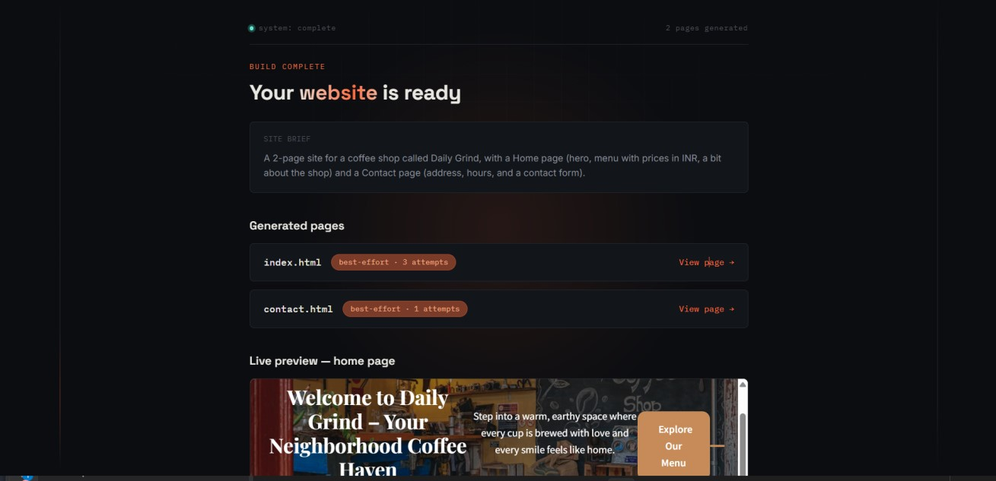
Figure 11.1 Generated Website Build Result

11.2.2 Generated Home Page
The generated Home page contains a navigation bar, hero section, introductory content and a menu section displaying coffee items with their descriptions and prices.

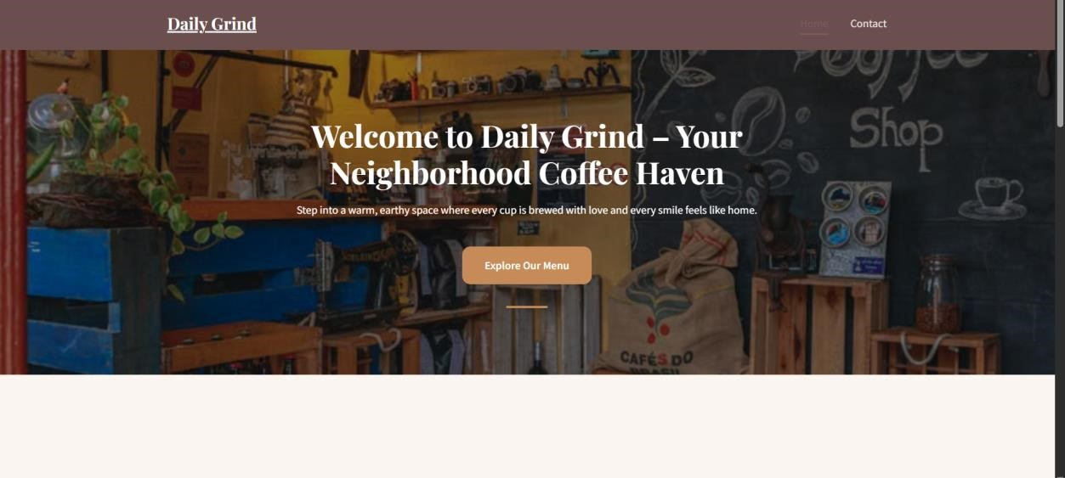
Figure 11.2 Generated Home Page

11.2.3 Generated Menu Section
The Home page includes a signature selections section containing coffee products such as Espresso, Cappuccino and Flat White. Each item contains an image, description and price.
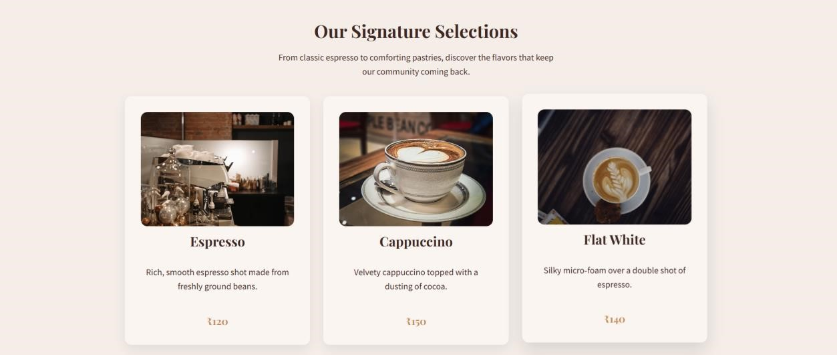
Figure 11.3 Generated Menu Section

11.2.4 Generated Contact Page
The Contact page provides the location of the coffee shop along with a contact section containing Name, Email and Message fields and a Send Message button.


Figure 11.4 Generated Contact Page

11.3 Test Results and Logs
The proposed multi-agent framework was tested by generating a two-page website for a coffee shop named Daily Grind.

11.3.1 Agent Pipeline Execution
The Planner Agent planned two pages, the Content Agent generated content for the Home and Contact pages, the Design Agent generated the visual design, the Asset Agent sourced images, and the Code Agent generated the website pages.
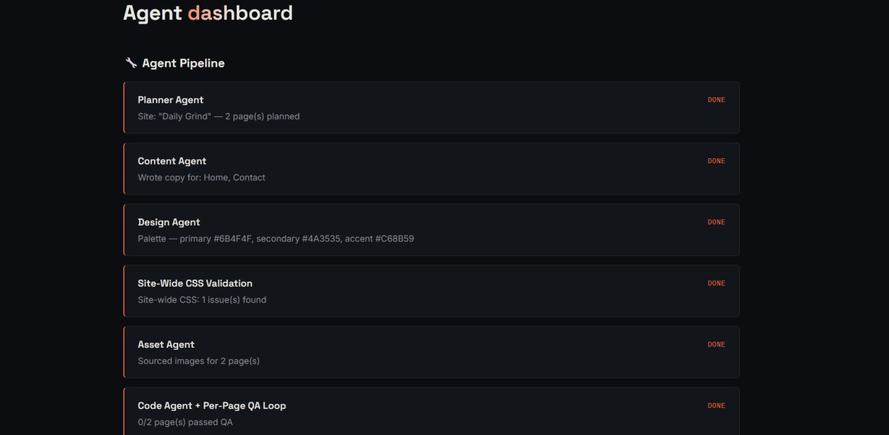
Figure 11.5 Agent Pipeline Execution

11.3.2 Per-Page QA Results
The framework performs quality checks on each generated page. The QA dashboard recorded multiple issues during the generation process and attempted corrections through the per-page QA loop.
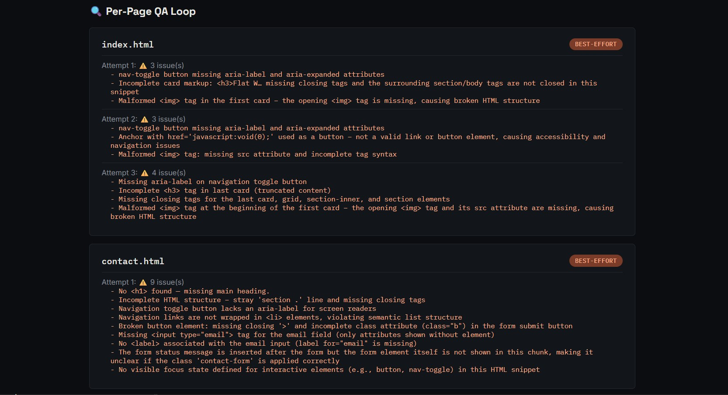
Figure 11.6 Per-Page QA Results
The index.html page was tested through three attempts. The detected issues included missing accessibility attributes, incomplete HTML tags and malformed image tags.
The contact.html page was also tested and several issues were identified, including missing main heading structure, incomplete HTML elements, navigation accessibility issues, malformed form elements, missing input attributes and missing visible focus states.
The results demonstrate that the QA agent is able to identify structural and accessibility problems in generated HTML. The system marks these pages as best-effort when all correction attempts do not completely resolve the detected issues.

11.3.3 API Usage and Performance Results
The framework records API usage and latency during website generation. In the recorded execution, 27 API calls were made, using a total of 70,483 tokens, with a total recorded latency of 46.3 seconds.

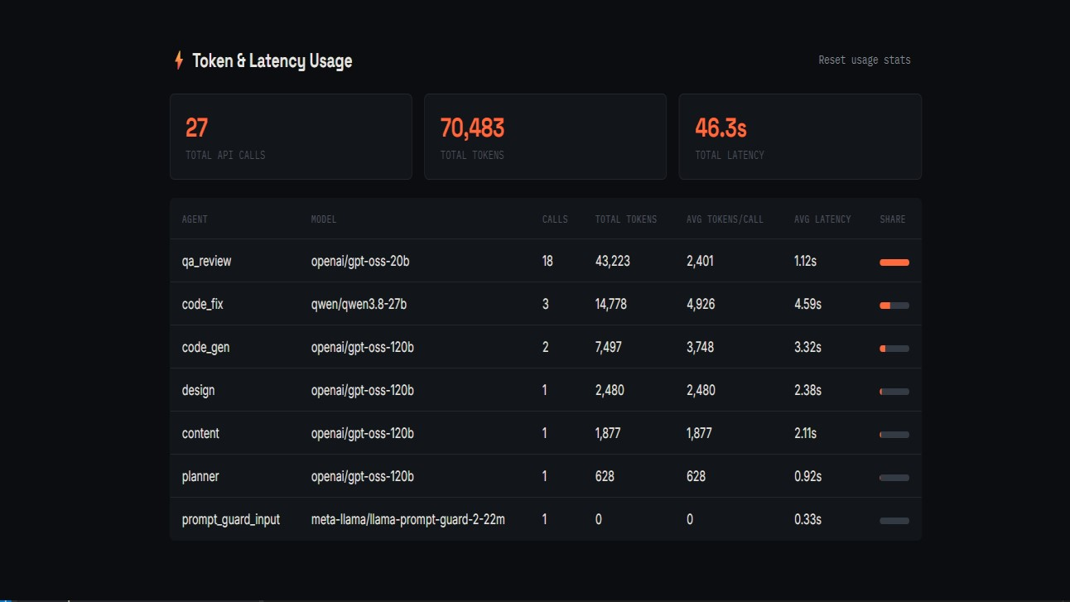

11.3.4 Overall Test Result
The test demonstrated that the proposed framework successfully executed the complete multi-agent website generation pipeline. The Planner, Content, Design, Asset and Code stages were executed and a two-page website was generated.
The QA stage identified structural and accessibility issues in the generated pages and performed correction attempts. However, the recorded execution ended with the pages marked as best-effort, with 0 out of 2 pages passing the QA checks. This demonstrates the importance of the integrated validation and QA mechanism for identifying problems in automatically generated websites.
The execution also demonstrated the framework's ability to track API calls, token usage and latency across different agents and models.

Table 11.1 Final Test Summary
Test Parameter | Result
Website Generation | Completed
Pages Generated | 2
Agent Pipeline | Executed
Asset Selection | Completed
CSS Validation | 1 issue detected
QA Testing | Completed
QA Passed Pages | 0/2
API Calls | 27
Total Tokens | 70,483
Total Latency | 46.3 seconds
Final Website | Generated

Summary
The final testing confirmed that the multi-agent framework successfully generated a two-page website by executing the agent pipeline, selecting assets, performing CSS validation, and completing QA testing. The process involved 27 API calls, used 70,483 tokens, and took 46.3 seconds. However, one CSS issue was detected, and neither page passed the QA testing. These results highlight the need for further improvements in CSS validation and quality assurance to enhance the reliability and overall quality of the generated website.

