**Gitlab Code Submission Instructions**

1. Install Git Client for Windows from the URL - [https://git-scm.com/download/win](http://wosggitlab.wipro.com/fullstack-modern-web-application-development/fullstack-modernweb-ilp-capstone-projects)

For other operating systems, check and install the Git client.

1. Goto the below link which is a public root repository and is **used only for forking**. After forking from the below repository, you will not be visiting it.

<http://topgear-training-gitlab.wipro.com/blockchain-immersive-learning-programs/blockchain-ilp-capstone-projects.git>

* You will be prompted to login. Provide your AD ID and AD Password.
* After you login successfully, the public root repository will be displayed.

1. Fork the project by clicking on and get your own repository. This repository will have your ADID in its name. After you successfully fork, you will see a message “The project was successfully forked” and the repository for your ADID will be displayed.
   1. The URL shown will be [http://topgear-training-gitlab.wipro.com/<your ad id>/blockchain-ilp-capstone-projects.git](http://topgear-training-gitlab.wipro.com/%3cyour%20ad%20id%3e/blockchain-ilp-capstone-projects.git)
   2. This repository is available in the wosggitlab of the Top Gear platform.
   3. For you, the master is your own repository created as per this step. Always ensure that your ADID is visible in the repository name in which you are working.
2. Make the repository created in **Step 3)** as a **Private** repository. **VERY IMPORTANT**
   1. Click on **“Settings”** menu at the top 🡺 Project Settings will be displayed
   2. Under **“Sharing & Permissions”** section, select “Private” in Project Visibility.

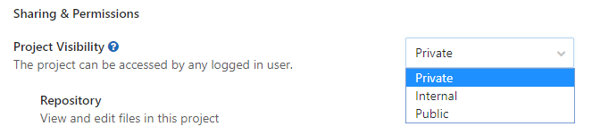

* 1. Click on 
  2. Give access permission to Venkat, Ashish, Prateek and Sandhya with Master permission rights. This is needed for review of the source code.
     1. Click on **“Members”** menu at the top 🡺 “Project members” page will be displayed.
     2. In **“Add member”** section, under **“Select members to invite”,** add the below mentioned email IDs **(one by one)** and then under **“Choose a role permission”**, select **“Master”,** leave **“Access Expiration date”** blank and then click on **“Add to project”**.

**Email IDs to add as members**

* venkatachalam.subra@wipro.com
* ashish.sinha3@wipro.com
* prateek.yammanuru@wipro.com
* sandhya.murali1@wipro.com

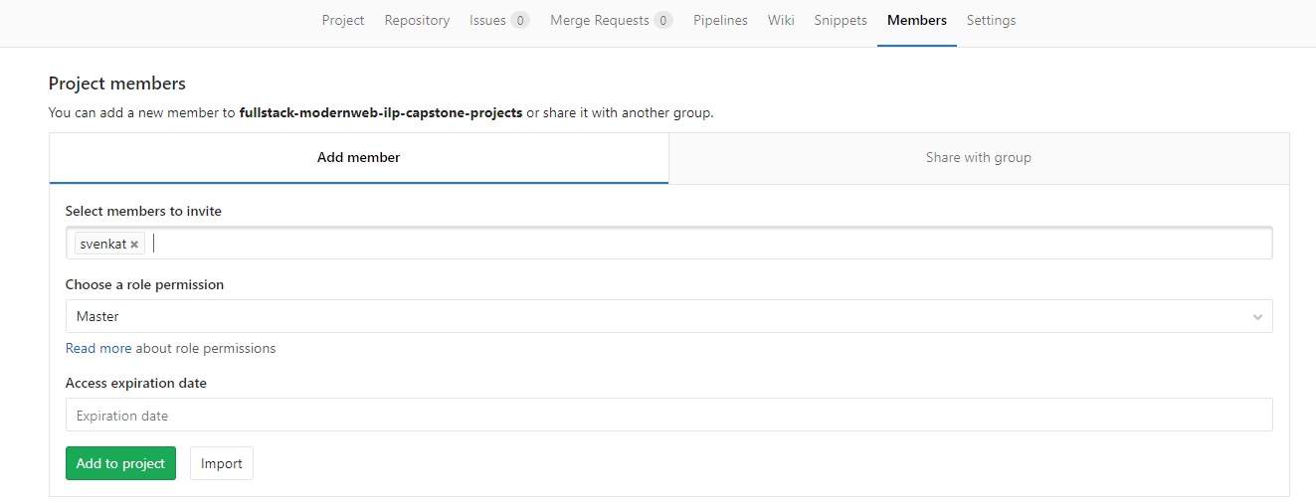

1. Clone your repository from the Top Gear platform into your local system. You should have **gitbash** installed in your system.
   1. git clone [http://topgear-training-gitlab.wipro.com/<your ad id>/blockchain-ilp-capstone-projects.git](http://topgear-training-gitlab.wipro.com/%3cyour%20ad%20id%3e/blockchain-ilp-capstone-projects.git)
      1. You will be prompted to login. Provide your AD ID and AD Password.
      2. After you login successfully, the repository will be cloned.
2. Make code modifications in your local repository which you had got it cloned in **Step 5)**. The code you develop for the integrated project or the final capstone project will be in this repository. You can work on the project in a different local folder in your system and finally copy the working project into this repository as per the directory structure created in the master template **(OR)** you can directly work on the project in this repository under the respective project folder structure (which you may do once you become comfortable with using Gitlab).
3. Once your code is ready to be submitted, a set of **git commands** (explained below) are to be executed.

**Note:**

* 1. The git commands are to be executed in the top level parent directory created in **Step 5)**. i.e. You should be in the directory “blockchain-ilp-capstone-projects“ when executing the git commands.
  2. **VERY IMPORTANT:**  Ensure you create a **.gitignore** file in the directory **“blockchain-ilp-capstone-projects”** and mention **node_modules** in a separate line in the file.

1. **git add .**
2. **git commit -m "<your message to be given here>"**

This will commit all your code modifications into your local repository in the system

1. **git push origin master**

This will push the code into the Top Gear Gitlab repository and the code will be submitted and available for review.

**See next page regarding instructions to update your full name (as seen in Outlook Address Book) in Gitlab Profile.**

**Important Note: Update your full name (as seen in Outlook Address Book) in Gitlab Profile**

After logging into <http://topgear-training-gitlab.wipro.com> , go to the link   <http://topgear-training-gitlab.wipro.com/profile>

Update your full name as seen in Outlook Address Book.  Otherwise, it is very difficult to identify and every time we need to refer the ADID and full name mapping, which is time consuming.

If you update the name, it will get displayed as cid:image002.png@01D340E8.88B797C0

Otherwise, it will get displayed as   cid:image003.png@01D340E8.88B797C0

which is time consuming  to map the full name.

