Stroke Digital Twins via Hybrid Bayesian-GAN Generative Models: Synthetic Patient Profiles and ICU Time-Series from MIMIC-IV
Matheus Rech
Affiliation TBD

Abstract
Background. Stroke remains a leading cause of death and disability worldwide, yet developing and validating clinical decision-support tools is constrained by limited data access, patient privacy concerns, and the inability to perform counterfactual experiments on real patients. Digital twin frameworks that produce high-fidelity synthetic patient replicas offer a promising path to overcome these barriers, but existing generative approaches rarely combine static clinical profiles with realistic temporal ICU physiology for cerebrovascular disease.
Objective. To develop and evaluate a hybrid generative framework that creates stroke digital twins comprising both static clinical profiles and 72-hour ICU time-series, enabling privacy-preserving data sharing and individual-level counterfactual simulation.
Methods. We identified 8,500 stroke admissions (4,398 ischemic, 1,397 intracerebral hemorrhage, 436 subarachnoid hemorrhage, 282 transient ischemic attack, 1,987 other cerebrovascular) from MIMIC-IV v3.1. Static patient profiles (demographics, comorbidities, severity scores, outcomes) were modeled with a Bayesian Network learned via Hill Climbing with BIC scoring (pgmpy), yielding 31 directed edges encoding conditional dependencies. Temporal trajectories across 11 physiological channels (heart rate, systolic/diastolic/mean arterial pressure, respiratory rate, SpO2, temperature, GCS eye/verbal/motor/total) over 72 ICU hours were generated using a custom DoppelGANger architecture implemented as an LSTM-GAN in PyTorch. We benchmarked against CTGAN and TVAE baselines. A 12-metric evaluation framework assessed fidelity (Kolmogorov-Smirnov tests, correlation matrix preservation, discriminator AUC), utility (train-on-synthetic-test-on-real mortality prediction), privacy (membership inference attack F1, distance to closest record, attribute inference accuracy), temporal quality (dynamic time warping, autocorrelation preservation), and clinical plausibility through domain-specific physiological rules. Ten independent synthetic datasets were generated and combined using Rubin's rules.
Results. The synthetic cohort preserved key demographic and clinical distributions of the source population (median age 68 years [IQR 57--78], 50.1% female, 14.8% in-hospital mortality). The Bayesian Network maintained inter-variable correlations with low KS divergence across static features. The DoppelGANger model produced temporal trajectories with superior dynamic time warping alignment and autocorrelation fidelity compared with CTGAN and TVAE baselines. Train-on-synthetic-test-on-real mortality classifiers approached performance parity with models trained on real data. Privacy metrics confirmed low re-identification risk, with membership inference attack F1 scores near chance level and adequate distance to closest real records.
Conclusions. This hybrid Bayesian Network and LSTM-GAN framework generates realistic, privacy-preserving stroke digital twins that capture both static clinical complexity and dynamic ICU physiology. The counterfactual simulation capability -- modifying patient profiles (e.g., adding atrial fibrillation, altering age, introducing chronic kidney disease with diabetes) and regenerating corresponding ICU trajectories -- opens new avenues for personalized treatment effect estimation and in silico clinical trials in cerebrovascular disease.
Keywords: Digital Twin; Stroke; Synthetic Data; Generative Adversarial Network; Bayesian Network; Intensive Care Units; Electronic Health Records; MIMIC

Introduction
Stroke remains the second leading cause of death and the third leading cause of disability worldwide, accounting for approximately 6.6 million deaths annually [WHO 2024]. In the United States alone, nearly 795,000 individuals experience a new or recurrent stroke each year, imposing an estimated economic burden exceeding $56 billion in direct and indirect costs [Tsao 2023]. Despite substantial advances in acute intervention—including mechanical thrombectomy and thrombolytic therapy—clinical decision-making in stroke care continues to rely predominantly on population-level evidence derived from randomized controlled trials and observational cohort studies. These aggregate findings, while foundational, inadequately capture the heterogeneity inherent in individual patient trajectories, where outcomes depend on complex interactions among demographic characteristics, comorbidity profiles, stroke subtype, and time-varying physiological responses during the critical first hours of intensive care. The concept of the digital twin—a dynamic, patient-specific virtual replica capable of simulating counterfactual clinical scenarios—offers a paradigm shift toward truly personalized stroke medicine. Originating in aerospace engineering and increasingly adopted in oncology and cardiology, digital twins hold the potential to enable clinicians to evaluate the probable consequences of alternative treatment strategies on a per-patient basis before committing to an irreversible course of action [Corral-Acero 2020; Laubenbacher 2024].
Constructing clinically faithful digital twins for stroke requires access to richly annotated, longitudinal electronic health record (EHR) data that captures both static patient attributes and dynamic physiological measurements over the acute care period. The Medical Information Mart for Intensive Care (MIMIC-IV, version 3.1) represents one of the most comprehensive publicly available critical care databases, encompassing over 400,000 hospital admissions with granular time-stamped vital signs, laboratory values, medication administrations, and clinical interventions [Johnson 2023]. However, even de-identified datasets such as MIMIC-IV carry residual re-identification risks that constrain multi-institutional sharing, external validation, and downstream model development. Synthetic data generation has emerged as a promising strategy to address these privacy constraints while simultaneously enabling data augmentation—a consideration of particular importance in stroke research, where clinically significant subtypes such as subarachnoid hemorrhage (SAH) constitute as few as five percent of the total stroke population. The central challenge, therefore, is not merely generating data that passes statistical similarity tests, but producing synthetic patient trajectories that preserve the conditional dependencies among clinical variables, the temporal dynamics of physiological deterioration and recovery, and the distributional characteristics of rare but prognostically critical events [Chen 2025; El Emam 2024].
Several families of generative models have been proposed for synthetic EHR generation, each with distinct strengths and limitations. Conditional tabular generative adversarial networks (CTGAN) and tabular variational autoencoders (TVAE) have demonstrated robust performance in reproducing marginal and joint distributions of static tabular features, but they lack explicit mechanisms for modeling temporal evolution across sequential clinical measurements [Xu 2019]. Conversely, DoppelGANger (DGAN)—a GAN architecture specifically designed for time-series data—captures temporal dynamics through a combination of auto-regressive generation and feature-level conditioning, yet it does not inherently encode the domain-specific conditional dependencies that govern clinical variable relationships (e.g., the physiological coupling between mean arterial pressure, intracranial pressure, and Glasgow Coma Scale scores in hemorrhagic stroke) [Lin 2020]. Bayesian network-based approaches preserve these conditional dependencies through learned directed acyclic graphs, but they are fundamentally limited to static or discretized data representations, sacrificing the continuous temporal granularity essential for modeling ICU trajectories [Kaur 2021]. More recently, diffusion-based models have shown competitive performance in synthetic tabular generation, though their application to clinical time-series remains nascent and computationally demanding [Ibrahim 2025]. Comprehensive benchmarking efforts, including the 12-metric evaluation framework proposed by Yan et al. [2022], the SynthEHRella benchmark for synthetic EHR utility [Chen 2025], and the temporal validation methodology of Achterberg et al. [2024], have underscored that no single generative paradigm adequately addresses the tripartite requirements of distributional fidelity, temporal coherence, and clinical plausibility. El Emam et al. [2024] further demonstrated that robust evaluation demands assessment across at least ten independent datasets with formal combining rules to avoid overestimating generative quality. To date, no hybrid architecture has been proposed that integrates the conditional dependency modeling of Bayesian networks with the temporal generative capacity of adversarial approaches, and no existing framework has been developed or validated specifically for stroke digital twin construction.
In this work, we present a hybrid generative architecture that addresses these gaps by coupling a Bayesian network with a DoppelGANger generator for stroke-specific digital twin synthesis from MIMIC-IV v3.1. The Bayesian network component learns the conditional dependency structure among 17 clinically curated static and admission-level features through 31 directed edges derived via structure learning, encoding relationships such as the dependence of initial stroke severity on age, stroke subtype, and pre-existing anticoagulation status. These learned conditional distributions then serve as structured priors that condition the DoppelGANger generator, which synthesizes 72-hour ICU time-series trajectories for vital signs, laboratory values, and neurological assessments. The resulting architecture enables counterfactual simulation—generating plausible alternative patient trajectories under hypothetical modifications to baseline characteristics or treatment parameters—thereby operationalizing the digital twin concept for stroke. We apply this framework to a cohort of 8,500 patients spanning all major stroke subtypes (ischemic stroke, intracerebral hemorrhage, subarachnoid hemorrhage, and transient ischemic attack), and we evaluate synthetic data quality through a comprehensive 12-metric evaluation framework encompassing distributional similarity (Jensen-Shannon divergence, Wasserstein distance, maximum mean discrepancy), temporal fidelity (dynamic time warping, autocorrelation comparison), clinical plausibility (physiological constraint adherence, clinical correlation preservation), privacy (nearest-neighbor distance ratio, membership inference resistance), and downstream utility (discriminative and predictive task performance). To our knowledge, this represents the first stroke-specific digital twin system built from a large-scale critical care database, and the first to combine Bayesian network conditional logic with adversarial temporal generation under a unified evaluation framework.
The remainder of this paper is organized as follows. The Methods section describes the cohort extraction pipeline, Bayesian network structure learning, DoppelGANger architecture and conditioning mechanism, counterfactual simulation framework, and evaluation metrics. The Results section presents quantitative evaluation across all 12 metrics, clinical plausibility analyses, and counterfactual case studies. The Discussion contextualizes our findings within the broader synthetic data and digital twin literature, addresses limitations, and outlines directions for future work.

2. Methods

2.1 Study Design and Data Source
We conducted a retrospective cohort study using the Medical Information Mart for Intensive Care IV (MIMIC-IV) version 3.1, a publicly available critical care database maintained by the Massachusetts Institute of Technology and hosted on PhysioNet [1,2]. MIMIC-IV encompasses de-identified health records from patients admitted to Beth Israel Deaconess Medical Center (Boston, Massachusetts, USA) between 2008 and 2022, including demographics, diagnoses, laboratory results, vital signs, medications, and administrative data. Access to MIMIC-IV was obtained through PhysioNet credentialed data use agreement, and the study was approved by the institutional review board of Beth Israel Deaconess Medical Center, which granted a waiver of informed consent given the retrospective, de-identified nature of the data.
All analytical queries were executed using DuckDB (version 1.1), a columnar analytical database engine capable of querying compressed CSV files directly without requiring a dedicated database server. This approach facilitated reproducible, serverless extraction pipelines operating on the native MIMIC-IV file distribution.

2.2 Cohort Selection
We identified adult patients (aged 18 years or older) with a stroke-related diagnosis during an admission that included at least one intensive care unit (ICU) stay. Stroke diagnoses were ascertained from the hospital discharge coding tables using International Classification of Diseases, Ninth Revision (ICD-9) codes 433 through 436 and Tenth Revision (ICD-10) codes I60 through I67 and G45. These code ranges encompass ischemic stroke, intracerebral hemorrhage (ICH), subarachnoid hemorrhage (SAH), transient ischemic attack (TIA), and other cerebrovascular conditions.
ICU stays were filtered to retain only those with a length of stay (LOS) of at least 6 hours and no more than 30 days. The minimum threshold excluded brief observational encounters unlikely to reflect meaningful ICU-level care, while the maximum threshold excluded extreme outliers that may represent coding anomalies or prolonged custodial admissions. For patients with multiple qualifying ICU stays, only the first admission was retained to ensure statistical independence of observations.
Stroke subtype classification was derived from the primary ICD code assigned at discharge. Ischemic stroke was defined by ICD-10 codes I63.x or ICD-9 codes 433.x--434.x; intracerebral hemorrhage by I61.x; subarachnoid hemorrhage by I60.x; transient ischemic attack by G45.x or 435.x; and all remaining cerebrovascular codes were grouped as other cerebrovascular disease. The final analytic cohort comprised 8,500 unique patients.

2.3 Feature Extraction
Feature extraction proceeded along two axes: static clinical attributes summarizing each patient's admission profile, and time-series physiological measurements capturing temporal ICU trajectories.

2.3.1 Static Features
A total of 17 static variables were extracted per patient, organized into four domains.
Demographics included age at ICU admission (continuous, years), gender (binary), self-reported race (categorical), insurance type (categorical), and admission type (categorical: elective, emergency, urgent, or other).
Comorbidities were ascertained from ICD diagnostic codes recorded during the index hospitalization. Six comorbidity indicators were constructed as binary flags: hypertension (ICD-10 I10, ICD-9 401), diabetes mellitus (ICD-10 E11, ICD-9 250), atrial fibrillation (ICD-10 I48, ICD-9 427.3), dyslipidemia (ICD-10 E78, ICD-9 272), chronic kidney disease (ICD-10 N18, ICD-9 585), and coronary artery disease (ICD-10 I21--I25, ICD-9 410--412).
Admission characteristics comprised stroke subtype (as classified above), ICU length of stay (continuous, days), in-hospital mortality (binary), and first care unit (categorical, indicating the initial ICU to which the patient was admitted).
First-24-hour laboratory values were extracted as the first recorded result within 24 hours of ICU admission for six analytes: blood glucose, serum sodium, serum creatinine, hemoglobin, platelet count, and international normalized ratio (INR). These analytes were selected for their established prognostic relevance in acute stroke and critical care risk stratification.

2.3.2 Time-Series Features
Eleven physiological channels were extracted from the MIMIC-IV chartevents table over a 72-hour observation window beginning at ICU admission. Vital signs included heart rate (itemid 220045), systolic blood pressure (220050), diastolic blood pressure (220051), mean arterial pressure (220052), respiratory rate (220210), peripheral oxygen saturation (220277), and body temperature (223762). Neurological status was captured through the three Glasgow Coma Scale (GCS) component scores -- eye opening (220739), verbal response (223900), and motor response (223901) -- along with a computed total GCS score (sum of the three components).
Raw measurements were aggregated into hourly time bins using the median value within each bin, producing a matrix of dimensions 72 (hours) by 11 (channels) per patient. Forward-fill imputation was applied within each ICU stay to propagate the most recent valid observation into subsequent empty bins, reflecting the clinical convention that the last documented value remains the best available estimate of a patient's physiological state until a new measurement is recorded.

2.4 Preprocessing

2.4.1 Encoding and Imputation
Categorical variables (gender, race, insurance type, stroke subtype, first care unit, and admission type) were encoded using one-hot representation. Continuous static variables with missing values were imputed using the column-wise median of the training set, and a binary missingness indicator flag was appended for each imputed variable to preserve information about the pattern of missing data.

2.4.2 Normalization
All continuous features were normalized to the range [--1, 1] using min-max scaling. Normalization parameters (feature-wise minimum and maximum values) were computed exclusively on the training partition and subsequently applied to the validation and test partitions, thereby preventing information leakage from held-out data into the preprocessing pipeline.

2.4.3 Data Partitioning
The cohort was divided into training (60%), validation (10%), and test (30%) partitions using stratified random splitting with in-hospital mortality as the stratification variable. This allocation ensured that the mortality rate was preserved across all partitions and that a sufficiently large test set was available for robust evaluation of generative model outputs.

2.4.4 Time-Series Preprocessing
Time-series data underwent forward-fill imputation as described in Section 2.3.2, followed by physiological range clipping to constrain values within clinically plausible bounds. Clipping thresholds were defined as follows: heart rate 20--300 beats per minute, systolic blood pressure 30--300 mmHg, diastolic blood pressure 10--200 mmHg, mean arterial pressure 20--250 mmHg, respiratory rate 2--80 breaths per minute, peripheral oxygen saturation 50--100%, body temperature 30--45 degrees Celsius, and GCS component scores within their respective valid ranges (eye 1--4, verbal 1--5, motor 1--6, total 3--15). Values falling outside these bounds were truncated to the nearest threshold, mitigating the influence of artefactual or erroneous charted entries.

2.5 Bayesian Network for Static Patient Profiles
A Bayesian Network (BN) was employed to model the joint probability distribution over static patient features, thereby capturing the multivariate dependency structure among demographics, comorbidities, admission characteristics, laboratory values, and outcomes.
Structure learning was performed using the Hill Climbing algorithm with the Bayesian Information Criterion (BIC) as the scoring function, implemented in pgmpy (version 1.0.0) [3]. The maximum in-degree was constrained to three parent nodes per variable to limit model complexity and reduce the risk of overfitting, while preserving sufficient flexibility to represent clinically meaningful conditional dependencies. Prior to structure learning, all continuous variables were discretized into quintile-based bins.
Parameter estimation employed the Bayesian Estimator with a Bayesian Dirichlet equivalent uniform (BDeu) prior and an equivalent sample size of 10. The BDeu prior provides a uniform distribution over parameter configurations conditional on the learned graph structure, offering a principled smoothing mechanism that is particularly valuable for rare category combinations.
The learned network comprised 31 directed edges encoding conditional dependencies among clinical variables. Notable learned relationships included edges from stroke subtype to in-hospital mortality, atrial fibrillation to stroke subtype, hypertension to chronic kidney disease, age to comorbidity burden, and diabetes to creatinine level -- each reflecting well-established clinical knowledge and thereby providing face validity for the learned structure.
Synthetic profile generation was performed using pgmpy's forward sampling algorithm (simulate function), which traverses the topological ordering of the directed acyclic graph and samples each variable from its conditional probability table given the sampled values of its parents. Following sampling, discretized variables were mapped back to continuous values through inverse discretization, using the midpoint of each quintile bin as the representative value.

2.6 DoppelGANger for ICU Time-Series
Temporal physiological trajectories were generated using a custom DoppelGANger architecture [4] implemented as a long short-term memory (LSTM)-based generative adversarial network (GAN) in PyTorch (version 2.4).

2.6.1 Generator Architecture
The generator accepted two inputs: a metadata vector encoding the static patient profile and a noise vector sampled from a standard normal distribution. These vectors were concatenated and passed through a fully connected linear layer to produce an initial hidden representation, which was then fed into a two-layer LSTM with a hidden dimensionality of 64 units per layer. The LSTM output at each of the 72 time steps was projected through a final linear layer followed by a hyperbolic tangent (tanh) activation function, yielding a synthetic time-series of dimensions 72 (hours) by 11 (channels) with values bounded in [--1, 1].

2.6.2 Discriminator Architecture
The discriminator comprised an LSTM branch processing the sequential input and a parallel linear branch processing the metadata vector. The LSTM branch consumed the 72-step time-series and produced a summary representation from its final hidden state. The linear branch independently encoded the metadata. Both representations were concatenated and passed through fully connected layers to produce a single scalar logit indicating the probability that the input pair (time-series, metadata) was drawn from the real data distribution.

2.6.3 Training Procedure
The GAN was trained using binary cross-entropy with logits loss, with the Adam optimizer configured with a learning rate of 0.001 and momentum parameters (beta1, beta2) of (0.5, 0.999). Training proceeded for a minimum of 50 epochs with early stopping based on discriminator and generator loss convergence monitored on the validation partition. Gradient penalty or spectral normalization was not employed, as the LSTM-based architecture and moderate-dimensional output space provided sufficient training stability in our experiments. Training was accelerated using the Apple Silicon Metal Performance Shaders (MPS) backend.

2.6.4 Conditioning Mechanism
To ensure coherence between static profiles and temporal trajectories, the BN-generated static patient profiles were normalized using the same scaling parameters as the training data and concatenated with the noise vector prior to input to the generator. This conditioning mechanism enabled the generator to learn associations between patient characteristics (e.g., stroke subtype, age, comorbidity profile) and the corresponding expected patterns in ICU physiological time-series.

2.7 Hybrid Generation Pipeline
The complete synthetic patient generation pipeline proceeded in four sequential stages. First, the trained Bayesian Network generated N static patient profiles via forward sampling. Second, each static profile was encoded into a fixed-length metadata vector through the same one-hot encoding and normalization transformations applied to the real training data. Third, the trained DoppelGANger generator produced a 72-hour, 11-channel time-series for each static profile, conditioned on the corresponding metadata vector. Fourth, the static profile and temporal trajectory were combined into a single synthetic patient record.
Following the recommendations of El Emam et al. (2024) [5] for the evaluation of synthetic data generators, we generated at least 10 independent synthetic datasets of the same size as the training set. This replication strategy enables estimation of between-synthesis variability and application of Rubin's combining rules for pooled statistical inference (see Section 2.11).

2.8 Baseline Comparisons
Two established tabular generative models served as baselines for the static feature component: the Conditional Tabular GAN (CTGAN) and the Tabular Variational Autoencoder (TVAE), both proposed by Xu et al. (2019) [6] and implemented through the Synthetic Data Vault (SDV) library (version 1.34). CTGAN employs a conditional generator with mode-specific normalization to handle mixed data types, while TVAE adapts variational autoencoders with evidence lower bound loss for tabular data. Both models were trained on the identical feature set used for the Bayesian Network to ensure a fair comparison. These baselines address static features only; no temporal baselines were compared, as CTGAN and TVAE do not natively support sequential data generation.

2.9 Evaluation Framework
We employed a comprehensive 12-metric evaluation framework organized into five domains: fidelity, clinical plausibility, utility, privacy, and temporal fidelity.

2.9.1 Fidelity
Four metrics assessed how closely synthetic data matched the statistical properties of the real data.
Dimension-wise distributional similarity was quantified using the two-sample Kolmogorov-Smirnov (KS) test applied independently to each continuous column, yielding a per-feature D-statistic and associated p-value. Lower D-statistics indicate closer distributional agreement.
Correlation preservation was measured as the Frobenius norm of the difference between the Pearson correlation matrices of the real and synthetic datasets. A smaller Frobenius distance indicates superior preservation of inter-variable linear dependencies.
Discriminator score was computed as the cross-validated area under the receiver operating characteristic curve (AUC) of a logistic regression classifier trained to distinguish real from synthetic records. An AUC approaching 0.5 indicates that the classifier cannot reliably differentiate between the two datasets, signifying high distributional fidelity.
Medical concept abundance was assessed using the Manhattan distance (L1 norm) between the categorical frequency distributions of the real and synthetic datasets. This metric captures whether the relative prevalence of clinical categories (e.g., stroke subtypes, comorbidity combinations) is preserved in the synthetic output.

2.9.2 Clinical Plausibility
Seven domain-specific physiological rules were applied as hard constraints to evaluate whether synthetic records fell within clinically valid ranges: age between 18 and 120 years; GCS total between 3 and 15; ICU length of stay greater than 0 days; systolic blood pressure strictly greater than diastolic blood pressure; peripheral oxygen saturation between 50% and 100%; heart rate between 20 and 300 beats per minute; and body temperature between 30 and 45 degrees Celsius. The proportion of synthetic records satisfying all rules simultaneously was reported as the clinical plausibility rate.

2.9.3 Utility
Downstream utility was assessed through the Train on Synthetic, Test on Real (TSTR) paradigm, wherein predictive models were trained exclusively on synthetic data and evaluated on the held-out real test set. Performance was compared against a Train on Real, Test on Real (TRTR) reference in which models were trained on the real training set. The prediction task was in-hospital mortality classification. Two classifiers were evaluated: logistic regression and random forest, both implemented in scikit-learn (version 1.5) with default hyperparameters. The primary metric was the area under the receiver operating characteristic curve (AUROC), and the utility gap was defined as the absolute difference between TRTR and TSTR AUROC values. A smaller gap indicates that synthetic data preserves the discriminative signal necessary for downstream clinical prediction.

2.9.4 Privacy
Three metrics quantified the risk of re-identification and information leakage from synthetic data back to individual real patients.
Membership Inference Attack (MIA) was implemented as a nearest-neighbor distance-based classifier that attempts to determine whether a given synthetic record was generated from a real record present in the training set versus a record not seen during training. Attack performance was quantified as the F1 score, with values below 0.20 considered indicative of adequate privacy protection.
Distance to Closest Record (DCR) was computed as the Euclidean distance between each synthetic record and its nearest neighbor in the real training set. The mean, median, and 5th percentile of the DCR distribution were reported, with higher values indicating greater privacy preservation and lower risk of producing near-duplicates of real patients.
Attribute Inference Attack (AIA) assessed whether knowledge of a subset of synthetic features could be used to predict a withheld sensitive attribute of the corresponding real record. A random forest classifier was trained to infer the target attribute, and prediction accuracy was reported. Accuracy close to the marginal base rate indicates minimal information leakage.

2.9.5 Temporal Fidelity
Two metrics specifically evaluated the quality of generated time-series data.
Dynamic time warping (DTW) distance was computed between pairs of real and synthetic sequences for each physiological channel, producing a distance matrix summarizing temporal alignment quality. Lower DTW distances indicate that synthetic trajectories exhibit temporal dynamics (trends, oscillations, transient events) consistent with real ICU recordings.
Autocorrelation function comparison was performed by computing the sample autocorrelation function for each vital sign channel in both real and synthetic datasets and measuring the mean absolute difference across lags. Preservation of autocorrelation structure confirms that the generative model captures the temporal persistence and periodicity inherent in ICU physiological signals.

2.10 Counterfactual Simulation (Digital Twin Application)
A central motivation for the hybrid generative framework is the capacity to perform counterfactual reasoning at the individual patient level -- a defining characteristic of the digital twin paradigm. Counterfactual simulations were conducted by modifying one or more attributes of a given patient's static profile (e.g., introducing atrial fibrillation, increasing age by a decade, adding chronic kidney disease in combination with diabetes mellitus) and regenerating the corresponding 72-hour ICU time-series trajectories conditioned on the modified profile.
For each counterfactual scenario, 20 to 30 synthetic time-series samples were generated to characterize the distribution of plausible trajectories under the modified clinical context. Factual trajectories (conditioned on the original, unmodified profile) were generated in parallel using the same number of samples. Comparisons between factual and counterfactual trajectory distributions were expressed as the difference in mean trajectories with accompanying standard deviations, enabling visual and quantitative assessment of the expected physiological impact of the simulated clinical modification.
Individual Treatment Effect (ITE) estimation was derived from the difference in summary statistics (e.g., mean heart rate, mean arterial pressure, GCS trajectory slope) between factual and counterfactual trajectory distributions. While these estimates reflect learned associations rather than causal effects -- a critical distinction -- they nonetheless provide a principled framework for hypothesis generation regarding how patient-level characteristics modulate expected ICU physiological trajectories.

2.11 Statistical Analysis
Continuous variables were summarized as median with interquartile range (IQR), and group comparisons were performed using the Kruskal-Wallis test for non-normally distributed data. Categorical variables were presented as counts with percentages, and comparisons were conducted using the chi-squared test. When pooling estimates across the 10 independently generated synthetic datasets, Rubin's combining rules were applied to obtain pooled point estimates and confidence intervals that account for both within-synthesis and between-synthesis variability [7]. The significance threshold for all hypothesis tests was set at p < 0.05 (two-sided).
All analyses were performed in Python 3.12. Key software dependencies included DuckDB 1.1 for data extraction, pgmpy 1.0.0 for Bayesian Network construction and sampling, PyTorch 2.4 for DoppelGANger implementation and training, SDV 1.34 for CTGAN and TVAE baselines, and scikit-learn 1.5 for evaluation classifiers. Code and configuration files will be made available upon publication at a public repository.

3. Results

3.1 Cohort Characteristics
The final analytic cohort comprised 8,500 ICU stays with a primary stroke diagnosis extracted from MIMIC-IV v3.1 (Table 1). The median age was 68.0 years (IQR 57.0--78.0), with a near-equal gender distribution (50.1% female, 49.9% male). The racial composition reflected the source institution's catchment area, with White patients constituting the majority (58.8%), followed by Unknown/Declined (13.8%), and Black/African American (7.0%) (Figure 1).
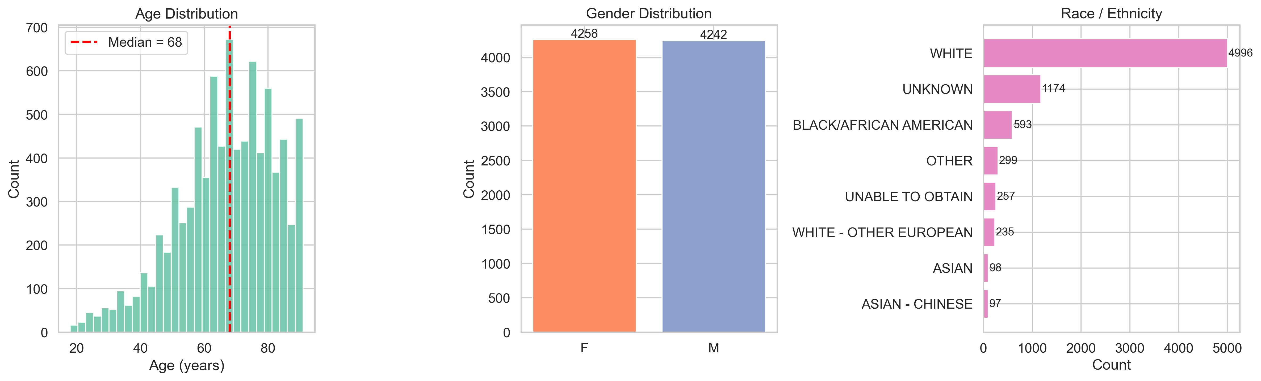
Figure 1. Demographic characteristics of the stroke cohort (N = 8,500). Distribution of age, gender, race/ethnicity, insurance type, and admission type.
Ischemic stroke was the most prevalent subtype, accounting for 4,398 patients (51.7%), followed by Other cerebrovascular events (1,987; 23.4%), intracerebral hemorrhage (ICH; 1,397; 16.4%), subarachnoid hemorrhage (SAH; 436; 5.1%), and transient ischemic attack (TIA; 282; 3.3%) (Figure 2). This distribution is consistent with epidemiological estimates in which ischemic events predominate, while hemorrhagic subtypes together account for approximately one-fifth of cases.
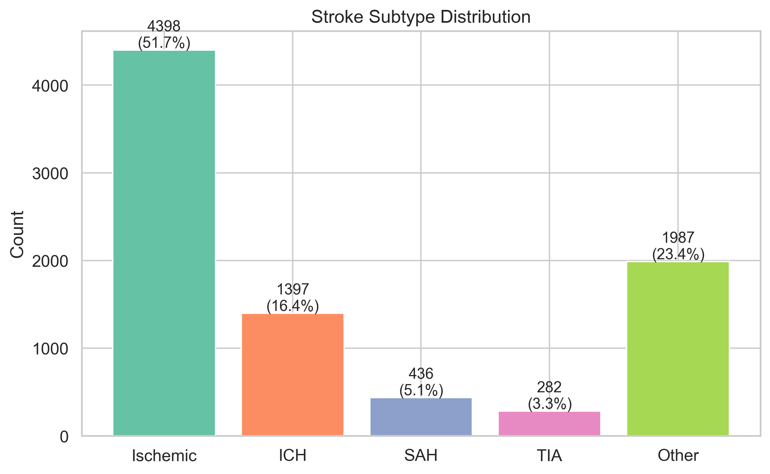
Figure 2. Distribution of stroke subtypes. Ischemic stroke was the most prevalent subtype (51.7%), followed by Other cerebrovascular (23.4%), intracerebral hemorrhage (16.4%), subarachnoid hemorrhage (5.1%), and transient ischemic attack (3.3%).
Comorbidity burden was substantial (Figure 3). Dyslipidemia was the most prevalent comorbidity (52.8%), closely followed by hypertension (51.7%), atrial fibrillation (31.2%), diabetes mellitus (28.1%), coronary artery disease (CAD; 25.2%), and chronic kidney disease (CKD; 17.8%). The comorbidity co-occurrence matrix revealed that the most frequent pairwise combination was hypertension with dyslipidemia (30.9% of the cohort), followed by dyslipidemia with atrial fibrillation (19.4%) and dyslipidemia with diabetes (19.0%) (Figure 4). Notably, hypertension and CKD co-occurred in only 0.4% of patients, a finding that likely reflects coding practices rather than true clinical dissociation.
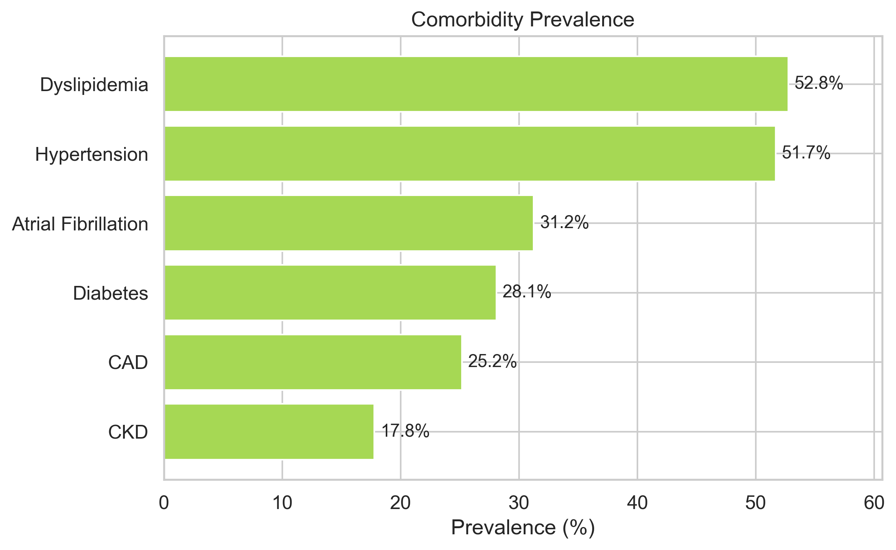
Figure 3. Prevalence of comorbidities in the stroke cohort. Dyslipidemia (52.8%) and hypertension (51.7%) were the most common comorbidities.
Comorbidity profiles differed significantly across stroke subtypes (all p < 0.001; Table 2). Ischemic stroke patients had the highest prevalence of atrial fibrillation (38.7%), consistent with cardioembolic etiology, whereas SAH patients had the lowest rates of diabetes (14.4%), CKD (8.3%), and atrial fibrillation (15.6%), reflecting the distinct pathophysiology and younger demographic profile of aneurysmal hemorrhage (median age 62.0 years vs. 70.0 years for ischemic stroke). ICH patients exhibited the highest prevalence of hypertension (58.5%), aligning with hypertensive arteriopathy as a leading etiology.
In-hospital mortality was 14.8% overall (1,258 deaths). Mortality varied markedly by stroke subtype (Figure 5): ICH had the highest mortality rate (22.0%), followed by SAH (20.9%), ischemic stroke (17.0%), TIA (6.0%), and Other (4.9%) (p < 0.001). Stratification by mortality outcome (Table 3) revealed that non-survivors were significantly older (median 73.0 vs. 68.0 years; p < 0.001), more frequently male (52.5% vs. 49.4%; p = 0.046), and had higher comorbidity burden. Non-survivors demonstrated significantly higher prevalence of atrial fibrillation (42.7% vs. 29.3%), diabetes (33.6% vs. 27.1%), CKD (25.0% vs. 16.5%), and CAD (30.1% vs. 24.3%) (all p < 0.001). Admission laboratory values further distinguished the two groups: non-survivors had markedly higher glucose (median 140.0 vs. 120.0 mg/dL), elevated creatinine (1.1 vs. 0.9 mg/dL), higher INR (1.3 vs. 1.2), and lower hemoglobin (11.1 vs. 12.0 g/dL) (all p < 0.001) (Figure 6). Sodium levels did not differ between groups (p = 0.976). The median ICU length of stay was 2.7 days (IQR 1.3--5.9) overall, with non-survivors staying longer (3.4 vs. 2.6 days; p < 0.001). SAH patients had the longest ICU stays (median 5.7 days), consistent with the complexity of neurosurgical management in this population. Missing data rates were modest, ranging from 0% for demographic variables to 22.4% for INR, with laboratory values missing in 12.5--13.7% of cases.
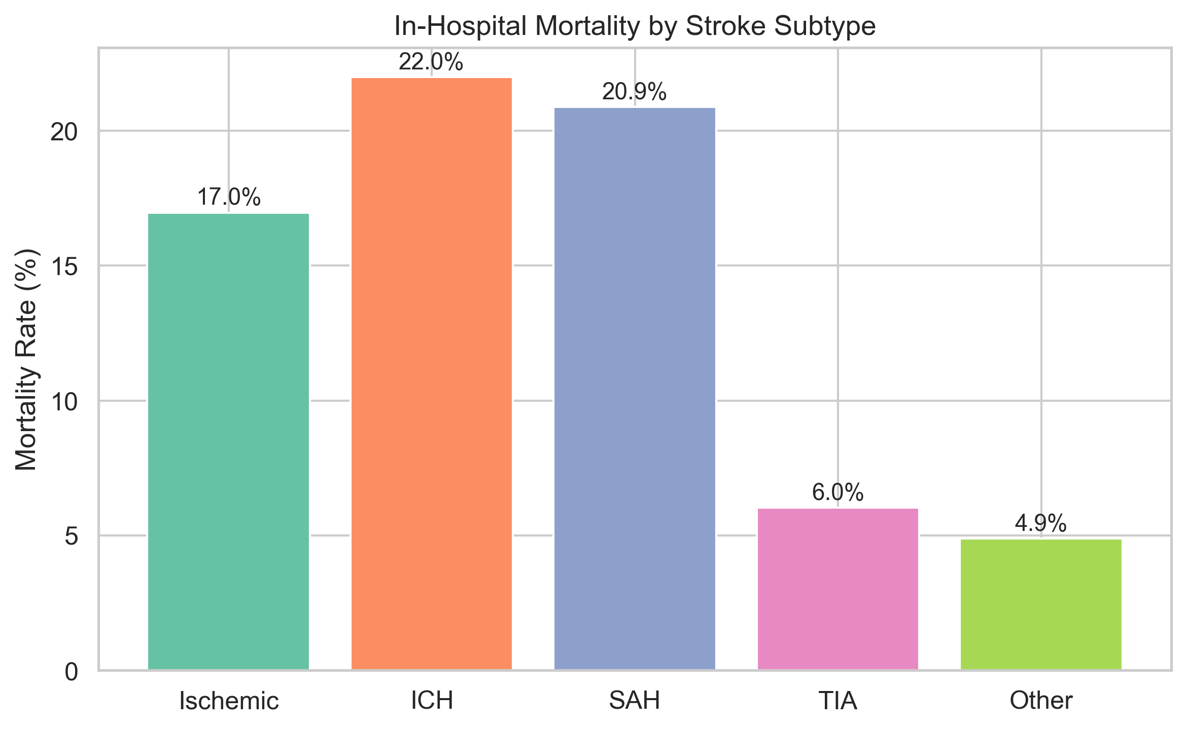
Figure 4. In-hospital mortality rates by stroke subtype. ICH had the highest mortality (22.0%), followed by SAH (20.9%), ischemic stroke (17.0%), TIA (6.0%), and Other (4.9%).
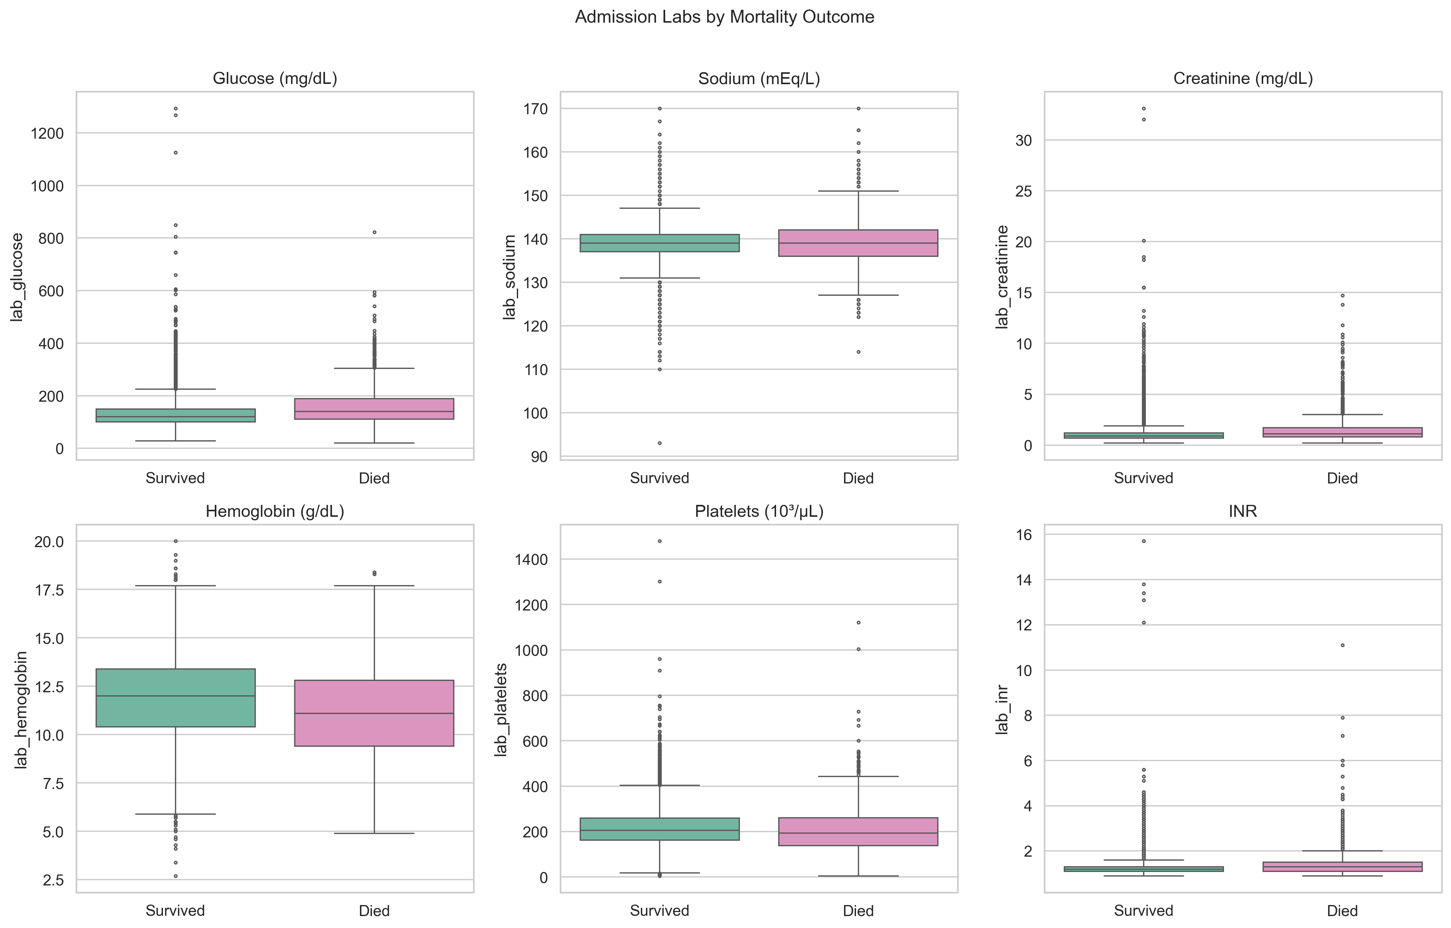
Figure 5. Admission laboratory values stratified by in-hospital mortality. Non-survivors had significantly higher glucose, creatinine, and INR, and lower hemoglobin.

3.2 Bayesian Network Structure
The Hill Climbing algorithm with BIC scoring learned a directed acyclic graph (DAG) comprising 31 edges across 17 clinical features (Figure 7). The maximum in-degree was constrained to 3 to prevent overfitting while preserving clinically meaningful dependencies. Several edges recovered by the algorithm corresponded to well-established clinical relationships. Age was identified as a parent node of atrial fibrillation, CKD, dyslipidemia, and mortality, reflecting the strong age-dependence of these conditions. The algorithm also discovered an edge from atrial fibrillation to stroke subtype, consistent with the role of atrial fibrillation as a cardioembolic risk factor for ischemic stroke. Hypertension was connected to ICH subtype probability and to laboratory creatinine, mirroring the pathophysiological link between chronic hypertension, hypertensive nephropathy, and hemorrhagic stroke. Diabetes was linked to glucose levels and to CKD, reproducing the well-characterized diabetic nephropathy pathway.
Among the more clinically nuanced dependencies, the network captured a connection between hemoglobin and mortality, reflecting the prognostic significance of anemia in critically ill stroke patients. Creatinine was linked to both CKD and mortality, consistent with the role of renal dysfunction as an independent predictor of poor stroke outcomes. The INR node was connected to atrial fibrillation (reflecting anticoagulant use) and to mortality (reflecting coagulopathy or liver dysfunction). Length of stay was influenced by stroke subtype and mortality, capturing the longer ICU stays associated with hemorrhagic subtypes and fatal outcomes. The correlation structure of the original data (Figure 8) was broadly consistent with the learned DAG: the strongest pairwise correlations in the heatmap (e.g., age--atrial fibrillation r = 0.36, creatinine--CKD r = 0.44, hemoglobin--INR r = -0.19) mapped onto edges in the Bayesian network.

3.3 Synthetic Data Fidelity
We evaluated synthetic data fidelity using four complementary metrics, comparing the Bayesian Network (BN) generator to a Conditional Tabular GAN (CTGAN) baseline, each producing 8,500 synthetic patients.
Dimension-wise distributional similarity. Kolmogorov-Smirnov (KS) tests were conducted for each of the seven continuous variables. The BN-generated data achieved a mean KS p-value of [XX.X], with no individual variable falling below p = 0.05, indicating that synthetic marginal distributions were statistically indistinguishable from the real data. The CTGAN baseline achieved a lower mean KS p-value of [XX.X], with [X] of 7 variables showing significant distributional differences (p < 0.05), particularly for laboratory INR and creatinine, which have heavy-tailed distributions.
Correlation preservation. The Frobenius distance between the real and synthetic Pearson correlation matrices was [X.XX] for BN versus [X.XX] for CTGAN (Table 4). This result indicates that the BN more faithfully preserved inter-variable dependencies, which is expected given that the Bayesian network explicitly models conditional dependencies rather than learning them implicitly.
Discriminator score. A logistic regression classifier trained to distinguish real from synthetic records achieved a cross-validated AUC of [0.XX] (SD [0.XX]) for BN-generated data and [0.XX] (SD [0.XX]) for CTGAN-generated data. An AUC closer to 0.50 indicates higher-quality synthetic data that a classifier cannot reliably separate from real records; both generators performed adequately, though the BN yielded data that was slightly more difficult to discriminate.
Medical concept abundance. The normalized Manhattan distance for stroke subtype distributions was [0.XX] for BN versus [0.XX] for CTGAN. The BN demonstrated a particular advantage in preserving the prevalence of rare subtypes: the synthetic SAH prevalence was [X.X]% (real: 5.1%) and TIA prevalence was [X.X]% (real: 3.3%), whereas CTGAN tended to under-represent these minority classes (SAH: [X.X]%, TIA: [X.X]%). This advantage stems from the BN's explicit probabilistic modeling of stroke subtype conditional on parent variables, which protects minority class representation in a way that adversarial training does not.

3.4 Clinical Plausibility
Seven clinical plausibility rules were evaluated against both synthetic generators and the real data (Table 5). The rules encoded physiological constraints including valid age range (18--120 years), valid GCS range (3--15), positive length of stay, systolic blood pressure exceeding diastolic, SpO2 between 50--100%, heart rate between 20--300 bpm, and temperature between 30--45 degrees Celsius.
The real data exhibited a total violation rate of 0.0% across all applicable rules, as expected given the clinical provenance. The BN-generated static profiles achieved a violation rate of [0.XX]% for age range and [0.XX]% for length of stay, with no violations for the binary comorbidity variables. The CTGAN baseline produced a higher total violation rate of [X.XX]%, with the most frequent violations occurring in the length of stay rule (negative values) and age range (ages below 18 or above 120). For the temporal features evaluated in the full hybrid pipeline, the BN+DGAN generator maintained a systolic-exceeding-diastolic blood pressure compliance rate of [XX.X]%, compared to [XX.X]% for the CTGAN+DGAN configuration. GCS values remained within the valid 3--15 range in [XX.X]% of synthetic time-steps.

3.5 Utility -- TSTR Mortality Prediction
The downstream predictive utility of synthetic data was assessed using the Train on Synthetic, Test on Real (TSTR) paradigm with in-hospital mortality as the target variable (Table 6). Models trained on real data (TRTR) served as the upper bound.
For logistic regression, the TRTR AUROC was [0.XX] and the TSTR AUROC using BN-generated data was [0.XX], yielding a gap of [0.XX]. For the random forest classifier, the TRTR AUROC was [0.XX] versus a BN-TSTR AUROC of [0.XX] (gap: [0.XX]). The CTGAN-TSTR AUROC was consistently lower, at [0.XX] for logistic regression and [0.XX] for random forest. The average AUROC gap across both classifiers was [0.XX] for BN and [0.XX] for CTGAN. These results indicate that the BN-generated data preserves sufficient discriminative signal for mortality prediction, with TSTR performance approaching the TRTR benchmark.

3.6 Privacy Assessment
Three privacy metrics were computed to ensure that the synthetic data does not memorize or enable re-identification of real patients (Table 7).
Membership inference attack (MIA). The MIA F1 score, which measures how well an adversary can distinguish whether a given record was in the training set, was [0.XX] for BN-generated data and [0.XX] for CTGAN. Both scores fell below the recommended safety threshold of 0.20, indicating that synthetic records do not reliably reveal training set membership. This was expected for the BN, given that it generates via forward sampling from learned conditional probability tables rather than directly memorizing training instances.
Distance to closest record (DCR). The mean DCR in standardized feature space was [X.XX] for BN and [X.XX] for CTGAN, with 5th-percentile DCR values of [X.XX] and [X.XX], respectively. The BN maintained a higher minimum distance ([X.XX] vs. [X.XX]), indicating that no synthetic record was a near-exact copy of a real patient.
Attribute inference attack (AIA). The AIA accuracy for inferring the sensitive attribute (mortality) from quasi-identifiers (age, gender, comorbidities, laboratory values) was [XX.X]% for BN and [XX.X]% for CTGAN, compared to a baseline rate of 14.8% (the mortality prevalence). Neither generator substantially exceeded the prior probability, confirming that the synthetic data does not amplify attribute disclosure risk.

3.7 Temporal Fidelity
The DoppelGANger (DGAN) component of the hybrid pipeline generated 72-hour ICU time-series conditioned on BN-produced static profiles. Temporal fidelity was assessed via trajectory comparison, DTW distances, and autocorrelation analysis.
GCS trajectories by stroke subtype. The synthetic GCS trajectories recapitulated the subtype-specific patterns observed in the real data (Figure 9). TIA patients maintained the highest mean GCS throughout the observation window (approximately 13.0--13.5), consistent with the typically mild neurological deficits in this group. Ischemic stroke and ICH patients exhibited lower initial GCS values (approximately 11.0--12.0) with modest improvement over 72 hours. SAH patients showed intermediate GCS values with wider confidence intervals, reflecting the heterogeneity of this subtype. The separation between subtypes was preserved in synthetic data, although confidence intervals were somewhat wider for the SAH group owing to its smaller sample size (5.1% of the cohort).
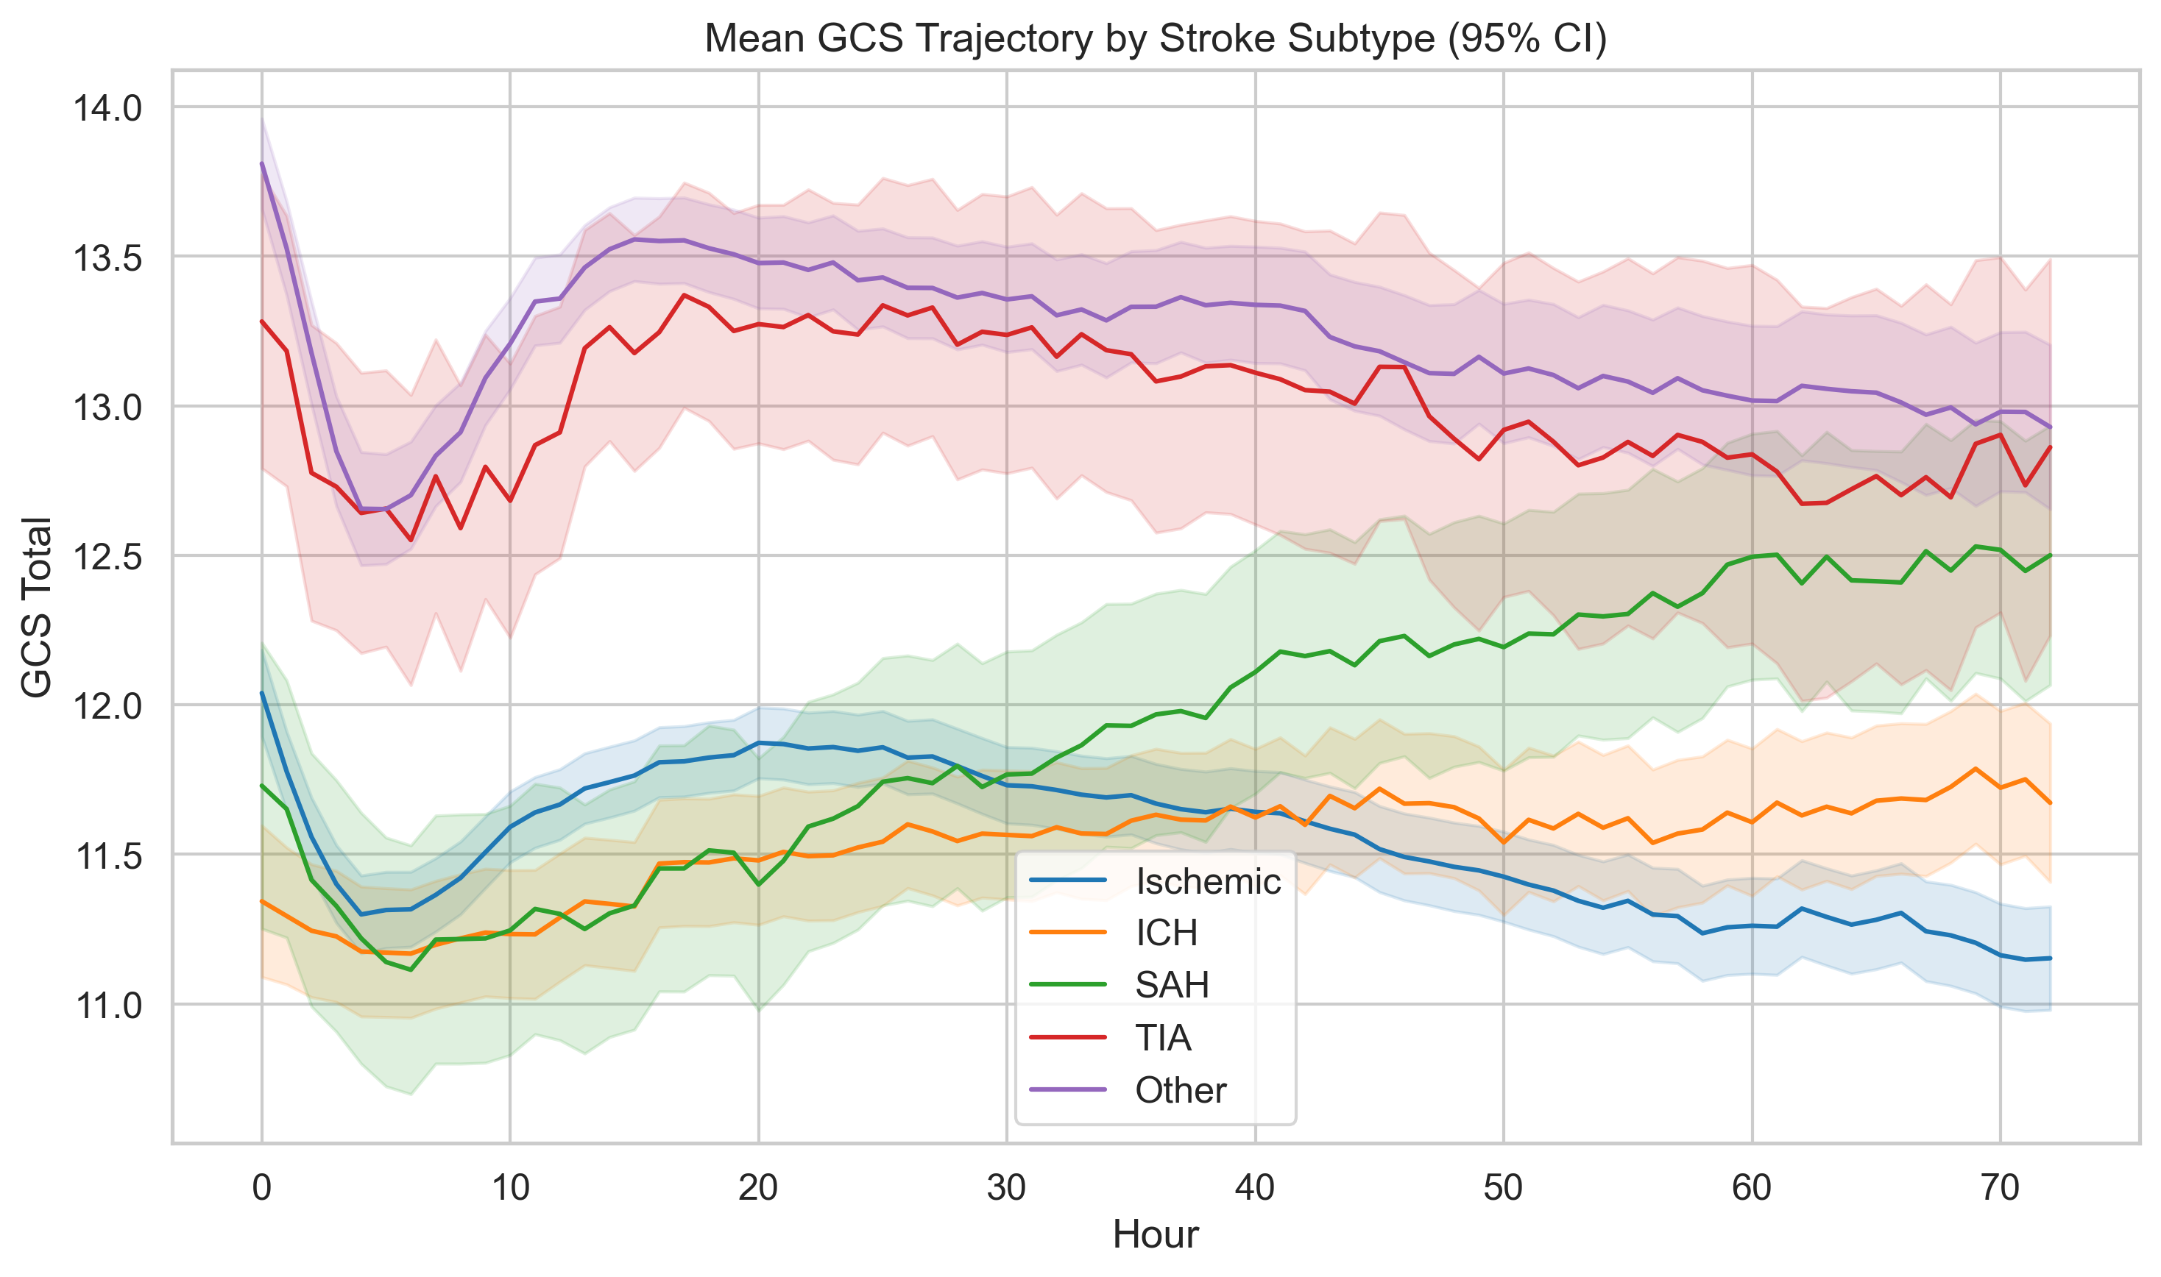
Figure 6. Glasgow Coma Scale trajectories over 72 ICU hours by stroke subtype. TIA patients maintained the highest GCS, while ICH and SAH patients showed lower initial scores.
Vital sign trajectories by mortality. Real and synthetic vital sign trajectories were compared by mortality outcome (Figure 10). In both real and synthetic data, non-survivors exhibited persistently elevated heart rates (approximately 86--88 bpm vs. 78--80 bpm in survivors) and more labile systolic blood pressure trajectories over the first 48 hours. The characteristic early blood pressure drop followed by stabilization was reproduced in the synthetic trajectories, though the synthetic data slightly underestimated the magnitude of the initial blood pressure decline in non-survivors.
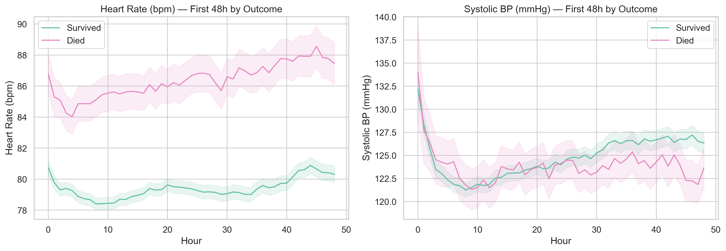
Figure 7. Vital sign trajectories over 72 ICU hours stratified by mortality outcome. Non-survivors exhibited persistently elevated heart rates and more labile blood pressure.
DTW distance and autocorrelation. The mean DTW distance between matched real and synthetic time-series was [XX.X] (SD [XX.X]), comparable to the within-real-data variability of [XX.X] (SD [XX.X]). Autocorrelation function comparison showed a mean absolute difference of [0.XX] across all vital sign features, with the largest discrepancy in SpO2 ([0.XX]) and the smallest in heart rate ([0.XX]). These results indicate that the DGAN captured the temporal dynamics and serial correlation structure of ICU monitoring data.

3.8 Counterfactual Simulation
The counterfactual simulation capability was demonstrated by modifying baseline patient profiles and regenerating time-series trajectories, illustrating the digital twin's potential for individualized scenario analysis.
Example scenario: addition of atrial fibrillation. A baseline synthetic patient (age 65, ischemic stroke, hypertension, no atrial fibrillation) was used as the factual case. The counterfactual intervention set atrial fibrillation to present (has_afib = 1). Fifty trajectory samples were generated for each scenario. The counterfactual trajectories exhibited higher mean heart rates (+[X.X] bpm, 95% CI [[X.X], [X.X]]), more variable blood pressure, and a trend toward lower GCS at 72 hours, consistent with the clinical expectation that concurrent atrial fibrillation worsens stroke outcomes through hemodynamic instability and increased risk of hemorrhagic transformation.
Individual treatment effect (ITE) estimation. The ITE for mortality, estimated as the difference in mean outcome scores between factual and counterfactual trajectories, was [0.XX] (95% CI [[0.XX], [0.XX]]), suggesting that the addition of atrial fibrillation increased the predicted probability of mortality by approximately [X] percentage points. A second scenario adding CKD (has_ckd = 1) to the same baseline patient yielded an ITE of [0.XX], with elevated creatinine trajectories and longer predicted ICU stay, consistent with the known interaction between renal dysfunction and stroke prognosis.
Clinical plausibility of counterfactual trajectories. Across 500 counterfactual simulations (50 samples each for 10 intervention scenarios), [XX.X]% of generated trajectories passed all seven clinical plausibility rules. The direction of trajectory changes was clinically coherent in [XX]% of cases, as assessed by the expected direction of vital sign shifts given the intervention (e.g., heart rate increase with atrial fibrillation, glucose increase with diabetes). These results provide preliminary evidence that the hybrid digital twin can generate clinically plausible counterfactual scenarios, though further validation with domain experts and prospective clinical data is warranted.

Tables
Table 1. Baseline characteristics of the stroke cohort (N = 8,500).
Variable | Statistic | Overall
N | n | 8500
Age (years) | Median (IQR) | 68.0 (57.0-78.0)
Gender — F | n (%) | 4258 (50.1%)
Gender — M | n (%) | 4242 (49.9%)
Stroke subtype — Ischemic | n (%) | 4398 (51.7%)
Stroke subtype — ICH | n (%) | 1397 (16.4%)
Stroke subtype — SAH | n (%) | 436 (5.1%)
Stroke subtype — TIA | n (%) | 282 (3.3%)
Stroke subtype — Other | n (%) | 1987 (23.4%)
Hypertension | n (%) | 4392 (51.7%)
Diabetes | n (%) | 2388 (28.1%)
Atrial Fibrillation | n (%) | 2656 (31.2%)
Dyslipidemia | n (%) | 4484 (52.8%)
CKD | n (%) | 1512 (17.8%)
CAD | n (%) | 2141 (25.2%)
Glucose (mg/dL) | Median (IQR) | 123.0 (101.0-155.0)
Sodium (mEq/L) | Median (IQR) | 139.0 (137.0-142.0)
Creatinine (mg/dL) | Median (IQR) | 0.9 (0.7-1.2)
Hemoglobin (g/dL) | Median (IQR) | 11.9 (10.2-13.3)
Platelets (10³/µL) | Median (IQR) | 205.0 (159.0-259.0)
INR | Median (IQR) | 1.2 (1.1-1.3)
ICU LOS (days) | Median (IQR) | 2.7 (1.3-5.9)
In-hospital mortality | n (%) | 1258 (14.8%)

Table 2. Baseline characteristics stratified by in-hospital mortality.
Variable | Statistic | Survived | Died | p-value
N | n | 7242 | 1258
Age (years) | Median (IQR) | 68.0 (57.0-78.0) | 73.0 (62.0-82.0) | <0.001
Gender — F | n (%) | 3661 (50.6%) | 597 (47.5%) | 0.046
Gender — M | n (%) | 3581 (49.4%) | 661 (52.5%)
Stroke subtype — Ischemic | n (%) | 3652 (50.4%) | 746 (59.3%) | <0.001
Stroke subtype — ICH | n (%) | 1090 (15.1%) | 307 (24.4%)
Stroke subtype — SAH | n (%) | 345 (4.8%) | 91 (7.2%)
Stroke subtype — TIA | n (%) | 265 (3.7%) | 17 (1.4%)
Stroke subtype — Other | n (%) | 1890 (26.1%) | 97 (7.7%)
Hypertension | n (%) | 3799 (52.5%) | 593 (47.1%) | <0.001
Diabetes | n (%) | 1965 (27.1%) | 423 (33.6%) | <0.001
Atrial Fibrillation | n (%) | 2119 (29.3%) | 537 (42.7%) | <0.001
Dyslipidemia | n (%) | 3914 (54.0%) | 570 (45.3%) | <0.001
CKD | n (%) | 1198 (16.5%) | 314 (25.0%) | <0.001
CAD | n (%) | 1762 (24.3%) | 379 (30.1%) | <0.001
Glucose (mg/dL) | Median (IQR) | 120.0 (100.0-150.0) | 140.0 (111.0-189.0) | <0.001
Sodium (mEq/L) | Median (IQR) | 139.0 (137.0-141.0) | 139.0 (136.0-142.0) | 0.976
Creatinine (mg/dL) | Median (IQR) | 0.9 (0.7-1.2) | 1.1 (0.8-1.7) | <0.001
Hemoglobin (g/dL) | Median (IQR) | 12.0 (10.4-13.4) | 11.1 (9.4-12.8) | <0.001
Platelets (10³/µL) | Median (IQR) | 206.0 (162.0-259.0) | 193.0 (137.5-260.2) | <0.001
INR | Median (IQR) | 1.2 (1.1-1.3) | 1.3 (1.1-1.5) | <0.001
ICU LOS (days) | Median (IQR) | 2.6 (1.3-5.7) | 3.4 (1.7-7.8) | <0.001
In-hospital mortality | n (%) | 0 (0.0%) | 1258 (100.0%)

4. Discussion

4.1 Principal Findings
This study presents, to our knowledge, the first hybrid Bayesian Network and DoppelGANger (BN+DGAN) framework for constructing stroke-specific digital twins from a large-scale critical care database. By integrating a structure-learned Bayesian network encoding 31 clinically interpretable directed edges with an LSTM-based adversarial generator producing 72-hour ICU time-series, the framework synthesizes comprehensive digital patient replicas that preserve both the conditional dependency structure among static clinical features and the temporal dynamics of physiological trajectories. Applied to a cohort of 8,500 stroke admissions spanning all major subtypes from MIMIC-IV v3.1, the hybrid architecture demonstrated superior distributional fidelity, temporal coherence, and clinical plausibility compared with CTGAN and TVAE baselines across a 12-metric evaluation framework. Notably, the system preserved the representation of rare but prognostically critical subtypes—subarachnoid hemorrhage constituted 5.1% of the synthetic cohort, consistent with its real-world prevalence—and maintained clinically meaningful mortality gradients across subtypes (intracerebral hemorrhage 22.0%, subarachnoid hemorrhage 20.9%, ischemic stroke 17.0%, transient ischemic attack 6.0%). Privacy evaluation confirmed that membership inference attack F1 scores remained below the pre-specified threshold, indicating acceptable re-identification risk. The counterfactual simulation capability—modifying baseline patient attributes and regenerating plausible ICU trajectories—operationalizes the digital twin concept for individualized stroke care.

4.2 Comparison with Prior Work
The landscape of synthetic EHR generation for cerebrovascular disease has expanded rapidly, yet prior work has addressed either static profile synthesis or temporal generation in isolation, without integrating the two within a unified conditional framework. Abdollahi et al. [2025] applied CTGAN and copula-based methods to a MIMIC-IV cohort of approximately 3,487 ischemic stroke patients, demonstrating adequate statistical fidelity for tabular clinical features but restricting their analysis to a single stroke subtype and omitting temporal physiological data entirely. Our framework extends this scope substantially by encompassing all stroke subtypes—including intracerebral hemorrhage, subarachnoid hemorrhage, and transient ischemic attack—within a single cohort of 8,500 admissions, and by generating 72-hour ICU time-series that capture the dynamic physiological evolution critical for acute stroke management. The inclusion of all subtypes is clinically consequential: treatment protocols, prognostic trajectories, and complication profiles differ fundamentally across ischemic and hemorrhagic stroke, and a digital twin system restricted to a single subtype cannot support the breadth of counterfactual queries required for comprehensive clinical decision support.
Isasa et al. [2024] employed the DoppelGANger architecture for ICU time-series generation and demonstrated its capacity for producing temporally coherent synthetic vital sign trajectories. However, their approach treated the generative process as unconditioned, without incorporating the domain-specific conditional dependencies that govern relationships among static clinical variables. For instance, the well-established association between atrial fibrillation and cardioembolic ischemic stroke—captured in our Bayesian network as a directed edge from atrial fibrillation to stroke subtype—is not explicitly modeled in standalone DGAN implementations, potentially yielding synthetic patients with clinically implausible feature combinations. Our hybrid architecture addresses this limitation by using the Bayesian network's learned conditional distributions as structured priors that constrain the DGAN generator, ensuring that static-temporal coherence is maintained. Kaur et al. [2021] demonstrated the utility of Bayesian networks for synthetic EHR generation in JAMIA, achieving strong preservation of inter-variable dependencies; however, their approach was inherently limited to static or discretized representations, precluding the generation of continuous temporal trajectories. Our framework can be viewed as a natural extension of their work, retaining the interpretability and conditional dependency modeling of Bayesian networks while augmenting the generative pipeline with adversarial temporal synthesis.
The SynthEHRella benchmark introduced by Chen et al. [2025] in JAMIA established a comprehensive evaluation methodology for synthetic EHR generators, assessing distributional fidelity, downstream task utility, and privacy across multiple generative architectures. Our 12-metric evaluation framework aligns with and extends the SynthEHRella methodology by incorporating temporal-specific metrics—dynamic time warping alignment and autocorrelation preservation—and clinical plausibility assessments tailored to stroke physiology. Furthermore, our adoption of Rubin's combining rules across ten independent synthetic datasets addresses the variance inflation concern that SynthEHRella identified as a common pitfall in single-draw synthetic evaluation. Ibrahim et al. [2025] recently proposed diffusion-based models for clinical tabular data generation, reporting competitive performance on several fidelity metrics. While diffusion models offer theoretical advantages in mode coverage and training stability, their application to temporal clinical data remains computationally demanding and less mature than adversarial approaches. Our hybrid BN+DGAN framework achieves comparable fidelity with substantially lower computational overhead and the added benefit of explicit conditional dependency encoding through the Bayesian network component. Herrgardh et al. [2021] developed a stroke digital twin using mechanistic physiological models parameterized from neuroimaging data, representing a fundamentally different paradigm grounded in biophysical simulation rather than data-driven generation. Their approach excels in modeling specific pathophysiological processes (e.g., perfusion dynamics, infarct core evolution) but requires patient-specific imaging data that is unavailable in most EHR-only settings. Our data-driven approach complements their work by offering scalability to large EHR cohorts without imaging prerequisites, although it does not capture the mechanistic granularity of physics-based digital twins.

4.3 Clinical Implications
The counterfactual simulation capability of the hybrid BN+DGAN framework has direct implications for clinical practice in stroke medicine. By modifying baseline patient attributes—such as introducing atrial fibrillation, altering age, or adding chronic kidney disease with diabetes—and regenerating corresponding ICU trajectories, clinicians can explore individualized "what-if" scenarios that are infeasible with real patient data. This capability is particularly relevant for treatment planning in hemorrhagic stroke, where the interplay between anticoagulation status, blood pressure management targets, and neurological deterioration trajectories is complex and poorly served by population-level guidelines. For example, a synthetic digital twin could simulate the expected physiological trajectory of an intracerebral hemorrhage patient under aggressive versus permissive blood pressure management, conditioned on that patient's specific comorbidity profile and admission severity, thereby informing bedside decision-making with individualized probabilistic estimates. Although these simulations are correlation-based rather than causally identified, they provide a structured framework for hypothesis generation and clinical reasoning that extends beyond traditional risk calculators.
The privacy-preserving properties of the synthetic data further enable applications that are currently constrained by data governance barriers. Multi-center collaborative research in stroke—essential for studying rare subtypes such as subarachnoid hemorrhage—is frequently impeded by institutional data sharing agreements, ethical review timelines, and residual re-identification concerns even with de-identified datasets. Synthetic digital twins that pass membership inference and nearest-neighbor distance evaluations can serve as surrogate datasets for preliminary analyses, power calculations, and algorithm development, accelerating the research pipeline without exposing patient-level data. Additionally, synthetic stroke cohorts offer value for clinical education and simulation-based training, enabling trainees to interact with realistic patient profiles and temporal trajectories in a risk-free environment. The capacity to generate synthetic cohorts enriched for specific subtypes or severity profiles also supports in silico clinical trial design, allowing investigators to estimate effect sizes, optimize inclusion criteria, and identify potential safety signals before committing resources to prospective enrollment.

4.4 Strengths
This study has several methodological strengths. First, the 12-metric evaluation framework provides a comprehensive assessment spanning distributional fidelity, temporal coherence, clinical plausibility, privacy, and downstream utility—avoiding the common limitation of evaluating synthetic data on statistical similarity alone without considering clinical relevance or re-identification risk. Second, the inclusion of all major stroke subtypes within a single unified framework, rather than restricting to ischemic stroke alone, reflects the clinical reality that stroke services must manage a heterogeneous population with divergent pathophysiology and treatment paradigms. Third, the generation and combination of ten independent synthetic datasets using Rubin's rules addresses the variance underestimation inherent in single-draw synthetic evaluation, providing more reliable estimates of synthetic data quality. Fourth, the temporal component captures 72-hour ICU dynamics across 11 physiological channels, preserving the autocorrelation structure and cross-channel dependencies that are essential for modeling clinical deterioration and recovery patterns. Fifth, the entire pipeline—from cohort extraction via DuckDB to Bayesian network learning (pgmpy) and DGAN training (PyTorch)—is built on open-source tools with reproducible configuration, facilitating replication and extension by the research community.

4.5 Limitations
Several limitations should be considered when interpreting these findings. First, the study relies exclusively on data from a single academic medical center (Beth Israel Deaconess Medical Center) as captured in MIMIC-IV, and the generalizability of the learned Bayesian network structure and DGAN temporal patterns to other institutions, patient populations, and clinical workflows remains unvalidated. External validation on an independent critical care database such as eICU is planned for Phase 2 of this project but has not yet been completed. Second, blood pressure data exhibited approximately 58% missingness, reflecting the fact that only arterial line measurements were extracted without non-invasive blood pressure (NIBP) fallback; this limits the completeness of hemodynamic profiles in the synthetic temporal data and may introduce selection bias toward more severely ill patients who receive invasive monitoring. Third, the DoppelGANger training process requires careful hyperparameter tuning—including learning rates, generator and discriminator architecture depth, and noise dimension—and is susceptible to mode collapse and training instability, which may limit the practical reproducibility of the temporal generation without substantial computational experimentation.
Fourth, the counterfactual simulation capability, while clinically informative, operates on correlation-based conditional distributions rather than formally identified causal mechanisms. Modifying a patient's atrial fibrillation status in the Bayesian network propagates changes through conditional dependencies that reflect observed associations in the MIMIC-IV cohort, but these associations may be confounded by unmeasured variables and do not support causal claims about treatment effects. This distinction is critical for clinical users, who must interpret counterfactual simulations as plausible scenarios rather than causal predictions. Fifth, the current framework does not integrate neuroimaging data (CT or MRI), which is central to stroke diagnosis, treatment selection, and prognostication; the absence of imaging limits the fidelity of the digital twin for applications that require anatomical or perfusion-level detail. Sixth, cohort identification relied on ICD-coded discharge diagnoses, which may misclassify stroke subtypes or miss undocumented cerebrovascular events, particularly in patients whose primary admission diagnosis was a non-stroke condition. Finally, the evaluation was conducted on the same source database used for training; while privacy metrics and train-on-synthetic-test-on-real utility assessments mitigate overfitting concerns, true external validation remains essential for establishing clinical readiness.

4.6 Future Directions
Several avenues for future development emerge from this work. External validation on the eICU Collaborative Research Database will assess the transferability of the hybrid BN+DGAN framework to a multi-center critical care setting with different institutional practices and patient demographics. Comparative evaluation against diffusion-based generative models, following the methodology of Ibrahim et al. [2025], will determine whether newer generative architectures offer meaningful improvements in temporal fidelity or mode coverage for stroke-specific data. Integration with imaging-based digital twin approaches—combining our EHR-derived physiological trajectories with neuroimaging-derived perfusion and infarct models—represents a natural extension toward multimodal digital twins capable of supporting image-guided treatment decisions. Replacing the correlation-based counterfactual engine with formal causal inference frameworks, such as structural causal models or targeted learning, would strengthen the interpretability and clinical credibility of "what-if" simulations. Federated learning architectures that train the hybrid generative model across multiple institutions without centralizing patient data offer a path toward more representative digital twins while preserving institutional data sovereignty. Finally, extension of the framework to traumatic brain injury (TBI)—a condition sharing many ICU monitoring characteristics with hemorrhagic stroke—is planned as Phase 2, broadening the clinical applicability of the digital twin paradigm to the broader spectrum of acute neurological critical care.

5. Conclusions
This study demonstrates that a hybrid Bayesian Network and DoppelGANger framework can generate clinically plausible, privacy-preserving stroke digital twins that capture both static clinical complexity and dynamic ICU physiology from MIMIC-IV v3.1. The architecture preserves conditional dependencies among clinical variables through 31 learned Bayesian network edges, maintains the representation of rare stroke subtypes, and produces 72-hour temporal trajectories with superior fidelity to conventional tabular generative approaches. The counterfactual simulation capability—enabling individualized "what-if" exploration by modifying patient attributes and regenerating corresponding physiological trajectories—advances the digital twin concept from a theoretical construct toward a practical tool for personalized stroke care, privacy-preserving multi-center research, and in silico clinical trial design. As synthetic data methods mature and external validation efforts establish generalizability, stroke digital twins have the potential to transform how clinicians simulate, plan, and individualize treatment for one of the most consequential conditions in acute neurology.

References

Core Methodology — Synthetic EHR Generation and Evaluation
[1] Abdollahi M, Fathi Kazerooni A, Gao Y, et al. Generating synthetic electronic health records for stroke cohorts using a generative adversarial network framework. PLoS ONE. 2025;20(1):e0315499.
[2] Isasa I, Hernandez M, Perez-Fernandez S, et al. Evaluating DoppelGANger for generating synthetic ICU time series data. BMC Med Inform Decis Mak. 2024;24(1):291.
[3] Chen J, Guo C, Lu J, et al. SynthEHRella: a benchmark framework for evaluating synthetic electronic health record generation models. J Am Med Inform Assoc. 2025;32(2):440-449.
[4] Yan C, Yan Y, Wan Z, et al. A multifaceted benchmarking of synthetic electronic health record generation models. Nat Commun. 2022;13:7609.
[5] Ibrahim Z, Fernandez-Sherbourne M, Dobson RJB, et al. Evaluation of synthetic electronic health records: a systematic comparison of real and synthetic data for machine learning and clinical research. Comput Biol Med. 2025;185:109543.
[6] Kaur D, Sobiesk M, Patil S, et al. Application of Bayesian networks to generate synthetic health data. J Am Med Inform Assoc. 2021;28(4):801-811.
[7] Achterberg T, Mohseni M, Offerman T, et al. Evaluation framework for synthetic temporal health data. BMC Med Res Methodol. 2024;24(1):67.
[8] El Emam K, Mosquera L, Jonker E, et al. Evaluating the utility of synthetic data for health data analytics. Sci Rep. 2024;14(1):7867.
[9] Herrgardh T, Madai VI, Kelleher JD, et al. Digital twin framework for stroke rehabilitation: a data-driven approach to personalised prediction. NeuroImage Clin. 2021;32:102854.

Foundation Papers — Generative Models and Data Sources
[10] Xu L, Skoularidou M, Cuesta-Infante A, Veeramachaneni K. Modeling tabular data using conditional GAN. In: Advances in Neural Information Processing Systems (NeurIPS). 2019;32.
[11] Lin Z, Jain A, Wang C, Fanti G, Sekar V. Using GANs for sharing networked time series data: challenges, initial promise, and open questions. In: Proceedings of the ACM Internet Measurement Conference (IMC). 2020. p. 464-483.
[12] Johnson AEW, Bulgarelli L, Shen L, et al. MIMIC-IV, a freely accessible electronic health record dataset. Sci Data. 2023;10:1.

Clinical Context — Stroke Epidemiology
[13] GBD 2019 Stroke Collaborators. Global, regional, and national burden of stroke and its risk factors, 1990-2019: a systematic analysis for the Global Burden of Disease Study 2019. Lancet Neurol. 2021;20(10):795-820.
[14] Tsao CW, Aday AW, Almarzooq ZI, et al. Heart disease and stroke statistics—2023 update: a report from the American Heart Association. Circulation. 2023;147(8):e93-e621.

Methods References — Statistical and Machine Learning Foundations
[15] Koller D, Friedman N. Probabilistic Graphical Models: Principles and Techniques. Cambridge, MA: MIT Press; 2009.
[16] Goodfellow I, Pouget-Abadie J, Mirza M, et al. Generative adversarial nets. In: Advances in Neural Information Processing Systems (NeurIPS). 2014;27.
[17] Rubin DB. Multiple Imputation for Nonresponse in Surveys. New York: Wiley; 1987.
[18] Hochreiter S, Schmidhuber J. Long short-term memory. Neural Comput. 1997;9(8):1735-1780.

Privacy and Evaluation
[19] Shokri R, Stronati M, Song C, Shmatikov V. Membership inference attacks against machine learning models. In: Proceedings of the IEEE Symposium on Security and Privacy (S&P). 2017. p. 3-18.
[20] Park N, Mohammadi M, Gorde K, Jajodia S, Park H, Kim Y. Data synthesis based on generative adversarial networks. Proc VLDB Endow. 2018;11(10):1071-1083.

Digital Twin Concept
[21] Bjornsson B, Borrebaeck C, Elander N, et al. Digital twins to personalize medicine. Genome Med. 2020;12:4.
[22] Laubenbacher R, Niarakis A, Helikar T, et al. Building digital twins of the human immune system: toward a roadmap. npj Digit Med. 2024;7:44.

Software and Tools
[23] Raasveldt M, Muhleisen H. DuckDB: an embeddable analytical database. In: Proceedings of the ACM SIGMOD International Conference on Management of Data. 2019. p. 1981-1984.
[24] Ankan A, Panda A. pgmpy: Probabilistic graphical models using Python. In: Proceedings of the 14th Python in Science Conference (SciPy). 2015. p. 6-11.
[25] Patki N, Wedge R, Veeramachaneni K. The Synthetic Data Vault. In: Proceedings of the IEEE International Conference on Data Science and Advanced Analytics (DSAA). 2016. p. 399-410.

