Supplementary Materials
Stroke Digital Twins via Hybrid Bayesian-GAN Generative Models:
Synthetic Patient Profiles and ICU Time-Series from MIMIC-IV
Stroke Digital Twin: A Multi-Model Synthetic Data Framework from MIMIC-IV v3.1

Supplementary Table S1: ICD Code Definitions for Cohort Selection

Stroke Diagnosis Codes
ICD Version | Code Prefix | Description
ICD-9 | 433.xx | Occlusion and stenosis of precerebral arteries
ICD-9 | 434.xx | Occlusion of cerebral arteries
ICD-9 | 435.xx | Transient cerebral ischemia
ICD-9 | 436 | Acute, but ill-defined, cerebrovascular disease
ICD-10 | I60.xx | Nontraumatic subarachnoid hemorrhage
ICD-10 | I61.xx | Nontraumatic intracerebral hemorrhage
ICD-10 | I63.xx | Cerebral infarction
ICD-10 | I65.xx | Occlusion and stenosis of precerebral arteries, not resulting in cerebral infarction
ICD-10 | I66.xx | Occlusion and stenosis of cerebral arteries, not resulting in cerebral infarction
ICD-10 | I67.xx | Other cerebrovascular diseases
ICD-10 | G45.xx | Transient cerebral ischemic attacks and related syndromes

Stroke Subtype Classification Logic
Stroke subtype was assigned from the primary (lowest `seq_num`) stroke ICD code on the index admission:
Subtype | ICD-10 Codes | ICD-9 Codes
Ischemic | I63.xx | 433.xx, 434.xx
Intracerebral hemorrhage (ICH) | I61.xx | --
Subarachnoid hemorrhage (SAH) | I60.xx | --
Transient ischemic attack (TIA) | G45.xx | 435.xx
Other cerebrovascular | I65.xx, I66.xx, I67.xx | 436

Comorbidity ICD Codes
Comorbidity | ICD-9 Codes | ICD-10 Codes
Hypertension | 401.xx | I10.xx
Diabetes mellitus | 250.xx | E11.xx
Atrial fibrillation | 4273.x | I48.xx
Dyslipidemia | 272.xx | E78.xx
Chronic kidney disease (CKD) | 585.xx | N18.xx
Coronary artery disease (CAD) | 410.xx, 412.xx | I21.xx, I25.xx

Supplementary Table S2: Cohort Characteristics by Stroke Subtype
Variable | Statistic | Ischemic (n = 4,398) | ICH (n = 1,397) | SAH (n = 436) | TIA (n = 282) | Other (n = 1,987) | p-value
Age (years) | Median (IQR) | 70.0 (59.0--80.0) | 69.0 (58.0--80.0) | 62.0 (51.0--73.0) | 68.0 (55.0--77.8) | 66.0 (56.0--75.0) | <0.001
Female sex | n (%) | 2,091 (47.5) | 668 (47.8) | 246 (56.4) | 137 (48.6) | 1,116 (56.2) | <0.001
Hypertension | n (%) | 2,277 (51.8) | 817 (58.5) | 227 (52.1) | 131 (46.5) | 940 (47.3) | <0.001
Diabetes | n (%) | 1,429 (32.5) | 349 (25.0) | 63 (14.4) | 78 (27.7) | 469 (23.6) | <0.001
Atrial fibrillation | n (%) | 1,703 (38.7) | 386 (27.6) | 68 (15.6) | 75 (26.6) | 424 (21.3) | <0.001
Dyslipidemia | n (%) | 2,459 (55.9) | 647 (46.3) | 155 (35.6) | 154 (54.6) | 1,069 (53.8) | <0.001
CKD | n (%) | 897 (20.4) | 209 (15.0) | 36 (8.3) | 56 (19.9) | 314 (15.8) | <0.001
CAD | n (%) | 1,121 (25.5) | 258 (18.5) | 58 (13.3) | 75 (26.6) | 629 (31.7) | <0.001
Glucose (mg/dL) | Median (IQR) | 123.0 (101.0--157.0) | 123.0 (103.0--151.0) | 126.0 (105.0--155.0) | 117.5 (100.0--150.2) | 121.0 (98.0--154.0) | 0.062
Sodium (mEq/L) | Median (IQR) | 139.0 (137.0--141.0) | 140.0 (137.0--142.0) | 139.0 (137.0--142.0) | 139.0 (137.0--141.0) | 139.0 (137.0--141.0) | <0.001
Creatinine (mg/dL) | Median (IQR) | 1.0 (0.8--1.3) | 0.9 (0.7--1.1) | 0.8 (0.7--1.0) | 0.9 (0.7--1.2) | 0.9 (0.7--1.2) | <0.001
Hemoglobin (g/dL) | Median (IQR) | 11.8 (10.1--13.3) | 12.2 (10.8--13.5) | 12.2 (11.0--13.5) | 11.8 (10.2--13.2) | 11.7 (10.0--13.2) | <0.001
Platelets (10^3/uL) | Median (IQR) | 207.0 (158.0--264.0) | 203.0 (158.0--254.8) | 205.0 (169.0--248.0) | 199.5 (158.2--258.5) | 202.0 (157.8--254.0) | 0.230
INR | Median (IQR) | 1.2 (1.1--1.4) | 1.1 (1.1--1.3) | 1.1 (1.1--1.2) | 1.1 (1.1--1.3) | 1.1 (1.1--1.3) | <0.001
ICU LOS (days) | Median (IQR) | 2.8 (1.5--5.9) | 3.9 (1.9--7.9) | 5.7 (2.4--11.9) | 2.1 (1.2--6.1) | 1.7 (0.9--3.3) | <0.001
In-hospital mortality | n (%) | 746 (17.0) | 307 (22.0) | 91 (20.9) | 17 (6.0) | 97 (4.9) | <0.001

Continuous variables are reported as median (interquartile range). Categorical variables are reported as n (%). P-values were computed using the Kruskal-Wallis test for continuous variables and the chi-squared test for categorical variables across all five stroke subtypes.

Supplementary Table S3: Comorbidity Co-occurrence Matrix
Prevalence of comorbidity pairs (% of total cohort, N = 8,500). Diagonal entries represent overall prevalence of each individual comorbidity.
 | Hypertension | Diabetes | Atrial Fibrillation | Dyslipidemia | CKD | CAD
Hypertension | 51.7 | 14.3 | 15.2 | 30.9 | 0.4 | 11.2
Diabetes | 14.3 | 28.1 | 10.1 | 19.0 | 8.9 | 10.4
Atrial fibrillation | 15.2 | 10.1 | 31.2 | 19.4 | 7.8 | 10.9
Dyslipidemia | 30.9 | 19.0 | 19.4 | 52.8 | 11.4 | 17.2
CKD | 0.4 | 8.9 | 7.8 | 11.4 | 17.8 | 7.7
CAD | 11.2 | 10.4 | 10.9 | 17.2 | 7.7 | 25.2

The most frequent comorbidity pair was hypertension--dyslipidemia (30.9%), followed by dyslipidemia--atrial fibrillation (19.4%) and diabetes--dyslipidemia (19.0%). Notably, hypertension--CKD co-occurrence was low (0.4%), likely reflecting coding patterns rather than true clinical independence.

Supplementary Table S4: MIMIC-IV Item IDs

Chartevents (ICU Time-Series)
Variable | Item ID | MIMIC-IV Label | Unit | Source Table
Heart rate | 220045 | Heart Rate | bpm | chartevents
Systolic blood pressure | 220050 | Arterial Blood Pressure systolic | mmHg | chartevents
Diastolic blood pressure | 220051 | Arterial Blood Pressure diastolic | mmHg | chartevents
Mean arterial pressure | 220052 | Arterial Blood Pressure mean | mmHg | chartevents
Respiratory rate | 220210 | Respiratory Rate | breaths/min | chartevents
SpO2 | 220277 | SpO2 | % | chartevents
Temperature (Celsius) | 223762 | Temperature Celsius | C | chartevents
Temperature (Fahrenheit) | 223761 | Temperature Fahrenheit | F | chartevents
GCS -- Eye opening | 220739 | GCS - Eye Opening | score | chartevents
GCS -- Verbal response | 223900 | GCS - Verbal Response | score | chartevents
GCS -- Motor response | 223901 | GCS - Motor Response | score | chartevents

Fahrenheit temperatures were converted to Celsius using: T_C = (T_F - 32) x 5/9. GCS total was computed as the sum of eye, verbal, and motor subscores.

Labevents (Admission Labs)
Variable | Item ID | MIMIC-IV Label | Unit | Source Table
Glucose | 50931 | Glucose | mg/dL | labevents
Sodium | 50983 | Sodium | mEq/L | labevents
Creatinine | 50912 | Creatinine | mg/dL | labevents
Hemoglobin | 51222 | Hemoglobin | g/dL | labevents
Platelets | 51265 | Platelet Count | 10^3/uL | labevents
INR | 51237 | INR(PT) | ratio | labevents

Additional lab item IDs referenced in the configuration but not used in the static feature extraction: potassium (50971), BUN (51006), WBC (51301), lactate (50813).
Only the first value recorded within 24 hours of hospital admission was retained for each lab test.

Supplementary Table S5: Model Hyperparameters

Bayesian Network (Static Profile Generation)
Parameter | Value | Description
Structure learning algorithm | Hill Climbing (`hc`) | Greedy local search over DAG space
Scoring method | BIC (Bayesian Information Criterion) | Penalizes complexity to prevent overfitting
Maximum indegree | 3 | Maximum number of parents per node
Prior type | BDeu (Bayesian Dirichlet equivalent uniform) | Smoothing prior for parameter estimation
Equivalent sample size | 10 | Strength of the BDeu prior
Number of features | 17 | Discretized age, gender, stroke subtype, LOS, mortality, 6 comorbidities, 6 labs
Age discretization | 6 bins: 18--45, 45--55, 55--65, 65--75, 75--85, 85+ | Expert-defined clinically meaningful age groups
LOS discretization | 5 bins: 0--1d, 1--3d, 3--7d, 7--14d, 14+d | Expert-defined length-of-stay categories
Lab discretization | Quartile-based (4 bins per lab) | Data-driven boundaries computed from training data
Inverse discretization | Uniform random within bin range | Midpoint + noise to recover continuous values

DGAN (ICU Time-Series Generation)
Parameter | Value | Description
Architecture | LSTM-based Generator + Discriminator | 2-layer LSTM in both networks
Epochs | 5,000 | Training iterations (from config)
Batch size | 32 | Samples per gradient update
Hidden dimension | 128 | LSTM hidden state size
Noise dimension | 100 | Input noise vector dimensionality
Number of LSTM layers | 2 | Depth of recurrent networks
Learning rate | 0.0002 | Adam optimizer with betas (0.5, 0.999)
Sample length | 6 | Sequence chunk length
Loss function | BCEWithLogitsLoss | Binary cross-entropy with logits
Generator output activation | Tanh | Output scaled to [-1, 1]
Discriminator architecture | LSTM encoder + metadata MLP + classifier | Separate sequence and metadata embeddings
Device priority | MPS > CUDA > CPU | Apple Silicon acceleration when available

CTGAN and TVAE (SDV Baselines)
Parameter | Value | Description
CTGAN epochs | 300 (SDV default) | Training iterations
CTGAN batch size | 500 (SDV default) | Samples per gradient update
CTGAN generator dimensions | (256, 256) | Two hidden layers
CTGAN discriminator dimensions | (256, 256) | Two hidden layers
TVAE epochs | 300 (SDV default) | Training iterations
TVAE compress dimensions | (128, 128) | Encoder hidden layers
TVAE decompress dimensions | (128, 128) | Decoder hidden layers

General Settings
Parameter | Value
Number of synthetic datasets | 10
Random seed | 42
TSTR test split | 0.3
Privacy k-neighbors | 5
t-SNE perplexities | 15, 25, 50
Time-series resampling frequency | 1 hour
Maximum time-series duration | 72 hours

Supplementary Table S6: Clinical Plausibility Rules
Seven domain-specific rules were used to evaluate the clinical plausibility of synthetic patient records. A synthetic record was flagged as implausible if it violated any rule.
Rule ID | Rule Name | Variable(s) | Acceptable Range | Clinical Rationale
R1 | Age validity | `anchor_age` | 18--120 years | Adult ICU population; upper bound accommodates MIMIC-IV age-shifting
R2 | GCS validity | `gcs_total` | 3--15 | GCS scale is bounded at 3 (minimum) and 15 (maximum) by definition
R3 | LOS positivity | `los` | > 0 days | ICU length of stay must be strictly positive
R4 | SBP > DBP | `sbp`, `dbp` | SBP > DBP | Systolic pressure must exceed diastolic pressure under normal physiology
R5 | SpO2 range | `spo2` | 50--100% | Oxygen saturation below 50% is incompatible with ICU survival; maximum is 100%
R6 | Heart rate range | `hr` | 20--300 bpm | Encompasses extreme bradycardia to supraventricular tachycardia
R7 | Temperature range | `temp_c` | 30--45 C | Encompasses severe hypothermia to extreme hyperthermia

The total clinical violation rate was computed as: total violations / (N_records x N_rules). Individual rule violation rates were computed per-rule as: violations / N_records. Rules were applied identically to both real and synthetic datasets to enable direct comparison.

Supplementary Figure S1: Correlation Heatmap of Static Features
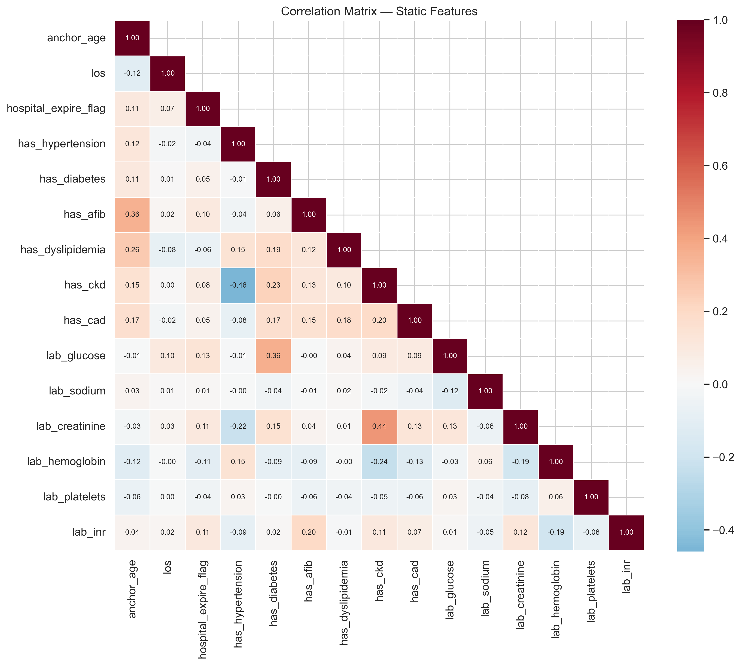
Figure S1. Pearson correlation matrix of static features in the stroke cohort (N = 8,500).

Supplementary Figure S2: Comorbidity Co-occurrence Heatmap
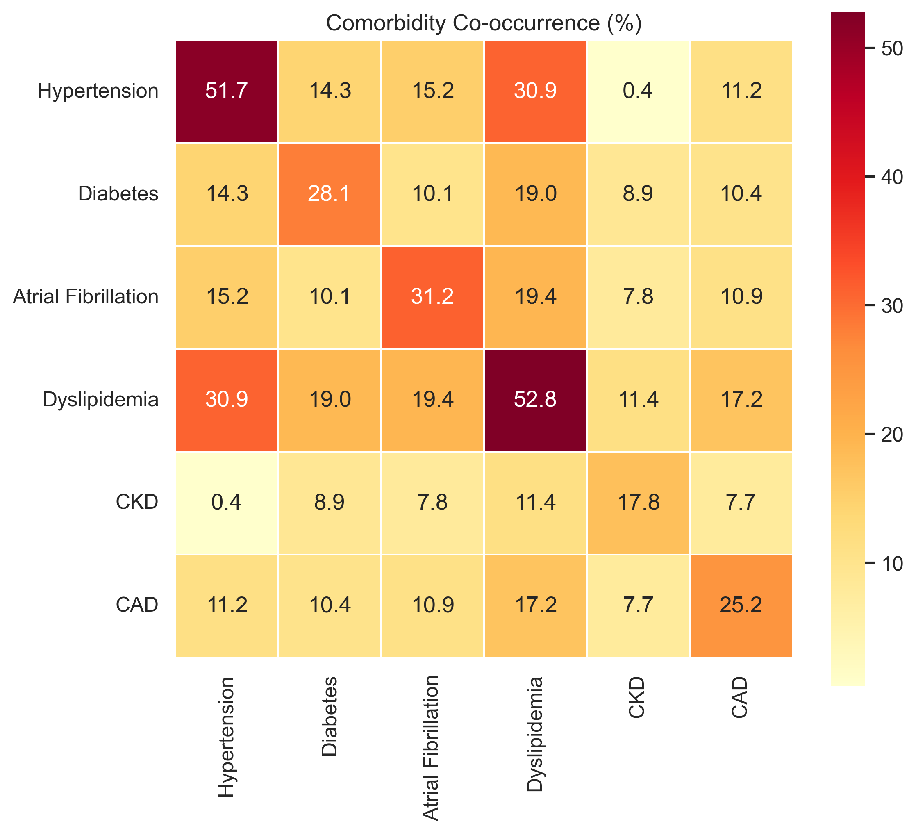
Figure S2. Heatmap of pairwise comorbidity co-occurrence rates.

Supplementary Figure S3: Age-Stratified Comorbidity Prevalence
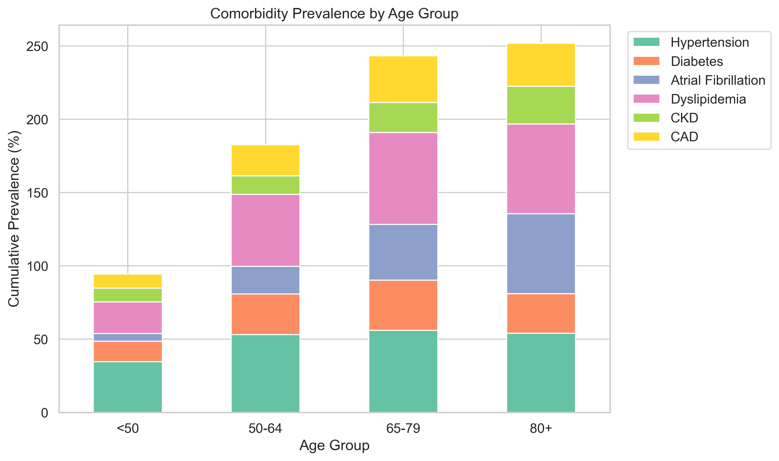
Figure S3. Age-stratified comorbidity prevalence across four age groups.

Supplementary Figure S4: Admission Laboratory Value Distributions
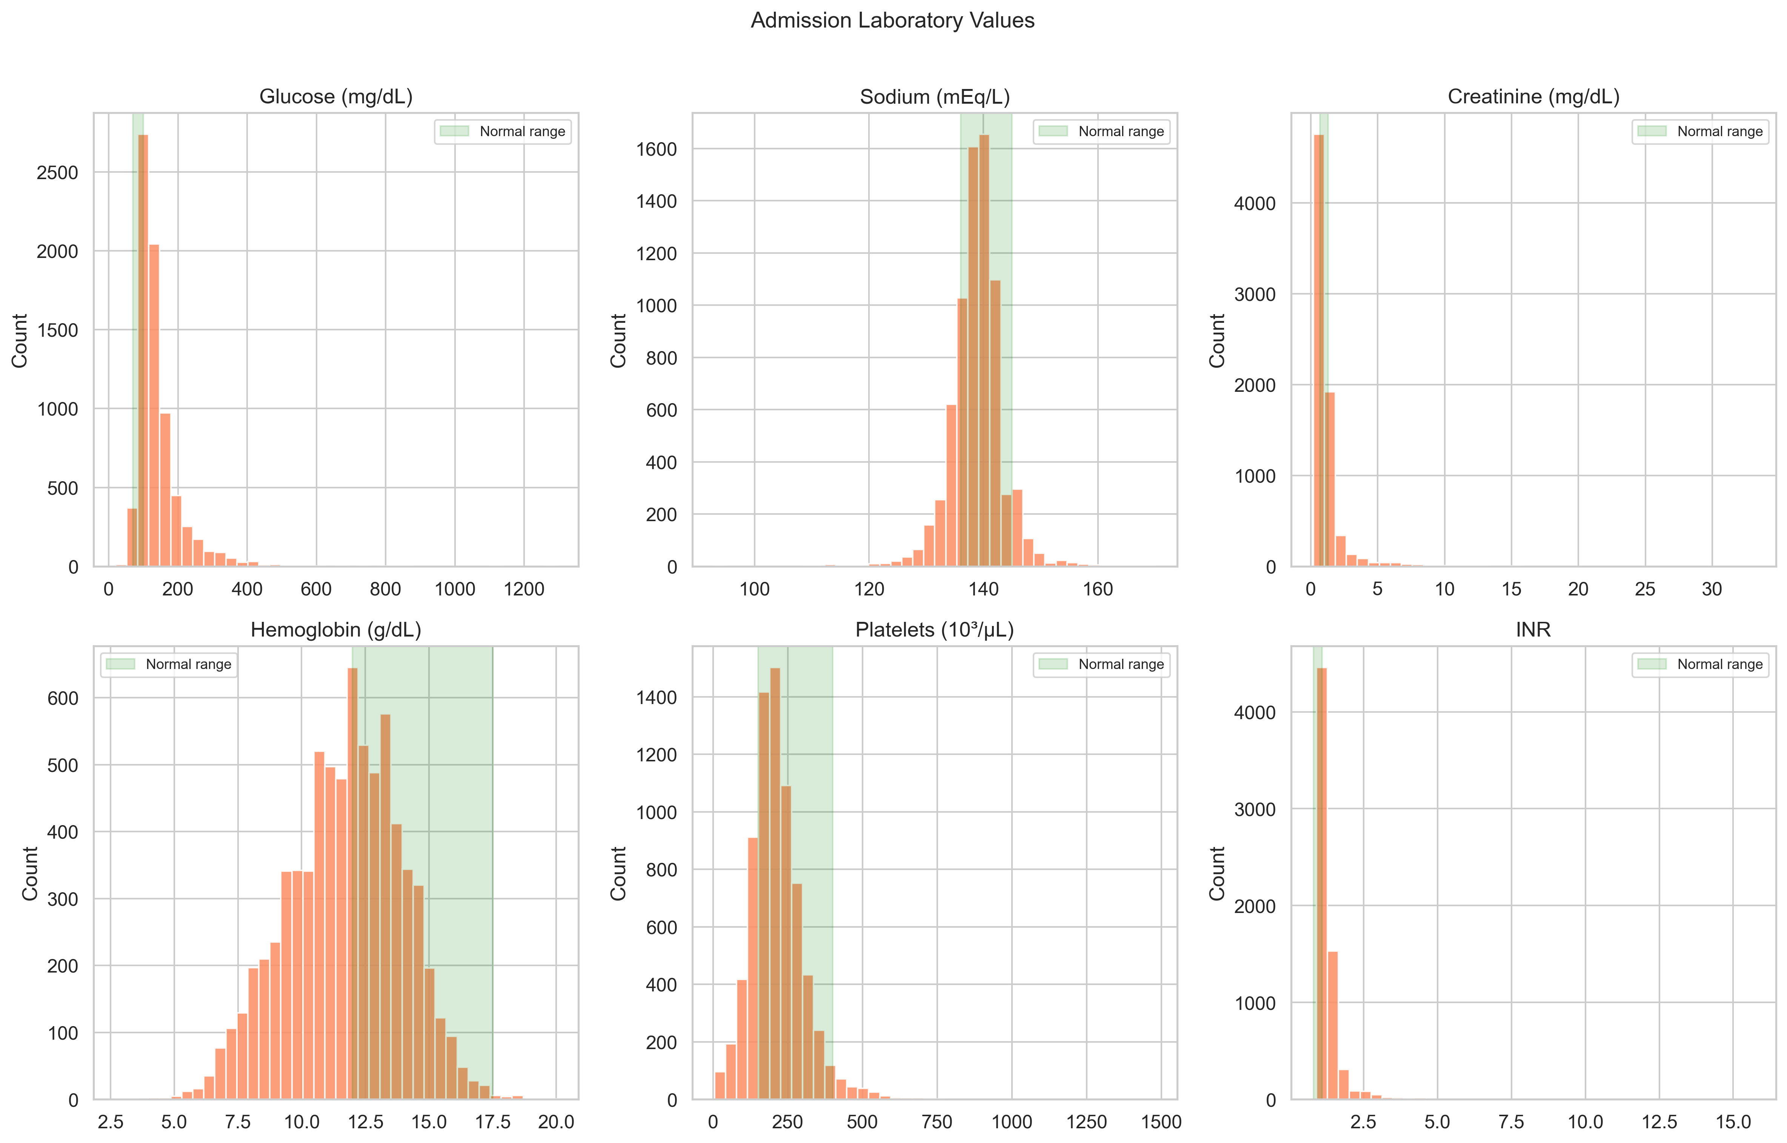
Figure S4. Distribution of six admission laboratory values with reference ranges.

Supplementary Figure S5: ICU Length of Stay Distribution by Stroke Subtype
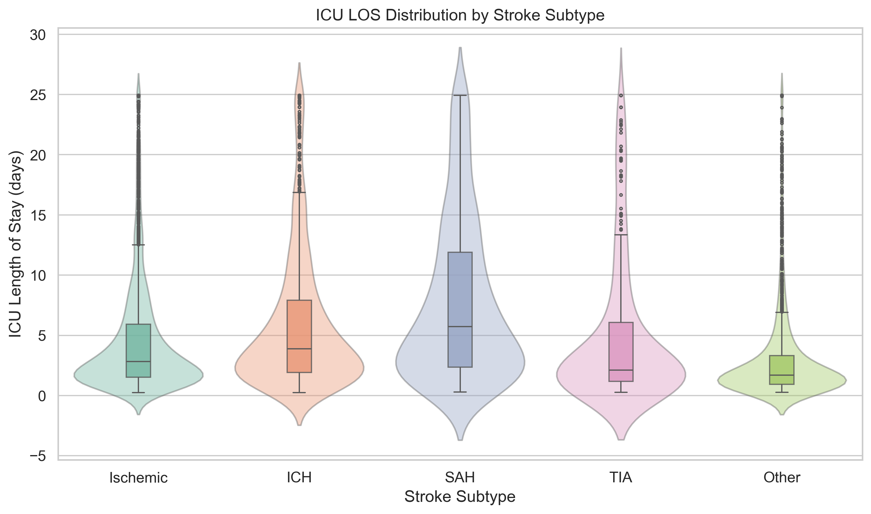
Figure S5. ICU length of stay distribution by stroke subtype.

Supplementary Figure S6: Time-Series Missing Data Rates
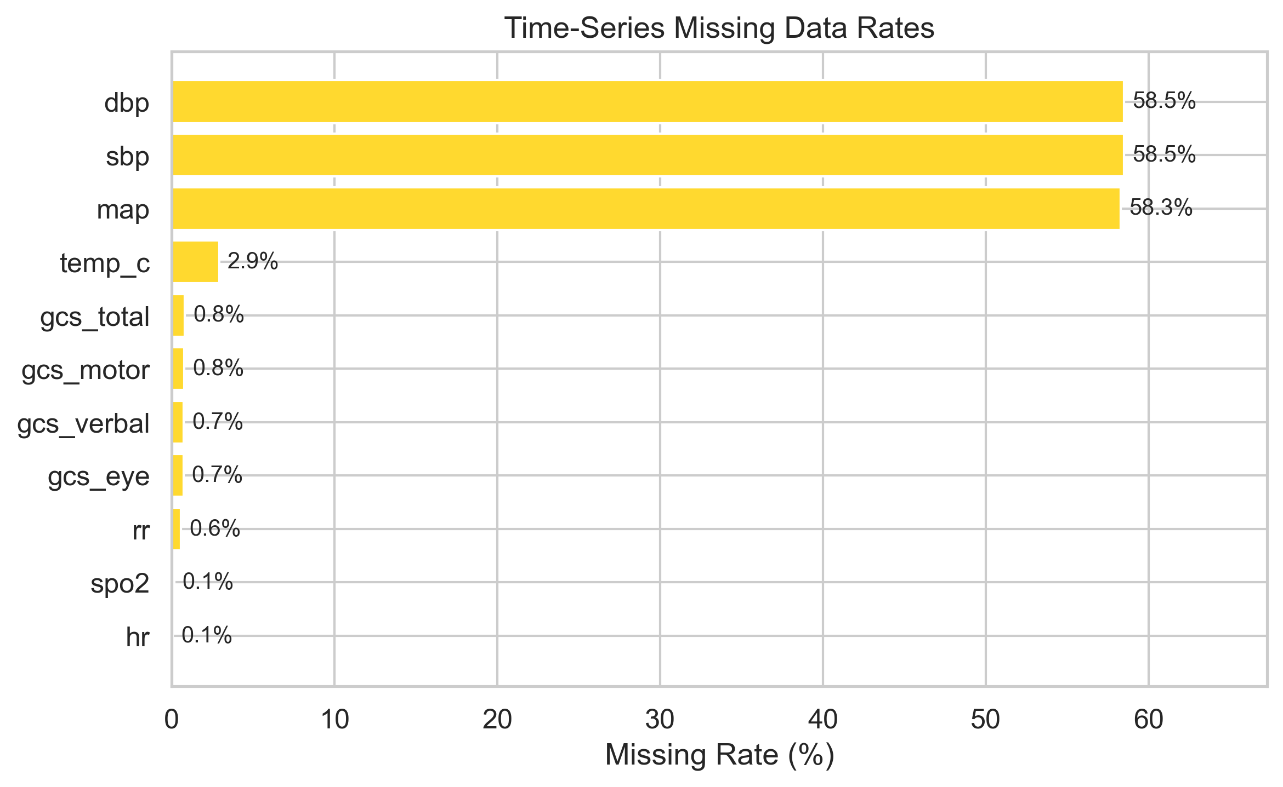
Figure S6. Hourly time-series missing data rates over 72 hours.

Supplementary Figure S7: Sample Patient ICU Trajectories
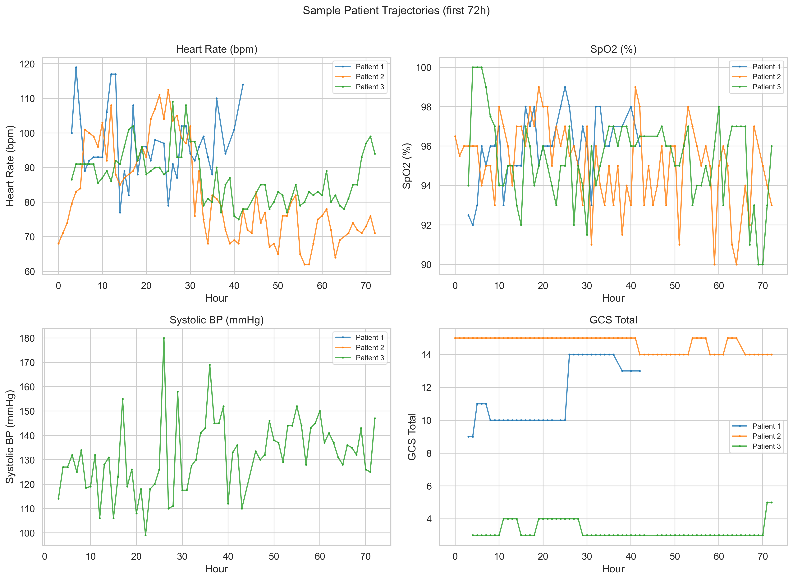
Figure S7. Example 72-hour ICU trajectories for three representative patients.

Supplementary Figure S8: In-Hospital Mortality by Age Decile
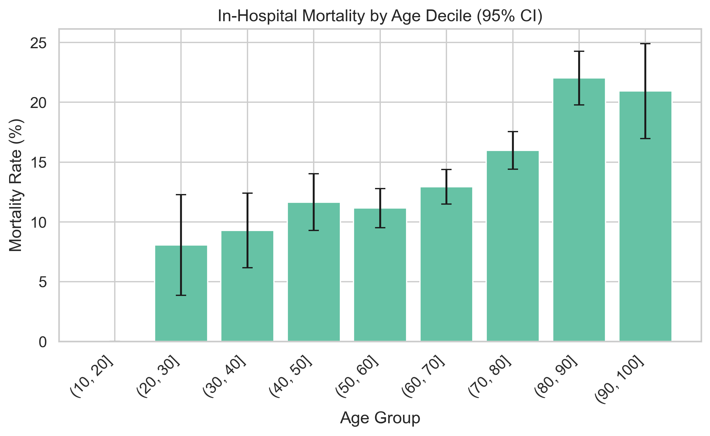
Figure S8. In-hospital mortality rate by age decile with 95% confidence intervals.

Supplementary Methods: SQL Cohort Extraction Pipeline

Overview
The cohort extraction pipeline used DuckDB (v0.9+) to query MIMIC-IV v3.1 data files directly in compressed CSV format (`read_csv_auto`) and Parquet format (`read_parquet`), without requiring a relational database server. This approach enabled reproducible, portable extraction with a single SQL engine.

Pipeline Architecture
The extraction proceeded through three sequential SQL scripts:
Script 01 -- Stroke Cohort Identification (`sql/01_stroke_cohort.sql`): 1. Identified all patients with at least one stroke-related ICD-9 (433.xx, 434.xx, 435.xx, 436) or ICD-10 (I60.xx, I61.xx, I63.xx, I65.xx, I66.xx, I67.xx, G45.xx) diagnosis code from the `diagnoses_icd` table. 2. Joined to `icustays` to select patients with at least one ICU stay associated with the stroke admission. 3. Applied inclusion criteria: ICU LOS >= 6 hours and <= 30 days. 4. Retained only the first ICU stay per patient (ranked by ICU admission time). 5. Joined demographics from `patients` (age, gender, date of death) and `admissions` (admission type, insurance, race, in-hospital mortality).
Script 02 -- Static Feature Extraction (`sql/02_static_features.sql`): 1. Extracted comorbidity flags by pattern-matching ICD codes on the index admission. 2. Classified stroke subtype from the primary ICD code (ischemic, ICH, SAH, TIA, or other). 3. Extracted first-within-24-hours admission laboratory values (glucose, sodium, creatinine, hemoglobin, platelets, INR) from `labevents`. 4. Pivoted labs to wide format using `ROW_NUMBER()` to select the earliest value per analyte.
Script 03 -- Time-Series Feature Extraction (`sql/03_timeseries_features.sql`): 1. Extracted hourly vital signs and GCS components from `chartevents` for each ICU stay. 2. Computed hour offset from ICU admission: `FLOOR(EXTRACT(EPOCH FROM (charttime - intime)) / 3600)`. 3. Aggregated multiple measurements within each hour using the median. 4. Pivoted to wide format with columns: HR, SBP, DBP, MAP, RR, SpO2, temperature (Celsius), GCS eye/verbal/motor/total. 5. Fahrenheit temperatures were converted to Celsius; GCS total was computed as the sum of three subscores. 6. Time horizon was truncated at 72 hours.

Key Design Decisions
- First ICU stay only: To avoid repeated-measures bias, only the first ICU admission per patient was included. - First-24h labs: The earliest laboratory value within 24 hours of hospital admission was selected to represent admission baseline status. - Hourly median aggregation: Multiple measurements within a 1-hour window were aggregated by median to reduce noise while preserving trends. - DuckDB direct file access: Eliminated the need for a PostgreSQL server, enabling the entire pipeline to run on a laptop with the raw MIMIC-IV files.

Supplementary Methods: Bayesian Network DAG Structure

Feature Set
The Bayesian Network was learned over 17 discretized features representing the static patient profile:
1. `anchor_age` (6 categories: 18--45, 45--55, 55--65, 65--75, 75--85, 85+) 2. `gender` (M, F) 3. `stroke_subtype` (ischemic, ICH, SAH, TIA, other) 4. `hospital_expire_flag` (0, 1) 5. `los` (5 categories: 0--1d, 1--3d, 3--7d, 7--14d, 14+d) 6. `has_hypertension` (0, 1) 7. `has_diabetes` (0, 1) 8. `has_afib` (0, 1) 9. `has_dyslipidemia` (0, 1) 10. `has_ckd` (0, 1) 11. `has_cad` (0, 1) 12. `lab_glucose` (Q1--Q4) 13. `lab_sodium` (Q1--Q4) 14. `lab_creatinine` (Q1--Q4) 15. `lab_hemoglobin` (Q1--Q4) 16. `lab_platelets` (Q1--Q4) 17. `lab_inr` (Q1--Q4)

Structure Learning
The DAG was learned using Hill Climbing search with BIC scoring and a maximum indegree constraint of 3. The BIC score penalizes model complexity, balancing goodness-of-fit against the number of parameters. The maximum indegree constraint limited each node to at most 3 parent nodes, preventing overfitting to spurious higher-order interactions.

Parameter Estimation
Conditional probability distributions were estimated using Bayesian estimation with a BDeu (Bayesian Dirichlet equivalent uniform) prior with equivalent sample size of 10. This prior provides Laplace-like smoothing, ensuring that no conditional probability is exactly zero even for rare combinations. Isolated nodes (those without any learned edges) received marginal probability distributions computed directly from training data frequencies.

Sampling
Synthetic profiles were generated via forward sampling from the fitted BN. Discretized values were converted back to continuous values by sampling uniformly within the bin range (midpoint + noise), preserving realistic continuous distributions while respecting the learned conditional dependency structure.

Data Availability Statement
The data underlying this study are available through the following channels:
- MIMIC-IV v3.1: Available via PhysioNet (https://physionet.org/content/mimiciv/3.1/) under a credentialed data use agreement. Access requires completion of the CITI "Data or Specimens Only Research" training course and institutional review board approval or waiver.
- Code and Pipeline: The complete extraction, modeling, and evaluation code is available at https://github.com/matheus-rech/MIMIC-Ext-Stroke. The repository includes all SQL extraction scripts, Python model implementations, configuration files, and evaluation notebooks necessary to reproduce the results.
- Synthetic Data: Pre-generated synthetic datasets are available upon reasonable request to the corresponding author. Because synthetic data were generated from MIMIC-IV, their distribution is governed by the same PhysioNet data use agreement principles, although the synthetic records themselves do not contain identifiable patient information.
*End of Supplementary Materials*

