Radionecrosis Rates with Concurrent SRS + Dual Immunotherapy vs. SRS + Single-Agent Immunotherapy vs. SRS Alone
This is arguably the hottest topic in the brain metastases field right now. A recent JAMA Network Open study showed that concurrent dual immune checkpoint inhibition (ipilimumab + nivolumab) with SRS significantly increases symptomatic radionecrosis risk—approaching 40% cumulative incidence—compared to single-agent immunotherapy or no immunotherapy.
The NCCN melanoma guidelines note "limited data are available, but currently there does not appear to be a concerning safety signal with the combination of RT and immune checkpoint inhibitors," highlighting the need for more real-world data.

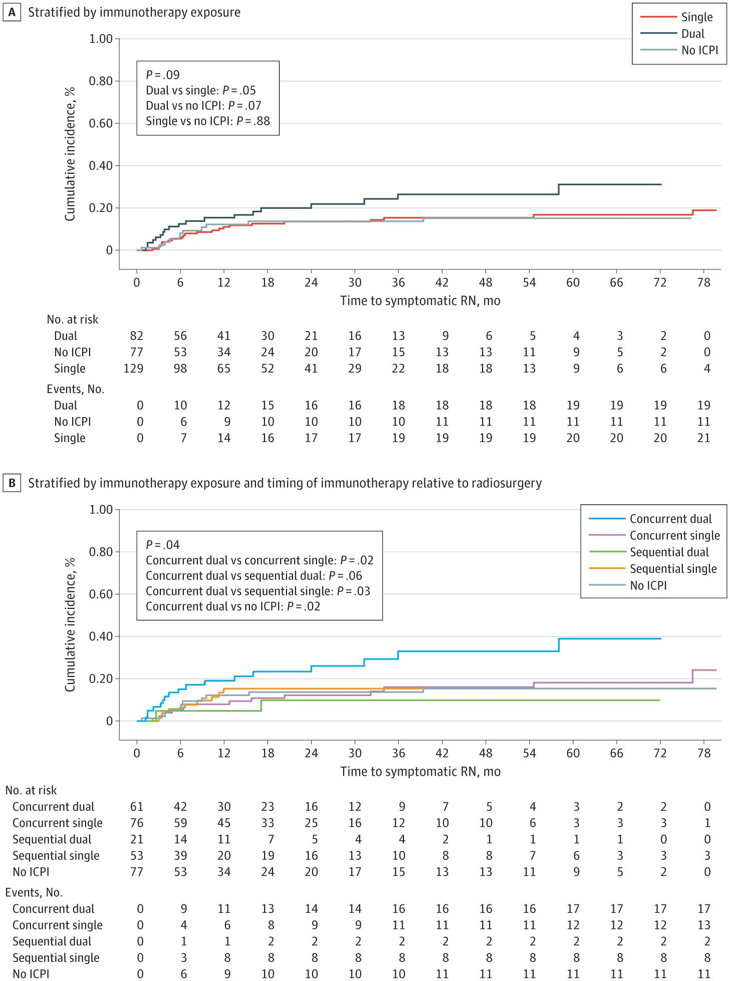
TriNetx can capture: SRS procedure codes, immunotherapy medication codes with timing, corticosteroid prescriptions (proxy for symptomatic radionecrosis), bevacizumab use (treatment for radionecrosis), neurosurgical interventions, and overall survival. This question is perfectly suited to TriNetx because it relies on medication timing, procedure codes, and healthcare utilization rather than imaging endpoints. You could stratify across melanoma, breast cancer, and NSCLC.
______________________________________________

2. Real-World Comparative Effectiveness: Tucatinib/Trastuzumab/Capecitabine vs. Trastuzumab Deruxtecan in HER2+ Breast Cancer Brain Metastases
Both tucatinib-based therapy and T-DXd are now NCCN-preferred options for HER2+ breast cancer brain metastases, but no head-to-head comparison exists.
[3]
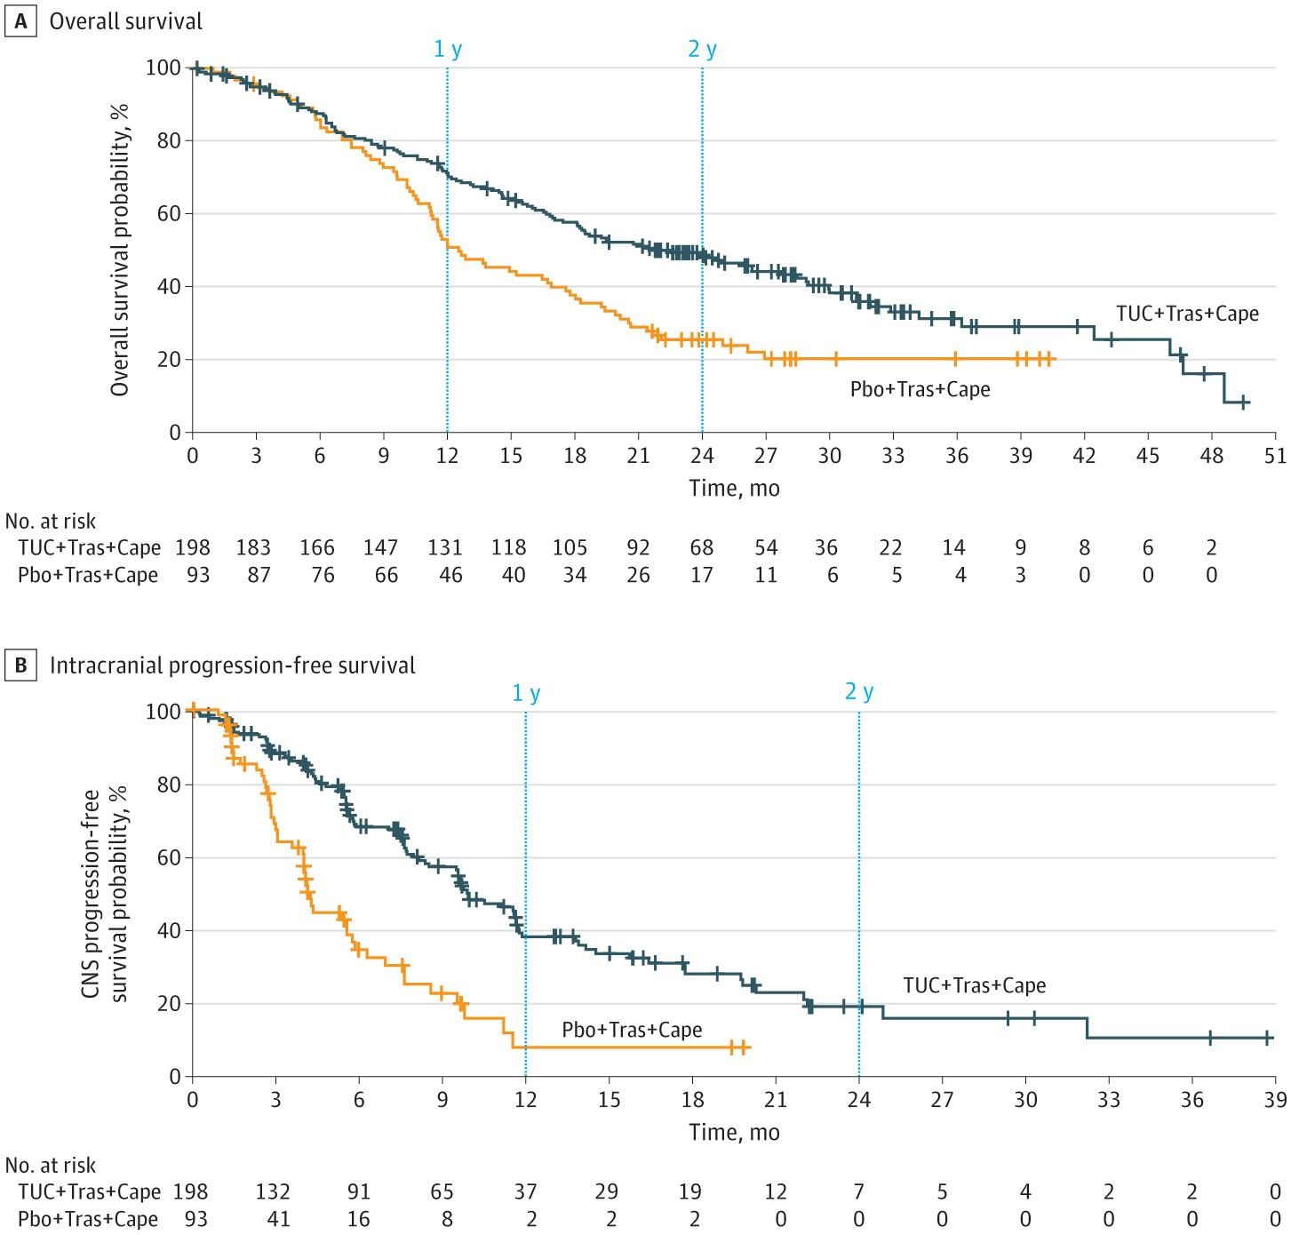

TriNetx can identify: HER2+ breast cancer patients (ICD-10 + trastuzumab use as proxy), brain metastases diagnosis, tucatinib vs. T-DXd prescriptions, time to treatment discontinuation, subsequent therapies, and overall survival.
The HER2CLIMB trial showed tucatinib reduced intracranial progression by 68%, while TUXEDO-1 demonstrated a 73.3% intracranial response rate with T-DXd. [4-6] Real-world comparative data would be extremely high-impact and conference-worthy.

______________________________________________

Impact of ADCs on Leptomeningeal Disease Outcomes Across Breast Cancer Subtypes
Leptomeningeal disease (LMD) is an emerging hot topic with historically dismal prognosis (median OS 3-7 months). [7-10]
Recent ASCO abstracts show that ADCs (particularly T-DXd) added to CNS-directed therapy significantly improved OS (13 vs. 5 months, p=0.002), and in HER2-low/ultralow patients, T-DXd improved OS from 5.5 to 23 months. [8]
The NCCN now lists T-DXd as preferred for breast cancer leptomeningeal disease. [3]
TriNetx can capture: LMD diagnosis (ICD-10 codes), breast cancer subtype (via medication proxies), ADC prescriptions, intrathecal chemotherapy codes, radiation codes, and overall survival. This is a massive unmet need with very limited real-world data.

