**Macro Finance – Homework 2**

*Canberk Tahil*

*Matheus Raka Pradnyatama*

*Oakley Liu*

**Section I: Financial Cycles**

**Question 1**

According to the CME Group’s FedWatch, interest rate traders are pricing:

|  |  |  |  |
| --- | --- | --- | --- |
| FOMC Meeting Date | Predicted Fed Target Rate | Change | Probability |
| June 18, 2025 | 4.25% - 4.50% | No change | 65.1% |
| July 30, 2025 | 4.00% - 4.25% | -25 bps | 55.2% |
| Sep 17, 2025 | 3.75% - 4.00% | -25 bps | 48.9% |
| Oct 29, 2025 | 3.50% - 3.75% | -25 bps | 36.9% |
| Dec 10, 2025 | 3.50% - 3.75% | No change | 36.4% |
| Jan 28, 2026 | 3.25% - 3.50% | -25 bps | 31.7% |
| Mar 18, 2026 | 3.25% - 3.50% | No change | 31.2% |
| Apr 29, 2026 | 3.25% - 3.50% | No change | 29.8% |
| June 17, 2026 | 3.25% - 3.50% | No change | 27.5% |
| Jul 29, 2026 | 3.25% - 3.50% | No change | 26.3% |
| Sep 16, 2026 | 3.00% - 3.25% | -25 bps | 25.9% |
| Oct 28, 2026 | 3.00% - 3.25% | No change | 25.8% |
| Scenario 1: Dec 9, 2026 | 3.25% - 3.50% | +25 bps | 25.2% |
| Scenario 2: Dec 9, 2026 | 3.00% - 3.25% | No change | 21.3% |

*Source:* [*CME Group as of May 3, 2025*](https://www.cmegroup.com/markets/interest-rates/cme-fedwatch-tool.html)

The current effective Fed Funds Rate is 4.33%, with a target rate of 4.25% - 4.50%. Most market participants are pricing around 100 – 125 bps of cut from today until the end of 2026. This translates to 5 interest rate cuts in the next year, with a possibility of one rate hike on the December 2026 meeting.

These number make sense given the latest macroeconomic landscape. The current government administration has a pro-growth outlook. Therefore, pushing for rate cuts that can lower borrowing costs and stimulate growth is aligned with the promises of the administration. The latest quarterly GDP growth number that was released on April 30th has shown that economic activity can slump due to uncertainties and government policies, further supporting the possibility of several rate cuts this year.

**Question 2**

Let’s observe how Fed Funds Rate move with 2 macro assets: equities and government bonds. The pictures are from the python files.

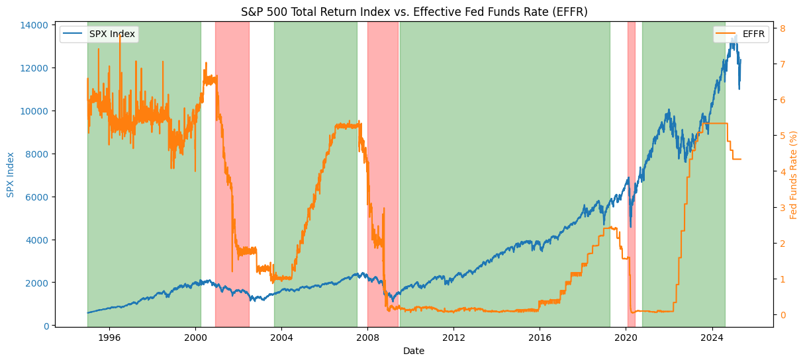

During periods of market downturns, the Fed significantly lowers interest rates to ~0%:

* Dot-com Bubble Burst (2000 - 2001)
* Global Financial Crisis (2008 - 2009)
* COVID-19 Pandemic (Early 2020)

However, pre- and post- financial crisis, after the Fed had lowered its target rate, there was always a period of economic boom (equities climbing up). The Fed in turn, began to raise rate and eventually, hold it at high levels, to combat inflation and reduce excessive lending conducted by banks.

Equities as an asset class benefit from a lower interest rate period and even during a rising rate environment, due to the cheaper borrowing cost and an increased economic activity. However, equities can be expected to exhibit negative returns when the Fed aggressively lower rates (which only happens when there's a financial crisis).

This thought process is proven to be correct 100% the time in the past 25 years (6 out of 6 times), when the Fed raise and lower rates in significant amounts. The Fed raise rates to slow down an overstimulated economy and lower rates to stimulate an economy that is in a recession.

During market downturns, the yield on UST 30Y goes down. Investors flock to safe-haven assets such as long-dated US treasuries. As the demand increase for those Treasuries, their price goes up and yields go down. Government bond as an asset class benefits from a lower interest rate environment.

However, this isn’t always the case. In the past 25 years, this logic is true during the 2008 GFC and COVID-19 Pandemic. But this was not realized when the Fed lowered interest rate in the period of 2001 – 2002. There was no abrupt drop in UST yields during that period. Thus, the fraction of the time this thought process is true is 2/3 times (~67% of the time) in the past 25 years.

The high probability of several rate cuts over the next year signals the possibility of a recession and a time where equities as an asset class suffers. Due to the high volatility and the proposed trade barriers, a recession is likely to happen. Investors should sell (short) equities and buy government bonds before Treasuries rally. Historically, the price of UST goes up and equities fall when a recession occurs, and interest rates decline.

**Question 3**

It makes sense to extrapolate how investors should behave right now, because history always repeats itself. Despite short-term price movements that may not conform to historical patterns, in the medium- and long- term, asset prices will behave according to historical patterns.

When macro assets such as equities decreased significantly, the government has incentive to stimulate economic growth. We can reverse the logic by thinking that if the government is lowering borrowing costs, it means that equities are in a decline. Investors should buy equities as the government is behind them to push equities to higher levels.

On the other hand, the Fed will raise rates to slow an overstimulated economy (equities at all-time highs). We can reverse the logic to see that if there are huge probabilities that the Fed is going to raise rates, investors should sell equities (given that they are at all-time highs) before the bubble burst.

**Section II: Macro Regimes**

**Question 4**

The macro variable data used are:

1. Interest Rate (measured by the Effective Fed Funds Rate)
2. Growth (measured by the US Industrial Production Index)

The level of interest rate in the US dictates how much liquidity is accessible in the market and the borrowing costs for individuals and companies in the US (and indirectly, all over the world).

As the world’s largest economy, the growth of the US production level reflects regional and even, global trade and economic activities. As it relates to the US GDP growth, it can be used to assess whether there’s a recession in the US. The rule-of-thumb is that 2 consecutive negative quarterly GDP growth is indicative of a recession.

During a recession, when the US Industrial Production Index (i.e., growth) falls and the Fed lowers interest rates, I would expect:

* Equities to go in a downward direction
  + Factories will not increase production, will focus instead on cost-savings measures such as layoffs
  + Companies will delay major acquisitions
  + The Fed is lowering borrowing cost to stimulate economic activity
* Government bonds to go in an upward direction
  + Investors will buy safe assets such as US treasuries
  + Demand and price for government bonds will rise
* Credit (Corporate bonds) to go in a downward direction
  + Default risk increase
  + Demand and price for corporate bonds will decline
* Commodities can go in an upward or downward direction
  + Reduced US production 🡪 reduced trade activities involving USD 🡪 Lower demand for USD
  + Lower rates also translate into a weaker USD
  + Investors will buy an alternative safe asset: Gold (increased demand for commodities)
  + But there might be lower demand for other commodities such as precious metals and oil 🡪 which can lower commodities as an asset class

**Question 5 Macro Regimes**

Periods of sustained economic growth (Low rates environment, followed by a rising rate period, and US production level is increasing):

1. 1995-01-01 – 2000-04-01

Dotcom bubble, fueled by the rise of internet and telecom companies

1. 2003-09-01 – 2007-07-01

Economic boom supported by Mortgage-Back Securities being issued and traded by banks and insurance companies, and the rise in home prices

1. 2009-07-01 – 2019-04-01

Near 0% interest rate, extremely low borrowing cost, high liquidity

1. 2020-10-01 – 2024-08-01

Government stimulus checks for US citizens, rise of retail investors

Periods of market downturns (Fed is lowering interest rate and US production level is falling):

1. 2000-12-01 – 2002-07-01

Dot-com Bubble Burst (recession)

1. 2008-01-01 – 2009-06-01

Global Financial Crisis (recession)

1. 2020-01-30 – 2020-06-01

COVID-19 Pandemic (recession)

**Question 6: Macro Asset Performance during Different Regimes**

During recessions, the mean return for equities and commodities are always negative. This makes sense as companies become more conservative in their business expansions, earnings, profit, P/E ratio all fall. Additionally, reduced economic activity resulted in a lower demand for industrial commodities such as precious metals and oil, causing commodities to have negative returns.

During economic booms, returns for equities are soaring high, as companies conduct major acquisitions and invest in new products and research. An exception can be made for commodities that is showing around 0% return post 2008. This can be explained by the 2014 – 2016 oil price plunge (pushing commodities’ price and return down).

Most of the time, government bonds are showing positive returns. However, as expected, their returns are generally higher during periods of recessions compared to returns during economic booms. During periods of high volatility, investors buy long-dated Treasuries which are considered safe-haven assets, driving up their price and returns.

Unsurprisingly, corporate bonds are showing low and negative returns during recessions. As default rates increased for various companies (due to lower sales and profit margin), the demand for those corporate bonds fell. During periods of growth, investors are risk-takers and are inclined to invest in riskier assets, driving up the demand and thus, return for credit.

**Question 7**

For each macro regime, we must use different risk metrics to capture the changing volatility. During economic busts such as the September of 2008 and March of 2020, there was significant volatility in the market. Investors should reduce their capital allocation from equities (which were showing low returns and high volatility) and move them to bonds. On the other hand, during an economic boom, when there’s a higher liquidity and equity returns are rising, investors should move towards equities. One way to capture this dynamic volatility is by using a trailing one-year return volatility in a risk-parity strategy.

This idea was popularized by Ray Dalio from Bridgewater Associates. Essentially, we allocate more resources towards assets that have lower volatility. However, as volatility changes in different regimes, the asset allocation process should be dynamic:

* During a recession, equities are riskier, give more allocation towards bonds.
* During an economic boom, equities are showing lower levels of volatility, give higher allocation to equities.

**Section III: Risk Parity Fund**

**Question 8: Correlations between Equities and Bonds**

The weekly returns for US equities and bonds (specifically, high-yield corporate bonds) have a moderate positive correlation with one another, almost 50% for the period of 2000 – 2019 (to be exact: 48.89%). For the rolling 1-year correlation, we noticed that the correlation revolves around 20 and 60%. Over time, we can see an increasing correlation between stocks and bonds:

* For the period of 2010 – 2018, the correlations are between 50% to 60%
* For the period of 2018 – 2019, the correlations are between 60% to 80%

**Question 9: Risk (Volatility)**

Over the life of the fund (from 2000 – 2019), the average allocation is 26.71% for equities and bonds: 73.29%. This makes sense because most of the time, equities show a higher volatility compared to bonds. The average weekly risk of the fund is 1.03% (annualized: 7.41%). The average contribution towards volatility for equities is 49.54% whereas from bonds is 49.42%. This is expected as in a risk-parity fund, we are trying to equalize the source of risk so that most of the time, we are capturing the same level of volatility from each asset class.

The risk-parity strategy is widely followed as it provides investors with a level of certainty of gaining returns in both market downturns and economic booms. Most investors want a stable portfolio. They want to capture the gains from equities being in all-time highs, yet to also generate returns that they can be proud of when all other funds are losing money. The risk-parity strategy provides just that. During periods of economic growth, investors are exposed more to equities and receive high returns. During periods of high volatility in the equity markets, they are more exposed to less volatile assets such as bonds (e.g., corporate bonds) that can still provide some returns.

**Question 10: From 2021 to Present**

From 2021 to the present, the fund’s performance is around -2% and 2%. However, in 2022 and 2025, when there’s a significant shock in the market, the return dropped to -3%. The fund performed poorly due to the low returns generated by the 2 asset classes in the portfolio: equities and bonds, during those periods.

The negative returns in 2022 can be attributed to the Fed raising interest rates by 350-bps from May 2022 until December 2022. This was enacted to combat inflation that reached 9.1% annually in June 2022.

The low returns in 2025 can be attributed to the fiscal policies enacted by the US government. The US proposed various tariffs on goods from multiple countries, and this was projected to decrease trade activities and raise the price for consumer and industrial goods in the US. The high volatility in the US caused a market sell-off and that’s why returns are either low or negative for assets in 2025.

Furthermore, there was significant correlation between both assets during those periods. The correlation from 2021 to the present is 70.40%. This means that when equities fall, bonds are also expected to fall. During periods of market downturn, uncorrelated assets can become correlated. Therefore, assets that do have some correlation will have an amplified correlation. It is not a surprise to learn that the correlation between equities and bonds is 79.14% in 2022, and 57.82% in 2025.

For risk-parity funds, since we have proven that equities and bonds have significant correlation, we can introduce other assets that may have lower correlations to existing assets in the fund. Other than corporate bonds, they can include US, European, and Emerging Market government bonds, as well as various commodities (gold, precious metals, oils, etc.). This would provide a higher diversification, and the risk management framework would be to dynamically allocate capital based on the risks of those various assets. Assets that show a low volatility during a regime will receive a higher capital allocation, but once their volatility significantly increased, exposure to those assets will be reduced as capital is re-allocated to other assets.