Here’s some examples of variables that I used on my program.





* Variable tickets:

The variable tickets is determined by querying all the Ticket objects from the database using Ticket objects all.

This variable is declared and initialized in the line: tickets = Ticket objects all

The purpose of this variable is to hold the list of available tickets.

* Variable form:

The variable form is declared and initialized based on the request method using the TicketBookingForm.

If the request method is "POST," the form is initialized with the submitted data request.POST. Otherwise, if it's not a "POST" request, the form is initialized with no data None.

The purpose of this variable is to handle the ticket booking form.

* Variable feedback:

The variable feedback is created to store the feedback object retrieved from the database using the get_object_or_404 function.

This variable is declared and initialized in the line: feedback = get_object_or_404(Feedback, id=feedback_id)

The purpose of this variable is to hold the feedback object associated with the given feedback_id parameter.

2.2 Determine, declare, and initialise data structures to meet a given requirement (e.g., array, lists).

Screenshot and explain where you have created data structures such as lists, dataframes, dictionaries, arrays, etc… (explain why you created them and show screenshots) **– DOES NOT HAVE TO BE ALL YOUR EXAMPLES JUST SHOW A FEW DIFFERENT EXAMPLES**



* Dictionary: context

The context dictionary is used to pass data to the template rendering context.

In various view functions such as book_ticket, ticket_details, available_tickets, feedback_list, and others. The context dictionary is populated with relevant data. The keys of the dictionary represent the variable names that will be accessible in the template, and the values are the corresponding data to be passed to the template.



* List: tickets

This list is used to store instances of the Ticket model retrieved from the database.

The tickets list is created in the book_ticket view function. It retrieves all the Ticket objects using the Ticket.objects.all() query and assigns them to the tickets list.

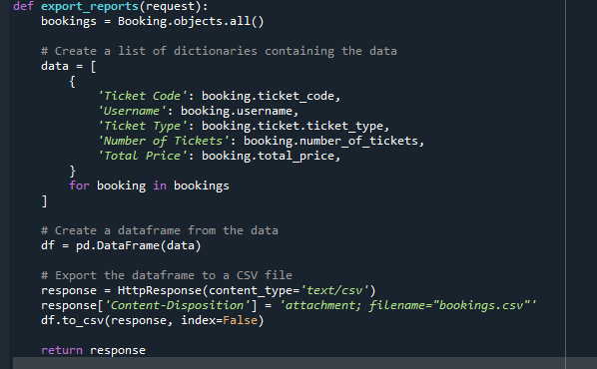

* List of Dictionaries: Data

The variable data is a list that stores dictionaries. Each dictionary represents the data for a single booking. The keys in the dictionary correspond to the column names in the CSV file, and the values represent the booking information for each column. This data structure is used to organize the booking data before creating a dataframe.

* Dataframe: df

The variable df is a dataframe created using the Pandas library. The dataframe is constructed from the list of dictionaries (data) created in the previous step. Each dictionary in the list represents a row in the dataframe, and the keys in the dictionary correspond to the column names. This data structure allows for easy manipulation and analysis of the booking data.