2D Simple Cave Generator
Basic Information:
This Cave Generator is made for 2D Games. Its a Script attached to an Empty. The Cave is being build in rooms. There are three Types of Rooms which are defined by an Integer.
-1 is the First Room; 0 all the Rooms in the middle and 1 is the last room.
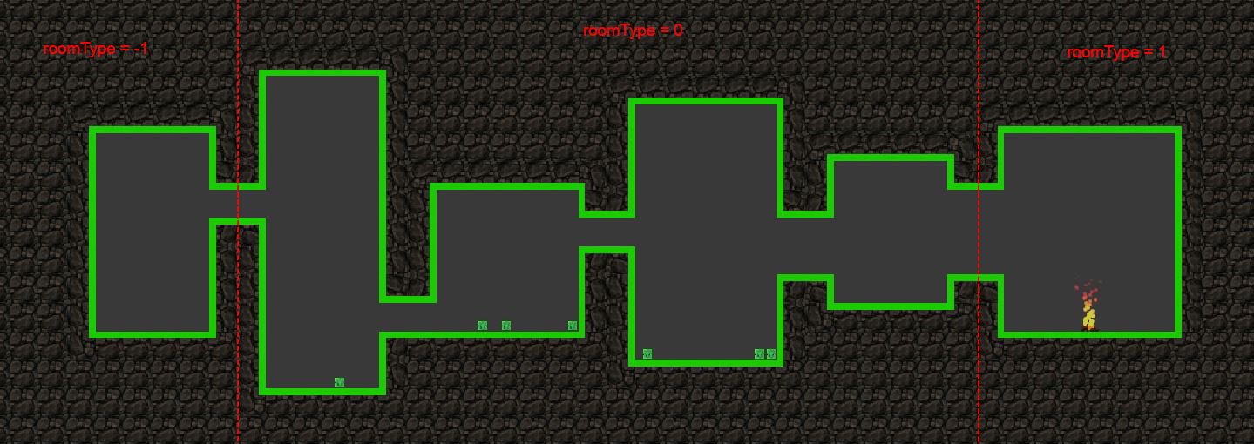
How to use:
- You can either drag the prefab „2DSimpleWorldGenrator“ into the position where your first room is going to start, or create a new GameObject which holds the script „CaveGenerator“ in it.
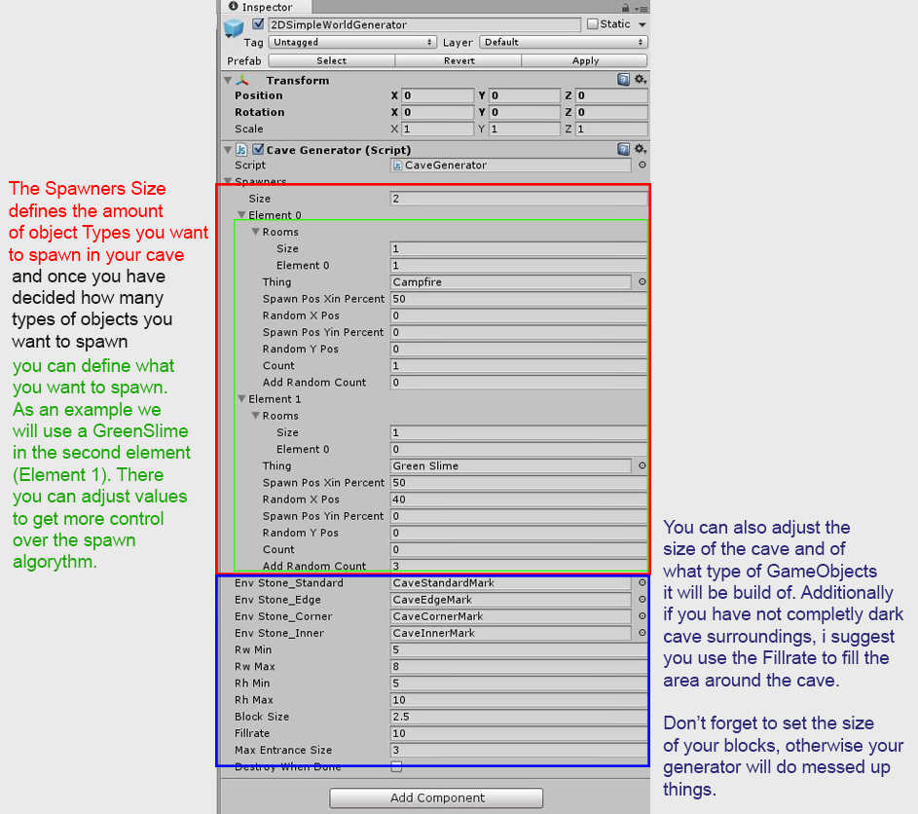
- Adjust the Values you need. In this example we have the Basic CaveGenerator with its possible values.
I will now explain the different meanings behind the variables you can adjust.
  - Spawners(Size): Determines the different types of things you want to spawn and allows you to spawn different things with different algorythms
    - Rooms asks for a count of the roomtypes used and then you have to type in the value of each roomtype in which the object will spawn. -1 = first room; 0 = all rooms between the first and the last; 1 = the last room.
    - Thing asks for a GameObject which will be spawned. I suggest you use a prefab.
    - Spawn Pos X in Percent is the place in the room on the X axis (in percent) where the „Thing“ is going to spawn. This can be randomized through Random X Pos which is going to set the position of the spawn +- the value you type in(in percent). Don't set the value higher then the Spawn Pos.
    - Spawn Pos Y in Percent is the same as Spawn Pos X in percent only for the Y Axis.
    - Count defines the Amount of „Things“ which will be spawned in the room. This can be randomized through Add Random Count which will be added to the Count.
  - Env Stone_Standard is the Prefab for the wall, ceiling and the floor of the cave. It should have a collision box applied if you don't want your Player to fall through the floor.
  - Env Stone_Edge is a convex type of corner. Needs collision.
  - Env Stone_Corner is a concave type of corner. Collision is not nacissary.
  - Env Stone_Inner is the prefab which will be used to fill the area around the cave. Doesn't needs collision.
  - RC min is the minimum amount of rooms. (not shown on Picture)
  - RC max is the maximum amount of rooms. (not shown on Picture)
  - Rw min (Room width minium) is the minium length of the room.
  - Rw max (Room width maximum) is the maximum length of the room.
  - Rh min (Room height minium) is the minium height of the room.
  - Rh max (Room height maximum) is the maximum height of the room.
  - Block Size is the size of your Env Blocks used to build the cave. If this value is not set right your cave will have a lot of holes.
  - Fillrate is the thickness of Env Cave_Inner blocks around the cave.
Use it if your background doesn't match the colour of the lower End of your other Env Blocks.
  - Max Entrance Size is the maxiumum height of the connection between the rooms.
  - Destroy when Done will destroy the World Generator after it has been created.

- Run your game and the CaveGenerator will generate the cave depending your input values. Have fun!

If you want to report any Bugs or have any questions, send me a message to grasbock@gmail.com!

