# PHP Journal

## Variables

### Check if the user typed a decimal input

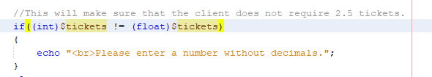

### Boolean

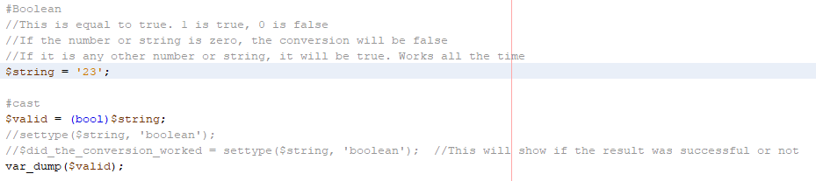

* In this case the result will be true. If you convert any number/string that is not zero to Boolean, it will be converted to true. Only zero will be converted to false.

### String

#### Length

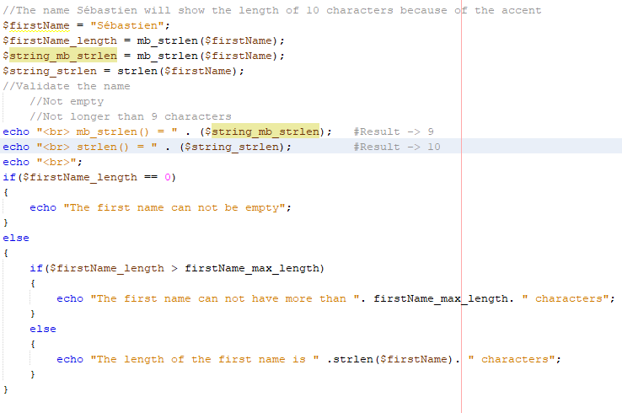

Two ways of finding the length a string

* strlen()
* mb_strlen()

The difference between the two of them is that if we use strlen(), words like ‘’Montréal’’ would have one character more because of the accent and this is not what we want when validating an input. That is why it is better to always use mb_strlen()

#### Trim

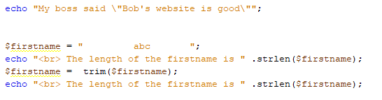

#### Substring and Strpos

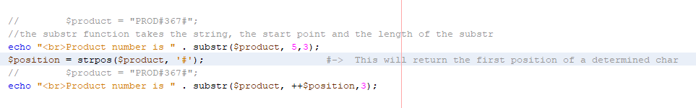

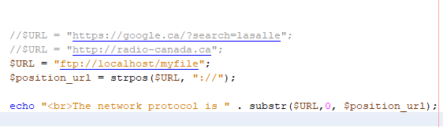

#### Str_replace

Modify and change a part of a string for another

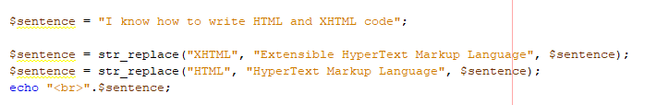

Explode and implode

Separate a string by a certain char and then unite it by a specific char.

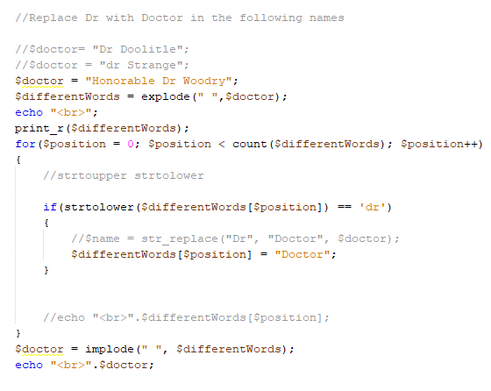

#### Summary of functions

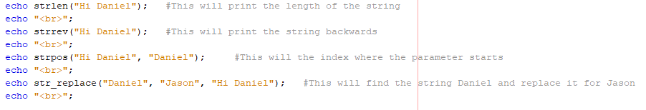

## Casting

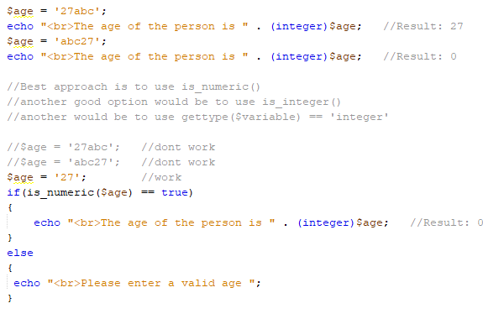

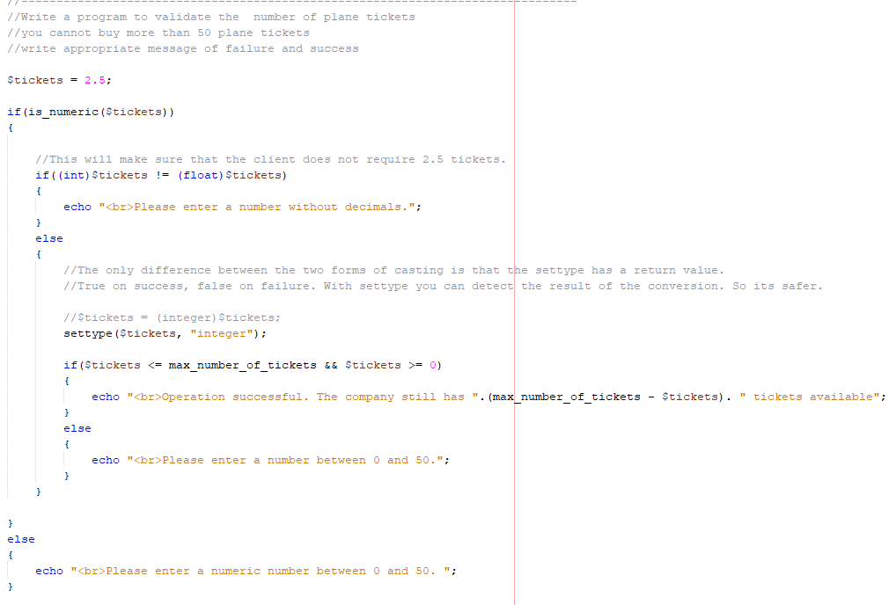

## Arrays

### How to output an array

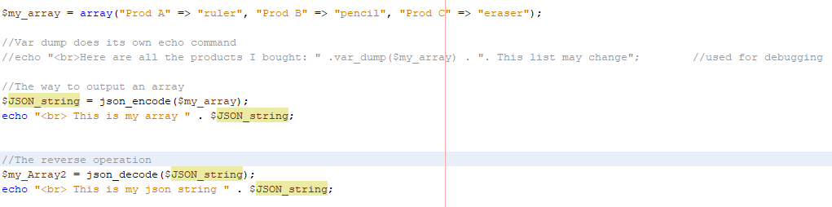

### Indexed Array

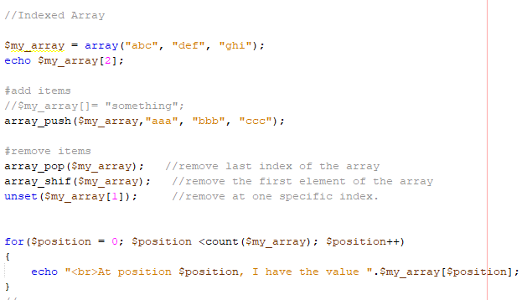

### Associative Array

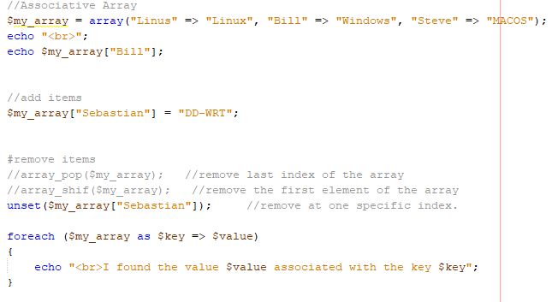

### Sorting

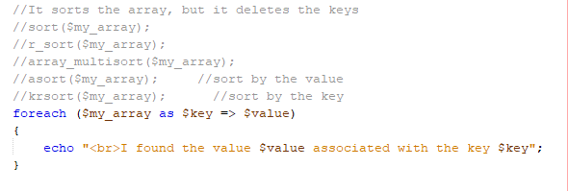

### Array applied

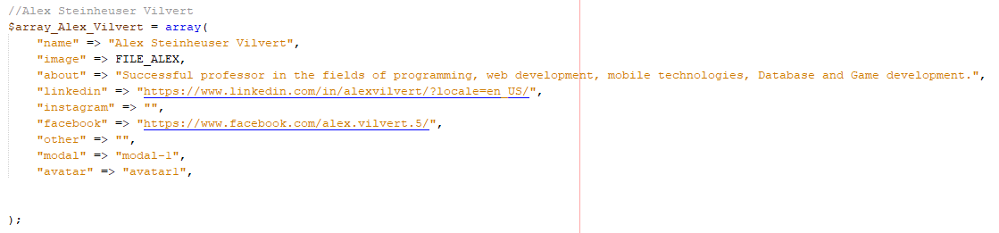

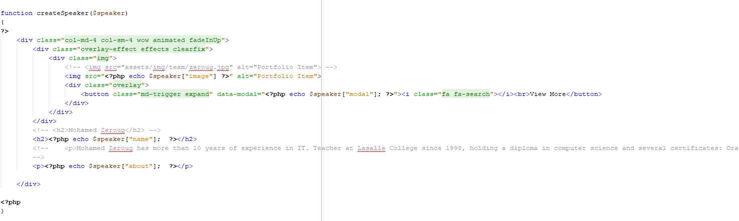

## Defining a constant

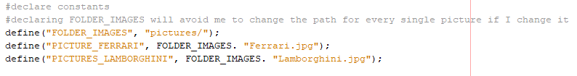

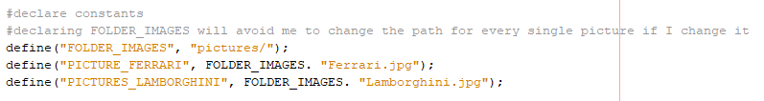

## DateTime

Different ways to manage Date the date

### 1: Date time Object

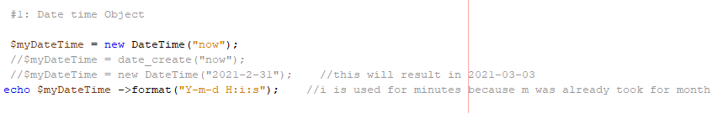

### 2: Timestamp

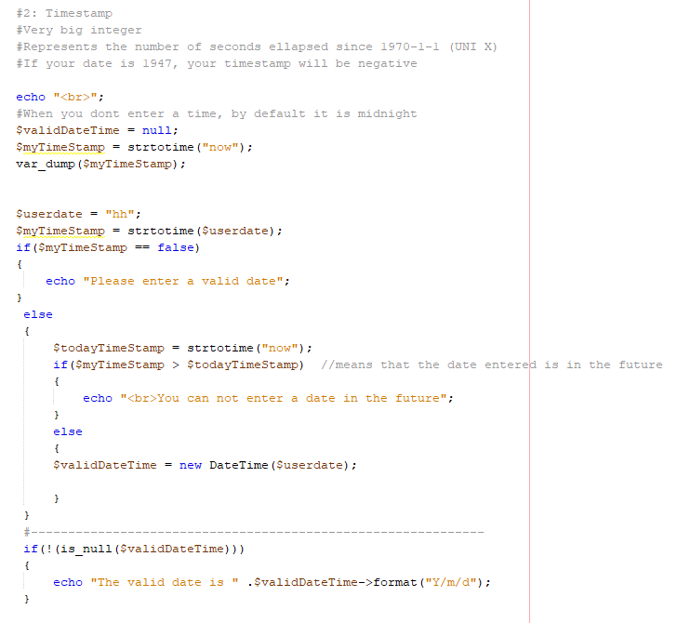

### 3: Bulletproof

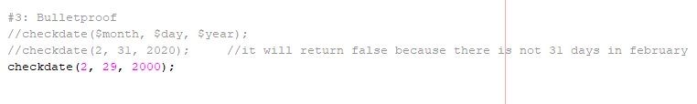

### 4: Array



### 5: Shortcut to get a quick string representation



### 6: Debugging and Calculate the difference between the two dates

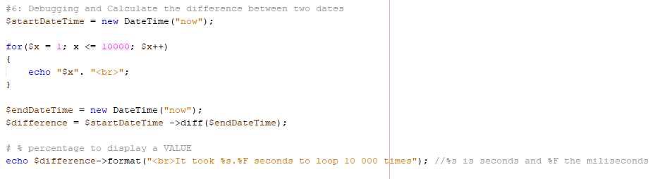

## Functions

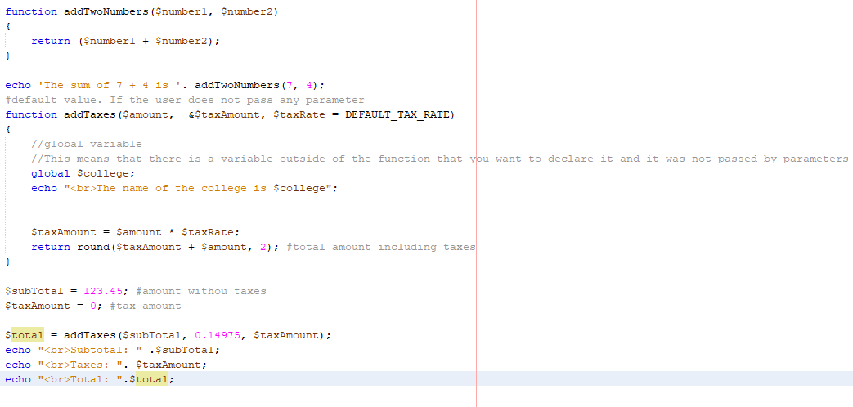

### Passing by reference

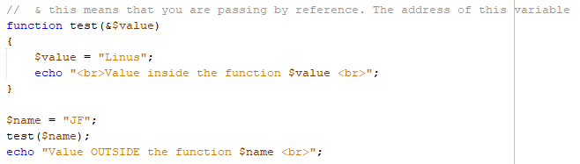

## Import one file to another

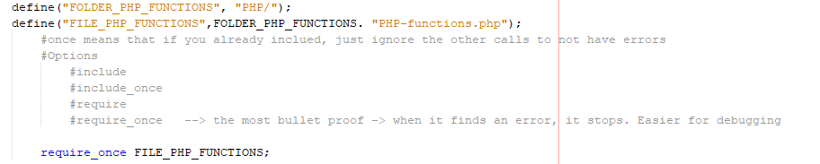

## Json_encode

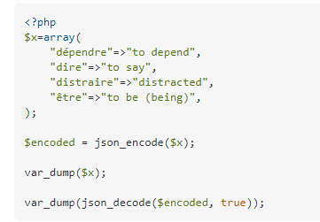

## Text File

### Modes

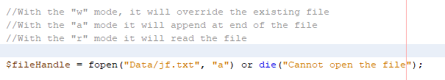

* It is important to notice that this will only create a text file in the htdocs, not on the NetBeans folder

### Write

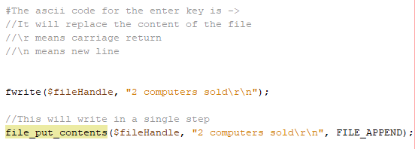

### Read

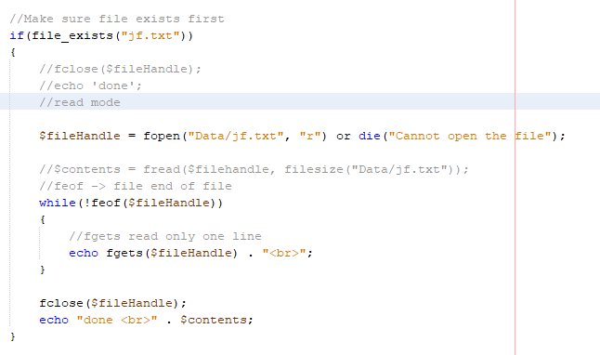

## Function to generate handle advertising picture

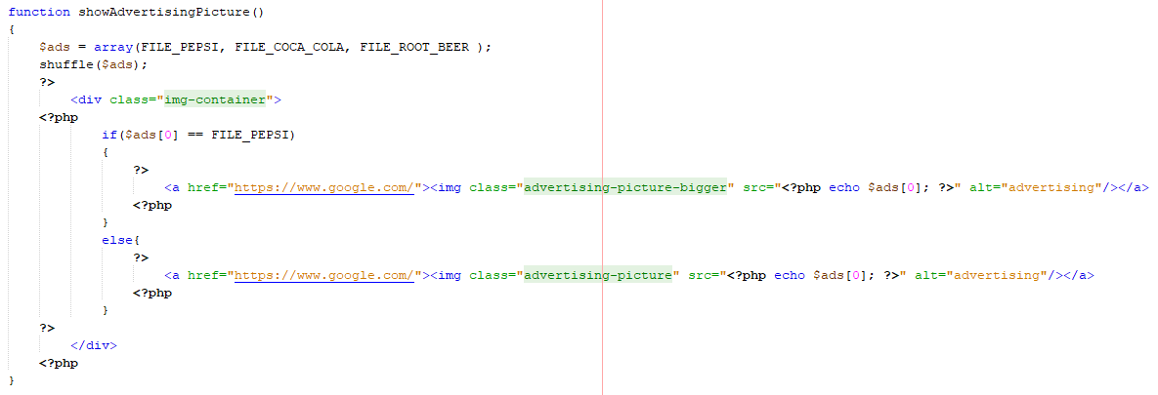

## Create Form

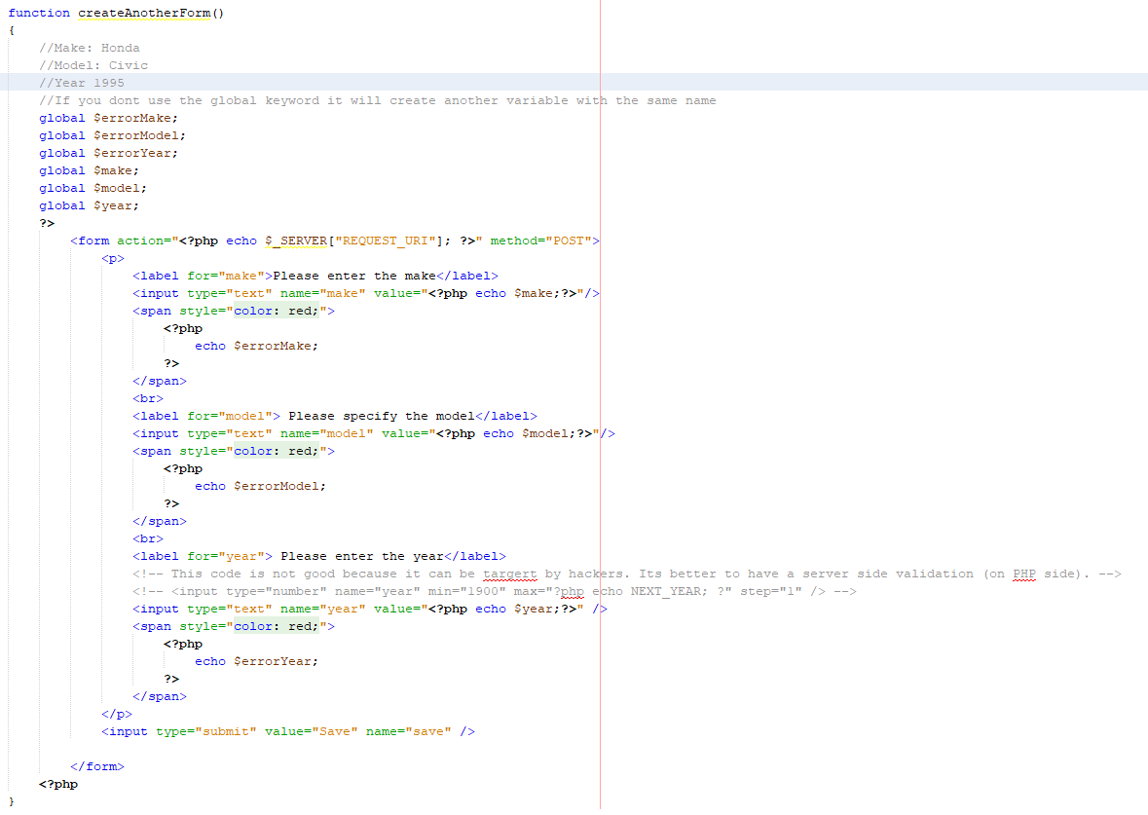

* Notes
  + It is important to note here the value for each input, by putting the own variable inside will avoid that the input is erased on the textbox if the validation is not successful, allowing the user to modify and submit again.

### Reading and validating input against injection

* Types of functions to validate data and protect against injection
  + Filter 1
    - Removes special chars and gets string. Would not be the best because we don’t want to remove input from the user
    - Would not get accents properly on the page source as well
    - Montréal would have a length of 8 instead of 7, because of the accent
      * echo "<br><br>Filter #1 SANITIZE STRING: <br>";
      * echo filter_input(INPUT_POST, "firstname", FILTER_SANITIZE_STRING);
  + Filter 2
    - Remains the special chars. It kept the script but it replace the '<' for codes in the page source
    - It would not be the best choice becaause it dont get the accent properly
      * echo "<br><br>Filter #2 SANITIZE FULL: <br>";
      * echo filter_input(INPUT_POST, "firstname", FILTER_SANITIZE_FULL_SPECIAL_CHARS);
  + Filter 3
    - Remains the special chars. It kept the script but it replace the '<' for codes in the page source
    - This is the one recomended because it gets the accent properly on page source and it blocks injection as well.
      * echo "<br><br>Filter #3 htmlspecialchars: <br>";
      * echo htmlspecialchars($_POST["firstname"]);
  + Filter 4
    - Remains the special chars. It kept the script but it replace the '<' for codes in the page source
      * echo "<br><br>Filter #4 htmlentities <br>";
      * echo htmlentities($_POST["firstname"]);

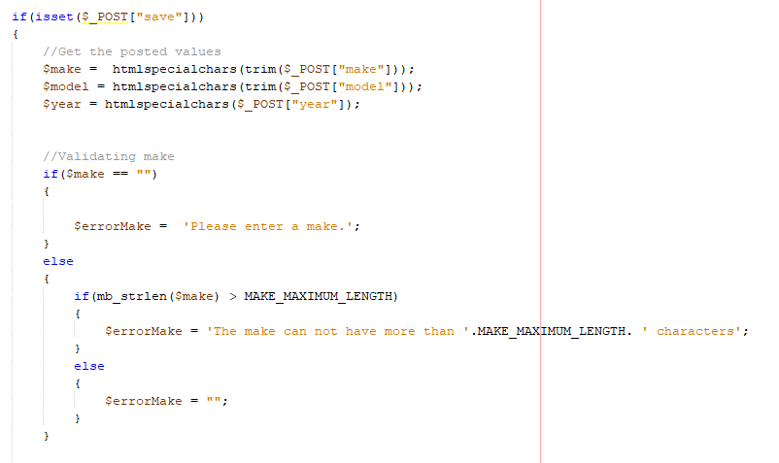

* Notes
  + The save is the name given to the button