Zero-Shot Inference with Tabular Prior-data Fitted Network (TabPFN)
for Soil MIR Spectral Analysis

Yin-Chung Huang*, José Padarian, Wartini Ng, Budiman Minasny, and Alex B. McBratney
School of Life and Environmental Science & Sydney Institute of Agriculture, The University of Sydney, NSW, Australia
*Corresponding author. E-mail: lloyd.yc.huang@sydney.edu.au

Supplementary information:

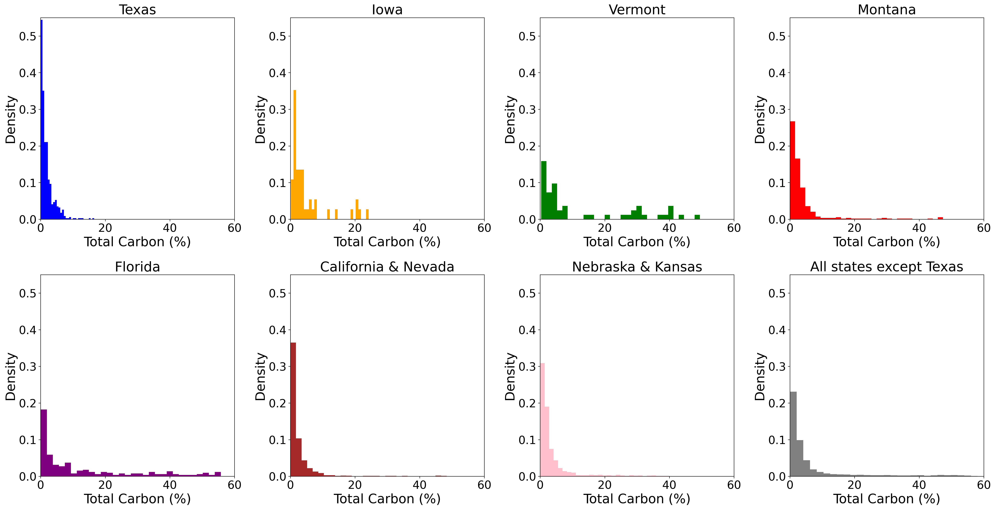
Fig. S1. Distribution of total carbon content in various datasets. Texas (N=620) served as the internal test set. Small datasets: Iowa (N=46) and Vermont (N=50); medium datasets: Montana (N=337) and Florida (N=275); large datasets: California + Nevada (N=1119) and Nebraska + Kansas (N=1253).

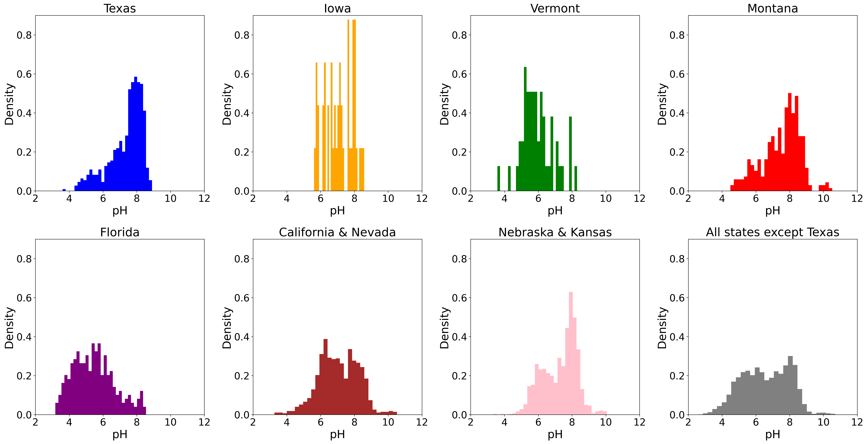
Fig. S2. Distribution of pH in various datasets. Texas (N=620) served as the internal test set. Small datasets: Iowa (N=46) and Vermont (N=50); medium datasets: Montana (N=337) and Florida (N=275); large datasets: California + Nevada (N=1119) and Nebraska + Kansas (N=1253).

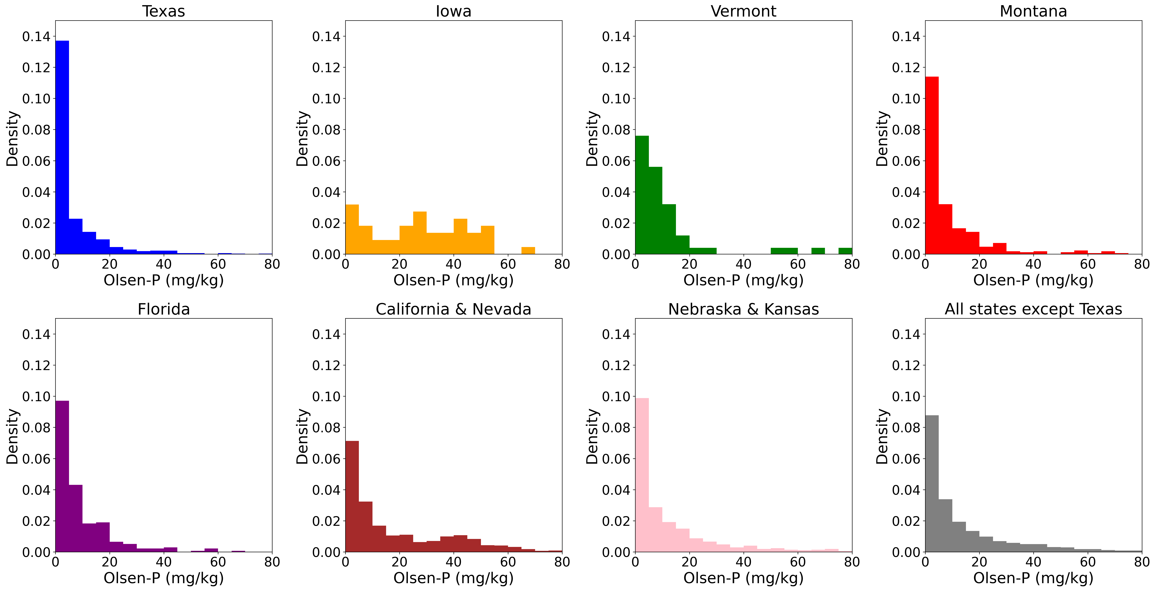
Fig. S3. Distribution of Olsen-P in various datasets. Texas (N=620) served as the internal test set. Small datasets: Iowa (N=46) and Vermont (N=50); medium datasets: Montana (N=337) and Florida (N=275); large datasets: California + Nevada (N=1119) and Nebraska + Kansas (N=1253).

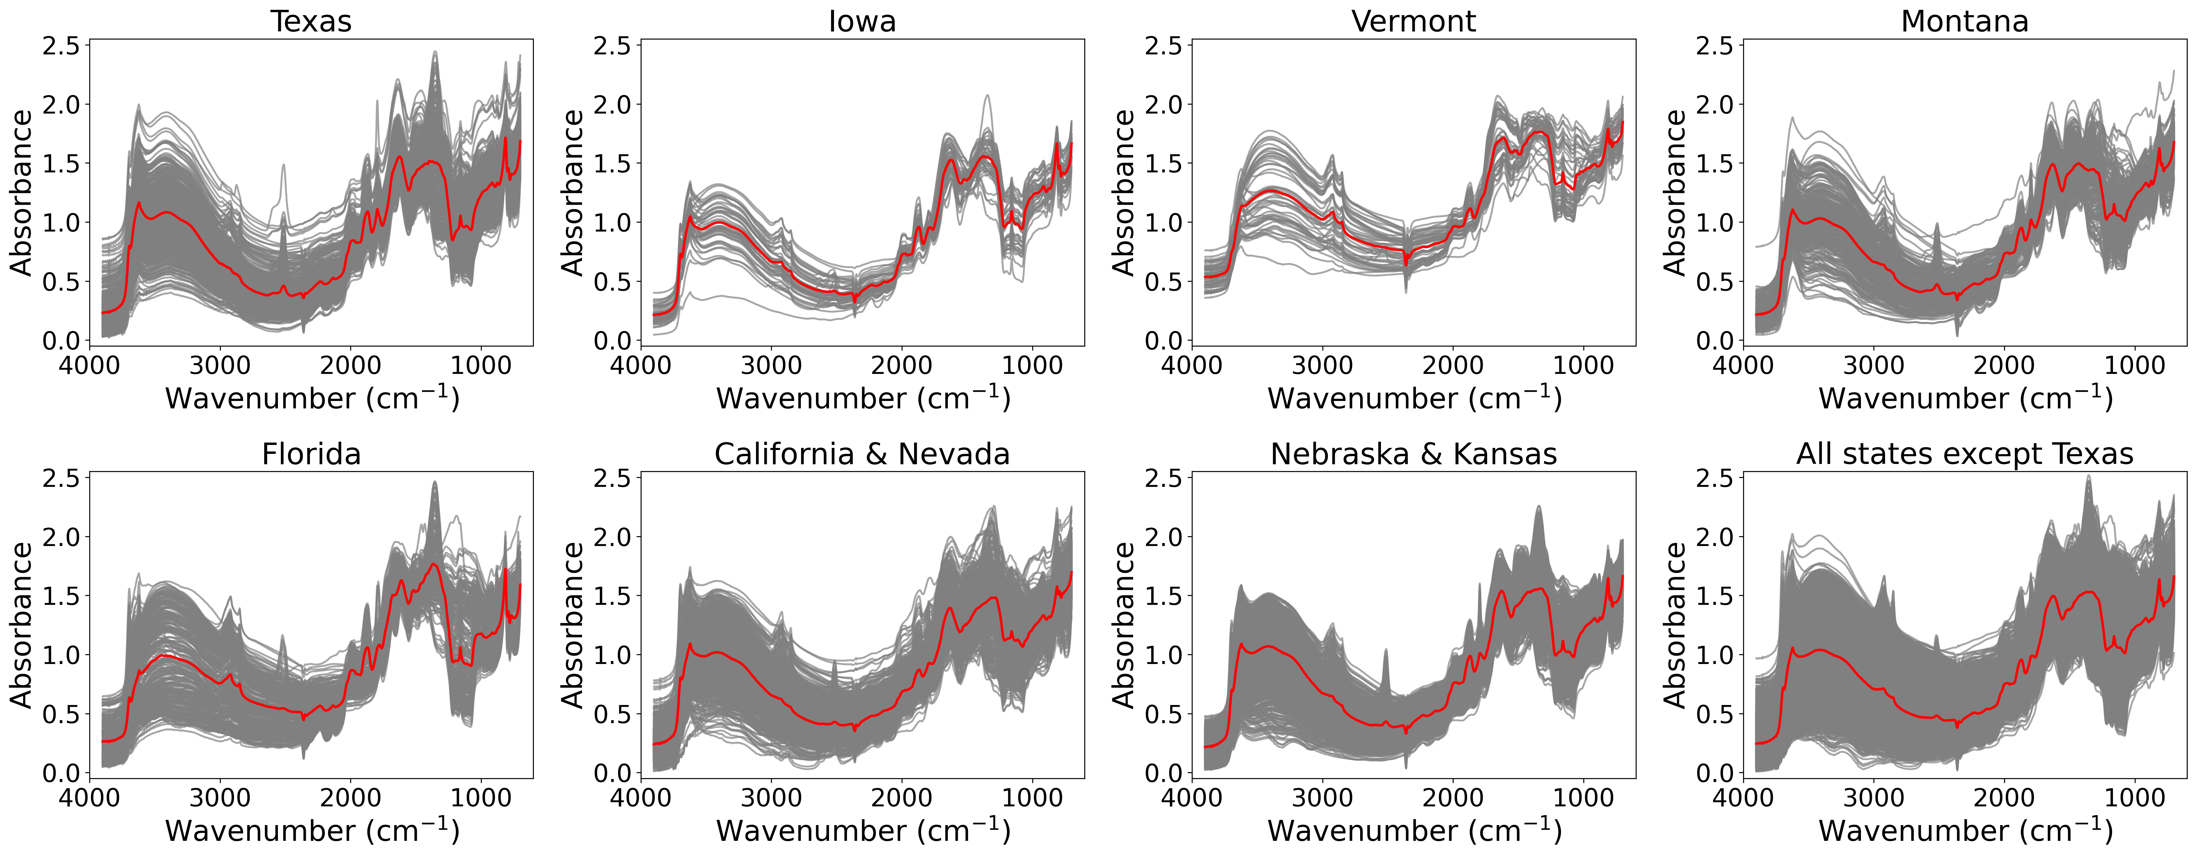
Fig. S4. Spectra of different datasets. Red line is the mean spectrum. Texas (N=620) served as the internal test set. Small datasets: Iowa (N=46) and Vermont (N=50); medium datasets: Montana (N=337) and Florida (N=275); large datasets: California + Nevada (N=1119) and Nebraska + Kansas (N=1253).

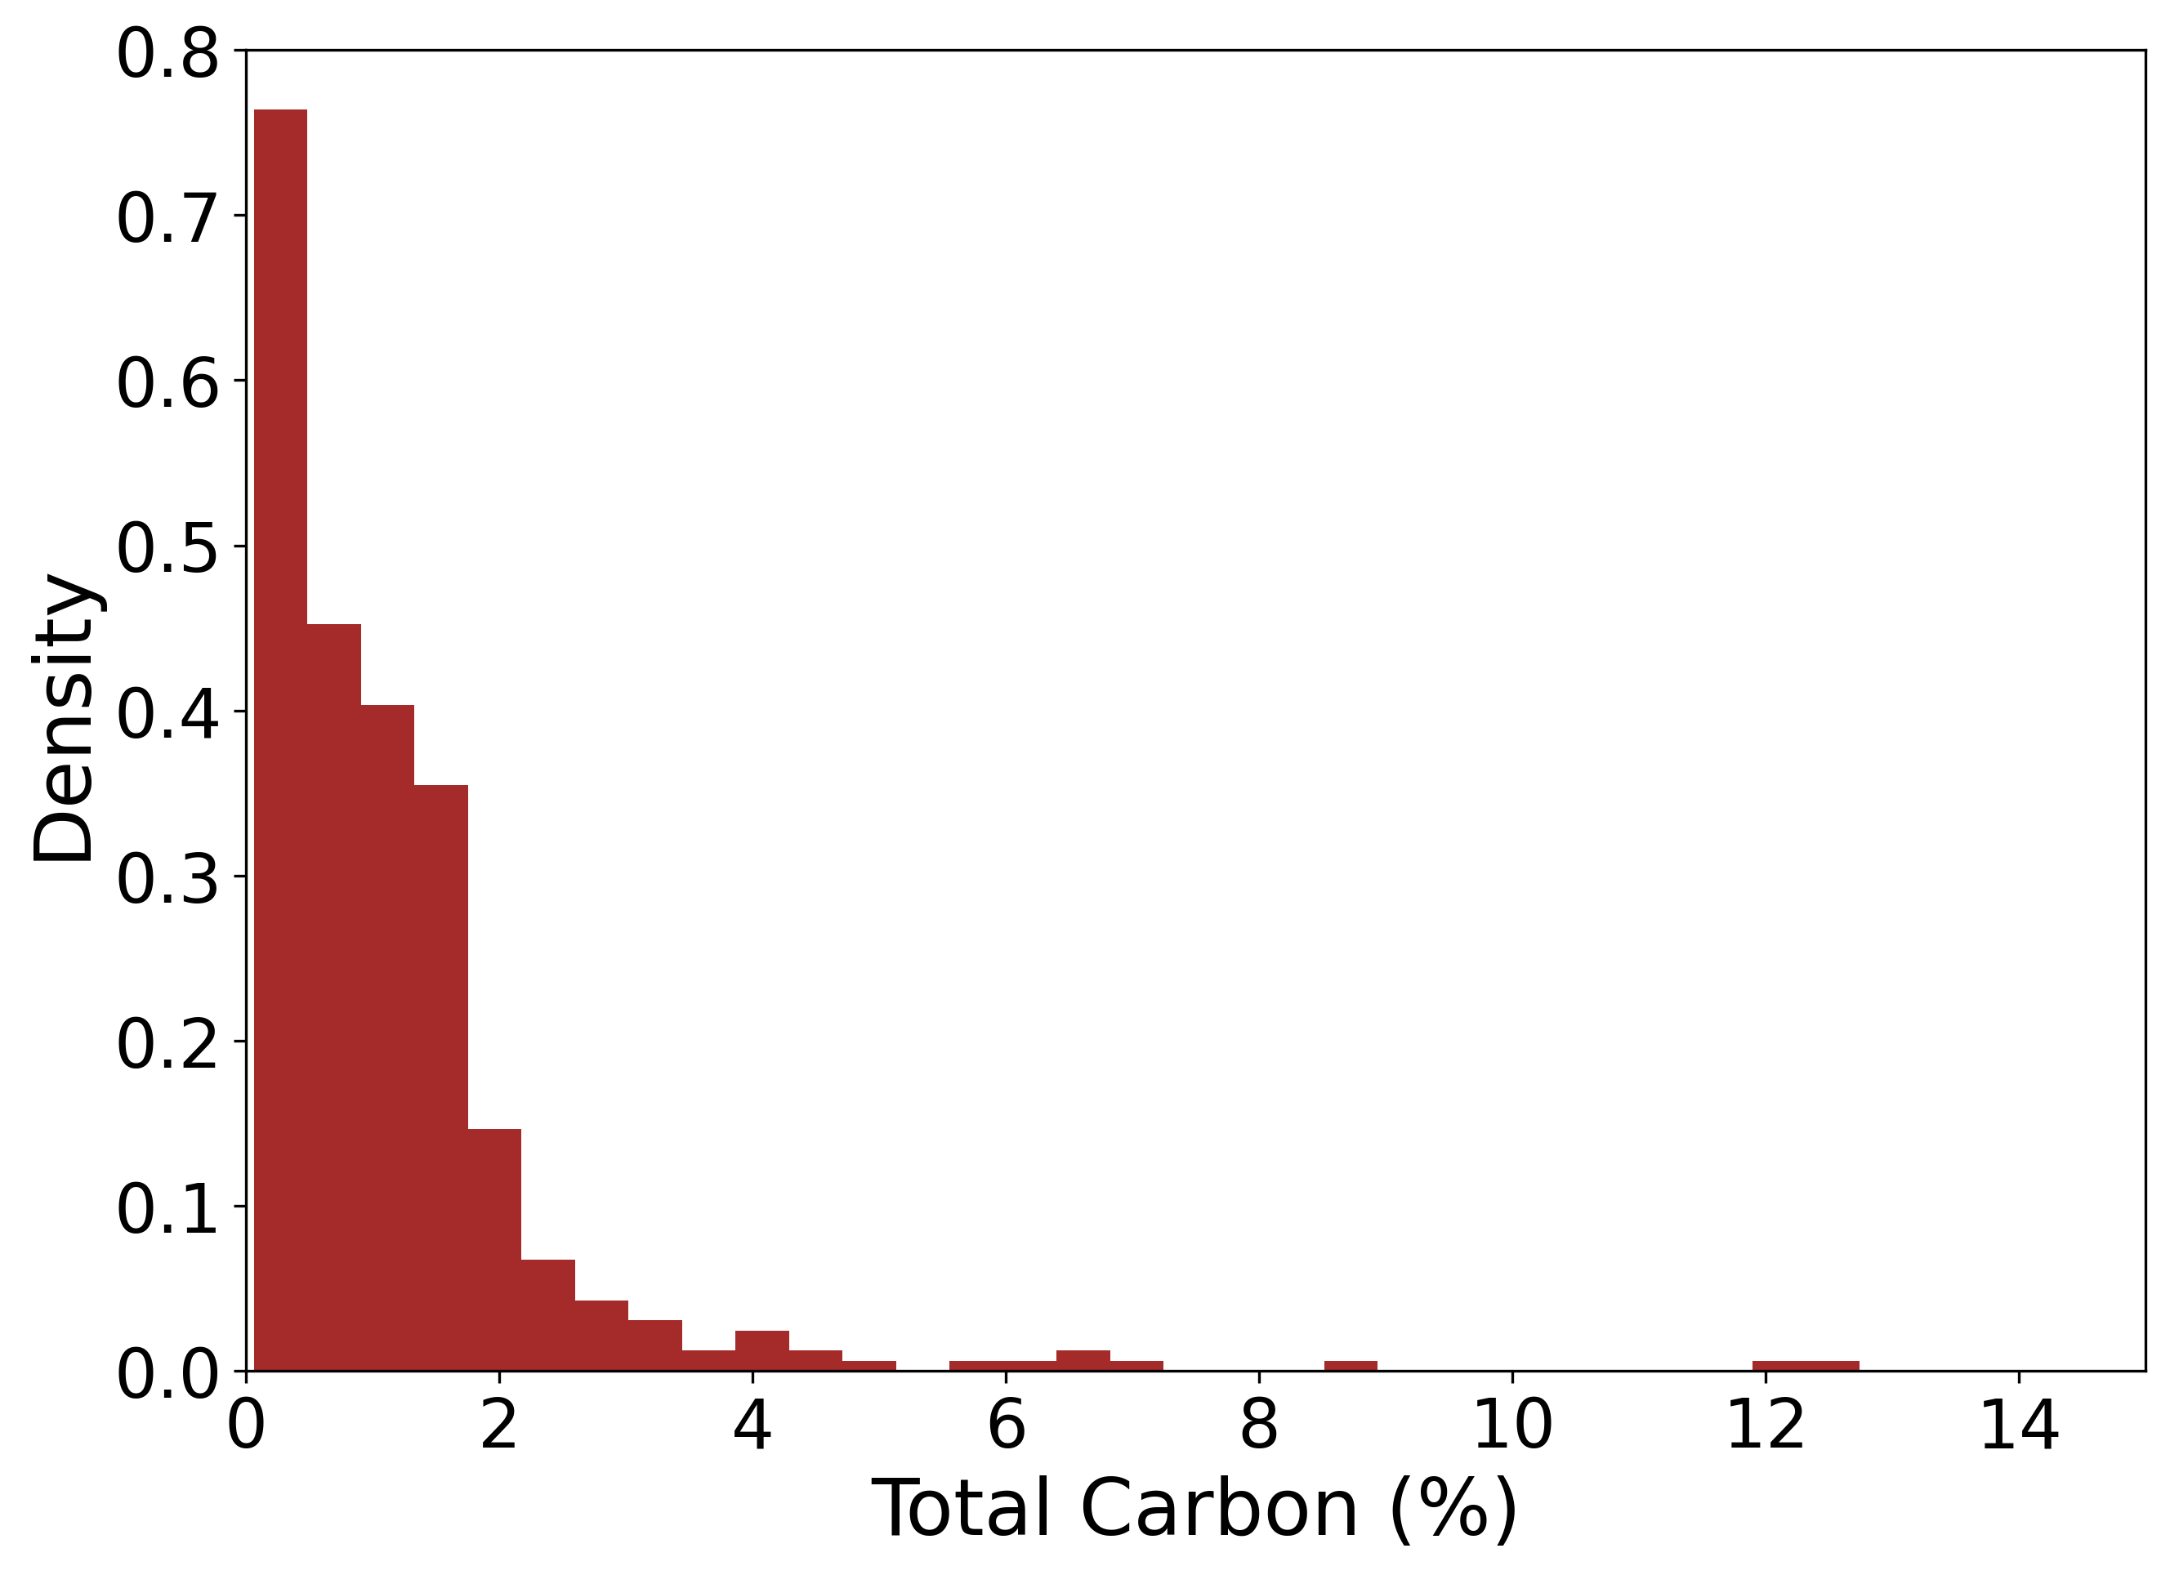
Fig. S5. Distribution of total carbon content in the Australian dataset.

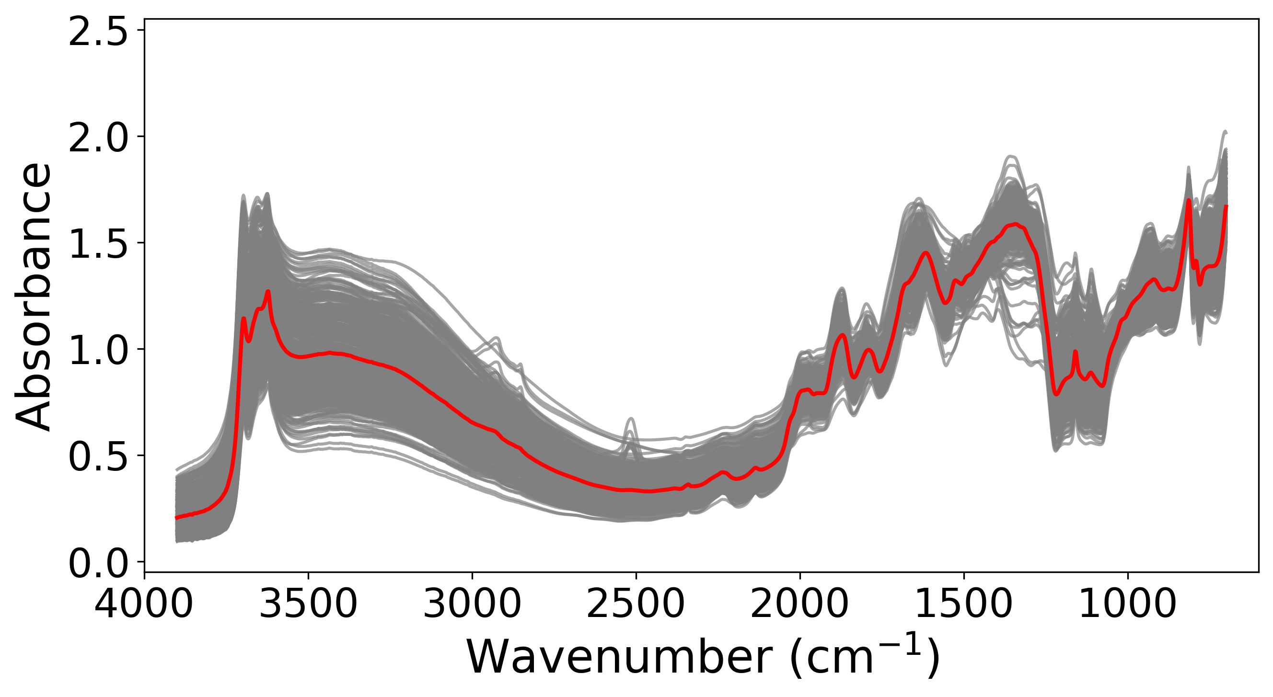
Fig. S6. Spectra of the Australian dataset. Red line is the mean spectrum.

Box S1. Specific code explanation for TabPFN
- Initialise the model
tabpfn_model = TabPFNRegressor()
When the TabPFNRegressor() class is created, it sets up default hyperparameters, including but not limited to:
- n_estimators: Number of ensemble members (default=8). For datasets with more than 500 features, each estimator processes a randomly sampled subset of 500 features. Predictions are obtained by aggregating the outputs of multiple estimators, effectively forming an ensemble over feature subspaces. Increasing n_estimators improves feature coverage, robustness, and uncertainty calibration for high-dimensional datasets.
- average_before_softmax (used only if n_estimators>1): Determines how predictions from multiple ensemble members are aggregated. If True, the ensemble outputs are averaged before applying softmax. If False (default), softmax is applied per estimator, then results are averaged.
- softmax_temperature (default=0.9).
- categorical_features_indices: Specify which input variables are treated as categorical rather than continuous. This is not irrelevant to the current study.
- ignore_pretraining_limits: TabPFN was pre-trained on synthetic datasets with at most 50,000 samples and 2,000 features. Data outside this range may lead to reduced predictive performance. In the present study, both the sample size and feature dimensionality were within these pre-training limits.
- random_state: Controls all stochastic components of the ensemble, including feature subsampling, feature-pair generation, and sample permutations. By default, a fixed seed of 0 is provided.
It also configures inference behaviour (precision, device, and memory strategy). At this point, no pretrained weights are loaded and no data are processed. It only sets up the configuration for further analysis.

- Fit the model on training data
tabpfn_model.fit(train_X_data, train_Y_data)
When .fit() is called, unlike conventional machine learning models, no model parameters are trained. Instead, it prepares the pre-trained foundation model for dataset-conditioned inference.
- Check tuning state: The model first checks whether TabPFN is in tuning mode or inference-only mode.
- The weights of the pre-trained TabPFN transformer are loaded into memory; no training is performed.
- The input data are validated and encoded.
- An ensemble of preprocessing configurations (according to n_estimators) is created. Each estimator randomly samples up to 500 features. Additionally, there is an option to subsample rows (without replacement) and create polynomial features by multiplying randomly selected feature pairs to capture nonlinear interactions. However, this option is disabled by default.
- Check constant target: The model checks whether all target values are identical, in which case inference can be skipped.
- Normalisation is applied to the target. A z-score transformation is used by subtracting the mean and dividing by the standard deviation. This makes the target scale-free.
- A discretised bin (bar) distribution is constructed in normalised target space. This binning is then mapped back to the original target scale, enabling TabPFN to produce full predictive distributions and uncertainty estimates in physical units.
- Create the inference engine. This creates an object that represents the ensemble of regressors (according to n_estimators). The subsequent .predict() call queries this object.

- Predict on test data
Y_pred_tabpfn = tabpfn_model.predict(test_X_data)
Y_pred_tabpfn = tabpfn_model.predict(test_X_data, output_type=“quantiles”)
When .predict() is called,
- Checks that .fit() has been called; otherwise, an error is raised.
- Preprocesses input data according to the ensemble configuration.
- Checks if the target is constant, in which case a shortcut prediction is returned.
- Runs the input through the pre-trained TabPFN model: each estimator performs one forward pass on its own feature subset.
- Converts the logits output by the network into probabilities over the discretised target bins.
- Transforms outputs back to the original target scale.
- Aggregates ensemble predictions according to the average_before_softmax setting.
- Returns outputs in the requested format (mean, median, mode, or quantiles). For uncertainty estimates, quantile output was used.

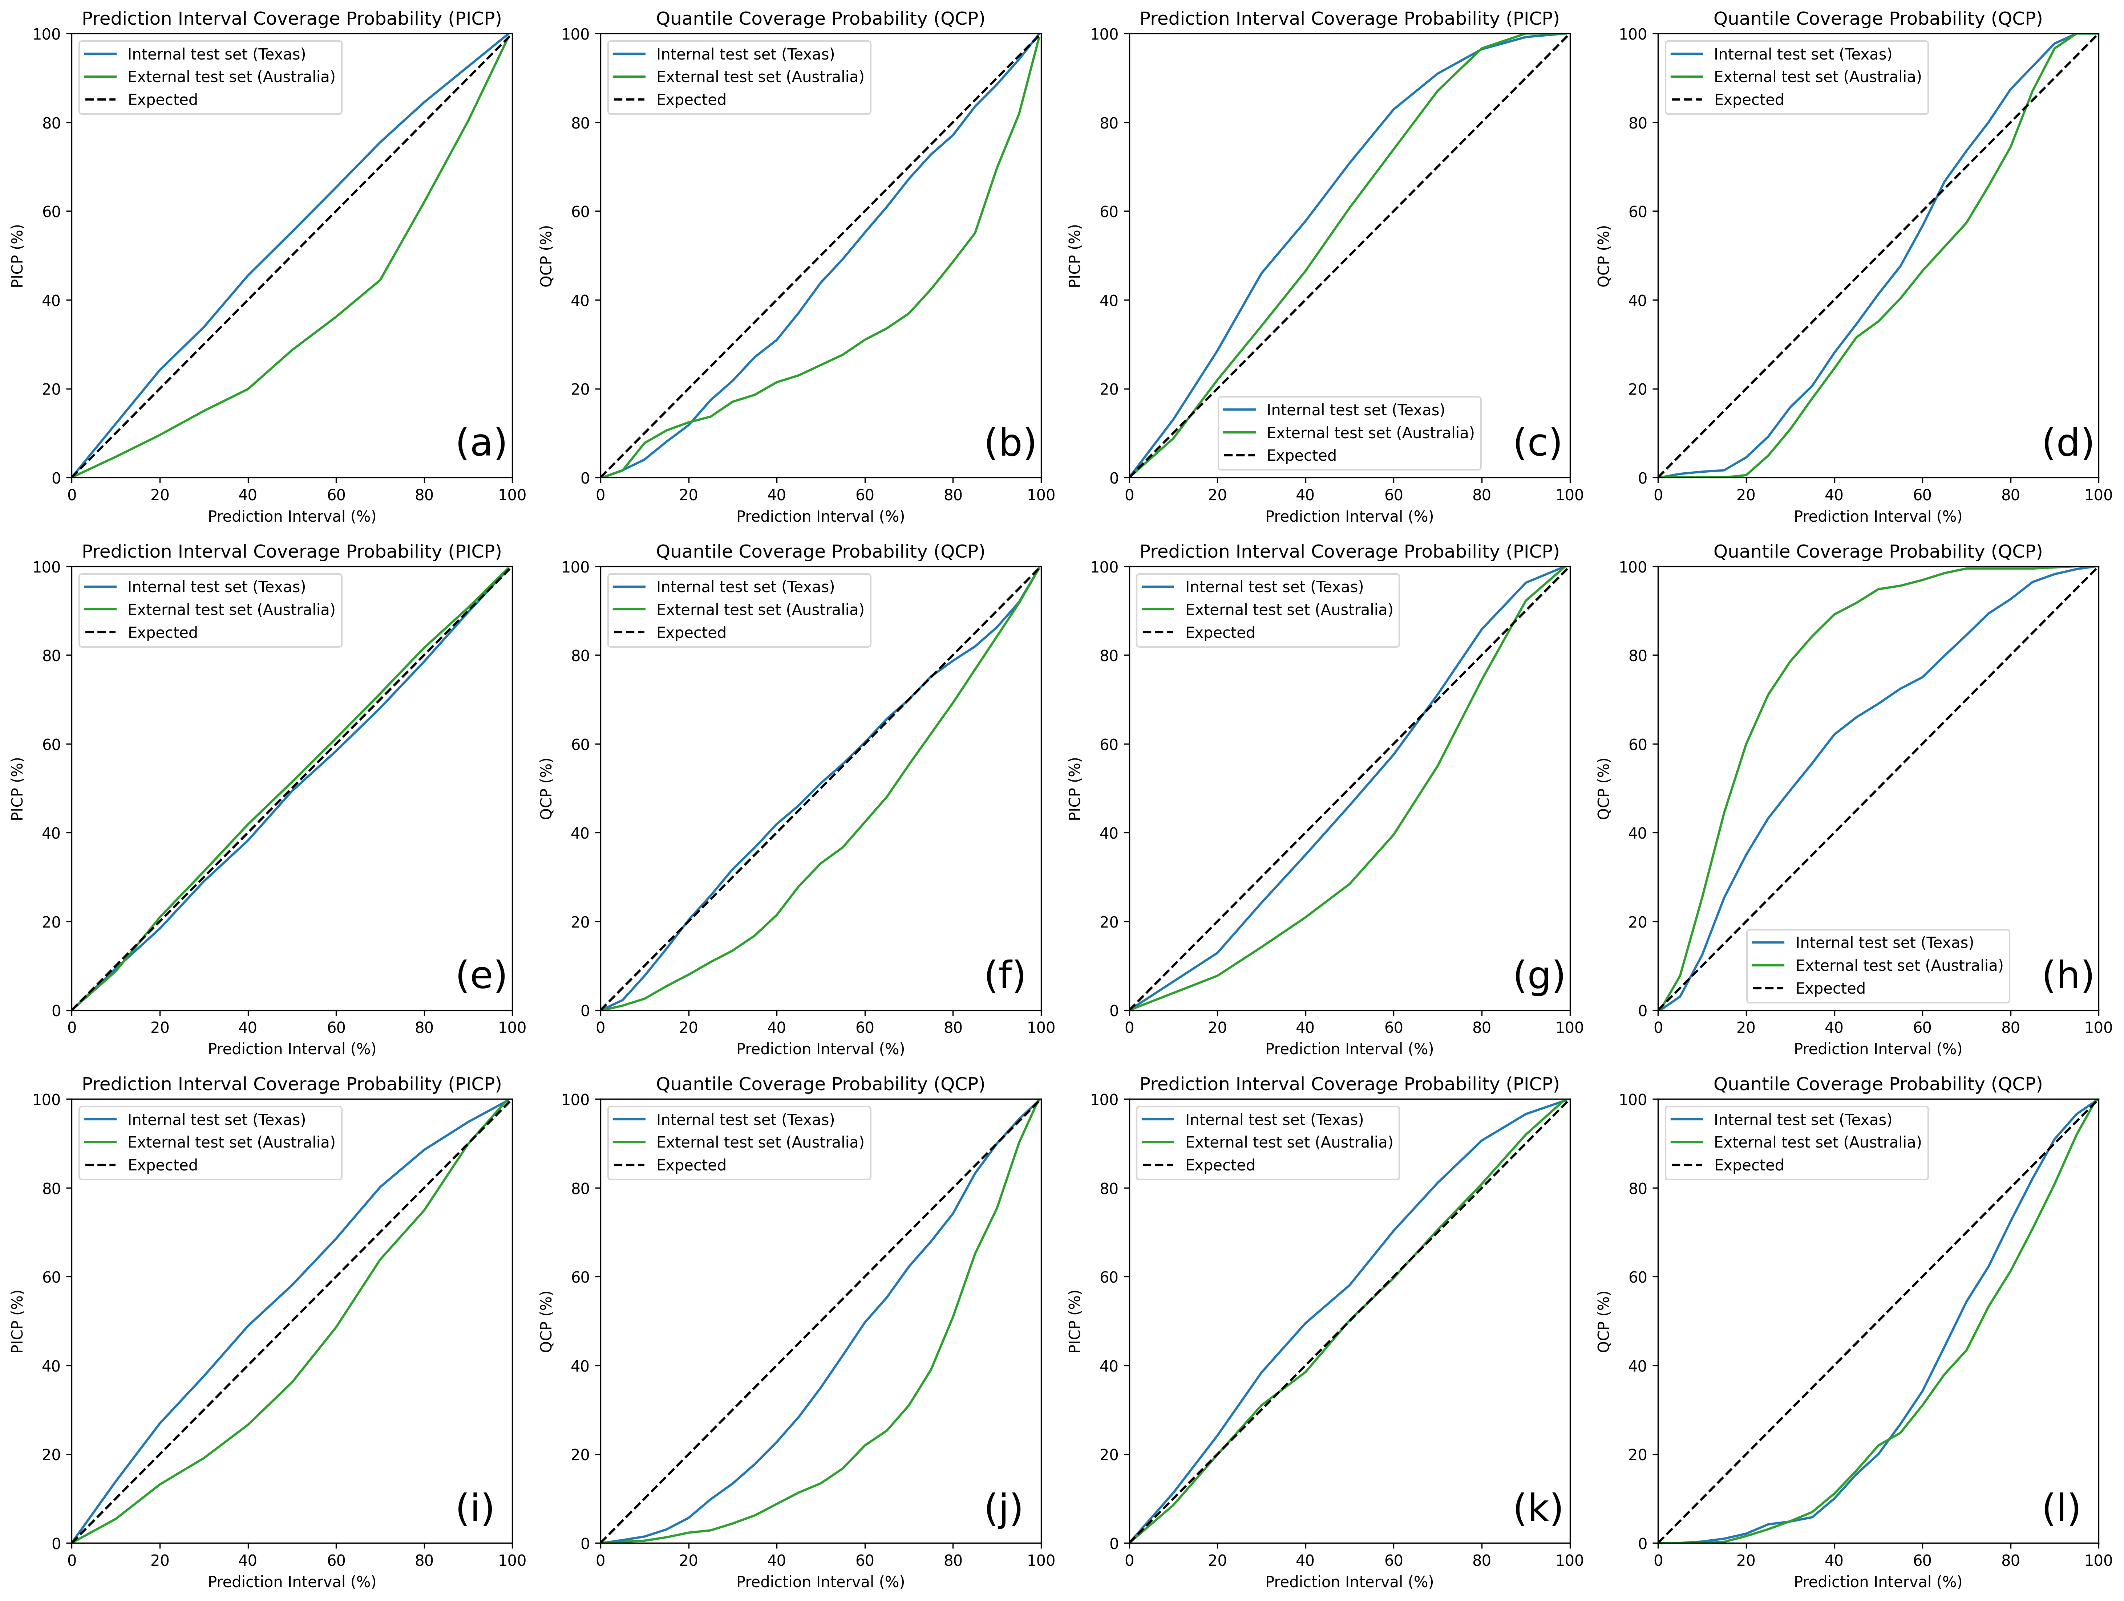
Fig. S7. Prediction interval coverage probability (PICP) and quantile coverage probability (QCP) of the TabPFN model trained on (a-b) Iowa (small dataset, N=46) with similar spectral features to Texas; (c-d) Vermont (small dataset, N=50) with different spectral features from Texas; (e-f) Montana (medium dataset, N=337) with similar spectral features to Texas; (g-h) Florida (medium dataset, N=275) with different spectral features from Texas; (i-j) California and Nevada (large dataset, N=1119); (k-l) Nebraska and Kansas (large dataset, N=1253) predicting total carbon content (%) of internal test set (Texas) and external test set (Australia).

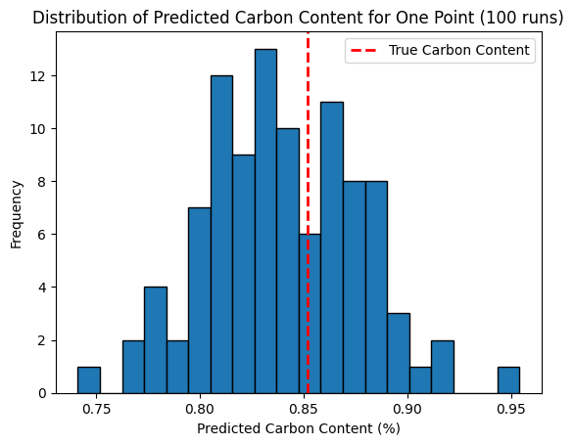
Fig. S8. Distribution of the predicted total carbon content by one-estimator TabPFN (n_estimators=1) with 100 different starting seeds. A sample from the Texas dataset was randomly selected as demonstration. TabPFN was applied to predict the total carbon content of the sample using the extra-large training samples while setting the n_estimators to 1 and repeat 100 times.

