Contents

Folder Dataset 3

Folder AI 4

Exemplary file A1.xlsx: 4

Exemplary file Funct1.xlsx 5

Folder AI_priorities 7

Exemplary file AI_priorities1_89000.xlsx 7

Folder all_patents_2009_2019 9

Exemplary file 1_83333.xlsx 10

Folder Data_additionalGUOs 11

Exemplary file Age.xlsx 11

Exemplary file DataCompanies1.xlsx 13

Folder Date 16

Exemplary file Date1.xlsx 17

Folder Deals 18

Exemplary file Deals1.xlsx 19

Folder DealsSubs 20

Exemplary file DealsSubs1.xlsx 20

Folder expired_data 21

Exemplary file Exp_1_200000.xlsx 22

Folder Final 23

Exemplary file Final1.xlsx 24

Folder GUO 26

Exemplary file GUO1.xlsx 27

Folder NewDataCitations 28

Exemplary file 1_200000.xlsx 29

Folder ownership_data 30

Exemplary file Ownership1_55556.xlsx 31

Folder Patents 32

Exemplary file Change1.xlsx 33

Exemplary file Stock1.xlsx 34

Folder priority_data 35

Exemplary file Pr1_200000.xlsx 36

Folder Share 37

Exemplary file Share1.xlsx 38

Folder Type 39

Exemplary file Banks1.xlsx 40

Exemplary file EMP1.xlsx 42

Exemplary file HFs1.xlsx 43

Exemplary file Insurance1.xlsx 44

Exemplary file MPFs1.xlsx 45

Exemplary file PAs1.xlsx 46

Exemplary file PEFs1.xlsx 47

Exemplary file RIs1.xlsx 48

Exemplary file VCs1.xlsx 49

Folder Corporate 50

Exemplary file Corporate1.xlsx 51

Folder IND 53

Exemplary file IND1.xlsx 54

# Folder Dataset

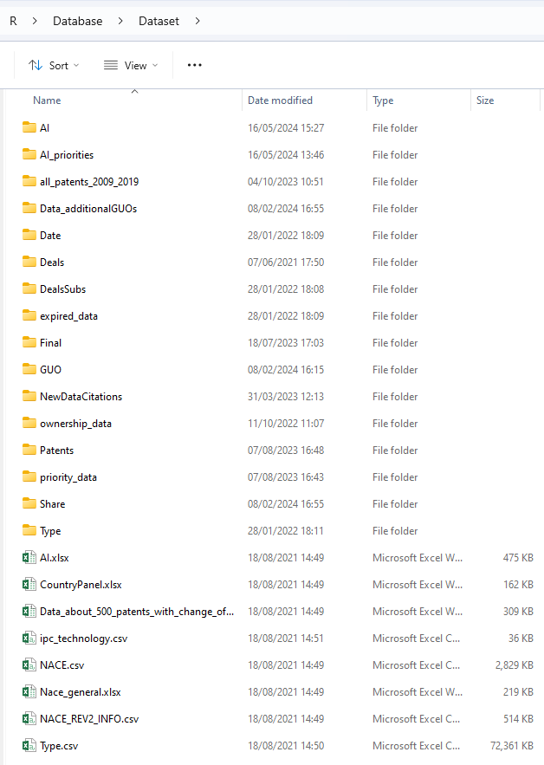

# Folder AI

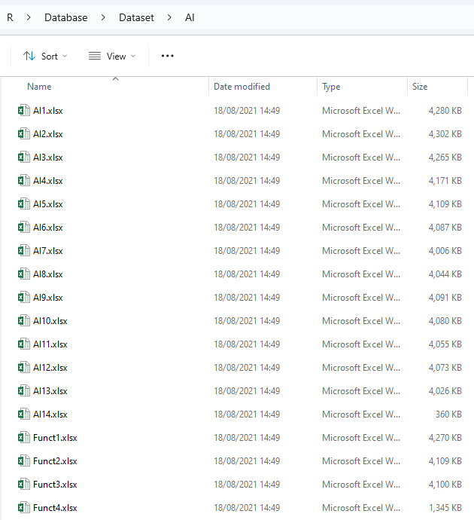

## Exemplary file A1.xlsx:

Patent text:

*ADABoost* OR *artificial intelligence* OR *Bayes network* OR *bio-inspired approach* OR *bio-inspired comput* OR *biologically inspired comput* OR *classification tree* OR *regression tree* OR *computation Intelligence* OR *decision model* OR *decision tree learn* OR *declarative programming* OR *deep learn* OR *deep structured learn* OR *hierarchical learn* OR *deep_learn* OR *deep-learn* OR *description logistic* OR *expert system* OR *fuzzy logic* OR *fuzzyfication* OR *game tree search* OR *genetic algorithm* OR *gradient tree boosting* OR *graphical model* OR *hidden markov model* OR *inductive logic* OR *instance-based learn* OR *latent dirichlet allocation* OR *latent represent* OR *latent semantic analysis* OR *learning algorithm* OR *learning model* OR *logic programming* OR *logical learn* OR *relational learn* OR *logistic regression* OR *machine intelligen* OR *machine learn* OR *machine_learn* OR *machine-learn* OR *memory-based learn* OR *micro-operators sear* OR *multilayer perception* OR *neural network* OR *ontology engineer* OR *pervised learn* OR *probabilistic reason* OR *probability logic* and *probabilistic logic* OR *random forest* OR *rankboost* OR *reinforced learn* OR *reinforcement learn* OR *reinforcement learn* OR *rule induction* OR *rule learn* OR *search partial observ* OR *semi-supervised connect* OR *semi-supervised learn* OR *semi-supervised_learn* OR *semi-supervised-learn* OR *stochastic gradient descent* OR *structured probabilistic model* OR *supervised learn* OR *supervised_learn* OR *supervised-learn* OR *support vector machin* OR *support vector network* OR *swarm intelligen* OR *task learn* OR *transfer learn* OR *transfer_learn* OR *transfer-learn* OR *unsupervised learn* OR *unsupervised_learn* OR *unsupervised-learn* OR *XGBoost* OR *3D imag* OR *augmented reality* OR *character recognition* OR *computational motion* OR *computer reason* OR *computer vision* OR *data mining* OR *distributed artificial intellig* OR *hyperspectral imag* OR *image classific* OR *image detec* OR *image recognition* OR *image segment* OR *information extraction* OR *intelligent agents* OR *intelligent personal assis* OR *machine control methods* OR *machine dial* OR *machine optimizat* OR *machine optimization* OR *machine phonology* OR *machine planning* OR *machine sentiment anal* OR *machine transl* OR *mobile agents* OR *multi-agent system* OR *object match* OR *object recognition* OR *object tracking* OR *phonological anal* OR *predictive anal* OR *question answering syst* OR *recommender syst* OR *robotic vision* OR *robotic* OR *scene understand* OR *semantic anal* OR *signal detect* OR *speaker recognition* OR *speech gener* OR *speech process* OR *speech recognition* OR *speech synthesis* OR *speech-to-speech* OR *text-to-speech* OR *video analysis* OR *video segment* OR *video summariz* OR *virtual reality* OR *visual biometrics* OR *visual inspect* (in Abstract, Description, Title)

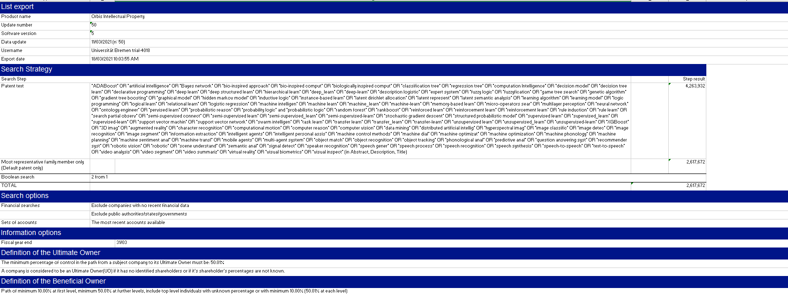

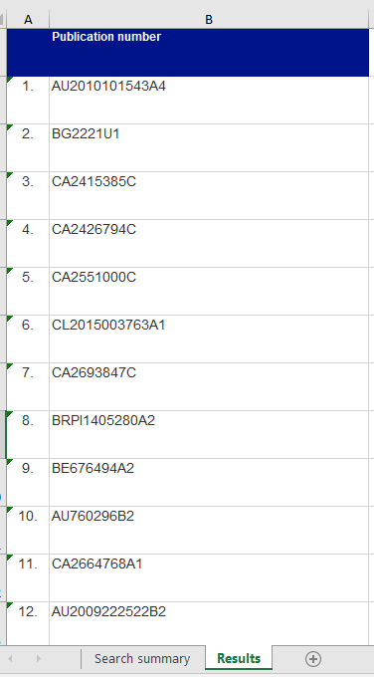

## Exemplary file Funct1.xlsx

Patent text: *3D imag*OR*augmented reality*OR*character recognition*OR*computational motion*OR*computer reason*OR*computer vision*OR*data mining*OR*distributed artificial intellig*OR*hyperspectral imag*OR*image classific*OR*image detec*OR*image recognition*OR*image segment*OR*information extraction*OR*intelligent agents*OR*intelligent personal assis*OR*machine control methods*OR*machine dial*OR*machine optimizat*OR*machine phonology*OR*machine planning*OR*machine sentiment anal*OR*machine transl*OR*mobile agents*OR*multi-agent system*OR*object match*OR*object recognition*OR*object tracking*OR*phonological anal*OR*predictive anal*OR*question answering syst*OR*recommender syst*OR*robotic vision*OR*robotic*OR*scene understand*OR*semantic anal*OR*signal detect*OR*speaker recognition*OR*speech gener*OR*speech process*OR*speech recognition*OR*speech synthesis*OR*speech-to-speech*OR*text-to-speech*OR*video analysis*OR*video segment*OR*video summariz*OR*virtual reality*OR*visual biometrics*OR*visual inspect* (in Abstract, Title)

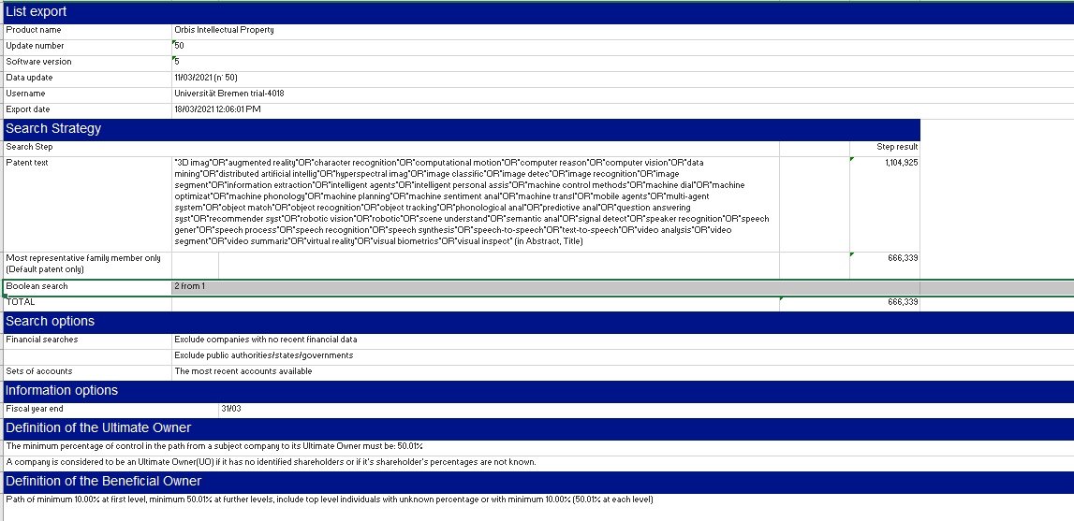

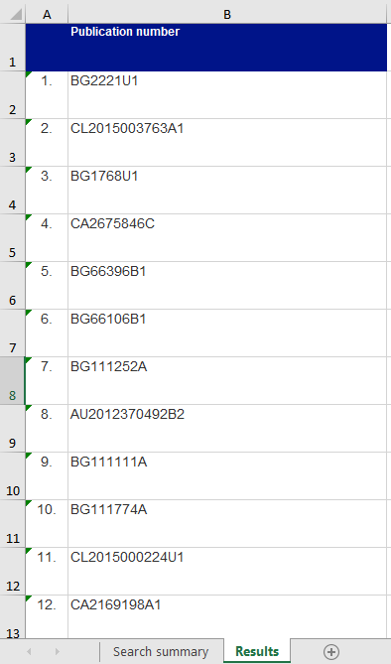

# Folder AI_priorities

## Exemplary file AI_priorities1_89000.xlsx

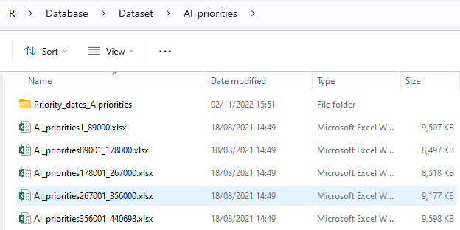

Patent text: "Artificial Intelligence" OR "machine learn" OR "Probabilistic reason" OR " Fuzzy Logic" OR "Logic Programming" OR "Ontology engineer" OR "pervised learn" OR "reinforced learn" OR "task learn" OR "neural network" OR "deep learn" OR "expert system" OR "support vector machin" OR "description logistic" OR "classification tree" OR "regression tree" OR "logical learn" OR "relational learn" OR "probabilistic graphical model" OR "rule learn" OR "instance-based learn" OR "latent represent" OR "bio-inspired approach" OR "machine intelligen" OR "probability logic" OR "probabilistic logic" OR "reinforcement learn" OR "multitask learn" OR "decision tree learn" OR "support vector network" OR "deep structured learn" OR " hierarchical learn" OR "graphical model" OR "structured probabilistic model" OR "rule induction" OR "memory-based learn" OR "bio-inspired comput" OR "biologically inspired comput" (in Abstract, Claims, Description, Title)

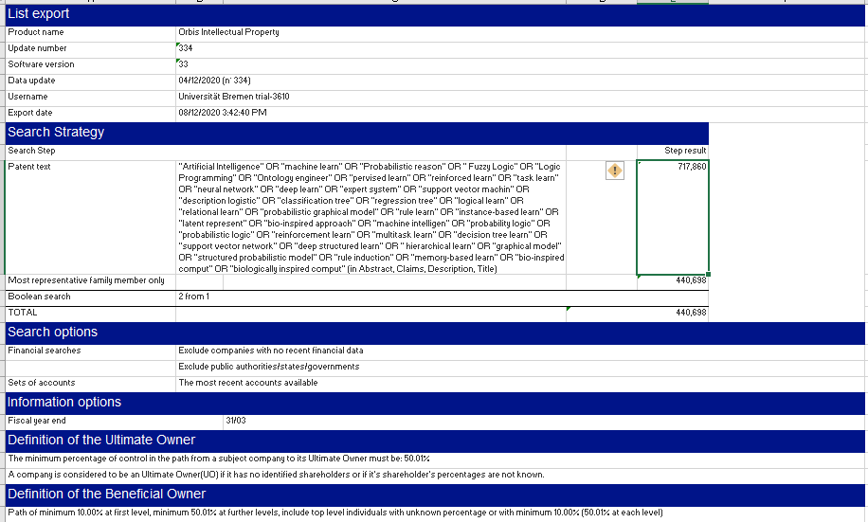

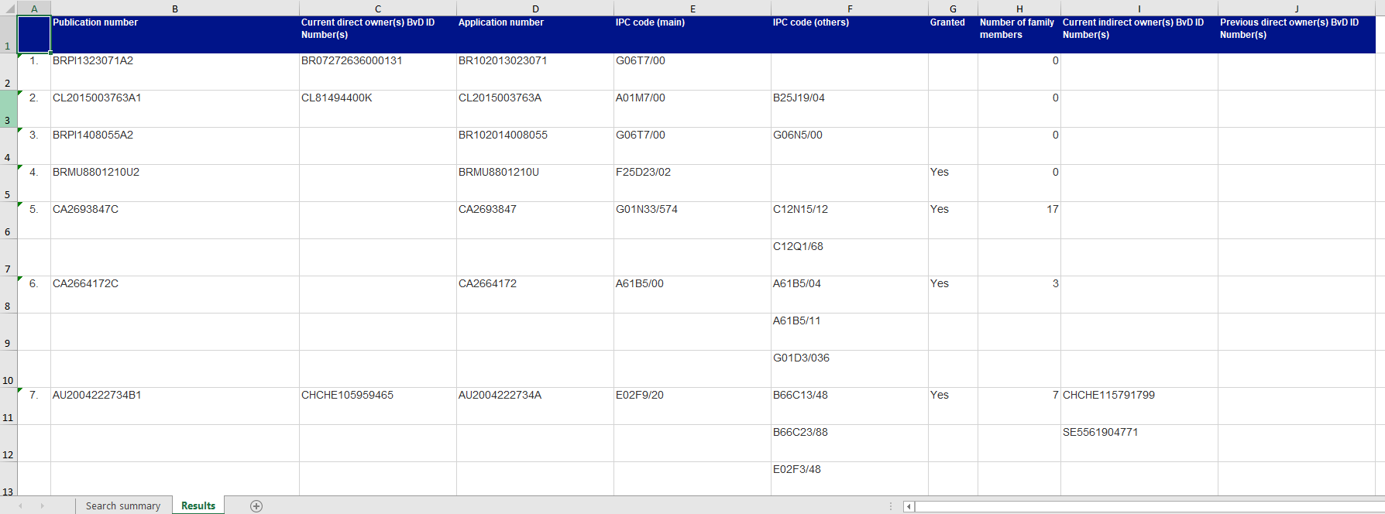

**Please note none of the files from the “Priority_dates_AIpriorities” folder is currently used to build the database, so they won’t be described here.**

Folder all_patents_2009_2019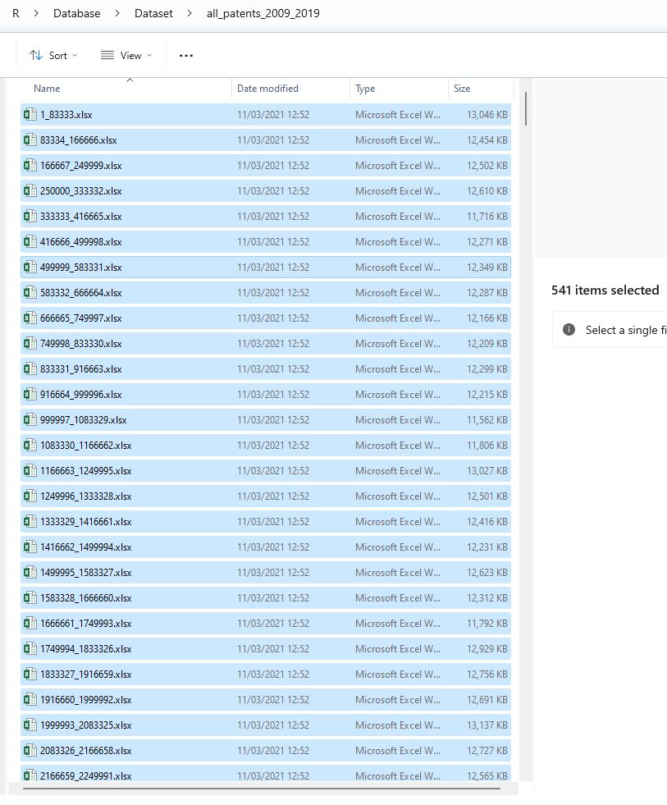

## Exemplary file 1_83333.xlsx

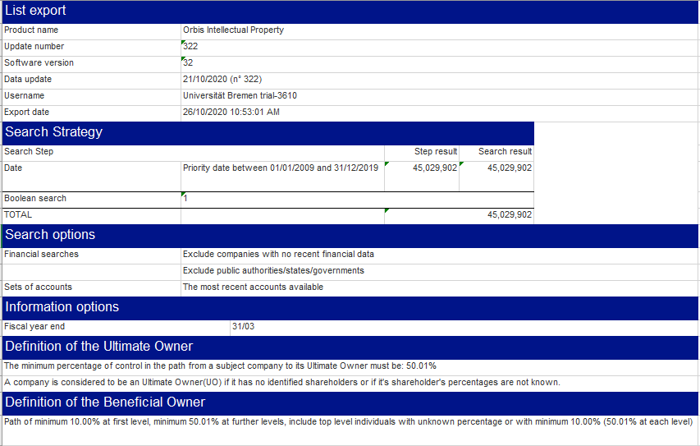

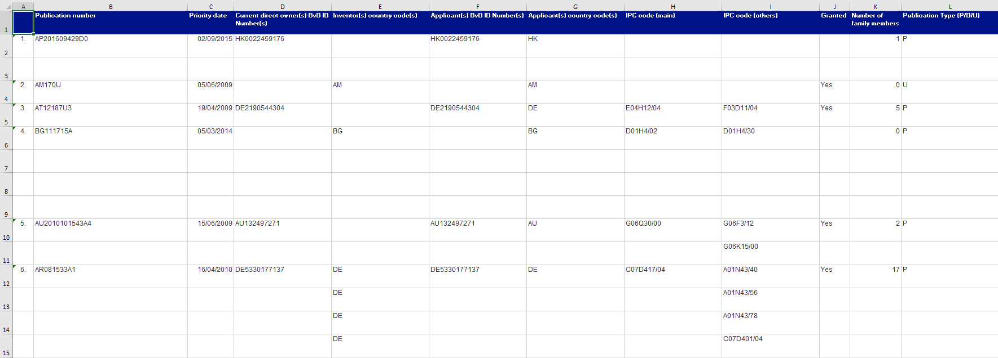

Folder Data_additionalGUOs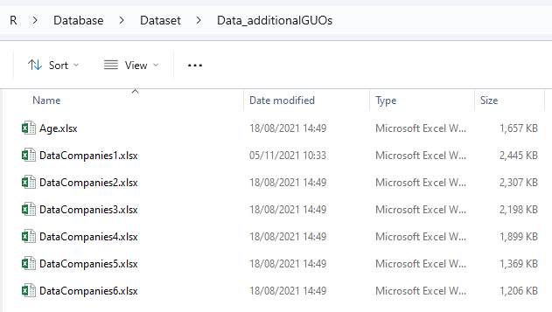

## Exemplary file Age.xlsx

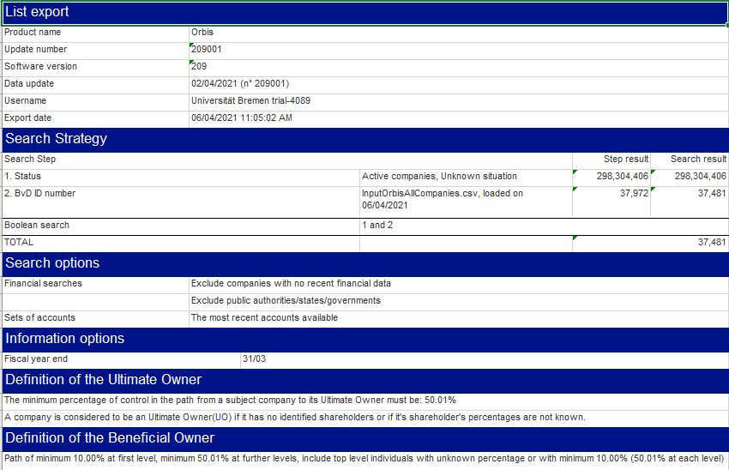

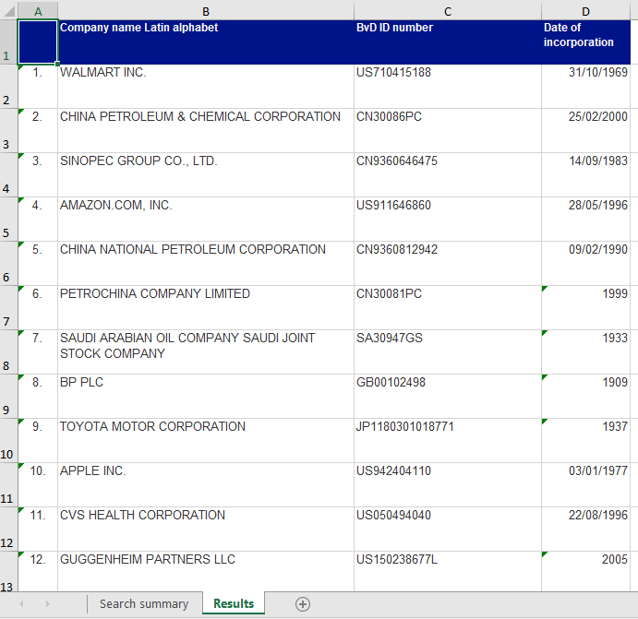

Exemplary file DataCompanies1.xlsx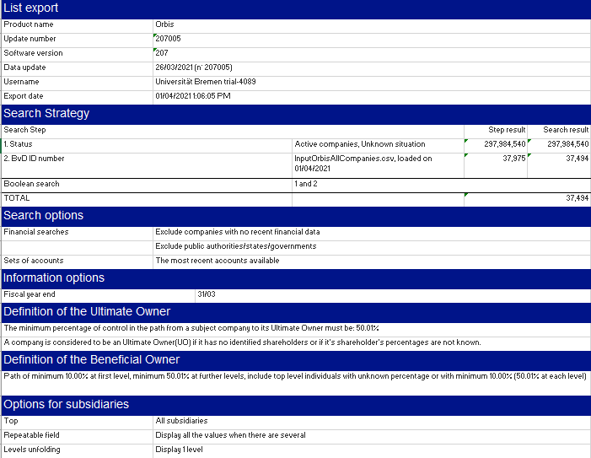

Print of file part1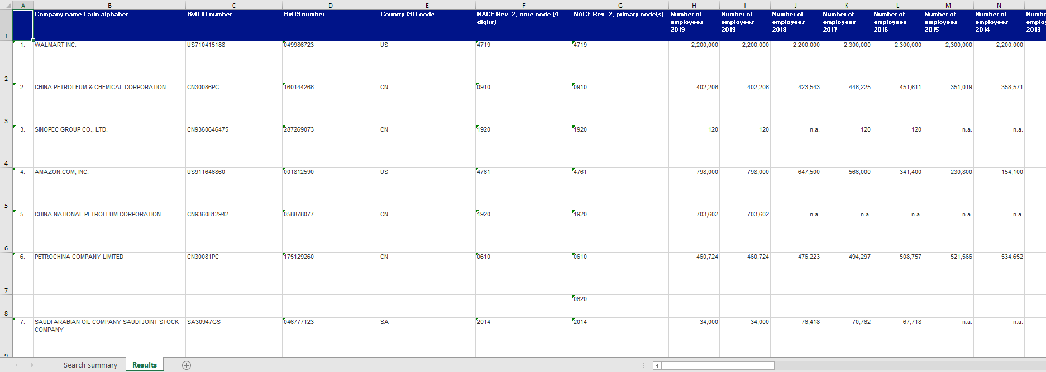

Print of file part2 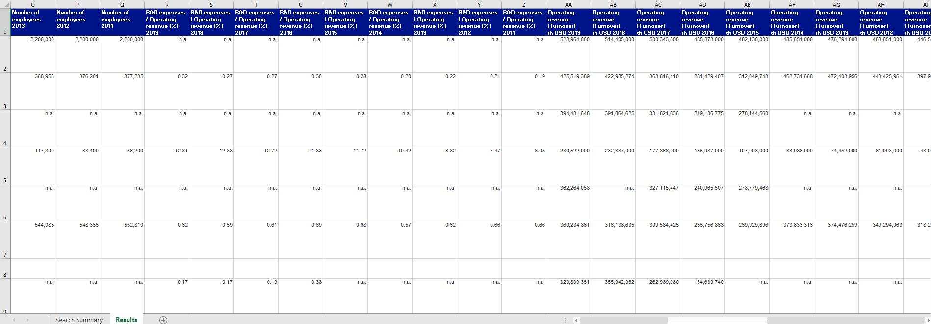

Print of file part3 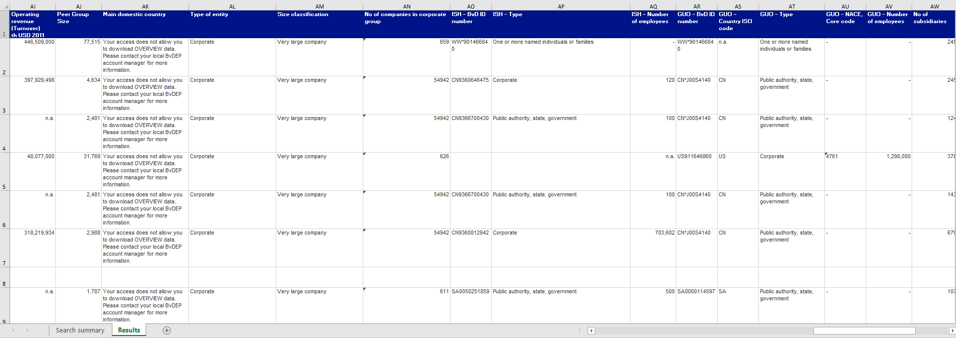

Print of file part4 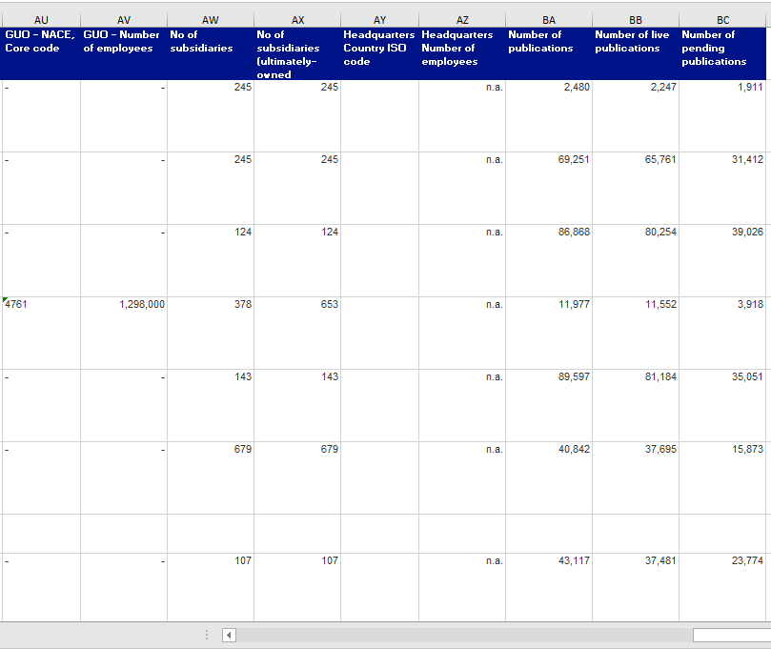

Folder Date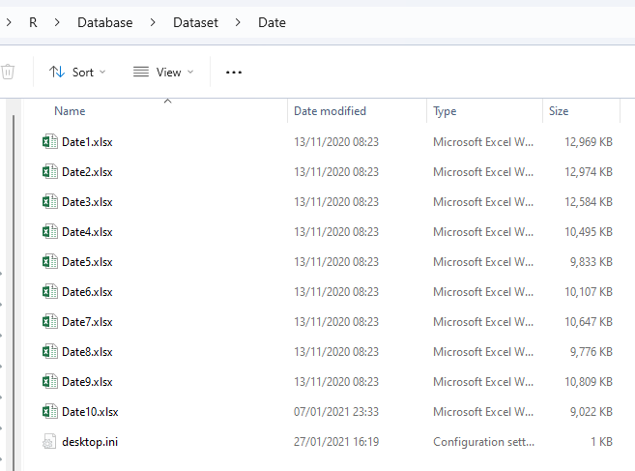

Exemplary file Date1.xlsx 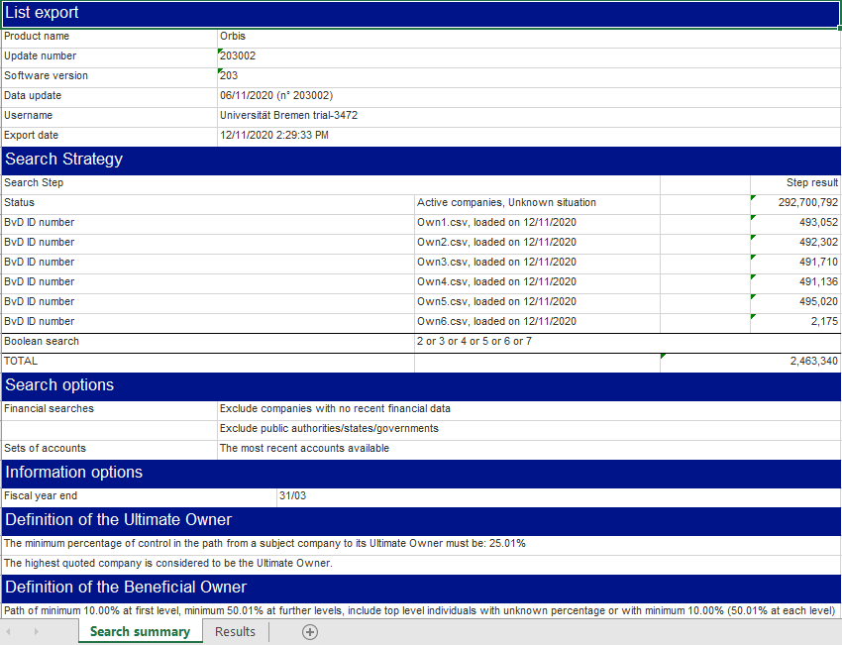 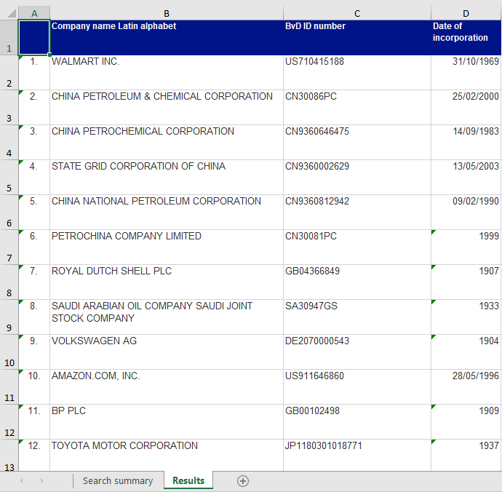

# Folder Deals

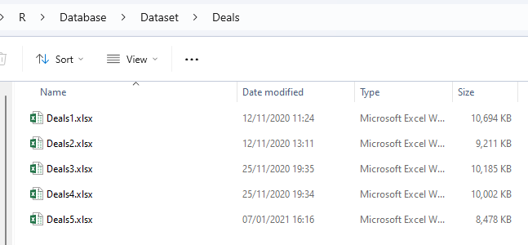

## Exemplary file Deals1.xlsx

Print of file part1 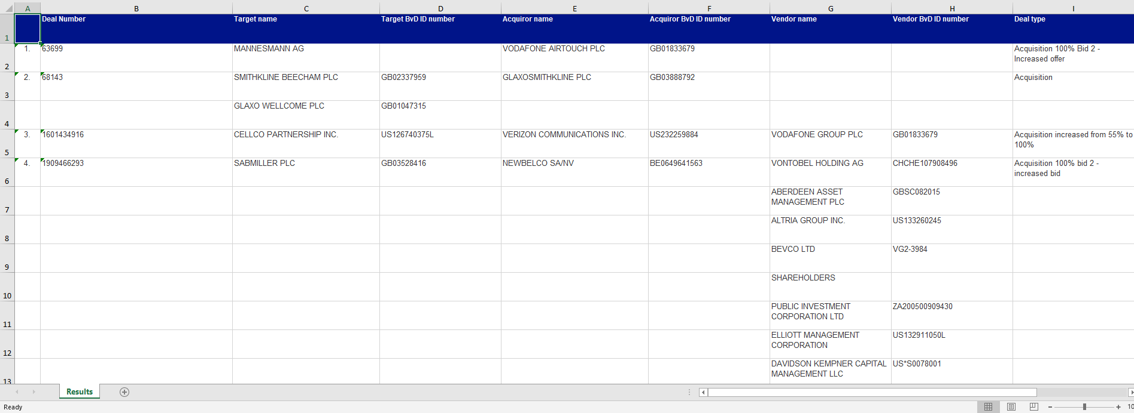

Print of file part2 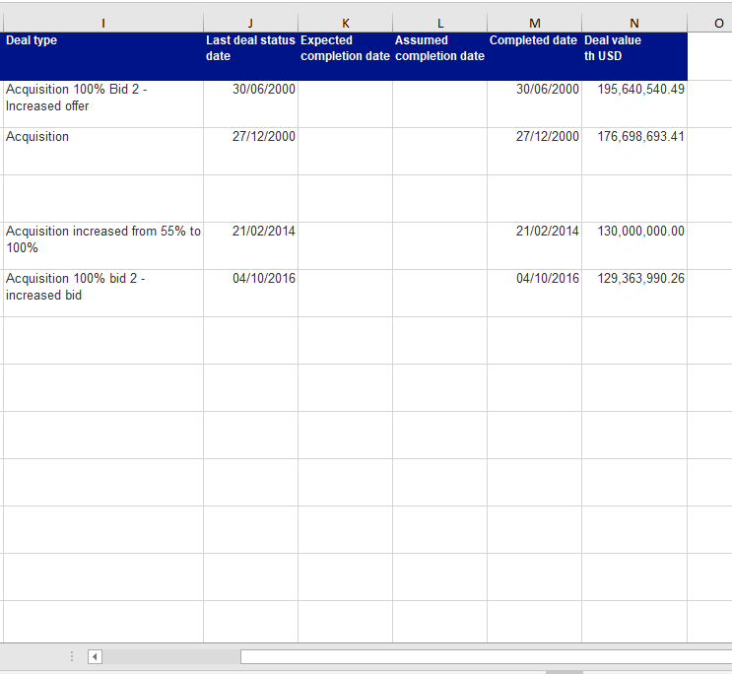

Folder DealsSubs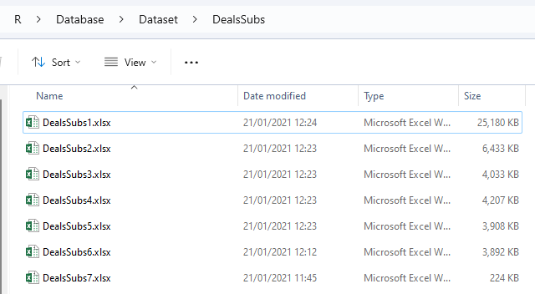

## Exemplary file DealsSubs1.xlsx

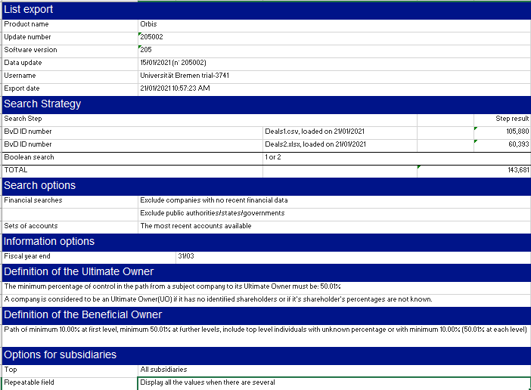

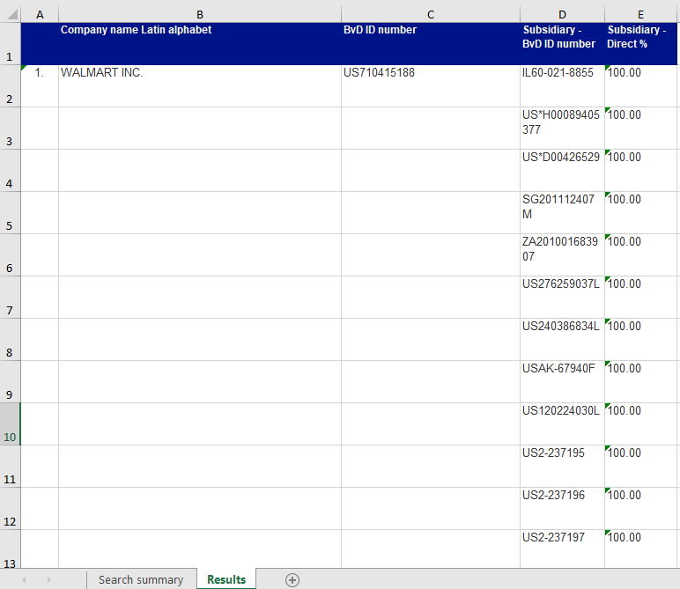

Folder expired_data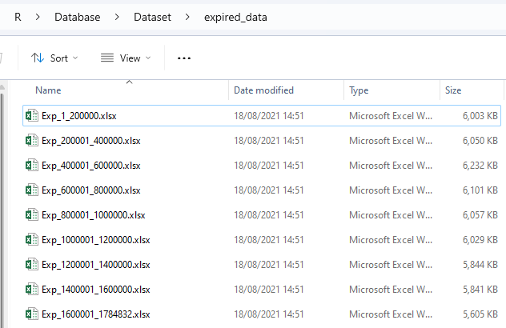

## Exemplary file Exp_1_200000.xlsx

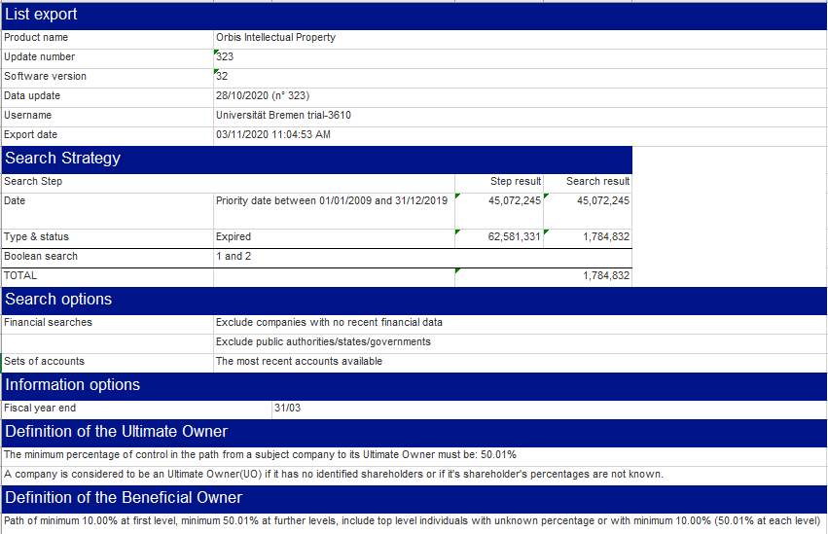 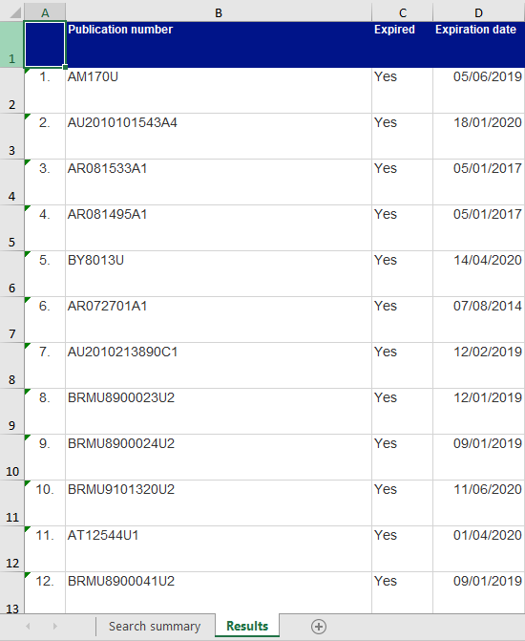

Folder Final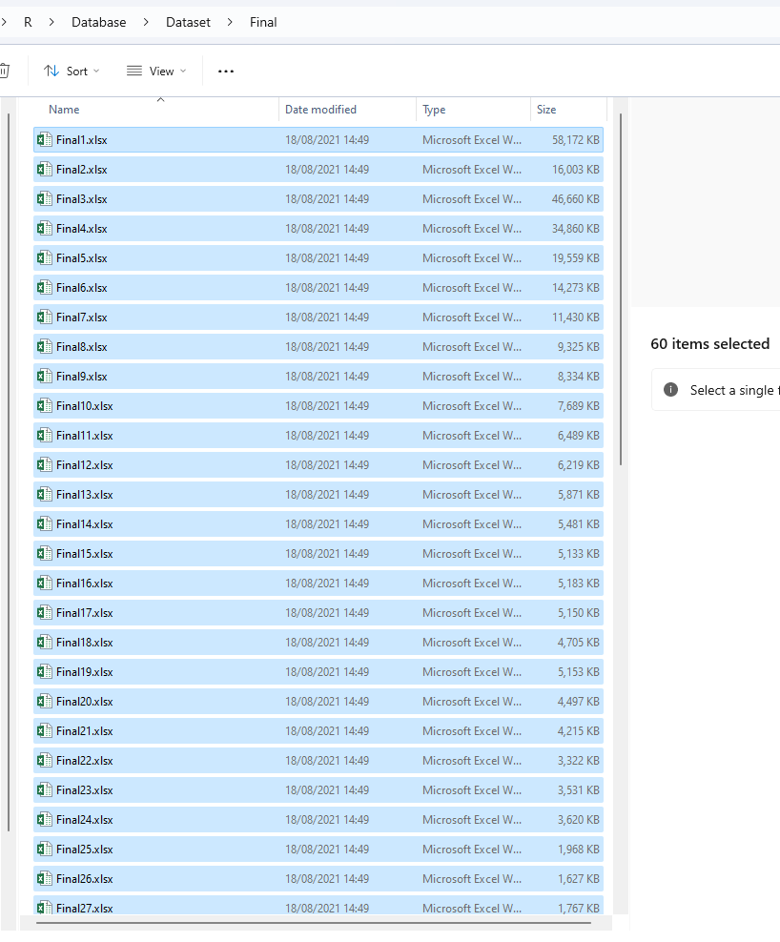

Exemplary file Final1.xlsx 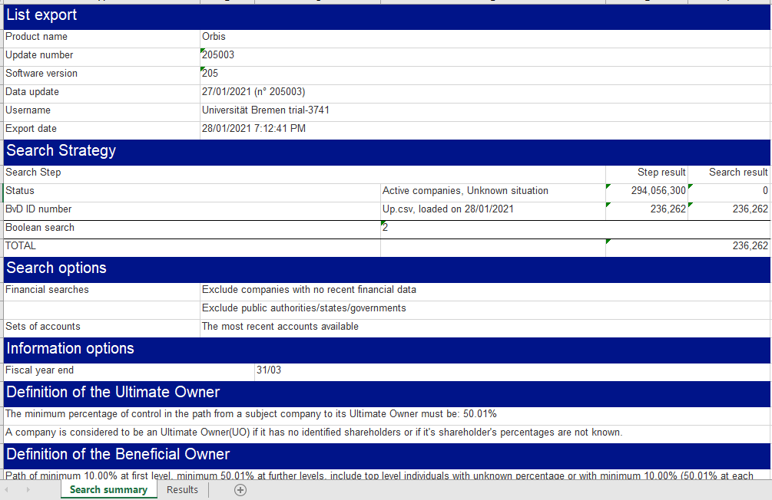

Print of file part1 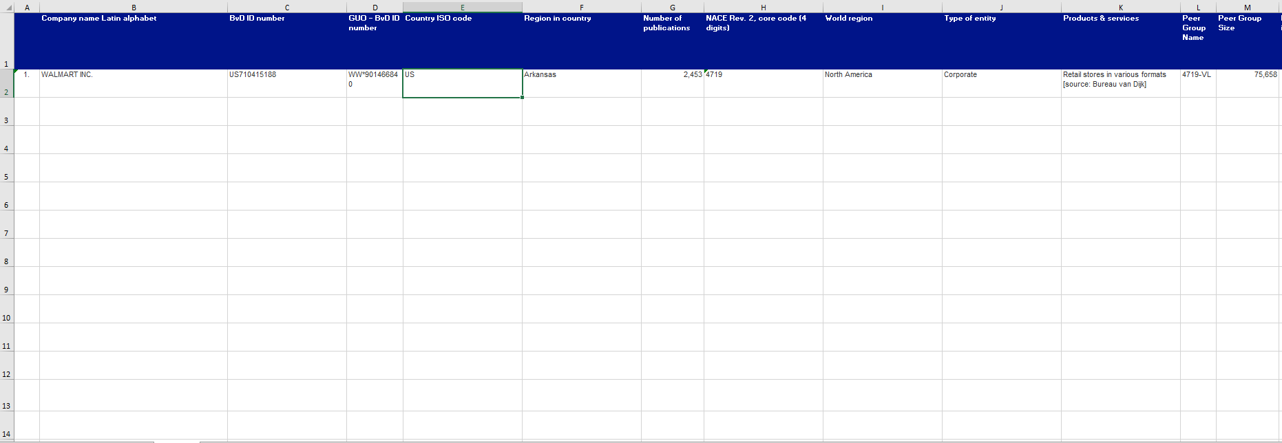

Print of file part2 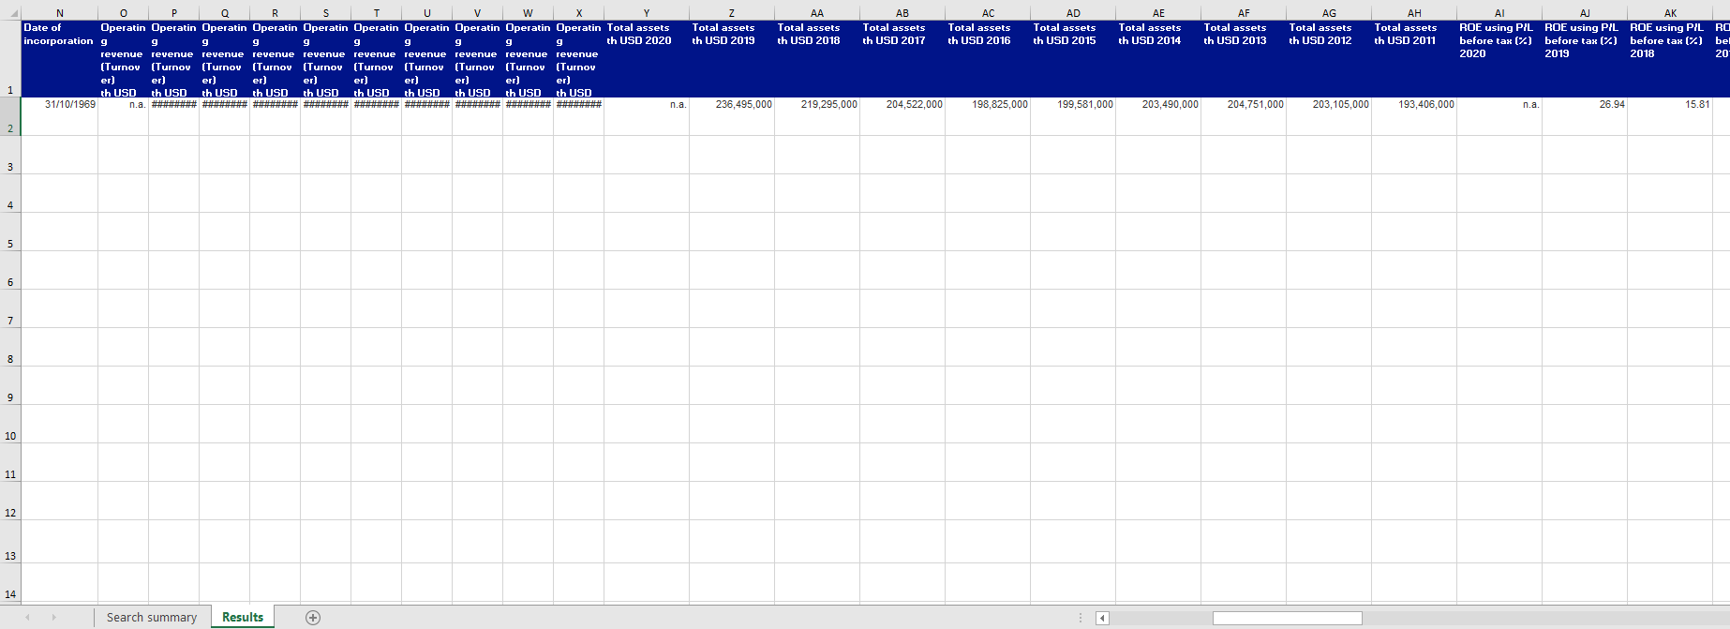

Print of file part3 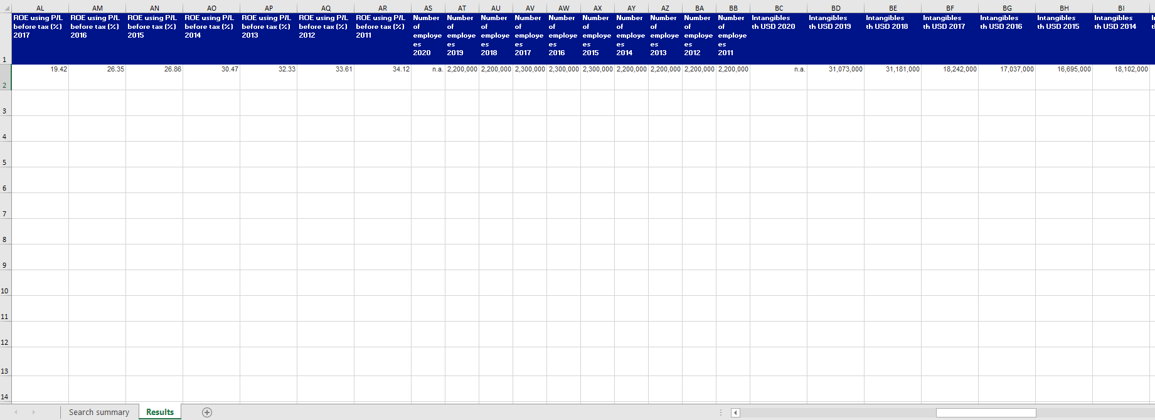 Print of file part4 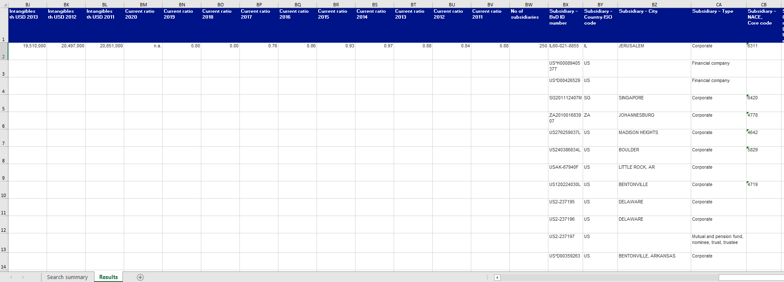 Print of file part5

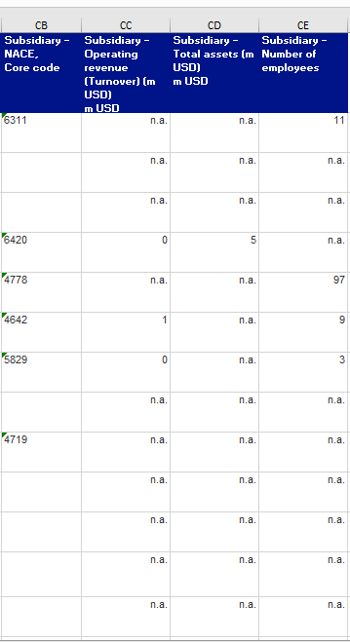

Folder GUO 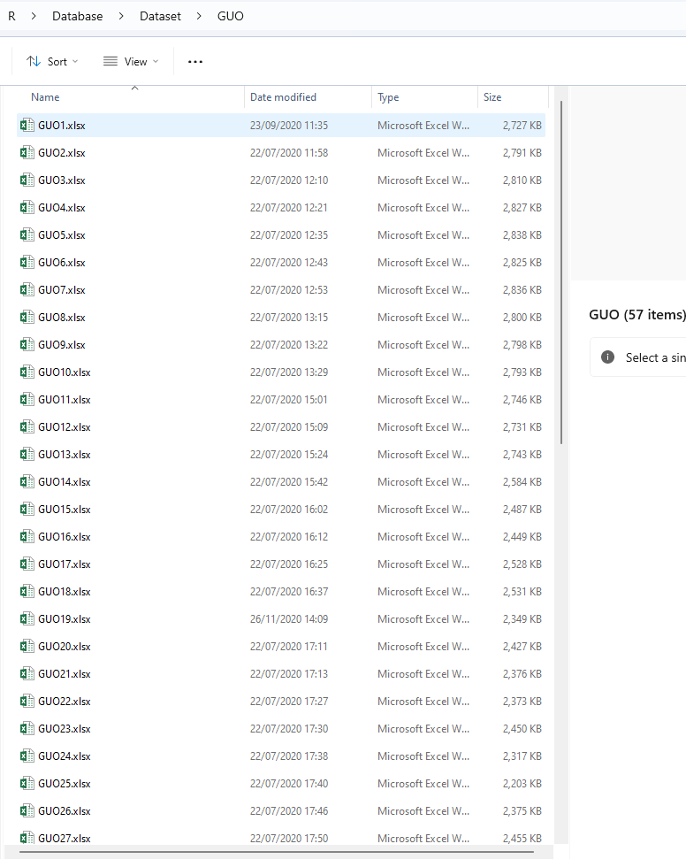

Exemplary file GUO1.xlsx 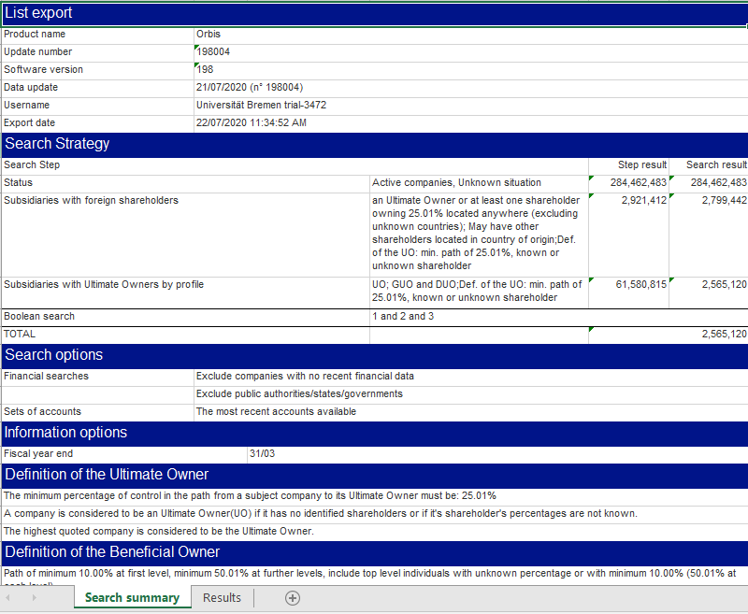 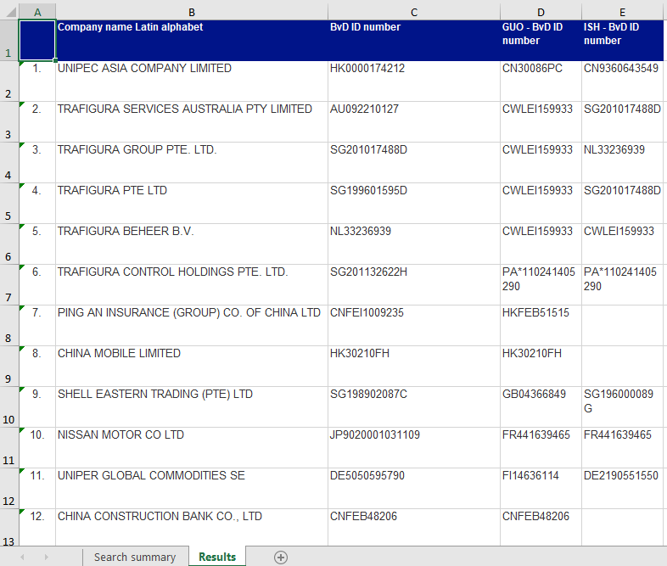

Folder NewDataCitations 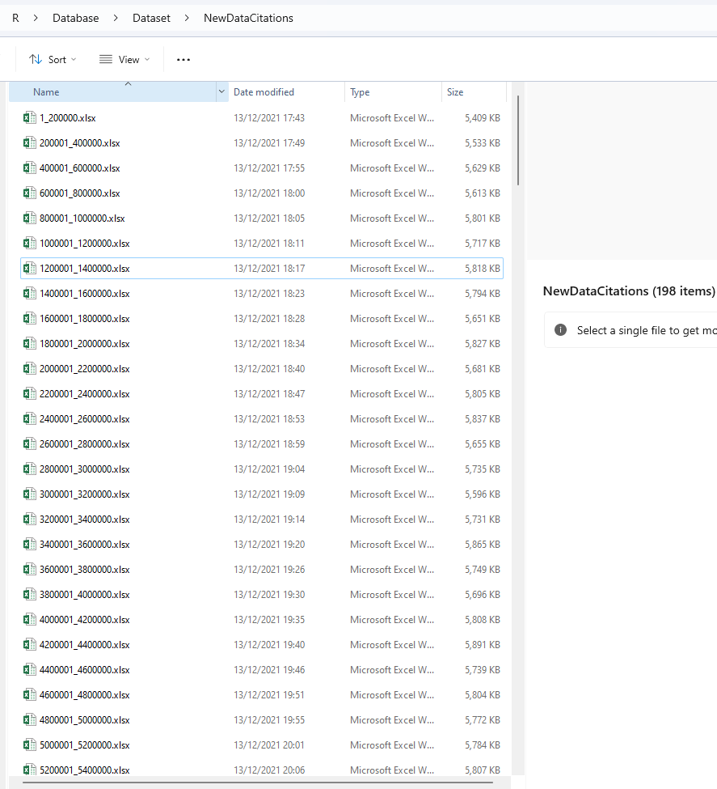

Exemplary file 1_200000.xlsx 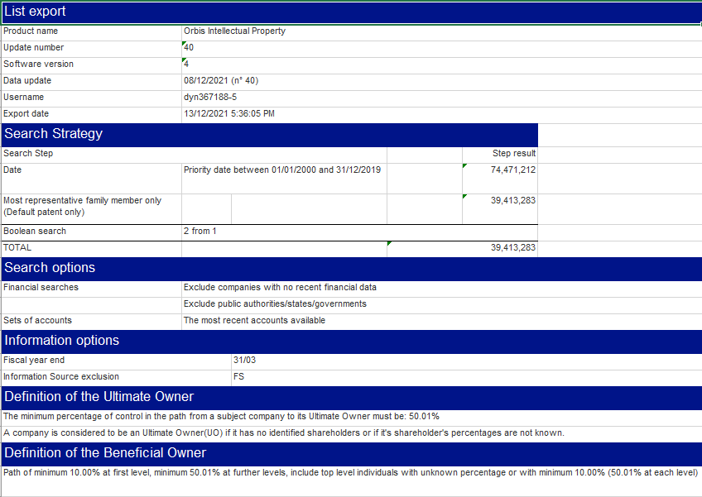 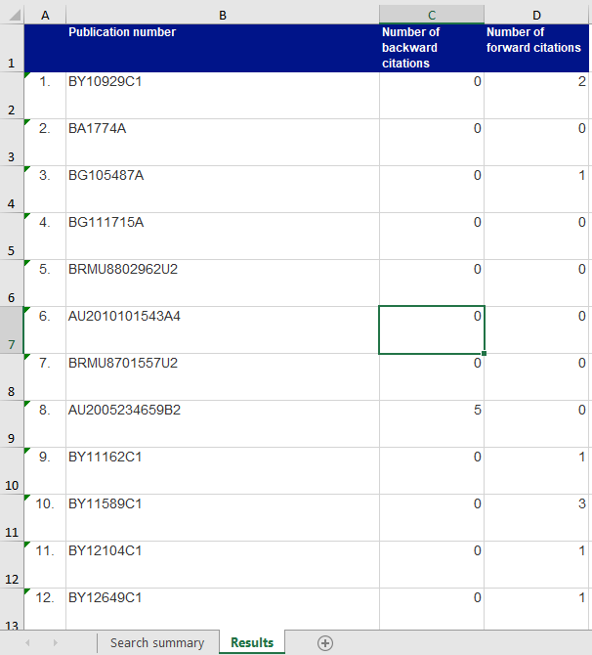

Folder ownership_data 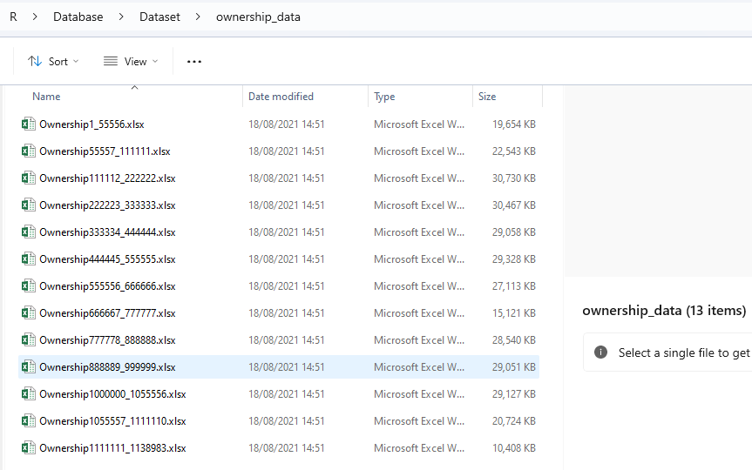

Exemplary file Ownership1_55556.xlsx 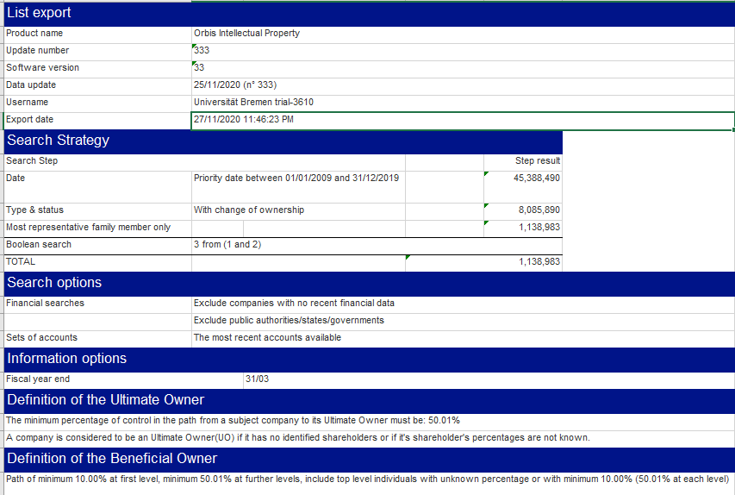 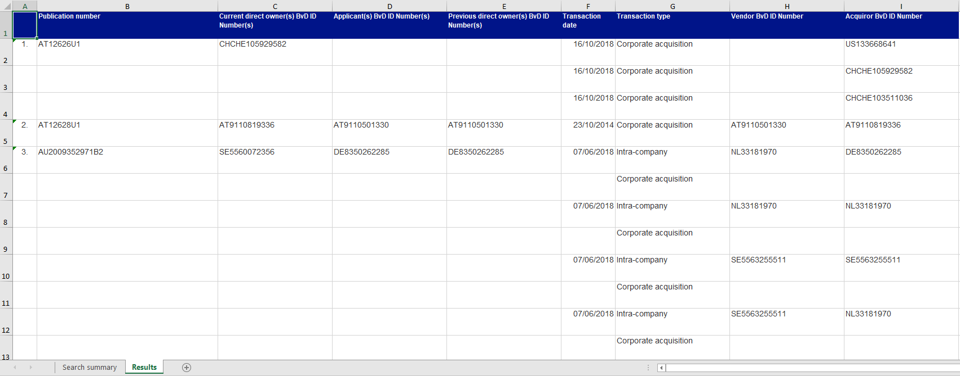

Folder Patents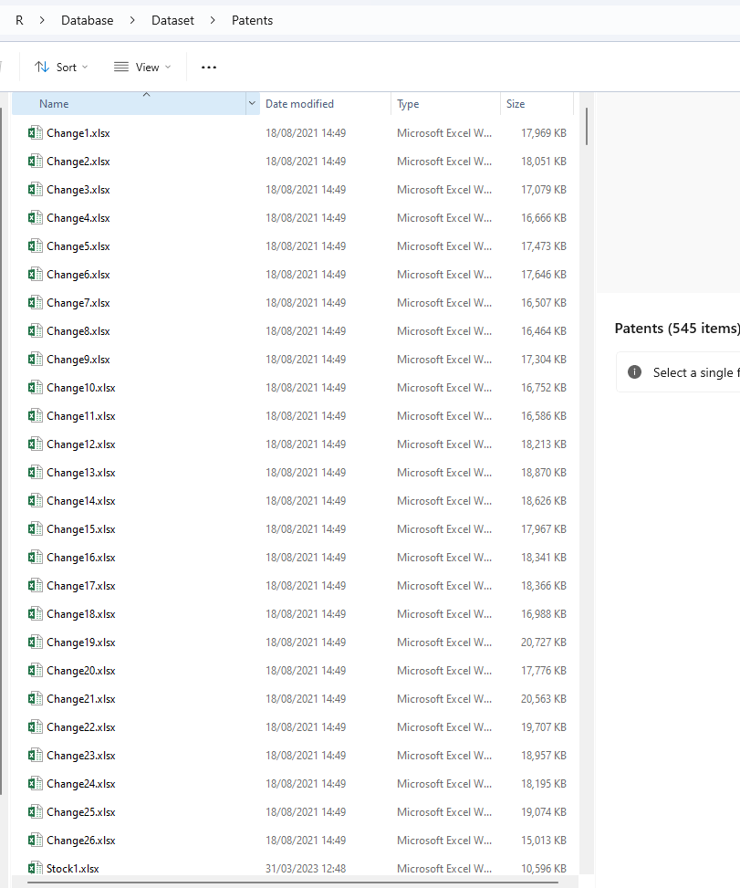

Exemplary file Change1.xlsx 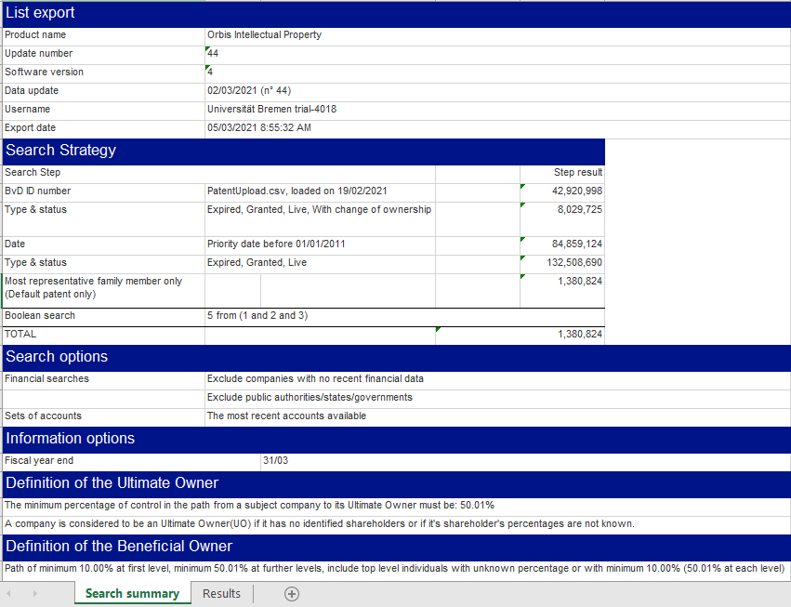 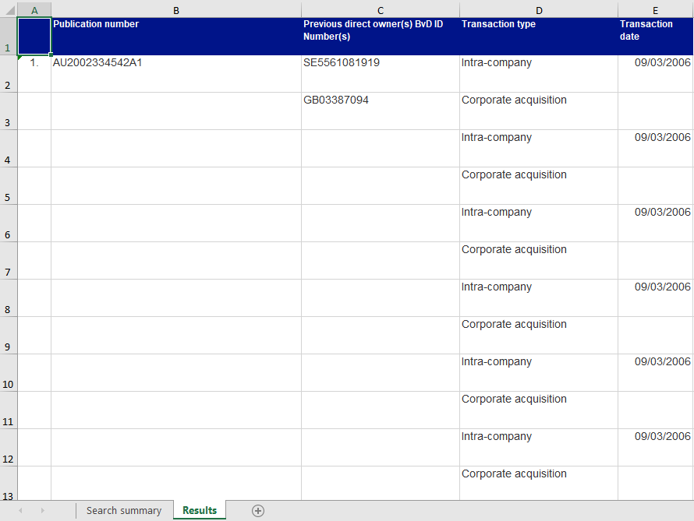

Exemplary file Stock1.xlsx 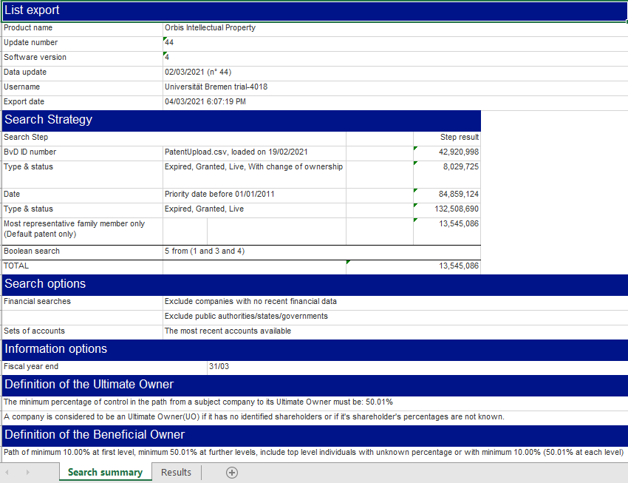 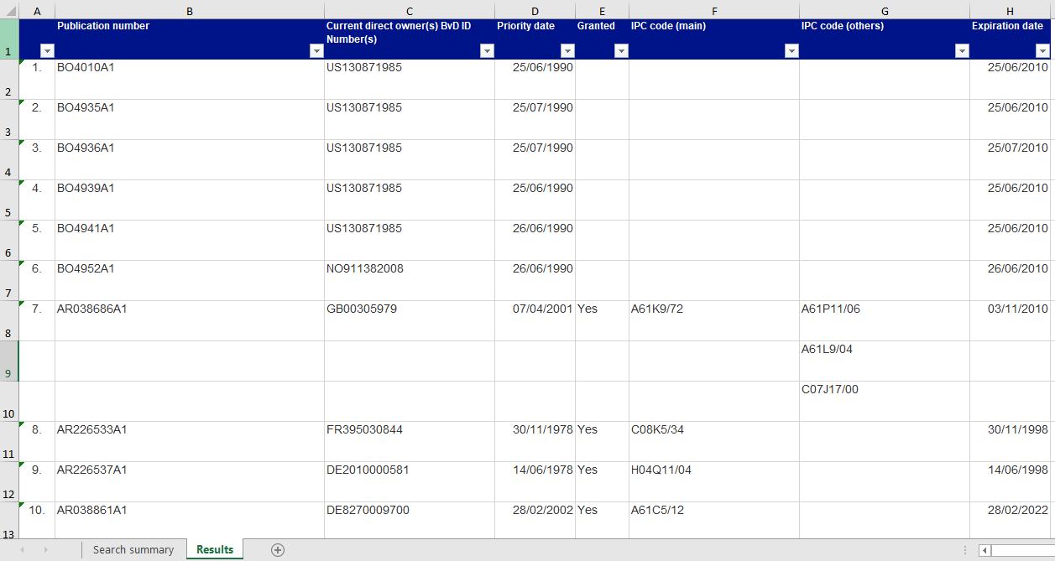

Folder priority_data 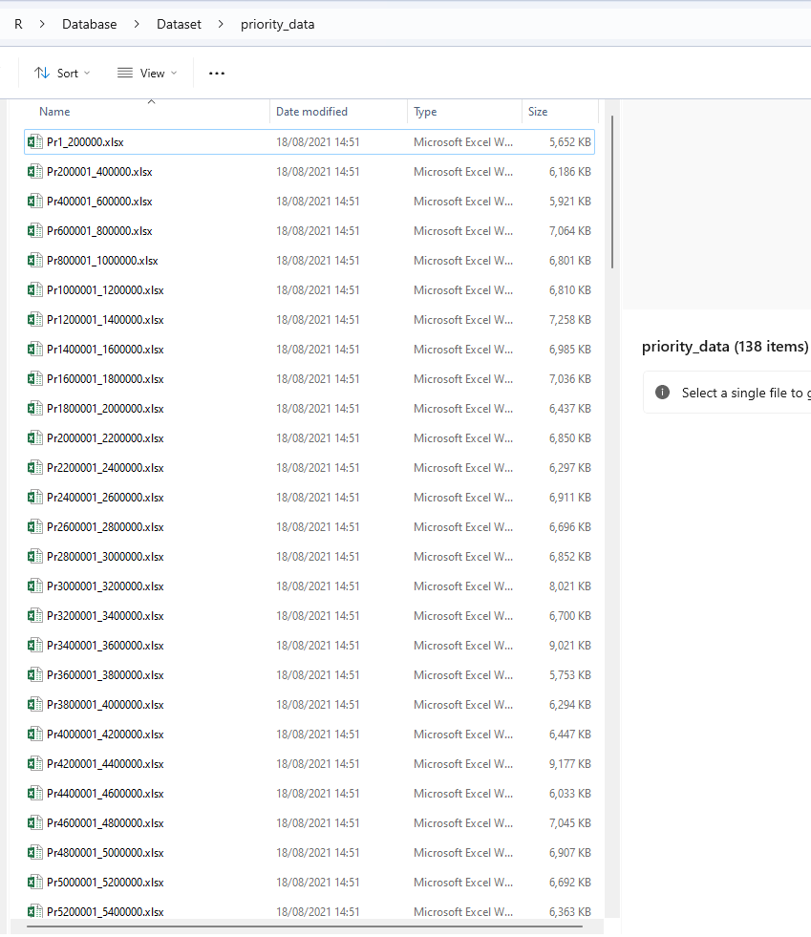

Exemplary file Pr1_200000.xlsx 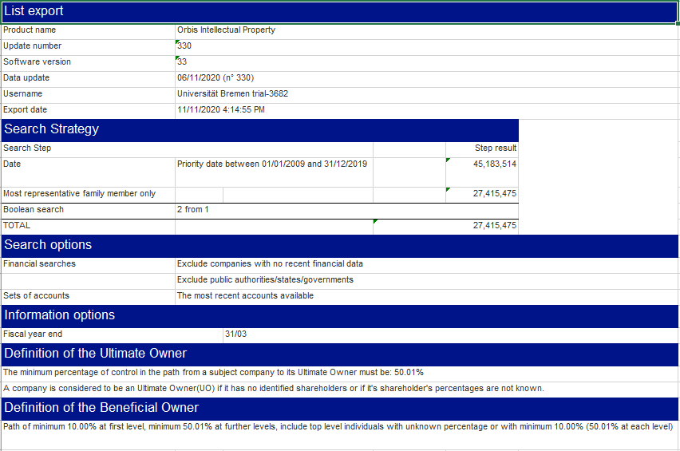 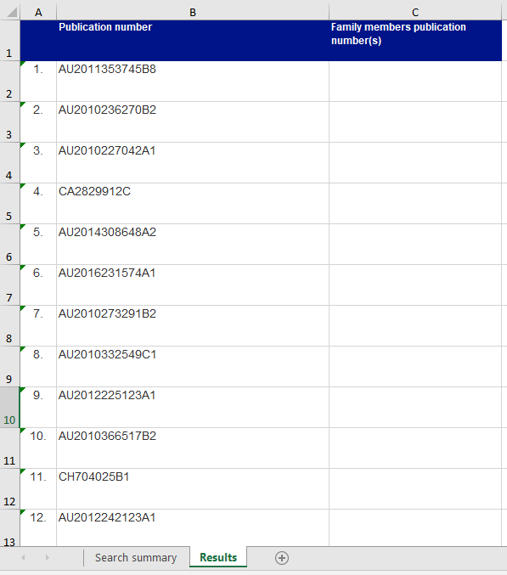

Folder Share 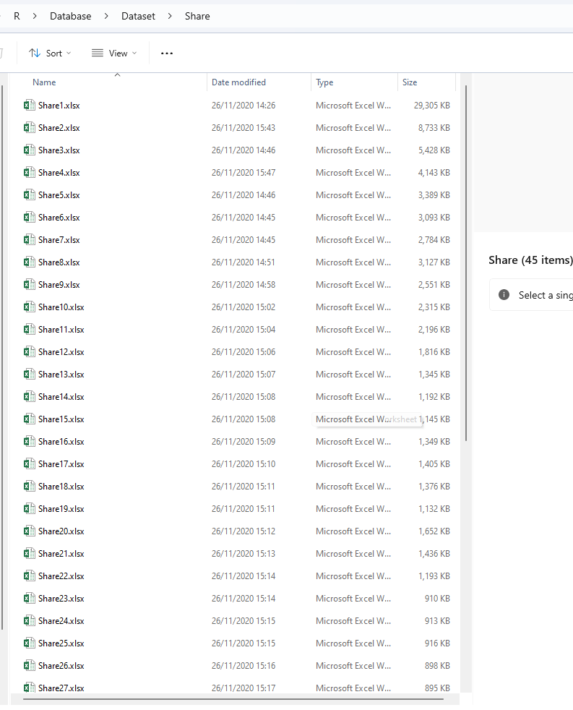

Exemplary file Share1.xlsx 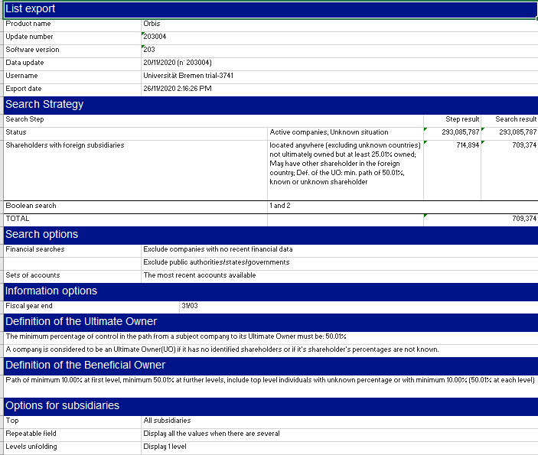 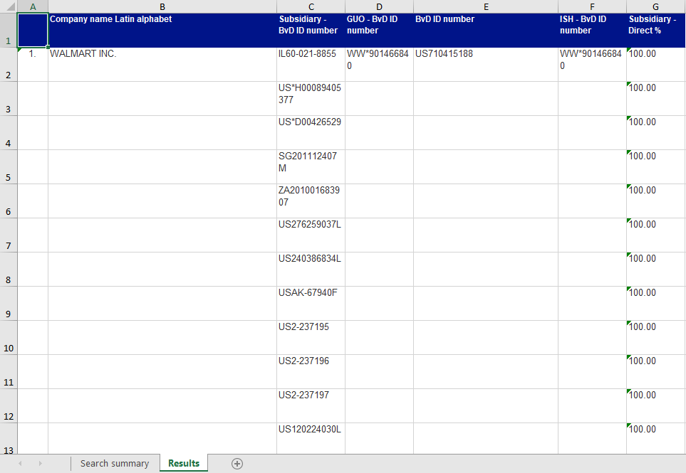

# Folder Type

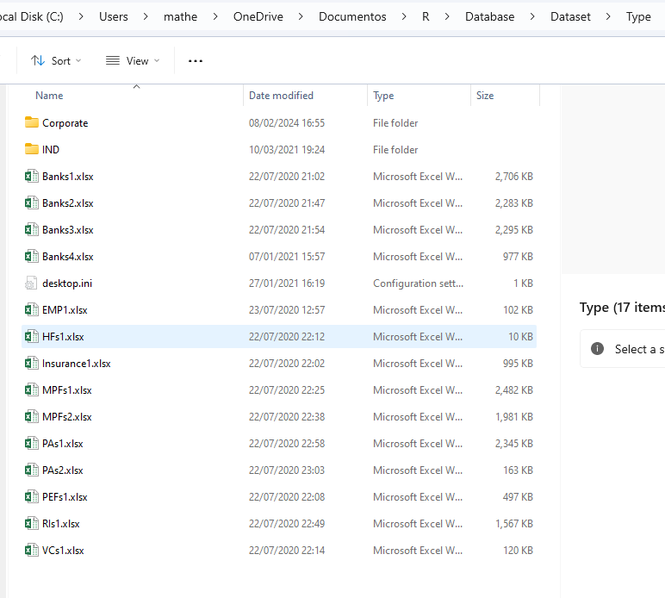

Exemplary file Banks1.xlsx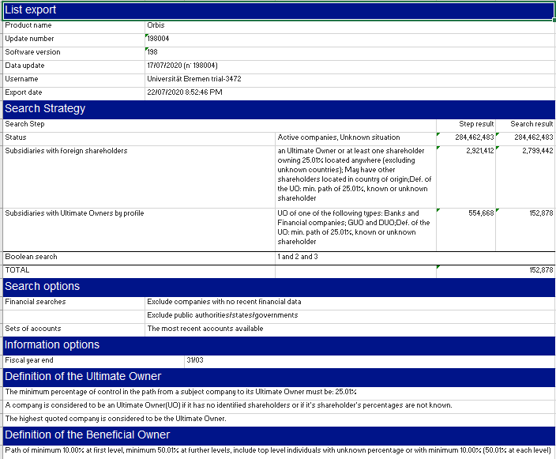 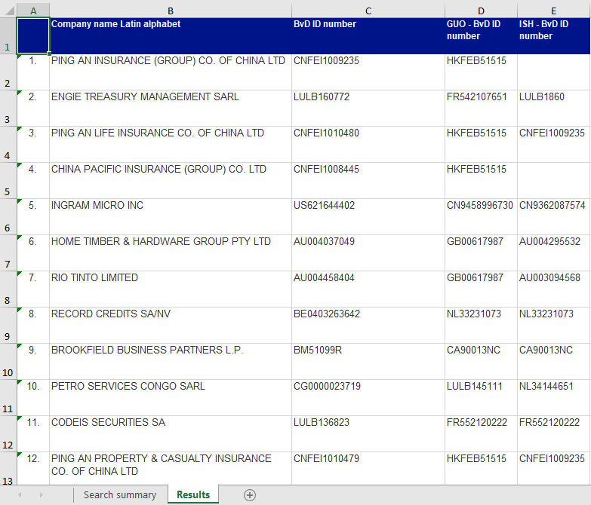

Exemplary file EMP1.xlsx 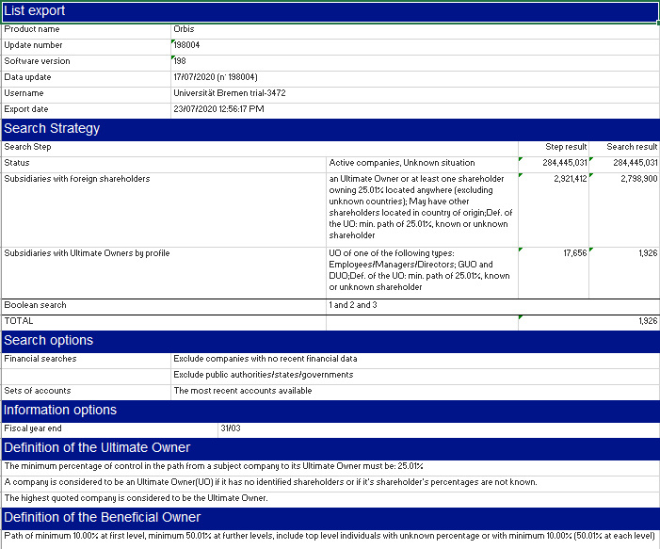 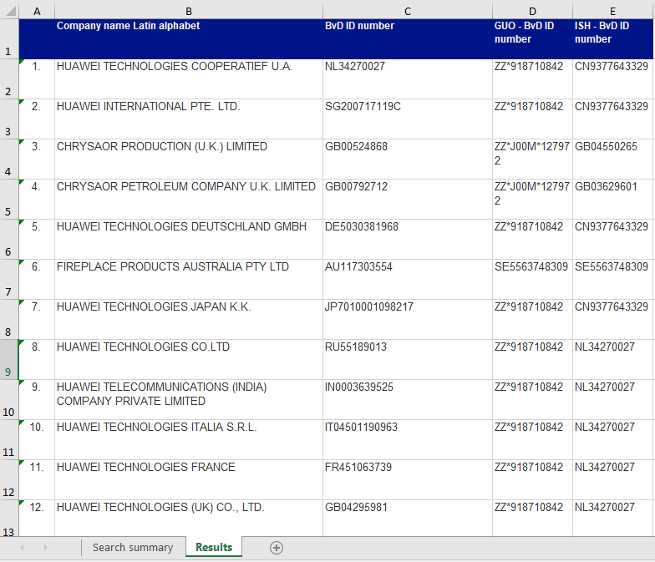

Exemplary file HFs1.xlsx 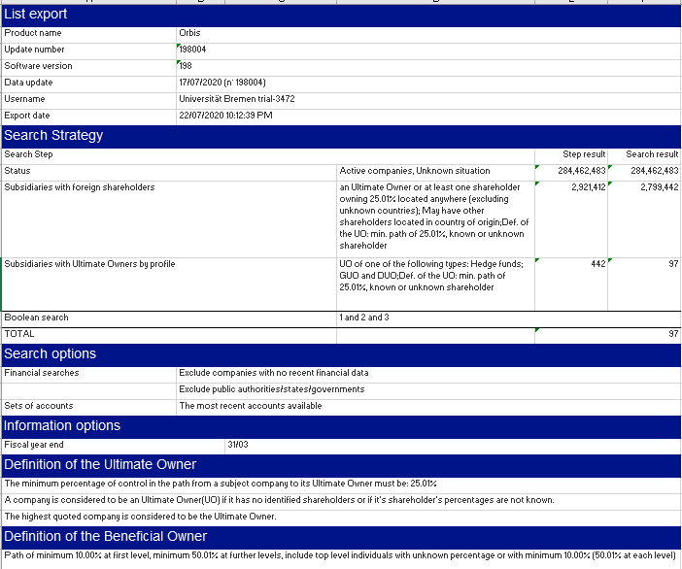 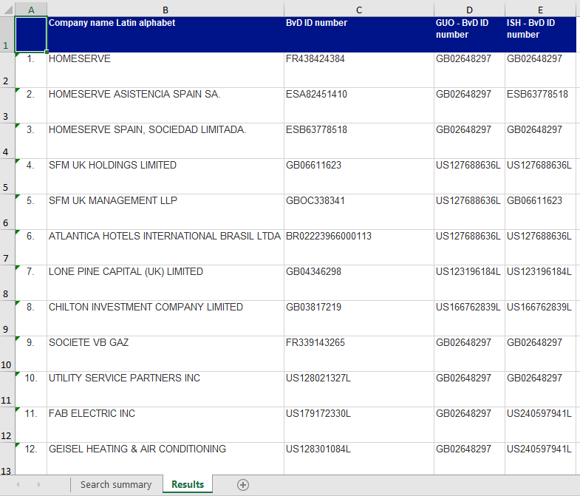

Exemplary file Insurance1.xlsx 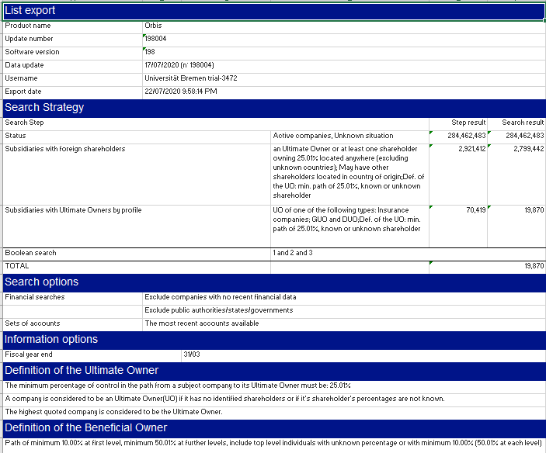 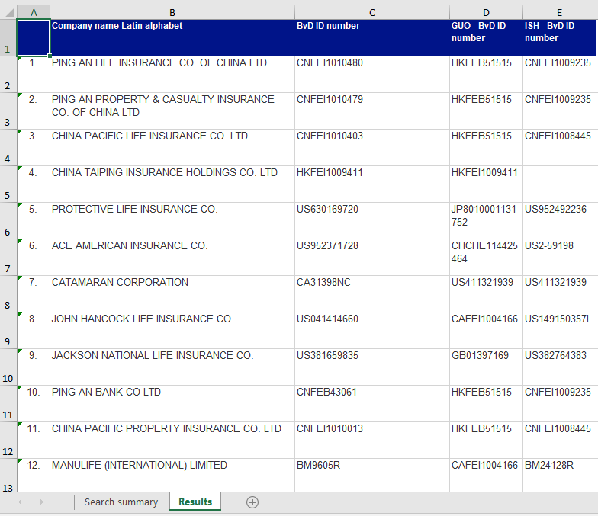

Exemplary file MPFs1.xlsx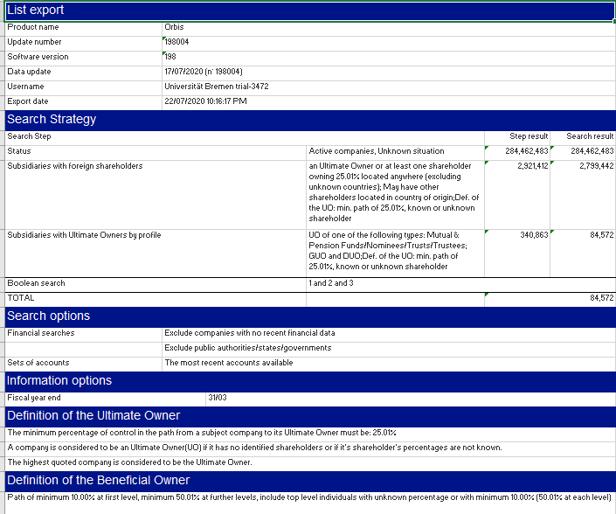 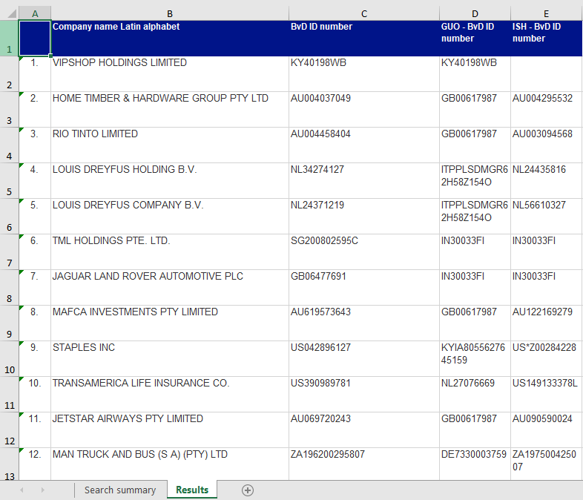

Exemplary file PAs1.xlsx 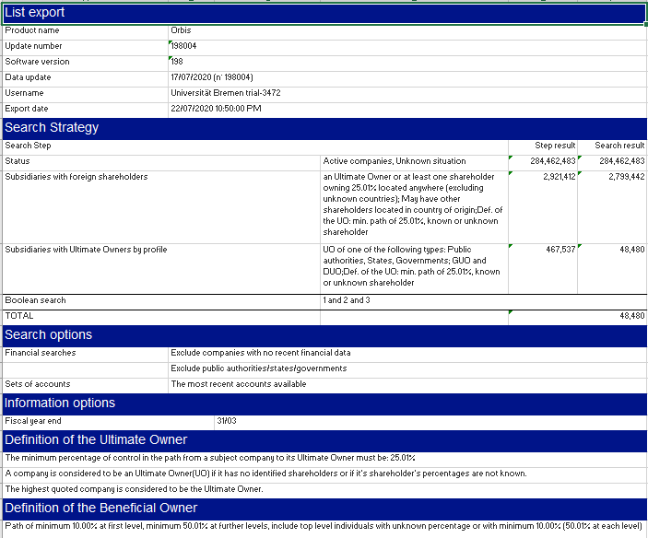 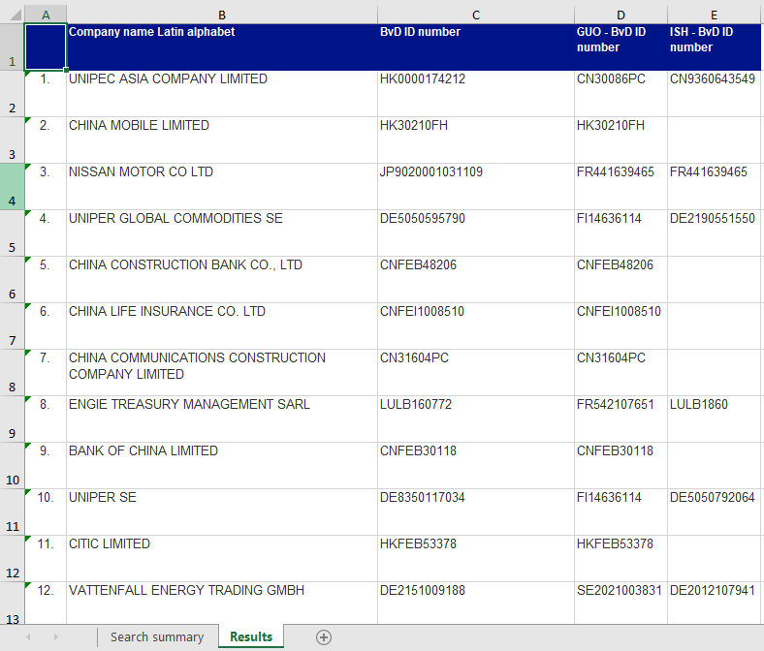

## Exemplary file PEFs1.xlsx

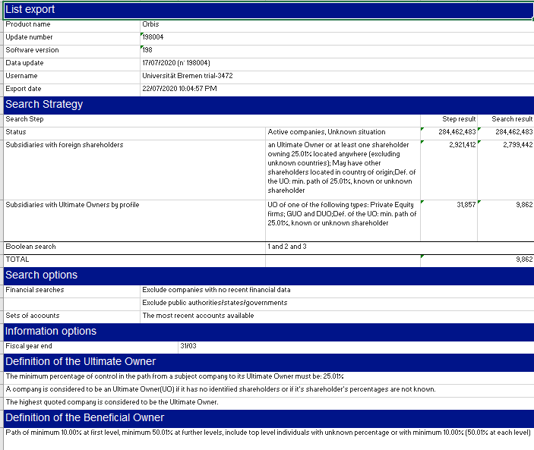 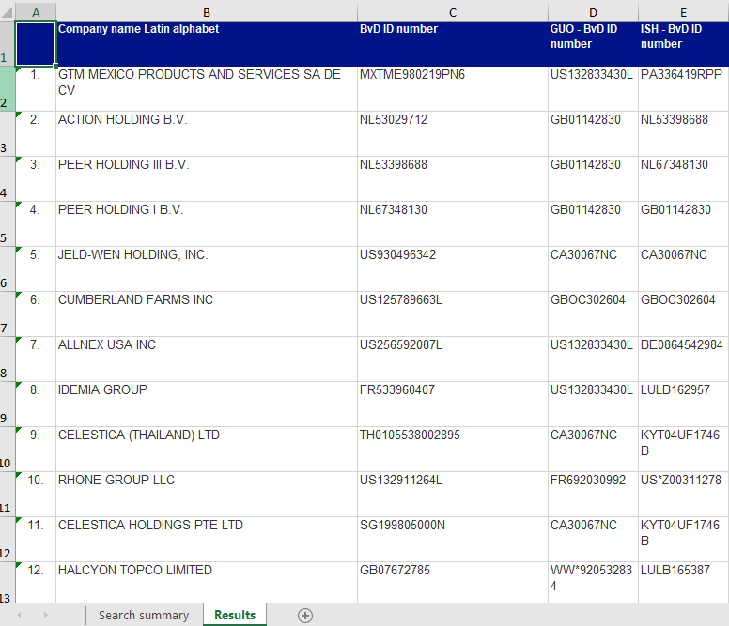

Exemplary file RIs1.xlsx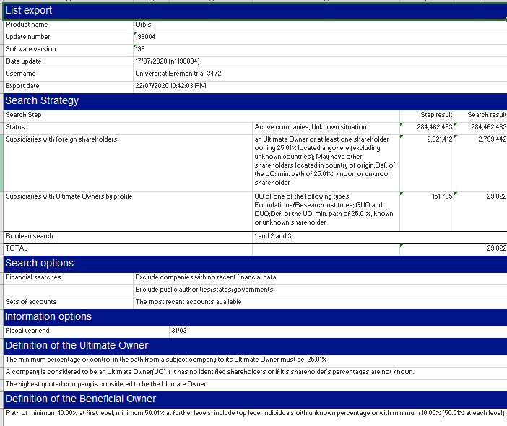 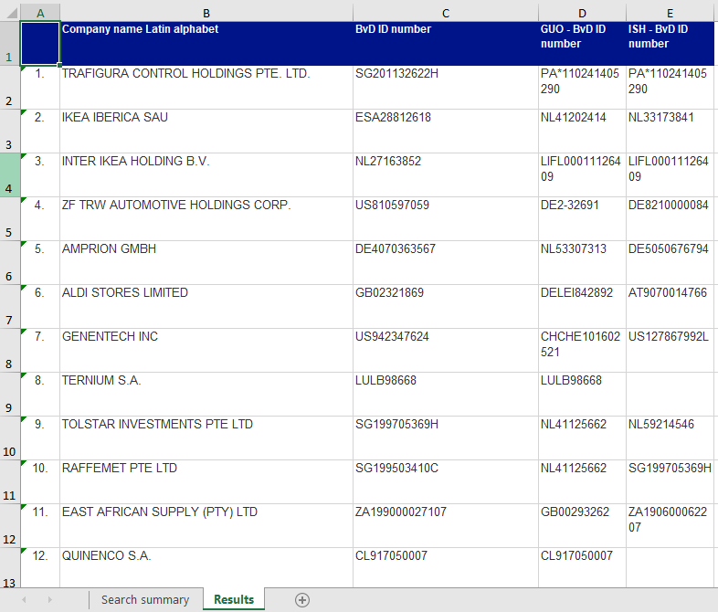

## Exemplary file VCs1.xlsx

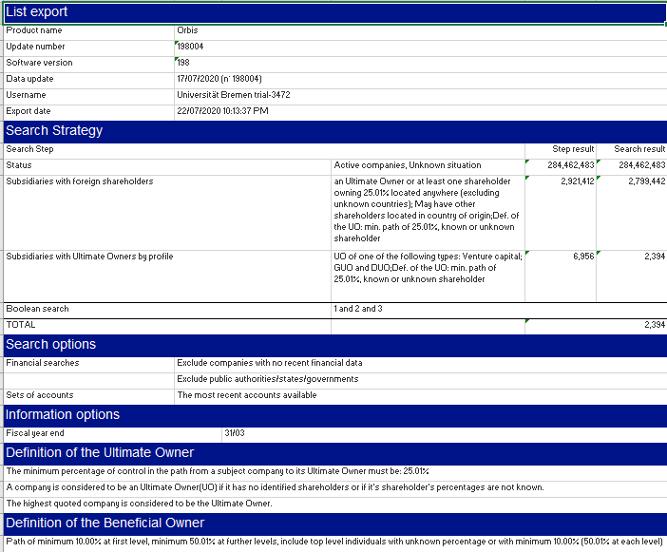 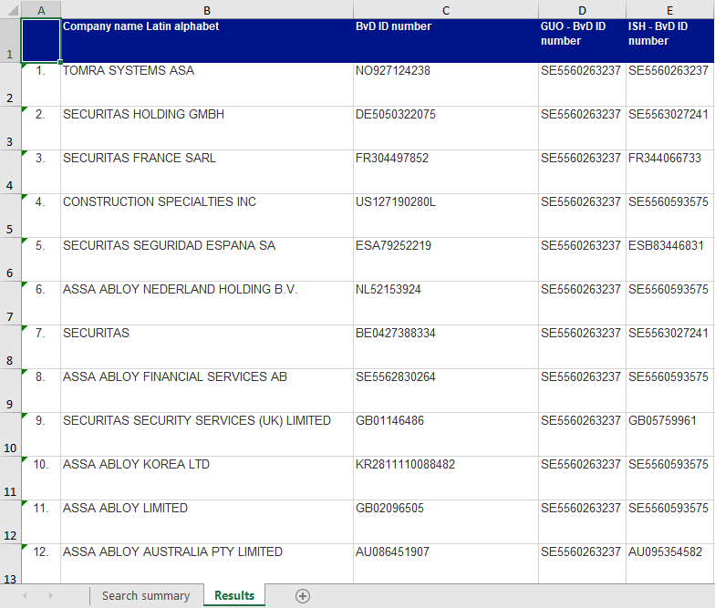

# Folder Corporate

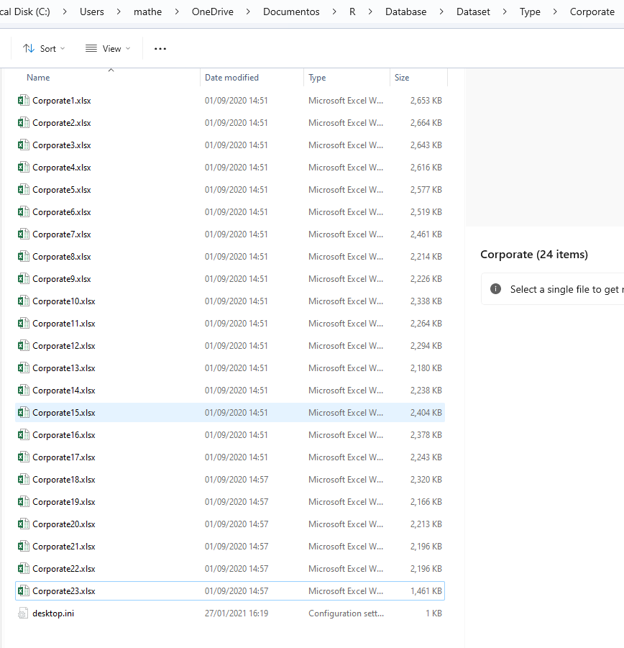

Exemplary file Corporate1.xlsx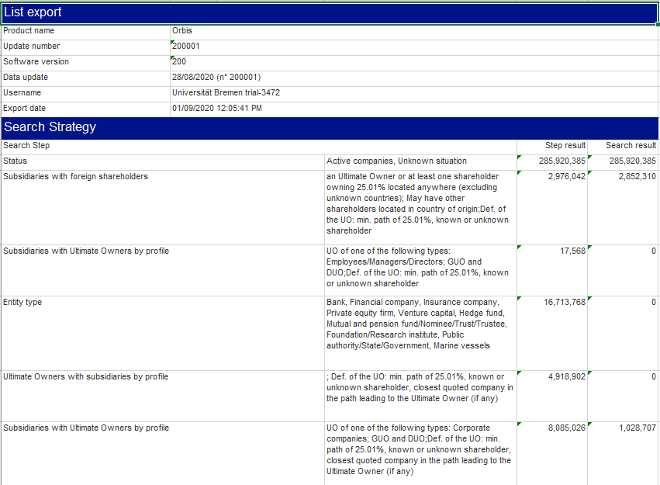 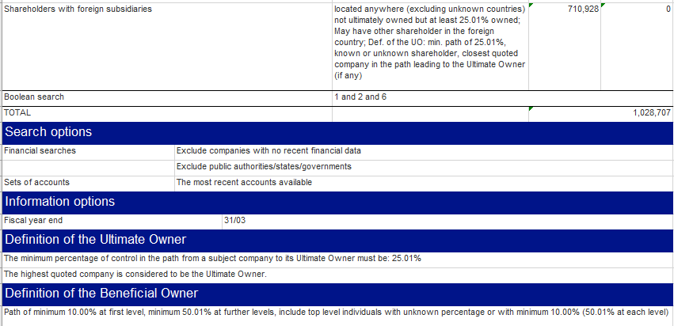

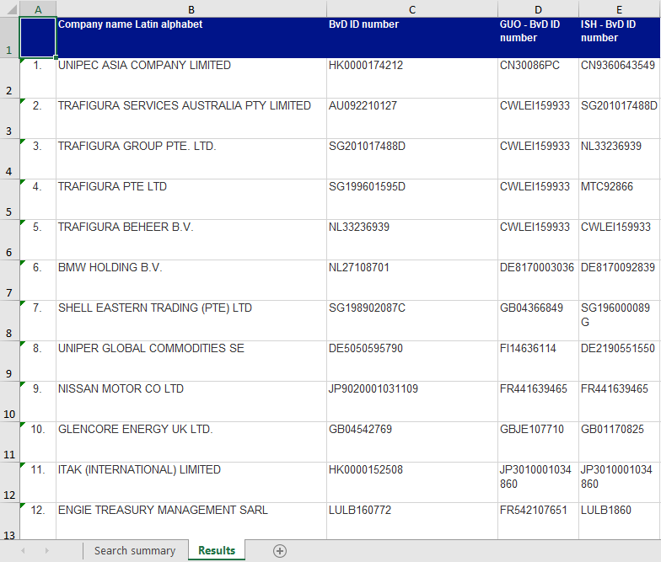

# Folder IND

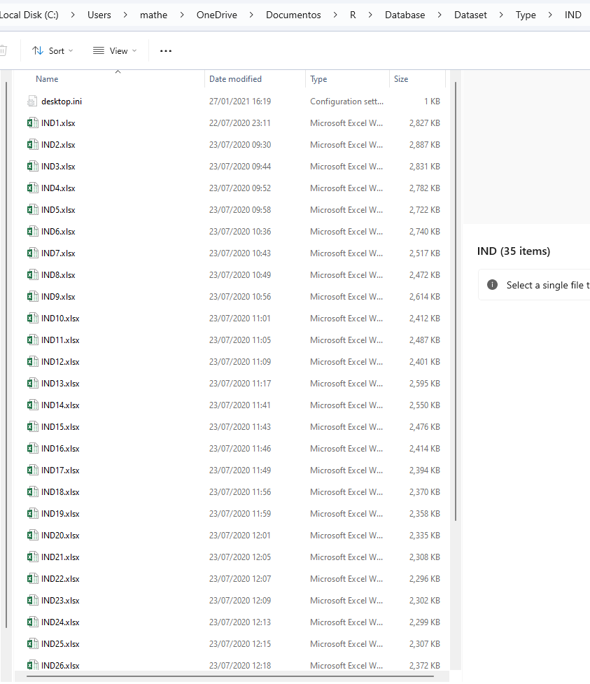

Exemplary file IND1.xlsx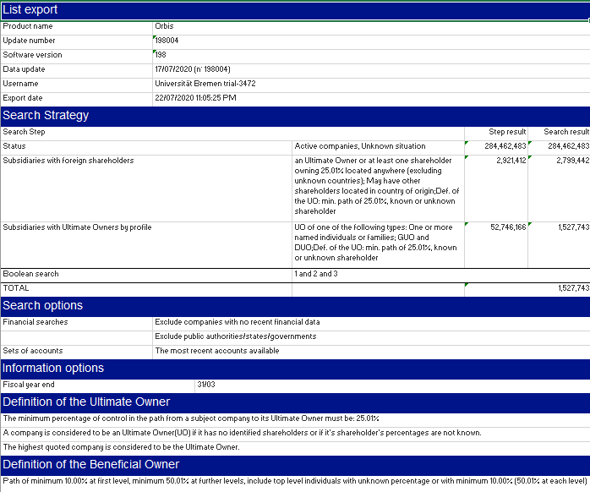 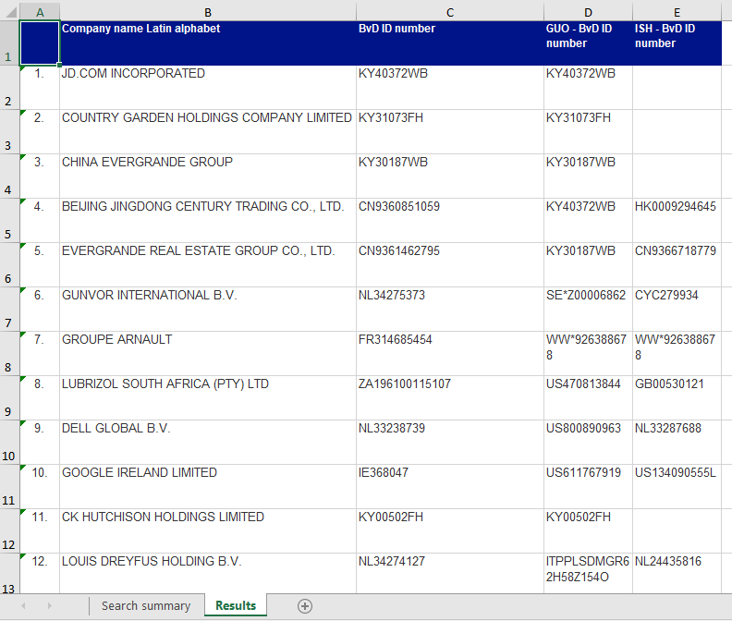

**File AI.xlsx: This file is made available at the folder Dataset**

**File CountryPanel.xlsx: This file is made available at the folder Dataset**

**File ipc_technology.csv: This file is made available at the folder Dataset**

**Files “Data_about_500_patents_with_change_of_own.xlsx”, “NACE.csv”, “Nace_general.xlsx”, “NACE_REV2_INFO.csv”, “Type.csv” are not necessary for creating the dataset and are therefore not made available.**