**INGLÊS INSTRUMENTAL**

**MATHEUS LUIZ MASSUDA (ESN)**

**ATIVIDADE 04**

**MAPA (FICTÍCIO) GERADO POR INTELIGÊNCIA ARTIFICIAL**

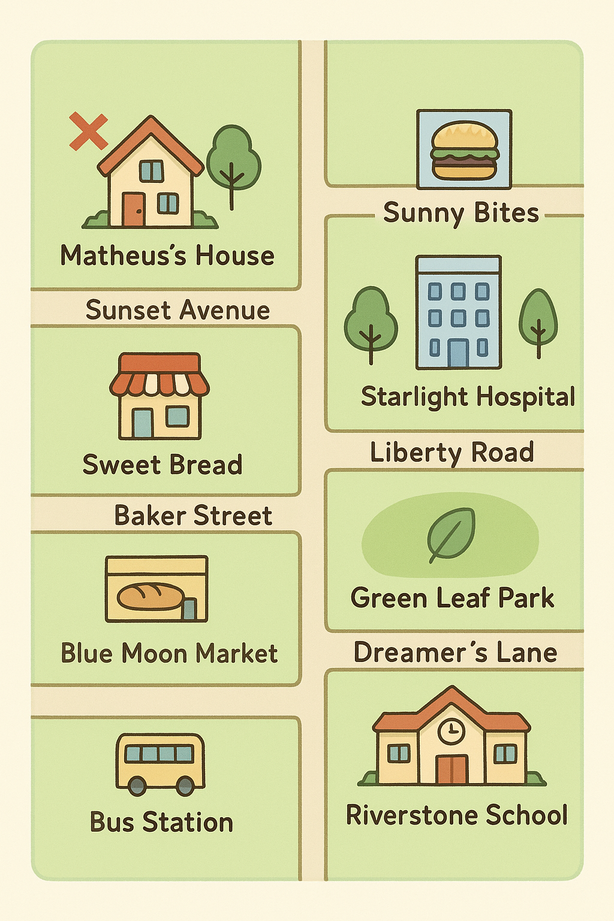

**TEXTO COM OS TRÊS TRAJETOS**

**Primeiro trajeto (rodoviária até minha casa):** Hello Kristin, welcome to Brazil! To go from the bus station to my house, just go straight for two blocks and turn left on Sunset Avenue. If you look to the right, you will see a yellow house.

**Segundo trajeto (minha casa até restaurante):** To go from my house to the nearest restaurant, first head towards Starlight Hospital. When you get there, turn left and turn right. You will see the Sunny Bites restaurant on the left side.

**Terceiro trajeto (minha casa até o hospital):** To go from my house to the hospital gate, first head towards Starlight Hospital. When you get there, just turn right and then left to reach the entrance on Liberty Road Street.

.