## linha horizontal



Prove of test

19/06/2024

**─**

Matheus Maciel Melchiades

MindRoom

# 

# Executive Summary

This document explains how to create and test a simple website about the Transformers cartoon. The website has four pages: Home, Characters, Episodes, and Gallery. All content, including images and text, is stored locally in an organized file structure.

# 

# 

# 

# 

# 

# 

# 

# 

# Introduction

This document is a guide to help you create and test a simple website about the Transformers animated cartoon. The website will have four pages: Home, Characters, Episodes, and Gallery. We will use HTML and CSS, and all content will be stored locally.

The goal is to provide clear instructions, so even someone with little experience in web development can follow along. The steps include setting up the website structure, organizing files, and testing the website to make sure everything works correctly. By the end, you will have a fully functional and tested website.

# Testing

Testing and validating a website involves checking its functionality, usability, and compatibility across different devices and browsers. Below are the steps and descriptions for testing and validating your Transformers fan site, which includes the Home, Episodes, Characters, and About pages.

Steps:

## Functionality Testing

## Usability Testing

## Compatibility Testing

## Validation

## 1. Functionality Testing

Ensure all elements on the site work correctly.

# Steps

## Home Page

- Verify that all links navigate to the correct pages.

- Check that images and text load correctly.

## Episodes Page

- Ensure that all episode appear with correct episode details.

- Verify the navigation menu links to other pages of the site.

## Characters Page

- Check that character profiles are correctly displayed.

- Verify the navigation menu links to other pages of the site.

## About Page

- Verify that all content is displayed correctly.

- Verify the navigation menu links to other pages of the site.

## 2. Usability Testing

Ensure the site is easy to use and navigate.

# Steps

## Home Page

- Check the readability and clarity of the text.

- Verify that the layout is user-friendly.

## Episodes Page

- Test the ease of navigating through episodes.

-Ensure the information is easy to find and understand.

## Characters Page

- Verify that character information is well-organized and easy to read.

- Ensure the navigation menu is intuitive.

## About Page

- Check that the content is clear and informative.

- Ensure the layout is simple and not cluttered..

## 3. Compatibility Testing

Ensure all elements on the site work correctly.

# Steps

## Test the site on major browsers (Chrome, Firefox, Safari, Edge):

- Open each page and check for any display issues or errors.

- Verify that all functionalities work as expected.

## Test the site's responsiveness on various devices (desktop, tablet, mobile):

- Ensure that the layout adjusts correctly to different screen sizes.

- Verify that all content is accessible and readable on different devices.

# 

# 

# Screenshots

Capture images showing the site on different browsers.

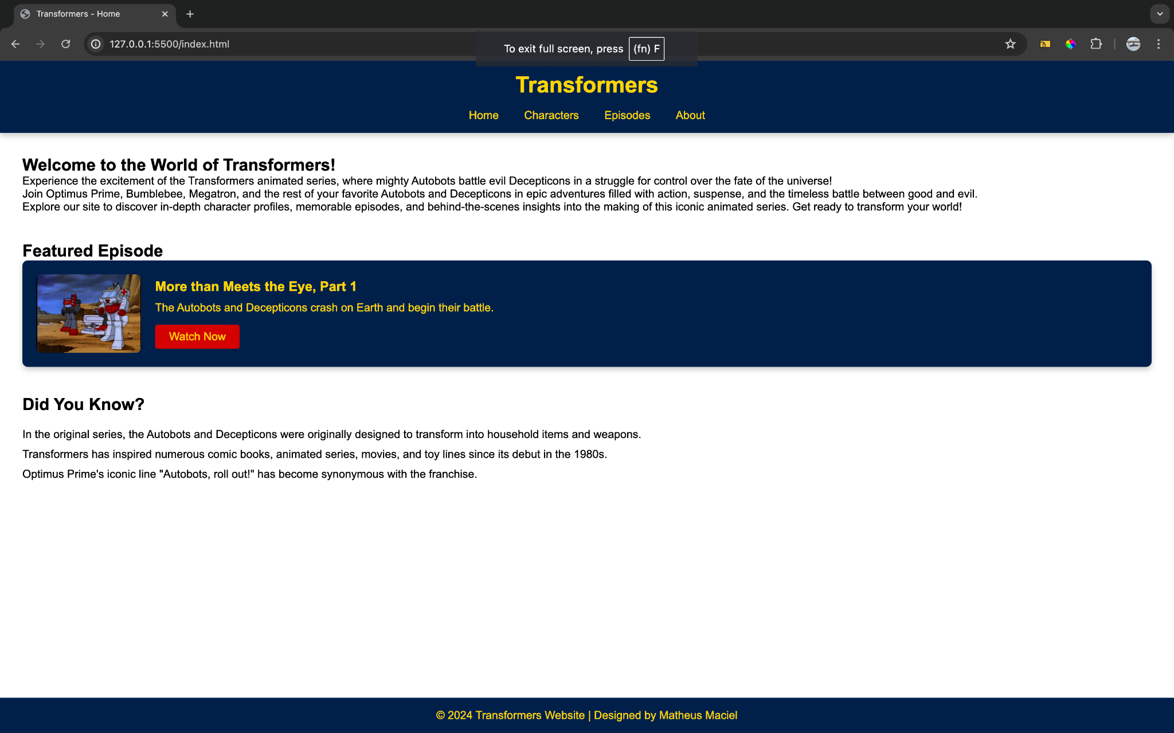

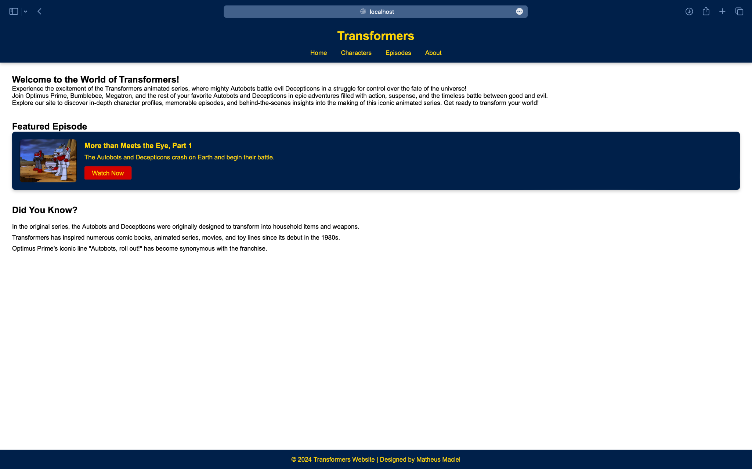

Test the site's responsiveness on various devices (desktop, tablet, mobile).

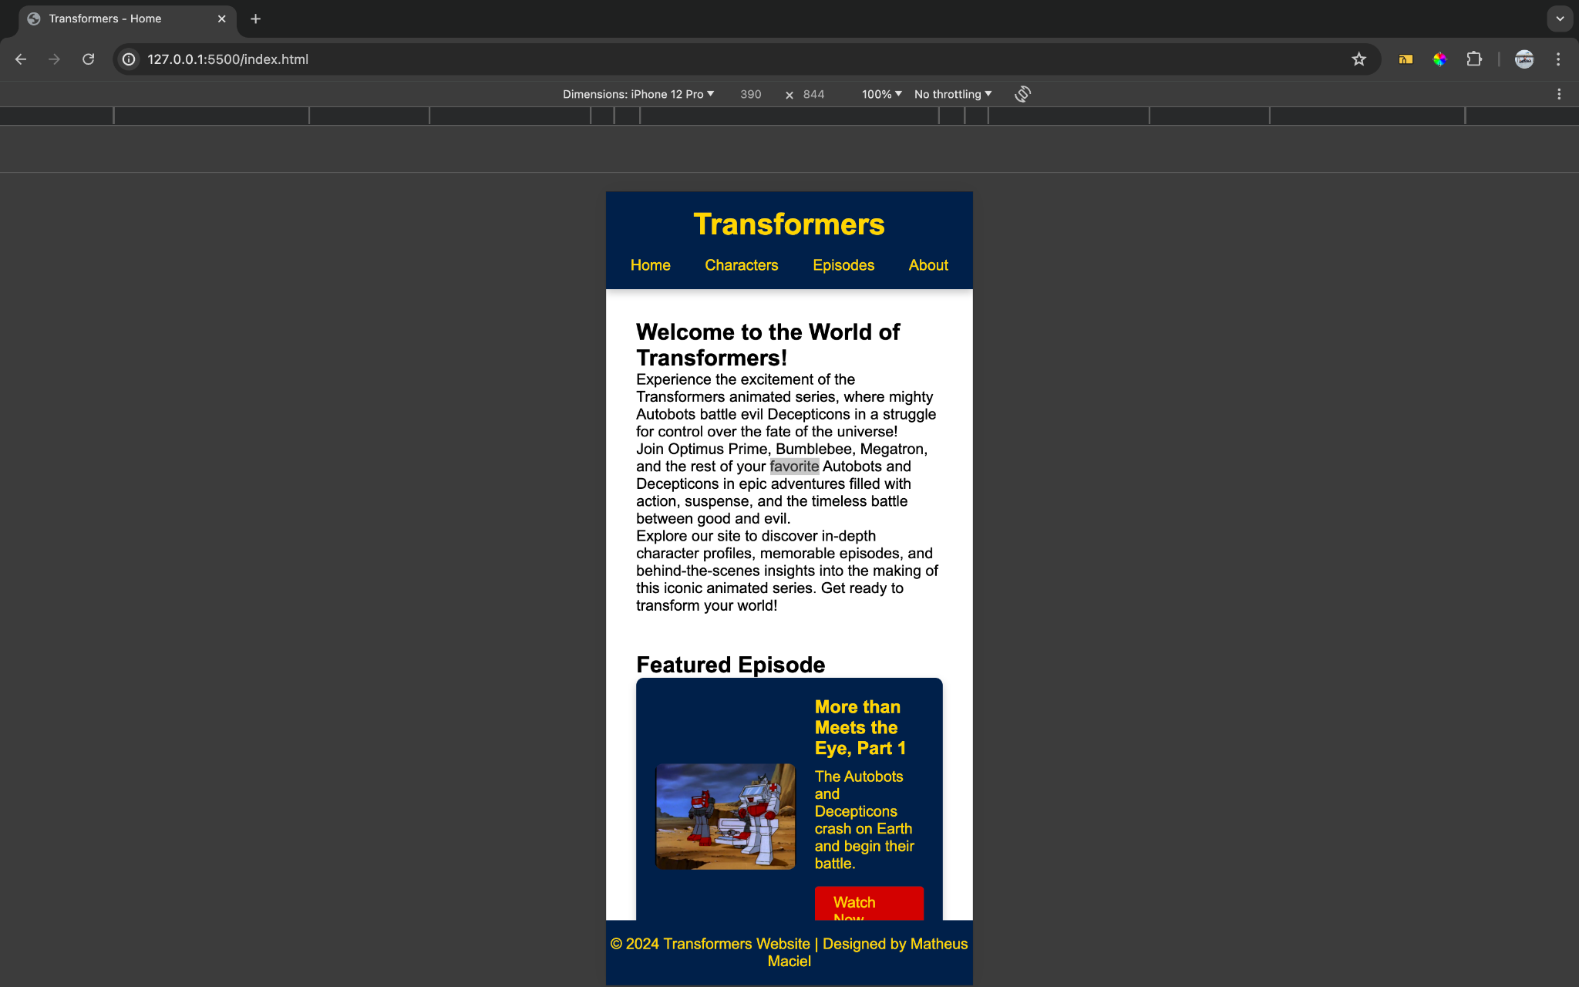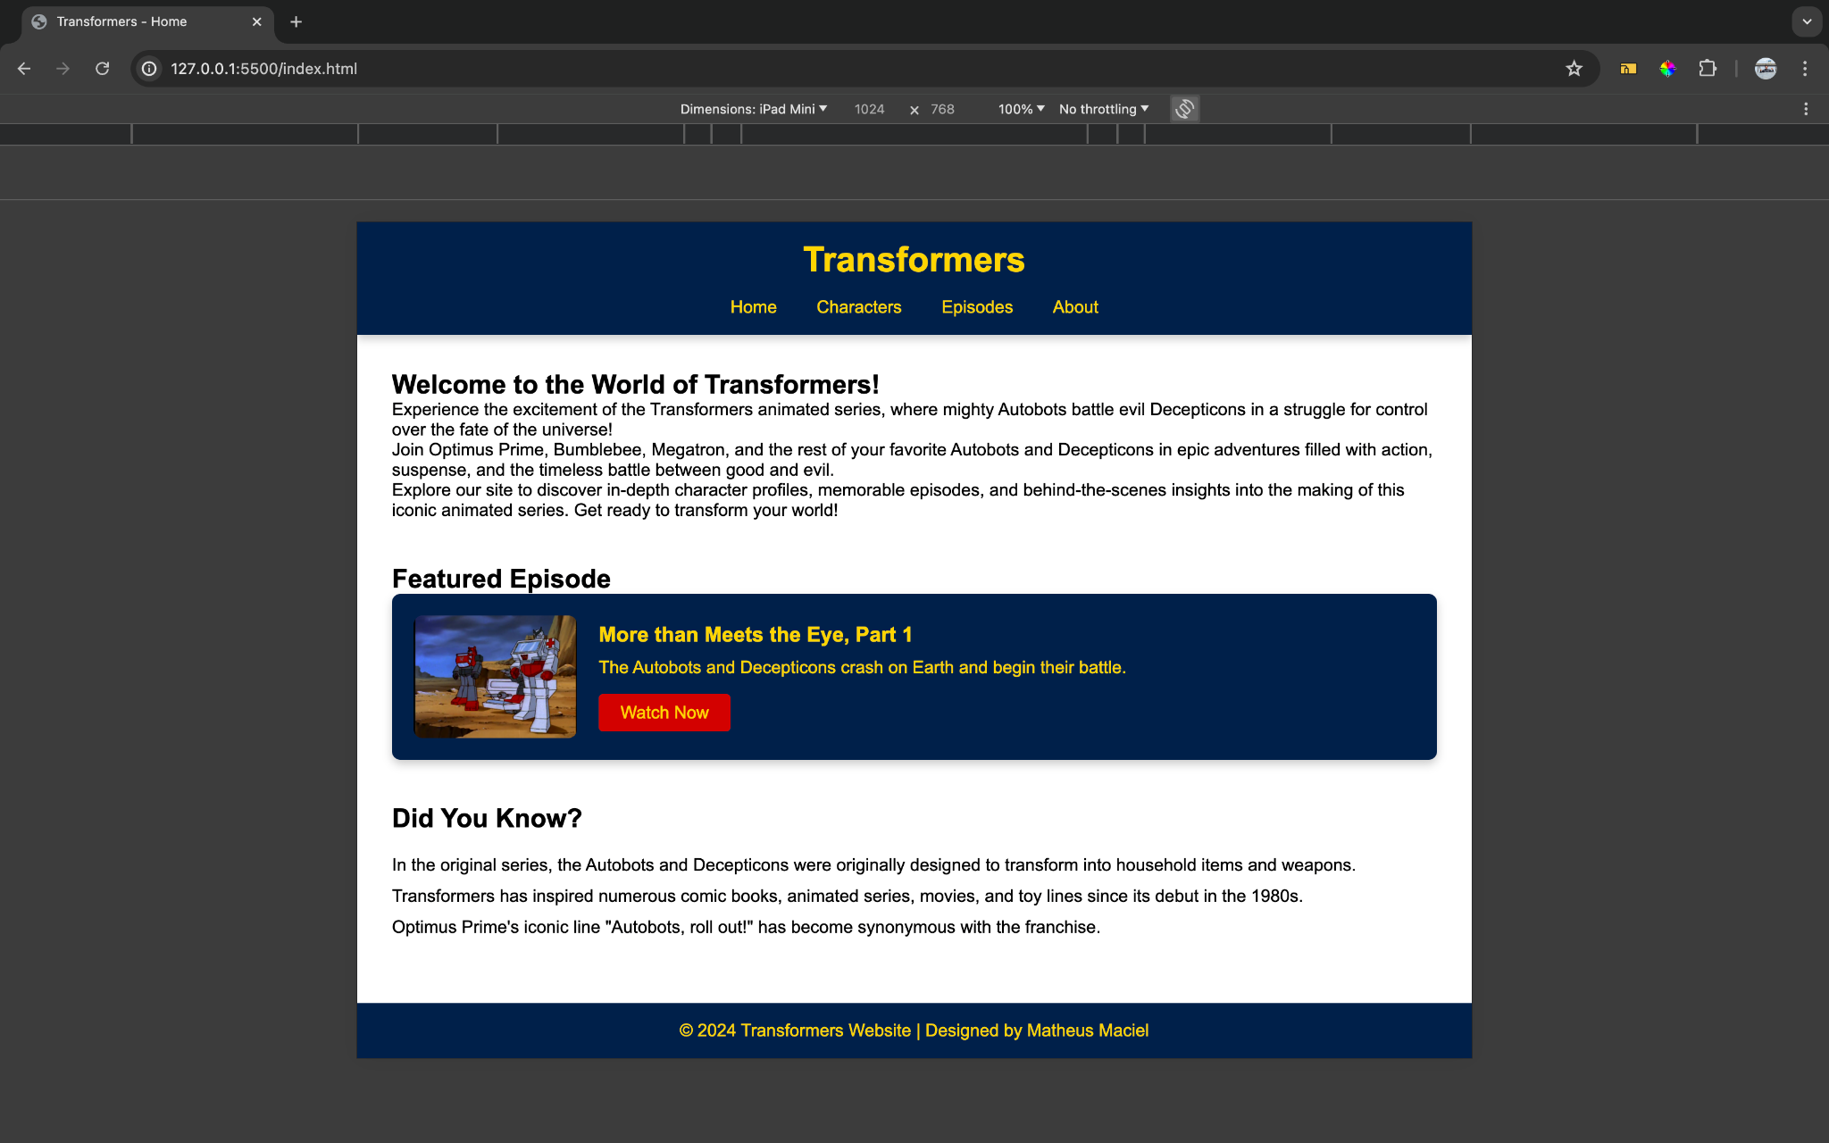

## 4. Validation

Ensure the HTML and CSS code is well-formed and follows best practices.

# Steps

## HTML Validation

- Use the W3C Markup Validation Service to validate the HTML code for each page.

- Fix any errors or warnings reported by the validator.

## CSS Validation

- Use the W3C CSS Validation Service to validate the CSS code.

- Fix any errors or warnings reported by the validator.

# 

# 

# Screenshot

