Inside Facebook Handbook

linha curta

Matheus Maciel Melchiades  
june 18, 2024

# Contents

1. Inroduction
2. Wireframes
3. Branding
4. Mockup
5. Design UI/UX

# 

# Introduction

This study aims to take a close look at how Facebook works and what it looks like. We will cover wireframes, branding, data flow, database layout, page layouts, and UI/UX elements. By reverse engineering and observing the site, we’ve created sketches, branding documents, data flow descriptions, and hypothetical database layouts. We also made page mockups and described interface and user experience considerations. This gives a comprehensive and detailed view of Facebook’s structure and how users interact with it.

# Wireframes

The wireframe for the Facebook home page shows how everything is laid out. At the top, there's a header with the Facebook logo, a search bar, navigation links (like Home, Friends, Watch, Marketplace, and Groups), and icons for your profile picture, notifications, messages, and menu. On the left side, there's a sidebar with your profile link, shortcuts to pages and groups, and explore options like events and memories. The main content area in the center includes stories, a section to create a new post, and the news feed with posts from friends and ads. On the right side, there's another sidebar with your contacts, birthday notifications, and sponsored ads. This layout helps you quickly find and interact with the features you use most.

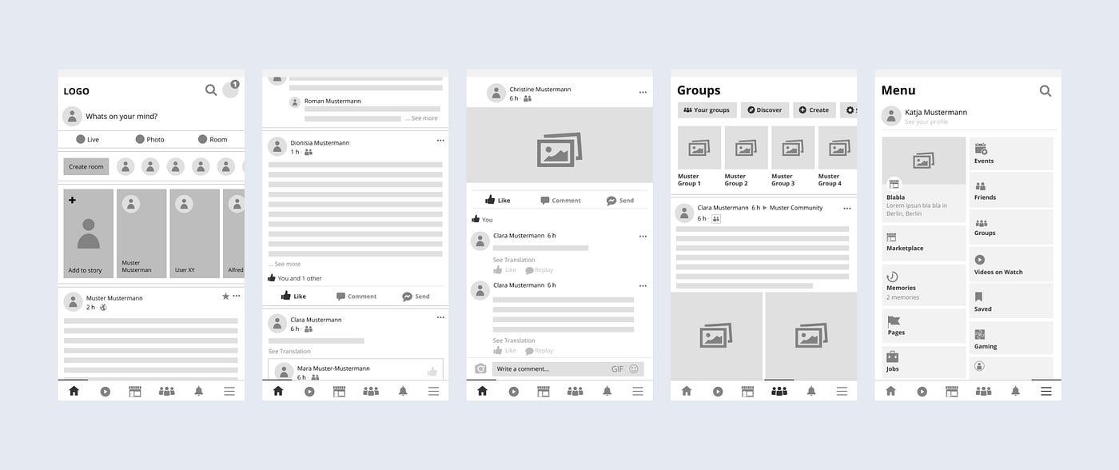

# 

# 

# Branding

Facebook’s branding is dominated by its use of a distinctive blue (#1877F2), which signifies trust and reliability. The font primarily used is Helvetica Neue for body text and Segoe UI for buttons and navigation, ensuring readability and a clean, modern appearance.

# 

# 

# Dataflow

The login process begins with the user entering credentials, which are sent to the server. Upon authentication, a session is initiated. For friend requests, when a user sends a request, it updates a 'pending requests' data structure. Once accepted, both users' 'friends list' structures are updated.

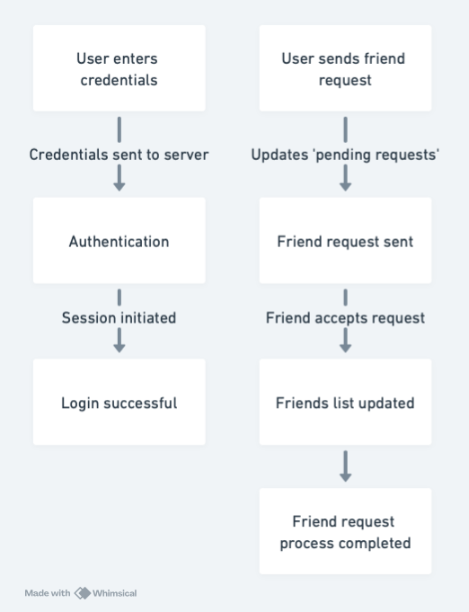

# Mockup

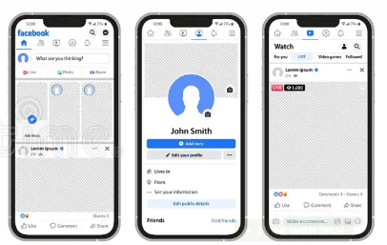

# UI/UX

UI/UX design emphasizes intuitive navigation with a consistent and familiar layout across all pages. Accessibility features like keyboard shortcuts and screen reader support are integrated. The user experience is further enhanced by a personalized content feed, leveraging machine learning to display relevant posts, stories, and ads.