## linha horizontal



Data into 3NF

04/09/2024

**─**

Matheus Maciel Melchiades

KNOWLEDGE QUESTION 1.1

# Overview

In this work, I will apply the data normalization process to a table that presents characters and their affiliations, including details about their devil fruits. With prior experience, the goal here is to transform the table into the Third Normal Form (3NF). This process eliminates redundancies and ensures data integrity, which is essential for building efficient and easily maintainable databases.

# Normalization Process

## Identify Attributes and Entities

* 1. Characters: Name, Affiliation, Devil fruit, fruit Type
  2. Affiliations: Affiliation name.
  3. Devil Fruits: Devil Fruit name, Fruit Type.

## Create tables for entities

* 1. Characters Table: Stores character-related details.
  2. Affiliations Table: Captures information on various affiliations.
  3. Devil Fruits Table: Records data about different devil fruits.

## Define the tables and Relationships

* 1. Character Table
* **character_id** (Primary Key)
* **name**
* **affiliation_id** (Foreign Key referencing Affiliations)
* **devil_fruit_id** (Foreign Key referencing Devil Fruits)
  1. **Affiliations** Table
* **affiliation_id** (Primary Key)
* **name**
  1. **Devil Fruits** Table
* **devil_fruit_id** (Primary Key)
* **name**
* **fruit_type_id** (Foreign Key referencing Fruit Types)
  1. **Fruit Types** Table
* **fruit_type_id** (Primary Key)
* **name**

## Populate the tables

After process applied to 3NF, we will populate according to their respective tables.

# Result Process

Before:

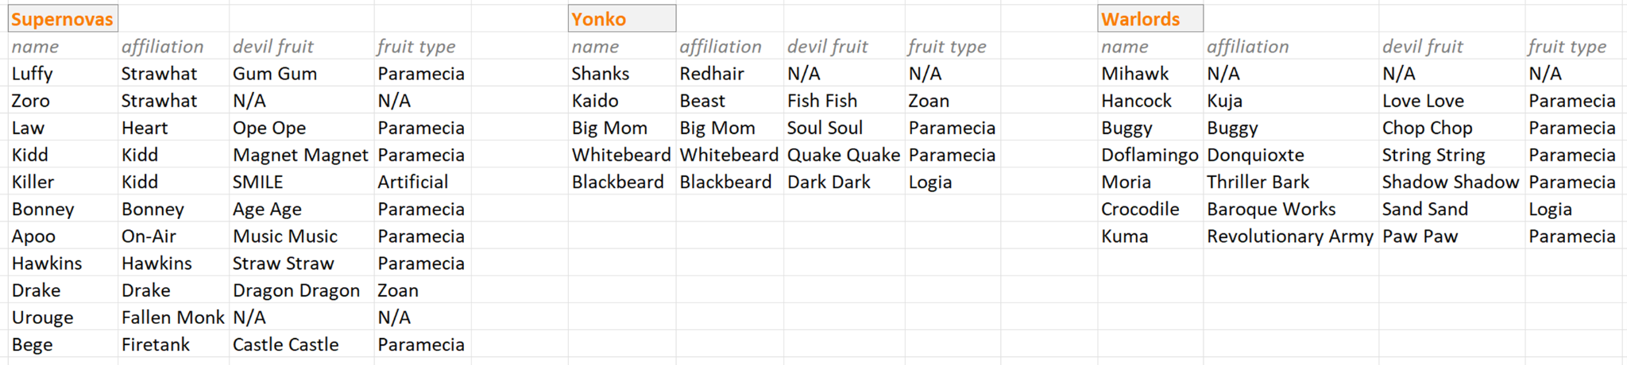

After:   
 