## horizontal line



CLOTHING BRAND

09.04.2024

**─**

Matheus Maciel Melchiades

Question 2.1

Prepare To connect to a database

# CLOTHING BRANDS

**Website Name**: Rip Curl

**Website Link**: [www.ripcurl.com/au](https://www.ripcurl.com/au)

**Data Collected:**

* Size
* Color selected
* Payment method
* Review of product
* Delivery instructions at checkout
* Postcode or suburb for store availability

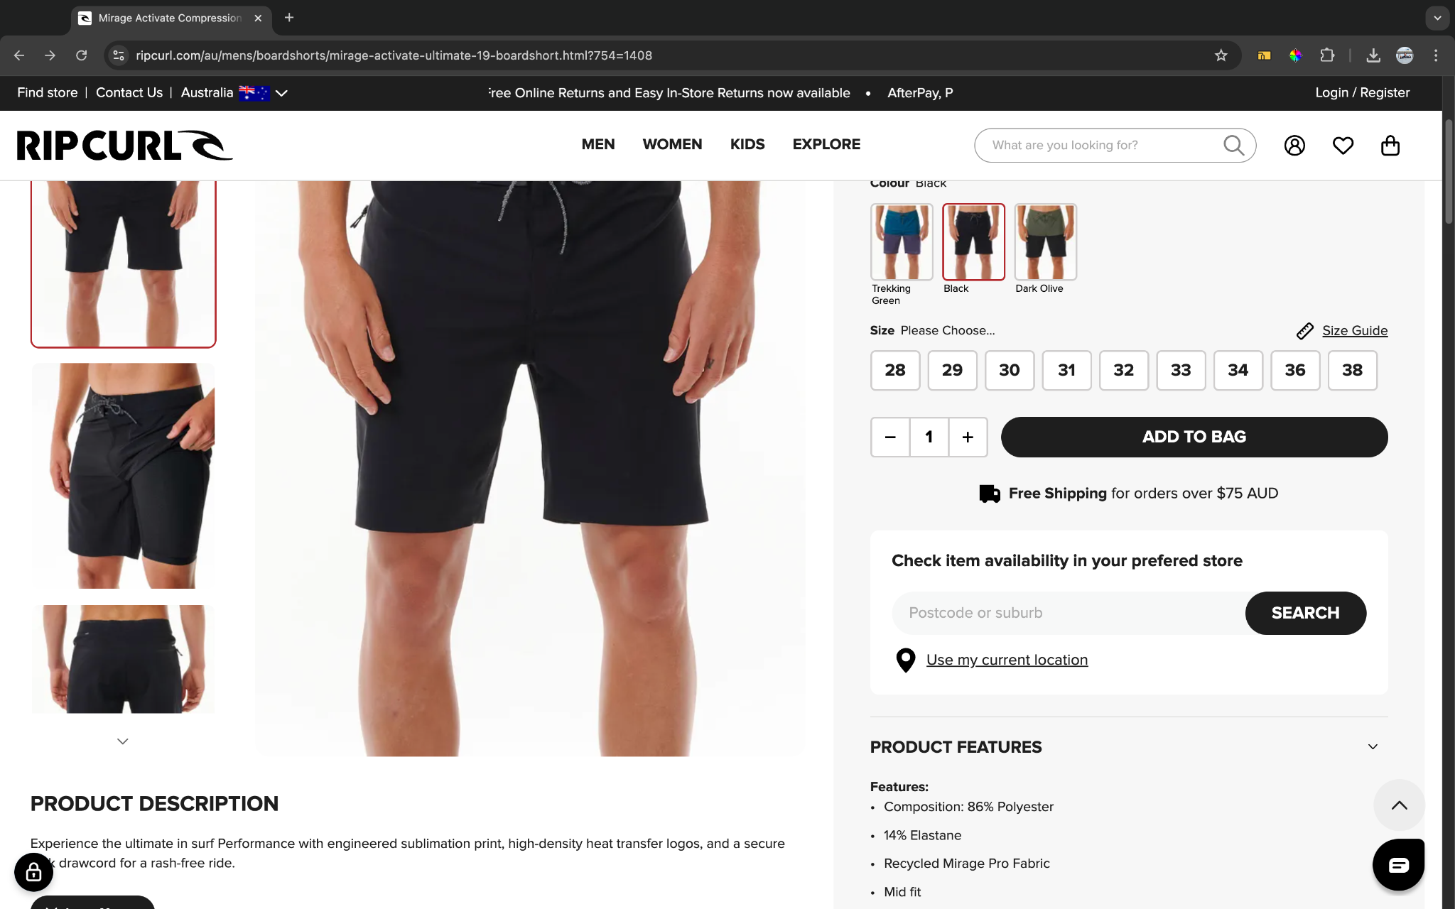

**Data elements:**

* Size: Numeric (Select from available options)
* Color: Selection (Black, Trekking Green, Dark Olive)
* Review: Text added (Star rating and written feedback)
* Postcode/Suburb: Text
* Name: Text (Not visible in screenshot but typically required)
* Email: Text (Not visible in screenshot but typically required)
* Phone Number: Numeric Values (Not visible in screenshot but typically required)

**Summary of Findings**

The Rip Curl website collects essential customer information to ensure proper order processing and delivery, such as size, color preferences, and location for store availability. This data helps streamline the shopping experience, offering customers relevant options based on their preferences and location.

**Website Name**: Billabong

**Website Link**: [www.billabong.com.au](https://www.billabong.com.au/otis-sun-t-shirt-3616750359366.html#cgid=men_clothing&start=10&hitcount=519)

**Data Collected:**

* Size
* Color selected
* Payment method
* Review of product
* Delivery instructions at checkout
* Postcode or suburb for store availability

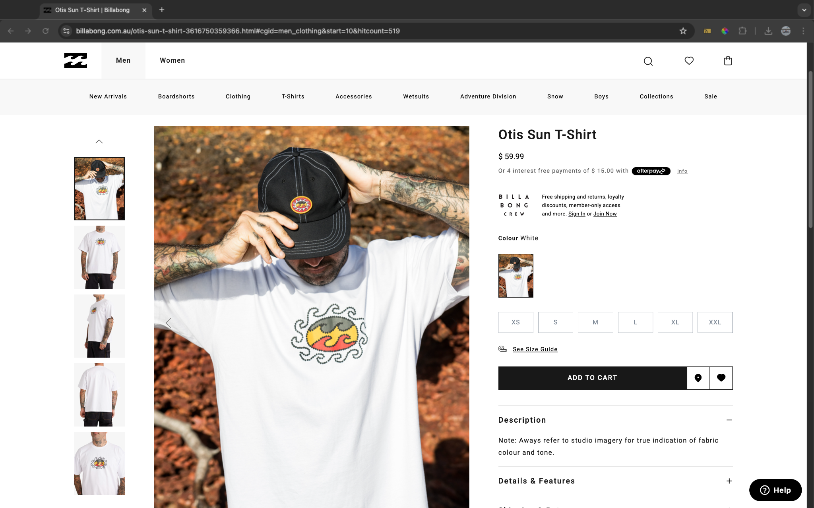

**Data elements:**

* Size: Numeric (Select from available options)
* Color: Selection (Varies by product)
* Review: Text added (Star rating and written feedback)
* Postcode/Suburb: Text
* Name: Text (Typically required at checkout)
* Email: Text (Typically required at checkout)
* Phone Number: Numeric Values (Typically required at checkout)

**Summary of Findings**

The Billabong website, similar to Rip Curl, collects critical customer information during the shopping process, including size, color preferences, and location-based availability. These details ensure a tailored and efficient shopping experience, making it easier for customers to find and receive the products they want.