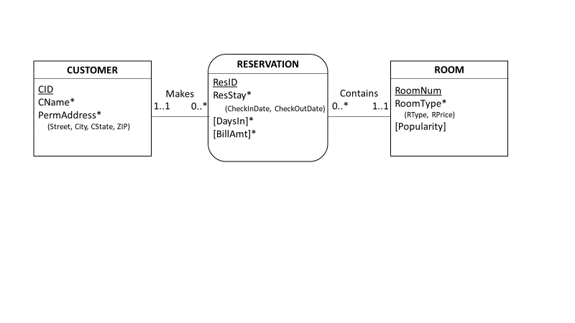

90%

10 APH

80 APH

80%

80%

75%

75%

100 APH

* For the Customer table, there are about 100 direct accesses per hour.
  + 75% of Reservation accesses reach Customer
  + 90% of Customer accesses reach Reservation
* For the Reservation table, there are about 80 direct accesses per hour.
  + 80% of Room accesses reach Reservation
  + Also, 80% of Reservation accesses reach Room
* For the Room table, there are roughly 60 accesses per hour.

**Relational Model Analysis**

|  |  |  |  |
| --- | --- | --- | --- |
| Table | Direct APH | Indirect APH | Total APH |
| Customer | 100 | (80*.75)+(10*.8*.8) | 66 |
| Reservation | 80 | (100*.9)+(10*.8) | 98 |
| Room | 10 | (80*.8)+(100*.9*.8) | 136 |