FAESA
SYSTEMS ANALYSIS AND DEVELOPMENT
FUNDAMENTALS OF COMPUTER NETWORKS

MATHEUS DIAS TECCHIO

Immersion to Computer Networks

Vitória/ES
2022
MATHEUS DIAS TECCHIO

Immersion to Computer Networks

Work of the discipline Fundamentals of Computer Networks presented by Matheus Dias Tecchio as part of the curricular grid of the Technologist in System Analysis and Development.

Tutor: Professor Jarbas Araujo.

Vitória/ES
2022
SUMMARY

1. my way of connecting to the internet 4
1.1 What transmission medium is used for data to be transported from the ISP to the computer 4
1.2 My ISP 4
1.3 Other equipment used to make the connection 4
1.3 How fast is my connection 5
1.4 Output of the "ipconfig" command on my personal machine 5
2. What is the Getmac command used for 5
2.1 Output of the "getmac" command on my personal machine 6
3. What is the ARP Protocol 6
3.1 Output of the "arp -a" command on my personal machine 6
7
REFERENCES 7

My way of connecting to the Internet

1.1 Which transmission medium is used for data to be transported from the access provider to the computer
In my personal computer, I use a twisted pair cable type Cat-5e 3 meters, which connects to my router, which is in my room. Already in my mobile phone, I use the Wi-Fi connection of this same router to connect to the Internet.

This router is connected by a twisted pair cable type Cat-5e 20 meters to the modem, which is in the living room of my house. And this modem connects to the access provider, which is on the street pole, by means of a coaxial cable.

1.2 My ISP
My ISP is NET.

1.3 Other equipment used for connection
The list of equipment to carry my transmission to my ISP is:

- Host's Network Card;
- Router;
- Modem;
- Access Point.

1.3 How fast is my connection
I contracted my plan for a 100 Mb speed and I have identified in a test that I am receiving 94 Mbps Download, and sent 62 Mbps Upload.

1.4 Output of the "ipconfig" command on my personal machine
My computer connects to the Internet using the Ethernet standard.
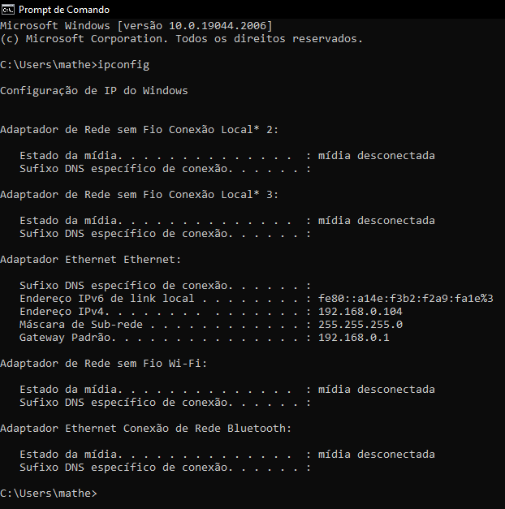

What is the Getmac command used for
Returns the MAC address and the list of network protocols associated with each address for all network cards on each computer, either locally or over a network. This command is particularly useful when you want to enter the MAC address into a network analyzer, or when you need to know which protocols are currently in use on each network adapter on a computer.

Output of the "getmac" command on my personal machine
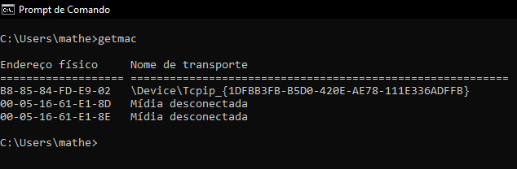

What is the ARP Protocol
ARP is a question and answer protocol used to dynamically map layer 3 (network) addresses to layer 2 (link) addresses. Typically, it is used to map IP addresses (Internet Protocol) addresses into MAC addresses (Media Access Control).

To control this mapping, the ARP protocol maintains a table called the ARP Table. Whenever a new packet with MAC or IP addresses appears and is not yet in the ARP Table or needs to be updated, the protocol modifies the table with the new data.

3.1 Output of the "arp -a" command on my personal machine

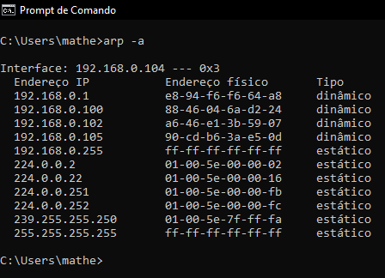

REFERENCES

Getmac. Microsoft, 2022. Available at: <https://learn.microsoft.com/pt-br/windows-server/administration/windows-commands/getmac>. Accessed on: 24, September 2022.

Gustavo Pantuza. THE ARP PROTOCOL - ADDRESS RESOLUTION PROTOCOL. Pantuza's Blog, 2022. Available at: <https://blog.pantuza.com/artigos/o-protocolo-arp-address-resolution-protocol>. Accessed on: 24, September 2022.

