**Introduction**:

In this exploratory data analysis (EDA), we aim to evaluate the communication and emotional qualities of 10 candidates based on their introduction videos. By analyzing their emotion scores, transcript features, and other related data, we aim to extract actionable insights that can assist in making informed recruitment decisions. The goal is to assess each candidate’s suitability for specific roles by identifying key traits such as emotional stability, communication effectiveness, and adaptability. Various visualizations, including heatmaps, spider plots, and correlation matrices, are used to present these insights in a clear and comprehensive manner.

**Distribution of emotions across all candidates together and seperately**

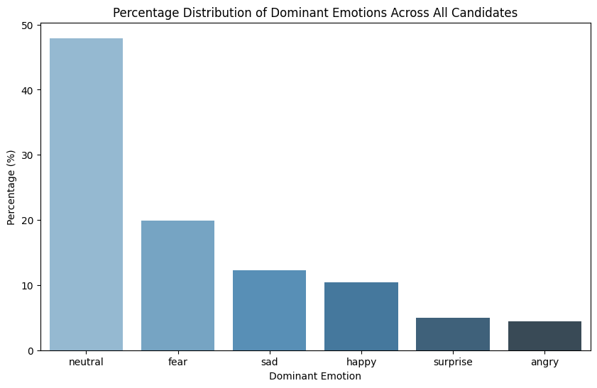

* This bar chart illustrates the percentage distribution of dominant emotions for all candidates. The **neutral** emotion is the most prevalent, covering nearly 50% of the emotional spectrum across candidates. Other dominant emotions include **fear**, **sadness**, and **happiness**, with smaller percentages attributed to **surprise** and **anger**.
* Candidates with a high dominance of **neutral** emotions might demonstrate emotional control and calmness, making them suitable for roles that require level-headedness under pressure.
* Emotions like **fear** and **sadness** appearing prominently may raise concerns about a candidate's resilience in high-stress environments, while **happiness** and **surprise** could indicate enthusiasm and adaptability.

**Side-by-Side Percentage Distribution of Dominant Emotions for Each Candidate**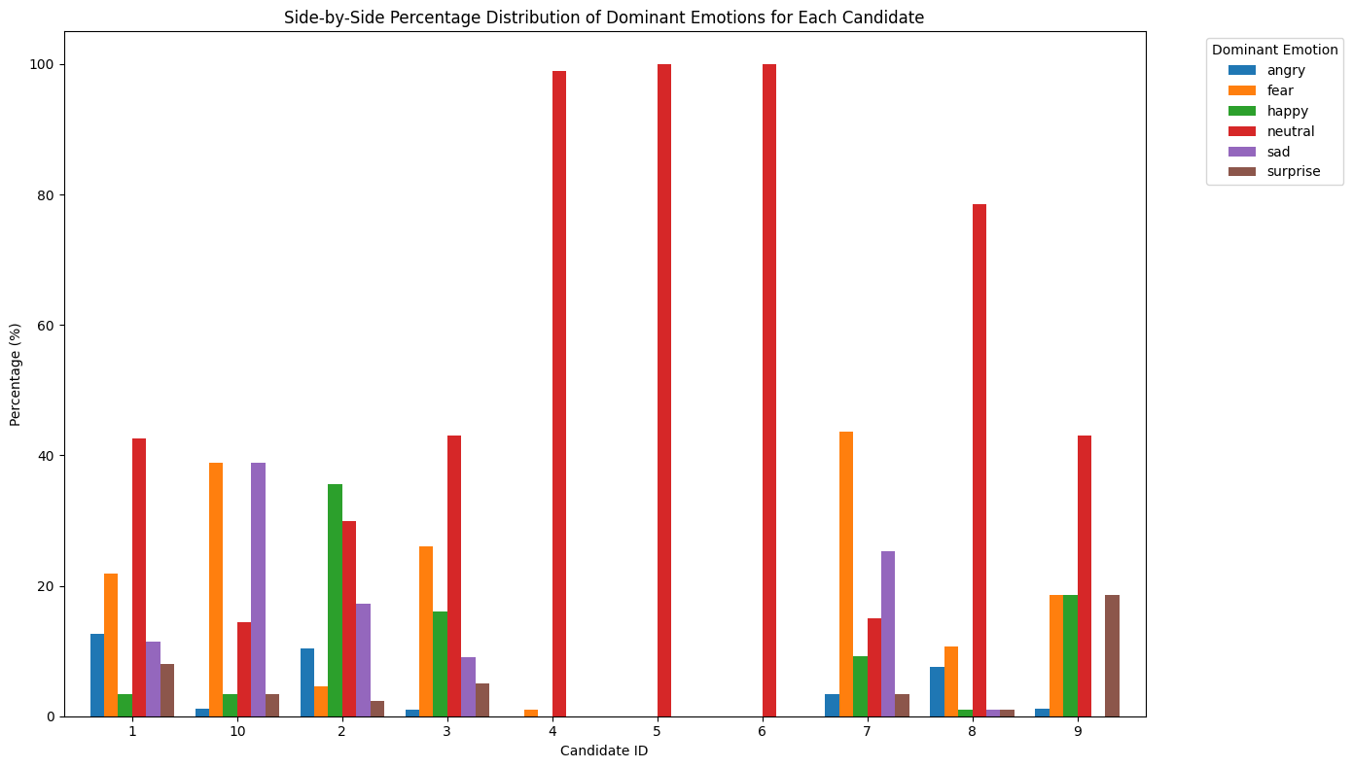

* This comparative bar chart shows the percentage of each dominant emotion (e.g., **neutral, fear, happy, sad**) per candidate. **Neutral** emotion is strikingly dominant in some candidates, while others exhibit a more varied emotional range, including **fear**, **sadness**, and **surprise**.
* **Emotionally Stable Candidates**: Candidates who exhibit a high percentage of **neutral** emotions may demonstrate strong emotional control and stability. Such traits are critical for roles where a calm demeanor is necessary, such as leadership, management, or high-pressure customer-facing roles. These individuals are likely to maintain composure, which can positively influence their decision-making and leadership presence.
* **Emotionally Dynamic Candidates**: Candidates showing a greater spread across emotions like **fear**, **sadness**, and **surprise** indicate more emotional variability. These individuals may be more expressive or responsive to situational changes, which can be advantageous in roles that require creativity, flexibility, or adaptability, such as **marketing**, **design**, or **dynamic team environments**. Emotional variation may also indicate higher empathy, which is important for roles that require understanding and responsiveness to others’ emotions.
* **Positive Emotions**: The presence of **happiness** in a candidate’s emotional profile, even in small percentages, can suggest enthusiasm and a positive outlook, which are valuable for roles that require high energy, team collaboration, or motivation, such as sales or public relations.

**Boxplot and violin plots of all emotion states for each candidates**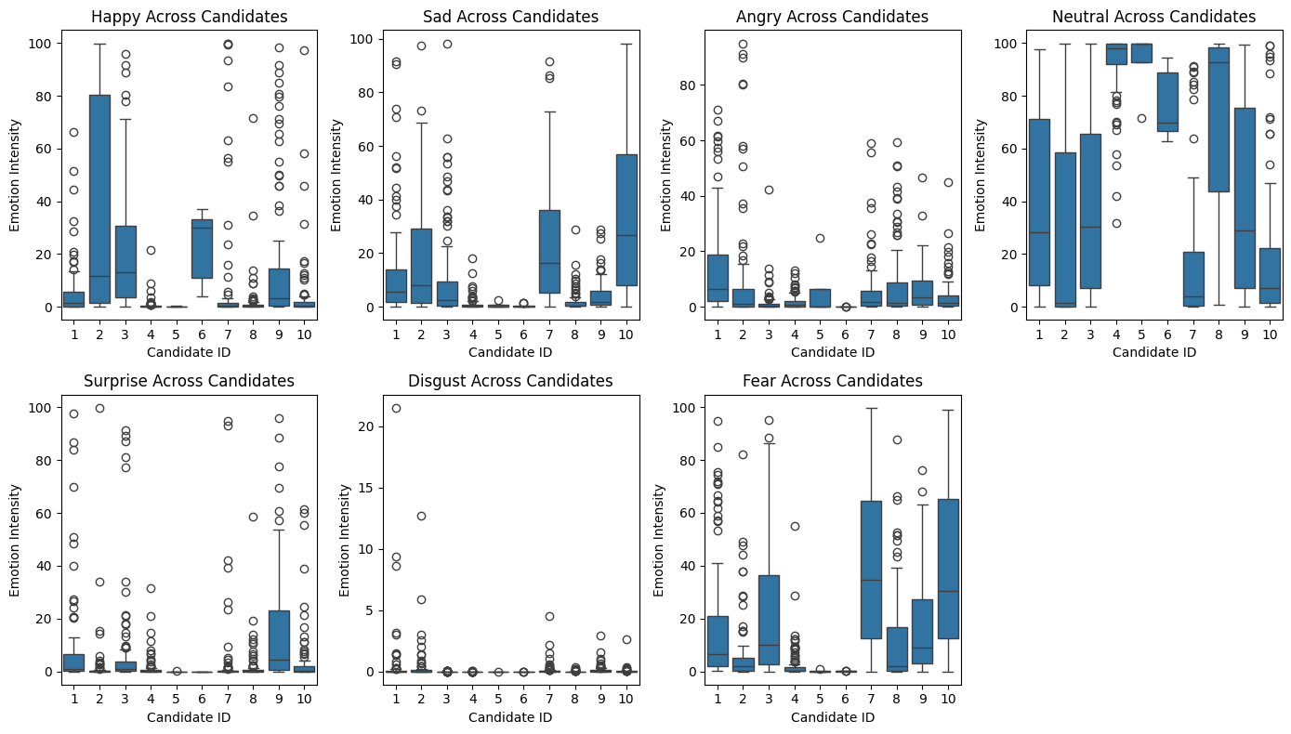

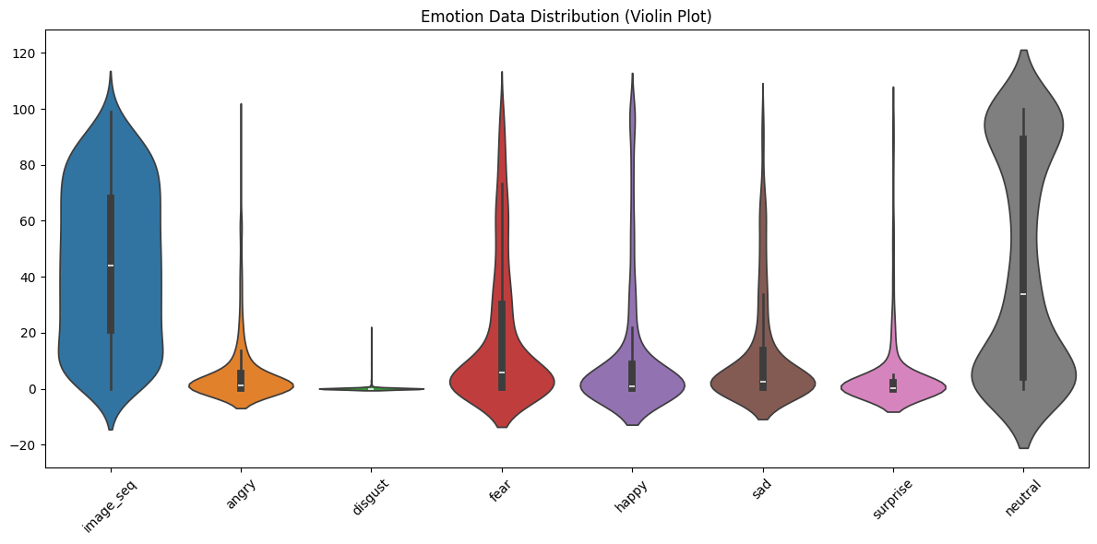

* These visualizations are focused solely on the distribution of **emotion scores** across all candidates. The **boxplot** gives a clear view of the spread of each emotion (e.g., **happy, sad, angry, neutral**) across candidates, highlighting key metrics such as the median, the interquartile range, and outliers. The **violin plot** complements this by showing the **distribution density** of these emotions, helping us understand where most of the emotion scores lie for each candidate.
* **Consistent Emotion Scores**: Candidates with narrow ranges in the boxplots may exhibit consistent emotional behavior, which could be a sign of emotional stability. For example, candidates with consistently high scores in **neutral** or **happy** emotions may be well-suited for roles requiring a calm and steady demeanor.
* **Outliers**: Candidates with significant outliers in emotions like **fear** or **anger** might require additional evaluation. While occasional spikes in emotions like **surprise** or **happiness** might reflect adaptability or enthusiasm, extreme emotional reactions like **fear** or **anger** could indicate potential challenges in high-pressure situations.
* **Density of Scores**: The violin plot reveals where most of the emotion data is concentrated. For instance, candidates with high-density regions in **positive emotions** like happiness might have a natural inclination toward optimism or positive interpersonal interactions, making them suitable for client-facing roles.

**Heat map of the features of emotion data**

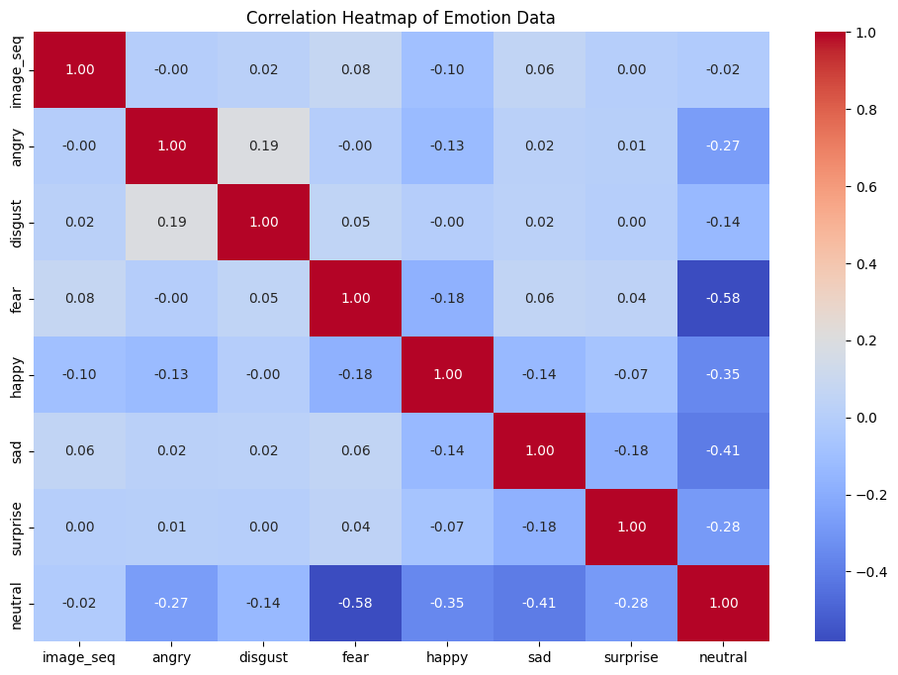

* The heatmap highlights the overall relationships between various emotions across all candidates. For example, emotions like **anger** and **disgust** show a slight positive correlation, suggesting that candidates who exhibit one emotion are more likely to exhibit the other in general.
* Notable negative correlations, such as between **neutral and fear** (-0.58) and **neutral and anger** (-0.27), suggest that candidates with more neutral emotions tend to experience lower levels of negative emotions like fear or anger.
* This may indicate that emotionally neutral candidates handle stress better and could be well-suited for leadership or high-stress roles.

**Gaze and Blink data for all the candidates**

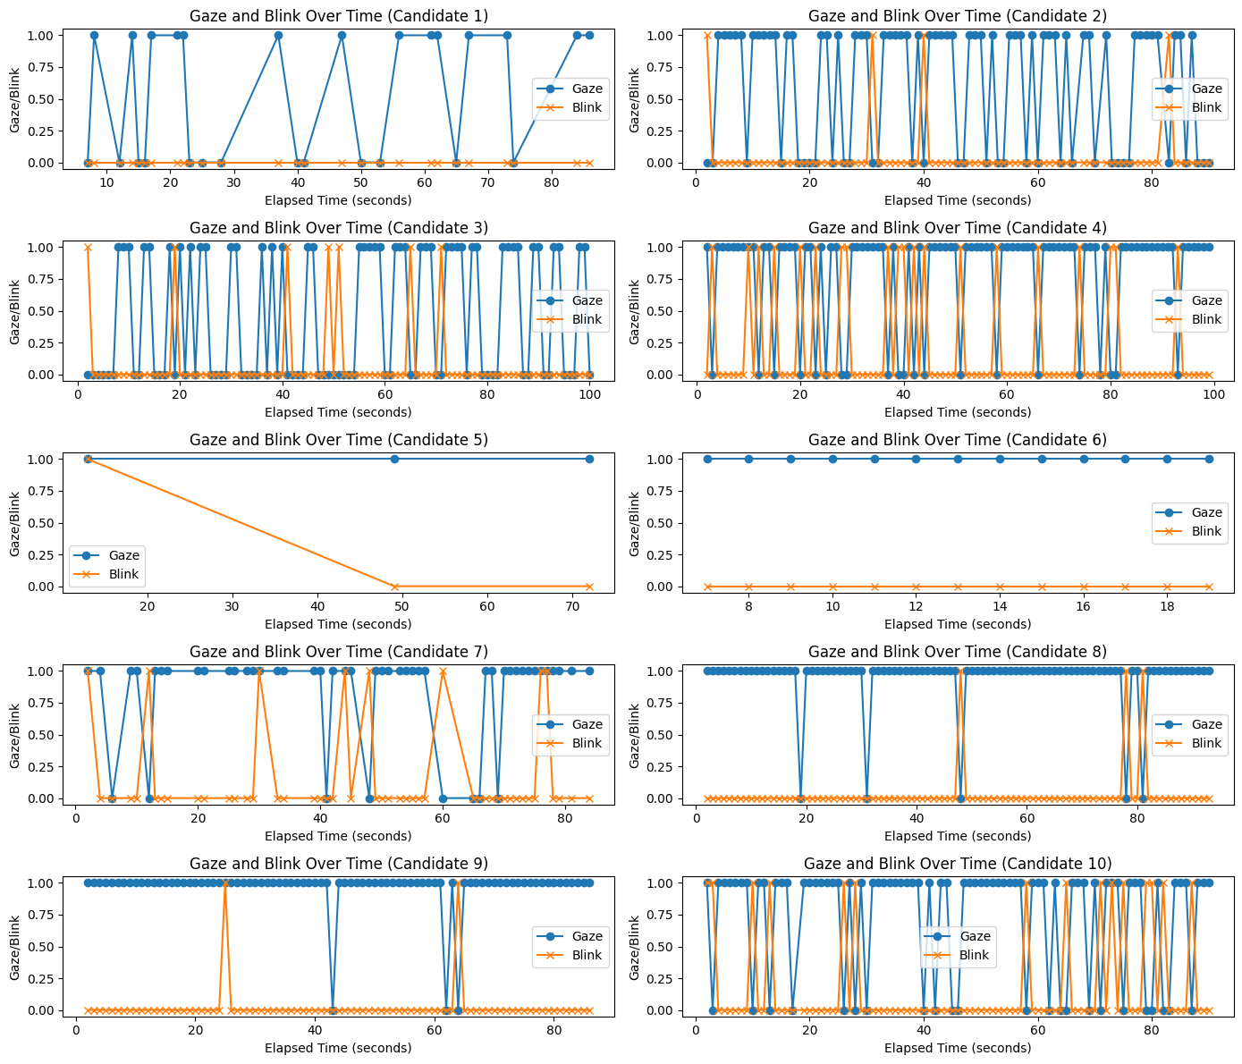

* This graph highlights the candidates' focus-related features, specifically analyzing **gaze direction** and **blink frequency**. These attributes give insights into the candidate's engagement and attentiveness during their introduction videos. By measuring how often a candidate blinks and how steady their gaze is, we can assess their ability to maintain focus.
* **Gaze Stability**: Candidates with a steady gaze might demonstrate high focus and attentiveness, which is crucial for roles that demand attention to detail or continuous engagement, such as customer support or consulting.
* **Blink Frequency**: While occasional blinking is normal, excessive blinking could indicate stress or discomfort, whereas too little blinking might indicate unnatural behavior or excessive focus. The ideal candidates would display a moderate, natural blink rate, reflecting calmness and steady engagement.
* **Recruitment Decision**: Candidates with stable gaze and moderate blink frequency are more likely to excel in roles that require prolonged focus and interaction, such as presentations or client meetings.

**Spider plot of the different emotions for candidates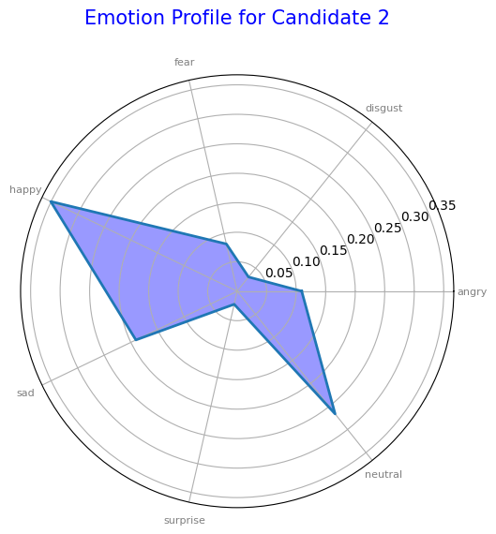**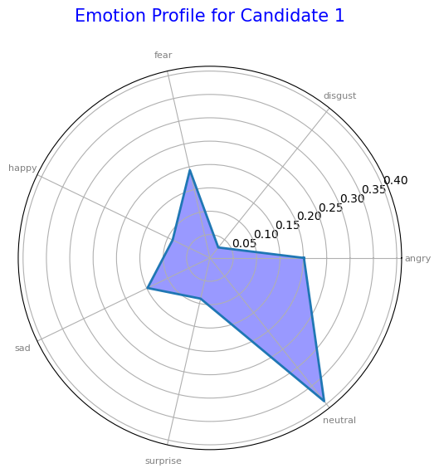

* The spider plot provides a comprehensive view of each candidate’s emotional strengths and weaknesses. The plot offers a quick glance at how emotions like confidence, enthusiasm, and hesitation vary among candidates.
* Candidates with balanced emotional profiles may be suitable for communication-heavy roles, while those who score high in specific areas might excel in specialized tasks.
* **Diverse Emotional Range**: Candidates who show a wider distribution across multiple emotions, such as **fear, anger, or disgust**, may demonstrate emotional variability. This variability could indicate adaptability in emotionally charged situations but may also suggest inconsistency in communication, which might be a concern for leadership or steady, client-facing roles.
* Candidates with higher scores in positive emotions like **happiness** or **neutrality** are likely to maintain a calm and positive demeanor, making them ideal for roles that require patience, emotional intelligence, and effective interpersonal communication, such as mentoring, customer service, or management.

**Transcript Profile Spider Plot for Communication Features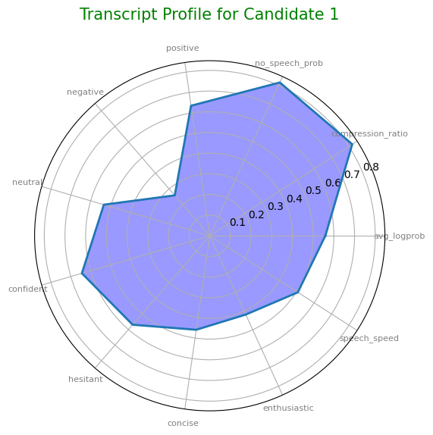**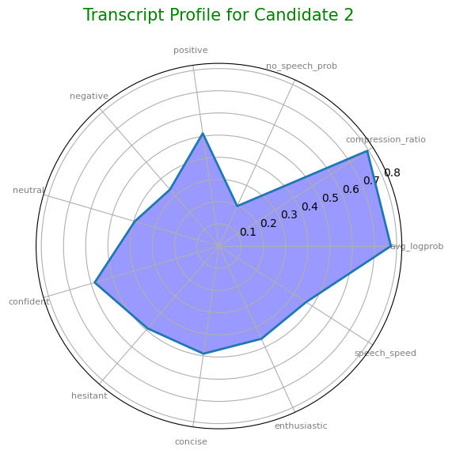

* The plot offers a quick glance at how well each candidate performs in these areas. Candidates who show balanced profiles across these communication features are more likely to be clear and effective communicators, which is crucial for **client-facing** or **presentation-heavy roles**.
* Candidates with more balanced profiles across the various communication metrics (like Candidate 1) demonstrate well-rounded speaking abilities. This indicates they are likely to maintain **clarity** and **confidence** throughout their speech, making them suitable for roles requiring regular communication, such as **sales**, **customer service**, or **management**.
* Candidates who score higher on **confidence** and lower on **hesitancy** are likely to communicate more effectively under pressure and in high-stakes situations, such as presentations or negotiations.
* Candidates with a **high level of balance** across communication qualities—such as **confidence, speech speed, and conciseness**—are more likely to excel in communication-centric roles. These candidates are often well-suited for leadership, marketing, or sales, where the ability to convey ideas clearly and confidently is essential.

**Correlation matrix between features of emotion data and transcript data**

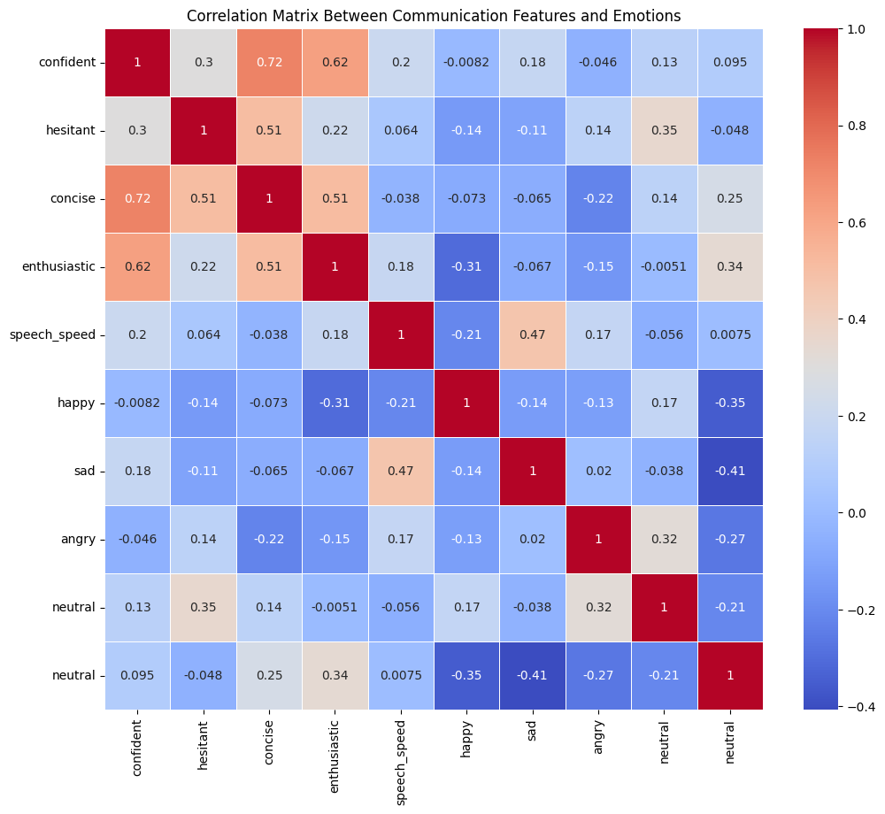

* **Strong Positive Correlations**: There is a notable positive correlation between **confidence** and **conciseness** (0.72), as well as between **confidence** and **enthusiasm** (0.62), suggesting that candidates who communicate confidently tend to be concise and enthusiastic.
* **Emotion and Communication Overlap**: The matrix shows that **speech speed** correlates positively with **sadness** (0.47), indicating that candidates who speak faster may also express higher levels of sadness during their speech, which could influence communication style.
* **Balanced Emotional Influence**: **Neutral emotion** correlates positively with **hesitancy** (0.35) and negatively with **sadness** (-0.41), suggesting that candidates with more neutral emotions are less likely to express sadness but may show more hesitation during speech.

**Conclusion**:

The results of this analysis provide a comprehensive view of each candidate’s emotional and communication strengths and weaknesses. Candidates exhibiting balanced emotional profiles, high confidence, and strong communication skills are likely to excel in leadership, customer-facing, or high-pressure roles.

This report demonstrates how emotional and communication data can be effectively used to make informed recruitment decisions, ensuring candidates are aligned with the demands of specific roles. These insights can be applied to future candidate evaluations, allowing for a more objective and data-driven selection process.