**HARA Policy (Helpful AI & Robotic Advancement)**

**STAR1**

1STAR AIR, STAR GROUP, Internet

star.technology@gmail.com

**ABSTRACT**

Recent development in AI (Artificially Intelligent) has led to fear of human unemployment. This paper hopes to separate them and keep them independent of each other. So that both can continue developing without interfering with each other.

This paper aims to resolve the clash between human and AI development by making a set of guidelines that can be followed in AI and Robotic development to prevent them from entering human fields.

Following the Guidelines will keep robots in fields that humans cannot enter. Hence preventing clashing.

This paper is still in development and is ongoing research.

1. **INTRODUCTION**

**A. CURRENT STATE**

AI and Robotics are rapidly developing fields being integrated into many other fields. AI models with the help of neural networks can learn things that humans do by using large amounts of data, often this makes them capable of doing these activities better and faster than humans can.

Current recent development in AI and robotics include text-to-image models, text-code models, Industrial Robots, and other systems.

Since they can often do these activities faster and better than a human, it has led to fear of unemployment issues.

**B. PROBLEM MOTIVATION**

Unemployment is a serious issue, not only will AI taking human Jobs create problems on economic and financial issues, individuals will also face lots of problems and new laws and grants will be needed to be made to counteract this problem. It would also cause problems with people not being fulfilled with themselves as they won’t have work to give them a sense of work, they may also become less physically and mentally challenged leading to even more unknown problems.

**C. PROPOSED IDEAL STATE**

An ideal state by the HARA committee(currently consists of only one person) would be one in which robots and humans develop independently of each other and do not interfere. Humans do things that are within their physical and mental capabilities. While robots do things that humans can’t do. This could be when it is too dangerous or complicated. This does not include development in which machines and robots advance human work. Robots that are fully automated fall into the robot development category and ones which do not go into the human development category.

1. **APPROACH AND SOLUTION**

To solve this issue, 2 possibilities are:-

1)Creating guidelines that robot and AI engineers will have to follow.

2)Creating a scoring and certification system to further encourage people to follow these guidelines.

The Guideline can be made to follow some of these requirements:-

-Entering fields where it is physically or mentally impossible(within a certain time frame) for humans to get in.

-Measuring how humans and robots are developing and manually creating laws that won’t allow robots to get into human fields.

-If only these won’t satisfy the need for robot & AI development. Only under certain conditions the HARA policy also allows for robots & AI to enter 3D’s of Robotization.

Dull, Dirty, and Dangerous Jobs.

This will be further explained in the Guidelines-approach section.

To compel more people to follow the HARAguidelines

We will also make HARA scores that will be calculated based on a lot of different factors and certifications for companies that make their robotic and AI systems follow the HARA guidelines.

This will be further explained in the Guidelines-approach section.

1. **GUIDELINES-APPROACH**

Based on what the HAA policy wants to achieve. One of the ways to achieve it is to create a set of guidelines that people will have to follow.

One of the ways AI and human development can be made independent is to make sure that AI and robotic development happens in areas and fields where humans can’t enter. AI is artificial intelligence it hopes to create machines that have human-like intelligence. So, AI clones the mental aspect of humans, and when both mental and physical aspects are copied it leads to an intersection. So, it is best to keep AI in fields that humans can’t physically enter or make robots in fields that humans can’t mentally enter, with or without help. This can be done by making it physically or mentally impossible for a human to do.

As shown in Fig 1. A lot of current AI robotic development is at the intersection between human mental capabilities and physical capabilities. This is also where human total capabilities lie and this leads to a clash between robotic & AI and human development making.

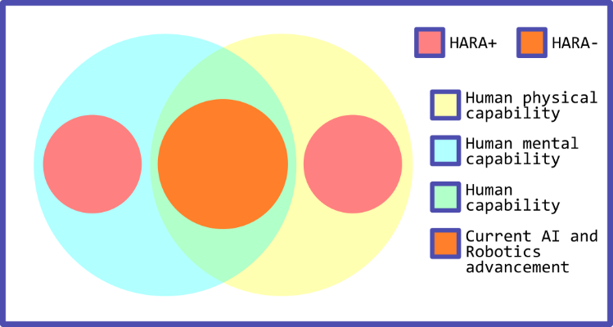

**Fig 1.** Venn diagram showing the possibility of HARA+ systems where it is impossible for humans to reach, on their own.

HARA+ systems lie within either one of the capabilities and thus do not cause a clash.

Another thing to make sure that these guidelines help not only in the present but also in the future so it is important that we estimate the trajectory of both where human and AI development and make sure that both of them also don’t intersect.

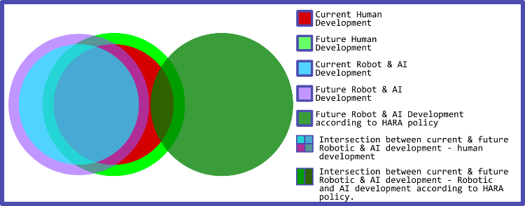

**Fig 2.** A Venn diagram showing a summary of what kind of robotic and AI development the HARA policy hopes to achieve.

If these are not enough, robots and AI will also have to enter human fields but these will but done only after lots of consideration. Laws will have to be made to make sure that these reasons are legitimate and robots and AI will have to enter those fields. The most common of the fields are the already popular 3D’s of Robotization or more recently the 4D’s of Robotization.

These include Dull, Dirty and Dangerous Jobs. Dear is also included in the 4D’s of Robotization.

Though some of the jobs in these fields won’t have serious effects if replaced by robots. Some others will have serious effects as they are heavily populated by human workers. So regardless of whether these jobs are Dull or Dirty, it will lead to unemployment, and as long as they don’t have better jobs to get this will lead to a lot of economic problems. So entering these fields should be a last resort and will only be allowed after serious review from a committee.

Dangerous jobs will have a higher consideration over others as this risk’s a human’s life or health. While the other 3 are just tedious or socially or mentally harmful and are often temporary.

It is also important to note that a single person making these laws will not suffice, as this is a major issue and therefore is made open-source so all people from around the world can team up and work on these issues.

A committee will also need to be made to specifically moderate it as the HARA policy can not remain the same, as humans and robots develop the HARA policy must also develop and change to meet the requirements.

**IV.GUIDELINES**

As discussed in the approach the set of guidelines are:-

1. Robots should do things that are impossible for humans to do.
   1. These include tasks that require human-like intelligence but are met with physical constraints.
   2. These also include tasks that require human-like form but are met with mental constraints.
2. HARA policies should make sure that these are valid in the present and the future.

2.1) The policies and score should be updated yearly. By the community.

1. If required developers will be allowed to step into the 4d's

3.1)Dull – These are the repetitive and tedious tasks robots are uniquely qualified for. Tasks that lack any creativity.

3.2)Dirty- These are unsanitary or hazardous tasks. These are tasks that humans don’t generally won’t to do.

3.3)Dangerous- These are jobs that could lead to physical or mental harm to humans. Unique properties could be used to make robots resistant to these harms.

3.4)Dear- Expensive or critical process where robots can cause lots of economic advantage.

1. Developers should only step into 4d’s under very unique circumstances, this should always be the last case scenario. The community will decide whether a certain project will be allowed.
2. If the above points are met, but humans have already entered the field by some method, then the community will decide if that development is allowed.
3. Community decisions will be made based on a vote. The majority vote will be ruled as final.

**V.SCORE-APPROACH**

HARA score is marked based on how well a system obeys the HARA policy.

It will be based on a lot of different factors given in Table 1.

These scores will also go along with a certification for getting this particular score. These things will hopefully encourage companies to follow the HARA guidelines.

This score will also be guided by a committee. Factors affecting the score will be clearly visible to the public for transparency.

TABLE I  
HARA SCORE

|  |  |  |  |
| --- | --- | --- | --- |
| **Sl.No** | 1. **HAA SCORING SYSTEM** | | |
| **Topic** | **Score Range** | **Weightage** |
| 1 | Number of Guidelines followed. | 0 to +10 | 20 |
| 2 | Number of guidelines broken | 0 to +10 | 10 |
| 3 | Community Score | -10 to +10 | 5 |
| 4 | Impossible for humans to do or 4D’s fields or other fields. | +1 or -1 or -2 | 2 |

**V.SCORE**

HARA score is marked based on how well a system objects to the HARA policy.

As shown in Table 1 the HARA score will be based on this table (as of version 1.2 this is still in a very early stage we hope to develop this in the future)

The total score will be based on +25 to -25 positive following HARA policies, 0 and negative, following HARA policies.

**V.EXAMPLES**

To further understand these guidelines, these are some examples of systems that obey the HARA guidelines.

**A. Nuclear Sites**

Nuclear Sites are an example, as high amounts of radiation are harmful to humans and are thus physically impossible for humans to enter. Thus robots can be used in these fields.

**B. Underwater beyond human limit.**

There is a limit to how deep humans can go underwater. Though this is further extended by scuba suits and other equipment and hence are under rule 5 of HARA guidelines. This is also under human development. But there is also a limit to how deep these suits(in the present this may change in the future and is explained in the next example) can go and hence robot’s can be developed for these purposes.

**C. Interplanetary space expeditions**

Robots can also be used to travel to other planets and on space expeditions, though even though this is possible with space suits, there are current limits, and though this may change in the future. If it is outside the period set by HARA guidelines. Then this development will also be deemed ok.

**D. For leading human development**

As shown in some of the above examples a lot of the HARA+ work can be done by humans in the future, outside the period set by humans. But this can change as told before HARA policies should be evolving. So robots could act as leaders which originally start something and humans can follow. For example in space exploration robots could first do the work that human development has not achieved yet but as it is achieved robots will move on to the next stage.

1. **FUTURE WORK**

As mentioned on various occasions throughout the paper, this must not and can not be final as humans, robots, and AI are going to be developing and these guidelines need to develop with them. As of now, the HARA committee has only one member and this is not enough. We hope to open source this paper. And constantly edit (this is not the final paper) (git will track the various versions of this paper as they evolve throughout the years) (minor changes will be just updated on GitHub but will be kept as the same version in the research, guidelines, and score, but if major change are made it will be made as a different versions in the research, guidelines, and score)

1. **CONCLUSION**

This paper will hopefully prevent robots from interfering in human development and prevent fears of unemployment. This will also hopefully help engineers and developers make better and more helpful systems.