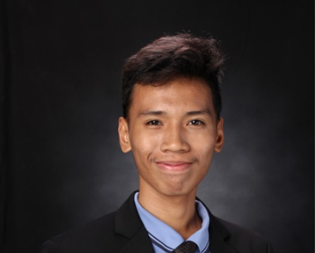**Dalisay, Mathew F.**

B307A El Pueblo Condo., King Christian St., Kingspoint

Subdivision, Brgy. Bagbag, Novaliches, Quezon City

09156915704

[mathewdalisay@gmail.com](mailto:mathewdalisay@gmail.com)

**Objectives:**

To create a web application and website that would benefit to our community. Explaining every line of code very clearly and databases to our beloved students with excellent communication skills.

**Skills and Interest:**

-Computer Literate (Backend Developer, System Analyst, Database Management, Microsoft Office, Computer Hardware Servicing)

-Programming (Java, c#, VB.Net, HTML, PHP, MySQL, JavaScript, CSS, Bootstrap 5)

-Communication Skills

-Still learning about (Kali Linux & front-end developing)

**Personal Data:**

Date of Birth: October 1, 2000

Age: 20

Place of Birth: Calamba, Laguna

Height: 5’7

Father’s Name: Noli Dalisay

Mother’s Name: Leonida Francisco

Religion: Christian

Sex: Male

Civil Status: Single

**Educational Background:**

Tertiary: Bachelor of Science in Computer Science

University of Manila

3rd year student, undergrad

2019-2022

Secondary: STEM – Science technology Engineering Mathematics

Gardner College

2018-2019

Tandang Sora National High School

2016-2017

Primary: Post Elementary School

2011-2012