

**The Automation of SF10 for Placido Del Mundo**

**Elementary School**

Presented by:

Dalisay, Mathew F.

De Jesus, Stephanie Ann E.

Gamit, Thaddeus Jude

Lapore, Jade Mark

Tecling, Ryan B.

Yu Vega, Anthony R.

Presented to:

Mr. Roger Plaza

**Table of Contents**

……………………………………………………………………………………………………………………….......

|  |  |  |
| --- | --- | --- |
| Acknowledgement  ………………………………………………………………………………………………………………………................... |  | 3 |
| Introduction |  | 4 |
| History | ………………………………………………………………………………………………………………………..............  ………………………………………………………………………………………………………………………............................ | 4 |
| Mission/Vision  ……………………………………………………………………………………………………………………. |  | 8 |
| Background of the Study |  | 9  ………………………………………………………………………………………………………………………... |
| Organizational Chart | …………………………………………………………………………………………………………………. | 10 |
| Statement of the Problem |  | 11  …………………………………………………………………………………………………………………….. |
| Objectives of the Study |  | 11  ………………………………………………………………………………………………………… |
| Review and Related Literature | ………………………………………………………………………………………………………………………................... | 12 |
| Old System |  | 13  ……………………………………………………………………………………………………………………… |
| Old System Flowchart | ………………………………………………………………………………………………………………………................. | 14 |
| New System | ……………………………………………………………………………………………………………………….... | 15 |
| Data Flow Diagram |  | 16  ………………………………………………………………………………………………………………………....... |
| System Flowchart | ………………………………………………………………………………………………………………………..... | 17 |
| Definition of Terms |  | 18  …………………………………………………………………………………………… |
| Hardware and Software Requirements | ………………………………………………………………………………………………………………………................... | 19 |
| Conclusion | ………………………………………………………………………………………………………………………................... | 20 |
| Summary | ………………………………………………………………………………………………………………………......... | 20 |
| Recommendation | ………………………………………………………………………………………………………………………................. | 21 |
| Bibliography | ………………………………………………………………………………………………………………………......... | 21 |
| Documentation |  | 23 |

**Acknowledgement**

This study materialized through the unwavering support of many individuals, whom we are wholeheartedly grateful for. We, the researchers, would like to thank the following:

First and foremost, we offer this endeavor to our God Almighty for the wisdom, strength, peace of mind and good health He bestowed upon us throughout the rollercoaster ride of pursuing this study; for being the listener when we are all burnt out; and for having our back in all difficulties.

Most especially, we would also like to express our deepest gratitude to our families, for their unparalleled love, moral and financial support and relentless inspiration. They were the shoulders when we were exhausted. To our parents, we are thankful for believing in us and motivating us from the construction to the completion of this study.

We sincerely like to thank our Friends and inspirations, for those people who are supporting and willing participants to help with our study;

We would also like to appreciate ourselves as Team Agnat as the researchers of this study, for the cooperation, hardwork, sleepless nights, and trust of each other to finish and make this research possible.

**Introduction**

Learner’s permanent record or as we knew as form 137. Today, this is SF10 form that contains the learner’s details and the historical academic and co-curricular records. There are two basic school records upon the student, one is the Form 137 and the second is form 138. Form 138 shows the academic performance of learners in a given school year.

The Bulk of transactions on transfer of learner’s school records normally happen during the enrollment period to the other schools and after opening class. To transfer data SF10 to the other schools you need a fax or via post office or courier to deliver the SF10. However, the registrar of the originating schools must provide the following requested SF10 with the date when documents have been sent.

**History**

Placido Del Mundo Elementary School was first known as Talipapa Elementary School. It was opened sometime in April 1922, for the operation of Barrio Talipapa, Caloocan. After some time, it was changed to Tandang Sora Elementary School which was supervised with fervent devotion by a man whose only aspiration in life was to have a small school that would respond to the academic needs of the children in the locality. This man was no other than Don Placido Del Mundo.

As years passed, the number of students multiplied so there was a need for expansion. On April 6, 1924, the second building was built, followed by the third one on February 7, 1925. After nine years, on May 5, 1934 the fourth building was built. Don Placido Del Mundo sought the assistance of Pedro Magsalin who redily contributed the amount of Php 3,000.00 from his pork barrel. Another Php 3,000.00 came from Ignacio Santos Diaz and Simeon Toribio on April 10, 1946. The last building, the Gabaldon Building which was the oldest building, was built in 1953 to 1957 with Php 73,000.00 assistance from Eulogio Rodriguez Sr.

The local government of Quezon City purchased the 9,648 sqm lot in the amount of Php 173,664.00 in 1965 from Don Simeon Toribio. The Home Economics Building or Sining ng Pantahanan was then constructed on June 21, 1967. This was during the term of Mayor Norberto S. Amoranto who extended all the needed help and assistance for the school.

More buildings were constructed during the years 1970 to 1980. The RPUS Building with three classrooms was built to house the Special Education classes or SpEd – for children with special talents. This was later maintained by the General Parent-Teacher Association. After some time, the Pre-Fabricated Building or Marcos Building was built with six rooms in May 1994 which was later used by Grade One pupils. With the increasing number of pupils coming from neighboring barangays and nearby subdivisions, the school administration requested another building from Mayor Adelina S. Rodriguez who was then the City Mayor of Quezon City.  The Federation of Filipino-Chinese Chamber Commerce and Industry headed by Mr. Yao Ka Po of Rubber World Philippines, Inc. donated a building with two classrooms in 1982. Two other buildings were constructed in 1984 which were later converted into Feeding Center and the School Clinic both of which received recognition as the Most Functional and the Most Effective Feeding Center and Clinic in the division.

Tandang Sora Elementary School became a performing and fast growing school in the division, school administrators, PTA Officers, teachers and parents sought the assistance of Assemblyman Estanislao Alinea and Rodolfo Quiambao to change the school’s name from Tandang Sora Elementary School to Placido Del Mundo Elementary School in honor of the man who initiated the construction of an elementary school in Talipapa. The said change of name was signed by Pres.  Ferdinand E. Marcos on May 6, 1984.

The Mathay Hall, a three-story building with 12 classrooms and water tank was built through the initiative of Mrs. Minda Jarbadan and Dr. Evelia Duremdes, PDMES principals. It was inaugurated in December 1994. This happened during the time of Mayor Ismael Mathay Sr who in turn donated a Covered Court which served as a venue for graduation rites, school programs and other activities. The construction of the Covered Court was facilitated by Brgy. Capt. Rogelio P. Juan who had always been supportive of all the undertakings of the school. From the funds of the General PTA, four other classrooms were built in 1995 with Mrs. Petronila Garcia as principal. In 1999, through the leadership of Dr. Milagros O. Luang had clear direction in all aspects of education. In English, she put up a Communication Center at the Fourth floor of SBI; a Filipino Service Bureau was put up at the Gabaldon Building showcasing all areas of concern in Filipino. A Toy Library with a play area was also built just beside Gabaldon Building.

In 2002, Sonny Belmonte Building otherwise known as SB I was built replacing the Old Tandang Sora Building. It is a four-story building with 16 classrooms and two comfort rooms per floor. Grade V and VI pupils hold their classes here. Another four-story Sonny Belmonte Building or SB II was constructed in 2006 with 18 classrooms during the administration of Mr. Joseph B. Acio, as the principal. Grades I, II, III and IV hold their classes here.

Dr. Lea G. Talosig, the 11th principal of PDMES added more beauty and grandeur to the school as she was very particular about the cleanliness and beautification of the school as a whole. Many big events and celebrations happened here as a result of the extensive efforts of the administration, parents and teachers to showcase what PDMES was then. She had focused her efforts toward academic excellence as shown with the honors and winnings achieved by the school. Another building was built sometime in 2008 – the DepEd Building which housed the kindergarten pupils, School Property Rooms, Mathematics Room, Computer Literacy Room. DepEd Kindergarten Model Classrooms were also built sometime February 2010, replacing the old PDMES Stage

The sudden transfer of Dr. Lea G. Talosig to Toro Hills Elementary School caused some problems but PDMES teachers being agents of change and obedient subordinates willingly accepted Dr. Rosemarie M. Yague as Dr. Talosig’s replacement on June 21, 2010. She instituted some reforms which the teachers readily acceded to. She continued the unfinished projects of the previous administrators like the repiping of Maynilad, improvement of the Home Economics Comfort Rooms, Gulayan sa Paaralan wherein a Bahay-Kubo donated by Makabayan group added the ambiance of a typical life in the province. She spearheaded the establishment of the Center for Excellence (CENTREX) for Grade I pupils whose intelligence quotient were above average under the helm of Mrs. Juliet R. Garcia, Master Teacher I. after Dr. Yague’s retirement, the said program stopped with the onset of the next administrator, Dr. Edgardo V. Morales from Payatas A Elementary School with 159 strong, committed and dedicated teachers. Dr. Morales is a workaholic administrator. He never rests on his laurels. He continuously finds ways and means to improve the reading level of the pupils because he wants zero non-reader rate. K12 is being implemented in Grade I SY 2012 – 2013, Grade II SY 2013 – 2014, Grade III SY 2014 – 2015 and Grade IV SY 2015 – 2016.

Dr. Morales introduced the Reading Intervention Program (RIP), a project out of the seminar-workshop he attended in Singapore to achieve zero non-reader rate. He sees to it that teachers, especially the new ones, are geared toward the improvement and enhancement of the learning level of the pupils. With the help of Mrs. Adela B. Lacaba, Head Teacher III and the Master Teachers – they work as a team to attain the desired goals and objectives of the school. In 2013, Castelo Building was built, a four-story building with three classrooms on each floor. The building caters to Grade V pupils. Footbridge was also built for easy access in going to Mathay Building and SB Hall I. To protect the school, he was able install 14 CCTVs. Through his effort to motivate teachers and stakeholders the school won in the Brigada Eskwela 2013 – 2014 for the Exceptional Category. He always reminds the teachers and pupils about the 5Ps, Prior Preparation Prevents Poor Performance. In fact, there are already 189 severely wasted pupils in the DSWD – School Based Feeding Program. “Leadership is less about your needs, and more about the needs of the people you are leading,” Dr. Morales said. He truly possesses some of the qualities of a 21st century leader, the ability to manage change, to motivate, analytic and problem-solving skills and strategic and visionary leadership.

**Mission**

To protect and promote the right of every Filipino to quality, equitable, culture-based, and complete basic education where;

Students learn in a child-friendly, gender-sensitive, safe and motivating environment.

Teachers facilitate learning and constantly nurture every learner Administrators and staff, as stewards of the institution, ensure an enabling and supportive environment for effective learning to happen.

Family, community and other stakeholders are actively engaged and share responsibility for developing lifelong learners.

**Vision**

We dream of Filipinos who passionately love their country and whose competencies and values enable them to realize their full potential and contribute meaningfully to building the nation.

We are a learner-centered public institution, the Department of Education continuously improves itself to better serve its stakeholders.

**Background of the Study**

Teacher’s from PDMES use a fax or post office to deliver the data of students to another school which may lead to delay the students to transfer, since this is a post office it takes 2 or 3 more weeks before they can receive it. Second one, human writing errors. They use a pen to write those grades and could be messy upon writing it and unreadable and uneditable. Third, the document is not properly sorted. They include the dates but some parts they couldn’t see properly in their pouch of document. This may lead to time consuming for the other school and missing or losing upon searching. Fourth, additional workloads for the teachers and lastly, not secured. This data is very confidential, leaners and/or their parents or guardians are not allowed to hand-carry the Permanent Records (SF10) to the receiving school. It is the policy statement of the DepEd regarding the schools.

Teachers will use the stand-alone web application to transfer the data to other schools. Some research uses a web app to be an Online Grading System that computes grades in all different subjects in the Basic Education Department (Andrienne Gail E. Ramos, 2011). None has focused specially in transferring the SF10 form to another school. The researchers propose this standalone web application for PDMES to transfer the data (SF10) to another school who requests to transfer to another school with PDF Converter via email from the system.

**Organizational Chart**

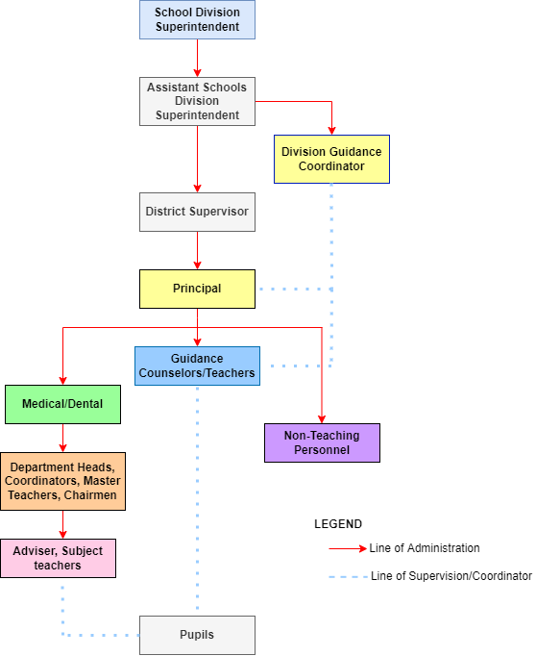

**Statement of the Problem**

* Using manual method – writing in a specific paper of SF10 may be messy because of unexpected erasures.
* Delivery – delivering the forms using fax or mail or courier may cause delay upon enrolling or transferring to other schools of the student.
* Overloaded workloads – teachers are having massive paper works from students due to school activities, and they might lose the SF10 on their site.
* Not Secured – Data is very confidential upon the policy statement of DepEd. Some people carry those data and lose upon delivering them into other schools.
* No proper pouch of documents – Since it is a very important document, they must keep it and have a copy of it. They may lose the documents because of inappropriate keeping of the data or may destroy by the insects since it is a paper.

**Objectives of the Study**

* Database – to store the data of the students that won’t lose right away and also, they may see where and when did they send it.
* System with Mailing – In the system, we include the sending files (SF10) and messages to the school.
* Downloadable PDF – This PDF includes the personal information, scholastic records, and other info of the students. They may print it out to get a hard copy.
* Sorted data – We can sort the data from grade 1 to grade 6 by date and are easy to navigate.
* Login – we create a login for the admin to ensure security.

**Review and Related Literature**

**Foreign Literature**

According to Elsevier B.V. (2011), the objective of Information Technology is to help humanity from doing loads of work overtime. By having a computerized system, the cost during enrollment will be cut down and effort will be reduced. The process of enrollment in schools nowadays requires information technology. The proponents now have a clear understanding of the value of information, the creation of new information; the retrieval of existing information, the storage of important information, and the disposal of redundant information. The proponent is aware of the cost of acquiring bad, incomplete, or inaccurate information that might encounter in the system.

Enrollment is the process of entering and verifying the data of students to register in a particular school. Different interrelated processes build up enrollment procedures called Enrollment System (ES). The enrollment system is a good example of a computer-generated process. This can lessen the workload and provide accurate information needed by the school. As a result, it will benefit not only the students but also the administration as a whole. They also aim to help increase the efficiency and productivity of the enrollment procedure with the help of the proposed enrollment system. (Evans Williamson, (2013)).

According to Bhakti (2015) A Database Management System is a program used to store, delete, update, and retrieve data in a database. These databases can be limited to a single desktop computer, or can be stored on large server machines too, like the IBM Mainframe. In the process of designing an enrollment system, the researchers will use a database management system in creating a database for their proposed system to store data. They also aim to design a good database so that the system can manage data and student records easily and efficiently.

**Local Literature**

The Online Registration System every school is the remedy for the long enrollment process of the school which is presented online. Enrollees will lessen their time and effort to go through the long process of the enrollment in the institution by this online enrollment reservation. They just check online for the instructions and the students just fill up the needed requirements. Furthermore, it is a collection of related components designed to support operations, management, and decision-making in an organization. The proponents include an Information System that supports people or users in making intelligent decisions based upon the information derived from reliable data. (Anne Ramirez (2013).

Stated by Fajardo et.al (2015) most schools used computers to help students deal with modern technology. However, as the population of the students continues to grow, many schools face difficulties in handling enrollment transactions. One of the solutions available to solve the problem is to transform the manual enrollment into a computerized system. The proponents will assure that the system database can handle the growing population of the students in the school. An Online Enrolment System was proposed to replace the manual enrolment system of certain schools around the Philippines.

In accordance with this study, a computerized enrolment system for a rural based higher education institution can give the staff of the school convenience in finding records of the students. It shows the importance of online enrollment especially in rural areas, because it helps the staff to find the records of the students easily and faster.

 Placido Del Mundo Elementary School was first known as Talipapa Elementary School. It was opened sometime April 1922, for the operation of Barrio Talipapa, Caloocan, Rizal Placido school causes some problems in terms of storing, retrieving and updating the SF 10 or known as the form 137 of every students in their school, the system of automation of SF 10 or Form 137 can be helpful to this school to stored and update the records of every students in placido elementary school. In this method the automation system of SF 10 can be sent through email, or can be printed, in this way the teacher and/or professors can access the records of SF 10 or form 137 easily.

**Old System**

They manually wrote the students information in a form and then they would request grades from the specific subject teacher. After they gather the information and the grades, they fill out the Form137/SF10 Form. And after they input all the data, they will verify and double-check all the data in case there’s an error, typographical error, or mistake. After that, if there is no error or mistake, they print it and give it to the students who are requesting it.

**Old System Flowchart**

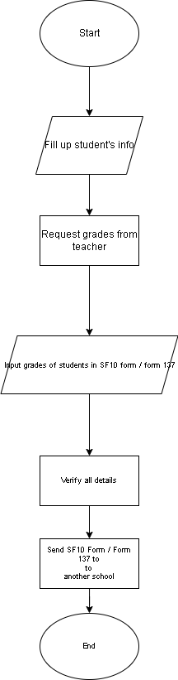

**New System**

They don’t need to write the information/data on paper; they will just input it directly into the system. First, the admin needs to log in and then search for the student’s name who is requesting the SF10 form/Form137. Second, after you search the name of the students, check if that student already has data in the system, if not fill out all the information given and then save it and after you save it, it is automatically in a PDF form. And if you already have the data/information or if you already fill out the form, click the name of the students and you will see all his/her information in a PDF form, and if you want to delete and edit the students data, after you search the name beside of his/her name there’s an action button, the delete and edit button just click the button of what action you will do. And lastly, check all the information there, the student info and the grades, and if there’s no problem, you can choose either of the two; to print it or to send it to the school where the student will transfer via email.

**Data Flow Diagram**

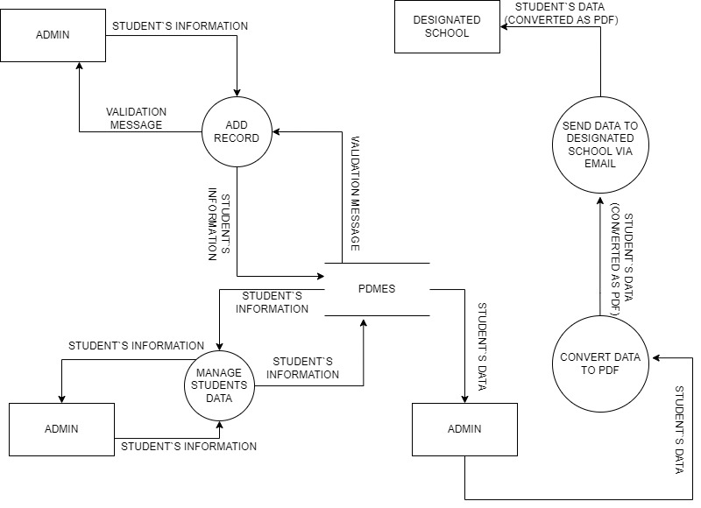

**System Flowchart**

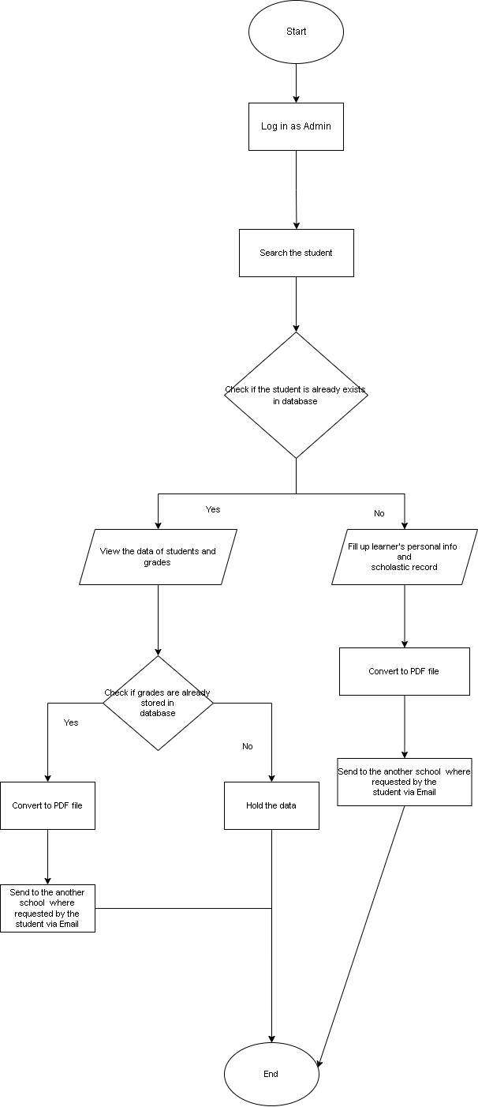

**Definition of Terms**

**SF10** – also known as Form 137 that is a record of attendance, participations, and grades. An essential school requirement for transferring and/or enrolling for a new school.

**DSWD** - Department of Social Welfare and Development (DSWD)

**DepEd** – Department of Education

**Proponent** - a person who advocates a theory, proposal, or project.

**Learning System** – it is a compilation of data about resources for learning; a means for creating and storing learning resources.

**Online Requirement -** something that is essential or needed to submit in a specific place or school through online.

**Database Management** - is the practice of collecting, keeping, and using data securely, efficiently, and cost-effectively.

**Database** - a structured set of data held in a computer, especially one that is accessible in various ways.

**PDF** - Portable Document Format this is a file format for the Sf10 that will print or send through email.

**Xampp** - it is a cross-platform where you will create the database.

**Browser** - a computer program with a graphical user interface for displaying and navigating between web pages.

**CPU -** central processing unit (CPU), principal part of any digital computer system, generally composed of the main memory, control unit, and arithmetic-logic unit.

**Operating System (OS)** - is a software programme required to manage and operate a computing device like smartphones, tablets, computers, supercomputers, web servers, cars, network towers, smartwatches, etc.

**Software** - the entire set of programs, procedures, and routines associated with the operation of a computer system.

**Hardware** - the physical components that a computer system requires to function.

**System Memory** - is the place where the computer holds current programs and data that are in use.

**Hard Disk** - is one kind of technology that stores the operating system, applications, and data files such a documents, pictures and music that your computer uses.

**Hardware and Software Requirements**

Software

- OS: Windows 10

- Xampp

- Any browser software

Hardware

- CPU: Quad Core 2.5 Ghz or more

- System Memory: 2GB or more

- Hard Disk: 12 GB or more

- Keyboard

- Mouse

- Internet Connection Required: at least 25mbps

**Conclusion**

In conclusion, the Placido del Mundo Elementary School can use the system Automation of SF10 to store, update, retrieve, and create a new form for every student that they have. In this method the researchers can be confident that the system is secure and that the Placido del Mundo Elementary School can easily use the Automation of SF10 system.

The Automation of SF10 works first, by the teacher/admin input, all the data of the student and the grades that they gathered in every subject teacher and save it. After that the teacher/admin can search the name of the student and check if there are errors, so, that teacher/admin can edit or delete it, and after the admin check it the teacher/admin can view the form in a PDF form and print it, or the admin can send it to the school through email where the student will enroll.

**Summary**

The Automation of SF10 for Placido del Mundo Elementary School is a system that can store and secure the data of every student, it generates the Form 137/SF10 in PDF form. The researcher adds some features like the SF10/Form 137 can send it to the school through email where the student will enroll.

The purpose of this research is to help the teacher to easily gather the information of every student and also to help them store the data so that they will not encounter losing files or data of students. The system is easy to use by reason of after they input the data and save it, it will be automatically downloaded in PDF form.

The researcher interviewed one of the Teachers and the teacher respond to the researchers that the school is having a problem in storing the data of every student since they manually write the records ofevery students in a form/sheet and there are events or situation that they are losing some student forms where the data, records, or to be specific the SF 10/ form 137 of the Placido del Mundo Elementary School students.

**Recommendation**

From the summary and conclusions of the study, the following recommendations are requested:

* The school should have back-up file in every data/information of the students.
* The system should have a pop up alert to know if the process has successfully done.
* Have a specific person to access the system for security.

**Bibliography**

Napit, B. (2019). Online Grading System with Grade Viewing Capstone Project. Retrieved on

March 18, 2022 from <https://www.inettutor.com/source-code/online-grading-system-with-grade-viewing-capstone-project/?fbclid=IwAR0Bq8oQU7_ScHH6Zl_nmJSFSofYvLOrNNLiJrDjLOz5Whphe0tDzuqXljs>

Eugerio, J. (2022). Enrollment System for St. Jude Parish School. Retrieved on March 18, 2022

from https://pdfcoffee.com/computerized-enrollment-5-pdf-free.html?fbclid=IwAR0faBNvYWx95Vl9PG_RJrOVT9K7vnWfPfBCdaeembhv1zvS9Obfs_ZdpqA#Jeremy+Eugerio

Agustin, M. (2016). Enrollment System for St. Jude Parish School. Retrieved on March 21, 2022

from <https://thesisbook.readthedocs.io/en/stable/Chapter%20II.html?fbclid=IwAR2SBSXFYoVM14hlnuDyO_QKcgQoHe2ZVlFBrVUG_kkGkZyGoPlJ9MiJNR8>

Robiso, I. (2022). Chapter II REVIEW OF RELATED LITERATURE AND STUDIES.

Retrieved on March 21, 2022 from <https://www.academia.edu/27705567/Chapter_II_REVIEW_OF_RELATED_LITERATURE_AND_STUDIES?fbclid=IwAR1xJBCI4uZD7ux_C60N0wYqQF5eAmG6cv1CNT4MU9nKtPHBu5pkxJUSG2k>

Ramirez, A. (2013), Online Reservation System For Enrollment of St. Clare College.

Retrieve on March 22, 2022 from <https://prezi.com/vl6cmggobkak/online-reservation-system-for-enrollment-of-st-clare-colleg/>

**Documentation**

