

**The University of Manila**

546 Mariano V Delos Santos St. Sampaloc Manila

Online Real Estate System

A Thesis Presented

To the faculty members of the

College of Computer Science

In Partial Fulfillment of the Requirements

of the Subject SP 101 leading to the degree

Of Bachelor of Science in Computer Science

Presented to:

Prof. Ervin Ramos

Presented by:

Dalisay, Mathew F.  
De Jesus, Stephanie Ann  
Gutierrez, John Paul

**Table of Contents**

Page

Acknowledgement ……………………………………………….i

**Chapter I**

Introduction ……………………………………………………... 4

Statement of the Problem ……………………………………... 5

Statement of the Problem ………………………………….…. 5

Scope and Limitation ………………………………..…………. 6

**Chapter II**

Review of Literature ………………………………………...….. 7 8

**Chapter III**

System Flowchart (old, New) ……………………………...….…. 9 11

Program Flowchart ………………………………………...…....12

Entity Relationship Diagram …………………………………....13

Data Flow Diagram ………………...………………………...... 14

Data Dictionary …………….……………………….…………....15 19  
Data Gathering Method …………………………………...…….20 26

**Chapter IV**

System Requirements ……………………………………….…. 27

Cost and Benefits Analysis.……………………………...……... 27 29

**Chapter V**

Software and Hardware Used ………………………………..... 30

System Screenshot ……………………………………………… ??

Conclusion ……………………………………………………...... 31

Team Composition ……………………..…………………………32

**ACKNOWLEDGEMENT**

The researchers would like to acknowledge first and foremost the Lord God Almighty for His never ending grace. This project cannot be completed without the effort and co-operation from our group members.

We also sincerely thank our professor Mr. Ervin V. Ramos for the encouragement in finishing this research,

We would also like to give special thanks to our parents for their continuous support and understanding before, during and after creating our project. They’re one of the reasons why we successfully finished this project. And also, we would like to thank some of our teachers for also guiding and giving us advice.

**CHAPTER I**

**Introduction**

This aspect of business in real estate industry involves engages on letting of property, sale and purchase of Real Estate Assets on behalf of clients. They are involved in listing properties for sale. Real estate agencies hit balance satisfaction between buyers and sellers, as they approach cache sales opportunity with victory. Intermediary between sellers and buyers of properties and makes an attempt to A real estate broker/real estate agent is considered to be one who acts as an discover sellers who wish to sell and buyers who wish to buy (Ajaem 2013).

El Pueblo Condormitel is an offshoot of her passion to provide an upgraded standard of living for the majority of her employees. This bias towards an upliftment in lifestyle was translated into this unique concept of providing compact but decent, upgraded but highly affordable dwelling units.EL Pueblo's concepts were based on three major philosophies: Respect for nature, Lifestyle integration and Understanding of Human needs, which when put together will result in Quality of Life. El Pueblo is not just a home, but an environmentally sound upliftment in the standards of living of the urban work force.

We developed online real estate system software to designed for new generation real estate consultants who want to promote their property online using the latest technologies. This is a web project so it can be accessed 24×7. To manage all the property dealing processes this project has been developed. In the traditional property handling process all the work is done manually. In this approach a large number of registers are maintained for each transaction. All the property details are maintained in different registers. Generation of reports is not an easy task. So we have developed this new Online real estate management project for builder. The system is very useful for the companies who develop apartments, hotels, villas, residential properties. This website is designed to attend to all your needs – from buying property, selling property or renting/ leasing. Here you found the better opportunity to invest your value of your entire life.

**Statement of the Problem**

1. **Not Secured -** the information of the client/s is just written on a paper and then the agent gives it to the office and they just compiled it, so there’s a chance/possibilities to lose the client/s information
2. **Agent Security -** the client doesn't know if the agent is legit or a true agent, and they might get scammed and waste the money they saved for the house
3. **Time Consuming** - the client needs to meet the agent to see their desired house and the agent will explain all the information of the condo
4. **Walk-in -** They don’t have any idea of the Condo availability
5. **Payment method -** Possible miscalculation of Client bills.

**Statement of the Solution**

1**. Computerize Data**- Easy management of customer’s payment records and bookings

2. **Online Booking**- We developed this system for the client satisfactions.

3.  **Search Engine -** for them to easily sort out the desired condo and price

4. **Online inquiry** - They will know the details and amenities of condo availability.

5. **Online payment** – It will be secured, automatic calculation process and we used pay pal for the online payment.

**Scope and Limitation**

Scope  
 In these days there is a lot of demand of online real estate website so we provide the users with a platform where they can easily find the best available properties and can bid for the property. Easy management of data as located at a server and provides instant information regarding the work under process with the company.

Limitations

* Only the permanent client can access the system
* System works in all platforms and its compatible environments.
* Advance techniques are not used to check the authorization

**CHAPTER II**

**Reviews of Related Literatures and Studies**

These are the lists of RRL or Review Related Literature and RRS or Review Related Systems. The purpose of this study is to support the theories and concepts that are discussed in this capstone project.

**Foreign Literature:**

The key responsibilities of a manager include organizing and directing a system to attain its objectives. Well-being issues, including housing, are vital to human survival. Organizations in practically every sector are deliberate about using data to gain insights, given the massive amounts of data available (Provost et al., 2013). With the help of an online Real Estate Service system, these issues have been reduced comparatively. Initially, online Real

In a study, Norizan et al. (2020) employed activity theory to provide an analytic perspective in a Malaysian environment. They discussed potential improvements in the real estate business as a result of advances in Internet and mobile technologies and the prospects for the application of Iot in the industry. Lot devices provide real estate brokers with practical and helpful property analytics that they can use to increase sales.

The last two decades have experienced an upsurge in the use of internet in providing real estate services to various stakeholders in the industry. Due to the quest for greater efficiency and improved trade effectiveness, consumers and service providers in the real estate industry have embraced internet use in contemporary times. The use of internet in real estate is likely to expand more in the future as more real estate service providers seek to increase their revenues, reach a wider clientele and provide real time quality services (Chin & Liu, 2004).

**Local Literature:**

In the Philippines, the traditional real estate process follows a certain way: buyer hunts for properties online, which is then linked to a certain real estate seller or broker. The buyer and broker go back and forth, with the buyer agreeing to a total contract price that is worth millions of pesos. Then they undergo the tedious process of fulfilling property ownership requirements, which may involve more money and time until the contract signing. And for most Filipinos, the contract signing does not involve actual ownership turnover yet. The contract signing may only signal the start of paying off the down payment needed to signify the *intention*of ownership. As such, return on a real estate investment takes a long time. (Andre Mercado, Signet Properties CEO 2015)

According to C Estates Inc., tokenization, which has long been used by financial institutions, is the process of representing the ownership of real-world assets digitally on a block chain, the same technology used by popular cryptocurrencies. Block chain is said to be a major advantage in the real-estate business as it has features that provide better transparency, limit fraud, and improve efficiency. Tokenizing real estate also makes it compliant to security regulations. C Estates further explained that a token can represent ownership in an asset, equity in the legal structure that owns the asset, or income based on cash flows from the asset. This is a far cry from the old and outdated way of real estate transactions that rely heavily on documents.

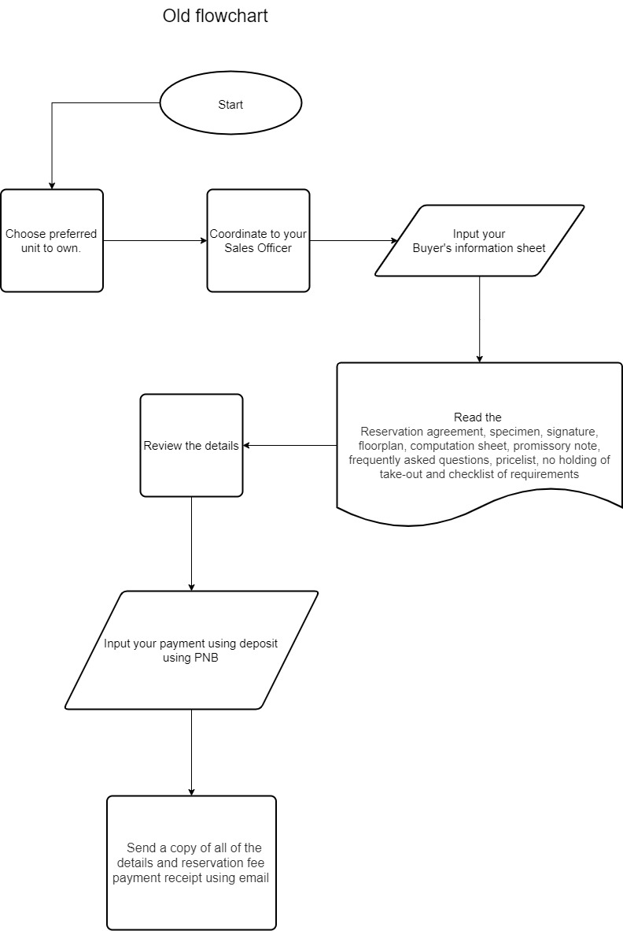**CHAPTER III**

System Flowchart (old)

Proposed Program Flowchart

Entity Relationship Diagram

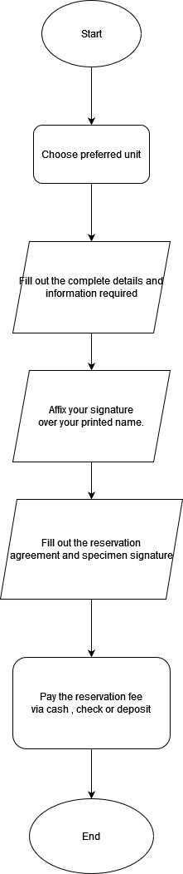Getting units

System Flowchart (new)

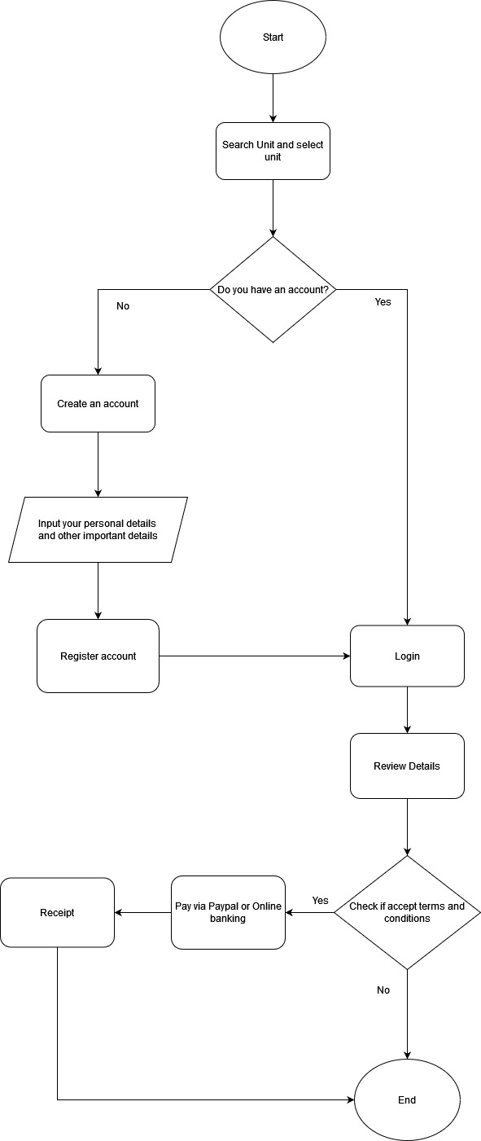

Program Flowchart

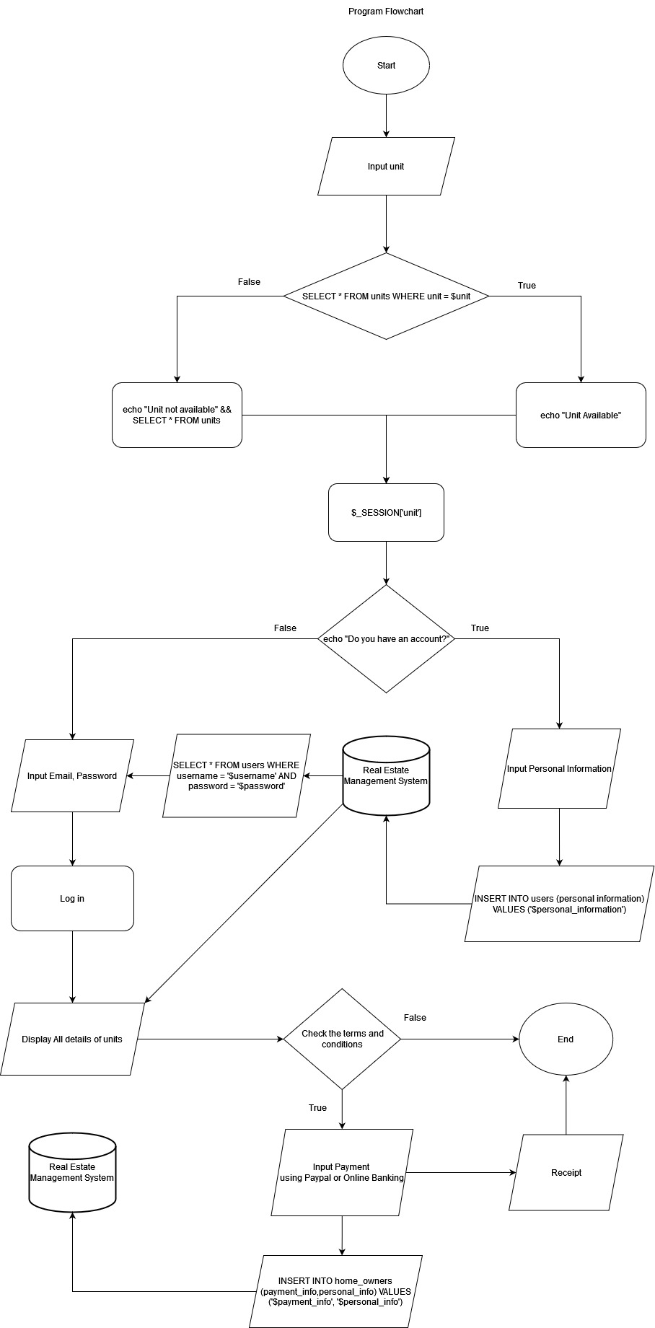Entity Relationship Diagaram

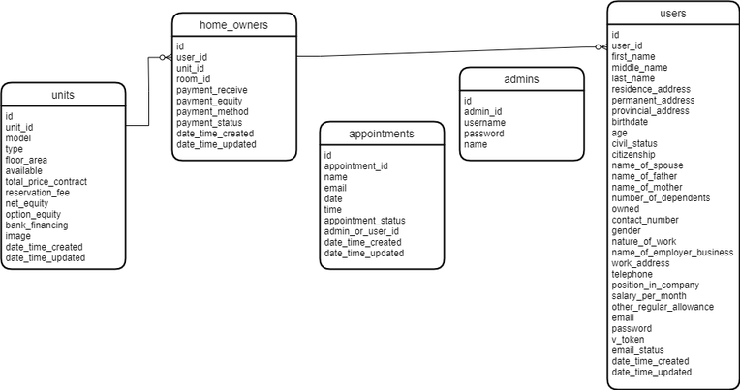

**Data Flow Diagram**

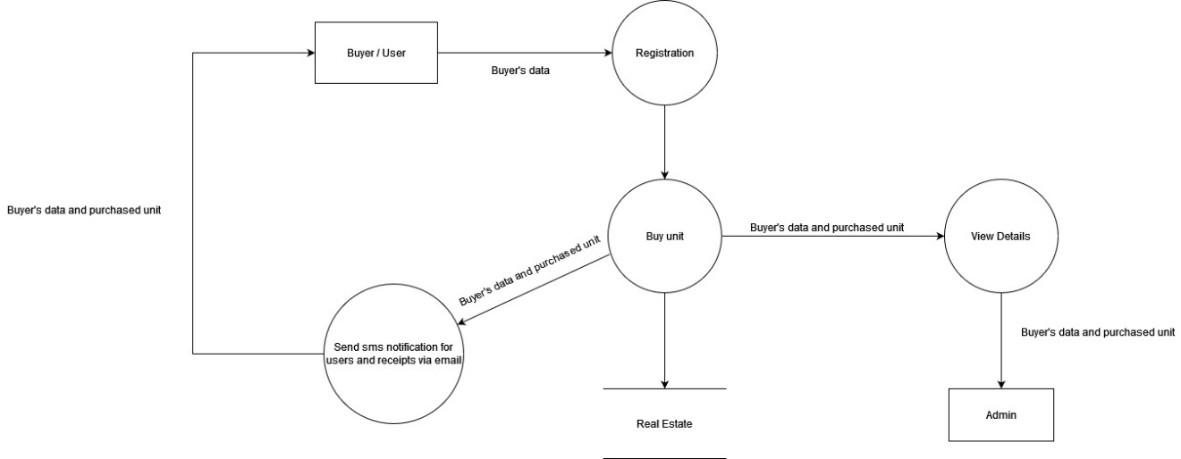

**Data Dictionary**

**Users**

|  |  |  |  |  |
| --- | --- | --- | --- | --- |
| Field name | Data Type | Field Size | Description | Sample |
| Id | int | 11 | Id of users | 7257124682 |
| First_name | varchar | 50 | First name of users | Mathew |
| Middle_name | varchar | 50 | Middle name of users | Santiago |
| Last_name | varchar | 50 | Last name of users | Melendez |
| Residence_address | varchar | 250 | Residence address of users | Blk 123 Tondo manila |
| Provincial_address | varchar | 250 | Provincial address of users | Metro Manila |
| Birthdate | date |  | Birthdate of users | March 28 1999 |
| Age | Varchar | 50 | Age of users | 24 |
| Civil_status | varchar | 50 | Civil status of users | Single |
| Citizenship | varchar | 50 | Citizenship of users | Filipino |
| Name_of_spouse | varchar | 50 | Name of spouse of users | Stephanie |
| Name_of_Father | varchar | 50 | Name of father of users | Rolando |
| Name_of_mother | varchar | 40 | Name of mother | Bernadeth |
| Number_of_dependents | varchar | 50 | Number of dependents | 5 |
| owned | varchar | 50 |  |  |
| Contact_number | Varchar | 50 | Contact number of users | 09257821249 |
| Gender | varchar | 50 | Gender of users | Male |
| Nature_of_work | varchar | 50 | Nature of work | Procedural |
| Name_of_employer_business | varchar | 50 | Name of employer business | Graphic of works |
| Work_address | varchar | 250 | Work address users | 1300 Main Street Montara, CA, 94037 |
| Telephone | Varchar | 50 | Telephone of users | 777 354 142 |
| Position_in_Company | varchar | 50 | Position in the company of users | Administrator |
| Salary_per_month | Varchar | 50 | Salary per month of users | 10,000.00 |
| Other_regular_allowance | Varchar | 50 | Other regular allowance | 2,500 |
| Email | Varchar | 50 | Email of users | dejesussteph03@gmail.com |
| Password | Varchar | 50 | Password of users | 1234567 |
| v_token | Varchar | 50 |  |  |
| Email_status | Int | 11 | Email status of users | dejesussteph03@gmail.com |

**Home Owner**

|  |  |  |  |  |
| --- | --- | --- | --- | --- |
| Field name | Data Type | Field Size | Description | Example |
| Id | varchar | 50 | Id of owner |  |
| Unit_id | varchar | 50 | Unit id of owner | 123EXX |
| User_id | varchar | 50 | User id of owner | 7772222 |
| room_id | varchar | 50 | Room id of room | 10 |
| payment_recieve | varchar | 50 |  | Paypal |
| payment_equity | varchar | 50 |  | Shareholders’ Equity |
| payment_method | varchar | 50 |  | Paypal |
| payment_status | int | 11 | Payment status of payment | Amount:45,000 |

**Units**

|  |  |  |  |  |
| --- | --- | --- | --- | --- |
| Field name | Data type | Field Size | Description | Example |
| Id | Int | 11 | Id of units | 1 |
| Unit_id | Varchar | 50 | Unit id of units | 123EXX |
| Model | Varchar | 50 | Mode of units | Condo |
| Type | Varchar | 50 | Type of units | Studio Type |
| Floor_area | double |  | Floor area of units | Studio unit |
| Available | Int | 50 | Available units | 45 |
| Total_price_contract | Varchar | 50 |  | 45,000 |
| Reservation_fee | Varchar | 50 |  | 3,000 |
| net_equity | Varchar | 50 |  | Owners’ equity |
| Option_equity | Varchar | 50 |  |  |
| bank_financing | Varchar | 50 |  | Bnp |
| image | Varchar | 255 |  | Condo.jpg |

**Appointments**

|  |  |  |  |  |
| --- | --- | --- | --- | --- |
| Field name | Data Type | Field size | Description | Example |
| Id | Int | 11 | Id of appointment | 3 |
| Appointment_id | Varchar | 50 | Appointment id of appointment | 512ABG |
| Name | Varchar | 50 | Name of appointment | Samantha Dela Cruz |
| Email | Varchar | 50 | Email of appointment | samanthadelacruz@gmail.com |
| Date | date |  | Date of appointment | 10/25/2022 |
| Time | Time |  | Time of appointment | 05:30 pm |
| Appointment_status | Int | 50 | Appointment status | Fri, November 16 2022 |
| admin_or_user_id | Varchar | 50 |  | 51354221 |

**Admin**

|  |  |  |  |  |
| --- | --- | --- | --- | --- |
| Field name | Data Type | Field size | Description | Example |
| Id | Int | 11 | Id of admin | 52135484 |
| admin_id | Varchar | 60 | Admin id of admin | 51354221 |
| Username | Varchar | 50 | Username of id | Admin |
| Password | Varchar | 50 | Password of admin | Sample password |
| Name | Varchar | 50 | Name of admin | Luke Jaro |

**Data Gathering Method**

In investigating the Online Real Estate Management System, the methods of the research will be presented, data gathering method, research instrument, analysis, statistical treatment of data and results.

Data collection is the process of gathering methods and measuring information on variables of interests. Data set is collected from a source, survey, observation, and others.

The survey consists of 10 questions with a 5-point, Likert scale response to the system. We conducted the survey from October 17 to September 23 with a total of 71 respondents via online and the survey was fully completed among the total respondents.

In this pie graphs the result is shown the effectiveness of Online Real Estate Management System.

**Research Instrument**

The researchers used Likert scale to access the results of the data clearly.

Likert Scale is a 5, 7, 9, agreement scale used to measure the respondent’s agreement with various statements. According to Bhandari (2020), this method is often used in survey analysis because it makes it easier to identify and gather the data clearly.

**Analysis**

In this study we used a quantitative approach to express the effects of the Online Real Estate Management System to the clients. The data was gathered using google form and then, we manually computed it. To look over the data, we used descriptive statistics to make it clear.

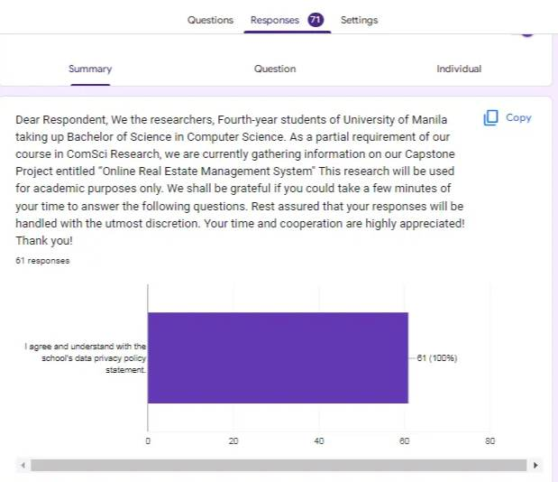

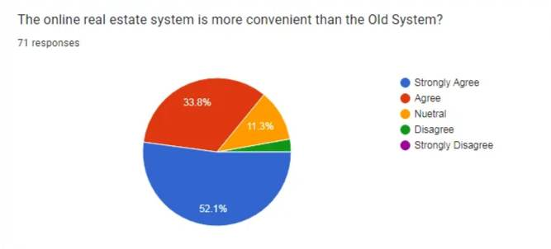

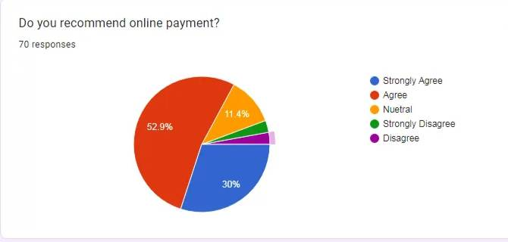

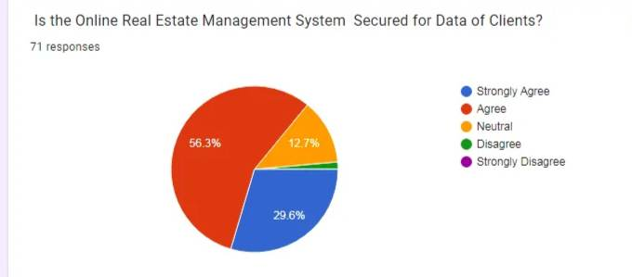

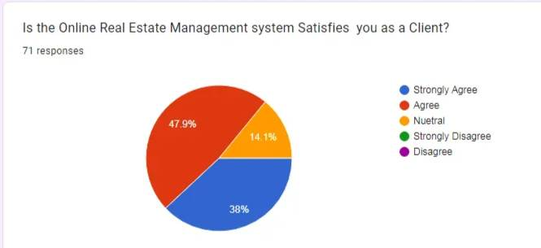

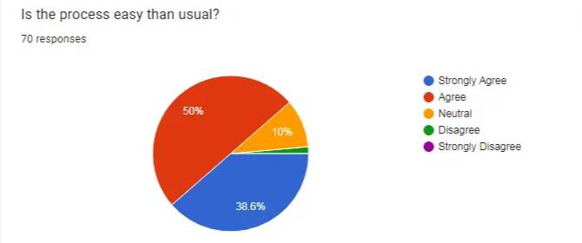

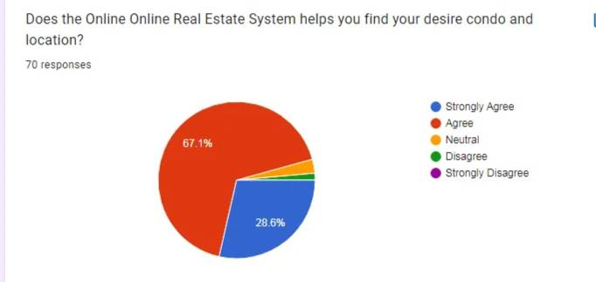

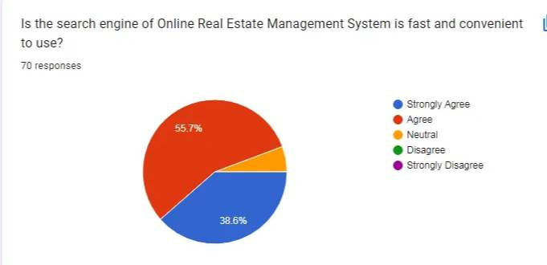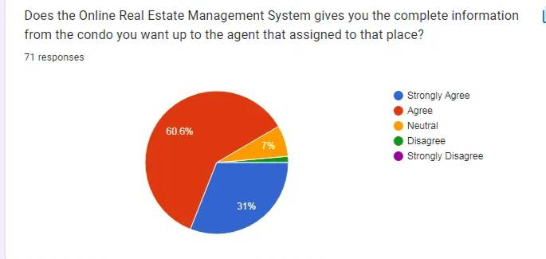

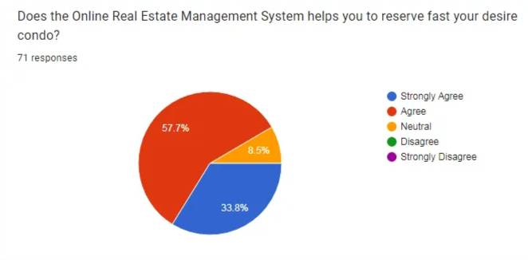

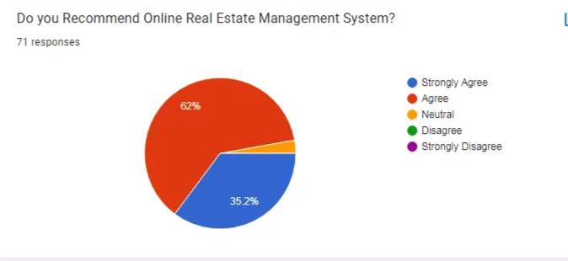**Statistical Treatment of Data**

The data gathered in this research was presented in a pie chart to view the details clearly.

1. Mean – the average or the most common value in a collection of numbers.

The formula was used to compute the mean.

**μ = ∑ number of terms / number of terms**

The summation of the numberof terms is divided by the number of terms. The result would be the mean value.

1. Range – it is the difference between the highest and lowest value in a data set.

The formula was used to compute the Range.

**Range = F2 – F1**

F2  Represents the highest value from the data set and F1 represents the lowest value from the set.

1. Standard Deviation – According to Wikipedia is the measure of the amount of variation of a set value.

The formula as used to compute the Standard Deviation

**σ = √∑ (xi – μ)2 / N**

xi = each value from the population

μ = the population mean

*N* = the size of population

σ = population standard deviation

**CHAPTER IV**

**System Requirements**

RAM: 4gb

CPU: intel Core i3 3rd Gen. up for AMD Ryzen 3000 series

RAM: 4gb

Hard disk drive: 500gb

Operating System: Windows, Mac, Linux

Internet: Internet connection is required

**Cost and Benefits Analysis**

Cost and benefits are absolutely important, you will see the amount of how much it will cost between manual system and computerized system. Chullamonthol (2001), Cost comparison between the existing system and the new proposed system should be made. It is a systematic approach to determine which system is more beneficial to save savings.

**Cost of Manual System, Php.**

|  |  |  |  |  |  |  |
| --- | --- | --- | --- | --- | --- | --- |
| Cost Items | Years | | | | |  |
|  | 1 | 2 | 3 | 4 | 5 |
| Fixed Cost: |  |  |  |  |  |  |
| Calculator | 1,350 | 1,350 | 1,350 | 1,350 | 1,350 | 1,350 |
| Telephone | 1,000 | 1,000 | 1,000 | 1,000 | 1,000 | 1,000 |
| Workers: |  |  |  |  |  |  |
| Agent (5) | 17,000 | 1,020,000 | 2,040,000 | 3,060,000 | 4,080,000 | 5,100,000 |
| Admin | 20,000 | 480,000 | 960,000 | 1,440,000 | 1,920,000 | 2,400,000 |
| Miscellaneous Fee | 5,000 | 60,000 | 120,000 | 180,000 | 240,000 | 300,000 |
| Total Manual System Cost: |  | 1,502,350 | 3,122,350 | 4,502,350 | 6,002,350 | 7,502,350 |
|  |  |  |  |  |  |  |

**Five Years of Accumulated Manual System Cost, Php.**

|  |  |  |
| --- | --- | --- |
| Year | Total Manual Cost | Accumulated Cost |
| 1 | 1,562,350 | 1,562,350 |
| 2 | 1,716,000 | 3,122,350 |
| 3 | 2,304,400 | 5,042,350 |
| 4 | 2,340,000 | 6,242,350 |
| 5 | 3,118,200 | 7,801,450 |
| Total | 11,040,950 | 23,770,850 |

**Computerized System Cost Analysis, Php**

|  |  |  |  |  |  |  |
| --- | --- | --- | --- | --- | --- | --- |
|  |  | 1 | 2 | 3 | 4 | 5 |
| Web hosting | 349 | 4,188 | 8,376 | 12,564 | 16,752 | 20,940 |
| Computer Set | 15,000 | 15,000 | 15,600 | 15,600 | 15,600 | 15,600 |
| Miscellaneous Fee | 5,000 | 60,000 | 120,000 | 180,000 | 240,000 | 300,000 |
| Admin | 20,000 | 480,000 | 960,000 | 1,440,000 | 1,920,000 | 2,400,000 |
| Total Computerized System Cost: |  | 495,000 | 1,095,600 | 1,455,600 | 1,952,352 | 2,415,600 |

**Five years Accumulated Computerized System Cost, Php.**

|  |  |  |
| --- | --- | --- |
| Year | Total Computerized System Cost | Accumulated Cost |
| 1 | 574,188 | 574,188 |
| 2 | 549,629.88 | 1,118,376 |
| 3 | 555,071.76 | 1,662,564 |
| 4 | 560,513.64 | 2,206,752 |
| 5 | 565,963.84 | 2,750,948 |
| Total | 2,805,340.12 | 8,312,328 |

**The Comparison of the System Costs, Php.**

|  |  |  |  |
| --- | --- | --- | --- |
| Year | Accumulated Manual Cost | Accumulated Computerized Cost | Difference Between the Manual to Computerize cost |
| 1 | 1,562,350 | 574,188 | 988,162 |
| 2 | 1,716,000 | 1,118,376 | 597,624 |
| 3 | 2,304,400 | 1,662,564 | 641,836 |
| 4 | 2,340,000 | 2,206,752 | 133,248 |
| 5 | 3,118,200 | 2,750,948 | 367,252 |

**Benefit Analysis**

Because the computerized system can store files in a database, it is unlikely to be printed. You can easily view the files, and the cost of paper and other supplies will be reduced.  
  
The benefits expected from the system:

* Saving time
* Increase customer satisfaction
* Secure-All realtors and brokers have almost certainly heard horror stories about large and small-scale security breaches.
* **Manageable- The information in them can easily be updated and old information can easily be permanently saved**
* **Faster payment- They can receive a payment within a few days by sending out automated payment reminders immediately.**

**CHAPTER V**

Software and Hardware Used

Hardware: Laptop / Desktop, Keyboard, Mouse

Software: VS Code, XAMPP

System Screenshot

**Conclusion**

The Online Real Estate Management System is an online platform that will help the clients to search their desired condo and to make it easier for them to find it and to easier contact the agent that is assigned to that specific place. In this system you will see all the information of the condo and the pictures from outside to inside the condo so that it will be easier for the clients to see the whole house. And also they can see the prices of each house, for them to understand the allocated amount they must have in order to purchase the condo they have been desiring. The company will assure the client/s that the agent that is assigned to that location where the client’s desired house is located is a legit or a true agent.

**Team Composition**

System Analyst: Dalisay, Mathew F.

Programmer: Dalisay, Mathew F.  
  
Debugger Dalisay, Mathew F.

UI/UX Designer: Gutierrez, John Paul E.

De Jesus, Stephanie Ann

Researcher: Gutierrez, John Paul E.

De Jesus, Stephanie Ann