Filmtopia Project Investigation
Introduction
Filmtopia is a small independent cinema theatre who is currently managing all business data using spreadsheets and paper. They sell food drinks and tickets using a variety of means such as a touchscreen kiosk which can only handle food and drinks and a concessions area where employees handle the business. The management of filmtopia has come to notice that they are falling back on managing and analysing the cinema, this means keeping track of sales records, screening analytics and a customer interest evaluation. I am now going to investigate further on how filmtopia functions to get a better understanding of how I should move with this project.
Stakeholder Analysis
Before beginning the investigation it is important to identify who the stakeholders are for this project. A stakeholder is any individual or group who has an interest in the system, will be affected by it or has the power to influence how it is developed. Identifying stakeholders early on ensures that the requirements gathered throughout the investigation reflect the needs of everyone involved rather than just one person.
For the Filmtopia system the stakeholders can be split into two groups, primary and secondary. Primary stakeholders are those who will interact with the system directly on a regular basis. Secondary stakeholders are those who are affected by the system indirectly or whose work is influenced by it without them necessarily using it themselves.
Starting with the primary stakeholders, the most important of these is the cinema manager Sarah Henshaw. As the person who commissioned this project she has the highest level of influence over what the system needs to do. She will use the management side of the system on a daily basis, for example adding new films, scheduling screenings and viewing sales reports. Her main priorities are operational efficiency, accurate reporting and a reduction in the customer complaints that are currently caused by the manual booking process. She has described herself as tech aware but not highly technical which means the system needs to be intuitive enough to use without specialist knowledge or extensive training.
The next primary stakeholder group is the box office staff. These are the people who handle ticket sales and customer enquiries on a day to day basis and who will use the booking interface most frequently. Their priorities are speed and simplicity. During busy periods a member of staff cannot afford to spend several minutes navigating a complicated interface to add a single booking. The system therefore needs to be designed with efficiency in mind so that even a brand new member of staff could use it confidently with minimal training.
The third primary stakeholder is the customer base of Filmtopia. Customers interact with the system either directly through the proposed self service kiosk or indirectly when staff process their bookings on their behalf. Their main interests are convenience, short queue times and the assurance that the seat they have been allocated will actually be available when they arrive. The questionnaire results discussed later in this investigation show that a large majority of customers would prefer self service ticketing and that seat selection is considered important by most respondents. This means the bar for the kiosk interface is high and it needs to be clean and simple enough for any customer to use without assistance.
Moving on to the secondary stakeholders, the concessions team is worth considering here. Although they do not use the booking system directly the proposed solution will integrate food and drink ordering with ticket purchases which means orders placed through the kiosk will need to reach the concessions team accurately and in a timely manner. The current system of passing handwritten notes is described by staff as disjointed and prone to error so the new system needs to address this.
Another secondary stakeholder is any external IT support that Filmtopia uses. As a small independent cinema there is no dedicated IT department meaning the system must be robust and straightforward to maintain. Complex setups that require specialist knowledge to troubleshoot would be impractical for a business of this size.
In summary the stakeholder analysis makes clear that the Filmtopia system needs to serve a wide range of users with different levels of technical confidence and different priorities. The investigation that follows has been designed to gather requirements from as many of these stakeholders as possible to ensure the final system genuinely reflects the needs of everyone who will be affected by it.

Investigation Plan
Task Description | Duration | Method | Comments
Initial meeting with client (Sarah Henshaw) to discuss project scope | 1 day | Face-to-face meeting | Establish what the client needs and agree on the direction of the project
Interview with cinema manager (Sarah Henshaw) | 1 day | Face-to-face interview | Gather detailed information about the existing system and requirements from a management perspective
Interview with box office staff member (Jake Pemberton) | 1 day | Face-to-face interview | Understand day-to-day operational problems from a staff perspective
Customer questionnaire design and distribution | 1 day | Paper questionnaire | Distribute to 20 cinema customers to gather end user requirements
Customer questionnaire analysis | 1 day | Data analysis | Summarise and interpret questionnaire responses
Direct observation of existing system | 1 day | Observation | Observe box office operations during a live evening screening
Desk based research — Vue Cinema (myvue.com) | 1 day | Online research and screenshots | Analyse features of a professional existing cinema booking system
Desk based research — Odeon Cinema (odeon.co.uk) | 1 day | Online research and screenshots | Compare a second professional system and identify additional features
Data flow diagram — existing system | 2 days | Diagram | Produce a DFD showing how data moves through the current paper based system
Overview of existing system | 2 days | Written analysis | Document inputs, outputs, processing and limitations of the current system
Problem definition | 1 day | Written analysis | Clearly define the core problems the proposed solution must address
Limitations of proposed solution | 1 day | Written analysis | Identify what the system will not include and explain why
Objectives and evaluation criteria | 2 days | Written analysis | Produce 15 numbered objectives each with a measurable success criteria
Methodology for investigating
Before carrying out the investigation it is important to think carefully about which methods to use to gather information. Different methods have different strengths and weaknesses and relying on just one would not give a complete enough picture of the existing system or what the new one needs to do. For this investigation four methods were chosen: face-to-face interviews, a customer questionnaire, direct observation and desk based research.
Starting with interviews, these were chosen as the main method for gathering requirements from the key stakeholders. The reason for this is that an interview allows open ended questions to be asked and the conversation can naturally go in directions that were not planned in advance. This is important because some of the most useful information gathered during an investigation comes from things that the person being interviewed mentions without being directly asked. A written survey would not allow for this kind of flexibility. The limitation of interviews however is that they are time consuming and the quality of what comes out of them depends heavily on how well the questions are prepared. To address this the questions were written in advance and kept open ended to avoid leading the person being interviewed towards a particular answer. Two interviews were conducted for this investigation, one with the cinema manager and one with a member of the box office staff, as these two stakeholders gave the most complete view of how the existing system operates day to day.
Moving on to the customer questionnaire, this was chosen because it allowed a much larger group of stakeholders to contribute to the investigation than would have been possible through interviews alone. Interviewing every customer individually would not be realistic, so a questionnaire was the most practical way to gather their views. The key advantage of a questionnaire is that it produces quantitative data which is easier to summarise and use as justification for design decisions. For example knowing that a large majority of customers would prefer a self service kiosk is a much stronger argument for including that feature than one person mentioning it in an interview. The limitation of a questionnaire is that the questions are fixed which means there is no opportunity to follow up on responses or ask for more detail. To partially work around this some of the questions included a list of options rather than just a yes or no answer which produced more useful and specific data.
Transitioning to direct observation, this was included because interviews and questionnaires rely on people describing the system from memory which is not always accurate. Watching the system being used in real time makes it possible to see problems that the people involved might not even be aware of because they have become used to working around them. The observation was carried out during a busy evening period deliberately, since the existing system's weaknesses are most likely to show up under pressure rather than during a quiet period. The main limitation of observation is the Hawthorne Effect, which is the tendency for people to change their behaviour when they know they are being watched. This was minimised by keeping the observation as low key as possible.
Finally, desk based research was used to look at how similar systems are designed in the real world. By researching the booking systems of established cinema chains it is possible to identify features and design patterns that set the standard for what customers already expect. This is useful because stakeholders do not always know what to ask for, particularly if they have not seen what is possible. The limitation of this method is that the systems being researched are built by large commercial teams with significant resources, so not everything observed will be feasible within the scope of this project. The research has therefore been used to inform and inspire the design rather than to copy it directly.
The reason all four methods were used together is that each one compensates for the weaknesses of the others. Interviews provide depth, the questionnaire provides breadth, observation provides real world evidence and desk based research provides industry context. Where the same issue or requirement appears across multiple methods it can be treated with much greater confidence than if it had only come from one source.

Interviews
Interview with Sarah Henshaw – Cinema Manager

Q: Can you describe how Filmtopia currently manages its ticketing and bookings?
A: At the moment everything is done manually. When a customer comes in, staff write their booking down in a paper diary. We have a touchscreen kiosk but it can only handle food and drink orders. It cannot sell tickets at all which is a real problem during busy periods because customers have to queue twice.
Q: What are the biggest problems you face with the current system?
A: Double bookings are a nightmare. Because everything is written on paper, if two members of staff take a booking for the same screening at the same time we do not find out until the customer arrives. We have had some very unhappy customers because of this. Also I have no real way of seeing how well the cinema is doing without physically going through every piece of paper we have.
Q: What data does Filmtopia currently store and how?
A: We keep a paper diary for bookings, a spreadsheet for staff rotas and another spreadsheet for food and drink stock. None of these connect to each other. If I want to know how many tickets we sold for a particular film last month I have to manually count through pages of handwritten notes.
Q: What would you most want a new computerised system to do?
A: The most important thing for me is being able to see everything in one place. I want to know how many seats are available for any screening at a glance, see sales figures without digging through paperwork and be able to add new films and screenings quickly and easily. I also want customers to be able to buy tickets through the kiosk rather than having to come to the desk.
Q: Who would be using this system on a day to day basis?
A: Mainly the box office staff and myself. The staff need something simple that they can use quickly during busy periods. They cannot be spending five minutes trying to figure out how to add a booking. I would need a separate manager view where I can see reports and make changes to the system that staff should not be able to access.
Q: Are there any constraints we should be aware of?
A: Budget is tight as we are an independent cinema so whatever is built needs to run on our existing computers. We are also only a small team so the system needs to be genuinely easy to use without much training.

Interview with Jake Pemberton – Box Office Staff Member

Q: Can you describe what your typical working day looks like at the box office?
A: It is pretty hectic on weekends. Customers come up to buy tickets, we check the paper diary to see if there are seats available, write down their details, take payment and give them a ticket stub we print from a template. During busy periods there can be a queue of ten or more people and it gets really stressful trying to manage everything manually.
Q: What problems do you regularly run into with the current system?
A: The biggest one is not knowing if a seat is already taken. Sometimes a customer picks a specific seat and we say yes, then another member of staff has already given that seat to someone else and we do not know until they both turn up. It causes a lot of awkward situations. Also finding information takes too long. If someone asks what time a film starts or how many seats are left I have to physically look through the diary.
Q: How do you currently handle food and drink orders alongside ticketing?
A: They are completely separate which makes no sense. The kiosk handles food and drinks but not tickets so a customer might queue at the kiosk for snacks and then have to queue again at the desk for their ticket. If they want to order food to be brought to their seat during a screening that is done on a notepad and passed to the concessions team. Nothing is joined up.
Q: What would make your job easier?
A: Something on a screen that shows me exactly which seats are taken and which are free for any screening. Being able to add a booking in a few clicks rather than writing it all down. It would be great if food orders could be linked to a ticket booking so everything is in one place.
Q: Do you have any concerns about moving to a computerised system?
A: As long as it is straightforward to use I am fine with it. I am not very technical so if it is complicated I will struggle during busy periods. It needs to be quick. I cannot be spending ages clicking through menus when there is a queue of people waiting.

Questionnaires
Questionnaire – Filmtopia Customer Survey
Date Administered: 15th January 2026
Method: Paper questionnaire handed to customers at the cinema
Number of Responses: 20
A questionnaire was distributed to customers visiting Filmtopia in order to gather feedback on their experience with the current system and to understand what they would want from a new one. The questions and summarised responses are as follows.
Q1: How do you currently purchase your tickets at Filmtopia?
Response | Number of Customers
At the box office desk | 14
I book in advance by phone | 4
Other | 2
The majority of customers purchase tickets directly at the box office. No customers reported being able to book online or through a kiosk which confirms that the current system offers very limited options for customers.
Q2: Have you ever experienced a problem when booking tickets at Filmtopia?
Response | Number of Customers
Yes | 13
No | 7
65% of customers reported experiencing a problem. This is a significant finding and strongly supports the need for a new system.
Q3: If yes, what was the problem you experienced?
Problem | Number of Customers
Long queues at the box office | 9
Seat already taken when I arrived, Other customers given the same seat number. | 5
Told screening was full when it was not | 3
Other | 2
Long queues and seat allocation errors were the most commonly reported problems. These directly reflect the issues raised by Sarah Henshaw and Jake Pemberton in their interviews.
Q4: Would you use a self-service kiosk to buy tickets if one was available?
Response | Number of Customers
Yes definitely | 12
Probably yes | 5
Not sure | 2
No | 1
85% of customers indicated they would use a self-service kiosk for tickets. This strongly justifies the inclusion of a customer-facing kiosk interface in the proposed system.
Q5: How important is it to you to be able to choose your specific seat when booking?
Response | Number of Customers
Very important | 11
Quite important | 6
Not important | 3
85% of customers felt seat selection was at least quite important. This supports the planned graphical seat selection feature in the Filmtopia system.
Q6: Would you find it useful to be able to order food and drinks at the same time as buying your ticket?
Response | Number of Customers
Yes | 16
No | 4
80% of customers would find combined ticketing and food ordering useful. This confirms that integrating food and drink ordering with ticket booking is a worthwhile feature.

Summary of Questionnaire Findings
The questionnaire results clearly show that customers are experiencing real problems with the current system at Filmtopia. The most significant issues are long queues at the box office, errors with seat allocation and the inability to book tickets through the kiosk. The results also show strong demand for a self-service ticketing kiosk, graphical seat selection and combined food and drink ordering. These findings have directly informed the objectives set out later in this investigation.

Direct Observation
As part of the investigation I visited Filmtopia during an evening showing to observe how the current system operates in practice. Rather than asking questions or interrupting the workflow I simply watched how staff handled customers during the pre-screening period when the cinema was at its busiest. The aim was to see the existing system in action and to identify any problems that might not have come up during the interviews or questionnaire.
The first thing that stood out was how the paper booking diary was being used by two members of staff at the same time. On more than one occasion both staff members reached for the diary simultaneously to check seat availability for the same screening. This caused a brief but noticeable delay in serving customers and illustrated exactly the kind of risk that the interviews had described, where two staff members could independently assign the same seat without either realising.
It was also clear that customers who had already used the kiosk to order food and drinks were then joining the box office queue to buy their tickets separately. This meant some customers were effectively queuing twice before they could take their seat. During the observation period this happened repeatedly and on a couple of occasions customers waiting in the box office queue made comments about having already waited at the kiosk. This confirmed what the staff interviews had suggested about the kiosk and ticketing systems being completely disconnected from each other.
Another thing worth noting was how long it took a staff member to answer a simple question about seat availability. When a customer asked which seats were still free for a particular screening the staff member had to manually look through several pages of the diary before being able to give an answer. This took around 90 seconds and caused the queue behind that customer to grow noticeably during that time. In a busier cinema this kind of delay would quickly become a serious problem.
Overall the observation confirmed and added detail to the problems that had already been identified through the interviews and questionnaire. Seeing the existing system in action made it clear that the issues are not occasional or minor but are a regular feature of how the cinema operates during busy periods. The findings from this observation have directly informed the objectives set out later in this investigation.

Desk-based Research
Desk Based Research – Vue Cinema (myvue.com)
As part of my investigation, I researched the Vue Cinema booking system, which is one of the largest cinema chains in the UK. Vue operates 94 cinemas across the UK and Ireland and their online booking system provides a useful reference point for what a professional cinema management system should look like.
Film Listings Page
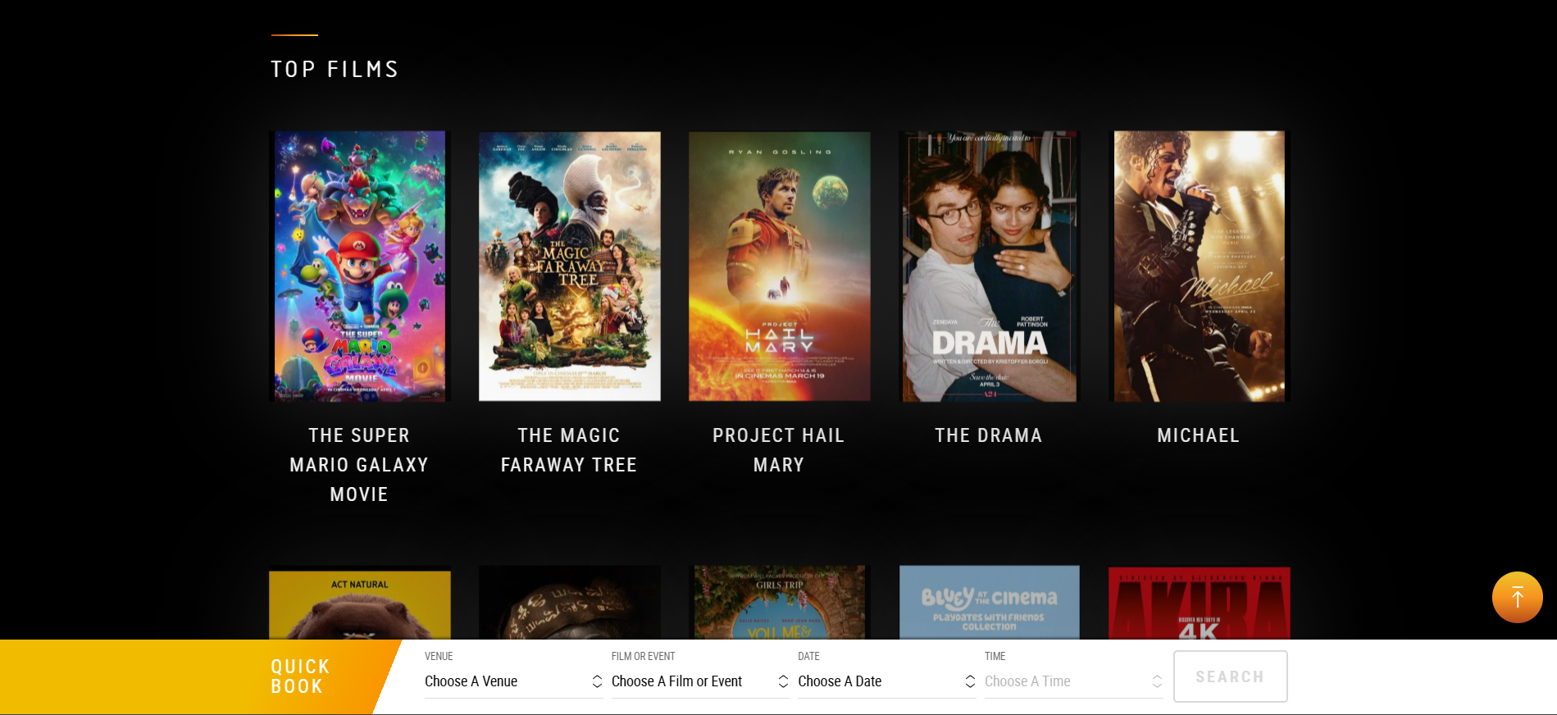
The Vue homepage presents films visually using large poster images organised under a "Top Films" heading. Each film is displayed with its title clearly beneath it and the page includes a Quick Book bar at the bottom allowing users to search by venue, film, date and time simultaneously. This is a clean and intuitive way of presenting information that allows customers to find what they want quickly without having to navigate through multiple pages. For the Filmtopia system I will incorporate a similar visual approach to displaying films on the customer kiosk, ensuring that screenings are easy to browse and select.
Screening Times Page
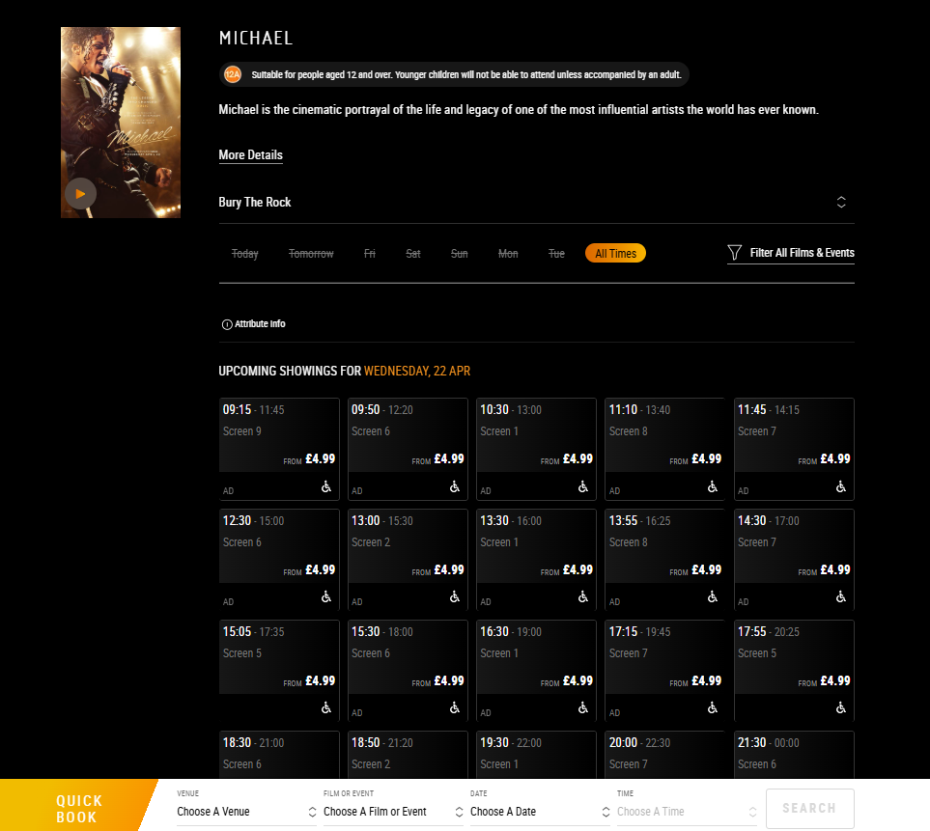
When a film is selected Vue displays all upcoming showings for that film at the chosen venue, organised by date and time. Each screening card shows the start and end time, the screen number and the ticket price. Accessibility information such as audio description and wheelchair access is also clearly displayed. This level of detail is something I aim to replicate in Filmtopia, where staff and customers should be able to see all relevant information about a screening at a glance without having to search through multiple menus.
Seat Selection Screen
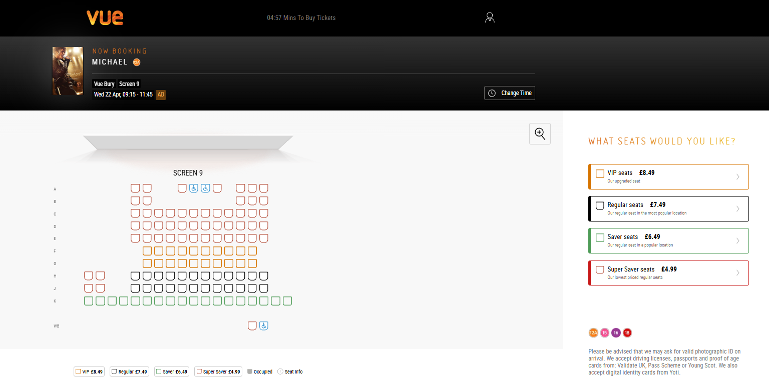
Vue's seat selection interface is a standout feature of their system. It displays a graphical layout of the screen showing every seat as a coloured icon, with different colours representing different seat types and prices. VIP seats are shown in orange at £8.49, Regular seats in black at £7.49, Saver seats in green at £6.49 and Super Saver seats in red at £4.99. Occupied seats are shown in grey so customers can immediately see what is available. Rows are labelled alphabetically on the left hand side. This graphical seat selection is a key feature I plan to implement in Filmtopia as it directly addresses the double booking problem identified in the interviews. By showing customers and staff exactly which seats are taken in real time the system eliminates the risk of two people being assigned the same seat.
Features Identified for Filmtopia
From researching Vue's system I have identified the following features that I will incorporate into the Filmtopia system:
- A visual film listings interface showing posters and screening times clearly
- A graphical seat map showing available and occupied seats in real time
- Colour coding to distinguish between different types of seats or statuses
- Clear display of screening information including screen number, time and date
- A quick search function allowing users to find screenings by film, date and time

Desk Based Research – Odeon Cinema (odeon.co.uk)
The second system I researched was Odeon, which is the largest cinema chain in the UK. Odeon operates over 120 cinemas across the UK and Ireland and their online booking system offered several useful features to compare against Vue and to inform the design of Filmtopia.
Film Listings Page
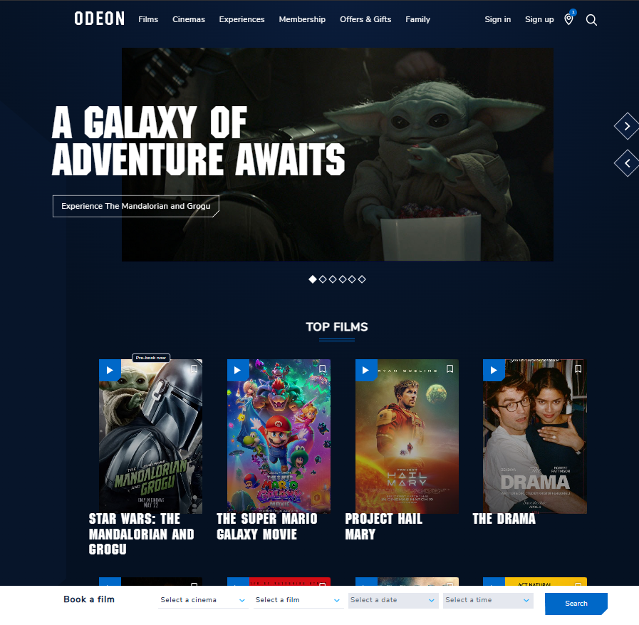
Similar to Vue, Odeon presents films using large poster images organised under a Top Films heading. However Odeon includes additional information directly on the film page such as the director, cast, runtime, release date and genre tags. This richer level of detail gives customers more context before making a booking decision. Odeon also includes a quick search bar at the bottom of the page allowing users to filter by cinema, film, date and time. One notable difference from Vue is that Odeon uses a darker navy blue colour scheme throughout which creates a more premium feel. For Filmtopia I will aim to display key film information clearly on the customer kiosk so customers can make informed decisions quickly.
Screening Times Page
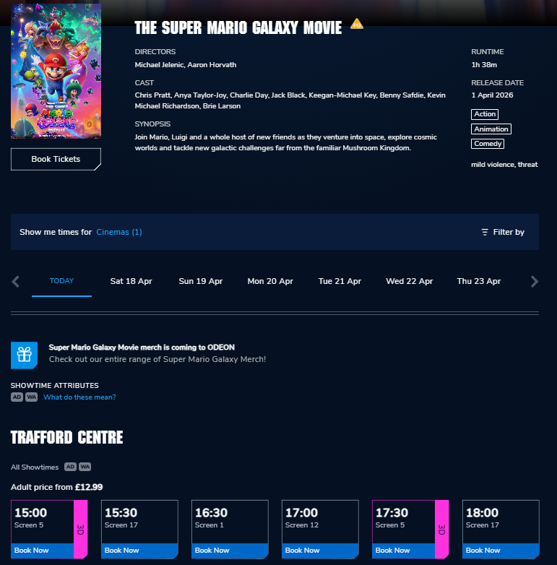
Odeon's screening times page clearly displays the film title, runtime, release date and genre alongside all available showtimes. Screenings are organised by date across the top of the page and grouped by cinema location below. Each screening card shows the start time, screen number and format such as 3D. A "Book Now" button is displayed prominently on each card making the next action immediately obvious. This clear layout is something I will replicate in Filmtopia where staff should be able to see all screenings for a given film at a glance.
Seat Selection Screen
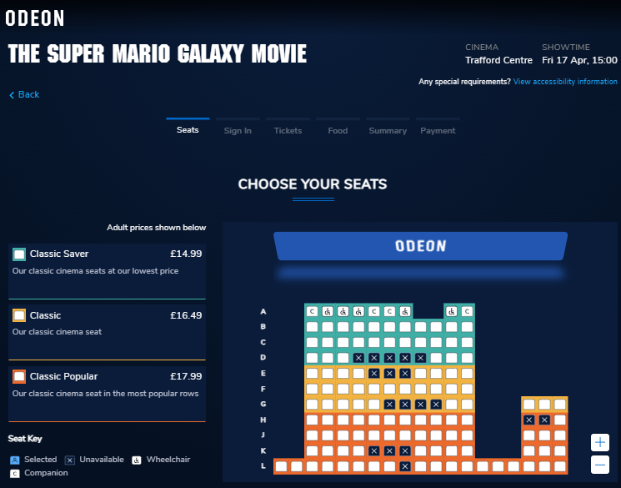
Odeon's seat selection screen is particularly well designed and shows several features worth incorporating into Filmtopia. The screen displays a graphical layout of the entire auditorium with seats colour coded by type and price. Green seats represent Classic Saver at £14.99, cream seats represent Classic at £16.49 and orange seats represent Classic Popular at £17.99. Unavailable seats are shown with an X so it is immediately clear which seats cannot be booked. A seat key at the bottom explains the colour coding including wheelchair and companion seat options. The booking process is also clearly structured using a step by step tab navigation at the top showing Seats, Sign In, Tickets, Food, Summary and Payment. This staged approach guides the user through the process logically and reduces confusion. For Filmtopia I will incorporate a similar colour coded seat map and a clear step by step flow for the customer kiosk booking process.
Features Identified for Filmtopia
From researching Odeon's system I have identified the following additional features to incorporate into Filmtopia:
- Detailed film information displayed alongside the listing including runtime and genre
- Colour coded seat map with a clear seat key explaining each colour
- Unavailable seats clearly marked so users cannot accidentally select them
- A stepped booking process guiding users through each stage in order
- Prominent call to action buttons making the next step always obvious
Data Flow Diagrams
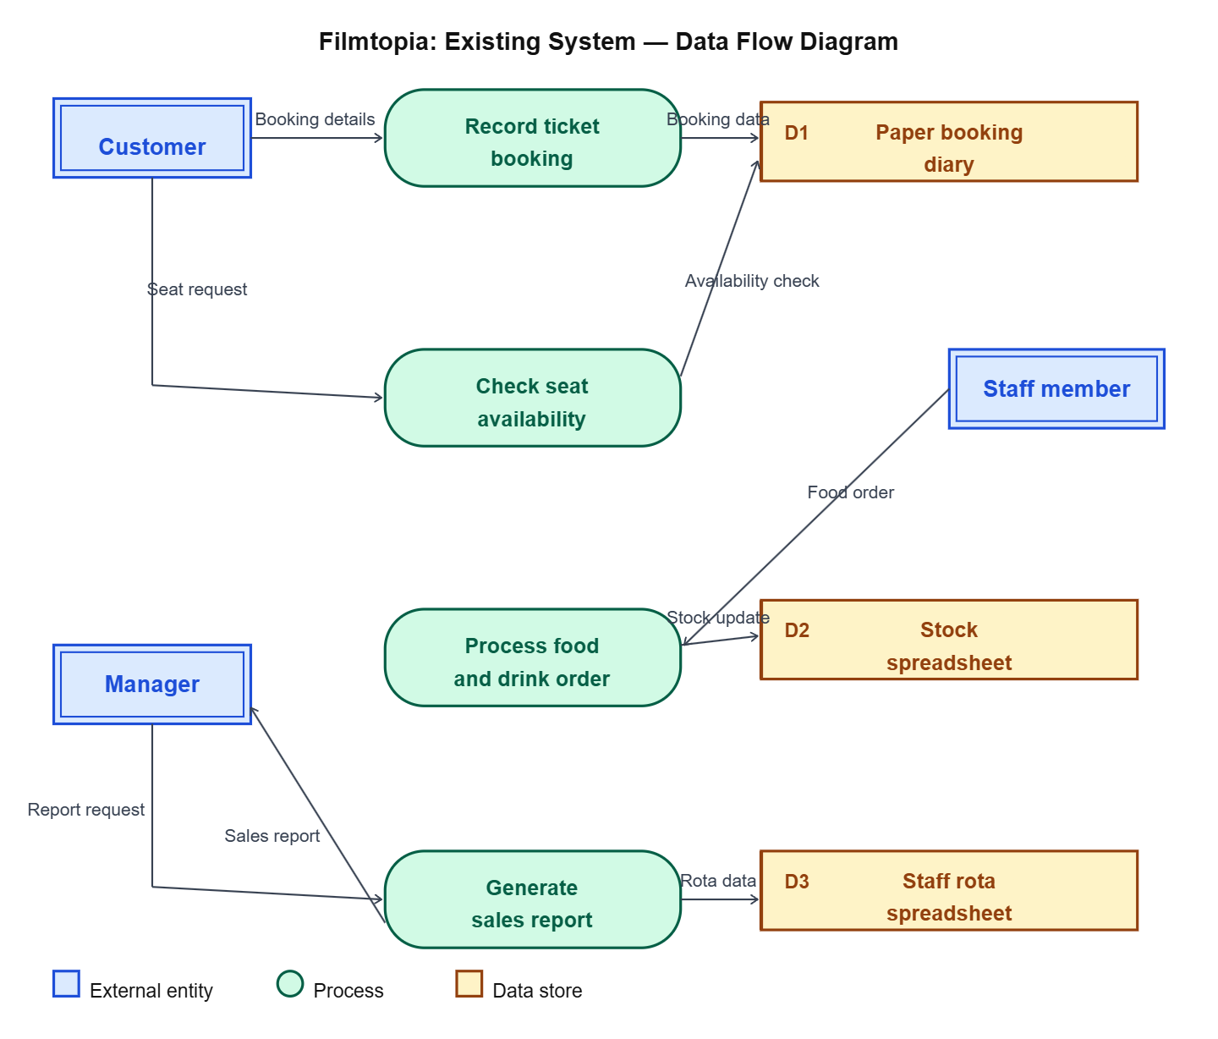

Overview of the Existing System
Before designing and building a new system it is important to fully understand how the existing one works. This includes looking at what data goes into the system, what comes out of it, how that data is processed in between and where the system falls short. Without this understanding there is a risk of building something that solves the wrong problems or misses important requirements entirely.
Inputs
The existing system at Filmtopia receives several types of input, all of which are entered manually by staff or the manager. When a customer arrives to book tickets a member of staff writes the customer's name, chosen film, screening time, number of tickets and preferred seats into a paper booking diary. There is no digital record of this at the point of entry meaning the accuracy of the data depends entirely on the staff member's handwriting and attention to detail.
When a customer purchases food or drinks at the concessions area their order is written on a notepad by a staff member and passed to the kitchen team. This is a completely separate process from the ticket booking and the two are never linked together in any way. If a customer wants to book tickets and order food at the same time they have to interact with two different systems and two different members of staff.
When a new film is added to the schedule or a screening time changes the manager updates a paper schedule kept at the box office. There is no automated way of notifying staff of changes which means it is possible for staff to be working from outdated information without realising. Stock levels for food and drink are updated on a spreadsheet periodically by the manager, meaning the data is never truly up to date and relies on manual stock counts being carried out regularly.
Processing
The processing that takes place in the existing system is carried out entirely by hand rather than by any software. When a customer asks for a specific seat a staff member must physically look through the paper booking diary to check whether that seat has already been assigned for that screening. This process is slow and becomes increasingly unreliable during busy periods when multiple staff members are taking bookings at the same time. Because there is no central record that updates in real time two members of staff can independently assign the same seat to different customers without either being aware of it until the customers arrive.
When a customer books tickets the total cost is calculated manually by the staff member based on the number of tickets and the price for that screening. There is no automated pricing system meaning human error in the calculation is possible. At the end of a trading period the manager must manually count through all entries in the booking diary and cross reference with till receipts to produce any kind of sales summary. This is a time consuming process that the manager has described as unreliable because it depends on the handwritten records being complete and legible.
Outputs
The outputs from the existing system are limited and almost entirely paper based. When a customer completes a ticket booking a staff member prints a ticket stub from a basic template on a computer and hands it to the customer. This ticket stub is not linked to any database and contains only the information that the staff member manually entered into the template at the time of printing.
At the end of each week the manager produces a handwritten or basic spreadsheet summary of sales figures by counting through the booking diary. This is the only form of reporting available to the manager and it provides no breakdown by film, screening time or seat type. Staff rotas are produced by the manager in a spreadsheet and printed out for staff to view. There is no digital way for staff to check their rota without physically being at the cinema.
Limitations
The existing system has several significant limitations that have been clearly identified through the investigation. The most serious of these is the risk of double bookings. Because there is no centralised real time record of seat allocations the same seat can be assigned to two different customers for the same screening. This has happened on multiple occasions and has resulted in customers arriving to find their seat already occupied. Not only is this a poor experience for the customer but it reflects badly on the cinema and undermines trust in the booking process.
Another significant limitation is the complete lack of meaningful reporting. The manager currently has no way of knowing how many tickets have been sold for a particular film, which screenings are most popular or what the cinema's total revenue is for a given period without manually processing a large amount of paper records. This makes it very difficult to make informed business decisions.
The customer facing experience is also heavily limited by the current setup. The touchscreen kiosk that is already installed in the cinema can handle food and drink orders but cannot sell tickets. This forces customers to queue at both the kiosk and the box office which is inefficient and frustrating. Several customers raised this issue in the questionnaire and it was also clearly visible during the observation visit.
Finally the data in the existing system is spread across multiple completely disconnected sources including the paper booking diary, a food and drink stock spreadsheet and a staff rota spreadsheet. None of these communicate with each other which makes it impossible to get a complete and accurate picture of the cinema's operations in one place. This disconnection is at the root of many of the other problems identified in the investigation.

Problem Definition
Having completed the investigation through interviews, a customer questionnaire, direct observation and desk based research, it is now possible to clearly define the problem that the proposed solution needs to address. The purpose of this section is to bring together the key findings from the investigation and explain precisely what needs to change and why.
Filmtopia is a small independent cinema that is currently managing all of its operations using a combination of paper records and disconnected spreadsheets. This approach may have been adequate when the cinema first opened but it has become increasingly problematic as the demands on the system have grown. The core problem is that the existing system is unreliable, slow and disconnected, and this is having a direct negative impact on both staff and customers.
The most critical issue identified through the investigation is the risk of double bookings. Because seat allocations are recorded manually in a paper diary with no real time updating, two members of staff can independently assign the same seat to different customers for the same screening without either being aware of it. This was confirmed by both members of staff interviewed and by 65% of customers in the questionnaire who reported having experienced a problem when booking at Filmtopia. It was also directly observed during the site visit. This is not an occasional or minor issue but a fundamental flaw in how the existing system manages booking data. A relational database with referential integrity enforced between the relevant tables will directly address this by ensuring that once a seat is recorded as booked for a particular screening it cannot be booked again.
The second major problem is the disconnected nature of the existing system. Ticketing, food and drink ordering, stock management and staff scheduling are all handled through separate paper or spreadsheet based systems that do not communicate with each other in any way. This means the manager has no way of viewing a complete picture of the cinema's operations without manually compiling data from multiple sources which is both time consuming and prone to error. A centralised relational database will resolve this by storing all of the cinema's operational data in one place with clearly defined relationships between tables, making it possible to retrieve and cross reference data quickly and accurately.
The third significant problem is the poor customer facing experience. The kiosk currently installed in the cinema can only handle food and drink orders and cannot sell tickets, which forces customers to queue at both the kiosk and the box office. This was raised by multiple customers in the questionnaire and observed directly during the site visit. The proposed solution will address this by providing a customer kiosk interface through which customers can browse films, select a screening, choose their seats and add food and drink items to their order in a single joined up process.
Requirements Analysis
To ensure the proposed solution fully addresses the problems identified above it is helpful to break the requirements down into two categories: functional requirements and non-functional requirements.
Functional requirements are the specific things the system must be able to do. For Filmtopia these include the ability to add and manage films and screenings, to display a graphical seat map showing which seats are available and which are already booked, to process customer bookings and link them to specific seats and screenings, to allow food and drink orders to be added to a booking and to generate sales reports for the manager. These requirements map directly to the objectives set out later in this investigation.
Non-functional requirements are the qualities the system must have rather than the specific things it must do. For Filmtopia the most important non-functional requirements are reliability, usability and data integrity. The system must be reliable enough to be used continuously during opening hours without crashing or producing errors. It must be usable by staff with varying levels of technical confidence without extensive training. And it must maintain data integrity at all times, meaning it should never be possible for the database to reach a state where bookings are duplicated, records are incomplete or data is inconsistent between tables.
Proposed Solution
The proposed solution is a Visual Basic .NET Windows Forms application built in Visual Studio, using OleDb to manage the connection between the application and a Microsoft Access database stored in the Access 2002 to 2003 .mdb format. Visual Basic .NET has been chosen because it is the language used throughout this course and it allows the rapid development of graphical Windows applications with a professional user interface. OleDb has been chosen as the database connectivity method because it provides a straightforward and reliable way of connecting a Visual Basic .NET application to a Microsoft Access database, allowing SQL queries to be executed directly from the application code to insert, update, delete and retrieve records. Microsoft Access has been chosen as the database because it supports a full relational structure with primary keys, foreign keys and referential integrity which directly addresses the data management problems identified in the investigation.
The system will support three distinct user types each with their own interface and access level. Customers will access the system through a self service kiosk interface. Staff will be able to log in to manage bookings and screenings. The manager will have full access to all areas of the system including film management and sales reporting. Access levels will be enforced through the login system to ensure that users can only access the parts of the system that are relevant to their role.

Limitations of Proposed Solution
Whilst the proposed Filmtopia system will address the core problems identified in the investigation, there are several areas that will not be included in the solution due to constraints of time, scope and available hardware and software. These limitations are outlined below.
The system will not include online booking functionality. Developing a web based booking system that allows customers to purchase tickets remotely would require a web server, a publicly accessible database and a payment processing integration, all of which are beyond the scope of an A Level project. The system will instead focus on in-cinema operations at the box office and customer kiosk.
The system will not include a real payment processing system. Taking card or cash payments involves integration with chip and pin hardware and payment gateway APIs which are not available for this project. Payment will be simulated within the system and the process of actually collecting money from the customer will be assumed to happen separately.
The system will not include a mobile application. Developing iOS or Android applications would require additional software, hardware and significant development time beyond what is available for this project.
The system will not support multiple simultaneous users over a network. Whilst OleDb connections to a Microsoft Access database can technically support multiple users, developing a fully networked multi-user system with appropriate concurrency controls and conflict resolution is beyond the scope of this project. The system will be designed for use on a single machine or a small number of machines accessing the same .mdb database file locally.
The system will not include automated staff scheduling or payroll functionality. Managing staff rotas and wages involves complex business logic and legal considerations that are outside the scope of this project. Staff management features will be limited to basic record keeping.
The system will not send automated notifications or emails to customers. Whilst it would be useful to send booking confirmation emails or screening reminders, this would require email server integration and SMTP configuration which is not available within the Visual Studio development environment used for this project.

Objectives and Evaluation Criteria
The following objectives have been produced based on the findings of the investigation. Each objective is numbered and includes a success criteria which will be used to evaluate whether the objective has been met when the project is complete.
Objective 1: The system must allow staff to add new customer ticket bookings for a selected screening, recording the customer name, chosen seats and number of tickets.
Success Criteria: A new booking should be added to the Microsoft Access database in under 30 seconds. The booking record should appear immediately in the database with the correct customer name, screening, seat numbers and ticket quantity. Validation should prevent a booking being saved without all required fields completed.
Objective 2: The system must prevent double bookings by ensuring that a seat which has already been allocated to a customer cannot be selected by another customer for the same screening.
Success Criteria: When a seat is already booked for a screening it should be visually marked as unavailable on the seat selection interface and it should be impossible to select or book it. Attempting to book an already taken seat should display a clear error message.
Objective 3: The system must display a graphical seat map for each screening showing which seats are available and which are already booked.
Success Criteria: The seat map should load within 3 seconds of a screening being selected. Available seats and booked seats should be displayed in clearly distinguishable colours. The seat map should accurately reflect the current state of the database at the time of loading.
Objective 4: The system must allow customers to purchase tickets through a self-service kiosk interface, selecting a film, screening time, seats and completing their booking without staff assistance.
Success Criteria: A customer should be able to complete a full ticket booking through the kiosk interface in under 2 minutes. The kiosk should guide the customer through each stage clearly using buttons and on screen instructions. The completed booking should be recorded in the database correctly.
Objective 5: The system must allow customers to add food and drink items to their order at the same time as booking tickets, with the combined order saved to the database.
Success Criteria: Food and drink items should be displayed on a clearly navigable menu during the booking process. A customer should be able to add multiple items to their order. The food and drink order should be saved to the database linked to the correct booking record.
Objective 6: The system must allow staff and managers to add new films to the system, including the film title, age rating, duration and description.
Success Criteria: A new film record should be saved to the database in under 20 seconds with all required fields validated. The film should immediately appear in the list of available films when adding a new screening. Duplicate film titles should be prevented through validation.
Objective 7: The system must allow staff and managers to add new screenings for existing films, specifying the screen, date, time and ticket price.
Success Criteria: A new screening record should be saved to the database correctly linked to the selected film. The screening should immediately appear in the list of available screenings on the customer kiosk. Validation should prevent a screening being added without a valid date, time, screen and ticket price.
Objective 8: The system must allow the manager to view a sales report showing total ticket sales and revenue for a selected date range.
Success Criteria: The report should be generated using an SQL query through the OleDb connection and displayed on screen within 5 seconds of the date range being selected. The report should show the correct total number of tickets sold and total revenue for the selected period, calculated directly from the bookings in the database.
Objective 9: The system must allow the manager to view a list of all bookings for a selected screening, showing customer names, seat numbers and the number of tickets booked.
Success Criteria: The booking list should load within 3 seconds of a screening being selected. All bookings for that screening should be displayed accurately. The list should be printable or exportable for use as a physical register.
Objective 10: The system must enforce access levels so that customers using the kiosk can only access booking functions, whilst staff can access management functions and managers can access all areas of the system.
Success Criteria: The kiosk interface should not display any staff or manager options. Staff should be able to log in with a username and password and access staff functions only. The manager login should provide access to all areas of the system. Attempting to access a restricted area without the correct login should be prevented.
Objective 11: The system must allow staff to search for an existing booking by customer name or booking reference.
Success Criteria: A search by customer surname should return all matching bookings within 2 seconds. The search should work with partial name entries. The correct booking record should be displayed with all associated details including film, screening, seats and food order.
Objective 12: The system must allow staff to cancel an existing booking, removing the seat allocation from the database and making those seats available again.
Success Criteria: Cancelling a booking should update the database immediately so the seats become available for other customers. A confirmation prompt should be displayed before any booking is deleted. The cancelled booking should no longer appear in the active bookings list.
Objective 13: The system must validate all data entered by users to prevent invalid or incomplete records being saved to the database.
Success Criteria: All required fields should be validated before a record is saved. Numeric fields should only accept numbers. Date fields should only accept valid dates. Text fields should have appropriate maximum lengths enforced. An informative error message should be displayed for each validation failure explaining what needs to be corrected.
Objective 14: The system must have a consistent and professional user interface across all forms, using a uniform colour scheme, layout and naming convention throughout.
Success Criteria: All forms should use the same colour scheme, font and button placement. Navigation buttons should appear in consistent positions across all forms. The system should look professional and be immediately recognisable as a Filmtopia branded application.
Objective 15: The system must be easy to navigate, with clearly labelled menus and buttons that allow staff and customers to find the function they need without requiring technical knowledge.
Success Criteria: A new member of staff should be able to complete a basic booking using the system without any training beyond a brief introduction. All buttons and menu options should use clear plain English labels. The system should never reach a state where the user cannot navigate back to the main menu.

