  - PROJECT RESEARCH AND PRACTICE JOURNAL

Business Case
Research and Analysis
  - A formal journal connecting project evidence,
professional decisions and practitioner contribution.
Team DOMINUS | PMGT5850 Capstone
Prepared for sponsor review | Lydia Wen
Recommendation: establish PRAPJ for formal publication, with a professional value proposition, supported contribution and an accountable implementation programme.
All financial amounts are hypothetical; no project budget or journal funding is committed. Final deliverable acceptance pending. Host arrangements and appointments remain open.

Contents
Read the Decision brief for the recommendation. The main chapters develop the evidence and operating case; the appendices make policy choices, calculations and sources traceable.
Decision brief 3
1. Mandate, scope and research method 6
2. Interview analysis and problem definition 8
3. Research evidence and competitive positioning 15
4. Stakeholder value and the proposed service 20
5. Strategic rationale and delivery alternatives 24
6. Operating model credibility and sustainable ownership 27
7. Financial feasibility, resource capacity and long-term sustainability 35
8. Publication validation, benefits and readiness 47
9. Delivery plan, accountability and handover 51
10. Risk, resilience and the publication recommendation 54
Appendix A. Publication design and benchmark decisions 57
Appendix B. Model definitions and reproducibility 59
Appendix C. Evidence coverage, limitations and package alignment 61
Appendix D. Source register 63
Figures and tables are placed beside the analysis they support. All figures are original analytical diagrams or plots; their labels distinguish evidence, hypotheses and planning scenarios.

Decision brief
PRAPJ should be established as a formally published Project Research and Practice Journal with a clear professional purpose: help people make better-informed project decisions and turn documented practice into knowledge that others can examine and use. The recommended direction is to launch a durable journal with accountable ownership, independent editorial judgement and a manageable first-year publication programme. Its case rests on a distinctive combination of rigorous evidence, practical interpretation and supported practitioner contribution. The launch programme should build these capabilities and test their effectiveness as it moves towards publication.
The journal addresses a useful opportunity between established research publishing and the information channels professionals use every day. Existing project-management journals already publish valuable practice-oriented work. PRAPJ earns its place by making the complete reader and contributor experience serve practical use: identify a project problem, understand the relevant evidence, judge the conditions for applying it, and contribute a documented lesson or unanswered question. A recognisable journal gives this exchange a continuing editorial home and a citable published record. Its value comes from consistently delivering that experience, rather than claiming that project research or accessible summaries do not already exist.
Four stakeholder interviews have been completed: Paul Rodman on 31 August, Louis Taborda on 3 September, Michael Hopmere on 24 September and James Bawtree on 8 October 2026. The interviews provide qualitative support and design evidence; they do not establish population demand, accepted appointments, promised submissions or funding. [L1, L2, L8–L10, L12, W31]

Why readers and contributors should choose PRAPJ
For experienced and mid-career professionals, the proposed value is trustworthy material organised around decisions they recognise: resource shortages, cross-project dependencies, governance, deliverability, prioritisation, risk, AI-related complexity and sustainability. Each contribution should explain the project objective, evidence, practical action and limits of transfer. Readers can begin with a short interpretation and inspect the full supporting contribution when they need more depth. James's interview sharpens this professional focus; students and emerging professionals are a secondary audience for selected explanatory material. [L8]
For practitioner contributors, PRAPJ offers a structured route from experience to an assessable publication. A short initial conversation, a guided outline and editorial writing support can reduce the barrier of starting a formal manuscript. Contributors retain responsibility for accuracy, permissions and substantive author decisions, and receive no guarantee of acceptance. For research authors, a linked brief connects the full research to professional questions and makes its practical relevance easier to find. Clear assessment routes and visible source links protect the credibility of both forms. [L1, L2, L8]
For a publishing institution or professional supporter, the value is a sustained exchange between research and practice, an accountable home for applied knowledge and a source of well-defined future research questions. These benefits can be assessed through reading, comprehension, useful application, contributor experience and continuity. The journal should earn support through that record. Downloads, publication counts and supportive interviews alone cannot demonstrate all of those outcomes.

The recommended publication programme
Retain four core tracks: Research Articles, including Evidence Reviews; Practitioner Cases; Research-to-Practice Briefs; and Practice Challenges or Evidence Notes. An illustrative first operating year contains 16 substantive items: four research contributions, six cases, four linked briefs and two challenges or notes. Release completed items when ready and assemble two curated collections. These are hypothetical planning volumes, not promised acceptances; linked outputs from the same research are not independent studies.
Build the first collections around a small number of recurring professional problems. Begin with text contributions and source-linked interpretation, while testing a small, accessible multimedia extension. Video interviews or explainers should support an identifiable contribution and carry a transcript or captions, source links, permissions and an accurate assessment label. The journal can add shorter student-oriented explanations from the same expert material. Multimedia is a delivery format, not a new category of independently validated evidence. Its adoption and scale require an explicit capacity decision.
Prefer diamond open access so that neither readers nor authors face a publishing charge under the proposed model. Secure an authorised publisher, editorial ownership and a supported platform before inviting real submissions. Institutional hosting or external publishing services can support the PRAPJ title; choosing such a service does not require abandoning the journal's identity or mission. Board candidates remain prospective until they accept an appointment.

Financial status and the purpose of the model
The whole capstone project has no approved or allocated actual budget. There is no committed journal funding. Every PRAPJ budget, cost, income, staffing valuation, reserve and cashflow in this report is hypothetical. The project lead confirmed this status on 8 October 2026. The model illustrates the resources a future publishing arrangement would need; it is not a spending authorisation, an actual expenditure report, a quotation or evidence of available money. [L9]
The illustrative core Year 1 cash envelope is AUD 37,605, including a hypothetical 15% contingency. A separately modelled paid validation exercise is AUD 6,440; this is not a capstone allocation or required payment. Contributed editorial and reviewer time is valued separately to show work that remains necessary even if supplied in kind. An optional interview-support and multimedia scenario adds AUD 2,657, rounded, only if its work is additional to the existing allowances. No budget is created by presenting these calculations.
The resource model supports a credible publication proposition by exposing its workload. The base scenario requires 48 completed external reports. A proposed roster of 25 active, subject-mapped reviewers, each accepting three assignments annually, provides an expected 60 reports at an assumed 80% completion yield; planning 48 uses 80% of that capacity. These figures are hypothetical readiness targets, not recruitment achievements or guaranteed performance.

The decision this case supports
Endorse the establishment of PRAPJ and its professional value proposition, and use this package to organise the work required for formal publication. Confirm the continuing publisher and accountable owner; adopt the editorial, author and review policies; verify resource availability and reviewer capacity; assemble cleared initial contributions; and approve the opening of submissions when the service can fulfil its commitments. This is a publication implementation programme, with evidence checks that strengthen the journal's offer to readers and contributors.
The earlier alternatives appraisal is retained for transparency. It shows why a dedicated journal offers control of the contribution model and why service feasibility needs attention. Its close numerical ranking is an illustrative judgement, not proof that any title will succeed. The present recommendation is to develop PRAPJ for formal publication and choose the most suitable support arrangement. Reader testing should improve the publication experience, while proportionate operating controls protect author trust and the future published record.
The capstone deadline is 20 November 2026. Prepared documents and mockups can satisfy the project's deliverable requirements before the journal opens. Formal publication remains a subsequent operating milestone, with its date determined by readiness. No funding, appointment, supplier agreement, submission acceptance or public launch is represented as already completed.

1. Mandate, scope and research method

Project purpose and acceptance boundary
The supplied project proposal requires three outcomes: a clear, factual and persuasive business case addressing stakeholder needs; Terms of Reference and prospective shortlists for the Advisory and Editorial Boards; and the necessary templates and guidelines with both a digital and hardcopy mockup. The business case is one part of that package. It analyses the proposed service and its feasibility; it does not absorb the separate author guide, governance instruments, website copy or reusable templates. [L3–L6]
The project has no approved or allocated actual budget, and no journal funding is committed. All financial figures are hypothetical. Host, final board membership and the formal publication date remain to be confirmed. The website implementation remains assigned to another team. The printable specimen demonstrates a journal issue layout. Neither is a production submission system or an actual published issue.
The three capstone Success Measures concern prepared deliverables. They should be judged through a quality review of the package, with formal acceptance recorded separately. The success of an operating journal is a later question involving use, quality, affordability and continuity. Keeping these two levels separate prevents a completed capstone from being mistaken for a funded journal and prevents an unlaunched journal from being mistaken for a missing mockup.

Decision structure
The report considers strategic need, alternative ways of meeting that need, commercial and operating arrangements, affordability and delivery management. This structure is informed by the five-case approach described in HM Treasury's business-case guidance, which distinguishes strategic, economic, commercial, financial and management questions. It is an analytical aid for PRAPJ, not a claim that this Australian capstone is subject to UK public-spending approval rules. No benefit–cost ratio or net present value is fabricated where benefits and future funding cannot credibly be monetised. [R01]

Evidence assembled
The research combines the original records, interview summaries, the project lead's 8 October confirmations, , the Microsoft Project schedule, the three Emerald pages recommended in the project correspondence and relevant linked guidance, the IJPM journal and author pages, selected comparator journals, original scholarly sources on research–practice relationships, and official publishing infrastructure and standards sources. Market, operational and financial evidence were examined separately and then reconciled against the proposed contribution model.

2. Interview analysis and problem definition

Michael Hopmere, 24 September: relevance, participation and assessment
The supplied PRAPJ interview summary repeatedly connects the gap to how research is expressed and used. Technical language and unclear practical implications can prevent a professional reader from seeing why an article matters. The design implication is more demanding than shortening an abstract: the publication must state the decision it informs, the evidence supporting the claim and the conditions that limit its use. This does not mean reducing methodological detail; the detailed article and practical interpretation serve different reading tasks. [L1]
The interview also describes a two-way relationship. Researchers should explain practical implications, while practitioners should share observations and questions that can shape research. A one-directional summary service addresses only part of that aspiration. PRAPJ's challenge/notes track is therefore a proposal to make practitioner questions visible, while its case track provides a more structured route for experience to become examinable evidence. Neither route should promise that every experience is generalisable or publishable. [L1]
Starting with practitioner cases is attractive because cases can make the purpose of the journal tangible. It is also demanding: access, employer permission, outcome evidence and reputational sensitivity can be harder to resolve than prose structure. The interview's preference for reviewers with academic and practical understanding is interpreted as a need for combined expertise. The proposed two-reviewer process is an editorial design choice, not a verbatim requirement extracted from the participant. [L1]
The discussion of quick editorial handling and the editor's final decision suggests a service expectation: contributors should understand what happens next and receive a reasoned outcome. Speed cannot be obtained simply by imposing deadlines on unpaid reviewers. The business case connects proposed service targets to assignment capacity, reminders, escalation and the ability to close or slow intake. The interview's suggestion of eight articles per quarter is treated as a later scale scenario, not an accepted launch quota. [L1]

Paul Rodman, 31 August: trusted channels and defensible decisions
Paul Rodman's account places experienced colleagues, internal specialists and established standards ahead of journals in routine knowledge seeking. Research can still matter when it supports defensible advice, especially where a decision must be explained to a client. A journal therefore competes with trusted relationships and fast internal answers, as well as with other journals. The practical question is whether a PRAPJ item improves a real decision sufficiently to justify the reader's search and reading time. [L2]
The interview identifies resistance when evidence conflicts with preferred assumptions about project cost or risk. This suggests an organisational adoption barrier that plain language alone cannot remove. A technically clear brief may still be ignored when it is inconvenient. PRAPJ should help users explain evidence and its limitations, but it cannot promise to overcome incentives, authority structures or political disagreement within projects. Measuring downloads as though they represented changed decisions would conceal this limitation. [L2]
Paul describes uneven retention and transfer of lessons, the pressure to move to the next project and reluctance to expose failure. The proposed response is a case format that records context, evidence, mixed outcomes and transfer limits without requiring unnecessary disclosure of commercially sensitive details. Permission and confidentiality remain substantive constraints; anonymisation does not automatically make a case safe or credible. An account stripped of every consequential detail may be unsuitable for publication even when permission is granted. [L2]
The interest in project data, risk analysis, reputable institutional support and possible professional-development value is conditional. It identifies reasons to test the concept, not a pledge to publish, review, fund or join a board.

James Bawtree, 8 October: practical usefulness and an easier contribution route
James supports the opportunity for PRAPJ when its design starts with professional use. His account reinforces Paul's observation that practitioners often turn first to standards, recognised frameworks and direct sources. He describes a divide in working habits rather than a lack of available research. The implication is that a new journal must become a useful part of a professional's decision process: make relevant material easy to recognise, consume and apply, and distribute it through channels professionals already use. His support is conditional on that design, rather than an unconditional endorsement of every proposed operating feature. [L8]
His description of project reviews provides a concrete model for trustworthy case evidence. He compares status reports, project schedules and interviews, looking for discrepancies between reported progress, recorded completion and people's accounts. PRAPJ cases should therefore explain which sources support each important claim, where those sources disagree and how the author investigated the disagreement. This does not require every case to contain the same three sources. It requires transparent reasoning and an honest account of what is missing or unverifiable. A coherent story is stronger when readers can inspect its basis rather than being asked to trust the narrator alone. [L8]
Transferability depends on objectives and conditions as well as sector. James's ESG example suggests that learning may cross from manufacturing to healthcare when the relevant objective and mechanisms are comparable. Accordingly, templates should distinguish the originating project objective, delivery setting, intervention, evidence, outcome and conditions of use. A reader should be able to explain both why a lesson might help and why it might fail in their setting. Similar labels such as 'agile', 'governance' or 'sustainability' are not sufficient evidence of comparability. [L8]
James identifies resource shortages, dependencies between projects sharing resources, organisational silos, governance weaknesses, implausible business cases and excessive 'priority one' initiatives as useful content areas. AI-related complexity and sustainability broaden that problem agenda. These are his suggested priorities, not a ranked survey of the profession. They supply a coherent starting point for commissioning: select cases and research that illuminate a specific decision within these problems, then compare the reader response across topics. [L8]
Writing support is an enabling service. James describes editors interviewing an expert and shaping the conversation into an article, with a 30–60-minute discussion as an example of a manageable starting contribution. That interval is his illustration of the conversation, not a promise that a manuscript can be completed or accepted in an hour. Editors would still need time to verify facts, locate records, resolve permissions, distinguish evidence from recollection and secure contributor approval. Where editorial assistance is substantive, its contribution must be acknowledged and authorship assigned by the adopted policy. An editor who helped create the submission should not provide its supposedly independent acceptance decision. [L8]
He recommends an initial focus on mid-career and experienced professionals because a useful exchange may encourage them to contribute back. Recognition matters, but the offer should also include relevant learning, a useful professional conversation and access to material they can apply. Students and emerging practitioners can benefit from selected derivative explanations after the expert material exists. This supports one coherent evidence base with different levels of explanation, rather than requiring the journal to commission unrelated products for every audience at launch. [L8]
Finally, James advocates testing video and other media alongside written content. A video interview could introduce a problem, a brief could explain the decision and a full article could carry the detailed evidence. These layers must remain linked and consistently qualified. A compelling speaker or high view count does not replace evidence assessment. Accessible transcripts or captions, contributor approval, permissions, source links and correction handling belong in the workflow before any media is released. The first test should determine which format adds value and how much additional effort it needs, rather than assuming that all readers prefer video. [L8]

Louis Taborda, 3 September: support for research, practice and education
Dr Louis Taborda supports the establishment of the Project Research and Practice Journal (PRAPJ), regarding it as a worthwhile initiative with potential value for both professional practice and project management education. He participated in an interview with the project team on 3 September 2026 and subsequently confirmed the supportive position recorded by the project lead. His support concerns the journal’s central purpose: creating a meaningful connection between research knowledge and the experience of people working on projects.
Taborda’s professional background provides relevant context for this position. His career has included teaching mathematics and computer science, working as an IT consultant, and teaching project management in higher education. The University of Sydney has also documented his interest in experiential learning and in involving students in real projects through industry collaboration. These experiences place his support at the intersection of professional application and education, where the relationship between knowledge and its practical use is especially important.
Within that context, PRAPJ offers a credible opportunity to make research more accessible to professional judgement. Practitioners need to understand how findings relate to a particular decision, what assumptions underpin them, and where their application may be limited. A journal connecting research with documented project experience could help readers examine these questions more carefully. Its value would come from helping professionals interpret evidence in context, while preserving the reasoning and limitations necessary for informed decisions.
The educational rationale is equally relevant. Experiential learning connects conceptual understanding with practical activity and reflection. A publication bringing research into conversation with project experience could provide material through which students examine decisions, consider alternatives, and understand why approaches produce different results in different circumstances. For educators, this creates opportunities to connect theoretical concepts with the uncertainty and complexity encountered in practice. Taborda’s confirmed support is therefore consistent with his publicly documented commitment to learning through practical application.
The proposed exchange also creates value for research. Professional experience can reveal unresolved questions, recurring difficulties, and contextual factors that deserve systematic investigation. When practitioners have a credible route to share documented experience, researchers gain opportunities to engage with problems that matter outside academic settings. Conversely, research can help practitioners question familiar assumptions and assess whether lessons from one project are transferable to another. This reciprocal relationship gives PRAPJ a substantive purpose beyond simply adding another publication to the field.
Taborda’s support should be understood in relation to this purpose. It supports the proposition that a journal connecting research, practice and education is worth developing. It also provides a relevant stakeholder perspective for the business case, complementing the views collected from the other interview participants. His contribution strengthens the qualitative rationale for PRAPJ by connecting the proposed journal with an established educational concern: enabling people to apply knowledge thoughtfully rather than treating theoretical understanding and practical experience as separate activities.
For the project team, this support provides encouragement to develop the journal’s purpose into a coherent publication offering. The business case, governance proposals, author guidance and journal mockups create materials through which that purpose can be examined and refined. Their practical value depends on whether the eventual journal makes the connection between evidence and professional decisions clear to its readers and contributors.
Overall, Taborda regards PRAPJ as a worthwhile initiative with potential to strengthen relationships between project research, professional practice and education. His confirmed support contributes to the case for establishing the journal and pursuing its development with a clear practical and educational purpose. It also provides qualitative stakeholder support for the journal’s rationale, while the project’s separate feasibility analysis and implementation planning address the resources and arrangements needed to realise that potential.

Interview register and evidence strength
Interviewee | Confirmed interview date | Permitted inference
Paul Rodman | 31 August 2026 | Attributed practitioner insights about trust, evidence and case-sharing barriers
Louis Taborda | 3 September 2026 | Support for establishing PRAPJ; research–practice–education rationale, with biography and analysis identified separately
Michael Hopmere | 24 September 2026 | Attributed academic insights about relevance, two-way exchange and assessment
James Bawtree | 8 October 2026 | Attributed practitioner insights about goals, context, writing support, multimedia and useful engagement

Convergence and productive disagreement
Michael, Paul and James converge on credible knowledge that professionals can understand and use. Michael emphasises a two-way research–practice exchange and a publication route. Paul explains trust, advice and the organisational obstacles to sharing and applying evidence. James adds detailed product and service requirements: goals and context, visible evidence comparison, assisted contribution and testing non-text formats. Louis's confirmed support adds a professional and educational rationale: connecting research knowledge with practical judgement and experiential learning. The expanded account explains how that purpose complements the other perspectives; it does not attribute agreement with every specific review, format or funding proposal to him. [L10, L12, W31]
The differences improve the design. Michael's aspiration for frequent publication creates a capacity question; James's emphasis on usefulness argues against treating volume as the main success measure. Paul's confidentiality concerns qualify the idea of easy contribution: an interview can lower writing effort but cannot make restricted evidence publishable. James's multimedia preference should be tested with other users, while the permanent text record remains a clear, inspectable basis for assessment and citation. A coherent journal can respond to all three concerns without claiming that one format suits everyone.
Theme | Evidence anchor | Publication response | Evidence to collect
Accessible practical meaning | Michael's relevance discussion; James's application focus | Decision statements, linked briefs and problem-led discovery | Readers identify a relevant action and its limits
Trust and evidence | Paul's knowledge-source discussion; James's triangulation | Visible source types, discrepancies, methods and accountable assessment | Readers can explain why the claim is credible and what remains uncertain
Supported practitioner contribution | Michael's two-way exchange; James's editor-interview example | Guided outlines and a permission-aware interview-to-manuscript route | Cleared outlines, time required and contributor experience
Context and transfer | Paul's lessons discussion; James's goal-comparability example | Objective, setting, conditions and transferability fields | Readers distinguish relevant similarities from material differences
Confidentiality | Paul and James on sensitive examples | Permission checks, justified generalisation and secure private files | Sufficient detail can be assessed and responsibly published
Format and accessibility | James's video and derivative-content proposal | Small tests of source-linked multimedia and shorter explanations | Format completion, comprehension, preference and additional workload
Practical value over volume | James's feature-to-benefit progression; Michael's metrics | Dashboard covering output, engagement, usefulness and considered use | Ratings with denominators, return/recommendation and documented examples
Research, practice and education | Louis’s confirmed support as reported by the project lead; expanded account and public biography [L12, W31] | Team implication: cases and linked briefs can support professional judgement and reflective teaching | Readers and educators assess usefulness, contextual limits and learning application

This is a purposive evidence base for developing a publication. The summaries support specific design choices; Louis’s expanded support account strengthens the practical and educational rationale. Together they do not establish representative demand or eliminate the need to learn from actual readers and contributors. [L1, L2, L8, L10, L12, W31]

The problem PRAPJ can reasonably address
The working problem statement is: some project professionals may struggle to locate, interpret and contribute sufficiently trustworthy evidence for time-sensitive project decisions, while some researchers lack a practical route to hear and examine those professionals' questions. This is deliberately narrower than claiming that research is generally inaccessible, that practitioners do not use evidence, or that existing journals are inadequate.
Four mechanisms sit within the proposed journal's influence: the way a contribution explains its decision relevance; the transparency of its evidence and boundaries; the route by which practitioners contribute; and the channels through which a relevant reader encounters it. Organisational incentives, confidential data ownership, research career incentives and overall project governance remain important external conditions. PRAPJ can support those conditions but cannot control them.
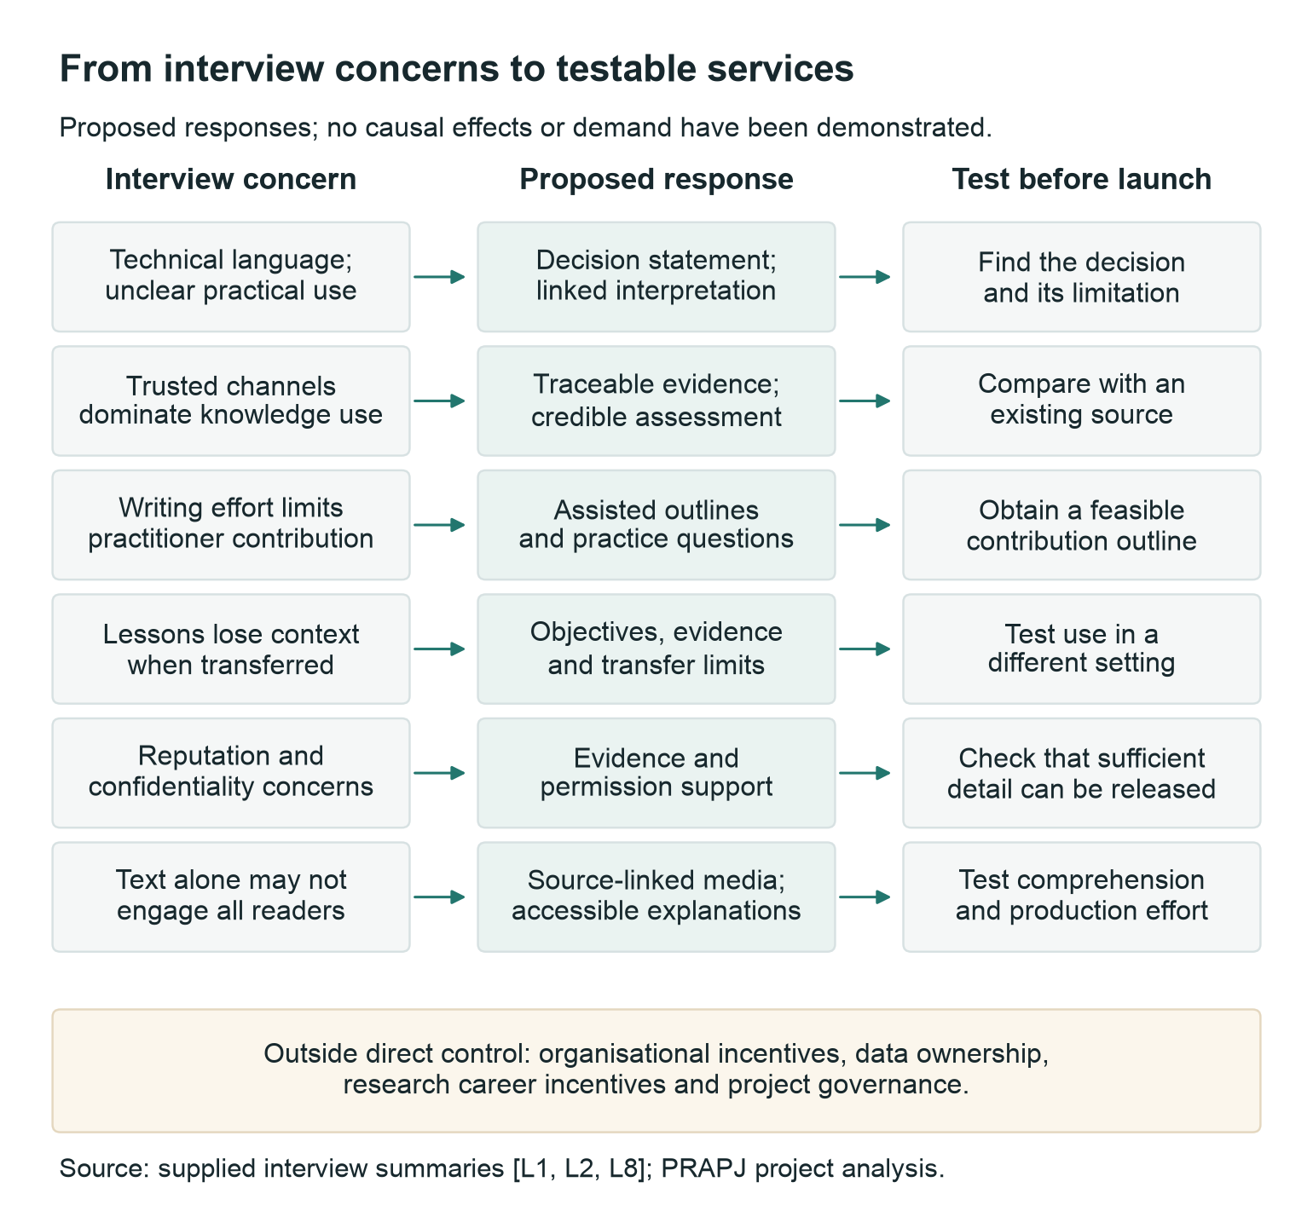
Figure 1. Proposed problem-to-service logic; arrows represent hypotheses, not demonstrated causal effects.

3. Research evidence and competitive positioning

What the research actually establishes
The literature is not a single body of experimental evidence that a new journal will close a gap. It combines conceptual arguments, research-network synthesis, qualitative empirical studies and institutional experience. The following evidence table preserves those distinctions. Findings in adjacent management fields are useful for designing PRAPJ, but they require testing in project-management settings.
Source and evidence type | Verified finding or argument | Relevance and boundary for this business case
Winter, Smith, Morris and Cicmil (2006): synthesis of the Rethinking Project Management network | The network's two-year work produced five directions: complexity, social processes, value creation, project conceptualisation and practitioner development. It was presented as an agenda to stimulate research, not an exclusive agenda. [M01] | Establishes a substantial history of questioning how project research relates to developing practice. It neither counts dissatisfied readers nor tests a publishing business model.
Cicmil, Williams, Thomas and Hodgson (2006): methodological and conceptual argument with research examples | The article redirects attention towards lived project experience, context-dependent judgement, ethics and reflexivity, rather than relying only on prescribed project-management practices. [M02] | Supports cases that explain context and actual decisions. It does not justify treating every practitioner narrative as reliable evidence.
Chaves (2021): project-management position paper | The paper recommends practitioner involvement across research and publishing, practice-relevant genres and help with writing. It explicitly suggests that special sections may be a more manageable initial step than wholly practitioner-dedicated outlets. [M03] | Supports participation and varied formats while directly challenging an automatic leap to a new journal. These are argued recommendations, not measured intervention effects.
Van de Ven and Johnson (2006): conceptual paper | The authors distinguish a transfer problem, differences between kinds of knowledge, and a knowledge-production problem. Engaged scholarship is proposed as a response to the last of these. [M04] | Provides a useful diagnostic distinction: a better summary, a contextual explanation and a jointly framed research question solve different problems. It is not evidence that any one format guarantees use.
Mohrman, Gibson and Mohrman (2001): empirical exploration involving ten companies | Perceived usefulness was associated with organisational self-design informed by findings and opportunities for researchers and practitioners to interpret results together. The accessible institutional working paper precedes the journal version. [M05] | Supports testing joint interpretation, rather than equating publication with application. The study concerns perceived usefulness in its participating organisations, not journal subscriber demand or causal project-performance gains.
Božič, Bachkirov and Černe (2022): qualitative grounded-theory study of 47 practising managers | Participants identified practice-engaged research, relevance and complementary knowledge as enablers. Barriers included trust, cognition, coping and heuristic information processing. [M06] | Indicates that reader-side conditions matter alongside academic communication. The sample is not a representative estimate of project professionals or an Australian market survey.
Makin (2021): case study in a medium-sized IT consultancy | An 11-month engagement examined attempts to use organisation-theory and information-systems research. The study describes a pragmatic knowledge boundary and considers collaborative practices and boundary objects as ways of addressing it. [M07] | Supports attention to situated interpretation and practical artefacts. A single embedded case cannot establish universal effectiveness, and the researcher's involvement requires attention to perspective.
Bansal and colleagues (2012): reflective account of the Network for Business Sustainability | The authors draw on their collaboration to argue for intermediary organisations that can support exchange beyond what isolated individuals can achieve. [M08] | Supports treating translation and coordination as organised work with owners and resources. It does not show that PRAPJ needs the same structure or that journal revenue will fund it.
Locatelli and colleagues (2023): project-management manifesto | The authors defend the relevance of contemporary project scholarship, emphasise its social-science foundations and invite collaboration with neighbouring disciplines. They argue for both academic rigour and social relevance. [M09] | Prevents a misleading claim that existing project research is merely technical or intrinsically irrelevant. The manifesto is an agenda-setting perspective, not a demand assessment for PRAPJ.
Tkachenko, Hahn and Peterson (2017): integrative literature review | The review brings together research-practice literature from management, applied psychology and human-resource development, synthesising seven themes and proposing a knowledge-production model. [M10] | Demonstrates that the issue extends beyond project management. Its abstract establishes scope and purpose; this review does not infer detailed results or sample counts from inaccessible full text.

Three implications follow from this mixed evidence base. First, PRAPJ should avoid a deficit story in which academics possess valuable knowledge and practitioners simply fail to read it. A professional may understand an article yet reasonably decide that its setting, incentives or evidence do not fit the present decision. Conversely, a familiar practice may be attractive because it is convenient rather than because it is well supported. The editorial task is to make both the evidence and the contextual judgement inspectable.
Second, practical relevance should be defined before production, then revisited after use. A research article can nominate an intended decision, audience and limitation; a practitioner reviewer can test whether those statements are comprehensible; a later reader can explain what was useful, irrelevant or misleading. These are different observations. An editorial claim of relevance should not be recorded as demonstrated use. A reader's favourable reaction should not be recorded as improved project performance. This proposed distinction keeps the benefits case measurable without overstating causal effects.
Third, the intervention should address the part of the problem it can control. PRAPJ can improve article labelling, preparation support, evidence disclosure, review and interpretation. It cannot directly alter employers' incentives, grant organisations access to confidential data, give practitioners protected reading time, or guarantee academic recognition. The business case should fund and evaluate the controllable service while recording these external conditions as dependencies. An attractive website may make the service easier to access, but it does not supply the editorial relationships or evidence quality on which usefulness depends.

Competitive boundary and comparator selection
The relevant market is the set of ways a project professional acquires credible help for a decision and the ways a contributor obtains a useful publishing route. This includes journals, professional-body summaries, organisational knowledge, colleagues, training and commissioned advice. Restricting the comparison to journals with similar titles would miss important substitutes. It would also confuse a shortage of publishing places with a shortage of usable evidence: the former does not automatically establish the latter.
Seven journals were selected for transparent qualitative comparison: prominent general project-management outlets; publications explicitly associated with practice, cases or society; and a closely named historical comparator. This is a purposive benchmark, not a census, ranking or exhaustive definition of “quality.” The matrix records features verified on official publisher, professional-association or university pages. A feature not established by the consulted page is marked unverified rather than absent. Promotional self-descriptions are evidence of positioning, not independent proof of effectiveness. [M11-M18]
Comparator | Verified scope or offer | Verified practice-facing route or signal | Strategic implication for PRAPJ
International Journal of Project Management (IJPM) | APM describes broad project-management coverage, cross-industry applications and double-blind review. [M11] | The separate APM Research Summary Series translates selected IJPM articles for practitioners. [M12] | Competing on “research plus practical meaning” alone would be weak. Test a more specific contribution workflow and decision format.
International Journal of Managing Projects in Business (IJMPB) | Emerald positions the journal as a connection between academia and project practice through rigorous, practice-informed research. [M13] | Its page supplies detailed author policies and guidance for special-issue proposals. [M13] | An existing journal already claims the central bridge position. A partner collection deserves investigation alongside an independent launch.
Project Management Journal (PMJ) | PMI states a mission combining theory and evidence-based practice across projects, programmes, portfolios and project-based organising. Journal access is a membership benefit. [M14] | PMI explicitly lists webinars, videos, summaries and Thoughtlets among routes serving practitioners. [M14] | Accessible formats and professional distribution are established competitive capabilities. PRAPJ must demonstrate a reason to return beyond a shorter article.
Project Management Research and Practice (PMRP) | UTS's archived page describes research and practitioner contributions addressing socially responsible change. It records a move to another platform in 2020 and archives 2016-2018 issues. [M15] | Archived contents distinguish practitioner cases with single-blind review and research articles with double-blind review. [M15] | A close conceptual predecessor exists. Investigate naming, continuity and possible collaboration; do not infer closure or business failure from the archive or an inaccessible current site.
Journal of Project Management Practice (JPMP) | The University of Malaya page describes a double-blind journal covering theory, research and practice across sectors, published twice yearly. [M16] | It expressly includes innovative practice case studies assessed for reader relevance. [M16] | Practice cases and broad professional relevance are established formats. PRAPJ needs a stronger proposition than adding a case category.
Project Leadership and Society (PLS) | IPMA's current journal page identifies PLS as open access and describes interactions between projects and economic, social, political and organisational processes. [M17] | Its association-owned description gives the journal an explicit connection to society and a professional research community. [M17] | Openness and societal orientation alone are insufficient differentiation. PRAPJ should specify the decisions and contribution service it will serve.
International Journal of Project Organisation and Management (IJPOM) | Inderscience describes a broad organisational and cross-industry audience including practitioners. It lists four issues annually, a subscription route and optional open-access articles. [M18] | Its topics include risk, post-deployment review, knowledge management, governance and consultancy projects. [M18] | The proposed initial topics are not unoccupied subject territory. Execution and contributor support must matter more than a new topic label.

APM's summary programme is a particularly relevant service comparator. Its official account says the series followed consultation about access, format and language barriers; experienced technical writers prepare summaries with original authors where possible, and reader feedback is invited. PRAPJ can learn from this division of labour. It should not claim that linked summaries, plain language or a feedback route are unprecedented. The programme demonstrates an operating precedent, not a quantified unmet market or a guarantee that a second service will attract readers. [M12]
The market evidence also counsels against using headline journal metrics as a shortcut. Citation indicators, acceptance rates, readership labels, publication frequency and service-time figures answer different questions and may cover different periods. Without aligned definitions and current comparable data, a numerical ranking would create apparent precision. This chapter therefore does not compare impact factors, infer market share from web traffic, or use a publisher's historical acceptance rate as PRAPJ's forecast. The appropriate next benchmark is a task-based comparison of content usefulness and contribution effort.
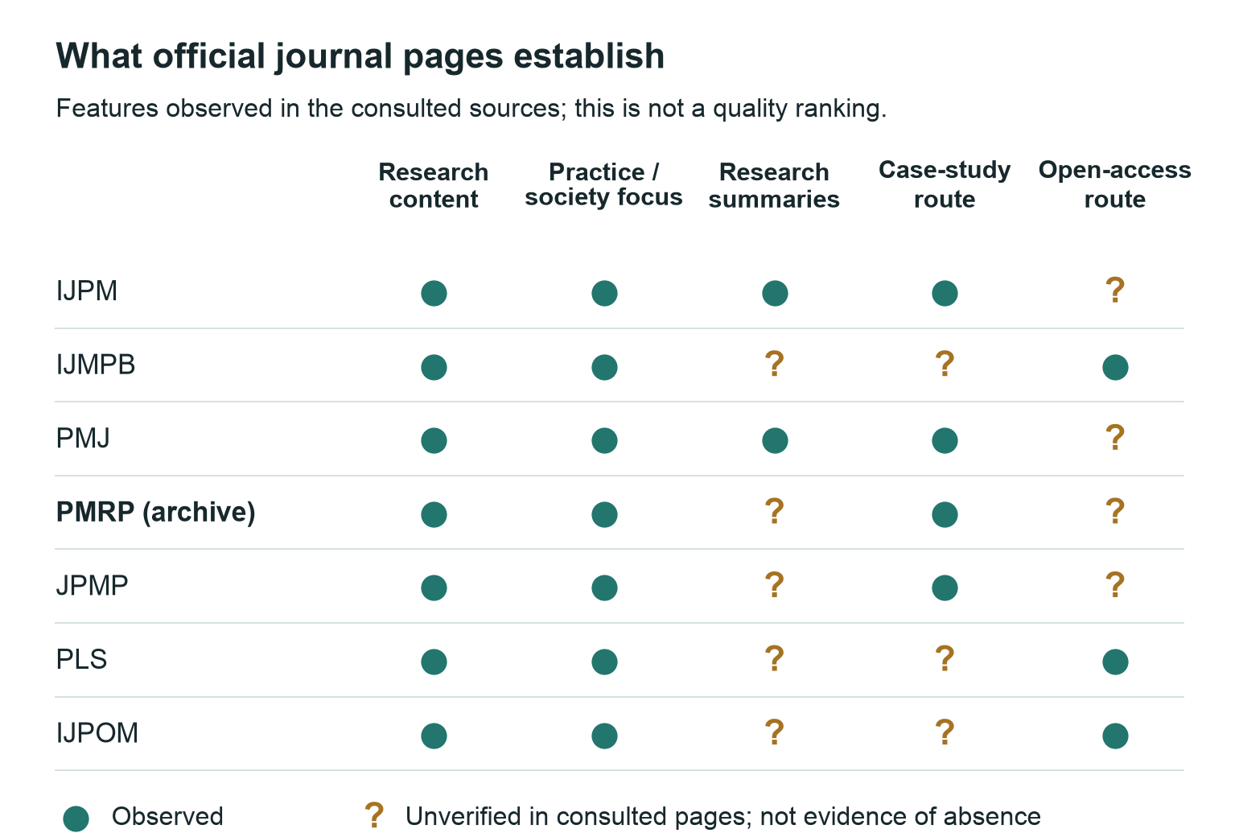
Figure 2. Comparator feature evidence from official sources; an unverified feature is not treated as absent.

Market size: what can and cannot be estimated
No credible estimate of the obtainable PRAPJ audience can be derived from the supplied evidence. The number of project professionals globally, the value of project expenditure, association membership or total journal downloads would describe broad populations or activities. None establishes how many people would use this particular service, contribute evidence, return repeatedly or fund its operation. Applying an arbitrary penetration percentage to such a population would create a misleading market forecast.
A more useful early market model is a set of linked, measured funnels. For readers, record invited people, eligible respondents, completed content tasks, first-time use and later return. For authors, record expressions of interest, eligible outlines, permission-feasible proposals, completed submissions and publishable contributions. For reviewers, record expertise, annual report capacity, conflicts, invitation response and actual completion. For funders, distinguish an introduction, an expression of strategic interest, a service contribution and a written funding commitment. The pilot requires all these flows; growth in one does not compensate automatically for failure in another.
The service is also constrained by its own capacity. A small qualified readership may be adequate for a focused evidence-exchange pilot, while a large audience with no suitable submissions or reviewers would be operationally fragile. Conversely, a large submission queue may increase costs before demonstrating reader value. The economically relevant question is therefore the cost of a useful, quality-controlled contribution and its sustained use by the intended audience. It is not the cheapest cost per page or the highest number of downloads. These are proposed management measures; the present package reports no achieved values.
Geographical scope should remain explicit. The capstone's networks may make an Australian starting cohort practical, but the four interviews do not establish nationwide demand. An English-language publication may receive international interest without having the editorial resources to cover every jurisdiction or sector. Commissioning should identify where a case occurred and which institutional conditions matter. The pilot can accept wider participation while evaluating a bounded initial audience, avoiding a public promise of universal relevance that its evidence cannot support.

A proposed seven-part service design
The following service-design analysis translates positioning into operating choices. These are proposals for PRAPJ, not a description of proven customer preferences. Its purpose is to expose the work and dependencies behind the public proposition.
Element | Proposed design choice | Why it matters and what must be tested
Product | Four contribution tracks, with a decision-relevance statement and evidence limits appropriate to each | Tests whether users need original research, documented cases, translations and questions as a connected service rather than four unrelated content categories
Price | Preferred diamond access, conditional on funding; disclose the substantial non-cash effort required from authors and reviewers | Removing a fee does not remove time, permission or production costs; examine willingness and ability to contribute labour separately from willingness to read
Place | Accessible public content distributed through approved professional and institutional channels | The website is a destination; distribution must reach people at the moment they have a relevant problem
Promotion | Demonstrate a specific decision task and invite critical feedback | Avoid launch claims based on broad enthusiasm; measure whether a sample earns attention compared with an existing option
People | Research, practice, translation and managing-editor responsibilities, supported by independent reviewers | The service depends on qualified judgement and coordination; headcount alone cannot establish capacity or subject coverage
Process | Predictable intake, scope checks, proportional review, revisions, permissions, production and corrections | A reliable process reduces uncertainty for contributors while protecting quality; test the workflow before opening submissions
Physical and digital evidence | A readable specimen, clear review labels, real publication details when assigned, and consistent policies | These make the proposition inspectable; presentation quality must not imply appointments, peer review, indexing or publication status that do not exist

4. Stakeholder value and the proposed service

Who would use, contribute to and sustain PRAPJ
A journal has several interdependent audiences. Readers need useful evidence; authors need a fair and worthwhile publication route; reviewers need manageable work and confidence that their effort matters; institutions need accountable expenditure and continuity. A concept that attracts readers but cannot obtain credible manuscripts is not viable. Neither is a well-designed manuscript workflow without a reachable readership. PRAPJ should test these sides together, while recognising that they may be motivated by different benefits.
The primary launch audience is experienced and mid-career project professionals: sponsors and PMO leaders making governance choices, consultants developing defensible advice, and delivery practitioners addressing risks, dependencies and learning. James's interview strengthens this proposed focus. Researchers are both contributors and users of practice-generated questions. Students and emerging professionals are a secondary audience for selected explanations derived from the same expert evidence. These priorities are design choices informed by interviews, not validated demographic market segments. [L8]
Stakeholder | Job the service should help accomplish | Main adoption barrier | Evidence of value to collect
Sponsor or PMO leader | Compare an intervention and its conditions before approving a change | Evidence is late, generic or politically inconvenient | A documented use in a decision brief, with permission
Consultant or specialist | Explain a defensible recommendation and its uncertainty | Client relevance and source credibility | Correct application to a realistic client scenario
Delivery practitioner | Learn from a comparable decision or outcome | Time, terminology and lack of comparability | Finds a relevant lesson and identifies a transfer limit
Practitioner author | Turn experience into an assessable contribution | Time, permissions and fear of reputational damage | A feasible case outline with accessible evidence
Research author | Reach professional readers without weakening the research | Career incentives and added translation effort | Willingness to submit under the actual proposed conditions
Reviewer or editor | Improve credible work within an explicit commitment | Unpaid workload and conflicts | Accepted subject-specific assignments and timely reports
Host, library or sponsor | Sustain a legitimate, useful publication | Unclear ownership, costs and service obligations | Written scope, resource commitment and succession owner

Value proposition and editorial boundaries
The proposed promise is that a reader can quickly identify the decision, inspect the basis of the claim and judge where the lesson may travel. It should be visible at article level, not merely in an About page. Every core contribution therefore includes a short decision-relevance statement. Research retains methods and limitations; cases distinguish observations from interpretations; briefs link to identifiable source research; and challenges separate a question from a claim that has already been tested.
PRAPJ should publish mixed and adverse outcomes when they are well evidenced and responsibly presented. Requiring success stories would undermine the learning purpose and encourage selective reporting. At the same time, a case must not become a grievance, an advertisement or an allegation without an appropriate evidential basis. Editors need a route to decline material whose claims cannot be assessed or whose necessary permissions cannot be secured.
The service should support authors through format guidance and clinics, while keeping assistance separate from acceptance decisions. A practitioner–researcher pair may improve method and interpretation, but co-authorship must reflect actual contribution. Researchers should not be added merely to make a case appear academically credible. Commercial sponsorship must not buy manuscript acceptance, reviewer selection or suppression of inconvenient findings.

A concrete promise to founding contributors
A founding author should be able to see what they gain and what they must provide. PRAPJ offers a publication route designed to connect an identifiable project problem with inspectable evidence and professional learning. Research authors retain methodological depth while a linked brief makes decision relevance visible. Practitioner contributors can begin with a guided outline or an editor-supported conversation, then develop a manuscript with sufficient records, permissions and context for assessment. The proposed diamond model removes author charges only when institutional support is secured and that policy is adopted; the current project cannot promise a funded service.
The initial contributor proposition should be tested in concrete terms: a relevant audience, clearly stated assessment, useful editorial feedback, accurate attribution, a durable article record and a source-linked practical interpretation. Do not substitute unearned prestige signals, promised citation impact or immediate indexing for these benefits. A new journal earns credibility through the quality of its initial contributions, the independence of its decisions and its treatment of contributors.
An interview-supported route can make participation easier without weakening authorship or review. A proposed workflow is: topic conversation; evidence and permissions screen; approved outline; supported drafting; contributor verification and declarations; independent assessment; final proof and publication. Allow the contributor to withdraw an unsuitable outline before formal submission. Record assistance and any authorship role, avoid hidden promotional ghostwriting, and assign an unconflicted handling editor. Support is a preparation service, never an acceptance guarantee.

Problem-led collections and a layered content model
The first publication programme should demonstrate a recognisable answer to 'What project decision does this help me make?' Suggested commissioning clusters are: resource and dependency decisions; governance and deliverability; prioritisation; and risk, sustainability or AI-related complexity. Each cluster can combine a detailed research or case contribution with a short interpretation and, where useful, a supported media explanation. James proposed these problem areas, but the eventual selection should follow available credible content and user feedback. [L8]
The core text is the authoritative contribution with methods or case evidence, limitations and publication metadata. A brief helps a time-constrained professional judge relevance. Optional video or audio explains a bounded point and links back to the text; captions or a transcript support access. A selected micro-explanation can introduce a concept to an emerging professional. Each derivative states its source, author/editor responsibility, date, rights and assessment status. Corrections propagate through the linked set. Viewing four formats derived from one contribution remains engagement with one evidence family.
This design gives PRAPJ a persuasive identity without multiplying full article categories. Multimedia is an optional delivery extension, while the four core tracks and their review routes remain stable. A small launch team should commission fewer, well-supported examples and expand when users value them and capacity is demonstrated. The incremental workload scenario in the financial chapter makes this choice visible.

Reader journey and distribution hypothesis
The journey begins before a reader reaches the journal. A professional may encounter an article through a colleague, an association, a course, a search or a project-specific query. The first screen should identify the project problem, intended objective, reading or viewing format, contribution type and level of assessment. Discovery should support problem-led browsing as well as conventional issue and article navigation. A brief should make its source and limitations easy to reach. The reader should then be able to inspect the full contribution, download a stable version and cite it accurately.
Distribution should initially concentrate on a small number of authorised, relevant channels. Record which channel brings people who actually read and understand the material, rather than rewarding the largest number of impressions. A voluntary email digest may support return visits only after the host has adopted a contact and consent process. No mailing list or distribution agreement is assumed in this business case.
The proposed challenge route closes the loop: readers can submit a structured question about a decision, context and evidence gap. Editors triage it for relevance, ethical concerns and whether existing evidence already answers it. Suitable questions may inform a commissioned review, a case comparison or a future research call. The value is the quality of the question and response, not the number of comments on a page.

Professional development: a useful hypothesis, not accreditation
PMI's official guidance permits certification-relevant self-directed reading as an Education PDU activity and recognises structured professional discussion as another route. This supports testing a reflective reading record, but it does not make PRAPJ an authorised training provider or guarantee that a specific article qualifies for an individual's claim. Readers remain responsible for the rules applying to their credential. [R02]
A proposed learning record would ask the reader to note the source, date, time spent, relevant professional capability, one learning point and one limitation. It should not automatically generate a certificate or calculate credits from article length. The test should ask whether this small reflection step improves useful return visits; it should not assume that a CPD label creates demand. If a professional body later agrees to a recognised arrangement, publish the exact scope and effective date.

Theory of change and failure points
The proposed sequence is resources and permission-ready evidence → fair assessment and translation → accessible, trustworthy contributions → comprehension and considered use → better documented learning and professional questions. Every arrow can fail. An article may be published but never found; it may be found but misunderstood; it may be understood but irrelevant; it may be relevant but impossible to apply in an organisation. Benefits evaluation must observe more than the first two stages.
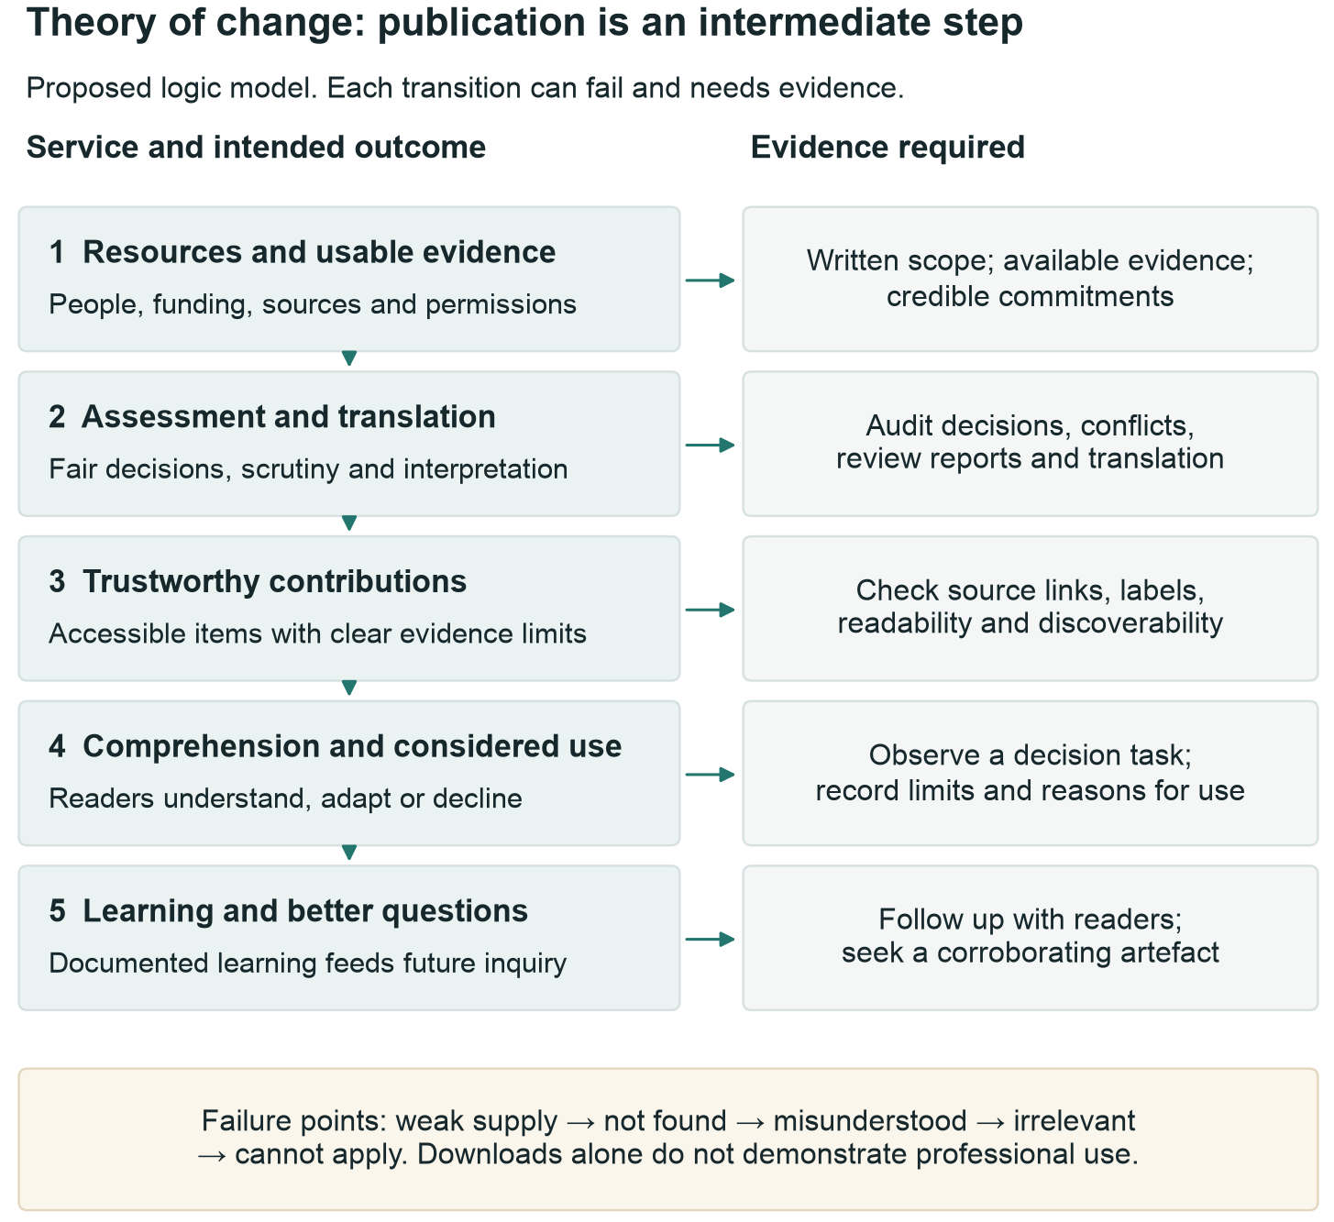
Figure 3. PRAPJ theory of change and the evidence required at each stage. This is a proposed logic model.
The journal can reasonably claim a contribution to better-informed decisions when readers describe how its evidence was used and, where possible, provide a corroborating artefact. It should not attribute a project's financial savings, schedule improvement or success to one article without a defensible evaluation. Citation counts and page views provide different signals and cannot replace evidence of professional use.

5. Strategic rationale and delivery alternatives

What the alternatives explain about the journal choice
Option A uses existing journals, standards, internal learning and professional networks without establishing a new publication. Its advantage is low incremental organisational complexity. Its limitation is that the project cannot control formats, access, editorial priorities or a dedicated practitioner-question route. This option should not be described as doing nothing; a carefully signposted evidence resource can still help readers.
Option B creates a curated evidence digest under an existing institution or professional group. It selects and interprets relevant research, obtains any necessary permissions and distributes concise summaries. It can test reader usefulness before building an original-research operation. It still requires editorial judgement, translation, quality checks and continuity. It does not automatically offer practitioners a durable, independently assessed case-publication route.
Option C develops a partner-hosted collection or practice section with an established publication. It could combine a distinct thematic programme with existing reputation, production and preservation arrangements. The trade-offs are policy compatibility, partner willingness, control over article types and possible charges or limits on ownership. No partner has agreed to this model; the business case treats it as a credible option to investigate, not an available offer.
Option D establishes PRAPJ as a dedicated journal, beginning with a controlled first operating year. It offers the greatest control over the four-track model, reciprocal participation and learning about the service. It also requires the most explicit ownership of editorial, administrative, financial and preservation responsibilities. This control is strategically valuable because it enables one coherent standard for practical interpretation, contribution support and reciprocal research questions. The formal journal direction is the project's intended outcome; the comparison explains the additional responsibilities that accompany it.

Appraisal method and score justification
Scores range from 1, weak, to 5, strong, against five criteria. The weighted total is the sum of each score divided by five and multiplied by its percentage weight. Weights reflect the project's emphasis on practical value and two-way contribution; they are proposed project judgements, not survey findings. Practical usability concerns the service's designed ability to help a reader; credibility concerns the support for trustworthy assessment; feasibility includes people and continuity as well as cash; participation concerns a contribution route; control concerns the ability to change and learn.
Criterion | Weight | A Existing channels | B Digest | C Partner collection | D PRAPJ journal
Practical usability | 25% | 2 | 4 | 4 | 5
Editorial credibility | 20% | 4 | 3 | 5 | 3
Feasibility and affordability | 25% | 5 | 4 | 3 | 2
Two-way contribution | 20% | 1 | 2 | 4 | 5
Control and future learning | 10% | 1 | 3 | 2 | 5
Weighted total /100 | 100% | 57 | 66 | 75 | 77

The high usability and participation scores for D describe its proposed design potential, not observed performance. Its credibility score is lower than C because a new title lacks an established operating record. C's feasibility score remains moderate because negotiation and policy fit are unresolved. B scores well for usability but lower for two-way contribution because summarising published work is not equivalent to assessing original practitioner evidence. A is strong on immediate feasibility and existing editorial credibility, but offers little project control.
These justifications expose a possible optimism bias: the model rewards D for functions not yet demonstrated. The appropriate corrective is not to add a general confidence percentage to the total, but to test those functions and rescore. At validation, ask the sponsor and at least one practitioner and publishing representative to score independently, discuss disagreements and record the final rationale. Do not average away a hard constraint such as no legal publisher or no funding.
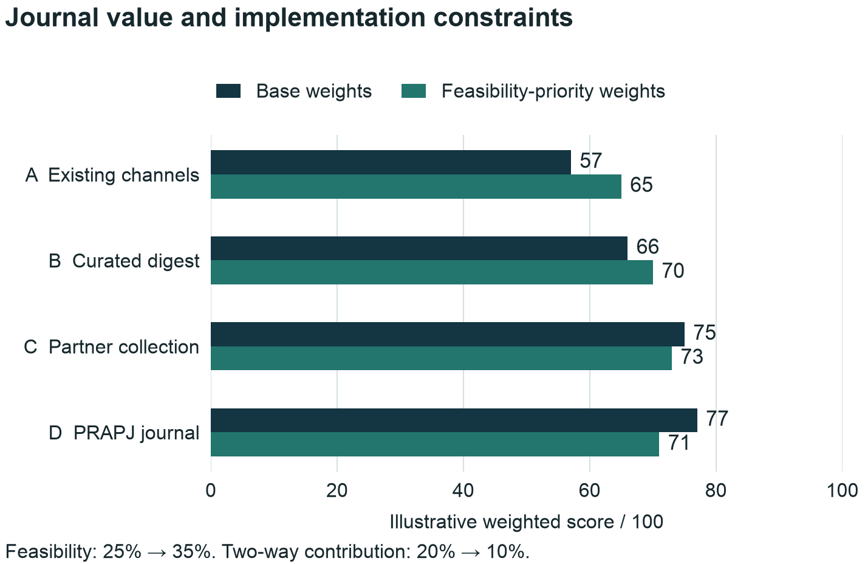
Figure 4. Illustrative option scores under base and feasibility-priority weights. Scores are analyst judgements, not measured preferences.

Sensitivity and switching conditions
In the base case D leads C by two points. Reducing D's feasibility score from 2 to 1 reduces its total by five points to 72, so C leads. Raising feasibility weight from 25% to 35% and reducing two-way participation from 20% to 10%, with all other weights unchanged, gives C 73 and D 71. Under that weight transfer, the options tie when feasibility reaches 30% and participation falls to 15%. This demonstrates that the preferred option depends on the sponsor's priorities, not just the arithmetic.
Other single-point changes are similarly material: a one-point reduction in D's practical usability reduces its score to 72; a one-point reduction in credibility gives 73. The numerical exercise therefore cannot establish robust superiority. The journal recommendation instead rests on the project's stated publication purpose and the strategic value of control over its integrated reader/contributor model. Conversely, a partner that cannot offer the proposed practice route or acceptable rights terms may deserve a lower participation or control score. Such a change requires an actual finding, not a convenient assumption to preserve the preferred answer.

Hard conditions and value of further information
The current task is to establish PRAPJ for formal publication. The alternatives appraisal remains useful because it distinguishes the benefits of a dedicated journal from the services it could obtain through a host or publishing partner. An institutionally supported PRAPJ title can retain its mission while reusing technical and production infrastructure. A practice section within someone else's title offers a different degree of identity and editorial control. These arrangements should not be treated as interchangeable merely because both involve a partner.
Before opening real submissions, establish an accountable publishing entity, adopted policies, independent handling, a credible first-content pipeline and available operating resources. No actual capstone budget or committed journal funding currently exists; all resource estimates are hypothetical. Readiness requirements are implementation dependencies, not evidence that the journal lacks a worthwhile purpose. They protect contributors from investing in an unsupported service.
Further information should improve the chosen journal model: reader comparisons refine the article experience; contributor outlines test support needs; reviewer assignments test capacity; and host proposals clarify responsibilities and cost. The same evidence can inform the service configuration and first-year scale. A bounded concept test may be conducted with available in-kind effort; the paid validation estimate is only a hypothetical alternative and does not create an expenditure request.

Recommended sequence
Advance PRAPJ as a formal journal. First, agree its professional value proposition and appoint a continuing implementation owner. Second, choose the supporting institutional or external service arrangement and allocate responsibility for editorial operations, production, preservation and records. Third, recruit a permission-ready founding contribution pipeline and test the reader and contributor experience using the supplied templates and mockups. Fourth, verify resources and workflow readiness, then open submissions and publish the initial contributions.
Use the first operating year to refine the service with actual evidence. Keep the journal's mission stable while adapting topic priorities, support intensity, publishing cadence and optional media. Should an operating constraint emerge, adjust the implementation plan or defer a specific service commitment under the authorised owner's direction. The case for publication is strongest when the proposed value is matched by a credible ability to deliver it.

6. Operating model credibility and sustainable ownership

The decision is a publishing service commitment
PRAPJ should be established as a formally published journal with an accountable publishing organisation that accepts the continuing obligations created by publication. Confirm the resources required for real submissions and publication; the current capstone has no actual budget and the operating figures are hypothetical. A functioning website is one component. The service also requires manuscript handling, independent assessment, production, rights clearance, metadata maintenance, complaints handling, correction of the published record and preservation after the founding team leaves. The capstone can prepare those arrangements; it cannot demonstrate that unspecified staff or institutions have accepted them.
The recommended configuration is a journal owned by a confirmed institution, society or other authorised organisation, supported by a named managing editor and an independently led editorial team. Hosting can be purchased or provided institutionally. Ownership should remain explicit even when most technical work is outsourced. The sponsor and continuing owner should organise a controlled first operating year, with scale informed by useful content, reliable operations, manageable effort and credible future support. This is a proposed model, not an assertion that any particular institution is the intended publisher.
Before selecting a platform, the sponsor should obtain a short operating agreement covering the journal title, domain, public identity, intellectual-property arrangements, access to editorial records, authority to appoint editors, financial delegations, complaints escalation and succession. The publishing organisation, service provider and Editor-in-Chief should sign only within their respective authority. The agreement should preserve editorial independence while identifying who may respond to a security incident, legal complaint or serious integrity allegation.

What the primary benchmarks establish
COPE's core-practices framework covers misconduct, authorship, complaints, interests, reproducibility, ethical oversight, intellectual property, management, review and corrections. Its relevance is that publication ethics depends on implemented processes and trained people as well as written policies. Using the framework does not establish COPE membership, certification or an investigation outcome. The draft PRAPJ policies provide a starting point; the pilot must assign operational owners and test them. [O07]
The joint COPE–DOAJ–OASPA–WAME transparency principles ask journals to make their identity, scope, schedule, review, ownership, editorial team, fees, rights, business model and preservation arrangements clear. They also separate editorial judgement from commercial influence. These are a widely used professional benchmark, not a universal statutory licensing regime. PRAPJ should use them as a public-information audit and record any deliberate deviation with its reason and responsible decision maker. [O08]
Edinburgh Diamond illustrates an institutional division of labour: its library supplies hosting, technical support, identifiers and preservation, while service users retain editorial responsibilities and perform submission, review and production work. Its conditions include institutional publisher identification and a management succession plan. This demonstrates a possible arrangement, not a service available automatically to PRAPJ. The important procurement lesson is to specify exactly which work the library covers and which remains with the journal. [O06]
Emerald Publishing Services describes a diamond open-access partnership in which journal owners retain ownership and receive infrastructure, a publishing manager, ScholarOne configuration, guidance and performance reporting. It advertises a financial outlay agreed in advance, but the inspected page supplies no PRAPJ-specific quote or contractual entitlement. Treat it as a potential service model requiring scope, price and policy negotiation. Its existence supports the feasibility of buying specialist capacity; it does not demonstrate affordability for this project. [O05]

Compare three operating arrangements on the same basis
The following matrix contains PRAPJ decision criteria, not supplier promises. Each option must be evaluated against the same forecast workload and service boundary. A low hosting invoice cannot establish a low total cost when the journal must supply unpaid editorial administration, production and technical support.
Decision dimension | Institutional OJS service | Managed hosting service | Publishing partnership
Necessary sponsor evidence | Written institutional eligibility, service scope and named budget owner | Contract with a provider plus an internal journal owner | Accepted journal proposal and negotiated publishing agreement
Likely internal burden to test | Editorial office, production and any work excluded by the library | Editorial decisions, administration and production unless specifically purchased | Editorial leadership, contributor development, policy oversight and excluded work
Technical accountability | Named library or IT service; clarify shared responsibilities | Provider service manager and documented escalation | Publishing partner and its subcontractors under agreed obligations
Control to preserve | Journal title, policies, editorial appointments, domain and records | Same, with data portability and administrator access tested | Ownership, editorial independence, brand use and termination rights written explicitly
Main uncertainty | Institutional eligibility, capacity and persistence of subsidy | Complete service price and ability to manage provider dependency | Total fee, policy constraints, approval timetable and exit terms
Suitable condition | A willing institution accepts durable responsibility | Owner exists but has insufficient technical capacity | Owner can fund bundled expertise and accepts the negotiated service model

OJS supports submission, review, production, publication, identifiers, metadata exchange, usage statistics and import/export. These are software capabilities, not proof that a particular installation is correctly configured, securely operated or accepted by an index. For PRAPJ, platform selection should therefore be followed by a workflow demonstration using synthetic manuscripts, rather than acceptance on the basis of a feature list alone. [O02]
PKP publishes tiered hosting plans with different support and configuration provisions. The financial analysis records the inspected price benchmarks and limitations; obtain a written proposal for the chosen scope. [O03]
PKP describes full installation backups on cancellation. Require a testable exit package, while using the financial chapter's service-boundary analysis to separate hosting, production, administration and preserved content. [O04]

Procurement questions that expose the real cost
Request a three-year comparison with identical assumptions: 16 published items in the first operating year, the agreed submission pipeline, four contribution tracks, article-level web pages, downloadable articles, linked briefs and two curated collections. Ask each provider to identify inclusions, exclusions, setup charges, recurring charges, volume thresholds, taxes, currency, annual increases and termination charges. The comparison should include a closure or transfer scenario because even a successful pilot may change ownership or service provider.
Work package | Evidence to request before selection | Budget treatment
Configuration and training | Demonstration of each contribution route, anonymity controls and staff permissions | One-time setup plus training for replacement staff
Editorial administration | Named tasks and hours for checking files, invitations, reminders and version records | Internal paid time or explicitly purchased service
Production | Sample copyediting, typesetting, references, accessible tables and author-proof cycle | Per-item rate plus exception handling
Identifiers and metadata | Registration responsibility, included fields, failed-deposit handling and maintenance | Membership/service fee, registration charges and staff time
Technical operation | Supported versions, upgrade policy, backup restore evidence and incident escalation | Recurring service plus out-of-scope work
Preservation | Agreement, deposit mechanism, covered formats and confirmation evidence | Service charge, integration and monitoring
Exit and continuity | Export specimen, readable records, migration assistance and domain transfer | Exit reserve and continuing archive expense

The sponsor should require a sample export before purchase. It should include published files, article metadata, licence information, identifiers and relationship links, together with a separate controlled export of editorial history where contractually permitted. A set of public PDFs is not a complete operational transfer. Nor does possession of a database guarantee that the next provider can restore it. Test restoration, character encoding, file associations and permissions in a clean environment.
Use a weighted appraisal only after excluding options that fail essential conditions. Suggested non-negotiable conditions are an accountable owner, independent manuscript decisions, a usable export, a defined preservation route and affordable minimum service. Weighted preferences may then compare service coverage, accessibility support, staff burden, technical flexibility and three-year cost. Do not award an option a high affordability score simply because the institution has not yet charged for staff time; record the subsidy and its renewal conditions.

Roles must survive the founding team
The following responsibility matrix is proposed for PRAPJ. Accountable means the role answerable for the decision or outcome; responsible means the role doing the work. A single person may hold compatible roles at pilot scale, but the record must distinguish those roles. An author or conflicted editor cannot supply independent oversight of their own manuscript.
Activity | Accountable | Responsible | Consulted or control
Funding, service contract and continuation | Authorised journal owner | Sponsor delegate or business manager | Advisory Board and service provider
Editorial policy and reviewer standards | Editor-in-Chief | Research and Practice Editors | Editorial Board; owner for institutional adoption
Completeness and file classification | Managing Editor | Editorial office | Author; academic decisions remain with editor
Manuscript decision | Independent handling editor within delegation | Handling editor | Independent reviewers; Editor-in-Chief where unconflicted
Translation fidelity | Translation Editor | Brief author and translation assessor | Source author or specialist where needed
Rights and production release | Owner's authorised publishing role | Managing Editor and production provider | Handling editor and corresponding author
Security and recovery | Named host service owner | Technical service provider | Managing Editor and institutional incident contact
Appeal involving the Editor-in-Chief | Independent publisher-designated handler | Unconflicted appeal editor or panel | Relevant evidence holders
Preservation and transfer | Journal owner | Managing Editor and technical provider | Archive provider; successor owner

At least two people should be able to perform essential administrative actions. Maintain a role-based account register, a documented process for removing access when people leave, and a monthly check of outstanding submissions. A student's personal email, laptop or cloud account should not be the sole route to author records or journal credentials. The owner should appoint a successor before the capstone team hands over and document how pending decisions will be managed during leave or departure.
The Advisory Board should review aggregate performance, relevance and financial resilience. It should not gain access to confidential manuscripts merely because it advises the publisher. Editorial meetings should resolve policy and capacity issues rather than vote on acceptance quotas. Staff performance should combine timely handling, defensible decisions and constructive communication. A target of publishing 16 items must never override evidence or permissions requirements.

A workflow with observable quality gates
Emerald's process benchmark distinguishes administrative checking, editorial assessment, reviewer invitations, assessment, decision and subsequent production. It also makes editorial judgement important where reports conflict. PRAPJ can adopt the process logic while retaining its own proposed targets and contribution routes. Emerald's published practices do not establish PRAPJ's actual turnaround time, and no current PRAPJ performance statistic exists. [O19]
Gate | Evidence before progression | Failure response
Complete submission | Correct files, author approval, declarations, evidence access and article type | Return with a precise list of missing items
Independent handling | Conflict check and assigned editor with appropriate authority | Reassign or seek an external editor
Evidence-ready manuscript | A clear question or decision, proportionate method, traceable evidence and limits | Decline, request preparation or agree a more suitable track
Required assessment complete | Reports from the adopted route and recorded expertise and independence | Obtain missing assessment; do not substitute a deadline for review
Reasoned decision | Editor's explanation connects evidence, reports and required changes | Clarify contradictory reports or obtain specialist advice
Acceptance ready for production | Accepted version and resolved material scholarly concerns | Retain revision status until concerns are resolved
Publication ready | Rights, proof, authorship, declarations, accessible files and correct labels | Hold publication while documenting outstanding actions
Record maintained | Tested links, metadata deposit, preservation confirmation and correction route | Repair and record the action; notify affected parties where appropriate

For research and evidence reviews, require the adopted minimum of two independent external reports. Cases normally use two reports spanning research and practice expertise. Briefs retain editorial translation assessment; challenges and notes retain editorial and domain assessment with escalation where substantive empirical claims require it. An editor should record why an item belongs in its chosen route. This protects the practical formats without implying that every item received the same assessment.
The APM summary programme discussed in the market analysis provides an operating precedent. [O20] PRAPJ should test source fidelity, preservation of limitations and decision relevance in each brief; shorter prose alone does not establish distinctive value.

Capacity is constrained by accepted assignments and completed work
The following is a transparent planning model, not an observed submission forecast. It retains the existing 16-item portfolio: four research articles, six cases, four briefs and two challenges or notes. Assume 24 research/case submissions, eight desk declines and 16 sent to external assessment; ten ultimately publish. Thirty-two first-round reports are required. Allow another 16 completed reports for revision reassessment, giving 48 reports annually. Content quality, rather than an acceptance quota, determines the actual outcome.
Separate invitation acceptance from completion after acceptance. If half of first-round invitations are accepted and 80% of accepted assignments produce a usable report, expected first-round invitations are 32 ÷ (0.50 × 0.80) = 80. This yields 40 accepted assignments and 32 completed reports. Sixteen reassessment reports require 20 accepted repeat assignments at the same completion rate. Across both rounds, 60 accepted assignments yield 48 reports. A pool of 20 reviewers accepting three assignments each has no remaining capacity margin under these assumptions.
Scenario | Initial invitation acceptance | Completion after acceptance | Expected initial invitations rounded up | Accepted assignments for 48 reports | Pool at three accepted assignments each
Strong engagement | 65% | 90% | 55 | 54 | 18
Planning base | 50% | 80% | 80 | 60 | 20
Recruitment stress | 35% | 80% | 115 | 60 | 20
Completion stress | 50% | 65% | 99 | 74 | 25

These expected values are useful for budgeting, not guarantees. The first-round invitation column excludes repeat invitations for reassessment. The pool calculation assumes relevant expertise can be matched across manuscripts and that all invited people remain independent. Real requirements may be higher because expertise is uneven, contributors become conflicted, or repeat reviewers decline. The proposed launch condition is 25 active reviewers for the base workload, with an expertise map and documented assignment capacity. This limits planned use to 80% of expected report capacity, consistent with the financial model; 20 remains the theoretical minimum without a reserve.
The proposed 320 annual Managing Editor hours can be decomposed into testable work packages: recurring administration 104; receipt checks 12; review coordination 32; production coordination 48; metadata and release checks 16; case-permission coordination 18; platform and preservation liaison 32; training and outreach administration 30; contingency 28. These assumptions sum to 320. Copyediting and typesetting are separate production work, while substantive editorial decisions and reviewer reports are separate contributions. This prevents the same hour being counted twice or disappearing inside a hosting fee.
An illustrative 72-hour academic handling allowance comprises 12 hours screening 24 submissions, 40 hours handling 16 externally assessed manuscripts, and 20 hours finalising ten accepted research/case manuscripts. At four hours per completed report, external review adds 192 hours; this excludes any uncompleted or partially completed review effort and is therefore a lower-bound exposure. Eighteen hours for briefs and notes and 72 for advisory/governance work reproduce the earlier 354-hour non-administrative estimate. These are workload assumptions to validate through pilot time logs; they are not evidence that named academics have donated the time.

Identity discoverability selection and metrics are different achievements
An ISSN identifies a continuing publication and does not guarantee quality or validity. It is associated with a publication title. Different media can have separate ISSNs, brought together through an ISSN-L. PRAPJ should establish its intended title, publisher and media before requesting identifiers. A printed capstone mockup is not itself evidence of a registered print serial or an allocated identifier. [O09, O21]
Crossref registers metadata and persistent identifiers; it does not receive the article files as an archive. Members must maintain their records and update changed URLs. PRAPJ therefore needs article landing pages, a responsible depositor and a correction process for metadata. The presence of a DOI is not equivalent to selection by a citation index, and it does not remove the need for preservation. [O10]
Crossref charges distinguish organisational membership from registration of individual records. The financial chapter gives the current and announced price benchmarks. Select the applicable organisational arrangement before costing the service; a proposed journal budget alone does not establish a university's fee tier. [O11]
Google Scholar's inclusion guidance describes crawlable article pages, appropriate bibliographic metadata and access to article text or abstracts. Meeting technical recommendations supports discovery but does not create a contractual promise that every item will appear. PRAPJ should test actual search results after publication and fix metadata and access barriers, while avoiding any statement that its prototype is already indexed. [O18]
DOAJ requires at least five research articles annually. New journals need more than one year of publishing history or at least ten open-access research articles. It requires two independent reviewers per article, subject to its arts/humanities exception, and limits research-paper endogeny to 25% under its specified calculation. Preservation and persistent identifiers are recommendations rather than basic requirements. [O01]
Clarify whether cases qualify and how editorially assessed briefs and notes fit the review criterion. Local labels do not establish eligibility. Apply after auditing actual content and policies. Preserve review labels; do not manufacture publications to satisfy a numerical threshold.
Scopus requires peer-reviewed content, a public review description, regular publication, a registered ISSN, publication history, English titles and abstracts, and an ethics statement. Selection also examines journal policy, content, standing, regularity and online availability; technical compliance alone does not guarantee admission. The inspected current page asks for publication history without specifying a universal two-year minimum, so the business case should not invent one. Coverage remains subject to re-evaluation. [O16]
Clarivate's official selection account describes 24 quality criteria and four impact criteria. Its current approach initially assesses new submissions for quality and adds selected journals to ESCI. Journal metrics follow separate collection and reporting arrangements; neither a DOI nor a hosted platform confers a Journal Impact Factor. The practical decision is to demonstrate sustained editorial quality first and investigate a future application when sufficient real evidence exists. No date, quartile or metric should appear as a guaranteed PRAPJ benefit. [O17]
For management reporting, maintain separate fields for identifier assigned, metadata registered, content discoverable, application submitted, selection confirmed and metric released. Each needs a dated evidence link. Use a second dashboard for practical usefulness: readers who can identify the decision and limitation, documented reuse in a real professional task, repeat practitioner participation and answered practice questions. Citation and download counts may complement these measures, but do not establish a causal improvement in project outcomes.

Preserve both the public record and the ability to operate
PKP PN is a possible preservation route for qualifying OJS journals. Its stated entry conditions include an ISSN, at least one published article, a supported minimum OJS version, activation of the plugin and acceptance of its preservation agreement. Installing OJS is therefore insufficient evidence of participation. PRAPJ would need to inspect successful deposits and resolve failures rather than claiming preservation from a plugin being present. The page's minimum software version is an eligibility statement, not a recommendation to run an obsolete release. [O13]
CLOCKSS is another possible arrangement. It receives content under preservation agreements and makes triggered content freely available when specified circumstances prevent continuing access. Publisher participation includes fees; the inspected material does not supply a PRAPJ quote. A dark archive should not be mistaken for ordinary website hosting or rapid operational recovery. Service selection must consider the trigger conditions, formats deposited and who maintains routine public access before a trigger. [O14]
The Keepers Registry monitors archival arrangements reported by participating agencies. It can help verify which service holds which journal and reveal coverage gaps. It is a monitoring service, not the journal's backup provider or proof that every newly published item has already been ingested. PRAPJ should reconcile its publication inventory with deposit receipts and independently visible coverage where available. [O15]
PRAPJ needs three distinct records: the public version of record and its corrections; a preservation copy with bibliographic metadata and rights; and restricted operational records such as decisions, reviews, permissions and correspondence. Give each a named custodian, retention decision, access rule and recovery procedure. Do not deposit consent forms or reviewer identities in the public archive. Before opening submissions, restore a synthetic submission and its attachments; before claiming preservation, confirm a real authorised publication deposit.
A linked brief should remain connected to its source if the host changes. Crossref supports typed relationships including derivation, basis and translation. A plain-language adaptation is not necessarily a translation into another language, so choose a relationship that describes the actual connection and verify it with the metadata provider. Add human-readable source links and correction links as well. Metadata supports navigation; the translation editor remains responsible for the brief's fidelity. [O12]

Supported contribution and multimedia responsibilities
The Practice Editor should own the proposed interview-to-manuscript route. An initial conversation is followed by a source and permissions check, an agreed outline, supported drafting, contributor verification and formal submission. The handling editor must distinguish author recollection from documentary evidence, record material discrepancies and retain enough context to assess transferability. Editorial assistance is disclosed and authorship follows the adopted contribution policy. Acceptance is assigned independently of the person who provided substantive writing assistance. [L8]
A multimedia lead or designated production editor should maintain a derivative-content register: source contribution and version, purpose, audience, transcript or caption file, permissions, factual approval, assessment label and release date. Every media item links back to its evidence source, and corrections to the source trigger a review of derivatives. Do not call a promotional interview or explainer peer reviewed merely because it discusses a reviewed article. Short student explanations should retain the limits of the parent evidence.
The initial owner should explicitly choose the volume of assisted conversations and media work. The finance chapter provides a hypothetical optional extension rather than silently absorbing unlimited support into the core workload. Track hours spent on each supported outline and media item during the first cohort. If support exceeds capacity, agree a later slot or a simpler format before promising a publication date.

7. Financial feasibility, resource capacity and long-term sustainability

Decision and evidence basis
The capstone project has no approved or allocated actual budget and the journal has no committed funding. All PRAPJ financial amounts in this chapter are hypothetical scenarios: costs, income receipts, paid effort, contributed effort, contingency, reserves and funding gaps. No figure authorises spending or reports actual expenditure. Public supplier prices are external benchmarks as of their recorded research dates, not PRAPJ budgets or quotations. The project lead confirmed the overall status on 8 October 2026. [L9]
The recommended journal model is diamond open access, supported by an accountable institution or coalition so that readers and authors can participate without a publishing charge. The financial analysis explains what a future publishing arrangement would need to sustain that offer. It makes labour, quality and continuity visible rather than assuming that a website and goodwill are sufficient. Formal publication is the intended outcome; host-specific resource commitments and service scope are implementation requirements to resolve before opening real submissions. None of the four interviews constitutes a financial commitment.
The existing core scenarios remain useful for comparing scale and support. A new optional scenario below identifies the additional effort associated with James's interview-supported contribution and multimedia ideas. The calculations describe possible service designs, not approved activities or payments. In-kind provision can replace a cash line only when its scope and capacity are confirmed; it does not make the underlying work disappear. [L8, MODEL]
The 2021 OA Diamond Journals Study surveyed 1,619 journals and disclosed geographical and participation biases. It described reliance on volunteers, financial uncertainty and multiple forms of institutional support; approximately 60% depended on volunteers, 25% reported a loss and almost one-third did not know their financial status. These historical, heterogeneous results are not estimates for PRAPJ. They support making work and commitments visible. [F01]
The 2022 Diamond Open Access Action Plan connects shared infrastructure, editorial capability, governance, financial administration and institutional support. For PRAPJ, it supports developing a complete publishing service with named owners. It is a policy framework, not a funding offer. [F02]

What public prices do and do not establish
Current service information allows several costs to be checked without pretending that a complete journal can be purchased for a hosting fee. PKP’s current journal-hosting table lists annual Basic, Professional and Enterprise prices of $925, $1,650 and $3,000 respectively, and institutional hosting by quotation. Basic uses a shared installation with standard themes and plugins; more tailored configurations require other plans. The table displays dollar symbols without an explicit currency label in its accessible price headings, so procurement must confirm currency and scope. These list prices are preserved as published and are not converted to AUD or substituted into the model. [F05]
Crossref’s schedule, last updated 11 September 2026, lists annual membership of USD 275 for the USD 1,000–1 million publishing-revenue-or-expense tier and USD 1 per current journal-article registration in 2026. The relevant tier depends on the publishing activity of the member organisation, not simply the PRAPJ budget. For an eligible standalone member in that tier, 16 such records would imply USD 291 before optional services or intermediary charges. A host may already provide registration through a broader arrangement; that must be checked before buying another membership. [F03]
Crossref has announced that current journal-article registration falls to USD 0.95 from 1 January 2027. At unchanged illustrative membership, 16 registrations would therefore total USD 290.20. These small registration amounts show why the AUD 1,000 allowance must be understood as a bundle for identifiers, metadata work, preservation-related support and administration, rather than described as “DOI fees”. No exchange rate or applicable membership arrangement has been assumed. [F04]
A locally relevant route exists: the University of Sydney Library’s Sydney Open Journals page invites researchers from the University or affiliated organisations to enquire about starting an open-access journal or transferring an existing OJS journal. That is evidence of a service pathway worth evaluating, not evidence that PRAPJ qualifies, that hosting is free, or that the Library has accepted responsibility. The request for support must specify the continuing academic owner, audience, editorial capacity, files, service boundaries and succession arrangements. [F07]
All prospective model values below are original planning assumptions [MODEL]. The model definitions appendix provides formulas and the monthly cash schedule.

Cost structure and boundaries
The base first-year model retains the existing 16-item mix: four Research Articles, six Practitioner Cases, four linked Research-to-Practice Briefs and two Practice Challenges or Evidence Notes. The briefs are separate publications but are linked to four research contributions. Thus 16 outputs do not represent 16 independent research findings. Planning reports should show both the number of publications and the twelve contributions excluding linked briefs. Quality thresholds govern acceptance; the mix is a capacity design, not an acceptance quota.
First-year cash component | Calculation or scope assumption | AUD
Managing editor | 320 paid hours × $55 | 17,600
Production | 16 items × $350 | 5,600
Hosting, support and backups | Annual service allowance | 3,000
Identifiers, preservation and metadata | Services and administration allowance | 1,000
Accessibility and author support | Annual allowance | 2,000
Outreach and evaluation | Annual allowance | 1,500
Policy and agreements | Annual establishment/maintenance allowance | 2,000
Planned operating cash | Sum before contingency | 32,700
Contingency | 15% of planned operating cash | 4,905
Hypothetical cash ceiling | Operating cash plus contingency | 37,605

This structure makes the largest controllable dependency visible: paid coordination represents 53.8% of the planned cash subtotal, compared with 9.2% for hosting. Selecting cheaper hosting cannot resolve an undefined editorial workload. Conversely, adding sophisticated website functions can create development and support obligations absent from a small publishing budget. The model assumes a standard supported workflow and the reuse of the supplied templates; custom integration, extensive redevelopment or a bespoke manuscript platform must be separately quoted.
The hourly amounts are cost assumptions rather than statements about salary entitlements or market pay. Before procurement, the host must identify the employment or contracting arrangement, taxes, employment on-costs, insurance, indirect charges and purchasing rules that apply. The present model excludes unconfirmed on-costs and institutional overhead; they are not zero-cost facts. A sensitivity adds 25% to paid coordination as an illustrative test, without presenting that percentage as a legal or institutional rate. The production allowance similarly requires specification of copyediting depth, page/word limits, table complexity, accessible PDF/HTML, metadata, corrections and rounds of author proof.
Validation is a separate one-off stage: 80 coordination hours at $55, plus $1,200 for test materials and specialist advice, totals $5,600 before contingency and $6,440 with 15% contingency. It is additional if paid. If the work is actually supplied within approved capstone effort, those hours should be recorded as an in-kind contribution and the cash requirement reduced accordingly. Completed student work is not assumed to recur after graduation. The $2,000 annual policy allowance remains in the operating model for establishment, review and specialist handling; quote-based estimates should split startup work from later maintenance.

Optional contributor-support and multimedia scenario
James's recommendations add value only if the journal can provide the support it describes. A hypothetical small extension comprises six assisted contribution conversations and four short derivative media items in Year 1. Assume three editorial hours for each supported conversation and its initial fact-checked outline, and six production hours per media item for planning, editing, source checks and captions/transcript. A 30–60-minute conversation is only one part of the effort. Final manuscript development, independent review and author work remain separate; complex cases may exceed these allowances. These hours are assumptions, not measured productivity. [L8, MODEL]
Optional activity | Hypothetical calculation | Incremental AUD
Six supported conversations and initial outlines | 6 × 3 hours × AUD 55 | 990
Four short source-linked media items | 4 × 6 hours × AUD 55 | 1,320
Incremental planned cash subtotal | 18 + 24 = 42 additional hours | 2,310
Additional 15% contingency | 2,310 × 15% | 346.50
Incremental hypothetical ceiling | 2,310 × 1.15 | 2,656.50
Core plus optional extension | 37,605 + 2,656.50 | 40,261.50

The extension is not included in the core AUD 37,605 scenario or in its three-year and monthly charts. Add it only for work demonstrably outside the core 320 managing-editor hours, AUD 2,000 accessibility/author-support allowance and normal per-item production scope. If existing allowances cover part of it, deduct that overlap before recalculating contingency. Equipment, platform storage, travel, external transcription, translation and extensive post-production are excluded and require separate scope decisions. No funds or providers are committed.
The first implementation choice is whether to reallocate limited effort within the core service or add supported media after the initial text workflow is stable. Test one coherent content family and record both user response and staff time. This gives a future owner evidence for scale without promising a broad media service before capacity exists. If support is offered in kind, record the hours and service boundary; a zero cash line does not mean zero resource cost.
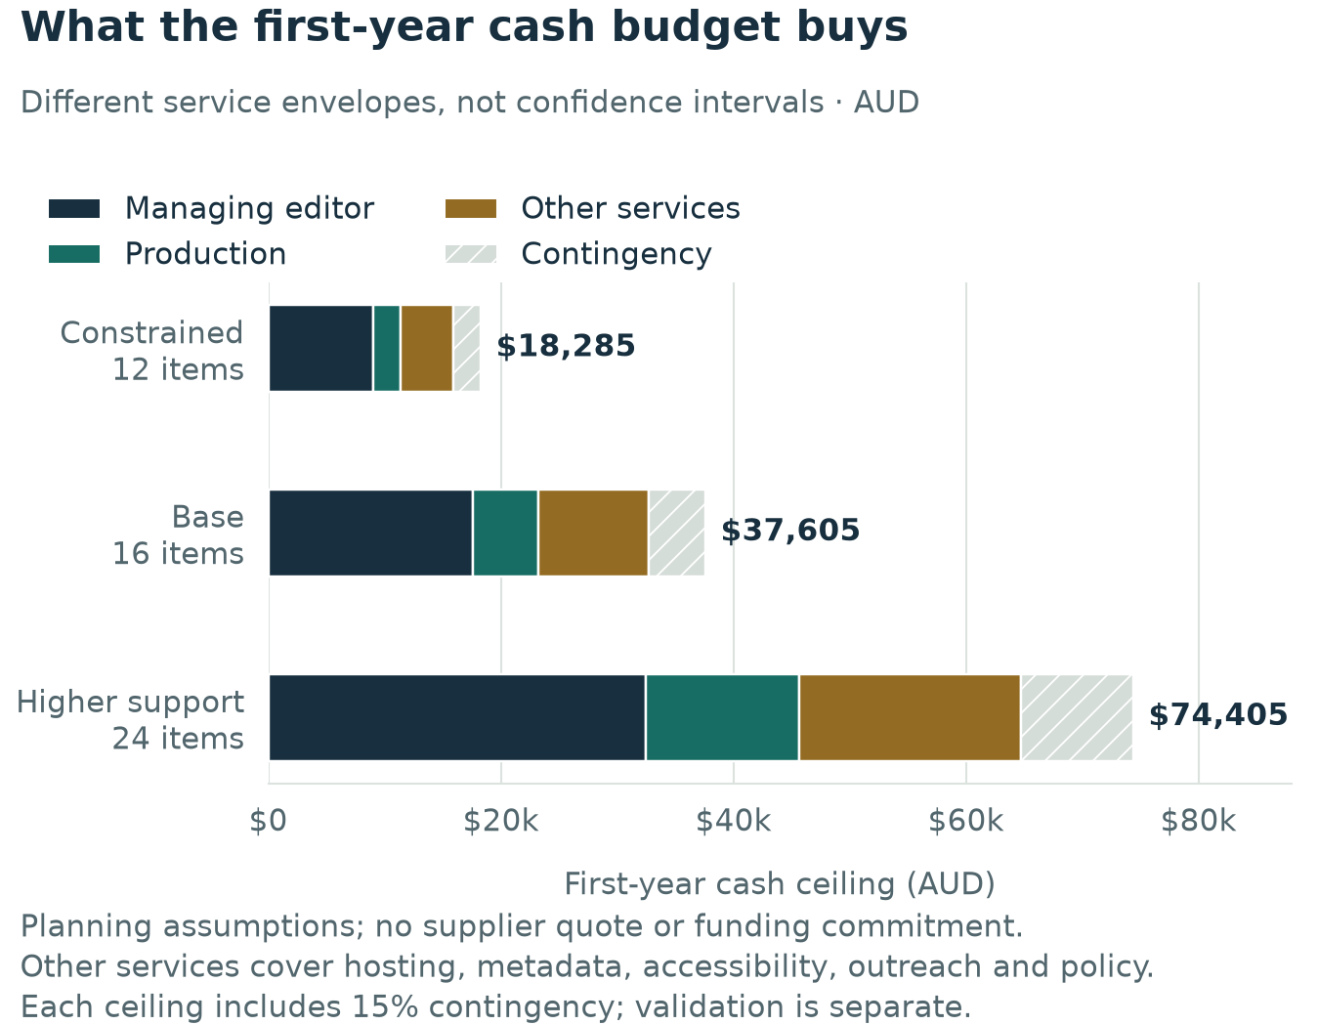
Figure 5. First-year cash envelopes by service scenario, including contingency. These are planning assumptions in AUD.

Cash, in-kind work and economic resources
A cash budget alone substantially understates the model’s dependence on professional contribution. In the base year, academic and practice handling is estimated at 24 externally reviewable submissions × three hours, or 72 hours. Forty-eight completed external reports at four hours each require 192 hours. Assessment of the four briefs and two challenges at three hours each adds 18 hours. Six advisory members contributing twelve hours each add 72 hours. The total is 354 contributed hours. At an assumed replacement value of $90 per hour, this equals $31,860. These amounts are neither fees offered to participants nor independently verified market prices.
Two totals must be distinguished. Planned operating resources, excluding contingency, are $32,700 cash plus $31,860 contributed expertise: $64,560. The resource envelope inclusive of cash contingency is $69,465. Describing the latter as actual or expected economic expenditure would imply that all contingency is spent. Both totals exclude author writing time, capstone work, partial effort on uncompleted reviews, and any currently unpriced host resource. They provide a transparent partial resource account, not a complete societal cost estimate.
In-kind support should be recorded by owner, task, hours or service scope, duration, and replacement consequence. If a library supplies hosting that genuinely displaces the $3,000 line, that line can be removed from the cash subtotal and recorded separately as institutional support. The 15% cash contingency would then also fall by $450 under the current rule. The journal has saved $3,450 of cash requirement, not eliminated the service’s resource use. The same task must never remain in both a supplier invoice and the donated-labour estimate.

Review capacity constrains publication growth
The base pipeline assumes 24 research/case submissions, eight desk declines and sixteen manuscripts entering external review. Ten of those are ultimately accepted: four research articles and six cases. Two reports per reviewed manuscript produce 32 initial completed reports. Eight manuscripts are assumed to require a further two reports, producing sixteen revision reports and 48 completed reports overall. Briefs and challenges follow their own assessment routes and do not inflate this external-review count. These are planning assumptions, not observed acceptance statistics.
Use a consistent completion convention. If each reviewer accepts three assignments annually and 80% of accepted assignments yield a completed report, twenty reviewers supply an expected 48 reports: 20 × 3 × 0.8 = 48. That is the base need with no headroom. To secure 32 initial completed reports at 50% invitation acceptance and 80% completion, the expected invitation count is 32 ÷ (0.5 × 0.8) = 80. At 35% acceptance it becomes 115 after rounding up. The sixteen revision reports require another twenty accepted assignments at the same completion yield; this is not an additional set of forty new reviewers.
Completion assumptions do not guarantee suitably independent expertise. A roster may be numerically adequate while lacking a methods specialist or practice reviewer for a particular submission. A more resilient capacity design limits planned use to 80% of the expected report capacity. It would require twenty-five reviewers for 48 reports, compared with the bare minimum of twenty. The corresponding growth-year rosters are 32 and 38 for 60 and 72 reports. These are operational design targets, not evidence that enough reviewers will volunteer. Record named capacity and coverage before opening intake.
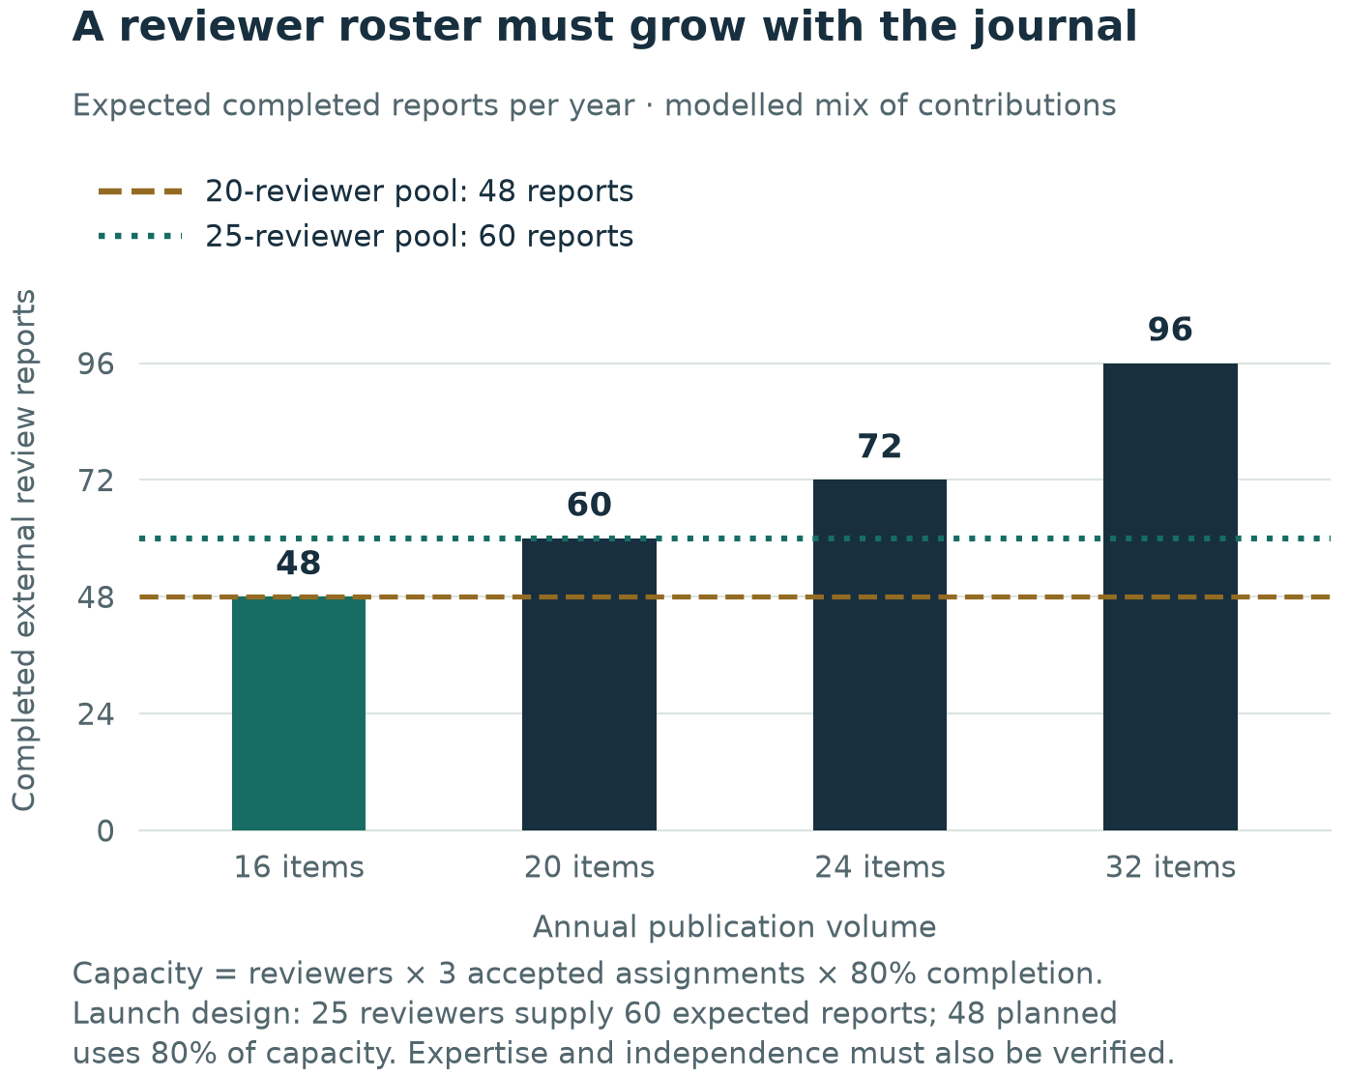
Figure 6. Required reports compared with expected reviewer capacity. Assumed completion is distinct from planned utilisation.

Three-year scenarios
Years 1–3 are operating years beginning only after a pilot is authorised; they are not launch commitments for 2026–2028. The model applies a uniform 3% annual price escalation to cash rates and replacement values solely as a planning sensitivity, not an inflation forecast. Scenarios are alternatives and are not assigned probabilities. They retain a 15% cash contingency and no author, reader or advertising revenue. Each includes the same separate $6,440 validation ceiling for comparability.
Scenario | Publication volumes Y1 / Y2 / Y3 | Cash ceilings Y1 / Y2 / Y3, AUD | Three-year cash including validation
Constrained service envelope | 12 / 12 / 12 | 18,285 / 18,834 / 19,399 | 62,957
Controlled growth, conditional | 16 / 20 / 24 | 37,605 / 42,997 / 48,679 | 135,722
Higher support and scale | 24 / 28 / 32 | 74,405 / 83,863 / 93,821 | 258,528

The constrained case preserves the original low assumptions: 200 managing-editor hours at $45; $200 production per item; and $4,500 of annual non-production service allowances before escalation. It represents a thinner service envelope, not the same service delivered more efficiently. Its twelve-item mix is three research articles, four cases, three linked briefs and two challenges. It still depends on 36 completed external reports and 285 contributed hours annually. A low cash request is therefore not sufficient evidence of viability.
Controlled growth expands only after demonstrated use, suitable submissions, funding and capacity: sixteen items in Year 1, twenty in Year 2 and twenty-four in Year 3. Managing-editor time increases from 320 to 360 and 400 hours. The formula is 160 annual coordination hours plus ten hours per published item, used as an aggregate planning proxy; the pilot must replace it with observed effort by submission, report, revision and publication. Production remains $350 per item before escalation, and other service allowances total $9,500.
Controlled growth workload | Y1 | Y2 | Y3
Research / cases / briefs / challenges | 4 / 6 / 4 / 2 | 5 / 8 / 5 / 2 | 6 / 9 / 6 / 3
Research/case submissions received | 24 | 30 | 36
Sent to external review | 16 | 20 | 24
Completed external reports | 48 | 60 | 72
Minimum reviewer roster at model yield | 20 | 25 | 30
Roster at 80% planned utilisation | 25 | 32 | 38
Paid managing-editor hours | 320 | 360 | 400
Contributed expertise hours | 354 | 423 | 495
Replacement value of contributions, AUD | 31,860 | 39,212 | 47,263

The higher-support scenario starts at the original high estimate of $74,405 for twenty-four items. Paid coordination rises from 500 to 560 and 620 hours at a starting rate of $65; production is initially $550 per item and other annual allowances total $19,000. This scenario deliberately combines more support with more volume. It is not a statistically derived upper bound. By Year 3 its 32 items require 96 completed reports and 636 contributed hours, before author effort or incomplete-review effort.
A constant sixteen-item control is useful because growth is optional. At 3% annual escalation, cash ceilings are $37,605, $38,733 and $39,895; three-year cash plus validation is $122,673. The controlled-growth pathway therefore requires approximately $13,048 more cash across three years for twelve additional publication items. That marginal difference should be judged against the value and staffing consequences of the expanded mix, not used to promise economies of scale or returns.
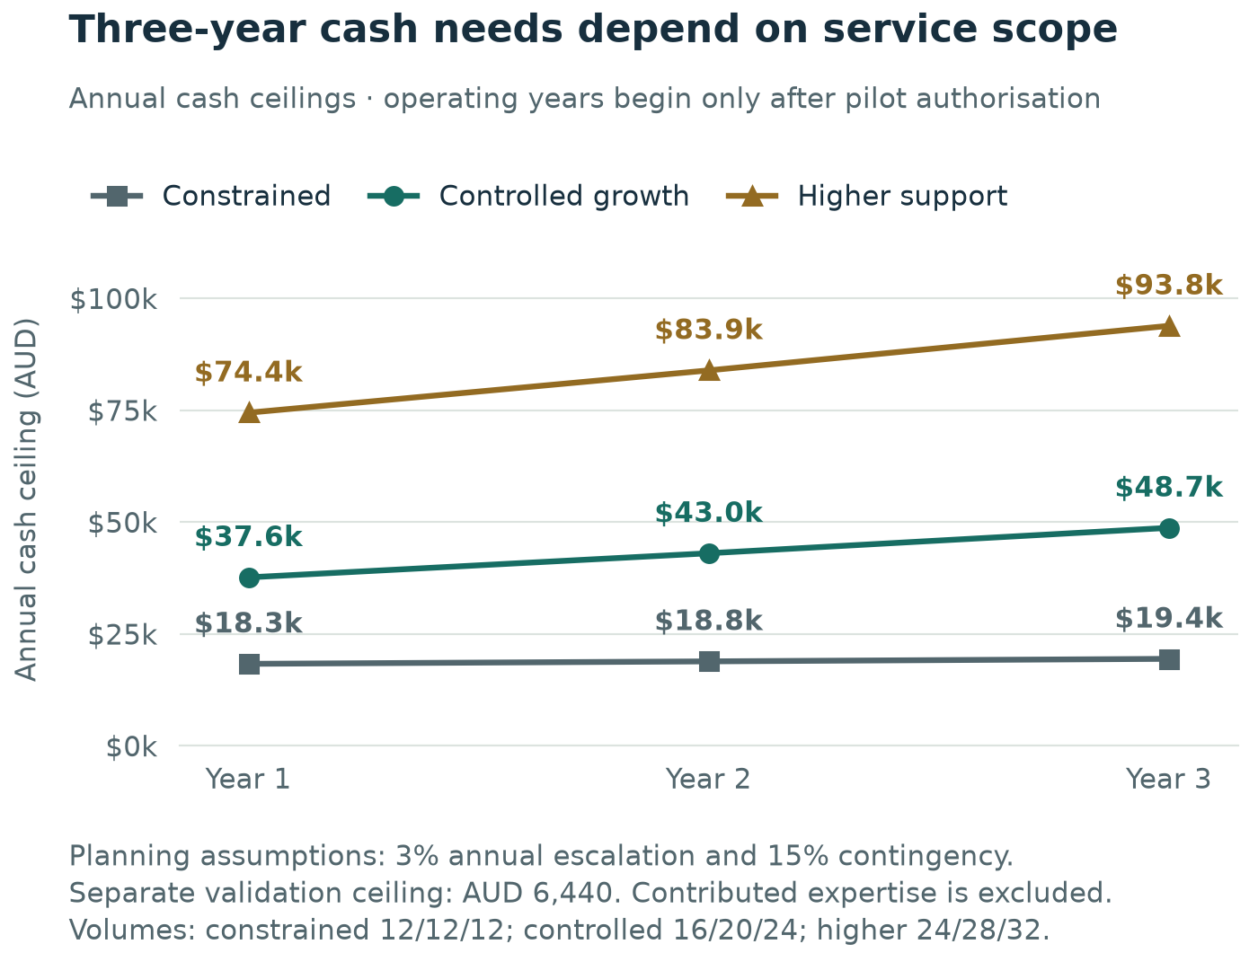
Figure 7. Conditional three-year cash ceilings; operating years begin only after authorisation. Validation is shown in the chapter totals.

Cash timing and funding runway
An annual award can cover the budget while arriving too late to pay bills. The illustrative first-year cashflow assumes hosting, identifier/metadata and policy allowances of $6,000 are paid in month 1; managing-editor cost is spread evenly; accessibility support is paid in months 3 and 9; outreach in months 6 and 12; and production of two items per month occurs in months 5–12. Planned cash expenditure is $32,700. The $4,905 contingency remains unspent in this schedule, rather than being automatically distributed across months.
Assume, only for illustration, an anchor pays $25,000 in month 1 and other supporters pay $12,605 in month 7. The schedule stays cash-positive and ends with $4,905. If the second payment slips to month 10, month 9 closes at minus $450, despite the same total annual funding. At least $450 of timely bridging liquidity is needed to avoid a negative balance; $5,355 would be needed to keep the entire contingency untouched at that low point. The bridge is a timing requirement, not another operating expense.
A launch decision should therefore examine monthly unrestricted cash, due invoices, contractual commitments and the credibility of payment dates. An expression of interest is not cash, and a grant restricted to outreach cannot automatically pay editorial wages. Before accepting additional manuscripts, the journal should be able to finish or responsibly transfer its existing obligations without relying on an unapproved renewal. The finance owner should show both an annual funding gap and a rolling thirteen-week cash view.
A separate working-capital reserve is a sponsor policy choice. As an explicit illustration, three months of first-year non-production planned cash equals $27,100 ÷ 4 = $6,775. If required in addition to the operating ceiling, initial funding including paid validation would be $50,820. This reserve is not an expense, not part of the three-year operating totals and not a standard imposed by an external source. Its final amount should follow the host’s payment terms and closeout obligations. It must not be counted again as spent contingency.
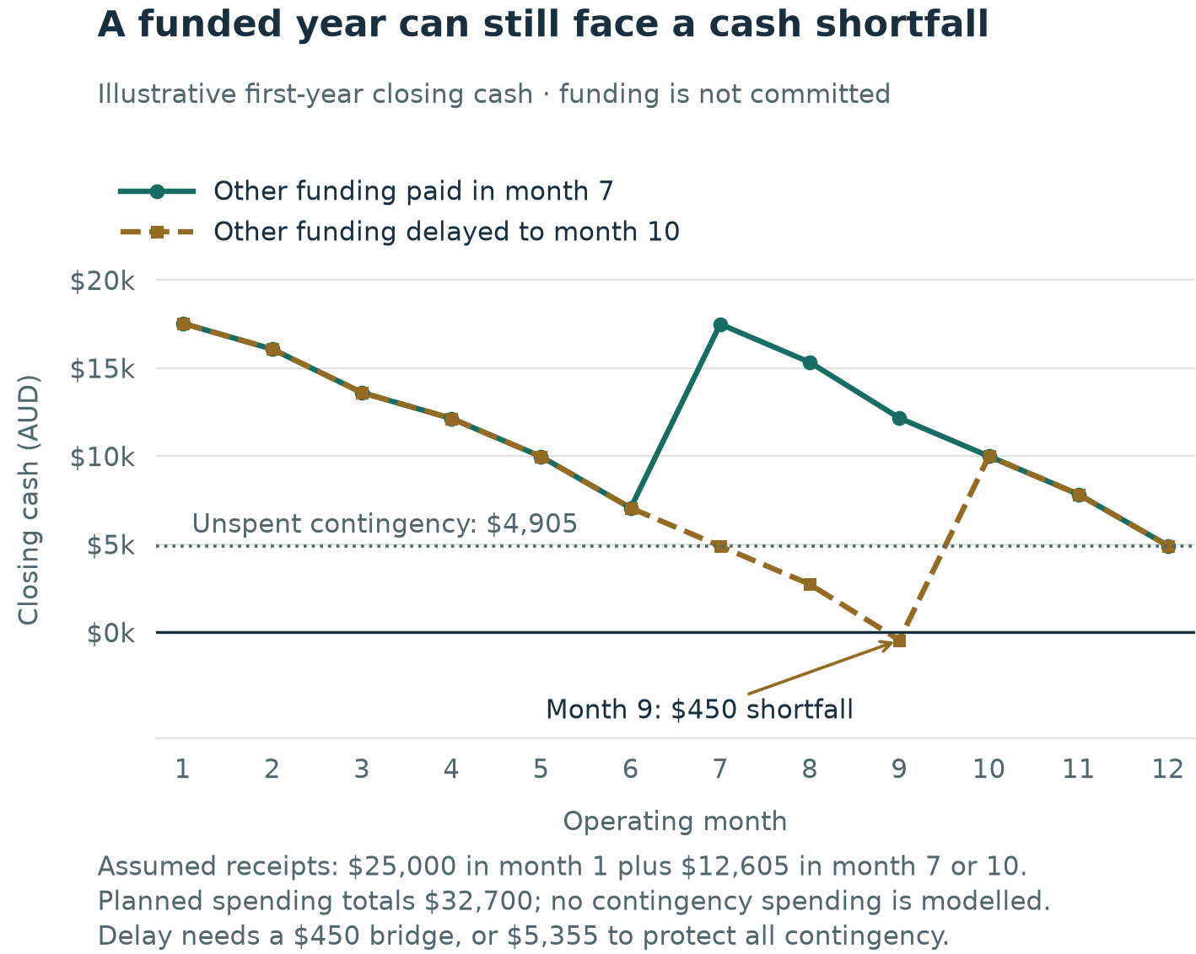
Figure 8. Illustrative monthly closing cash under different funding timings; no funding shown is committed.

Funding architecture and concentration risk
The initial proposition should be an institutional public-interest service, with an anchor providing accountable ownership and core coordination and supporting partners funding defined annual contributions or shared services. Any contribution should have a period, payment schedule, restrictions, renewal notice, acknowledgement rules and a clear boundary preventing influence over individual manuscript decisions. Funding and editorial authority need separate documentation even where one institution supplies both people and money.
A consortium is a credible design pattern, but its existence elsewhere is not evidence of commitments here. SCOAP3 describes collective institutional funding, a central contracting arrangement and a redirection of existing subscription resources to support publishing without charges to authors. Its field, installed relationships and existing expenditure base differ materially from a new project-management title. PRAPJ cannot assume that comparable subscription money is available to redirect. The transferable lesson is coordinated funding and accountability, not an immediately obtainable subsidy. [F09]
Funding route | Potential role | Main condition or weakness for PRAPJ
Host operating allocation | Coordination, service ownership and continuity | Needs an actual budget owner and a defined multi-year or renewable commitment
Professional or scholarly partners | Cash support, dissemination or documented service contributions | Protect editorial independence; expressions of interest do not establish funds
Library/shared-platform support | Displaces specified infrastructure tasks | Verify eligibility, scope, service levels and succession; it may exclude production
Time-limited grant | Validation, setup, accessibility or transition | Separate one-off investment from a recurring salary and publishing obligation
Donations or voluntary membership | Supplementary unrestricted support | Collection costs and uncertain renewal make it unsuitable as the sole launch assumption
Sponsorship or events | Possible supplementary activity | No demand evidence; quantify staff effort, restrictions and conflicts before assuming surplus
APCs or subscriptions | Different funding model | Excluded from the preferred diamond model; requires a separate mission and demand decision

The example $25,000 anchor supplies 66.5% of the $37,605 ceiling. Losing half that support creates a $12,500 gap against the ceiling and a $7,595 gap even against planned cash before contingency. Eliminating only hosting and outreach would not close that planned-cost deficit. Response options are replacement support, a smaller service with fewer new obligations, a partner pathway, or managed cessation. An unannounced author charge is not a sound contingency.
University read-and-publish agreements should not be mistaken for startup-journal finance. Sydney’s current guidance applies to eligible corresponding authors and covered journals, and states that the Library does not pay APC invoices issued directly to authors. This support mechanism does not establish a grant for PRAPJ’s editorial operation or an entitlement for a new title to join an agreement. [F10]

Sensitivity, alternatives and financial decision rules
Change to base first-year assumption | Change in cash ceiling, AUD | Revised ceiling, AUD
Managing-editor hourly assumption +20% | +4,048 | 41,653
Production unit assumption +30% | +1,932 | 39,537
Additional 80 coordination hours | +5,060 | 42,665
Pay for half the modelled reviewer hours at $90/hour | +9,936 | 47,541
Host replaces only the $3,000 hosting line | −3,450 | 34,155
Illustrative 25% on-cost on paid coordination | +5,060 | 42,665

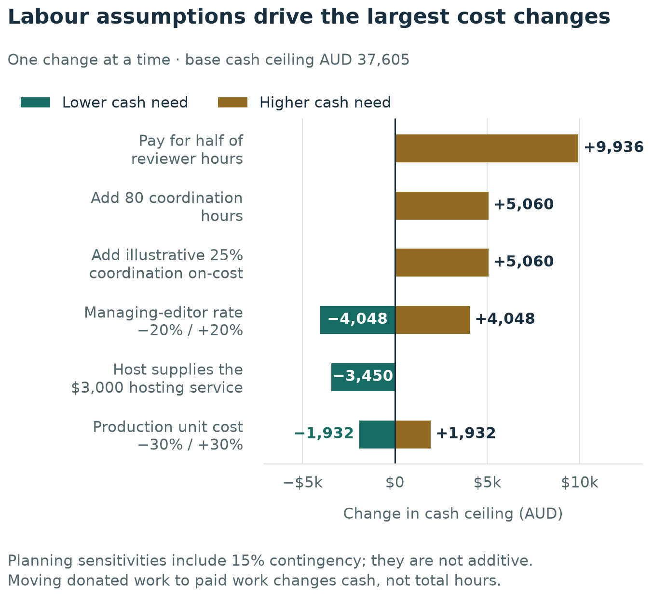
Figure 9. First-year cash sensitivity to selected assumptions, relative to the AUD 37,605 base ceiling.
The largest tests concern labour and its availability. Paying for half the reviewer hours transfers $8,640 of replacement value from the in-kind account into planned cash and adds $1,296 of cash contingency. It does not create another 96 hours of review resource. Conversely, needing longer reports increases the economic workload even if reviewers remain unpaid. At six rather than four hours per completed report, reviewer time grows by 96 hours and its assumed replacement value by $8,640; paid coordination could also increase if the more demanding manuscripts require additional handling.
Two counterfactuals should be evaluated on comparable scope. A twelve-brief digest illustrates a smaller service: 160 coordination hours at $55, twelve production units at $350, and the same $9,500 service allowances give $22,500 planned cash or a $25,875 ceiling. Thirty-six hours of translation assessment are separately valued at $3,240. This is an original conservative planning alternative, not a quotation; it provides interpretation of existing evidence but does not offer the same original research/case publication route or independent research-review system.
For a partner collection, leave the external service price unknown. If PRAPJ retains 160 coordination hours, $1,500 outreach and a $2,000 agreement allowance, its local subtotal is $12,300. Let Q represent a fully scoped partner quotation for the delegated services. The cash ceiling is 1.15 × ($12,300 + Q). Cash parity with the base journal occurs at Q = $20,400, before tax and omitted obligations. This threshold is useful for negotiation and comparison, but does not establish that any publisher will offer that price, accept the project or supply equivalent review, rights, access and continuity terms.
Financial approval should depend on scope-matched quotations, a fundable host, realistic reviewer/editor capacity and evidence that the chosen option addresses a distinct need. No monetary return on investment is calculated: the project has neither a validated willingness-to-pay model nor attributable benefits capable of supporting a defensible return estimate. The renewal question is whether documented reader and contributor value, fair assessment and a maintainable publication record justify the continuing resource commitment relative to the alternatives.

Continuity and the procurement questions that matter
PKP’s FAQ describes an archived hosting option at USD 450 annually and explains that its preservation network does not preserve the editorial/review history needed to reconstruct an active journal. This distinction means the host must determine who retains confidential workflow records, exports, account control and published content if the pilot ends. An archive fee is a useful benchmark, not the total price of PRAPJ closure. [F06]
Before a pilot decision, obtain written answers on: the legal publisher; service inclusions; paid and donated roles; production scope; applicable taxes and on-costs; currency and renewal pricing; backup restoration; export of public and confidential records; identifier maintenance; preservation eligibility; incident responsibility; continuity if an editor leaves; funding restrictions; and the cost of stopping. Update the model with actual quotes, preserve the original assumptions for comparison and record who accepts residual gaps. The finance plan should then be reviewed monthly in operation and formally before any growth or renewal decision.

8. Publication validation, benefits and readiness

Validation should test behaviour and feasibility
Validation should refine PRAPJ for formal publication: confirm which content helps readers, make the contribution route practical, test evidence and permissions, calibrate assessment, and establish the resources needed to deliver reliably. Comparison with existing resources identifies where the journal experience can improve. The four completed stakeholder interviews inform this design; the reader-test protocol below is proposed future work, with no results or commitments represented as collected.
Recruit ten practitioners from at least three organisations and two sectors, including people who rarely read journals. Focus initially on experienced and mid-career professionals, with a mix of sponsor/PMO, consulting and delivery roles rather than recruitment entirely from academic contacts. Include a small secondary check with students or emerging professionals for derivative explanations without conflating the two audience needs. Record role, sector, usual information sources and potential prior connection to the project. This is a formative sample chosen to expose problems; it will not estimate population preferences with statistical precision.
Use two comparable evidence tasks, for example a risk-assumption decision and a lessons-transfer decision. Give participants a PRAPJ specimen and an appropriately sourced existing article or summary dealing with comparable subject matter. Do not compare an unusually polished new specimen with an irrelevant or deliberately difficult alternative. Counterbalance reading order where practical. Clearly label synthetic specimen content; it can test comprehension and navigation, but cannot establish the usefulness of real empirical findings. A later test with cleared real content is needed before launch.
Ask each participant to identify the decision the item could inform, describe the main evidence, state one material limitation and explain what additional information they would need before applying it. Record unaided responses and elapsed time. Only then ask for preference, perceived credibility and likelihood of returning. Invite criticism and ask when the item would be unhelpful. Avoid coaching the reader toward the answer or introducing a positive project description before the comprehension task.

Interview and multimedia test improvements
Retain an open closing question in every future interview: 'Is there anything we have not discussed that you think would benefit PRAPJ or be important for the project?' James's response to that question introduced multimedia as a material design issue. Ask about video and other formats explicitly in future tests, while leaving room for unanticipated needs. Record contrary views and distinguish a participant's suggestion from a team decision. [L8]
Test the same substantive lesson in a written brief and a short media explanation, keeping the evidence and limitations comparable. Ask participants which format helps them understand the objective and conditions of use, whether captions/transcripts are useful, where they would encounter it, and when they would choose the full article. Measure comprehension and completion before preference. Format appeal is not evidence of better learning or improved project results. The test should also record production time and accessibility effort so that preferences can inform a feasible publication programme.
For the supported-contribution route, invite a feasible practice example and record the initial conversation, records required, confidentiality questions, outline approvals and editing time. Capture whether the contributor understands their authorship responsibility and the independent assessment route. A positive reaction to being interviewed does not establish willingness to approve or publish the resulting article. Treat James's 30–60-minute example as a possible conversation length, not a full publication-service promise.

Proposed test measures and decision rule
Test | Proposed formative threshold | Interpretation and limit
Decision and limitation comprehension | At least 7 of 10 readers identify both within five minutes on each task | A practical usability gate, not proof of general effectiveness
Comparative preference | At least 6 of 10 prefer the PRAPJ approach after both comparisons; one judgement per participant | Review reasons and role differences; a narrow majority is weak evidence
Concrete contribution pipeline | Twelve expressions of interest with topic, evidence source and date, including at least four research and four case prospects | A lead is not a submission or a permission approval
Permission feasibility | At least two cases have documented routes to sufficient evidence and owner clearance | Necessary seed supply; not a full year's accepted content
Reviewer readiness | For the core PRAPJ scenario: 25 active, subject-mapped reviewers committing three accepted assignments annually | Proposed launch gate at 80% planned utilisation of expected report capacity; twenty is the theoretical minimum without a reserve
Publication ownership and resources | Named continuing owner and verified cash or cost-replacing service capacity for the adopted scope | No budget or funding is currently available; all financial figures remain hypothetical

Agree a correct-answer rubric before testing. Score comprehension separately for each task, and collect one comparative preference per participant after both tasks. The thresholds are proposed management rules, not results or established industry benchmarks. Record the denominator and all failures. Seven successful readers out of ten does not mean that 70% of the market will benefit. With such a small purposive sample, one or two participants can change the apparent percentage materially. If the concept passes narrowly, review the specific difficulties and retest the affected design; do not convert the percentage into a revenue forecast.
The contributor test should require a one-page outline: the decision or question, context, available records, observed outcome, author involvement, confidentiality constraints, permission owner and realistic drafting date. Classify prospects as interested, evidence-feasible, permission-feasible, draft-ready and submitted. Keep permission feasibility distinct from permission granted. A pipeline dominated by enthusiastic but inaccessible cases is a warning about the model, not a healthy backlog.
The reviewer test should ask about specific subjects, conflicts, willingness to assess both methods and application, assignments per year and current availability. A short calibration exercise using a synthetic manuscript can reveal disagreement over evidence sufficiency and review labels. Record whether the process produces a reasoned editorial decision and how much time it takes. Do not use real confidential manuscripts without an authorised handling arrangement.

Benefits register
Benefit and intended beneficiary | Indicator and collection method | Proposed owner | Main attribution limit
Clearer interpretation for professional readers | Correct decision and limitation identification in a structured test | Research and evaluation lead | Comprehension does not demonstrate later use
Better-supported professional decisions | Voluntary follow-up example with source link and, where possible, a redacted decision artefact | Practice Editor | Multiple information sources and organisational factors contribute
More assessable practice evidence | Cases progressing from outline to cleared, review-ready manuscript | Practice Editor | Editorial support may reveal that some cases are unsuitable
Practice-informed research questions | Questions developed into a documented research or review proposal | Research Editor | Subsequent research may occur outside PRAPJ
Fair, predictable contribution experience | Stage timings, reasons for delay and confidential author feedback | Managing Editor | Fast processing alone is not a quality measure
Sustainable institutional capability | Documented succession, cost coverage and tested records transfer | Journal owner | Annual subsidy may remain essential

Separate output, outcome and longer-term impact. An output is a published contribution. An early outcome is that a reader correctly understands and uses its evidence. A longer-term impact might be stronger project learning or decisions, but causal attribution will usually be weak in a small pilot. Use contribution narratives with their limitations rather than attributing financial savings to article counts.

Operating dashboard and measurement definitions
Before first publication, capture a baseline from the concept test and the actual pipeline. For each subsequent month, record submissions by track, complete submissions, desk decisions, manuscripts under review, accepted assignments, usable reports, accepted articles, published items and waiting time by stage. Separate author revision time from editorial handling time. Report both the median and the longest unresolved waits when volumes are small; a single average can conceal a stuck manuscript.
Proposed service measures remain targets: at least 80% of completeness checks within five working days and scope decisions within ten working days; at least 70% of accepted reviewer assignments completed by the agreed date. Track overdue assignments separately from all eventual completions so the 80% modelled completion yield is not confused with the on-time target. A report received late may count as completed but not on time.
At six operating months, seek at least five of eight follow-up participants able to describe a concrete use or well-reasoned decision not to apply an item. At twelve months, seek eight of twelve. Count and explain missing responses rather than replacing them only with enthusiastic readers. These are small learning samples, not representative estimates. Include examples of misunderstood or unhelpful content and the resulting editorial change.
For reach, report article views, full-text accesses and repeat visits using the host's documented definitions and available privacy controls. State bot filtering and the limits of identifying unique users. A brief and its parent article should be reported separately as formats and together as one evidence family when assessing overall contribution. Do not add downloads, page views and email impressions into a single invented impact total.
At twelve months, assess the 16-item planning volume alongside evidence quality, permissions, readership learning, actual cost, volunteer burden and funded renewal. Fewer high-quality items may be preferable to meeting a quota through weak or unsuitable content. Conversely, a high output count with a departing editor and no funding is not sustainable success. The continuation decision should record which benefits occurred, which did not and what changes are affordable.

Usefulness, return and recommendation measures
James distinguishes producing a feature from demonstrating its benefit. Extend the dashboard beyond article counts with a short optional response after reading or viewing: rate usefulness from one to five; identify the decision it helped clarify; state one condition or limitation; and indicate whether the reader would return or recommend the item. Report the distribution and number of responses, the invitation denominator where available, missing responses and how participants were recruited. Do not present an average of a few enthusiastic responses as a market-wide satisfaction score. [L8]
Proposed management learning targets, to be agreed before collection, are: at least ten substantive usefulness responses across each initial collection, a median usefulness rating of at least four out of five among respondents, and documented reasons for low ratings. These are hypothetical targets rather than industry benchmarks or observed outcomes. Report whether the same people respond repeatedly. Return intention and recommendation intention remain self-reports; actual repeat visits require the host's privacy-appropriate measurement and a stated observation window.
At six and twelve months, combine these signals with the existing comprehension and use follow-ups. Seek permission before publishing any testimonial, identify the content and context, and retain critical feedback alongside positive examples. A useful decision not to apply a finding can be evidence of responsible learning. Do not use media views to claim adoption or add views of an article, brief and video as though they were independent people or independent studies.

Publication-readiness gates
Gate | Required evidence | Decision and responsible authority
G0 Capstone acceptance | Business case, board TORs/shortlists, guides/templates and both mockups checked | Team and sponsor accept or request revisions to preparation outputs
G1 Publication direction and implementation ownership | PRAPJ mission, priority readers and continuing accountable lead agreed | Sponsor confirms the formal-publication programme and authorised preparatory work
G2 Service arrangement and first-content plan | Publisher/host scope, contribution support, initial pipeline, resource assumptions and policy responsibilities | Proposed owner selects the support arrangement and practical first-year scope
G3 Opening submissions | Adopted policies, available resources, staffed handling, permissions workflow and rehearsal; core scenario proposes 25 subject-mapped reviewers | Authorised publishing owner approves the real submission opening and public statements
G4 Six-month service review | Content quality, contributor experience, reader usefulness, workload and resource outlook | Owner and editors improve the service and adjust commissioning or optional formats
G5 Twelve-month publication review | Benefit evidence, quality record, actual operating accounts, succession and next-period resources | Owner approves the next publication programme and continuity arrangements

These gates organise the intended launch; they do not imply that publication or funding has already been authorised. The project currently has no actual budget, and financial scenarios remain hypothetical until a future authorised owner makes and records a resource decision. Formal adoption of the journal's policies and operating commitments is separate from accepting the capstone files.

9. Delivery plan, accountability and handover

Work to the capstone deadline
The capstone deadline is 20 November 2026. The four interview dates below are confirmed completed events; subsequent activity windows are planning proposals from the 8 October update and depend on team availability and access. Interview completion does not establish that unrelated tasks in the source schedule are complete. A revised Microsoft Project XML schedule accompanies the package, with source assumptions and inherited progress explicitly distinguished from verified interview facts.
Date or period | Status and work | Reviewable output and dependency
31 August 2026 | Completed interview: Paul Rodman | Written interview summary available
3 September 2026 | Completed interview: Louis Taborda | Written support account added 10 October;interview date unchanged [L12]
24 September 2026 | Completed interview: Michael Hopmere | Written interview summary available; identity/date confirmed
8 October 2026 | Completed interview: James Bawtree | Detailed written summary available; integrate practical design insights
9–16 October | Proposed: validate priority reader and contributor experience; seek host scope information where authorised | Test notes, contribution outlines and documented service requirements
17–30 October | Proposed: consolidate formal-publication proposition and implementation responsibilities | Sponsor presentation narrative, resource scenarios and readiness record
31 October–6 November | Proposed: check all documents, website copy and both mockups together | Consistency record and physical print proof from the editable Word specimen
7–13 November | Proposed: independent team review and sponsor feedback | Corrected package with unresolved operational decisions recorded
14–19 November | Proposed: final references, formatting, version freeze and handover rehearsal | Final editable files, responsibility record and submission copy
20 November 2026 | Confirmed submission deadline | Capstone submission confirmation and retained archive

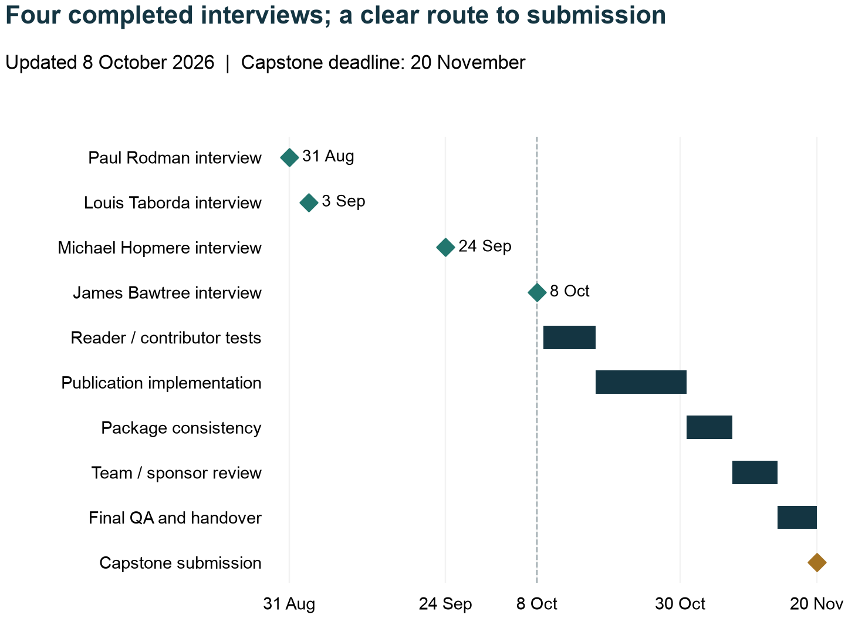
Figure 10. Confirmed interview dates and proposed remaining capstone work to 20 November 2026.
The key delivery sequence runs through evidence review, the assumptions and decision record, consistency across the publication materials, and team/sponsor review. The website team's work can proceed with approved copy and the mockup while publishing ownership remains under discussion, provided unconfirmed appointments, fees and submission-opening claims remain clearly held for release.

Team responsibilities proposed from the charter
The charter provides the initial division of work, and the supplied schedule records a later 17 September allocation. Jinchi Han coordinates integration; Tingting Yu maintains controls; Xinyao Wang leads governance; Ningyue Gao leads engagement; Juan Fan leads quality assurance. The later schedule assigns Jinghao Liu to planning and analysis, including the WBS, schedule and feasibility, and Ningxin Xu to research and documentation, including website, author and publication files. Use that later allocation when reconciling the earlier charter, and confirm the current team assignment before treating it as an instruction. Lydia Wen is the project sponsor. Capstone responsibilities do not automatically become permanent journal appointments. [L5, L11]
Integration should maintain a single decision log containing the decision, rationale, source, affected documents, owner and date. Research should retain source access limitations, not simply a bibliography. Publication development should ensure that the Guide for Authors, website copy and mockups use the same tracks, limits and review labels. Quality assurance should check the user journey from selecting a track to completing the correct template and understanding the assessment process.

Acceptance and change control
The sponsor review should ask whether the report makes a persuasive, evidence-based case for formal publication, explains the reader and contributor offer, exposes hypothetical financial assumptions and sets an achievable implementation programme. It should not ask reviewers to accept a conclusion simply because the document is long. The companion governance review should test whether decision rights are clear and candidates remain tentative. The publication-material review should test usability and consistency, including the difference between a demonstration and a real submission service.
For each requested change, record whether it alters scope, policy, cost, evidence or presentation. A changed contribution type may affect the guide, templates, review workflow, cost model, website copy and mockups simultaneously. A corrected source URL may affect only the reference register. The integration lead should identify these dependencies before approving a version freeze. Do not quietly make divergent copies of the same policy for different audiences.

Operational handover after the capstone
A continuing journal needs an owner beyond the student team. Handover should include the adopted policies, current role and access register, supplier and funding agreements, outstanding manuscript status, rights records, metadata/export instructions, preservation evidence, complaints route and annual review calendar. Confidential records should transfer only through the authorised host's controlled process. Public website copy and blank templates do not need the same access level as reviewer identities or complaint records.
Demonstrate the handover through a synthetic manuscript: locate the applicable policy, assign an unconflicted editor, record the assessment route, produce a reasoned decision, create a publication-ready record and retrieve it after an export/restore exercise. Then demonstrate an editor's departure and an appeal. These exercises reveal whether responsibility is actually transferable, rather than merely documented.
Confirm a continuing owner before the student team hands over operational responsibilities. If that appointment is still pending at the capstone deadline, submit the complete preparation package and record the named authority responsible for completing the transition. Keep the formal-publication objective in the handover record, with a clear outstanding-action list. Students should not inherit indefinite obligations to maintain a public site, confidential manuscripts or author expectations by default.

10. Risk, resilience and the publication recommendation

Risk approach
The register below is a qualitative planning assessment. Priority reflects the potential to invalidate the model or damage trust, not a calculated probability or expected monetary loss. These are prospective operating risks because the journal has not yet begun publishing. Each risk needs an observable trigger, a response and an accountable role. Contingency is not a substitute for a response plan, and the 15% financial allowance is not evidence that every risk has been costed.
Risk and priority | Early warning or trigger | Proposed response and owner
Insufficient distinct reader value — high | Readers prefer existing resources or cannot name a useful decision | Improve problem focus, formats and distribution; sponsor and Practice Editor
Weak permission-ready case supply — high | Many expressions of interest but no assessable cleared evidence | Offer bounded case support; reduce commissioning; Practice Editor
Unfunded continuing work — high | Endorsement without confirmed cash or cost-replacing service scope | Resolve resources and adjust first-year scope before opening submissions; journal owner
Reviewer exhaustion or mismatch — high | Repeat declines, uncovered methods/topics or overdue reports | Recruit reserve, adjust intake and report workload; Editor-in-Chief
Sponsor or author conflict — high | Pressure to accept, suppress findings or choose a favourable reviewer | Independent handling and recorded escalation; owner and unconflicted editor
Misleading practical translation — high | Brief's recommended action exceeds source findings | Require claim-to-source checks; correct linked outputs; Translation Editor
Confidentiality or rights failure — high | Unclear permission or identifiable sensitive project material | Hold release, seek authorised clearance or decline; publishing role
Key-person departure — high | Only one person holds credentials or decision knowledge | Shared role coverage and rehearsed handover; owner
Production scope underestimated — medium/high | Extra rounds, complex figures or accessibility repairs exceed allowance | Requote exceptions and prioritise quality; Managing Editor
Metadata or preservation gap — high | Failed deposits, broken DOI targets or no deposit confirmation | Assign monitoring and repair; host and Managing Editor
Delayed funding receipt — high | Annual commitment exists but cash arrives after costs fall due | Secure upfront working capital or defer commitments; finance owner
Indexing expectations outrun eligibility — medium/high | Authors assume immediate DOAJ, Scopus or metric status | Publish accurate status and staged criteria; Editor-in-Chief
Biased contributor network — medium/high | Founding institution dominates authorship and review | Broaden commissioning and independent review; Editorial Board
Weak evidence of benefit — medium | Good traffic but few credible examples of comprehension or use | Redesign evaluation and content; advisory/evaluation lead
Uncontrolled expansion — medium/high | Extra formats, events or data services added without resources | Change request with owner, effort and funding; sponsor
Capstone deadline pressure — medium | Validation results are unavailable close to submission | Record gaps and transfer next steps; integration lead

Resilience through controlled scale
The first response to overload should be to control intake and commitments, not to weaken review or silently extend every deadline. Editors can close a special call, limit commissioning, defer a collection or publish fewer items while preserving standards. A documented reserve reviewer pool and deputy roles reduce fragility, but cannot substitute for a realistic scope. The workload model should be refreshed after the first real cohort because assumed hours, revision rates and completion yields may be wrong.
There are at least three viable continuity outcomes: renew the independent journal; transfer or partner while preserving the published record and rights; or stop new submissions and maintain access to existing content. Each can be responsible. An unmanaged disappearance is the outcome to avoid. Closing intake should trigger author communication, decisions about pending manuscripts, funded archive/identifier maintenance and an accurate public notice under the owner's authority.

Assumptions requiring active ownership
Assumption | Current status | Evidence needed before commitment
Readers value this bundle over an existing alternative | Design proposition informed by three interview summaries, Louis’s expanded confirmed-support account and comparator research | Comparative task results and reasons for preference
Sixteen items is a manageable first-year portfolio | Planning volume | Actual submission mix, editor time and production scope
Cases can be shared with sufficient detail | Unproven beyond supplied discussion | Cleared evidence routes and real outlines
Qualified reviewers complete 80% of accepted assignments | Modelling assumption | Recorded cohort performance and reserve availability
AUD 55/hour and other unit costs reflect the host's cost | Scenario input | Fully specified quotes and applicable on-costs/taxes
Diamond funding can continue beyond the first year | Preferred model, no commitments | Written funding duration, renewal and exit terms
A host can supply the required service | Candidate arrangement | Named ownership and a signed service boundary
The mixed portfolio can meet a chosen directory's criteria | Unresolved | Current criteria review and classification of actual articles
The capstone team can transfer responsibility cleanly | Proposed plan | Named recipient and completed handover exercise

Sponsor implementation register
The recommended decision is to endorse PRAPJ's establishment as a formally published journal and progress the implementation programme. Record the rationale, accountable person and date for each required arrangement: authorised publisher and host; continuing operating ownership; priority professional audience; initial content programme; resource requirements and actual commitments when available; appointment and complaints authority; four-track policy and service targets; rights, licence and access model; reviewer and production capacity; contributor support and optional media; public submission opening; and continuity responsibilities. The journal direction is clear; unconfirmed operating decisions remain visibly open.
PRAPJ is worth publishing because it can give credible research and documented professional experience a consistent, practical route into project decisions, while giving practitioners a fair route into the published knowledge base. Michael and Paul identify the value and barriers of that exchange; James shows how to make participation and use more concrete; Louis’s confirmed support reinforces the connection between research, professional judgement and education, as explained in the expanded account. [L12, W31] The proposed evidence, review, context and contribution standards turn that promise into a reviewable publication model.
The strongest invitation to readers and contributors is a specific, trustworthy offer: useful problems, transparent evidence, clear limits, supported preparation and independent editorial decisions. The next work is to make that service ready for formal publication. Accepting the capstone confirms that the preparation deliverables have been reviewed; opening the journal confirms that the authorised owner can fulfil its publishing commitments. All current budget figures remain hypothetical, with no approved project budget or committed journal funding.

Appendix A. Publication design and benchmark decisions

What is borrowed and what remains a PRAPJ choice
The recommended publisher resources are useful because they expose the complete publication journey: choosing an outlet, preparing files, passing editorial checks, obtaining assessment, revising, producing a final version and maintaining the published record. Emerald's publishing entry pages and peer-review hub were read as reference material for that journey. They provide external benchmarks and do not establish a publishing relationship. The project has developed original PRAPJ policies and templates from the relevant needs, while retaining the supplied guide's contribution structure. [E1–E3]
Emerald's linked principles and review-model resources make fairness, confidentiality, appropriate expertise and clear assessment arrangements visible. The bias guidance and review-preparation material help identify the questions a reviewer should answer and the risks of judging an author or institution instead of the evidence. PRAPJ applies those concerns through conflict checks, explicit assessment criteria and reasoned decisions. Its proposed review routes and time targets still require editorial adoption and operational testing. [E4, E5, E7, E8]
The IJPM site provides a useful content architecture: journal scope and identity; author and publishing guidance; editorial information; article discovery and reading; and routes into submission. Its author guide demonstrates that detailed file, ethics and publication requirements belong in a stable author resource. PRAPJ's website team can use this functional pattern while using the original content supplied in files 05–06. No private IJPM submission workflow was tested, and no screen, publisher identity or journal metric has been copied into a claim about PRAPJ. [J1, J2]
Benchmark issue | Proposed PRAPJ design | Reason and decision still required
Scope and audience | A clear account of project decisions, evidence and practitioner contribution | Readers and authors should know the journal's purpose before selecting a track
Author preparation | A separate Guide for Authors and reusable manuscript/private-file templates | Supports consistency without placing the whole guide inside the Business Case
Research assessment | At least two independent external reports for Research Articles and Evidence Reviews | Provides a clear proposed minimum; reviewer capacity and policy adoption remain necessary
Practice assessment | Normally two case reviewers spanning practice and research; distinct labels for briefs and notes | Matches evidence type while preventing blanket peer-review claims
Practical interpretation | Source-linked briefs with explicit decision relevance and transfer limits | Addresses comprehension without treating the brief as a second independent study
Editorial decisions | Editor-owned, reasoned decisions; independent handling of conflicts and appeals | Reviewer recommendations are evidence for the decision, not a vote or an acceptance guarantee
Production and release | Rights, proof, metadata, accessible output and accurate public status | Acceptance alone is not permission to release an incomplete publication record
Post-publication responsibility | Corrections linked to affected articles and briefs, with an owner for records | Practical summaries can become misleading if their source changes

Preserve a coherent contribution model
The expanded business case does not replace the supplied guide with another publisher's word limits. Research Articles remain 6,000–9,000 words, with Evidence Reviews as a research subtype at 5,000–8,000. Practitioner Cases remain 3,000–5,000, Research-to-Practice Briefs 1,200–2,000, and Practice Challenges or Evidence Notes 1,500–2,500. Invited Editorials or Debates at 1,500–3,000 are supplementary; teaching cases remain deferred. James's proposed videos and micro-content are supplementary delivery forms linked to the core evidence, not extra manuscript tracks. Their volume, review labels, permissions and workload require an explicit operating decision. [L8] [L3, L4]
Research abstracts remain 200–300 words; other core contributions use a 150–200-word summary. Core items include a 100–150-word decision-relevance statement and four to seven keywords. The guide's word-count convention includes main text, footnotes, table text, captions and published appendices; it excludes the title page, abstract/summary, keywords, relevance statement, highlights, declarations, references and separate supplements. No borrowed per-figure word allowance is added. These are proposed PRAPJ requirements, not universal journal standards. [L3]
The linked-brief proposal introduces additional work and should be costed as such. Authors of accepted research prepare a linked brief with translation support, but a research article ready for publication should not wait indefinitely for its brief. The published relationship and dates should remain explicit. Where a brief interprets external research, the editor must also consider rights, source access and whether the summary represents the findings accurately.

Policy differences that need an explicit adoption decision
Emerald's author and publication-ethics resources address authorship, permissions, integrity and the use of AI tools. PRAPJ's current proposed author approach permits disclosed and verified preparation assistance and differs from Emerald's restrictions on generating manuscript prose. The PRAPJ review process separately prohibits generative-AI assessment or the creation/editing of confidential review reports and prohibits uploading confidential review material. A future service agreement requires a policy comparison; it does not silently replace the proposed PRAPJ guide. [E9, E11]
The proposed appeal window is 30 calendar days from the decision, including desk decisions. A handler independent of the disputed decision should acknowledge within five working days, aim to resolve within 30 calendar days and issue progress updates every 20 working days while unresolved. These are proposed service targets, not legal entitlements or measured performance. Minor and major revisions use proposed 30- and 60-calendar-day targets; extensions may be agreed. Publisher-specific deadlines from another journal are not automatically imported.
Diamond open access, author-retained copyright, a non-exclusive publishing grant and CC BY 4.0 remain proposals requiring the host's adopted agreement and accurate treatment of third-party material. CC BY 4.0 permits sharing and adaptation, including commercial use, subject to attribution, licence information and indication of changes. It does not remove privacy or other rights. The business case recommends deciding these terms before submissions open rather than resolving them after authors have invested in a manuscript. [P2]

Accessibility and the website team's handoff
The content handoff should include readable headings, plain link labels, meaningful article metadata, text equivalents for figures, accessible tables and clear notices about review status. WCAG 2.2 provides a technical accessibility benchmark for web implementation; a polished static mockup is not a conformance assessment. The website team should test the actual implementation with keyboard navigation, assistive technology and realistic long article content. [P3]

Appendix B. Model definitions and reproducibility

Financial model identity
[MODEL] denotes the original PRAPJ planning model prepared for this report. The capstone has no approved or allocated actual budget and no journal funds are committed. All PRAPJ amounts labelled AUD, including costs, hypothetical receipts, allowances and labour valuations, are assumptions rather than quotes, allocations or actual expenditure. Year 1 starts when the journal begins its authorised operating programme; Years 2 and 3 are conditional future operating years. The equations below allow a reviewer to reproduce the calculations without relying on an unexplained chart. Tables round to whole dollars; calculations retain decimals until the final presentation step.
Quantity | Formula and interpretation
Planned cash | Managing-editor hours × rate + items × production unit cost + specified service allowances
Cash ceiling | Planned cash × 1.15; the 15% allowance is a scenario contingency, not forecast spending
Annual escalation | Year n unit-cost multiplier = 1.03 raised to n−1; this is a sensitivity assumption
Contributed expertise | Handling + completed review + translation/note assessment + advisory hours
Resource cost before contingency | Planned cash + contributed hours × assumed replacement rate
Resource envelope | Cash ceiling + contributed expertise value; excludes author effort and unpriced resources
Funding gap | Remove verified displaced cash costs, recalculate contingency, then subtract confirmed eligible cash; include validation/reserve only if chosen
Initial invitations | Required first-round reports ÷ (invitation acceptance × post-acceptance completion), rounded up
Bare reviewer roster | Reports ÷ (accepted assignments per person × completion yield), rounded up
Resilient reviewer roster | Reports ÷ (assignments × completion yield × 80% planned utilisation), rounded up

Completion yield and planned utilisation are different. Completion yield estimates how many accepted assignments produce usable reports. Planned utilisation limits how much of the resulting expected capacity is committed, leaving some reserve. At three accepted assignments, 80% completion and 80% planned utilisation, each reviewer supports 1.92 planned completed reports. Forty-eight reports therefore require 25 reviewers. The model assumes compatible expertise and independence; it cannot guarantee either.

Base cost-driver detail
The base fixed service allowances total AUD 9,500: hosting 3,000; identifiers/preservation/metadata 1,000; accessibility/author support 2,000; outreach/evaluation 1,500; and policy/agreements 2,000. At 16 items, 320 managing-editor hours at AUD 55 and production at AUD 350 give 17,600 + 5,600 + 9,500 = 32,700. Contingency adds 4,905 for the 37,605 ceiling. The 320 hours include operating slack for uneven work; the separate cash contingency protects the budget. Procurement should define the intended cover to avoid charging twice for the same risk.
Controlled growth uses 160 fixed coordination hours plus ten hours per published item: 320, 360 and 400 hours for 16, 20 and 24 items. This is an aggregate proxy, not a claim that accepted articles are the only source of work. The operating model separately decomposes the base hours by task. Replace the proxy when time logs show how submissions, revisions and production exceptions actually drive effort.
The constrained case assumes 200 hours at AUD 45, production at AUD 200 and AUD 4,500 in services. The high-support case starts with 500 hours at AUD 65, production at AUD 550 and AUD 19,000 in services, then adds 60 coordination hours for each four-item annual increase. These scenarios change service depth as well as output. They should not be plotted or interpreted as a confidence interval around one fixed service.
The one-off paid validation calculation is (80 × 55 + 1,200) × 1.15 = AUD 6,440. No scenario assumes fee, subscription or advertising revenue. At preparation, confirmed funding is zero, so the modelled gap equals the full chosen requirement. If a host confirms support later, record its scope and duration before deducting it.

Optional extension calculation
The James-informed support/media extension assumes six conversations plus initial outlines at three hours each and four short media items at six hours each. At the hypothetical AUD 55 rate, (6 × 3 + 4 × 6) × 55 = AUD 2,310. A 15% contingency adds AUD 346.50, giving AUD 2,656.50. Core plus extension is AUD 40,261.50. These are additional hours only to the extent they are not already covered by the core 320 hours, existing author/accessibility support or normal production allowance. This extension is not inserted into the unchanged core monthly or three-year charts; it is a separate scenario and has no funding commitment.

Monthly base cash schedule
This table demonstrates liquidity, not agreed payment terms. It starts with zero cash, uses the planned AUD 32,700 expenditure before contingency and assumes illustrative income of AUD 25,000 in month 1 plus AUD 12,605 in month 7. The stress column delays the second receipt to month 10. A negative balance shows the need for timing changes or bridging liquidity; it is not permission to overdraw.
Operating month | Planned cash cost | Closing cash: receipt M7 | Closing cash: receipt M10
1 | 7,467 | 17,533 | 17,533
2 | 1,467 | 16,067 | 16,067
3 | 2,467 | 13,600 | 13,600
4 | 1,467 | 12,133 | 12,133
5 | 2,167 | 9,967 | 9,967
6 | 2,917 | 7,050 | 7,050
7 | 2,167 | 17,488 | 4,883
8 | 2,167 | 15,322 | 2,717
9 | 3,167 | 12,155 | -450
10 | 2,167 | 9,988 | 9,988
11 | 2,167 | 7,822 | 7,822
12 | 2,917 | 4,905 | 4,905

The finance chapter and charts use the same core data. Paid validation, reserves, unconfirmed taxes/on-costs and closure charges are excluded here. A future adopted budget must resolve these exclusions, regardless of the illustrative balance.

Appendix C. Source register

Supplied project records
L1. PRAPJ Interview.docx. Michael Hopmere interview summary, interview 24 September 2026; identity and date confirmed by the project lead on 8 October 2026. Relevant sections: Quick recap; Project Management Research-Practice Gap; Practitioner Journal Pilot Planning; Journal Evaluation Metrics Discussion. Preparation chatter excluded. The project lead confirmed the identity; public attribution permission remains separate.
L2. Paul Rodman Industry Interview Summary, 31 August 2026, approximately 28 minutes. File: Paul_Rodman_Interview_Summary_English.docx. Q1–Q7 and sections 3–6 used; no recording or transcript independently inspected.
L3. PRAPJ_Guide_for_Authors.docx. Supplied proposed author policy; no adoption date. Basis for contribution types, lengths, disclosures, files and the linked-brief model.
L4. PRAPJ_About_Publish_and_Website_Content_Proposal.docx. Supplied proposed public copy. Missing licence passage and incomplete trailing text identified for revision.
L5. PMGT5850_2026S2_Team DOMINUS_Journal Business Case.pdf. Preliminary charter and blueprint, 15 slides. Pages 9–14 define scope, success, constraints and gates; page 15 contains the preliminary WBS and timetable. The confirmed 20 November deadline supersedes that timetable.
L6. Screenshot at 12.29.51 on 25 September 2026. Project proposal and Success Measures. Used as the deliverable acceptance basis, not proof of market size.
L7. Screenshot at 12.31.39 on 25 September 2026. Dr Hopmere's message recommending Emerald publishing and peer-review resources. It does not constitute a publishing partnership.
L8. PRAPJ_James_Bawtree_Interview_Summary_EN_Updated.pdf. James Bawtree interview, 8 October 2026; eight-page detailed summary of a recorded interview. Full supplied summary examined. It paraphrases the transcript and notes transcription errors; direct public quotation requires recording checks and permission.
L9. Project lead confirmations in the project conversation, 8 October 2026: four interview identities/dates; no approved or allocated actual project budget; all financial figures hypothetical; no committed journal funding; formal-publication intention; no PDF deliverables. These instructions supersede inconsistent earlier planning assumptions.
L10. Original project-lead account of Louis Taborda's interview, conducted 3 September 2026, supplied 8 October. It recorded general support for establishing PRAPJ. Retained as the original evidence trail and supplemented by L12
L11. Supplied PMGT5850_2026S2_TeamD1_Project_ Journal Business Case.mpp. The file contains Microsoft Project XML despite its extension. Original schedule and cost fields are retained in a source audit; interview dates and the 20 November deadline are updated in a correctly named editable XML deliverable. Other inherited progress is not independently verified.
L12. Louis Taborda support account, prepared for the Business Case on 10 October 2026 following the project lead's report that Louis had confirmed his support. The 600-word third-person text combines that reported supportive position, the public biographical context in W31 and explanatory analysis of PRAPJ's potential value.
L13. Project lead confirmation in the project conversation, 10 October 2026: the sponsor has signed the Project Charter and PMP; final deliverables have not yet been accepted. Final presentation and capstone deadline: 20 November 2026. Signed planning documents do not constitute operational launch authorisation or final acceptance.

Public biographical context
W31. University of Sydney (18 March 2024). Community of expert educators to transform student experience
Official historical profile inspected 10 October 2026. It documents Louis Taborda’s earlier mathematics and computer-science teaching, IT consultancy, project-management teaching, experiential-learning research and industry-linked student projects. Used only for professional and educational context; it does not establish University support for PRAPJ, a current appointment, or PRAPJ-specific interview views.

Scholarly, journal, operating and funding sources
M01. Winter, M.; Smith, C.; Morris, P.; Cicmil, S. (2006). Directions for future research in project management: The main findings of a UK government-funded research network
DOI: 10.1016/j.ijproman.2006.08.009. Primary author-affiliated institutional abstract and bibliographic record inspected. Agenda-setting synthesis, not a representative demand study or an evaluation of a new journal. No claim to full-paper review.
M02. Cicmil, S.; Williams, T.; Thomas, J.; Hodgson, D. (2006). Rethinking Project Management: Researching the actuality of projects
DOI: 10.1016/j.ijproman.2006.08.006. Primary institutional abstract and metadata inspected. Linked publisher-version PDF retrieval was blocked. Methodological/conceptual argument is not an outcome estimate.
M03. Chaves, M. S. (2021). Narrowing the research-practice gap in project management
DOI: 10.5585/gep.v12i3.17227. Full 24-page published paper retrieved from the author's institutional repository; abstract, introduction, recommendations and conclusion inspected. Position paper, not a controlled test. Publisher landing page returned an access error. Recommendations are not measured effects.
M04. Van de Ven, A. H.; Johnson, P. E. (2006). Knowledge for theory and practice
DOI: 10.5465/amr.2006.22527385. Primary author-affiliated abstract and bibliographic record inspected, supplemented by publisher-indexed abstract. Conceptual argument; no causal effect size or journal-market evidence.
M05. Mohrman, S. A.; Gibson, C. B.; Mohrman, A. M., Jr. (2001 (institutional working paper: 2000)). Doing Research That Is Useful to Practice: A Model and Empirical Exploration
DOI: 10.5465/3069461. Publisher-indexed abstract and USC research-centre record inspected. Crossref publisher-deposited metadata confirms Academy of Management Journal 44(2), 357-375, April 2001; platform's later online date is not treated as original publication year. Perceived usefulness is not a causal project-performance outcome.
M06. Božič, K.; Bachkirov, A. A.; Černe, M. (2022). Towards better understanding and narrowing of the science-practice gap: A practitioner-centered approach to management knowledge creation
DOI: 10.1016/j.emj.2021.09.006. Primary author-affiliated abstract and bibliographic record plus publisher-indexed abstract/introduction inspected. Qualitative sample does not estimate Australian project-management demand or population prevalence.
M07. Makin, S. (2021). The research-practice gap as a pragmatic knowledge boundary
DOI: 10.1016/j.infoandorg.2020.100334. Publisher-indexed introduction and substantial section excerpts inspected; direct page opening returned 403. Crossref publisher-deposited record verified author and Information and Organization 31(2), 100334, June 2021. Single embedded case; no general effect size inferred.
M08. Bansal, P.; Bertels, S.; Ewart, T.; MacConnachie, P.; O'Brien, J. (2012). Bridging the research-practice gap
DOI: 10.5465/amp.2011.0140. Primary author-affiliated abstract and bibliographic record inspected, with the originating network's account as corroboration. Reflective institutional experience is not proof that an independent PRAPJ journal is the best vehicle.
M09. Locatelli, G.; Ika, L.; Drouin, N.; Müller, R.; Huemann, M.; Söderlund, J.; Geraldi, J.; Clegg, S. (2023). A Manifesto for project management research
DOI: 10.1111/emre.12568. Publisher-indexed substantive text, issue metadata and author-affiliated published-version records inspected. Agenda-setting perspective, not a representative reader study. Authors' editorial positions are historical disclosure, not evidence of current appointments or PRAPJ support.
M10. Tkachenko, O.; Hahn, H. J.; Peterson, S. L. (2017). Research-Practice Gap in Applied Fields: An Integrative Literature Review
DOI: 10.1177/1534484317707562. Primary author-affiliated abstract and bibliographic record inspected. Detailed themes, study counts and effect claims are not reproduced because full review methods/results were not inspected. General applied-field evidence requires contextual interpretation for PRAPJ.
M11. Association for Project Management (Undated current webpage). International Journal of Project Management (IJPM)
Full accessible official association page inspected. Publisher homepage returned 403 in this research pass. This association page is not treated as an exhaustive inventory of current article types, policies, prices or metrics.
M12, O20. Association for Project Management (Undated current webpage). APM Research Summary Series
Full accessible programme page inspected. The page establishes service design and APM's rationale, not quantified impact, unmet market size or demand for a competing service.
M13, J4. Emerald Publishing (Undated current webpage). International Journal of Managing Projects in Business
Publisher-indexed page text and official journal-finder description inspected; direct fetch returned 403. Promotional positioning does not independently demonstrate practical impact. Historical metrics and acceptance-rate figures are not used for market share or PRAPJ forecasting.
M14, J5. Project Management Institute (Undated current webpage). Project Management Journal
Full accessible official PMI page inspected. The page's reader and citation metrics are not used because comparability and denominator details were not established. Membership benefit does not mean every article is inaccessible to non-members.
M15, J6. UTS ePRESS (Archive covers 2016-2018; migration notice refers to 2020). Project Management Research and Practice: UTS archive and migration notice
Full accessible official archive homepage inspected. This is a historical comparator; the archive cannot establish current output, ownership, operational health, closure or failure. Current linked site was not successfully assessed in the wider project review.
M16. University of Malaya (Undated current webpage). Journal of Project Management Practice
Official university indexed page text inspected; direct opening timed out. Scope describes the intended offering, not proven practitioner uptake. No author charge or throughput claim is inferred.
M17. International Project Management Association (Undated current webpage). IPMA Journals: Project Leadership and Society
Full accessible official association page inspected. Direct publisher page returned 403. Earlier launch announcements and expired fee-waiver promotions were not treated as current policies; no APC amount or turnaround promise is used.
M18. Inderscience Publishers (Undated current webpage). International Journal of Project Organisation and Management
Accessible official publisher page inspected. The topics and publication model are positioning evidence; article-level practical utility and market share are unmeasured. Optional open access must not be described as a wholly open-access journal.
O01. Directory of Open Access Journals (n.d.). Guide to applying Version 2.9
Live criteria may change. Mixed-format treatment and whether specific practitioner cases qualify require clarification; no PRAPJ application or acceptance exists.
O02, P1. Public Knowledge Project (n.d.). Open Journal Systems
Product description establishes capabilities, not configuration quality, platform operation, indexing admission or a service contract.
O03, F05. Public Knowledge Project (n.d.). OJS Journal Hosting
The inspected plan table did not explicitly state the currency. Do not treat the dollar figures as AUD; verify currency, taxes and all inclusions through a written quote.
O04, F06. Public Knowledge Project (n.d.). Hosting and Services FAQ
Vendor description is not a negotiated service agreement. Full backup usability, migration assistance, retention and service responsibilities need testing and confirmation.
O05, E10. Emerald Publishing (n.d.). Emerald Publishing Services
Marketing/service description, not a PRAPJ-specific offer. No price, acceptance, institutional affiliation or guaranteed indexing inferred.
O06. University of Edinburgh Library Edinburgh Diamond (2024). Roles and Responsibilities
Published 21 August 2024. This is an example only; no inference that PRAPJ qualifies for Edinburgh support or that another university supplies equivalent terms.
O07. Committee on Publication Ethics (n.d.). Our core practices
Direct PDF fetch failed. Primary-source indexed PDF text was retrieved and read; verify the currently operative document when adopting policy. Not a claim of membership or certification.
O08. COPE DOAJ OASPA and WAME (2022). Principles of Transparency and Best Practice in Scholarly Publishing Version 4
Published 15 September 2022. Best-practice principles are distinguished from a statutory licence and from individual services’ formal admission criteria.
O09. ISSN International Centre (n.d.). What is an ISSN
Specific identifier applications and media/title treatment must be confirmed with the responsible ISSN centre. No number has been allocated to PRAPJ.
O10. Crossref (n.d.). Content Registration
A DOI is not evidence of citation-index selection or preservation. Actual membership and deposit arrangements are unconfirmed.
O11, F03. Crossref (n.d.). Fees
Live US-dollar fees observed 25 September 2026; subject to change. Sponsored membership may include additional sponsor service charges; no AUD conversion or contractual quote is inferred.
O12. Crossref (n.d.). Relationships
The correct relation for a plain-language brief depends on the actual content relationship and provider implementation; no automatic semantic mapping is claimed.
O13, F08. Public Knowledge Project (n.d.). PKP Preservation Network
The minimum version listed on the page is not a recommendation to run an old release. Actual journal acceptance and successful preservation deposits remain unverified.
O14. CLOCKSS (n.d.). FAQs
No PRAPJ price or agreement exists. Service description does not replace ordinary hosting, backup recovery or confirmation of coverage.
O15. ISSN International Centre (n.d.). Keepers Registry
It is not an archive or backup provider; published title coverage is not proof that every new item has been deposited.
O16. Elsevier (n.d.). Scopus content policy and selection
The current inspected page requires publication history without stating a universal two-year minimum. Readiness does not guarantee inclusion or a particular timetable.
O17. Clarivate (n.d.). Journal evaluation process and selection criteria
Direct retrieval returned 403; the official page’s detailed indexed search extract was read. Recheck before any application. No guaranteed collection placement, metric or date.
O18. Google Scholar (n.d.). Inclusion Guidelines for Webmasters
Technical readiness does not guarantee discovery of every item. Prototype content is not evidence of actual indexing.
O19, E6. Emerald Publishing (n.d.). The journal peer review process
Publisher-specific practices do not establish PRAPJ policy or actual turnaround statistics. Existing PRAPJ routes and targets remain proposals.
O21. ISSN International Centre (n.d.). The ISSN-L for publications on multiple media
This does not establish that a capstone print specimen is an independently registered print publication.
F01. Science Europe / cOAlition S commissioned consortium (2021-03-09). The OA Diamond Journals Study: recommendations and findings
Material inspected: Recommendations printed pp. 25 and 32 (PDF pp. 27 and 34); Findings overview and methodology printed pp. 7–8 and 13–14 (PDF pp. 45–46 and 51–52). Historical multi-country survey; not a representative Australian PM-journal cost estimate.
F02. Science Europe, cOAlition S, OPERAS and ANR (2022-03). Action Plan for Diamond Open Access
Material inspected: Printed pp.3–6: efficiency, capacity, governance and sustainability. Policy recommendations, not an available PRAPJ funding award.
F04. Crossref (2026). Fee update: lowering and removing DOI registration fees in January 2027
Material inspected: Table: current journal-article fee USD 1.00; January 2027 USD 0.95. Announced future registration price; membership arrangements separately assessed.
F07. University of Sydney Library (Current webpage). Sydney Open Journals
Material inspected: Starting a journal; institutional or affiliated researchers; OJS platform. Support pathway only; no PRAPJ eligibility, acceptance, cost or service commitment established.
F09. SCOAP3 (Current webpage). Frequently Asked Questions
Material inspected: Business model, central CERN arrangement and pooled subscription resources. Different discipline and installed funding base; no claim of transferable funds or exact current membership counts.
F10. University of Sydney Library (Current webpage). Read and publish agreements
Material inspected: Author eligibility, covered journals and treatment of direct APC invoices. Author-publication support is not evidence of financing for a new journal.
R01. HM Treasury (2025). Publishing business cases: guidance for departments
Five-case structure used as an analytical aid. UK public-spending rules are not applied to this capstone.
R02. Project Management Institute (Current webpage). Ways to earn PDUs
Official reading and informal-learning categories inspected; no PRAPJ accreditation or individual credit award is inferred.
E1. Emerald Publishing (Current webpage). Publishing with us
See the reading-coverage chapter. Used as a benchmark, not a PRAPJ approval or performance claim.
E2. Emerald Publishing (Current webpage). Publish in a journal
See the reading-coverage chapter. Used as a benchmark, not a PRAPJ approval or performance claim.
E3. Emerald Publishing (Current webpage). Peer review resource hub
See the reading-coverage chapter. Used as a benchmark, not a PRAPJ approval or performance claim.
E4. Emerald Publishing (Current webpage). Peer review pillars and principles
See the reading-coverage chapter. Used as a benchmark, not a PRAPJ approval or performance claim.
E5. Emerald Publishing (Current webpage). Understanding different peer review processes
See the reading-coverage chapter. Used as a benchmark, not a PRAPJ approval or performance claim.
E7. Emerald Publishing (Current webpage). How to manage bias in peer review
See the reading-coverage chapter. Used as a benchmark, not a PRAPJ approval or performance claim.
E8. Emerald Publishing (Current webpage). How to begin your review
See the reading-coverage chapter. Used as a benchmark, not a PRAPJ approval or performance claim.
E9. Emerald Publishing (Current webpage). Publication ethics
See the reading-coverage chapter. Used as a benchmark, not a PRAPJ approval or performance claim.
E11. Emerald Publishing (Current webpage). Author policies and guidelines
See the reading-coverage chapter. Used as a benchmark, not a PRAPJ approval or performance claim.
J1. Elsevier / International Journal of Project Management (Current webpage). IJPM homepage and live journal navigation
See the reading-coverage chapter. Used as a benchmark, not a PRAPJ approval or performance claim.
J2. Elsevier / International Journal of Project Management (Current webpage). IJPM Guide for Authors
See the reading-coverage chapter. Used as a benchmark, not a PRAPJ approval or performance claim.
J3. Elsevier / International Journal of Project Management (Current webpage). IJPM Research Summary Series
See the reading-coverage chapter. Used as a benchmark, not a PRAPJ approval or performance claim.
J7. University of Malaya (Current webpage). University of Malaya Journal of Project Management Practice
See the reading-coverage chapter. Used as a benchmark, not a PRAPJ approval or performance claim.
P2. Creative Commons (Current webpage). Creative Commons Attribution 4 point 0 licence deed
See the reading-coverage chapter. Used as a benchmark, not a PRAPJ approval or performance claim.
P3. World Wide Web Consortium (Current webpage). W3C Web Content Accessibility Guidelines 2 point 2
See the reading-coverage chapter. Used as a benchmark, not a PRAPJ approval or performance claim.

