**Differential privacy in the 2020 Census distorts pandemic-associated mortality rates**

Mathew E. Hauer1,2* & Alexis R. Santos-Lozada3,4

**Affiliations:**

1Department of Sociology, Florida State University, Tallahassee, Florida, USA.

2Center for Demography and Population Health, Florida State University.

3Human Development and Family Studies, Pennsylvania State University, State College, PA, USA.

4Population Research Institute, Pennsylvania State University.

*[mehauer@fsu.edu](mailto:hauer@uga.edu)

As the coronavirus disease 2019 (COVID-19) grips the world, scientists, policy makers, and journalists use population data calculate various CVOID-19 rates (mortality, incidence or the new case rate, and prevalence or the total case rate) to better understand, communicate, address, and inform mitigation efforts of the COVID-19 pandemic. Because of these rate calculations, we know that the elderly are more susceptible to COVID-19 related mortality1 and that racial minorities are presently harmed are higher rates than racial majorities [NYT citation]. Accurate COVID-19 rate calculations and estimates are thus paramount to managing the pandemic and illuminating how to manage future pandemics.

The calculation of any COVID-19 rate is relatively straightforward -- one divides the COVID-19 counts (mortality, incidence, prevalence) by the appropriate population counts from Census data. To date, scientists have largely focused on properly counting COVID-19 deaths 2,3 with a focus on the numeric amount of deaths and cases. However, scientists and policy makers in the United States will need to pay closer attention to population counts due to the implementation of differential privacy (DP) in Census 2020. DP is a disclosure avoidance system starting with the 2020 Census tabulations 4 where population counts will be subject to noise injection in an effort to protect respondent privacy. Scientists are only beginning to study DP’s implementation and the extent to which DP, as proposed, would distort the calculation of pandemic related rates is currently untested. For the calculation of COVID-19 incidence and prevalence rates there will be no alternative to DP Census 2020 data. Given how crucial population counts are for the evaluation, tracking, and prediction of epidemiological rates, noise-infused population counts could lead to erroneous COVID-19 rate calculations and harm our ability to understand the current pandemic and future public health crises.

The US Census Bureau is charged with protecting the confidentiality of its respondents. Beginning with Census 1970, the US Census Bureau employed a wide array of disclosure avoidance techniques to protect respondent confidentiality. These techniques include suppression of tables with small cell sizes, swapping or interchanging responses, and suppressing and then imputing responses [CITE]. Starting with Census 2020, the US Census Bureau plans to “modernize” its disclosure avoidance practices using DP [CITE]. Under the Census Bureau’s proposed DP algorithm, population counts will be subject to noise infusion, drawn from a statistical distribution.

Accurate population counts are just as important as accurate COVID-19 related counts for the calculation of COVID-19 rates and after the release of Census 2020 data we fear DP will render most COVID-19 rates confused at best and highly inaccurate at worst. The implementation of DP will substantially reduce our understanding of the pandemic’s dynamics for rural areas, racial/ethnic minorities, and age groups.

To demonstrate the extent to which DP could distort COVID-19 rates by age-sex and by race, we combine the US Census Bureau’s DP demonstration products 6 with empirical COVID-19 age and sex mortality curves from Italy 1 and the United Kingdom [CITE]. This allows us to simulate the difference between hypothetical mortality rate calculations using counts produced with DP from population counts produced using current methods.

**Figure 1** shows the distortion of COVID-19 age-sex specific mortality rates by population size for US counties using the 2010 demonstration products. We calculate absolute error for each county-age-sex combination. We find that smaller age-sex populations have much higher absolute errors than larger populations. These errors are not limited to small areas or a single age group, rather these errors are present in *all* age groups. Additionally, using DP as the denominator causes some age-specific mortality rates to impossibly exceed 100% (**Figure 2**). For example, Census 2010’s Lincoln County Georgia contained 183 women aged 80+ but the DP count is 5. If the COVID-19 fatality, incidence, or prevalence exceeds 5 individuals in this age-sex group, the COVID-19 calculated rate would exceed 100%. It is particularly worrisome that age-sex groups with fewer than 1000 persons -- more than 40% of all county-age-sex groupings -- exhibit particularly large errors (**Table 2**) making any meaningful COVID-19 rate riddled with error for large segments of the country.

This distortion is not limited to age-sex population groupings but impacts race-specific analyses too**. Figure 3** shows the distortion of COVID-19 race specific mortality rates by population size for US counties. Much like with age-sex specific mortality, error increases as population size decreases for all race groups. Only White, Non-Hispanic has the lowest error, all other race groups – including pooling all non-white groups together – exhibit large errors as population size decreases. Race-groups with fewer than 1000 persons – more than 60% of all county-race groups – still exhibit median errors in excess of 15%.

**Differential Privacy**

[Possible Background]

**BALANCING DATA PRIVACY AND UTILITY**

We highlight how the planned, noise-infused U.S. Census data will significantly alter our understanding of a pandemic similar to COVID-19 via noisy mortality rates. Using age-sex specific COVID-19 mortality curves from Italy and Wuhan, we show that differential privacy will introduce significant errors in COVID-19 expected age-sex specific mortality rates – sometimes causing age-specific mortality rates to exceed 100% -- hindering our ability to understand the pandemic. These errors are particularly large for approximately 40% of county age-sex groupings and 60% of county-race groupings containing fewer than 1000 persons. Overall, differential privacy will introduce significant challenges in our understanding of mortality amid a global pandemic.

The Census Bureau’s demonstration product currently only contains age-sex-county and race-county breakdowns and does not contain age-sex-race-county. Yet race differentials in COVID mortality are an important aspect of the pandemic [CITES]. The potential errors in COVID mortality by age and sex are already significantly large and we believe analyzing COVID mortality by age-sex-race would further split cell sizes, ensuring an ever greater number of combinations with fewer than 1000 persons – the identified threshold with the largest errors. How are we to understand this pandemic if the very foundation upon which we calculate the most basic rates are riddled with error? How will cities, states, and the federal government effectively manage the current or future pandemics if important denominators are untrustworthy? If we cannot parse out the noise from the true values, we are left with a muddied vision of the pandemic and our responses will further reflect that uncertainty. Journalists, scientists, and policy makers are then left to navigate this error with little, if any, guidance.

To provide some guidance, we offer recommendations for the Census Bureau and anyone calculating COVID-19 rates.

The Census Bureau is still tweaking their DP algorithm and has previously expressed concern about the trade off between privacy and utility. The currently proposed algorithm sacrifices the usefulness of basic COVID-19 calculations in most counties. Census data are foundational to many kinds of analyses – some analyses the Census Bureau probably never envisioned – and unfortunately the COVID-19 pandemic arose during disclosure avoidance modernization. Because the Census Bureau DP demonstration products are so new, deep analysis of the impact this disclosure modernization will have on the utility of public health data are yet to be determined.

The first Census 2020 data products were originally slated for release in December 2020 but with the updated Census 2020 timeline, the first products will be released by April 2021. Our health and mortality data are immensely lagged by the CDC so detailed COVID-related analyses in the next 12 months will very likely rely on Census 2020 DP population counts. There is still time for the Census Bureau to continue refining their DP algorithm or improve the privacy budget to allow more stable estimates in more population groups.

The decisions the Census Bureau makes now will have long-term repercussions for what we can learn about COVID-19. Scientists, policymakers, and journalists turn toward the last major global pandemic – the 1918 Spanish Flu – to draw important parallels from the historical clues left behind in pictures, newspapers, and scientific articles. Those parallels play a powerful role in shaping public discourse, even with their historical patina. When we look back on COVID during the next major global pandemic, as we demonstrate here, any statistical measures arising from the United States will be far less meaningful due to the purposeful injection of noise in the very building blocks of COVID-19 rates. The US Census Bureau should consider alterative datasets or alternative disclosure avoidance systems during this historical pandemic. It is entirely possible that future scientists of the next major pandemic will turn to the remnants of the COVID-19 data to understand their own pandemic – data that will certainly be distorted by DP.

When, and not if, the Census Bureau releases DP data, the breadth of data users analyzing COVID-19 need to be aware of the limitations in using DP data for COVID-19 analyses. Based on our findings, we offer three recommendations to scientists and policy makers. First, we suggest a minimum cell size of 1000 persons for the calculation of any COVID-19 rates (fatality, incidence, and prevalence). COVID-19 rates rapidly approach acceptable error rates as population sizes get larger than 1000 persons. Second, scientists and policymakers can combine areas to create larger cell sizes via regions, sacrificing geographic detail for age-sex-race specificity. The Census Bureau uses this approach for their public use microdata samples (PUMS), and we recommend a similar approach for COVID-19 analyses. Third, scientists can pool data together in either wider age intervals (ie 20-year age intervals rather than 10-year age intervals) or wider race classifications (ie using OMB’s 2, 4, or 5 race classifications rather than the fully detailed 9 race classification). The Census Bureau should publish suggested guidance on using DP data far in advance of the release of DP products in order to minimize their disruption.

**Reproducible Research**. All data and code necessary to reproduce the reported results are licensed under the CC-BY-4.0 license and are publicly available in a replication repository located at https://osf.io/fp52x/?view_only=754d9a72a2ea4f6b8e0c193dc9a590d1.

**Supp. Figure 1** shows age-sex structures from 2010 population counts (gray pyramids) and counts resulting from the implementation of DP for six counties (in red). In Panels A and B, the changes in age-sex structure is negligible or marginal. The rest of the cases are instances where if not the whole pyramid, then at least one category is substantially altered. In Panel C, this is the case for persons aged 60-69 where there is an under reporting of females and a substantial over reporting of males, the contrary happens to persons aged 80 + and 30-39 years. In Panel D, we observe shifts for all except for those aged 50-59 years, with higher differences observed for older age groups - with un under representation of persons aged 60-69 years and over representation of those aged 70-79 years and 80 +. In Panels E and F, we observe shifts in the population at oldest age group. We ask how the implementation of DP would affect an assessment of a pandemic with similar patterns to those as COVID-19.

**References**

1. Dowd, J. B. *et al.* Demographic science aids in understanding the spread and fatality rates of COVID-19. *Proc. Natl. Acad. Sci. U. S. A.* **117**, 9696–9698 (2020).

2. Remuzzi, A. & Remuzzi, G. COVID-19 and Italy: what next? *The Lancet* **395**, 1225–1228 (2020).

3. Banerjee, A. *et al.* Estimating excess 1-year mortality associated with the COVID-19 pandemic according to underlying conditions and age: a population-based cohort study. *The Lancet* **395**, 1715–1725 (2020).

4. Mervis, J. Can a set of equations keep U.S. census data private? *Science* (2019) doi:10.1126/science.aaw5470.

5. Santos-Lozada, A. R., Howard, J. T. & Verdery, A. M. How differential privacy will affect our understanding of health disparities in the United States. 1–8 (2020) doi:10.1073/pnas.2003714117.

6. National Historical GIS. Differentially Private 2010 Census Data. https://www.nhgis.org/differentially-private-2010-census-data (2019).

7. Murdock, S. H. & Ellis, D. R. *Applied Demography: An Introduction to Basic Concepts, Methods, and Data*. (Westview Press, 1991).

**Supp. Figure 1** Changes in age-sex structures due to the implementation of differential privacy in 2010 U.S. Census data

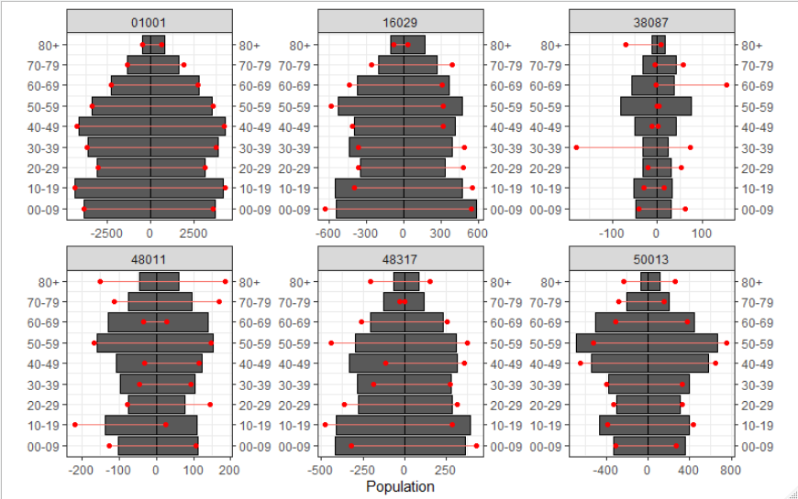

**Figure 2** The distortion of COVID-19 age-sex specific mortality rates for US counties.

|  |  |  |  |  |
| --- | --- | --- | --- | --- |
| **Pop. Size** | **Med. Abs. % Err** | **Mean Abs. % Err** | **n** | **% of county-age-sex groups** |
| < 1,000 | 13.4% | 40.9% | 17,950 | 42.9% |
| < 2,500 | 8.3% | 27.6% | 28,836 | 69.0% |
| < 5,000 | 6.5% | 23.6% | 34,379 | 82.2% |
| < 10,000 | 5.5% | 21.6% | 37,711 | 90.2% |
| < 20,000 | 5.0% | 20.5% | 39,735 | 95.0% |
| All | 4.6% | 19.5% | 41,812 | 100.0% |

