Answers

. Click on "Download now" to get the installation media creation tool.

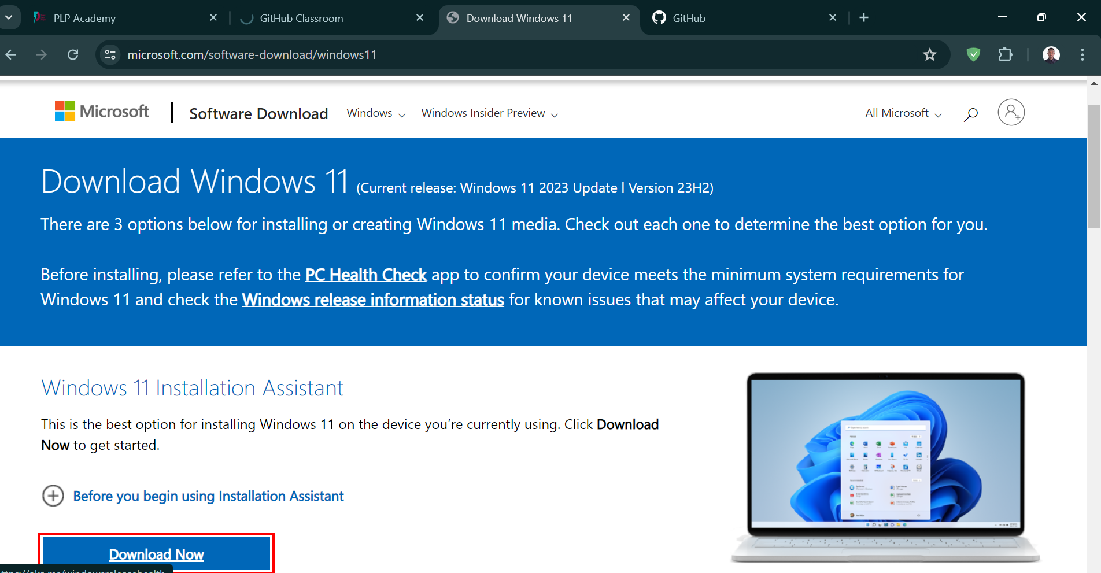

. Follow the installation wizard to complete the installation.

2. Install a Text Editor or Integrated Development Environment (IDE)

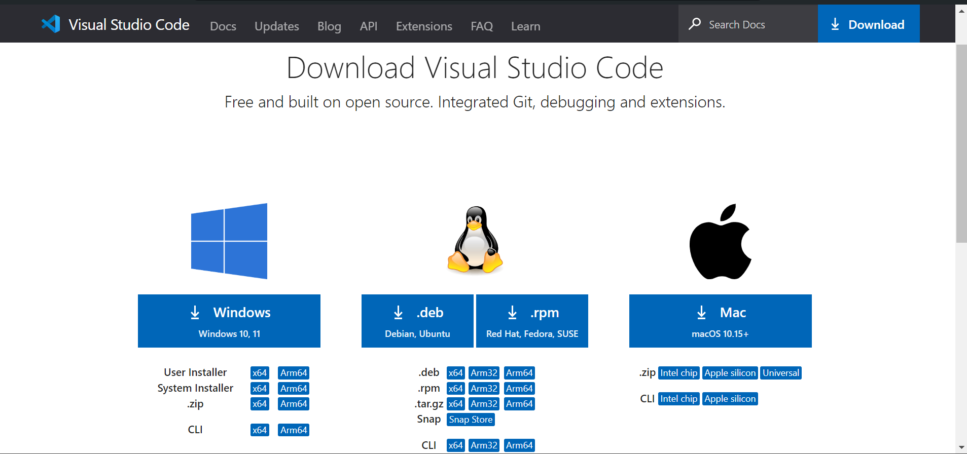

. Run the downloaded installer and follow the setup instructions.

. Launch Visual Studio Code after installation.

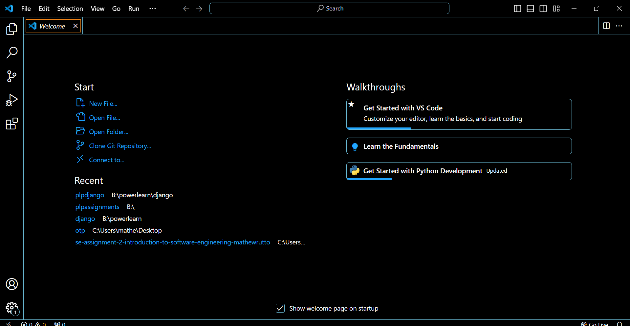

3. Set Up Version Control System

1. Visit the Git download page: Git Download](<https://git-scm.com/>

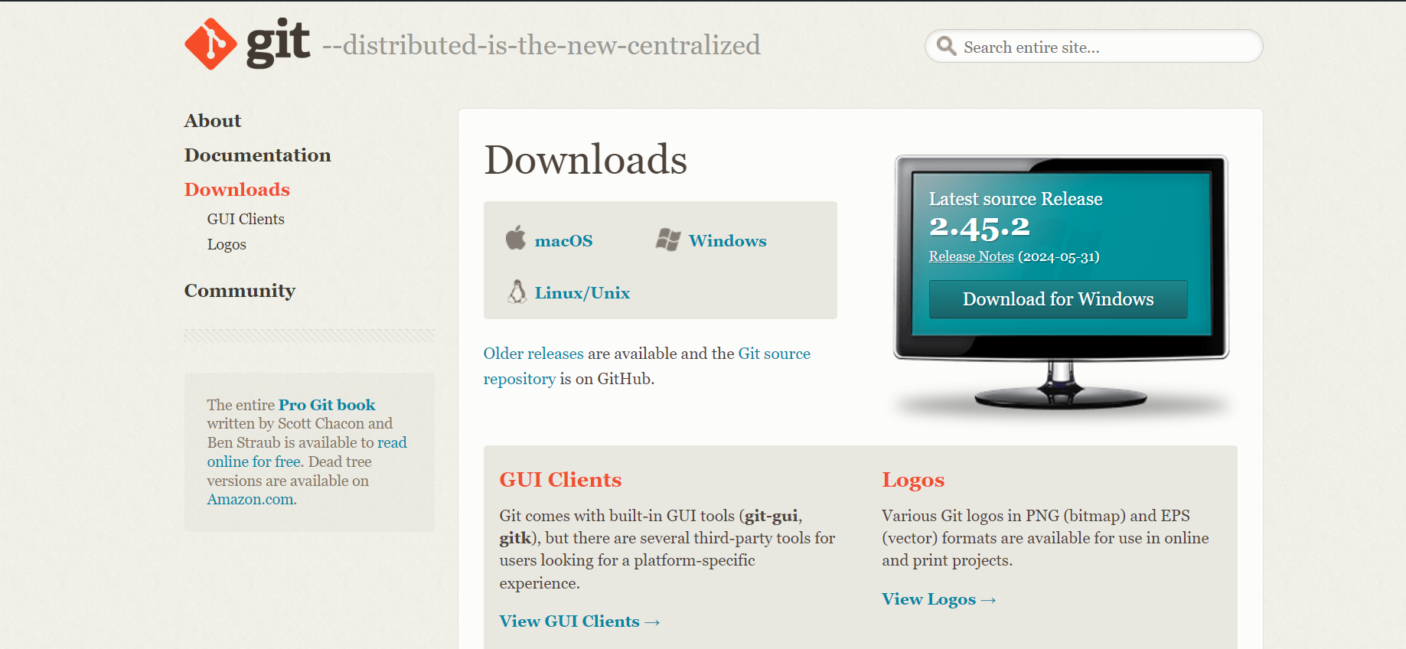

2. Download the Windows version of Git and run the installer.

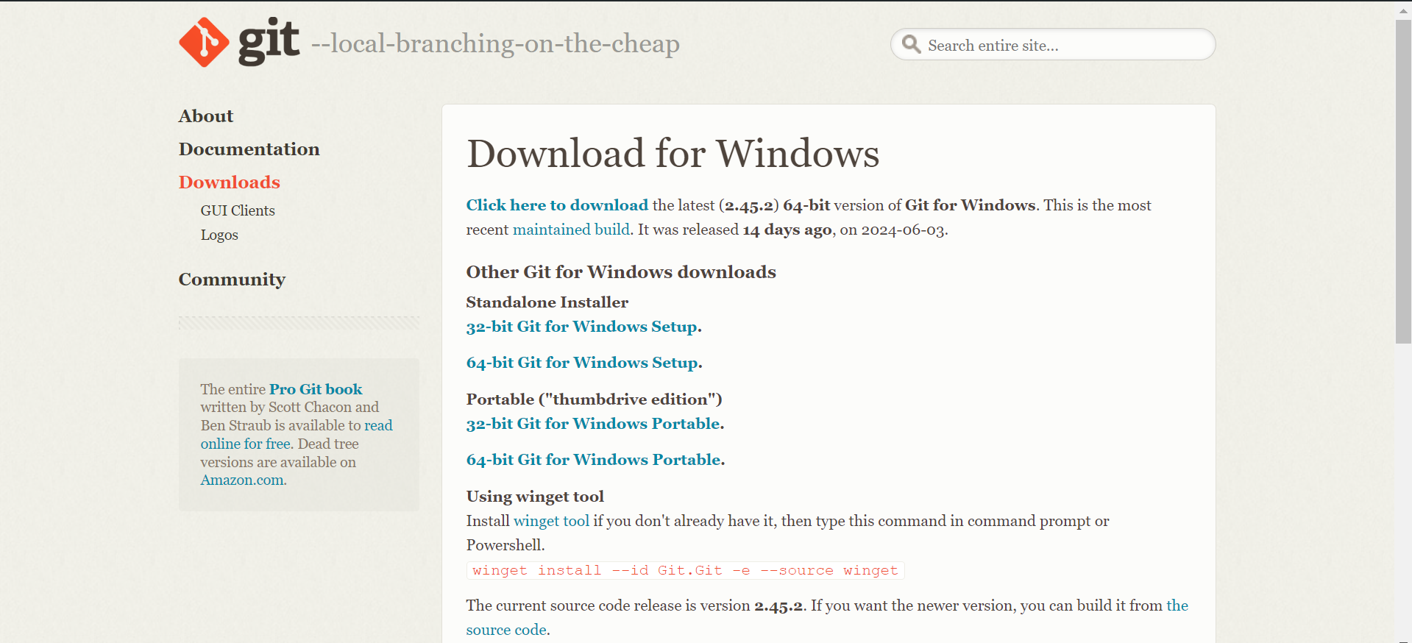

3. Follow the installation wizard, choosing the default options unless specific configurations are needed.

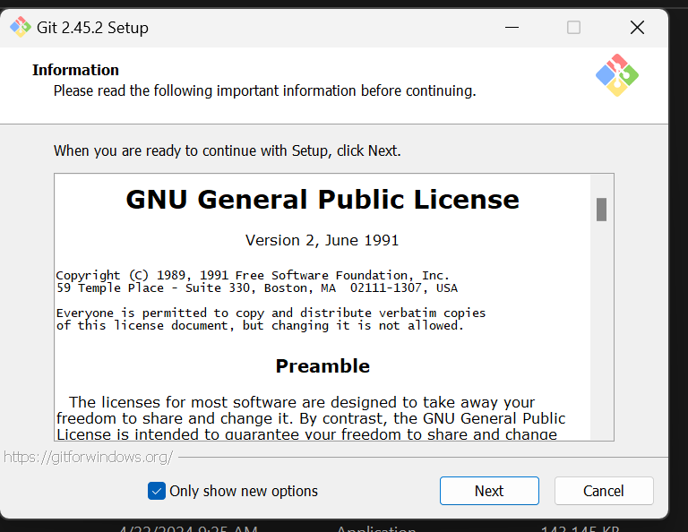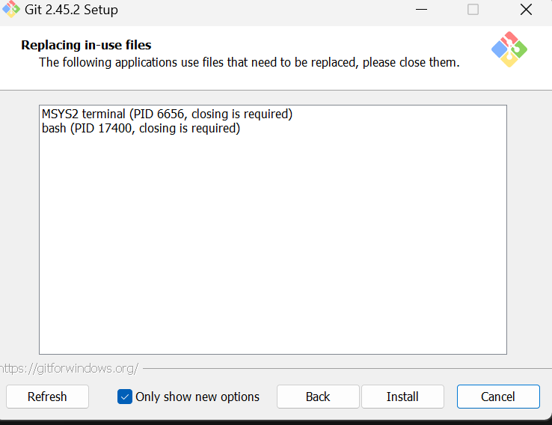

4. After installation, open Git Bash and configure

git config --global user.name " Name"

git config --global user.email "email@example.com"

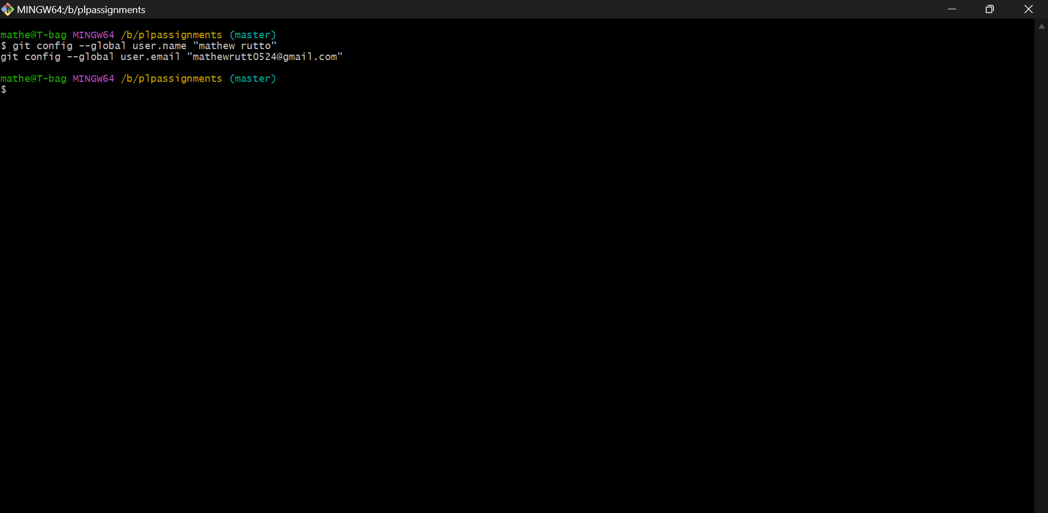

5. Create a GitHub account: [GitHub Sign Up](https://github.com)

6. Create a new repository on GitHub.

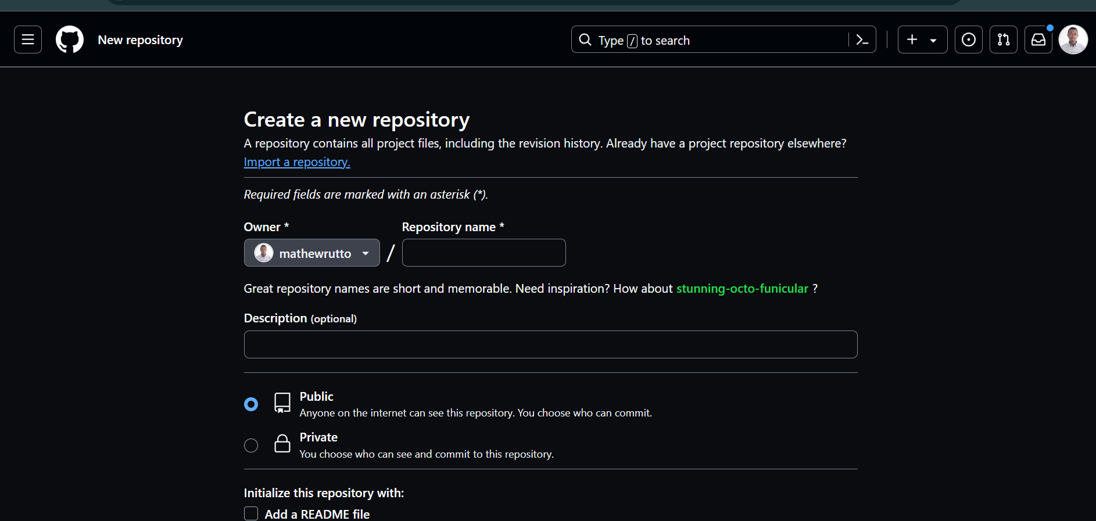

7. Clone the repository to your local machine:

git clone

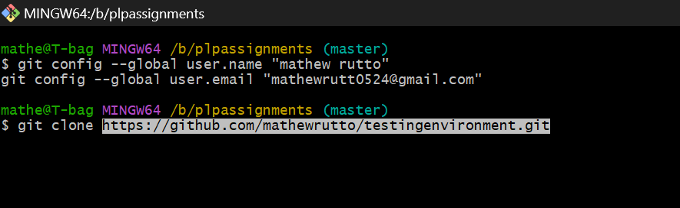

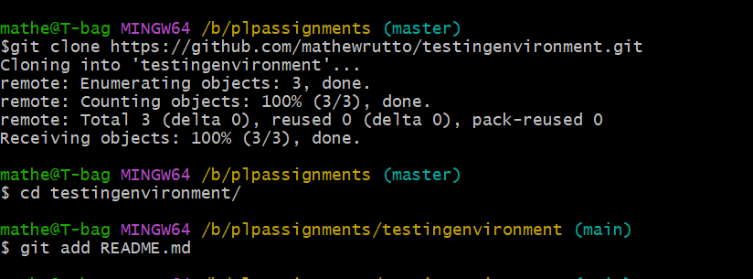



Installing Python

1. Visit the Python download page: Python Download https://www.python.org/downloads/

2. Download the latest version of Python for Windows.

3. Run the installer and ensure "Add Python to PATH" is checked before clicking "Install Now".

4. Verify the installation by opening Command Prompt and inputting python –version

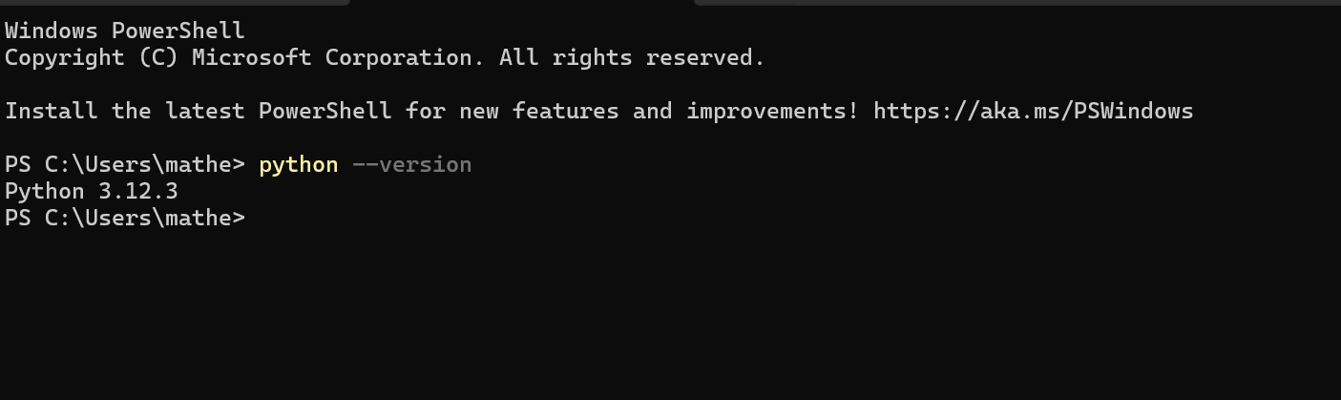

5. Installing Package Managers

Installation -- pip for Python

pip is installed by default with Python

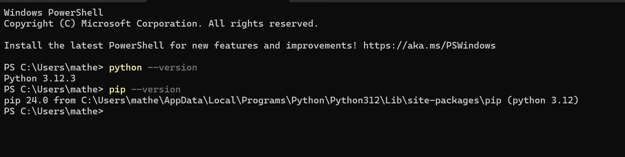

6. Configuring a Database (MySQL)

1. Download https://dev.mysql.com/downloads/windows/installer/5.7.html

2. Download the MySQL Installer for Windows.

3. Run the installer and follow the setup wizard to install MySQL Server.

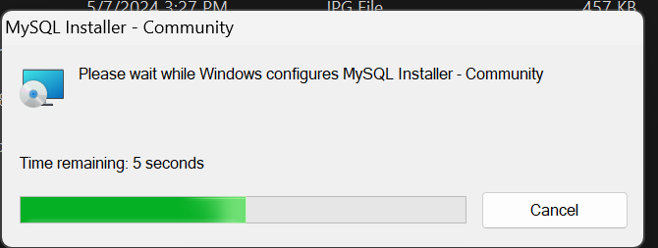

4. Configure MySQL server with a root password and complete the setup.

5. Verify MySQL installation by opening MySQL Command Line Client and logging in with the root password.

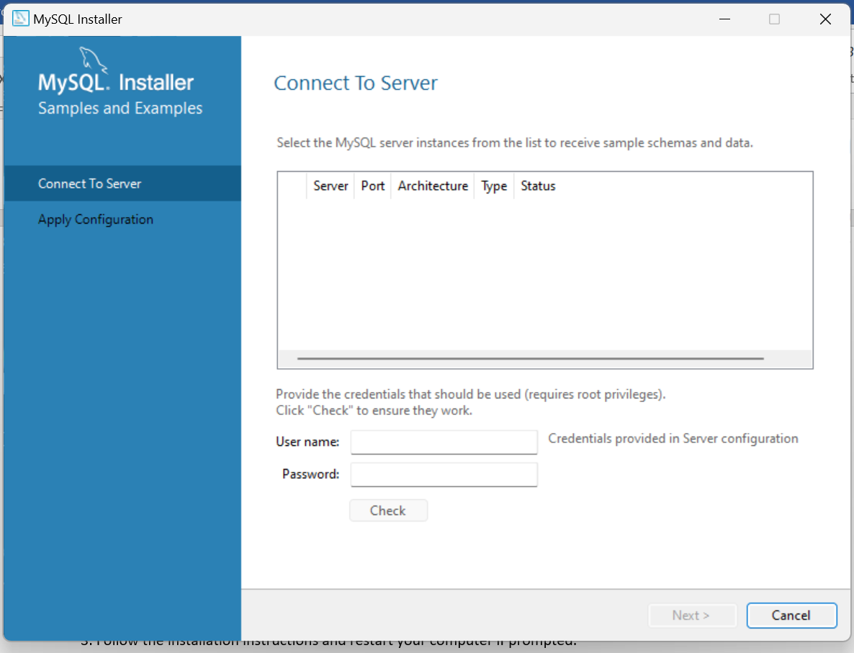

7. Set Up Development Environments and Virtualization

Installing Docker

1. Visit the Docker download page: [Docker Desktop Download](https://www.docker.com/products/docker-desktop/)

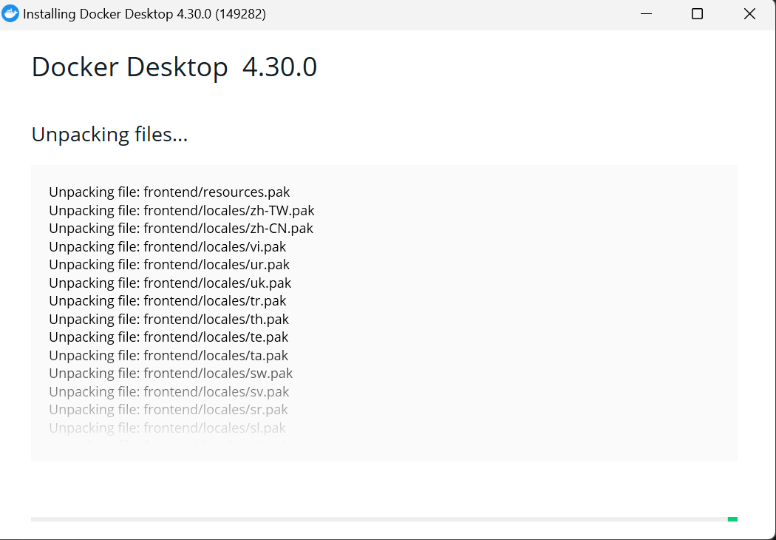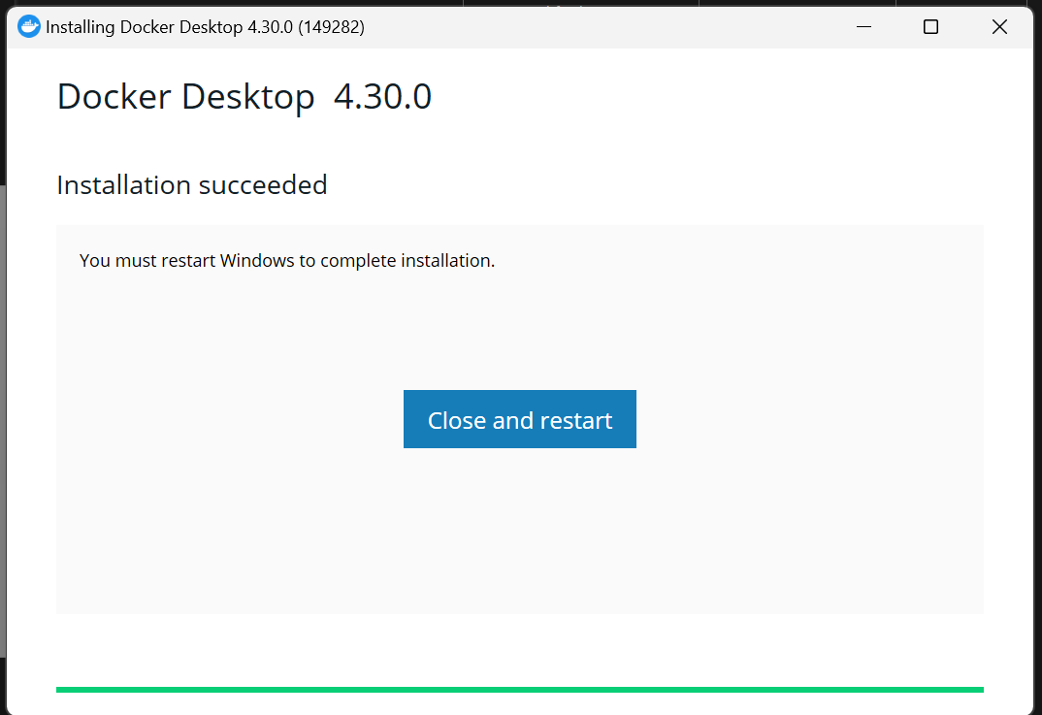.

3. Follow the installation instructions.

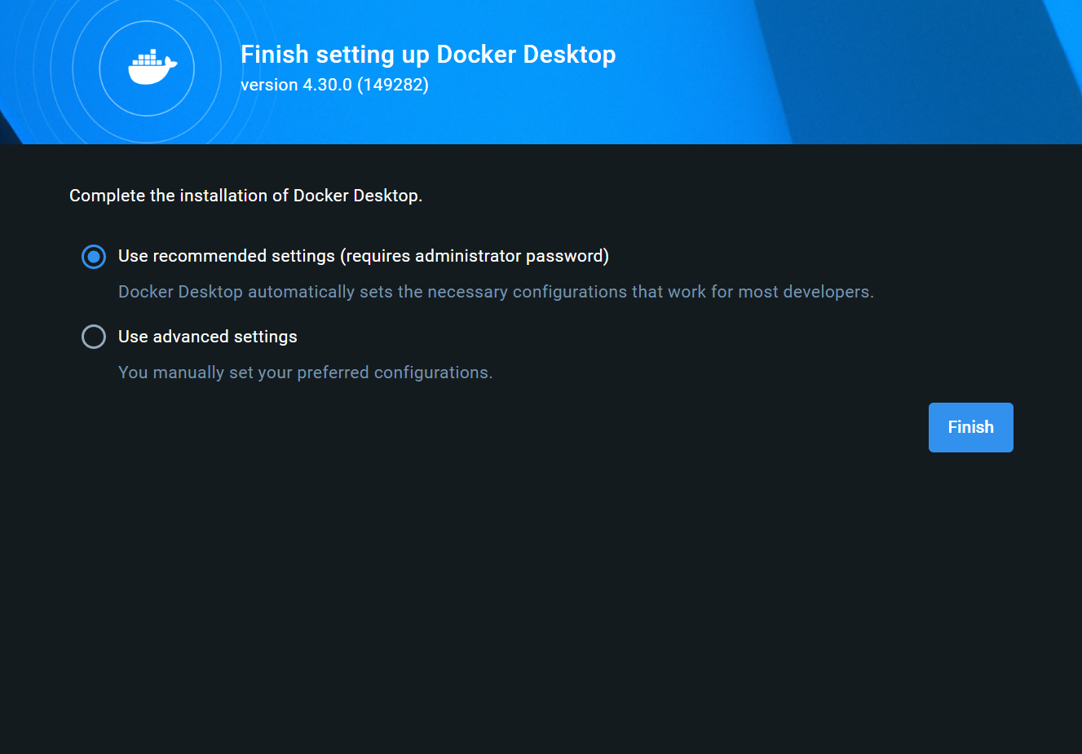

4. Verify Docker installation by opening Command Prompt and typing:

docker --version

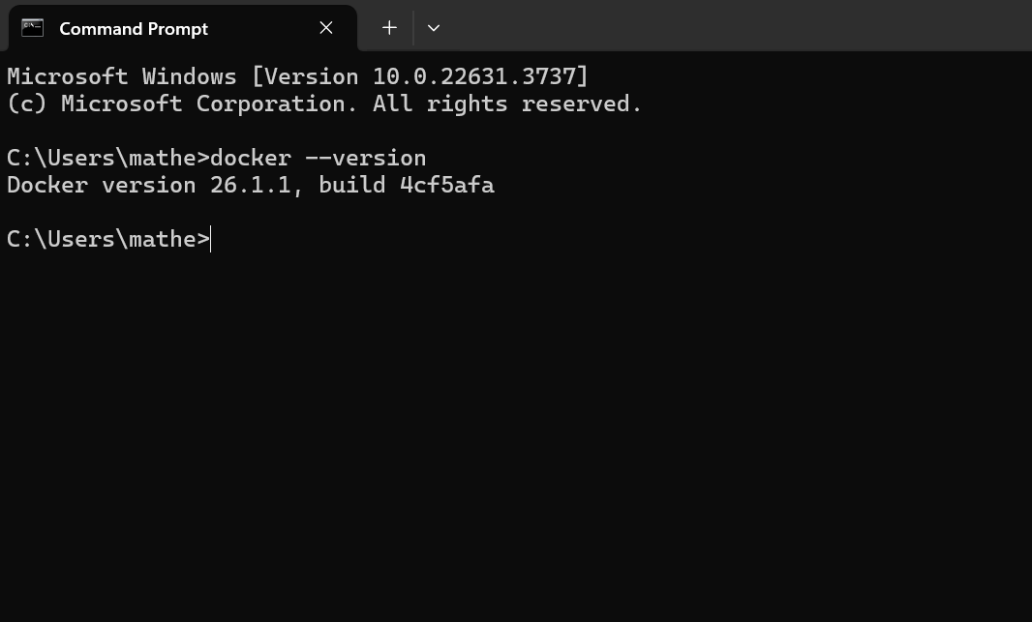

8. Extensions and Plugins

1. Open Visual Studio Code and go to the Extensions view by clicking the Extensions icon in the Activity Bar on the side of the window or by pressing `Ctrl+Shift+X`.

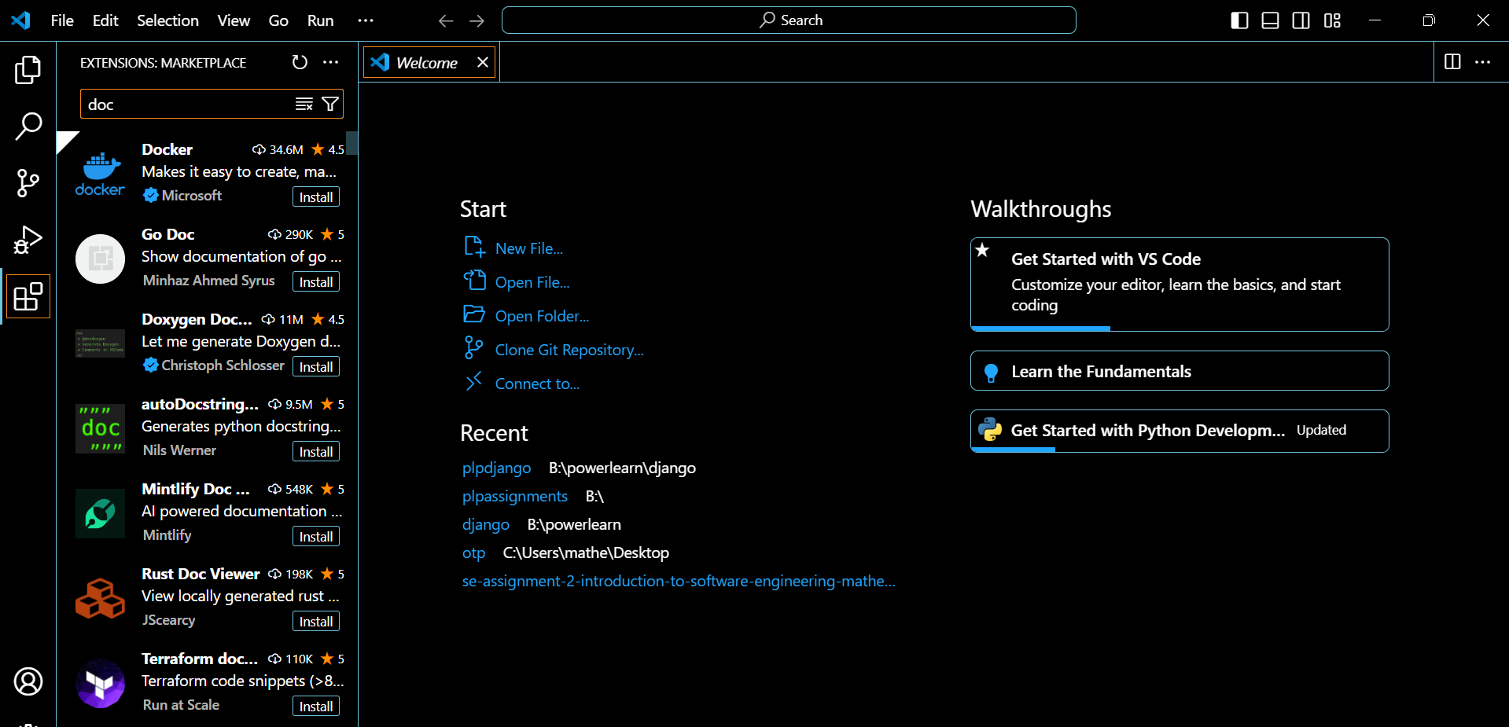I have Installed the following extensions:

- Python (by Microsoft)

- GitLens

- Docker (by Microsoft)

- Prettier - Code formatter (by Prettier)

- ESLint (by Dirk Baeumer)

And many others

Challenge: Installing MySQL with proper configuration.

Solution I Used MySQL official installation guide and referred to community forums for troubleshooting.

Deliverables

GitHub Repository: Sample Project Repository https://github.com/mathewrutto/testingenvironment.git