Code Review Report

*Assessment 2 - CMP1903M Object Oriented Programming, Mathews Joy*

*(The code review process was done by cloning the code repositories from GitHub and submitting a pull request with changes to be made / sending an informal email with changes to be made)*

1. **Who did you provide reviews for.**

Mitchell Seng ID 25300387, Alex Wright ID 25186998, Joe Larke ID 25246407, Luke Wellman ID 25264357, Kieran Sinden ID 25153374, Tom Clough ID 19698748

1. **How many reviews you received, and who were they from.**

Received reviews from : Mitchell Seng, Alex Wright, Joe Larke, Luke Wellman, Kieran Sinden, Tom Clough

1. **Were the reviews you received helpful/not helpful?**

All of the review I had received where overall very helpful, each person that reviewed my code efficiently highlighted the positives and negatives to the code I had written and gave me a different way to view my code from others perspectives. Allowing me to further identify mistakes/errors I otherwise would not have seen. Personally, I wouldn’t say I had received any unhelpful comments.

1. **What did you consider changing/modifying after the reviews?**

A lot of my comments where positive, which I was pleased with. However, one review had received was “the program will accept anything, maybe set it up so it only accepts yes or no only”. Although this comment was labelled as a ‘Nit’ (nit-picking) I thought this was a valid suggestion as it meant the user couldn’t enter something by accident, so I improved my code by making my code be stricter on what user inputs is accepted.

Furthermore, another helpful review I had was that some of my variables/commenting were misspelled, especially in my comments. So, after further checking I went through all my comments again and made sure to fix these mistakes, so that other reading my code in the future don’t get confused on what I’m trying to explain through my commenting.

Another key suggestion I was told, was to change the fields which were not used outside the deck class from public to private. I decided to add this modification suggested as it help keep my overall program better encapsulated, allowed to keep the code more secure. Also, another modification which linked to this suggestion was to make some of the fields which shouldn’t be allowed to be changed directly outside the Card or Deck class to have a private set, for example my list of cards field which kept track off all the cards in the deck. I made sure to change this to have a private set, so that nothing outside the class could change it.

A further suggestion I had received was to think about giving the option to shuffle the deck after every time the user draws a card, although this was a valid idea, I thought it was best not to implement this for the time being and stick with what the brief asked. However, I will keep it in mind for the future.

A final improvement suggestion I was given by my peers was to consider moving my main draw cards code, out from the static void main and into its own private static method in program.cs. I think this was overall I good idea as it kept my main as minimal as possible.

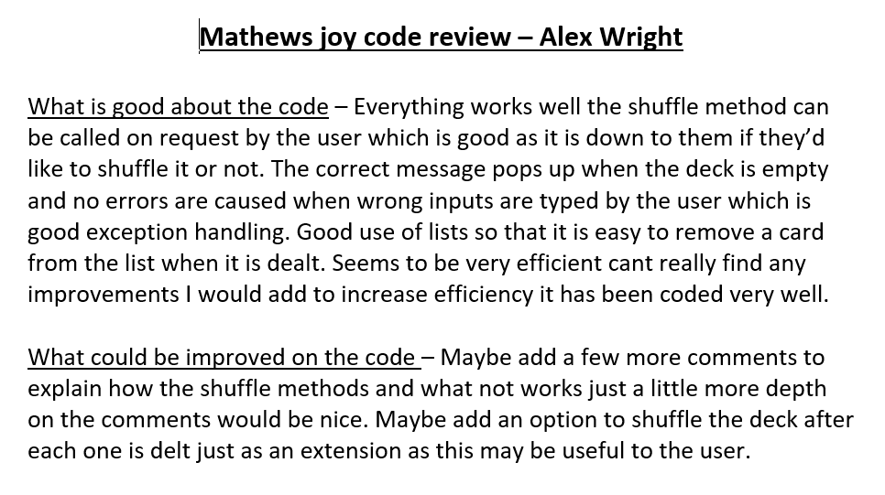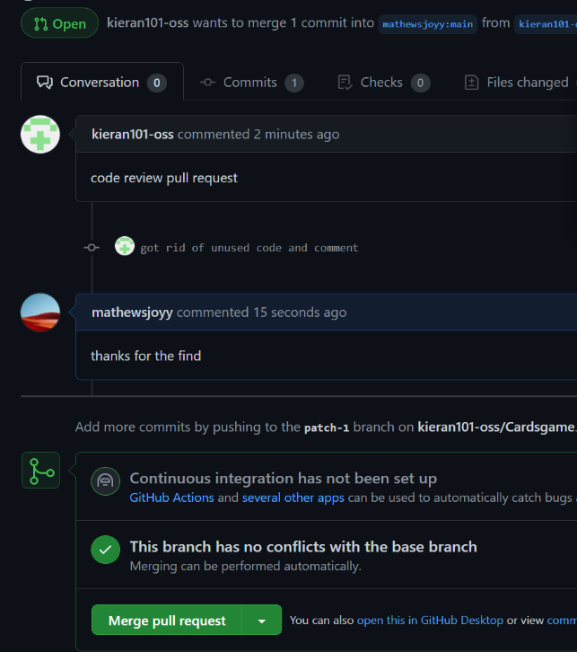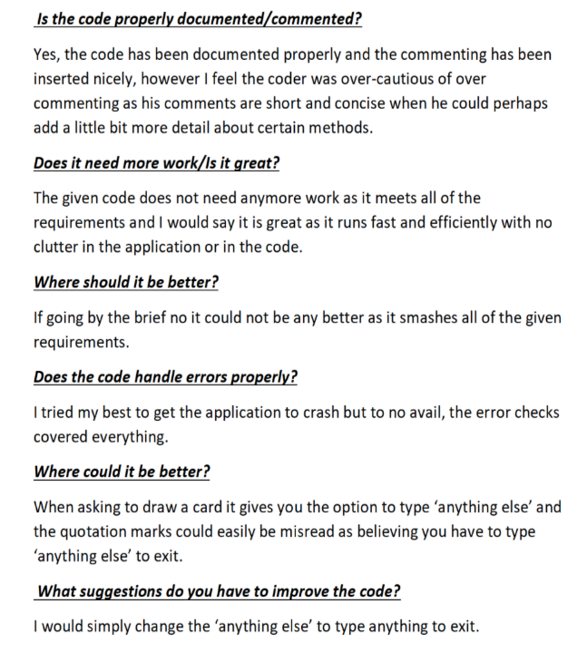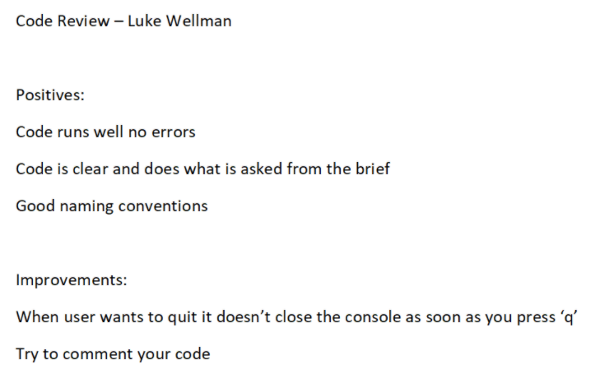Evidence of code review

Code Review by Joe Larke

GitHub Pull Request