## Queries

1.SELECT PERSON.FirstName, PERSON.LastName, PERSON.Email, PERSON.Phone, PERSON.CountryNameID, PERSON.Role FROM PERSON  
WHERE CountryNameID = 'Australia'  
ORDER BY LastName;  
  
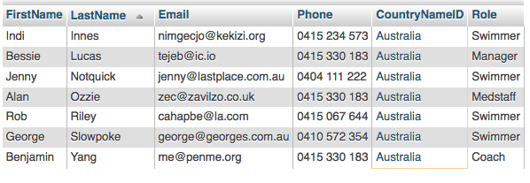

2. SELECT CountryNoOfSwimmers.CountryNameID, CONCAT(PERSON.FirstName, " ", PERSON.LastName) AS ManagerName, CountryNoOfSwimmers.NumberOfSwimmers FROM CountryNoOfSwimmers  
JOIN PERSON ON PERSON.CountryNameID = CountryNoOfSwimmers.CountryNameID  
WHERE PERSON.Role = 'Manager'  
ORDER BY CountryNoOfSwimmers.CountryNameID;

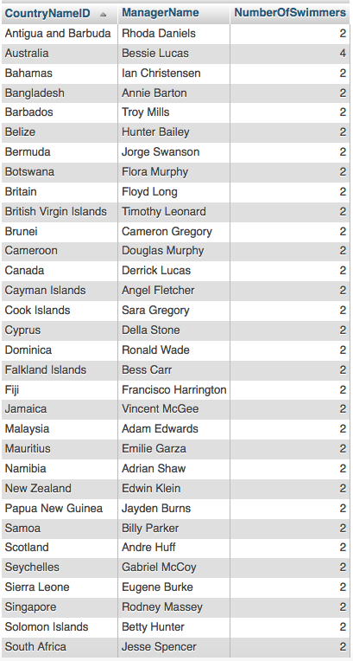

3. SELECT PERSON.CountryNameID, PERSON.FirstName, PERSON.LastName, PERSON.Email, PERSON.Phone, EVENTS.EventNameID, EVENTS.MinQualifyingTime, ER.QualifyingTime AS SwimmersTime, (QualifyingTime-MinQualifyingTime) AS Difference FROM PERSON  
JOIN SWIMMER ON PERSON.PersonID = SWIMMER.PersonID  
JOIN EVENTREGISTRATION AS ER ON ER.SwimmerID = SWIMMER.SwimmerID  
JOIN EVENTS ON ER.EventNameID = EVENTS.EventNameID  
WHERE MinQualifyingTime < QualifyingTime;  
  
For this Query I only had 2 swimmers who didn’t qualify as my initial assumptions was that all swimmers had to Qualify and I created my Data accordingly.  
  


4. SELECT PERSON.FirstName, PERSON.LastName, PERSON.Email, PERSON.Phone, PERSON.CountryNameID, MEDICALSTAFF.Specialisation FROM PERSON  
JOIN MEDICALSTAFF ON PERSON.PersonID = MEDICALSTAFF.PersonID  
ORDER BY Specialisation DESC, LastName;  
  
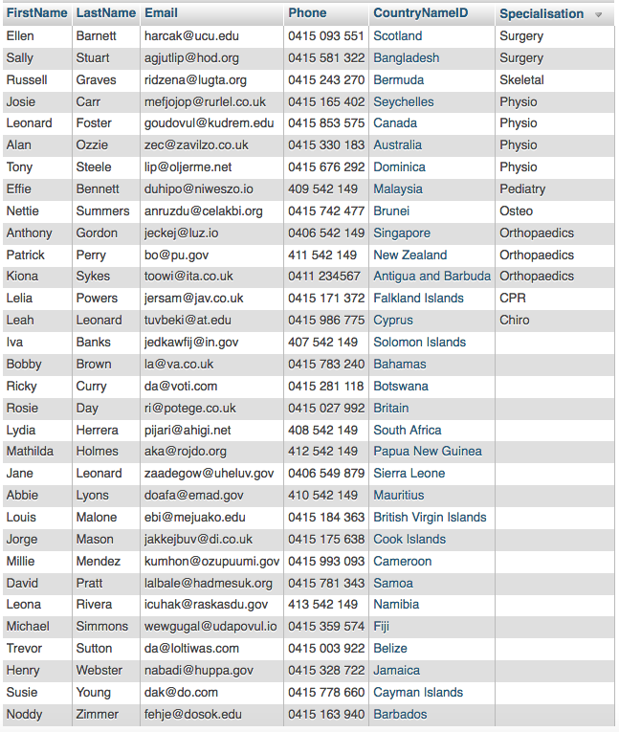

5. SELECT EVENTS.EventNameID, RACES.RaceType, RACES.Time, POOLS.PoolName AS Location FROM `EVENTS`  
JOIN RACES ON EVENTS.EventNameID = RACES.EventNameID  
JOIN POOLS ON RACES.PoolID = POOLS.PoolID  
WHERE RACES.EventNameID = '50m Freestyle - Women'  
ORDER BY Time;

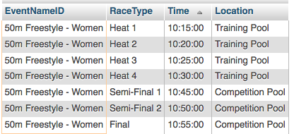

6. SELECT RACES.EventNameID, CONCAT(PERSON.FirstName, " ",PERSON.LastName) AS SwimmerName, RACESWIMMERS.Time, RACESWIMMERS.Place, RACESWIMMERS.Medal FROM RACES  
JOIN RACESWIMMERS ON RACESWIMMERS.RaceID = RACES.RaceID  
JOIN SWIMMER ON RACESWIMMERS.SwimmerID = SWIMMER.SwimmerID  
JOIN PERSON ON PERSON.PersonID = SWIMMER.PersonID  
WHERE RACES.RaceType = 'Final' AND (RACESWIMMERS.Place = 1 OR RACESWIMMERS.Place = 2 OR RACESWIMMERS.Place = 3)  
ORDER BY EventNameID ,Place;  
  
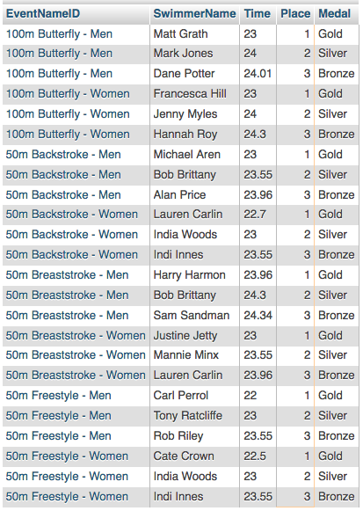

7. SELECT SWIMMER.FirstName, SWIMMER.LastName, RACES.EventNameID, RACES.RaceType, RACES.Day, RACES.Time, RACESWIMMERS.Time AS RaceTime, RACESWIMMERS.Place, RACESWIMMERS.Medal FROM RACESWIMMERS  
JOIN PersonSwimmerNo AS SWIMMER ON RACESWIMMERS.SwimmerID = SWIMMER.SwimmerID  
JOIN RACES ON RACESWIMMERS.RaceID = RACES.RaceID  
WHERE SWIMMER.FirstName = 'Lauren' AND SWIMMER.LastName ='Carlin'  
ORDER BY EventNameID, RaceType;

For this Query I chose the swimmer named Lauren Carlin.

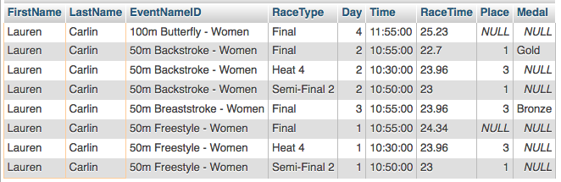

8. SELECT CountryNoOfSwimmers.CountryNameID, CountryNoOfSwimmers.NumberOfSwimmers, GOLD.GoldMedals, SILVER.SilverMedals, BRONZE.BronzeMedals FROM CountryNoOfSwimmers  
LEFT JOIN CountryGoldView AS GOLD ON GOLD.CountryNameID = CountryNoOfSwimmers.CountryNameID  
LEFT JOIN CountrySilverView AS SILVER ON SILVER.CountryNameID = CountryNoOfSwimmers.CountryNameID  
LEFT JOIN CountryBronzeView AS BRONZE ON BRONZE.CountryNameID = CountryNoOfSwimmers.CountryNameID  
ORDER BY GoldMedals DESC;

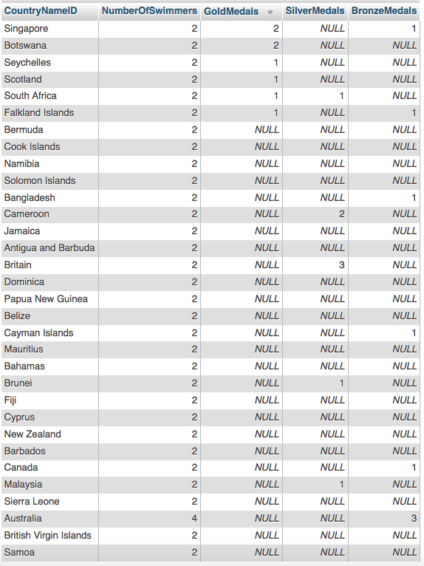

9. SELECT PERSON.CountryNameID, PERSON.LastName, PERSON.FirstName, PERSON.Phone, PERSON.Role, COACH.FedCertLevel, COACH.FedCertDate, MEDICALSTAFF.Qualification, MEDICALSTAFF.QualificationYear, MEDICALSTAFF.Specialisation FROM `PERSON`  
LEFT JOIN COACH ON PERSON.PersonID = COACH.PersonID  
LEFT JOIN MEDICALSTAFF ON PERSON.PersonID = MEDICALSTAFF.PersonID  
WHERE PERSON.Role = 'Coach' OR PERSON.Role = 'MedStaff'  
ORDER BY CountryNameID, LastName, FirstName;

This Query had a result with 64 rows, the screenshot was not able to capture all rows, please see the result in phpmyadmin for all 64 rows.

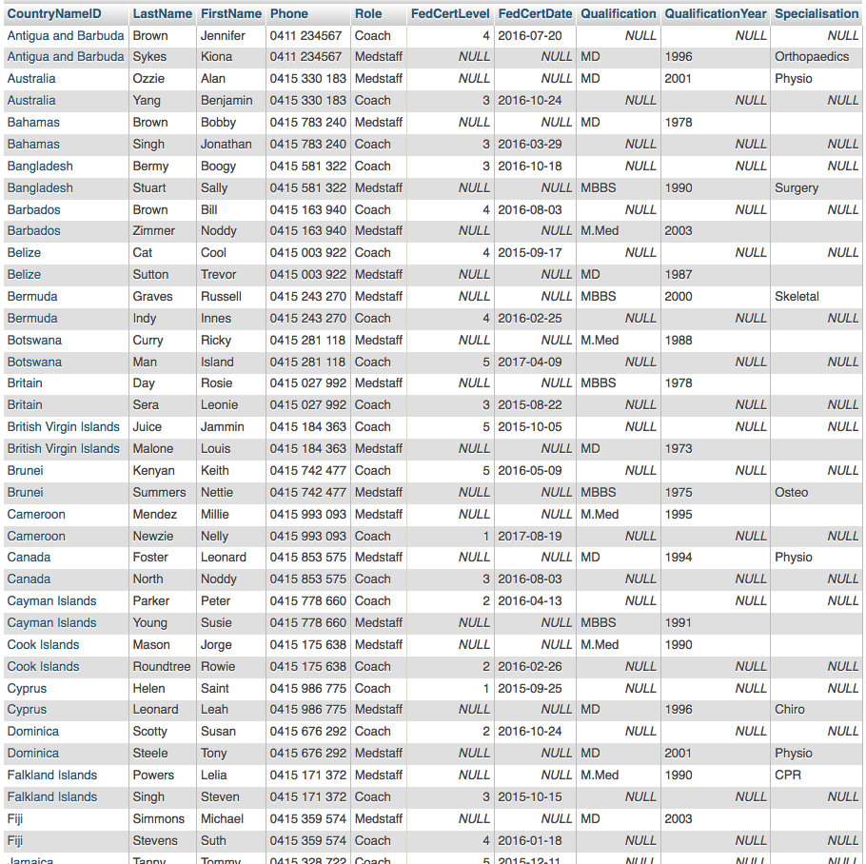

10. SELECT PERSON.CountryNameID, CONCAT(PERSON.FirstName, " ",PERSON.LastName) AS CoachName, PERSON.Email, PERSON.Phone, COACH.FedCertDate FROM PERSON  
JOIN COACH ON PERSON.PersonID = COACH.PersonID  
WHERE PERSON.Role = 'Coach';  
  
