AV-GRU Autoencoder Model and Flow
Stage 2 architecture, training path, embedding flow, and runtime handoff
Source reviewed: /Users/spaceboxcarbonite/Downloads/av_GRU_autoencoder

Purpose
This Stage 2 package turns Stage 1 hand-landmark CSVs into fixed-length motion windows, trains a GRU autoencoder, converts each window into a compact latent gesture vector, clusters those latent vectors, and exports the trained artifacts for Stage 3 runtime use.
Key point: the encoder input is motion only. Audio is an optional auxiliary training target, gated by each window's audio_quality value. The deployed runtime can therefore operate from camera/MediaPipe hand landmarks without live audio features.

End-to-End Flow
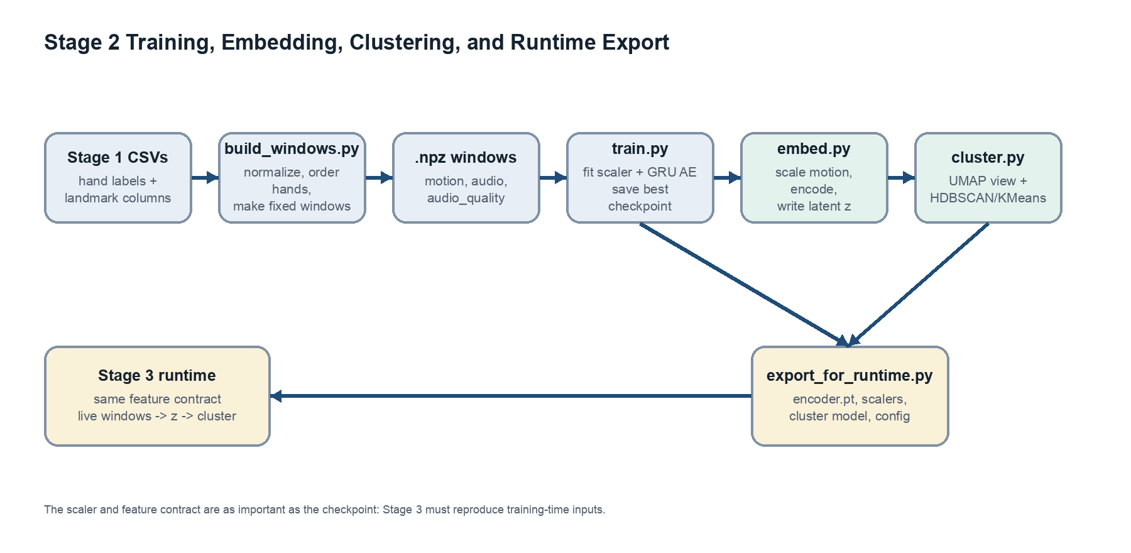
Figure 1. Data and artifact flow from Stage 1 landmark CSVs to Stage 3 runtime package.

Model Architecture
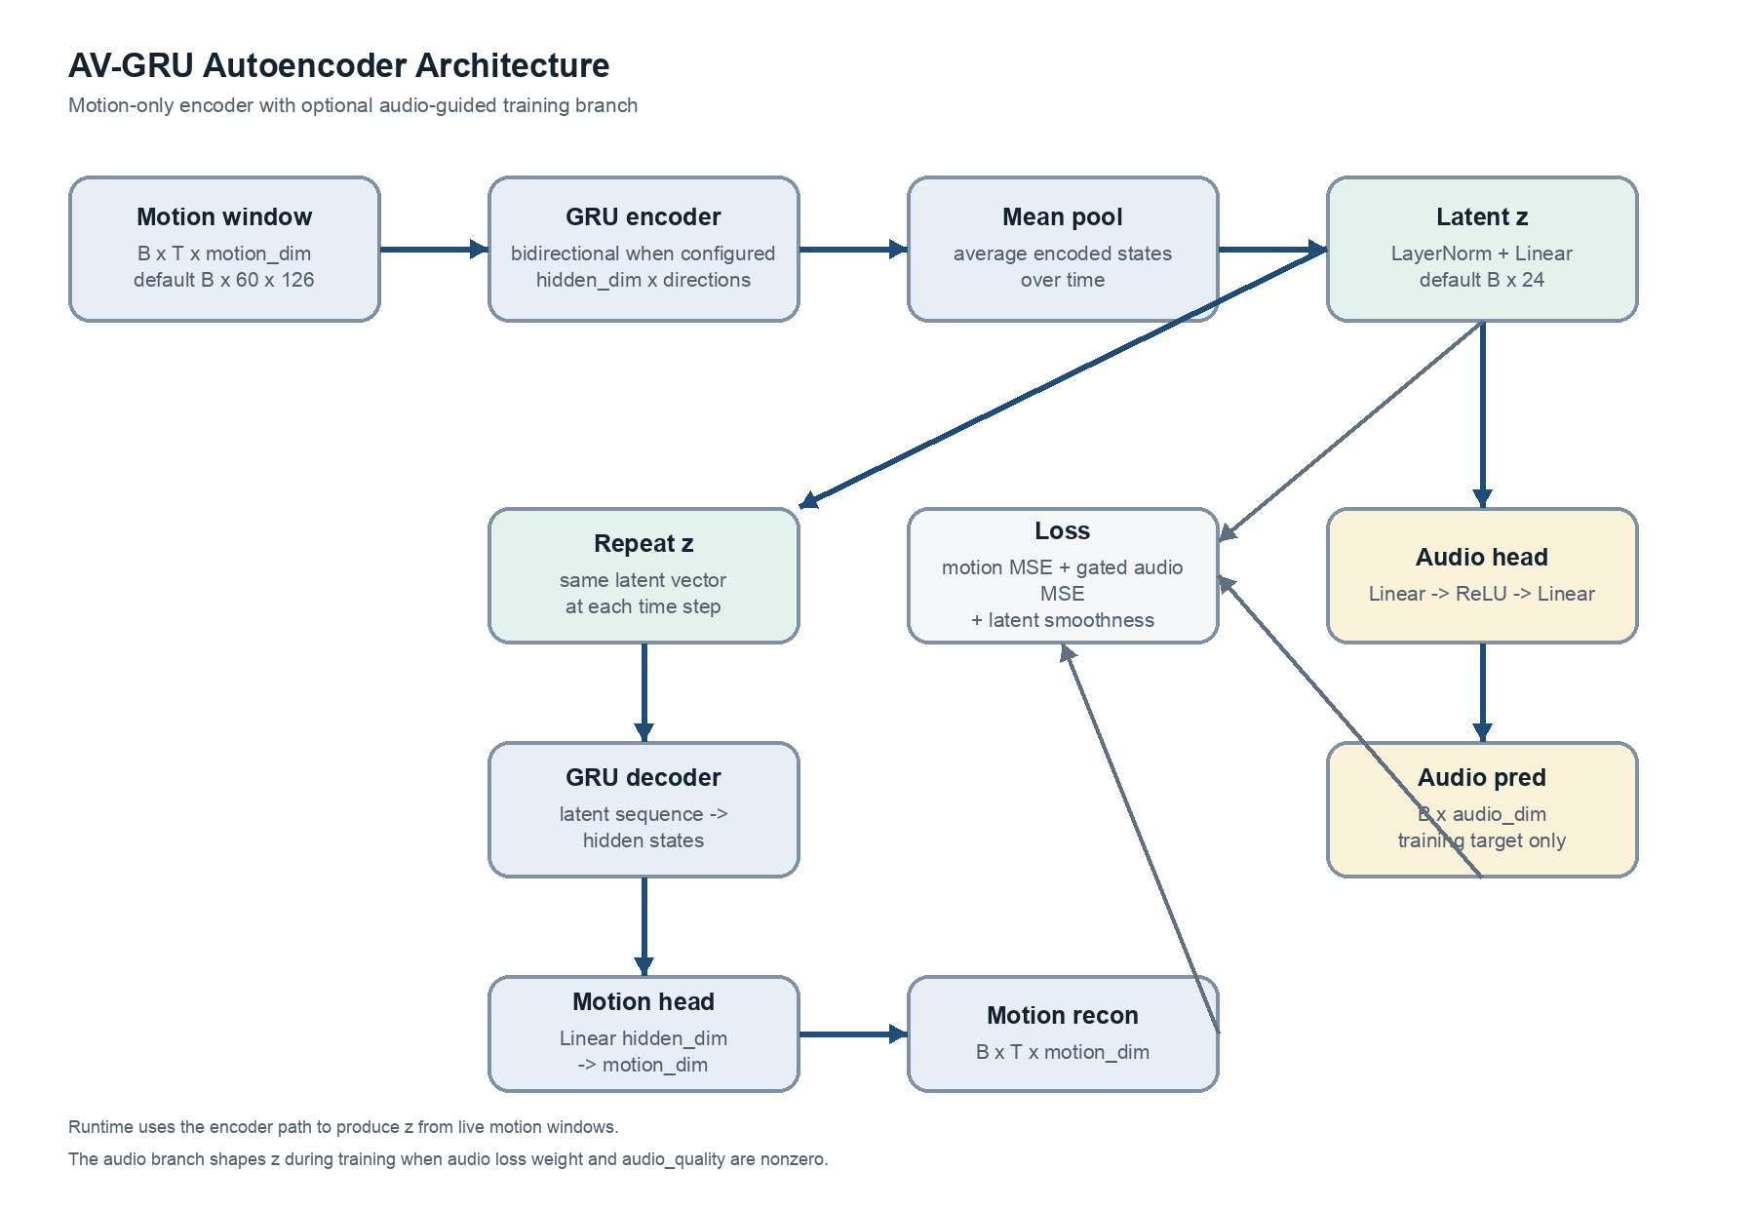
Figure 2. Forward pass through the motion encoder, latent vector, motion decoder, and audio prediction branch.

Data Contract
The default motion vector is right hand 63 values plus left hand 63 values, for 126 total features. Each hand has 21 MediaPipe landmarks with 3 coordinates. The builder uses handedness labels when available so the model sees a stable right-then-left order instead of raw detection order.
- Missing hands are represented with zeros.
- Each hand is normalized relative to the wrist landmark.
- Scale normalization uses landmark 9 by default.
- Optional velocity features can be appended, but the default configs keep include_velocity false.
- Each .npz window stores motion, audio, audio_quality, source metadata, and a serialized feature contract.

Forward Pass
For a batch shaped B x T x motion_dim, the encoder GRU emits B x T x hidden_dim*directions. The model averages those encoded states across time and projects the result through LayerNorm plus Linear to produce the latent gesture vector z.
The decoder receives z repeated across T time steps, then reconstructs the full motion sequence through a decoder GRU and linear motion head. The audio head separately maps z through Linear, ReLU, and Linear layers to predict an audio summary vector.
Runtime note: Stage 3 only needs the encoder path and preprocessing artifacts. The audio prediction branch is useful during training when real audio guidance is enabled, but it is not required for live inference.

Training Objective
The total loss is a weighted sum of motion reconstruction MSE, gated audio prediction MSE, and a latent smoothness regularizer.
- Motion reconstruction loss compares motion_recon against the scaled input motion sequence.
- Audio prediction loss compares audio_pred against the audio target; if the target is time-varying, it is averaged over time first.
- The audio squared error is multiplied by audio_quality, so placeholder or poor audio can have little influence.
- Motion-only configs set audio_prediction_weight to 0.0, which disables the audio branch's contribution.
- The smoothness term compares adjacent latent vectors in the current batch. With shuffled training batches, it is a light regularizer rather than guaranteed source-video temporal smoothing.

Training Flow
Training discovers the manifest, validates that the first window matches the configured sequence length and feature dimensions, creates train/validation/test splits, fits a StandardScaler on flattened training motion frames, and applies that scaler to every batch before the model sees it.
The model is optimized with AdamW, gradient clipping, early stopping on validation total loss, and checkpointing of the best validation model.

Embedding, Clustering, and Evaluation
After training, embed.py reloads the feature scaler and best checkpoint, scales each motion window, calls model.encode(...), and writes the latent vectors to embeddings.npy and embeddings.csv. The clustering step standardizes the latent columns, fits UMAP for two-dimensional visualization, then clusters the standardized latent vectors with HDBSCAN or KMeans. HDBSCAN is the default.
The evaluation script summarizes total windows, non-noise clusters, noise windows, and clustering metrics such as silhouette and Davies-Bouldin when enough valid clusters exist.

Runtime Export
export_for_runtime.py packages the checkpoint, motion scaler, clustering artifacts, cluster names, and a compact runtime_model_config.json file. The runtime config records the feature contract and model dimensions that Stage 3 must reproduce.
Artifact | Purpose
best_model.pt / encoder.pt | Model checkpoint containing the trained AVGRUAutoencoder weights and config.
feature_scaler.joblib | StandardScaler fit on training motion frames; required before encoding.
embeddings.csv / embeddings.npy | Per-window latent gesture vectors generated by model.encode(...).
cluster_model.joblib | HDBSCAN or KMeans model trained on standardized latent vectors.
embedding_scaler.joblib | Scaler applied to latent vectors before clustering.
runtime_model_config.json | Feature contract and model dimensions that Stage 3 must follow.

Configuration Profiles
Config | Sequence | Motion dim | Audio dim | Hidden | Latent | Layers | Audio loss
default.yaml | 60 | 126 | 12 | 128 | 24 | 1 | 0.35
full_av.yaml | 60 | 126 | 12 | 128 | 24 | 2 | 0.35
motion_only.yaml | 60 | 126 | 1 | 128 | 24 | 2 | 0.0
small_test.yaml | 60 | 126 | 1 | 64 | 16 | 1 | 0.0
small_test_seq15.yaml | 15 | 126 | 1 | 64 | 16 | 1 | 0.0

The code contains a use_audio_guidance config field, but the active loss behavior is controlled by audio_prediction_weight and audio_quality. In the current implementation, setting audio_prediction_weight to 0.0 is the effective way to disable audio guidance.

Implementation Notes
- from_latent is defined in the model but is not used by the current forward method.
- audio_quality_threshold appears in config files, but the shown loss code directly uses per-window audio_quality rather than thresholding it.
- Runtime correctness depends on keeping hand order, normalization, scale landmark, sequence length, feature dimension, and scaler identical between training and Stage 3.
- The architecture is practical for live camera-driven interaction because the encoder consumes motion only, even when training uses audio as additional supervision.

Source Files Reviewed
- models/av_gru_autoencoder.py
- src/losses.py
- src/dataset.py
- build_windows.py, train.py, embed.py, cluster.py, evaluate.py, export_for_runtime.py
- configs/default.yaml, full_av.yaml, motion_only.yaml, small_test.yaml, small_test_seq15.yaml

