**COMPONENTS USED**

**NEMA 17 Motor:** A NEMA 17 stepper motor is a stepper motor with a 1.7 x 1.7 inch (43.2 x 43.2 mm) faceplate. The NEMA 17 is larger and generally heavier than for example a NEMA 14, but this also means it has more room to put a higher torque. However, it is useful to remember that its size is not an indication of its power. Stepper motors are generally used in a variety of applications where precise position control is desirable and the cost or complexity of a feedback control system is somewhat unwarranted. This hybrid bipolar stepping motor has a 1.8° step angle (200 steps/revolution). Each phase draws 1.7 A at 2.8 V, allowing for a holding torque of 3.7 kg-cm (51 oz-in). The motor has four color-coded wires terminated with bare leads: black and green connect to one coil; red and blue connect to the other. It can be controlled by a pair of suitable H-bridges.

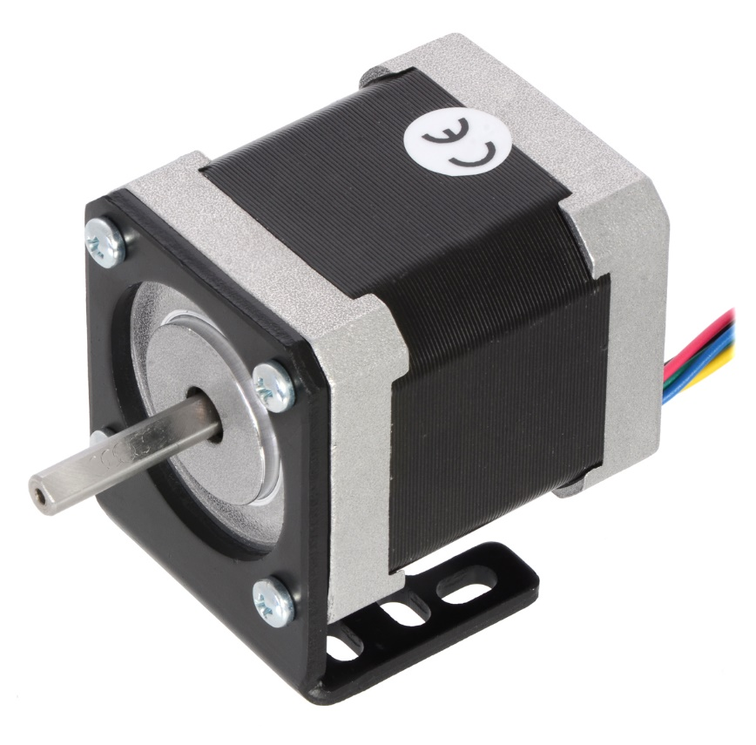

**GT2 pulley & belt:** The positive drive pulley is a wheel designed to support movement and change of direction of a taut cable, here a timing belt. The pulley used has grooves on its periphery to mesh with the timing belt that uniformly protrudes transversely. The GT12 belt is a timing belt that has transverse protrusions and these mesh with the grooves of the positive drive pulley. There is no slip with this belt except for ratcheting or tooth jumping.

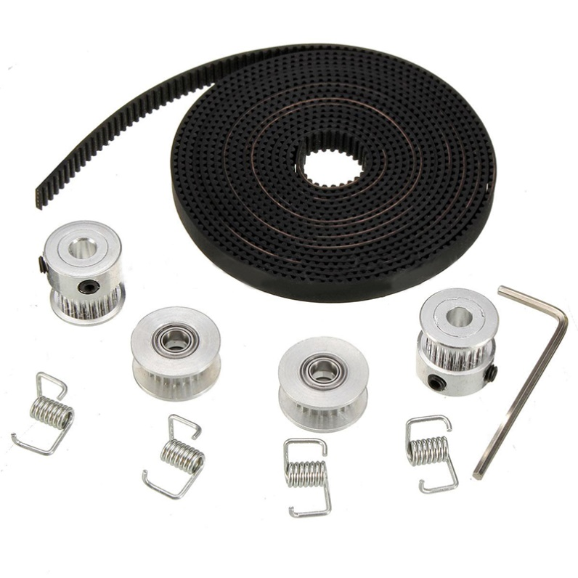

**Lead screw:** A lead screw, also known as a power screw or translation screw, is a screw used as a linkage in a machine, to translate turning motion into linear motion. It is a linear actuator that produces precise and accurate linear motion, is compact, and easy to manufacture. Although these are easy to manufacture, and suitable for vertical motion applications, these are not suitable for continuous power transmission since it can lead to excessive wear and a respective drop in efficiency. The lead screw is employed to provide linear vertical motion to the physible edible by translating the supporting bed beneath, by virtue of the drive from a motor at the base.

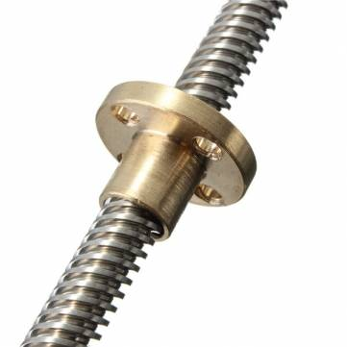

**Smooth rod:** A smooth rod is a metal rod usually used on the axis for components such as the X-carriage or print bed of a 3D printer. The most commonly used diameter is 8 mm, but 10 mm and 12 mm are seen in more rigid designs as well. Stainless steel smooth rods, as used herein, is a pretty hard steel, and doesn't rust, making them ideal to slide bushings on. (A smooth rod can be seen as a kind of cut-to-length construction material). Smooth rods are used to guide the motion of the extruder and the bed, and ensures that it does not get offset, as this may lead to calibration errors and hence a loss in finish and accuracy.

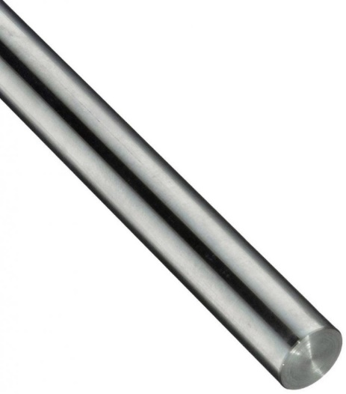

**Aluminium tubes:** These are used to form the supporting structure/framework/skeleton of the food printer. They were chosen owing to their resistance to corrosion, and relatively high strength-weight-ratio. The tubes are joined to each other to form the supporting structure using acrylic L-joints and M-bolts.

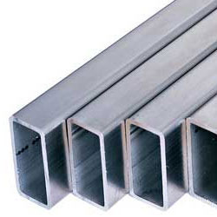

**Acrylic joints:** Pre-designed, laser-cut, acrylic joints were used to sturdily hold together the constituting aluminium tubes, since they have great weatherability and may be easily machined and drilled into without cracking that easily. Besides, they are somewhat inexpensive and easily available.

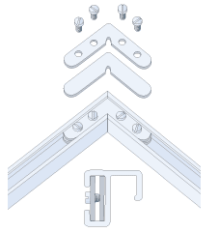

**LM8UU Linear Bearing:** These bearings are perfect for linear motion in a 3 printer, CNC machine, or other such applications, and work with 8mm shafts, as in the smooth rods. This linear ball bearing is sort of the opposite of the radial ball bearings as they are intended to slide along an 8mm linear shaft, rather than rotate around it. These are very slim, very basic bearings that are meant for a stepper-motion controlled setup, and so may not be ultra-smooth.

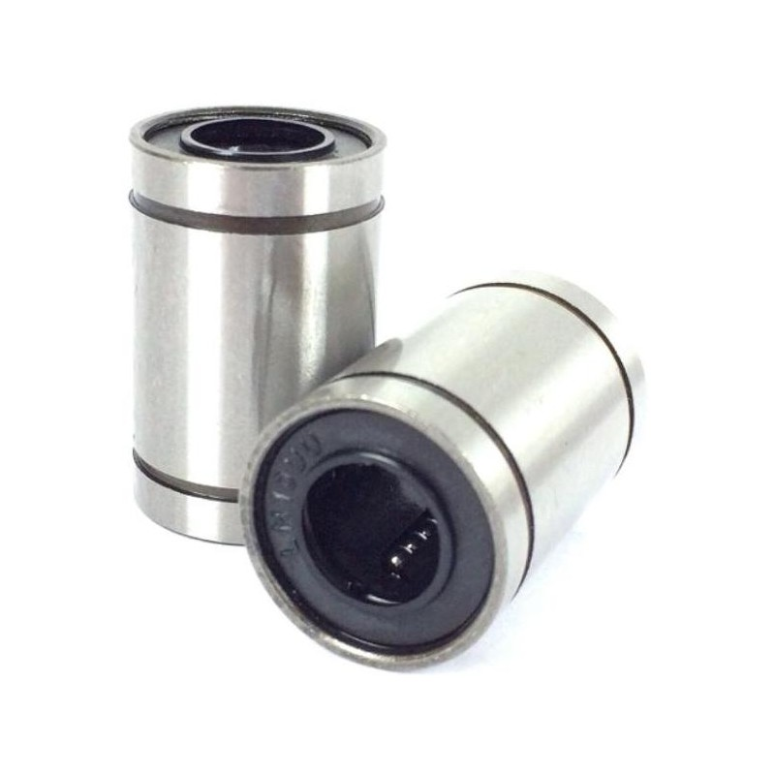

**608 Rotational bearing:** The 608 series is the original standard ball bearing. It is characterized by an 8mm inner diameter (the bore of the ball bearings), a 22mm outer diameter, and a width of 7mm. For purposes of normal usage however, a 608 ball bearing typically consists of chrome steel balls, both for durability and economic reasons.

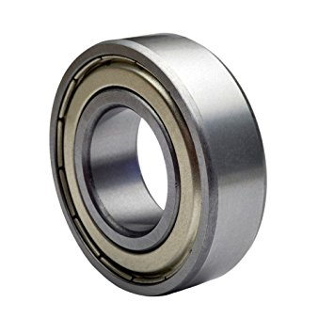

**Couplers/supports/joints:** A gamut of couplers, supports and joints were fabricated using another 3D printer to steadily anchor and support the moving and fixed parts of the food printer. These were manually designed on a 3D design software package, and later printed out before being mounted on.

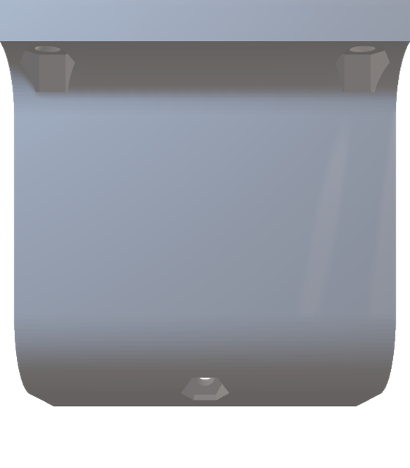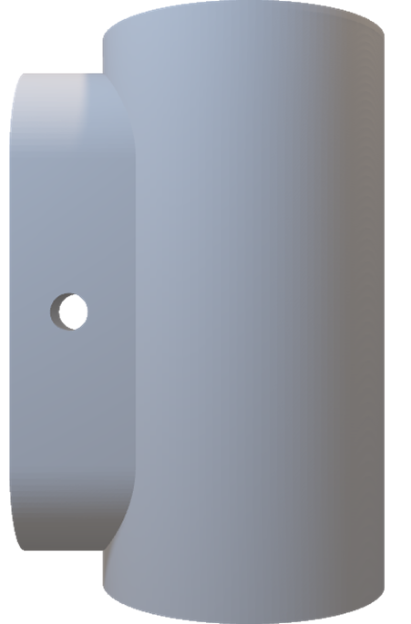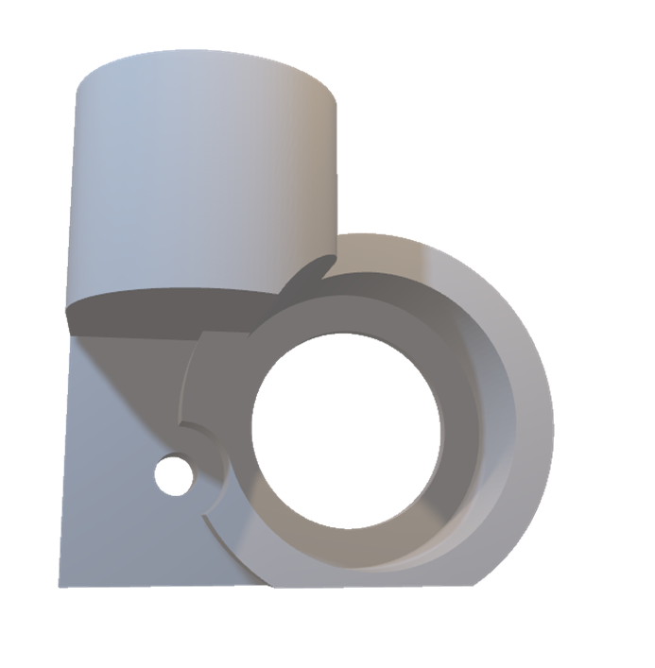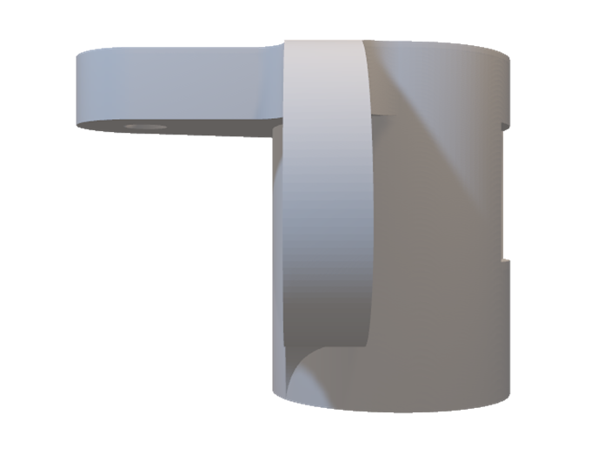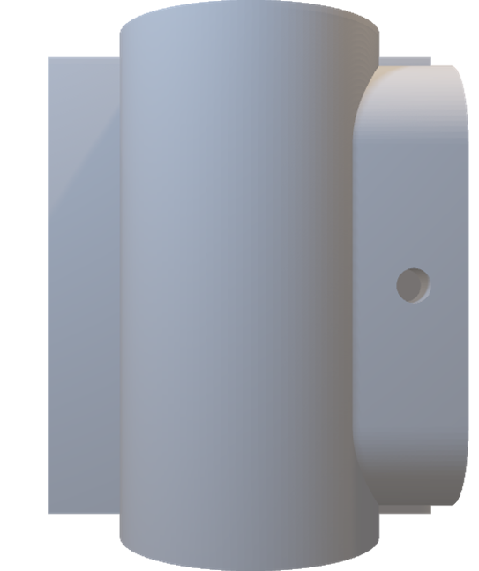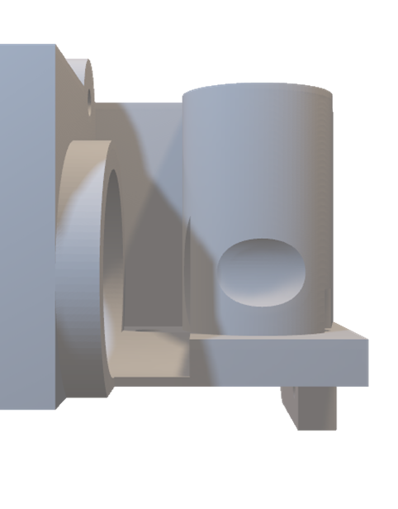

**Extruder:**

**Extruder**: The extruder used is a simple reciprocating pump consisting of a plunger/piston that fits tightly within a cylindrical tube/barrel. The plunger can be linearly pulled and pushed along the inside of the tube, allowing the extruder to take in and expel semi-solid margarine, chocolate, and/or cake dough, through a discharge orifice at the front end of the tube. The open end of the extruder may be fitted with nozzles of different profiles as per requirement.

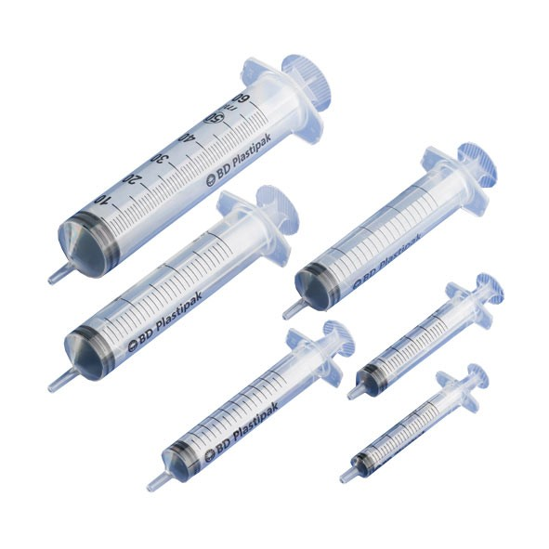

Food Printer

A PROJECT REPORT

Submitted by

Abhijith E M

Mohamed Risvan

Mathew Varghese

Jefin Joseph

To

APJ ABDUL KALAM KERALA TECHNOLOGICAL UNIVERSITY

In partial fulfillment of the requirements for the award of the Degree of

Bachelor of Technology



Mar Athanasius College of Engineering

Kothamangalam, Kerala, India 686 666

NOVEMBER 2017

MAR ATHANASIUS COLLEGE OF ENGINEERING KOTHAMANGALAM



This is to certify that the project report entitled **Food Printer** submitted by Mr. Abhijith E M, Mr. Mohamed Risvan, Mr. Mathew Varghese, and Mr. Jefin Joseph towards partial fulfillment of the requirement for the award of Degree of Bachelor of Technology from the APJ Abdul Kalam Kerala Technological University, Thiruvananthapuram for the year 2017 is a bonafide record of the project carried out by them under our supervision and guidance.

|  |  |  |
| --- | --- | --- |
| Prof. Benny Cherian | Prof. Athira  Prasad | Prof. Rintu George Thomas |
| Project Guide | Project Guide | Project Guide |