**IOT AND PLC BASED HOME AUTOMATION SYSTEM WITH PV INVERTER**

**Mathew Varghese1, Ameer Fayiz2, Athira Prasad3**

*1,2Student, Dept. of Electronics and Communication Engineering, MACE, Kerala, India*

*3Assistant Professor, Dept. of Electronics and Communication Engineering, MACE, Kerala, India*

---------------------------------------------------------------------***----------------------------------------------------------------------

Abstract **-** Typical IOT based smart home systems requires Wi-Fi coverage for the whole area. This is usually done using expensive routers. Also studies are going on to confirm suspected harmful effects of Wi-Fi on human health. We eliminate the need for this broad WI-FI coverage for smart homes by communicating control signals over the powerline itself. This can be used for public systems like streetlights, bus stops etc. The system consist of a pure sine wave solar inverter, a main PLC control box and a control box at every switchboard. The control unit is provided with internet access either via lan cable or via WI-FI modem. All the switchboards and appliances will be connected to the control unit via existing powerline itself. We implement a UPS system with lead acid battery and MPPT for the PV system. The main control box is connected to the internet which enables the whole system to be communicated remotely via a website or mobile app. This also enables us to do the store and do analytics on the usage pattern of households to predict energy demand.

The inverter market is dominated by a few individuals and majority of the companies buy rights from these proven designers and this increases the cost of them. We aim to make it open source so that engineering community can work on it ,contribute and thus benefit from the knowledge generated by doing this project.

***Key Words*: IOT, PLC, Home automation, Pure sine wave inverter, MPPT, Solar, PV inverter**

# INTRODUCTION

Electric generators transform kinetic energy into electricity. This is the most used form for generating electricity and is based on Faraday's law. It can be seen experimentally by rotating a magnet within closed loops of conducting material (e.g. copper wire). Almost all commercial electrical generation is done using electromagnetic induction, in which mechanical energy forces a generator to rotate. This produces sine wave. This sine wave is required to drive motors and mostly the designs for various appliances are designed based on this 50 Hz 220V sine wave. Older inverters are based on square wave and is not suitable for some applications like driving an AC motor.The ever-increasing reliance on electronic devices which utilize AC power highlights the problems associated with the unexpected loss of power from the electrical grid. In places where the electrical infrastructure is not well-developed, brown-outs can prove fatal when electronic medical instruments become unusable. Therefore, there is a need for inexpensive and reliable pure-sine wave inverters for use with medical devices in the underdeveloped world. This report documents the development of one component of an uninterruptible power supply, the DC-to-AC inverter. Through the use of analog signal processing techniques, a prototype which efficiently and accurately emulates the pure-sine wave power present on the power grid was created. The pure sine wave inverter is created with the possibility of a feedback-regulated system to be implemented in the future.

A power line communication system is implemented to enable telemetry and control of home appliances without using expensive routers present in conventional IOT systems. The MPPT charge controller associated with the solar panel and battery increases the efficiency of the system to as high as 95%

# PROPOSED DESIGN

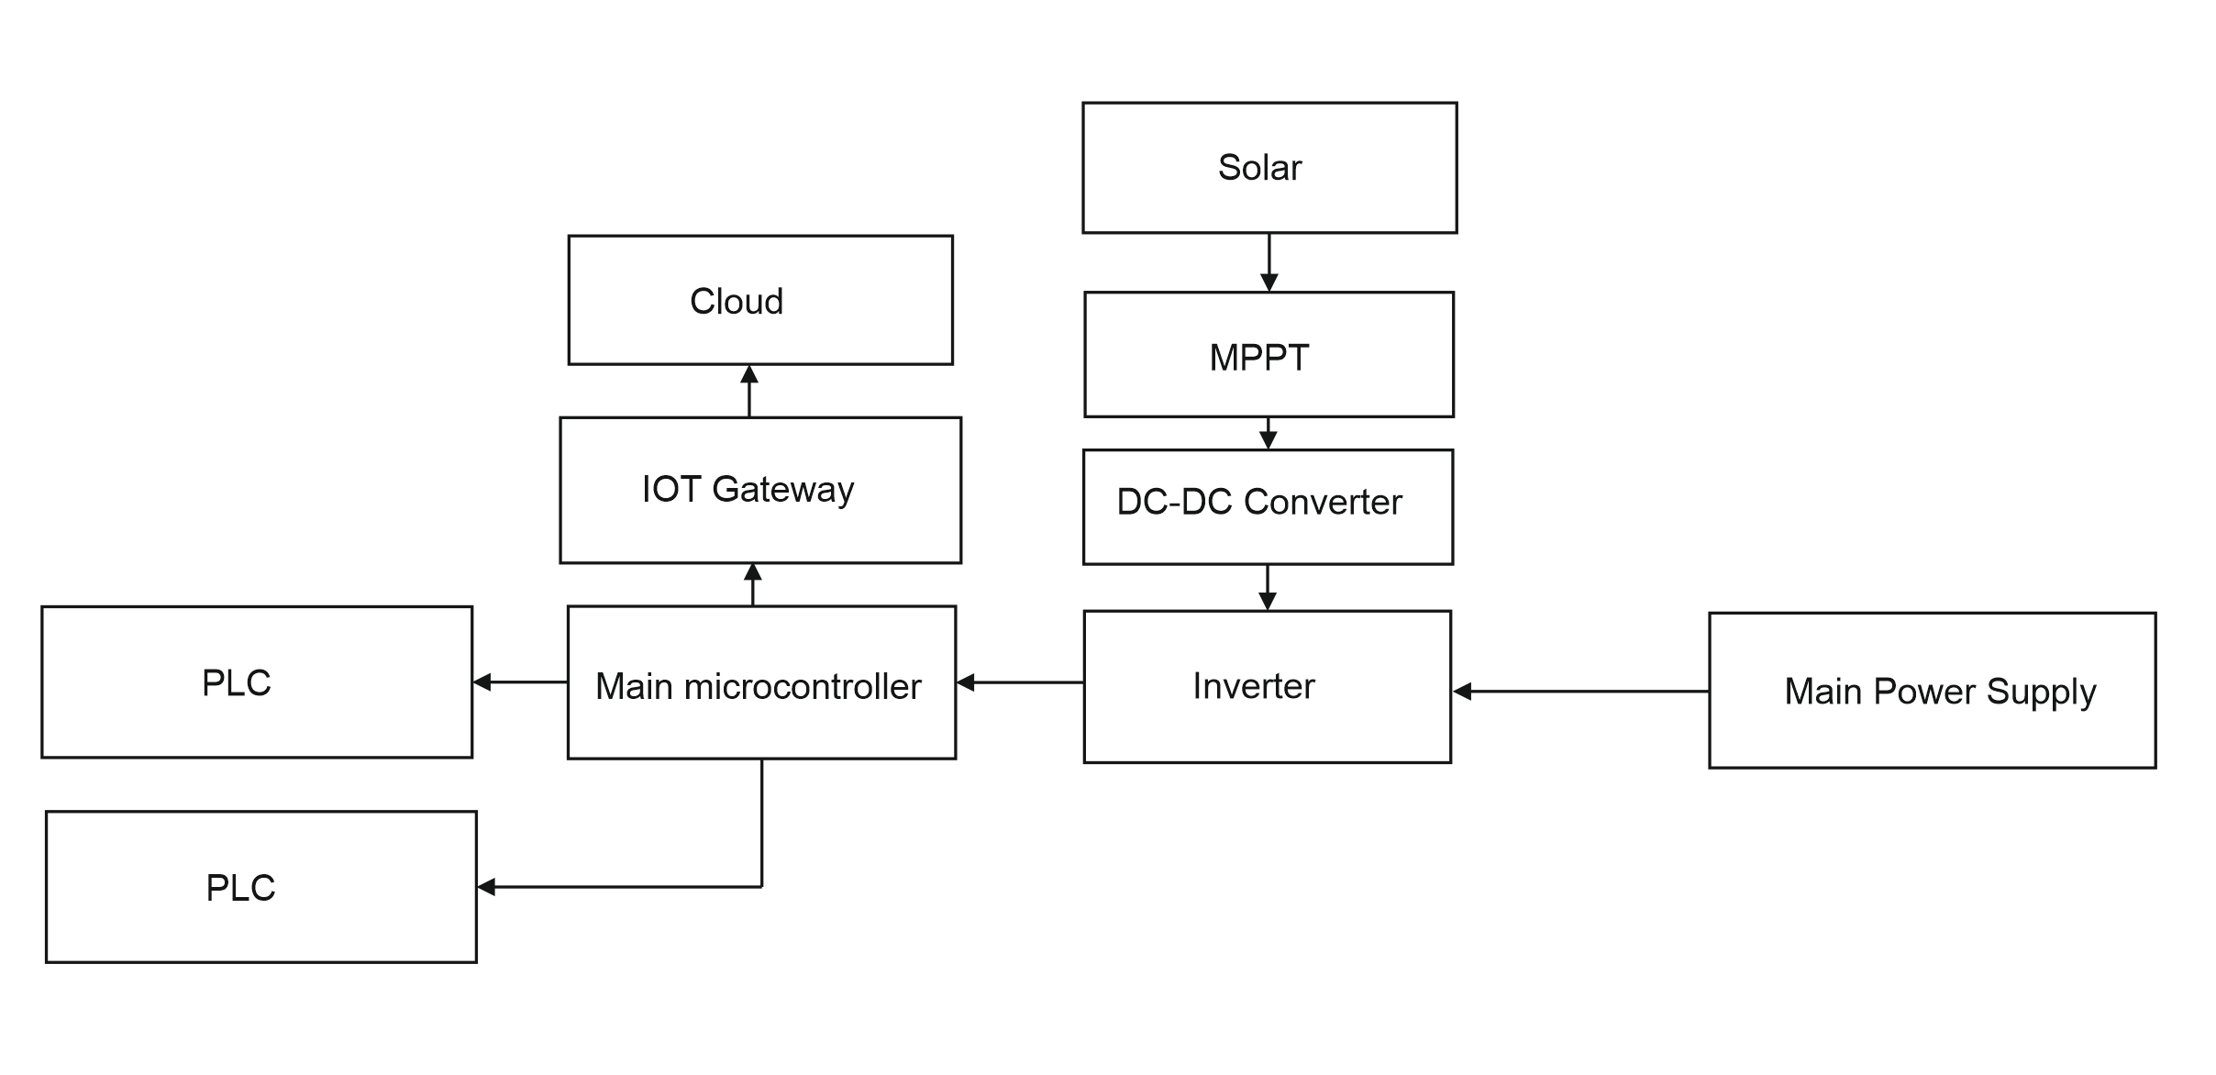

Figure 1-Hardware Block Diagram

The battery of the inverter is charged by a solar panel, which is connected to an MPPT. The MPPT makes use of maximum power point tracking algorithm to derive the maximum available electrical power from the solar panel. This power is fed to a charge controller, which in turn charges a lead acid battery. Alternatively, battery can be charged by rectifying the mains supply using a crossover switch.

The pure sine wave inverter uses battery power and converts DC to AC. The 220v 50Hz sinewave produced is fed to the household appliances as power source. In the main controller portion, an FSK signal is injected to the 220v 50Hz sinewave to facilitate powerline communication using the powerline modem. At the receiver end, this FSK signal is retrieved and demodulated to obtain the corresponding signal. This communication occur in half duplex mode using ALOHA algorithm. Any of the PLC module can start communication.

An IOT modem is connected to the main microcontroller which uses MQTT protocol with the help of thinger.io platform to enable telemetry and control of appliances. A mobile app is provided to the user, which enable him/her to control the appliances and view the status of devices remotely.

# SOFTWARE BLOCK DIAGRAM

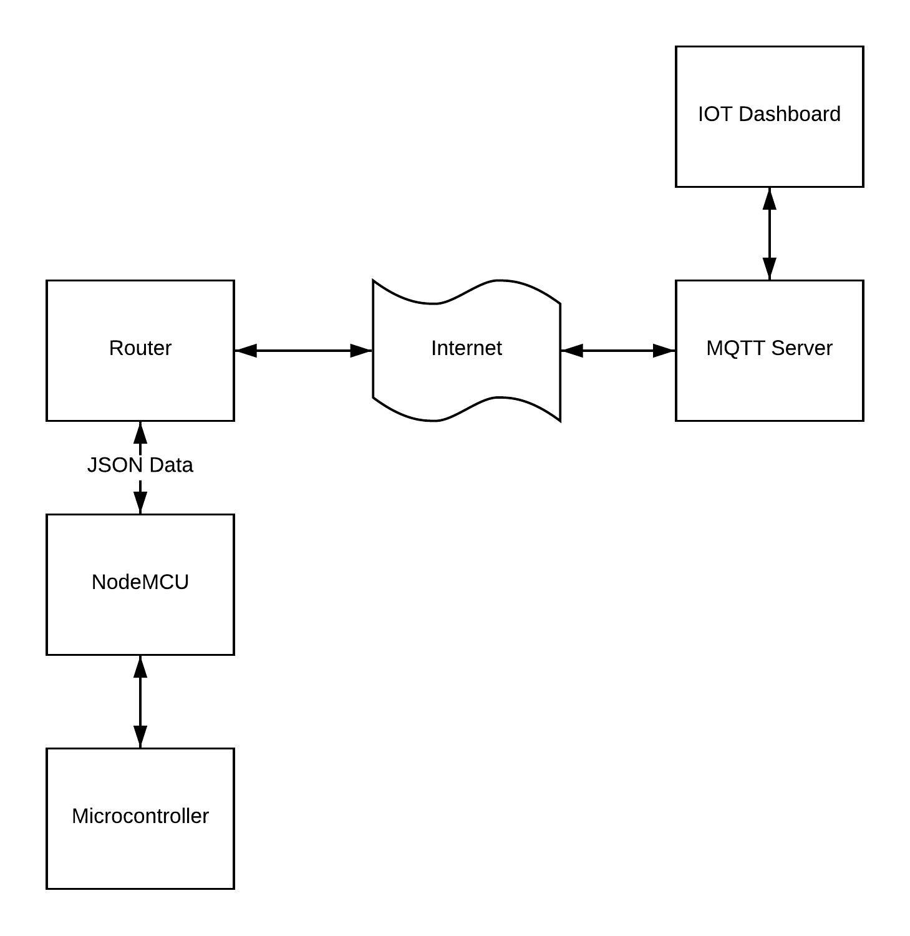

Figure 2-Software block diagram

The data from the microcontroller is sent to NodeMCU Wi-Fi module using the UART protocol. This data is sent to router using the JSON data format. An MQTT server is used to send this JSON data to the IOT Dashboard. The IOT Dashboard can also send this data to the mobile app so that the user can control and monitor appliances remotely.

# DEVELOPEMENT

The system consist of a base station, receiver node, inverter, and MPPT systems.

Base station is the main controller system which coordinates the communication of PLC to internet

Receiver node controls the appliances connected to it

Inverter produces pure sine wave from the battery

MPPT system ensure maximum power delivery from the solar panel

## MOSFET IRF540

RF540 is basically an N-Channel power Metal Oxide Silicon Field Effect Transistor (MOSFET) and operates in enhancement mode. Mosfet is a lot sensitive in comparison to an FET (Field Effect Transistor) due to its very high input impdence. IRF540 can perform very fast switching as compared to the normal transistor. If we need some switching application between different signals or to perform any of amplification process, MOSFET IRF540 will be the best option in this case because it can perform very fast switching as compared to the similar general transistors. It has a very wide range of applications in real life e.g. high power switching drivers for high speed, switching regulators, relay drivers, switching converters, motor drivers. Figure shows the image of IRF540.

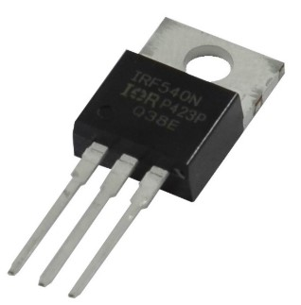

Figure 3-IRF540

## ACS712 Current Sensor

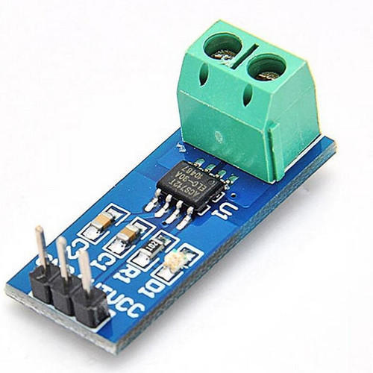

Figure 4-Current sensor module based on ACS712

It is a fully Integrated, Hall Effect-Based Linear Current Sensor with 2.1 kVRMS Voltage Isolation and a Low-Resistance Current Conductor.   Sensing and controlling current flow is a fundamental requirement in a wide variety of applications including, over-current protection circuits, battery chargers, switching mode power supplies, digital watt meters, programmable current sources, etc. This ACS721 current module is based on ACS712 sensor, which can accurately detect AC or DC current. The maximum AC or DC that can be detected can reach 30A, and the present current signal can be read via analog I / O port of Arduino

## Solar Panel

The process of converting light (photons) to electricity (voltage) is called the solar photovoltaic (PV) effect. Photovoltaic solar cells convert sunlight directly into solar power (electricity). They use thin layers of semi-conducting material that is charged differently between the top and bottom layers. The semi-conducting material can be encased between a sheet of glass and/or a polymer resin.

When exposed to daylight, electrons in the semi-conducting material absorb the photons, causing them to become highly energised. These move between the top and bottom surfaces of the semi-conducting material. This movement of electrons generates a current known as a direct current (DC). This is then fed through an inverter, which converts the power to alternating current (AC) for use in your home.

## PLC1672 Power Line Communication Module

Power line Modem is a communication module which sends data on the 230 Volt mains power lines. Power line communication module basically uses the existing power lines to transfer both AC power as well as data simultaneously. This form of communication is also known as power-line carrier, power-line digital subscriber line (PDSL), mains communication, power-line

telecommunications, or power-line networking (PLN). This module provides bi directional communication in half duplex mode i.e. it can either transmit or receive data at one time but cannot do both at the same time. If the module received data via power line it sends data via Tx pin to your controller and if it receives data serially via your microcontroller it switches to transmit mode and sends data via the power line. The communication is quite simple and any serial data at 9600 bps can be easily transmitted via power line. The interfacing is also quite simple just connect your controllers Tx line to Modules Rx line and the controllers Rx line to the Modules Tx line and you are ready to go. No need of any settings or anything just a simple plug and play module.

## ARDUINO

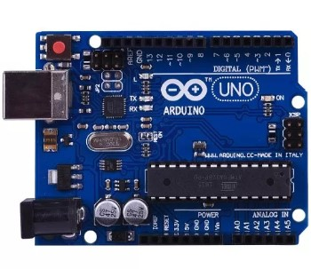

Figure 5-Arduino Uno

The Arduino UNO is an open-source microcontroller board based on the Microchip Atmega328P microcontroller and developed by Arduino.cc. The board is equipped with sets of digital and analog input/output (I/O) pins that may be interfaced to various expansion boards (shields) and other circuits. The board has 14 Digital pins, 6 Analog pins, and programmable with the Arduino IDE (Integrated Development Environment) via a type B USB cable. It can be powered by a USB cable or by an external 9 volt battery, though it accepts voltages between 7 and 20 volts. The Uno board and version 1.0 of Arduino Software (IDE) were the reference versions of Arduino, now evolved to newer releases. The Uno board is the first in a series of USB Arduino boards, and the reference model for the Arduino platform. The Atmega328 on the Arduino Uno comes preprogrammed with a bootloader that allows uploading new code to it without the use of an external hardware programmer. It communicates using the original STK500 protocol. The Uno also differs from all preceding boards in that it does not use the FTDI USB-to-serial driver chip. Instead, it uses the Atmega16U2 (Atmega8U2 up to version R2) programmed as a USB-to-serial converter.

## NodeMCU 1.0

**NodeMCU** is an open source IoT platform.It includes firmware which runs on the ESP8266 Wi-Fi SoC from Espressif Systems, and hardware which is based on the ESP-12 module. The term "NodeMCU" by default refers to the firmware rather than the development kits. The firmware uses the Lua scripting language. It is based on the eLua project and built on the Espressif Non-OS SDK for ESP8266.

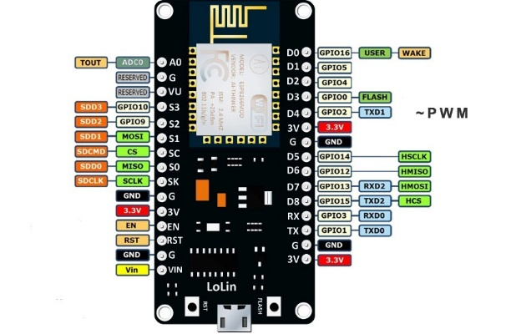

Figure 6-NodeMCU 1.0

The ESP8266 is a low-cost Wi-Fi microchip with full TCP/IP stack and microcontroller capability produced by manufacturer Espressif Systems[ in Shanghai, China.Processor: L106 32-bit [RISC](https://en.wikipedia.org/wiki/Reduced_instruction_set_computing) microprocessor core based on the [Tensilica](https://en.wikipedia.org/wiki/Tensilica) Xtensa Diamond Standard 106Micro running at 80 MHz

## MOSFET Driver TLP250

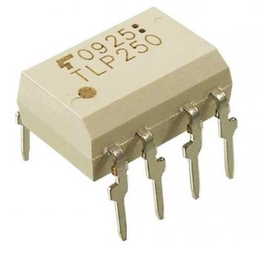

Figure 7-TLP250

The driver TL250 like other MOSFET drivers have input stage and output stage. It also have power supply configuration. TLP250 is more suitable for MOSFET and IGBT. Here, IRF540 Mosfet is uesd. The main difference between TLP250 and other MOSFET drivers is that TLP250 MOSFET driver is optically isolated. Its mean input and output of TLP250 mosfet driver is isolated from each other. Its works like a optocoupler. Input stage have a light emitting diode and output stage have photo diode. Whenever input stage LED light falls on output stage photo detector diode

# CONCLUSIONS

The IOT and PLC based home automation system was designed and working was verified. The Powerline Communication circuitry could be expanded beyond 2 devices by parallel connection with the phase and neutral wires.A solar panel was attached to the MPPT circuit and a battery was charged using the solar power. The system automatically cutoff charging when the battery is full and thus proper operation of charging circuitry was verified. The mobile app enhances the user experience by allowing the user to monitor the devices while on the move. This circuitry can be easily installed in a house after incorporating an overload protection, low voltage cut off and short circuit protection. This system could be easily connected to grid using a changeover switch, which can be electrically controlled. A two way meter could be incorporated in the future to facilitate energy trading based on advanced secure technologies like bitcoin.

Future collaboration and further development of this project is facilitated using GitHub, which is a version management system. The whole project is open source and publicly available in

https://github.com/mathewvarghesemanu/MainProject_IOT-PLC-inverter

## REFERENCES

1. Salman Salman, Xin Al, Zhouyang WU (2018) Design of a P-&-O algorithm based MPPT charge controller for a stand-alone 200W PV system
2. Akarte, Vivek & Punse, Nitin & Dhanorkar, Ankush. (2014). Power Line Communication Systems.
3. Rayyan Azam Khan , Liaquat Ali Khan , Farzan Majeed Noori , Zareena Kausar , and Aaqib Majeed(2016) Design and Simulation of a Sine Wave Inverter with PID Control for Nonlinear Load Applications ISSN 2351-8014 Vol. 26 No. 2 Sep. 2016
4. Kirti P.Shinde (2017) a low-cost home automation system based on power-line communication links ISSN: 2320-2882
5. Kodali, Ravi & Jain, Vishal & Bose, Suvadeep & Boppana, Lakshmi. (2016). IoT based smart security and home automation system. 1286-1289. 10.1109/CCAA.2016.7813916.
6. Shumin Ding, Faqiang Wang, New Negative output buck-boost converter with wide conversion ratio, IEEE transactions on industrial electronics
7. Deep Cycle Battery FAQ. (2009). Retrieved October 15, 2010, from Northern Arizona Wind and Sun: http://www.windsun.com/Batteries/Battery_FAQ.htm#Battery%20Voltages
8. Doucet, J. D. (2007). DC/AC Pure Sine Wave Inverter. Worcester, MA: Worcester Polytechnic Institute.