LI-FI BASED TOLL COLLECTION SYSTEM

*Project Report*

*Submitted by*

USHA NAIR

MAANASY RANJITH

APARNA VC

SHILPA SHILAJAN

*In partial fulfillment for the award of the Degree of*

BACHELOR OF TECHNOLOGY

IN

ELECTRONICS AND COMMUNICATION ENGINEERING

#### Department Of ELECTRONICS AND COMMUNICATION ENGINEERING

#### Mar Athanasius College of Engineering

#### Kothamangalam, KERALA, INDIA 686666

#### *Affiliated to*

**APJ Abdul Kalam Kerala Technological University**

**Thiruvananthapuram, Kerala, India**

**May 2019**

LI-FI BASED TOLL COLLECTION SYSTEM

*Project Report*

*Submitted by*

USHA NAIR

MAANASY RANJITH

APARNA VC

SHILPA SHILAJAN

*In partial fulfillment for the award of the Degree of*

BACHELOR OF TECHNOLOGY

IN

ELECTRONICS AND COMMUNICATION ENGINEERING

**Department Of ELECTRONICS AND COMMUNICATION ENGINEERING**

#### Mar Athanasius College of Engineering

#### Kothamangalam, KERALA, INDIA 686666

#### *Affiliated to*

**APJ Abdul Kalam Kerala Technological University**

**Thiruvananthapuram, Kerala, India**

**May 2019**

Department of ELECTRONICS AND COMMUNICATION ENGINEERING

#### Mar Athanasius College of Engineering

Kothamangalam

CERTIFICATE

## *This is to certify that the project report entitled*

LI-FI BASED TOLL COLLECTION SYSTEM

## *Submitted by Ms. Usha Nair (Reg. No.MAC15EC123), Ms. Aparna VC (Reg. No.MAC15EC000), Ms. Maanasy Ranjith (Reg. No.MAC15EC075) and Ms. Shilpa Shilajan (Reg. No.MAC15EC116) towards partial fulfillment of the requirements for the award of Degree of Bachelor of technology in Electronics and Communication Engineering is a bonafide record of the work carried out by them under our supervision and guidance.*

**Dr. SIDDHARTH SHELLY Prof. ATHIRA PRASAD Prof. BABU P K**

**Project Guide Project Coordinator HOD**

***Date:*** ***(Office Seal)***

Font:-Times New Roman Size :- 12

Italics Letters

***Place:***

ACKNOWLEDGEMENT

First and foremost, we sincerely thank the ‘God Almighty’ for his grace for the successful and timely completion of the project.

We express our sincere gratitude and thanks to Dr. Solly George, our Principal and Prof. Babu P Kuriakose, Head of the Department, Electronics and Communication Engineering, for providing the facilities and all the encouragement and support.

Finally, we would like to acknowledge the heartfelt efforts, comments, criticisms, co-operation and tremendous support given to us by our dear friends during the preparation of the project and also during the presentation without whose support this work would have been all the more difficult to accomplish*.*

**ABSTRACT**

Li-Fi is a wireless optical networking technology that uses light-emitting diodes (LEDs) for data transmission. Li-Fi stands for Light-Fidelity which involves transmission of data using visible light by sending data through an LED light bulb that varies in intensity faster than the human eye can follow. If the LED is on, the photo detector registers a binary one; otherwise it’s a binary zero. Li-Fi is designed to use LED light bulbs similar to those currently in use in many energy-conscious homes and offices. Currently, Li-Fi bulbs are outfitted with a chip that modulates the light imperceptibly for optical data transmission. Li-Fi data is transmitted by the LED bulbs and received by photoreceptors. Proposed system uses Li-fi technology to improvise the conventional toll automation systems. Toll automation uses Li-Fi for communication between vehicles and the toll booth. There will be data transmitting LED array connected at the bottom of the vehicles. The data is read from a photoreceptor which is placed on the platform. The data which is a unique id is passed (to the internet) using IoT to a pre-registered database which is used to find the account details, vehicle info and owner details. After deduction, the balance is conveyed to the user through sms. After getting a confirmation from the server, the gates are opened for the vehicle to pass.

CONTENTS

**LIST OF FIGURES** **………...………………………………………......…v**

**LIST OF ABBREVIATIONS............…………….…….………………...vi**

1. **CHAPTER 1………….................................................................................1**
   1. **Introduction……………………………………………………......1**
2. **CHAPTER 2.................................................................................................4**
   1. **Visible Light Communication………………………………….....4**
      1. **History……………………………………………………….....5**
   2. **Overview…………………………………………………………...5**
   3. **Introduction to Li-Fi Technology…………....…………………...6**
      1. **Advantages of Li-Fi Technology………………………….......9**
3. **CHAPTER 3 ….........……….......................................................................10**
   1. **Working Principle…………………………………………..…....10**
   2. **Light Fidelity....…….………………....…………………………..11**
      1. **Li-Fi Network Topologies…………………...……………...12**
      2. **Li-Fi Protocol Stack…………………..…………………..…..12**
      3. **Li-Fi Physical Layer………………………….……………...13**
      4. **Li-Fi MAC Layer…………………………….………………16**
      5. **Li-Fi Modulation Types....………....…….…….…………….17**
4. **CHAPTER 4 ………...........…………….…………………...…………......21**
   1. **Introduction to STM32 (BLUE PILL) Boards…........................21**
      1. **STM32F103C8T6 Specifications……..…………..…………22**
      2. **STM32 Pin Details…………..………..……………………...23**
   2. **Raspberry Pi Zero W………………………………………....….25**
   3. **Additional Components………………...………………….…….29**
      1. **Light Emitting Diodes……...………………………………..29**
      2. **Photo diode………….......…...…………………………….....30**
      3. **DC Motor…......….…………………………………………...30**
5. **CONCLUSION AND FUTURE Scope…..........…..…………...……..33**
6. **REFERENCES……...……….…………………..............………………………35**

LIST OF FIGURES

Figure 2.1: Electromagnetic Spectrum ……………………………………...4

Figure 2.2: Li-Fi access Points………………………………………….........7

Figure 3.1: Li-Fi Network Topologies……………………………...………12

Figure 3.2: Li-Fi protocol Stack Layer…………………………….……….13

Figure 3.3: Li-Fi Physical Layers (PHY-I Type)…………………..............14

Figure 3.4: Li-Fi Physical Layer (PHY-II Type)……………………...…...15

Figure 3.5: Li-Fi Physical Layer (PHY-III Type)…...………….………….15

Figure 3.6: PPDU Frame Structure…………………………….…………...15

Figure 3.7: Li-Fi MAC Frame (MSDU structure)………………..……...…17

Figure 3.8: OOK Modulation……………………………………….…...….18

Figure 3.9: VPPM Modulation……………………………………….....…...18

Figure 3.10: CSK Modulation………………………………………….....…..19

Figure 4.1: Block Diagram………………………………………………….24

Figure 4.2: Circuit Diagram…………………………………………...……31

LIST OF ABBREVIATIONS

LI-FI -- LIGHT FIDELITY

WI-FI -- WIRELESS FIDELITY

VLC -- VISIBLE LIGHT COMMUNICATION

LED -- LIGHT EMITTING DIODE

VPAN -- VIRTUAL PRIVATE AD HOC NETWORKS

PHY- -- PHYSICAL

MAC- -- MEDIUM ACCESS CONTROL

SAP- -- SYSTEMS, APPLICATIONS, PRODUCTS

GPIO -- GENERAL PURPOSE INPUT/OUTPUT

MCU -- ­­MICROCONTROLLER UNIT

STM -- ST MICROELECTRONICS

PWM -- PULSE WIDTH MODULATION

LQFP -- LOW PROFILE QUAD FLAT PACKAGE

# **CHAPTER 1**

**INTRODUCTION**

Li-Fi or light fidelity is the space-age technological innovation which refers to the visible light communication era. The visible light communication (VLC) systems make use of light emitting diodes as a medium to high speed communication in a similar manner as wireless-fidelity (Wi-Fi). Li-Fi is a new way to establish wireless communication links using the LED lighting networks. The Li-Fi protocols are defined by the international standard IEEE 802.15 established since 2011 by the IEEE comity. For numerous specialists, Li-Fi is a major breakthrough technology for the mobile Internet community and for the connected objects domain. Li-Fi is transmission of data using visible light by sending data through an LED light bulb that varies in intensity faster than the human eye can follow. If the LED is on, the photo detector registers a binary one; otherwise it’s a binary zero. The idea of Li-Fi was introduced by a German physicist, Harald Hass, which he also referred to as “data through illumination”. According to Hass, the light, which he referred to as D Light, can be used to produce data rates higher than 10 Megabits per second which is much faster than our average broadband connection. The paper discusses the implementation of Li-Fi based toll collection system which uses Li-fi technology to improvise the conventional toll automation systems. Toll automation uses Li-Fi for communication between vehicles and toll booth. There will be data transmitting LED array connected in the bottom of the vehicles. The data is read from a photoreceptor which is placed on the platform. The data which is a unique id passed to the internet using IoT to a pre-registered database which is used to find the account details, vehicle info and owner details. After deduction, the balance is displayed to the user as sms. After getting a confirmation from the server the gates are opened. The proposed system consists of the following sections:

1. Data reading and conversion module (ARM STM32 BOARD)
2. Light emitting diode (transmission)
3. Photo detector (reception)
4. Data connectivity and IoT application (Raspberry Pi)
5. User interface module (Web application)

It is more secure and achieves high data rates as compared to conventional wireless technologies like Wi-Fi, Bluetooth, Wi-max, etc. which use radio waves for Communication. Reliability and network coverage are the major issues to be considered by the companies while providing VLC services. Interferences from external light sources like sunlight, normal bulbs, and opaque materials in the path of transmission, lack of line of sight between the sender and the receiver are some major concerns during the implementation of Li-Fi based systems. High installation costs of the VLC systems can be complemented by large-scale implementation of VLC.

Adopting VLC technology will reduce further operating costs like electricity charges, maintenance charges, etc. Li-Fi relies heavily on special LED light bulbs for data transmission; hence the market availability of these Li-Fi compliant LED bulbs is extremely important. In addition, the usability of these LED bulbs with current home electric wiring is another catalyst. The manufacturing and retail costs of LED are major factor for Internet Service Providers and customers wishing to switch from Wi-Fi to Li-Fi respectively. Li-Fi may be implemented as a complementary technology to the existing wireless networks. It is expected to penetrate M2M communication, smart cities, power over Ethernet (PoE), wireless sensor networks, ubiquitous networks, augmented reality etc. Li-Fi technology can perform a critical role in providing super -fast home broadband speed that will allow higher bandwidth data communication on different platforms at the same time. In future one can use micro LEDs for data transmission which flickers at a much higher rate than ordinary LEDs and in turn provides higher speed. A cluster of LEDs can be used for parallel data transmission. LEDs of different colours such as red, green and blue can be used to enhance the transmission rate.

**CHAPTER 2**

Li-Fi technology is based on Visible Light Communication (VLC) technology. VLC is one of the advanced optical wireless communication technologies in which light in the visible region (375nm-780nm) is used as a medium for data transmission. This section of the paper discusses the so called Visible Light Communication and a fruitful application of it on which this paper is based, Li-Fi.

**2.1 VISIBLE LIGHT COMMUNICATION**

Visible Light Communication [1] is a communication method where visible light within a particular frequency range is used as the medium of communication. The visible light frequency range for VLC is from [400](tel:400) to [800](tel:800) THz.



Fig 2.1 Electromagnetic Spectrum

VLC (Visible Light Communication) operates under the concept of transmission of data via light rays to send and receive messages in a given distance. Putting into use LED lighting; VLC can be used as a replacement for radio frequencies in areas where it cannot be applied. In addition, VLC has the upper hand over radio frequencies as it offers ultra-fast data transmission and also high bandwidth transmission. This has been most evident in traffic lighting, besides other sectors.  
  
**2.1.1 HISTORY OF VISIBLE LIGHT COMMUNICATION**

The concept of VLC dates back as early as [1880](tel:1880). This was first put into use by Alexander Graham Bell, a Washington D.C resident when he invented the photo-phone. The method relayed speech over long distances via modulated sunlight. However, back then the idea was not applied much as it was centuries ahead of its time. Due to this, the technology paved way for slower communication media thus was never a big hit.

**2.2 OVERVIEW**

Given that light travels [186](tel:186),[000](tel:000) miles in a second, communication via this source is virtually instantaneous. This makes VLC the fastest means of communication between all means available in the market. To function, VLC uses visible light between [780](tel:780) to [375](tel:375) nm which are visible to the human eye. Every form of data can be broken down into single units of ones and zeroes that can be deciphered as low or high signals. In VLC, this is achieved by fast turning of light on and off (also called on-off keying, OOK). However, this form of data transmission is dependent on how fast the light can go on and off. To achieve great results, LED lighting is well suited for the task as it has a short rise and fall time thus faster switching. Due to this, LED lighting is used in all wireless forms of VLC.  
  
To function, VLC requires a receiver (photo detector), a transmitter (LED) and a channel of communication. In addition, the circuit features a photodiode, trans-impedance amplifiers, auto gain controllers, high pass filters and in some cases analog-digital converters. From the source of the signal, an enhanced photodiode is fitted so as to convert light into a current. At the source and recipient of the instructions, a digital unit is fitted so as to encode and decode the instructions relayed accordingly. In most of the conventional systems, in order to increase the speed and the gain of the photodiode, a trans-impedance amplifier is used to make the process faster. Additionally, an automatic gain control is featured thus boosting speeds for messages between the sender and the receiver.

Once the message is relayed, the photodiode on the other end breaks the current into a voltage that can be interpreted by the computer as a unit of ones and zeros, hence achieving a targeted result. So as to prevent disturbance from surrounding light sources, a high pass filter is used in the model. However, this forms a passive set of both the trans-impedance amplifier and the auto gain controllers are both gainers and hence no more gain was required. With this, the set is completed and thus messages are delivered instantly without any external disturbances.

**2.3 INTRODUCTION TO LI-FI TECHNOLOGY**

Li-Fi is high speed bidirectional networked and mobile communication of data using light. Radio frequency communication requires radio circuits, antennas and complex receivers, whereas Li-Fi is much simpler and uses direct modulation methods similar to those used in low-cost infrared communications devices such as remote control units. Li-Fi comprises of multiple light bulbs that form a wireless network. When an electrical current is applied to a LED light bulb, a stream of light (photons) is emitted from the bulb. LED bulbs are semiconductor devices, which mean that the brightness of the light flowing through them can be changed at extremely high speeds. This allows us to send a signal by modulating the light at different rates. The LED [1] [2] lights used to transmit Li-Fi signals are modulated at such a fast rate that the eye cannot perceive the modulation or “flicker”. As a comparison, the lowest frequency at which the lights are modulated is 1MHz and this is 10,[000](tel:000) times higher than the refresh rate of our computer screens [9]. The signal can then be received by a detector which interprets the changes in light intensity (the signal) as data.

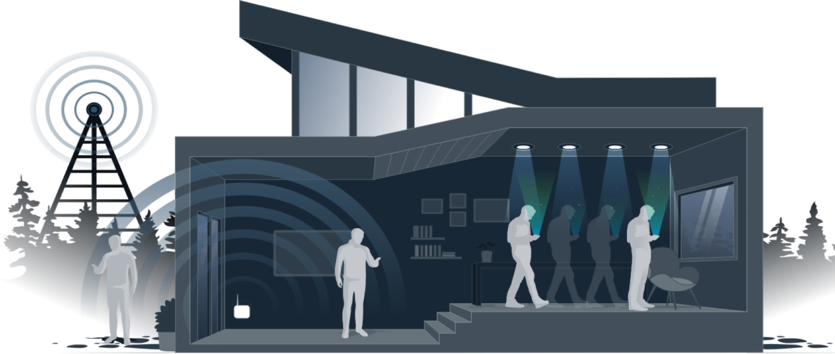

Fig 2.2 Li-Fi Access Points

The intensity modulation cannot be seen by the human eye, and thus communication is just as seamless as other radio systems, allowing the users to be connected where there is Li-Fi enabled light. Using this technique, data can be transmitted from a LED light bulb at high speeds. LED is more advantageous than the existing incandescent in terms of long life expectancy, high tolerance to humidity, low power consumption, and minimal heat generation lighting. The Ministry of International Trade and Industry of Japan estimates, if LED replaces half of all incandescent and fluorescent lamps currently in use, Japan could save equivalent output of six mid-size power plants, and reduce the production of greenhouse gases. LED is not only used as a lighting device, but also to be used as a communication device. It is a kind of optical wireless communication that uses the “visible” white ray as the medium. This dual function of LED, for lighting and communication emerges many new and interesting applications.

Li-Fi can operate in daylight and even in direct sunlight conditions, as the modulated light can still be detected. Li-Fi relies on detecting the fast changes in light intensity and not on the absolute or slowly varying levels caused by natural disruptions in daylight or sunlight. Li-Fi technology modulates the light at very high rates and sunlight is constant light and therefore can be filtered out at the receiver.  
Now, if all power to a light is turned off then there is no Li-Fi. However, Li-Fi technology can be enabled to dim low enough that a room will appear dark and still transmit data. There is consistent performance between 10 and 90 percent illumination [5] [6]. There are also other options for using invisible parts of the light spectrum such as infra-red, which is currently already being used for sending information back to the light bulb (uplink).  
  
Li-Fi is a complimentary technology that works alongside other wireless technologies such as Wi-Fi. If the light signal to a Li-Fi enabled device is below the receiver’s threshold then it will not receive data. In that instance, radio systems or cellular networks, if available, will continue to deliver data. However, the moment the device begins to receive light from a Li-Fi light bulb; the device will resume high speed communications using light as an additional communications medium.

Li-Fi is significantly more secure than other wireless technologies because light can be contained in a physical space. Our doors and windows can be shut, and physical barriers and adjustments can be implemented to contain and protect the light. We can create the conditions that allow us to shut the door on our wireless data. It should be understood that the existing security protocols for encryption and authentication can be leveraged in Li-Fi systems to provide even more secure wireless systems.

**2.3.1 ADVANTAGES OF LI-FI TECHNOLOGY**

1. **Speed and bandwidth**: Li-Fi can deliver multiple Gbps speeds in mobile devices. This next generation technology will drive wireless beyond any current capability, opening up unprecedented bandwidth.
2. **Reliability**: Li-Fi provides enhanced reliability enabling interference-free communication and 1000 times the data density, dramatically improving the user experience.
3. **Low latency**: Li-Fi currently offers latency by a factor of three times lower than Wi-Fi and can radically enable innovation, automation, and applications such as AR and VR.
4. **Security**: Light can be contained, and secured in a physical space. Li-Fi enables additional control as Li-Fi offers precise localization for asset tracking and user authentication.
5. **Localisation**: Li-Fi is fully networked, and each Li-Fi enabled light has its unique IP address which means advanced geofencing can be deployed simply in a Li-Fi network.
6. **Interference Free**: RF is vulnerable to interference from a wide range of devices such as cordless phones, microwaves and neighboring Wi-Fi networks. Li-Fi signals can be defined by the area of illumination, which means interference is much simpler to avoid and even stop altogether. This also means Li-Fi can be used in RF hostile zones such as hospitals, power plants and airplanes [9].

Li-Fi is the optical wireless communication for data, audio and video streaming in LEDs, this type of new invention can be encouraged to produce a safe and green technology.

**CHAPTER 3**

The proposed project, LI-FI BASED TOLL COLLECTION SYSTEM uses Li-fi technology to improvise the conventional toll automation systems. Toll automation uses Li-Fi for communication between vehicles and toll booth. This paper focuses on faster data transmit at toll plaza by using Li-Fi module which will reduce the problems that arise in ETC.

**3.1 WORKING PRINCIPLE**

The Li-Fi mechanism is implemented in every vehicle (four wheelers) and at toll plaza. At the toll plaza, once the vehicle’s Li-Fi transmitter is paired with the Li-Fi receiver, the system at toll plaza automatically identifies the vehicle details. This paper is based on Li-Fi technology; the Li-Fi system uses Li-Fi which collects information of vehicle passing through the toll plaza and automatically debits the toll amount from prepaid account of vehicle owner, which in return reduces the traffic congestion and human errors. The vehicle owner has to register his vehicle with Li-Fi, creating a rechargeable account. There will be data transmitting LED array connected in the bottom of the vehicles. The data is read from a photoreceptor which is placed on the platform.

The data which is a unique id passed to the internet using IoT to a pre-registered database which is used to find the account details, vehicle info and owner details. After deduction, the balance is displayed to the user as sms. After getting a confirmation from the server the gates are opened. The proposed system consists of the following sections:

1. Data reading and conversion module (ARM STM32 BOARD)
2. Light emitting diode (transmission)
3. Photo detector (reception)
4. Data connectivity and IoT application (Raspberry Pi)
5. User interface module (Web application)

Li-Fi has the advantage of being able to be used in sensitive area such as in Aircraft and other transportation without causing interference. This OWC technology uses light from Light-Emitting Diodes (LEDs). The light received by photodiode is converted to binary data and is fed to the PC (Raspberry Pi) or the database. The Li-Fi receiver at toll booth updates the contents in the server and the database. Hence the vehicle detail gets stored and the fare amount (toll) gets deducted from the prepaid account of the user which is also notified to the user via SMS. This payment procedure is done the vehicle is free to move out of the toll plaza. Once the confirmation of payment is received, a signal is passed to the motor driver to open up the toll gates. All this happens within few seconds as Li-Fi is very fast in transmission. The basic advantages of the system is travelling time is decreased, congestion free network, less emissions in toll area and no infrastructure cost is required. This gives a win condition for both toll authorities and toll customers. The study of each section will be done in detail [8]

**3.2 LIGHT FIDELITY**

Li-Fi is the short form of "Light Fidelity". It works on the principle of Visible Light Communication (i.e. VLC) [1]. The network is also referred as VPAN or VLC Personal Area Network. The VLC standard or VPAN standard defines three classes of devices viz. infrastructure, mobile and vehicle. These devices operate in one of the three topologies mentioned below. The different device has different coverage range, data rate and other requirements.

**3.2.1 LI-FI NETWORK TOPOLOGIES**

It works in three modes as mentioned above in figure-1. In star topology, communication is established between central controller (i.e. coordinator) and devices. In peer to peer topology, one of the devices should become the coordinator at the time of establishing association. Each device or coordinator has unique 64 bit address. Device can use 16 bit address also upon request at the time of establishing association with coordinator.

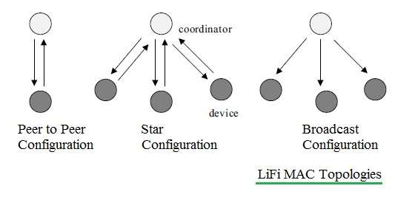

Fig 3.1 Li-Fi Network Topologies

**3.2.2 LI-FI PROTOCOL STACK**

Figure 3.2 depicts protocol stack used in a typical VPAN device. As shown, protocol stack consists of PHY (PHYSICAL), MAC and upper layers.   
Physical layer houses light transceiver. PHY switch housed in PHY layer interfaces with optical SAP which connects it to the optical medium. The optical medium is composed of one or multiple optical sources or optical detectors (e.g. laser diodes or photodiodes). MAC layer provides channel access for all types of data and control message transmissions. Upper layer consists of network layer and application layer. Network layer takes care of providing network configuration, network manipulation, message routing etc. Application layer takes care of providing intended functionality as needed by the VPAN or Li-Fi device. DME (Device Management Entity) is also supported by Li-Fi or VPAN network architecture. It makes interfacing between dimmer and PHY/MAC a reality.

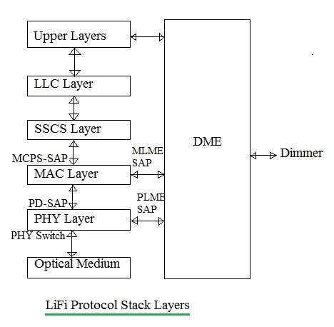

Fig 3.2 Li-Fi protocol Stack Layer

**3.2.3 LI-FI PHYSICAL LAYER**

There are three types of physical layer configurations supported in VLC or Li-Fi System namely PHY-I, PHY-II, PHY-III. Different rates can be achieved in different configurations. They can be used indoor or outdoor.

Following are the functions of Li-Fi Physical layer:

* Provide services to upper layer.
* Used to provide error correction at the receiver by using FEC techniques such as Convolution encoding and RS encoding.
* Used to activate and de-activate VLC transceiver.
* Provides WQI for all the received frames.
* Helps in synchronization at the receiver using preamble incorporated in the frame structure.
* Inserts header (PHR) at transmit end. This is decoded at receive end to determine length field of the PSDU.
* It is used for channel selection as per requirement.
* RLL (Run Length Limited) Encoding helps in correcting DC balance, clock recovery and flicker mitigation.

There are different Li-Fi physical layers based on different data rate and application of use such as indoor or outdoor. [4]

* Li-Fi PHY-I version is developed to meet low data rate requirement from 12 to [267](tel:267) Kbps. It is ideally used for outdoor application.

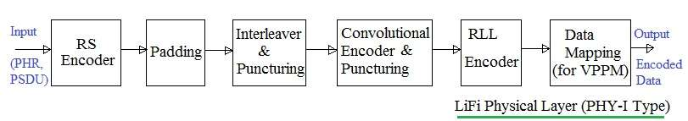

Fig 3.3 Li-Fi Physical Layer (PHY-I Type)

* Li-Fi PHY-II version is developed to meet moderate data rate requirement from [1.25](tel:1.25)Mbps to 96 Mbps. It is ideally used for indoor application.

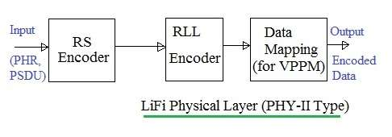

Fig 3.4 Li-Fi Physical Layer (PHY-II Type)

* Li-Fi PHY-III version is developed to meet data rate requirement of 12 Mbps to 96 Mbps. It is used in the systems where colour source based on RGB and detectors are widely employed.

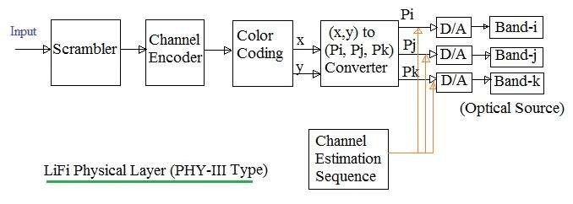

Fig 3.5 Li-Fi Physical Layer (PHY-III Type)

Li-Fi system uses PHY frame consisting of preamble, PHY header and PSDU. Multiple octets are transmitted where least significant octet is transmitted first and in each octet least significant bit first.

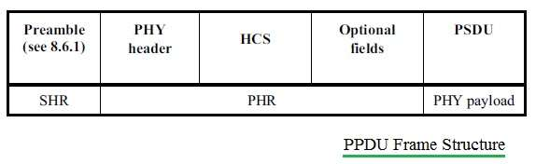

Fig 3.6 PPDU Frame Structure

* **Preamble**: It is used by the transceiver to perform optical clock synchronization.   
  Preamble = {FLP (64 to [16384](tel:16384) bits), TDP (15 bits each), ~TDP, TDP, ~TDP}   
  FLP (Fast Locking Pattern) consists of alternate one and zeros. Four TDPs (Topology Dependent Patterns) distinguish PHY modes used. Every alternate TDP pattern is inverted to achieve DC balance in the Li-Fi Physical layer.
* **PHY Header**: It is transmitted along with OOK modulation type. It carry burst mode, channel number, MCS ID (defines PHY type (PHY-I, II or III) and data rate), PSDU length etc.
* **HCS**: It is 16 bit in size. It is used to protect PHY header in Li-Fi Physical layer. There are optional fields in the frame used in PHY-I mode at clock rate of [200](tel:200) KHz.
* **PSDU Field**: This field has variable length. It carries data of PHY frame.   
  PSDU: {MHR, MAC Payload i.e. MSDU, FCS, Tail Bits},

**3.2.4 LI-FI MAC LAYER**

MAC layer takes care of resource management i.e. allocation of channels, IDs as well as entire network management. The Li-Fi standard uses following MAC modes for transmission of data and management frames:

• **Single mode**: In this mode, frames carry one PPDU per frame. It is used for short data communication e.g. ACK, Association, Beacon etc.   
• **Packed mode**: In this mode, frame carry multiple PPDUs destined for same destination. This mode improves the efficiency of MAC layer as it eliminates repetitive PHY and MAC headers for the same destination.   
• **Burst mode**: In this mode, frame uses PHY preamble with reduced length after the 1st frame. Moreover it uses RIFS instead of SIFS. Hence this mode increases efficiency and also improves the throughput.   
• **Dimmed OOK mode**: It is used for data transfer in dimming applications

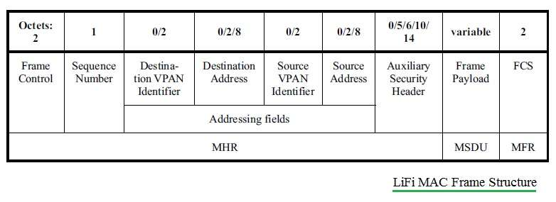  
Fig 3.7 Li-Fi MAC Frame (MSDU structure)

Li-Fi MAC frame consists of MHR, MSDU and MFR. Frame control field carried in MHR is of size 2 octets. It is composed of frame type, addressing fields, control flags.  
The MAC frame type is 3 bits long. It is used to differentiate different frame types e.g. Beacon, Data, Acknowledgment, Command, CVD etc. Source and destination addresses are 16 bit or 64 bit long in size.

**3.2.5 LI-FI MODULATION TYPES**

There are different modulation schemes used in different physical layer modes.

1. **OOK (On-Off Keying modulation)**

In this modulation, data is represented by on and off of the LED. In simple terms, light 'ON state' represents logic '1' and light 'OFF state' represents logic '0'. In Li-Fi standard, OOK uses Manchester codes to represent digital information in the form of 1's and 0's. Here encoding is done using edge transition concept where in low to high represent logic '1' and high to low transition represent logic '0'. OOK modulation technique under dimming helps to achieve variable data rate and constant range. This is achieved using insertion of compensation time.

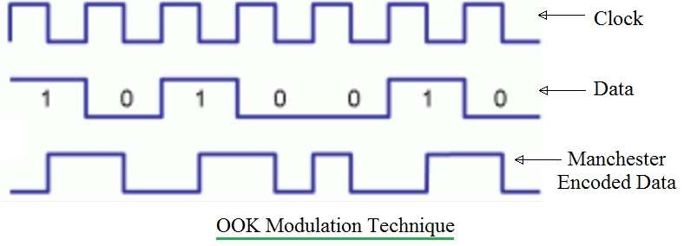

Fig 3.8 OOK Modulation

1. **VPPM (Variable Pulse Position Modulation)**

This modulation technique is similar to PPM technique but here pulse width is variable for light dimming control application. VPPM modulation technique under dimming helps to achieve variable range and constant data rate. This is achieved by adjusting pulse width. The advantage of this modulation type is that it protects from intra frame flicker. This is due to the fact that pulse amplitude is held constant and dimming is controlled by variable is pulse width.

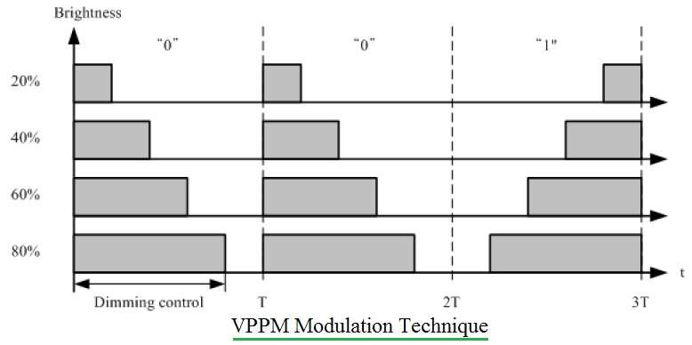  
Fig 3.9 VPPM Modulation

* Logic '0' is mapped using positive pulse at the beginning of period followed with negative pulse.
* Logic '1' is mapped using negative pulse at the beginning of period followed with positive pulse.

For VPPM modulation to be efficient, the duration of period which contains pulses should be long enough so that pulse positions can be distinguished.

1. **CSK (Colour Shift Keying modulation)**

The CSK modulation scheme is used to represent information bits in the form of different colour wavelengths. Red LED, Green LED and Blue LED are used at the transmit end to produce different colours of different wavelengths to code the information bits. The diagram maps various wavelengths marked in 'blue' with its colour counterparts.

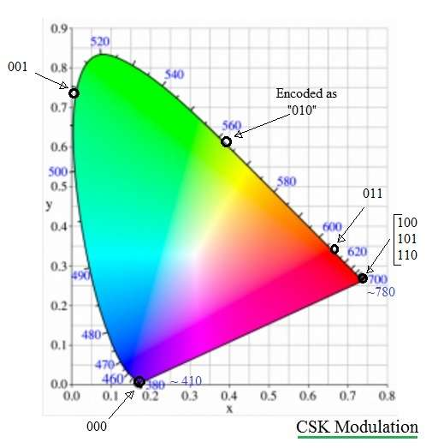  
Fig 3.10 CSK Modulation

**Advantages and Disadvantages of CSK**

The CSK modulation requires complex design at the transmit and receive end of optical system. This is the only disadvantage of CSK modulation. Inspite of this, the CSK modulation has following advantages due to which it has become very popular.

• Colour co-ordinates are used to represent information and the same is represented in the form of binary codes for simplicity in programming.   
• As information is represented by colour of light, amplitude is kept constant and hence total average power of light sources will be kept constant.   
• CSK helps achieve variable high bit rate due to higher order modulation support such as 4-CSK, 8-CSK and 16-CSK.

**CHAPTER 4**

The chapter discusses the different sections of the proposed project, projects a detailed block layout and circuit layout of the project. The proposed system consists of the following sections:

1. Data reading and conversion module (ARM STM32 BOARD)
2. Light emitting diode (transmission)
3. Photo detector (reception)
4. Data connectivity and IoT application (Raspberry Pi)
5. User interface module (Web application)

**4.1 INTRODUCTION TO THE STM32 (BLUE PILL) BOARDS**

The STM32 board a.k.a Blue Pill is a Development board for the ARM Cortex M3 Microcontroller. It looks very much similar to the Arduino Nano but it packs in quite a punch. These boards are extremely cheap compared to the official Arduino boards and also the hardware is open source. The microcontroller on top of it is the STM32F[103](tel:103)C8T6 from STMicroelectronics. Apart from the Microcontroller, the board also holds two crystal oscillators, one is an 8MHz crystal, and the other is a 32 KHz crystal, which can be used to drive the internal RTC (Real Time Clock). Because of this, the MCU can operate in deep sleep modes making it ideal for battery operated applications.

Since the MCU works with [3.3](tel:3.3)V, the board also houses a 5V to [3.3](tel:3.3)V voltage regulators IC to power the MCU. Even though the MCU operates at [3.3](tel:3.3)V most of its GPIO pins are 5V tolerant. The pin of the MCU are neatly pulled out and labelled as header pins. There are also two on-board LEDs, one (red colour) is used for power indication, and the other (green colour) is connected to the GPIO pin PC13. It also has two header pins which can be used to toggle the MCU boot mode between programming mode and operating mode.

**4.1.1 STM32F**[**103**](tel:103)**C8T6 SPECIFICATIONS**

The ARM Cortex M3 STM32F[103](tel:103)C8 Microcontroller is used in the Blue pill board. Unlike the name, “Blue Pill” the Microcontrollers name STM32F[103](tel:103)C8T6 has a meaning behind it.

* STM -stands for the manufacturers name STMicroelectronics
* 32 -stands for 32-bit ARM architecture
* F[103](tel:103)- stands to indicate that the architecture ARM Cortex M3
* C- 48-pin
* 8- 64KB Flash memory
* T- package type is LQFP
* 6-operating temperature -40°C to +85°C.

The specifications of this Microcontroller are as follows:

* Architecture: 32-bit ARM Cortex M3
* Operating Voltage: [2.7](tel:2.7)V to [3.6](tel:3.6)V
* CPU Frequency: 72 MHz
* Number of GPIO pins: 37
* Number of PWM pins: 12
* Analog input Pins: 10 (12-bit)
* USART Peripherals: 3
* I2C Peripherals: 2
* SPI Peripherals: 2
* CAN [2.0](tel:2.0) Peripheral: 1
* Timers: 3(16-bit), 1 (PWM)
* Flash Memory: 64KB
* RAM: 20Kb

**4.1.2 STM32 PIN DETAILS**

The complete pin-outs of the STM32 Blue pill board is shown below. That is the G is used to denote the ground pin, [3.3](tel:3.3)V outputs a regulated [3.3](tel:3.3)V and the 5V pin can either be used to power the board or obtain the +5V if powered via micro USB. The on-board LED is connected to the PC13 pin of the Microcontroller. Unlike Arduino boards, the STM32 development board has to be manually set to programming mode using the boot 1 and boot 0 jumper wires. The position of Boot 1 is normally not disturbed. But the boot 0 jumper has to be set as [3.3](tel:3.3)V for programming mode and set to ground for operating mode.

**Programming STM32F**[**103**](tel:103)**C8T6 STM32 Blue Pill Board [7]**

The STM32 is just another microcontroller form the STMicroelectronics family. So, all the existing methods to program an ARM chip can be used for the STM32 board as well. One famous and commonly used IDE is the Keil ARM MDK and apart from that we can also use IAR workbench, Atollic TrueStudio, MicroC Pro ARM, Crossworks ARM, Ride 7, PlatformIO+STM32 etc. The A9 is the Transmitter pin of STM32 MCU and the A10 is Receiver pin. The STM32 Blue Pill development board when purchased does not come with a bootloader to make it Arduino IDE compatible. However, this bootloader can be flashed into the STM32 board and then the micro-USB port can be directly used to upload the programs. The STM32 Board has to be put into programming mode before uploading any program; to do this put the boot 0 jumper in the lower position. Now, to upload the program make sure the boot 0 jumper is in programming mode as shown above and then press the Reset button. As soon as you press the reset button the board will enter into programming mode and the green LED will be turned off, this indicates that the board is ready for upload. Press the upload button on the Arduino IDE and your program should get compiled and uploaded. After uploading the program the boot 0 should be changed back to operating mode so that next time when the Board is powered the uploaded program starts to get executed automatically.

PIC16F876A

LEDS

Photo diode

Raspberry

pi

MQTT

Web

Application

Dc motor

Motor driver

ARM STM 32

SERVO MOTOR

Fig 4.1 Block Diagram

**4.2 RASPBERRY PI ZERO W**

The Raspberry Pi is a popular Single Board Computer (SBC) in that it is a full computer packed into a single board. Raspberry Pi Zero W is ideal for making embedded Internet of Things (IoT) projects. The Pi Zero W has been designed to be as flexible and compact as possible with mini connectors and an unpopulated 40-pin GPIO, allowing you to use only what your project requires. At the heart of the Raspberry Pi Zero W is a 1GHz BCM2835 single-core processor, the same as the B+ and A+, with 512MB RAM.

Consists of the following features:

* 1GHz, Single-core CPU
* 512MB RAM
* Mini HDMI and USB On-The-Go ports
* Micro USB power
* 40-pin header
* Composite video and reset headers
* CSI camera connector
* 802.11n wireless LAN
* Bluetooth 4.0

1. **Mini HDMI**

Unlike the previous models of the Raspberry Pi which use a standard HDMI connector, the Zero uses a mini HDMI connector to save space. To connect the Zero to a monitor or television, we use a mini HDMI to HDMI adapter or cable.

1. **USB On-the-Go**

The Raspberry Pi 3 and other models have traditionally had [2-4](tel:2-4) standard size female USB connectors, which allowed for all variety of devices to connect including mice, keyboards, and Wi-Fi dongles. Again to save space, the Zero has opted for a USB On-the-Go (OTG) connection. The Pi Zero uses the same Broadcom IC that powered the original Raspberry Pi A and A+ models. This IC connects directly to the USB port allowing for OTG functionality, unlike the Pi B, B+, 2 and 3 models, which use an on-board USB hub to allow for multiple USB connections. To connect a device with a standard male USB connection, we will need a USB OTG cable. Plug the micro USB end into the Pi Zero, and plug the USB device into the standard female USB end.

1. **Power**

Like other Pis, power is provided through a micro USB connector. Voltage supplied to the power USB should be in the range of [5-5.25](tel:5-5.25)V.

1. **Micro SD Card Slot**

Another familiar interface is the micro SD card slot where we insert our micro SD card that contains our Raspberry Pi image file.

1. **Wi-Fi and Bluetooth**

As with the Raspberry Pi 3, the Zero W offers both [802.11](tel:802.11)n wireless LAN and Bluetooth [4.0](tel:4.0) connectivity. This frees up many of the connections that would have been made over USB, such as a Wi-Fi dongle and a USB keyboard and mouse if substituting a Bluetooth keyboard/mouse.

1. **Camera Connector**

The Raspberry Pi Zero V[1.3](tel:1.3)+ and all Zero W’s have an on-board camera connector. This can be used to attach the Raspberry Pi Camera module. However, the connector is a 22pin [0.5](tel:0.5)mm and different than the standard Pi. We will need a different cable to connect the camera to the Pi Zero W.

1. **Hardware Assembly**

Depending on the use case, setup for the Pi Zero can be minimal, or it can be cumbersome due to smaller connectors on the Zero and the adapters needed to connect standard devices such as mice, keyboards, and monitors.

1. **Monitor**

To attach the Pi Zero to a Monitor or TV that has an HDMI input, attach a mini HDMI to HDMI cable or adapter to the mini HDMI connector on the Pi Zero. Connect the other end to the HDMI port on the monitor or television. Connect the USB OTG cable to the Pi Zero via the micro USB connector. If we have a keyboard/mouse, attach the dongle to the standard female USB end. If we have a separate mouse and keyboard, we will need a USB hub to attach both to the USB OTG cable. Make sure that we have a valid Raspberry Pi image on the micro SD card. Insert the micro SD card into the micro SD slot. Power Pi Zero via the micro USB power input.

The Pi Zero has a 40 pin GPIO connector on the board that matches the pinout of the standard Pi 3. We can solder wires, headers or Pi Hats to this connector to access the GPIO pins or even power. The camera connector will allow we to connect the Raspberry Pi camera although it is worth noting that the connector is a 22pin [0.5](tel:0.5) mm and different than the standard Pi and will need a different cable to connect the camera to the Pi.  
  
**Installing the OS**

When it comes to creating an image on an SD card for Pi Zero W, there are two options:   
Option 1: NOOBS

The Raspberry Pi foundation has created NOOBS (New out of the Box Software) which is easy to use and get we started. Most generic kits such as the Pi3 Starter Kit will come with a NOOBS micro SD card. Unfortunately as of the release of the Pi Zero Basic Kit the NOOBS image will need to be updated to work on the Pi Zero boards. If we don't have a current NOOBS image or just want to start again from scratch installing NOOBS is easy, we don't need any special software to install it on a card. Just download the image, unzip, drag and drop the files to the card, and we are good to go. Once we have NOOBS on the card, insert it in the board, apply power, and we should see action on the screen. Follow the prompts and install Raspbian (we may also want to select a different region for the keyboard and language). We can also go into the Wi-Fi screen and setup Wi-Fi. If we do we will get a lot more options for images to install.  
  
Option 2: image File

If we want something other than the basic Raspbian install or other options found on NOOBS, we will need to install our own image on the micro SD card. This method is slightly more involved because we need a special *.img file that not only puts the files on the card, but also sets up things like making the card bootable. The Raspberry Pi foundation has a handful of images like Ubuntu, OSMC (Open Source Media Centre), and even Windows 10 IOT Core.   
To install our own image on the card, we use software called Etcher. Download the image, then run the program, select the image, select the micro SD card drive, and then hit flash. Once it is done, remove the card and we are done. Once the image is installed, insert the card into the board and apply power.  
  
**Using Raspbian**

Raspbian and most Raspberry Pi OS’s are going to be Linux based. In the upper left hand corner of Raspbian we will see six icons. The first is a Raspberry. This is basically the same as the 'Start Menu' on Windows machines. The second icon looks like a globe, and it is the Web Browser. Then we have the "File Manager", "Terminal", "Mathematica", and finally "Wolfram".

**Changing the Password**

The default Raspbian user id is "pi" and the password is "raspberry". Raspberry Pi’s tend to have a reasonable amount of processing power and are often left running with very little to do. Recently viruses have been showing up that were written specifically to log into Raspberry Pis using the default user name and password and use their processing power to mine crypto currencies. So, the first thing we are going to do is change the password. Open up a terminal window and type **pi@raspberrypi: ~ $ sudo passwd**. We will be prompted to enter a new password. Type in the new password and Pi will be that much more secure from unwanted visitors.

**Connecting to Wi-Fi**

To connect Pi Zero W to the internet, we need to add a Wi-Fi dongle to the board's USB port (we may need a USB hub at this point). The Pi Zero W has built in Wi-Fi, so we will not need any external Wi-Fi dongles. To enable Wi-Fi on the Pi, look at the upper right corner of the Desktop, and left click the Wi-Fi icon. We should see a list of available networks. Select the one we want. If it is a secured network, it will prompt us for a password. Enter the network password, and press OK. Give it a few seconds, and we should be connected. The Wi-Fi symbol on the Desktop will change its appearance once connected. If we setup Wi-Fi in Noobs, this information will already be saved.

**Update Software**

The last thing we are going to do is to update all the software packages on the board. Packages are constantly updated, and no one wants to be left behind. Luckily, Linux uses a package manager. Open the terminal and type the following:  
**pi@raspberrypi:~ $ sudo apt-get update**. This will go fetch the latest package information and tell the package manager what needs to be updated.

-- **sudo** (also known as super user) is a command that makes sure we have the correct

privileges. Depending on settings, it may or may not ask us for a password.

-- **apt-get** is the package manager and update is the command we are giving it.

**4.3.1 LIGHT EMITTING DIODE**

A light-emitting diode (LED) is a semiconductor light source that emits light when current flows through it. Electrons in the semiconductor recombine with electron holes, releasing energy in the form of photons. This effect is called electroluminescence.[5] The colour of the light (corresponding to the energy of the photons) is determined by the energy required for electrons to cross the band gap of the semiconductor.[6] White light is obtained by using multiple semiconductors or a layer of light-emitting phosphor on the semiconductor device. The OWC technology uses light from light-emitting diodes (LEDs) as a medium to deliver networked, mobile, high-speed communication. Li-Fi could lead to the Internet of Things with LED lights on the electronics being used as Li-Fi internet access points. LED and photodiode are the major components of Li-Fi circuit. We assume that the noise in an AWGN (additive white Gaussian noise). In optical channels, the quality of transmission is typically dominated by shot noise [15]. The desired signals contain a time-varying shot-noise process which has an average rate of 104 to 105 photons/bit. In our channel model, however, intense ambient light striking the detector leads to a steady shot noise having a rate of order of 107 to 108 photons/bit, even if a receiver employs a narrowband optical filter. Therefore, we can neglect the shot noise caused by signals and model the ambient-induced shot noise as a Gaussian process [17]. When little or no ambient light is present, the dominant noise source is receiver pre-amplifier noise, which is also signal-independent and Gaussian (though often on-white).

**4.3.2 PHOTO DIODE**

Photodiodes basically perform the opposite effect to LEDs and laser diodes. Instead of using electric current to cause electrons and holes to combine to create photons, photodiodes absorb light energy (photons) to generate electron-hole pairs, so creating an electric current flow.

**4.3.3 DC MOTOR**

DC Motor or Direct Current Motor to give it its full title, is the most commonly used actuator for producing continuous movement and whose speed of rotation can easily be controlled, making them ideal for use in applications were speed control, servo type control, and/or positioning is required. A DC motor consists of two parts, a “Stator” which is the stationary part and a “Rotor” which is the rotating part.

Fig 4.2 Circuit Diagram

With the circuit complete, various softwares are required for the system to operate. This consists of parts like; data packaging, hardware control, encoding and decoding, error handling and synchronization. With the appliance of Linux network module, VLC technology can be used with any application that runs on a Linux computer. Since the set works with encoding and decoding of data, appropriate software is needed so as to complete it. This will handle packages in the system and ensure that each command is performed appropriately. The transmitter sends a preamble that is synchronized with the receiver and thus data is transmitted followed by a checksum.

Once data is submitted, the command is applied or transmitter waits for a message. Once the receiver gets the message relayed, a signal is sent to the transmitter by applying the command. So as to handle any errors that may arise in the process, checksums are sent alongside data. If the sender checksum is identical to the one with a receiver, the message will be relayed thus enabling transmission of the next package. The procedure is carried out repeatedly until packets are successfully relayed and intended purpose is achieved.

**CHAPTER 5**

**CONCLUSION AND FUTURE SCOPE**

Being the fastest means of relaying messages, VLC has been put to use in a number of fields. However, wired VLC is used in more instances as wireless VLC is limited to open spaces and cannot pass through fields that have obstructions like walls. This limits wireless VLC to indoor applications and few outdoor functions provided that no barrier exists between the sender of the message and the recipient.  
  
Among the uses of VLC are:

1. **Smart lighting:**

With the infusion of technology with real estate development, smart homes have become a trendy topic. With VLC in housing, one will be able to connect to fast speeds of data transmission in the house and also have a cheaper source of bright light. With appliance of VLC in a building, one will not only cut on the cost of wires but also save the electricity costs.

1. **Infrastructure and transportation**:

Among the fields that highly apply visible light communication, the transport sector is on top of the list. Ranging from traffic signs, street lamps, and car LEDâ€™s VLC proves to be a great addition. Not only because the minimal wiring is required but also because the systems get to operate efficiently with minimal chances of damage. In vehicle indicators, VLC is used to send signals to the LED lights thus achieving communication between vehicles. The messages indicated via this medium include breaking warning, direction indicators, and hazard lighting. This, in turn, prevents road accidents and carnages.

1. **Security purposes:**

Unlike other media transmission of data, chances of messages being relayed via VLC getting intercepted are equally low. This given that one across the wall cannot access the messages getting delivered on the other side of the wall. This, in turn, reduces the ability of messages leaking as the messages will be accessed by people within a given floor space. Additionally, this method is way faster than other methods present and thus few instances of delay of messages.

1. **Mobile connectivity:**

By directing a visible light to another device, a high-speed medium of data transmission is created. This medium is way faster than Bluetooth and equivalent transmission methods hence ability to transfer large data packets within a small duration of time.

1. **Healthcare sector:**

In hospitals, several machines will benefit from VLC as they will get less interference from radio waves from other machines. This will reduce interruption from other devices using radio waves hence easier operation.  
Li-fi- unlike Wi-Fi where a radiofrequency is used, Li-Fi solely depends on the light so as to operate. With this, data is relayed faster and costs on wiring are saved.

1. **Aviation:**

Since radiofrequency is warned against by several flights in passenger compartments, VLC would be a great replacement. This provided that LED lighting already exists in aircraft. Usage of VLC will reduce the overall weight of the plane and cut on wiring costs. Additionally, passengers will enjoy fast data connections hence easy communication inflight [4].

# **REFERENCES**

1. *Fundamental Analysis forVLC system using LED Lights.* **Masao Nakagawa, Toshihiko Komine. 2004.** 2004, IEEE Transactions on Consumer Electronics, Vol. 50, No. 1, pp. 100-107.
2. *Implementation of A Simple Li-Fi Based System.* **Rahul R. Sharma, Akshay Sanganal, Sandhya Pati. 2014.** 9, Navi Mumbai, India : IJCAT - International Journal of Computing and Technology, 2014, Vol. 1. ISSN : 2348 - 6090.
3. **John, Charles. 2018.** visible-light-communication. *circuits today.* [Online] June 25, 2018. [Cited: December 23, 2018.]
4. http://www.circuitstoday.com/visible-light-communication.
5. *Li-Fi Technology in Wireless Communication.* **M.Thanigavel. 2013.** 10, Sullerpet, AP : International Journal of Engineering Research & Technology (IJERT), 2013, Vol. 2. ISSN: 2278-0181.
6. LiFi tutorial. *RF Wireless World.* [Online] 2012. http://www.rfwireless-world.com/tutorials/LiFi-tutorial.html.
7. **Raj, Aswinth. 2018.** Programming STM32F103C8 Board. *Circuit Digest.* [Online] 2018. http://circuitdigest.com/microcontroller-projects.
8. *Toll Collection using Li-Fi.* **Aayushi Shah, Shivani Sharma, Harsh Shirke, Saifalli Shaikh, Prof.Gauri Bhange. 2017.** 11, Pune : International Journal of Advanced Research in Computer and Communication Engineering, 2017, Vol. 6. ISSN 2278-1021.
9. **2014**. PureLiFi. http://purelifi.com/