Table of Contents
........................................................................................................................................ 1 Load meshes ...................................................................................................................... 1 MODIS MCD14ML ............................................................................................................ 1 MODIS RSAC routines ........................................................................................................ 1
% The purpose of this script is to work with MODIS data
Load meshes
As built by functions in the ALOC8/Data/Omega folder
load('C:/Users/Alex/Documents/MATLAB/ALOC8/Datasets/Omega/OUTPUT/
meshes.mat'); %Consult structure in workspace for formatting
MODIS MCD14ML
%years = { '/2010','/2011','/2012','/2013','/2014','/2015' };
%MODISroot = 'C:/Users/Alex/Documents/MATLAB/ALOC8/Datasets/Ongoing Fire/MODIS';
%for yy = 3:3%numel(years)
% FileNames = gunzip([ MODISroot '/GZ' years{yy} '/*.gz' ],...
% [ 'C:/Users/Alex/Documents/MATLAB/ALOC8/Datasets/Ongoing
Fire/MODIS/ASC' years{yy} ]);
%end
%delete(FileNames{:}); %Clear directory
MODIS RSAC routines
filelist = dir('C:/Users/Alex/Documents/MATLAB/ALOC8/Datasets/Ongoing Fire/MODIS/TXT/2012'); %List files in the directory
lon = []; lat = []; FRP = []; tt = []; %Initialize variables to load for ff = 3:numel(filelist) %For each file skipping directories
dat = readtable(filelist(ff).name,'Delimiter','\t'); %Read file into table
dat(dat.Confidence < 80.0,:) = []; %Only save FRP Confidence
80-100% (see Hereborn et al 2014)
lon = [ lon;dat.Longitude ]; %Parse longitude
lat = [ lat;dat.Latitude ]; %Parse latitude
FRP = [ FRP;dat.FRP ]; %Parse fire radiative power
%Parse time stamp
tt =
[ tt;datetime(strcat(dat.DetectionDate,dat.DetectionTimeUTC),'InputFormat','dd MMM yyyyHH:mm') ];
end
% Build some test plots
T0 = datenum(2012,7,20); TF = datenum(2012,7,29); TSTEP =
0.5; %Initial time, final time, time step
tComb = (T0:TSTEP:TF)'; %Forming a comb/partition of the time interval
1
tt = datenum(tt); %Convert to datenum format
[numPts,~,bins] = histcounts(tt,tComb); %Bin times by times according to tComb
xx = mesh(13).grid(mesh(13).in,1); %x-coordinates
yy = mesh(13).grid(mesh(13).in,2); %y-coordinates
for nn = 1:(numel(tComb)-1) %For each time step
disp(['Time step ' num2str(nn) ' @ '
num2str(tComb(nn)) '...']); %Report progress to user tf = (bins == nn*ones('like',bins)); %Boolean indicator for current time interval
lon2plot = lon(tf); %Peel longitudes
lat2plot = lat(tf); %Peel latitudes
FRP2plot = FRP(tf); %Peel FRP values
if ~isempty(lon2plot)
% Cluster the coordinates to try to capture single fire averages
MaxClusterSep = inf; %Initialize cluster separation capK = 1; %Number of clusters
while MaxClusterSep > 0.83 %Threshold in degrees separation capK = capK + 1; %Bump up number of clusters [idx,lonlat2interp] = kmeans([lon2plot
lat2plot],capK); %k-means subroutine
MaxClusterSep = min(pdist(lonlat2interp)); %Compute the maximum of cluster centroid spacings
end
% Look into the distribution of FRP measurements LARGE_FIRE = 18; %Initialize large fire size lf = 0; %Initialize large fire count
FRP2interp = NaN*ones(capK,1); %Initialize FRP means or whatever
for kk = 1:capK %For each cluster
if sum(idx == kk) > LARGE_FIRE %If there is some binning worth doing (this is a definition of large fire?)
lf = lf + 1; %Iterate large fire count if nn == 2
figure; cla; h = histogram(FRP(idx == kk)); title([num2str(sum(idx == kk)) ' Measurements of "Large" Fire at (' num2str(lon2plot(kk)) ',' num2str(lat2plot(kk)) ')']); view(0,90); xlim(h.BinLimits); ylim([0 max(h.Values)]); pause(0.5);
end
% TODO: Fit exponential distribution (TRY WEIBULL) end
% Take average value for each cluster at centroid (this could be any statistic)
FRP2interp(kk) = max(FRP2plot(idx == kk)); %FRP2interp(kk) = mean(FRP2plot(idx == kk)); end
disp([' -> Found ' num2str(lf) ' LARGE_FIREs.']); % Annex corner zeros for better interpolation ptA = [ min(mesh(13).outline(:,1))
min(mesh(13).outline(:,2)) ];
ptB = [ max(mesh(13).outline(:,1))
min(mesh(13).outline(:,2)) ];
2
ptC = [ max(mesh(13).outline(:,1))
max(mesh(13).outline(:,2)) ];
ptD = [ min(mesh(13).outline(:,1))
max(mesh(13).outline(:,2)) ];
lonlat2interp = [ lonlat2interp;ptA;ptB;ptC;ptD ]; %Append to coordinate vector
FRP2interp = [ FRP2interp;zeros(4,1) ]; %Append to values to be interpolated
% MATLAB's interpolation routine (natural for C^2 functions) F =
scatteredInterpolant(lonlat2interp(:,1),lonlat2interp(:,2),FRP2interp,'natural'); Z = F(xx,yy);
% griddata provides a different/slower approach, the 'v4' setting is awesome
%[xq,yq] = meshgrid(xx,yy);
%Z =
griddata(lonlat2interp(:,1),lonlat2interp(:,2),FRP2interp,xq,yq,'cubic'); %cla; surf(xq,yq,Z,'EdgeAlpha',0.25); hold on; pause
% Report result to user
disp([' (Number of clusters,MaxClusterSep) = ('
num2str(capK) ',' num2str(MaxClusterSep) ').']); %Print diagnostic else
Z = zeros(numel(xx),1);
idx = [1 1 1];
end
figure; cla; hold on;
scatter3(lon2plot,lat2plot,FRP2plot,25,idx,'filled'); %Plot clusters in different colors
scatter3(xx,yy,Z,'r.'); view(-35,38); grid('on'); xlim([-140 -60]); ylim([25 50]);
xlabel('Longitude'); ylabel('Latitude'); zlabel('FRP (MW)'); title(['DOY = ' num2str(tComb(nn) - datenum(2012,1,1))]);
pause(0.5);
%SLIM = 0.105; %Parameter for "globality" or "demand
loudness", larger values give Dirac-delta type bumps
% Could we vary the urgency here by proximity to WUI, fire size, etc...?
%z =
expBumpGenr8er(coords(:,1),coords(:,2),xq,yq,SLIM*ones(numel(coords(:,1)),1),2); %surf(xq,yq,z); pause
%scatter(coords(:,1),coords(:,2)); view(0,90); pause(0.25); end
Time step 1 @ 735070...
-> Found 2 LARGE_FIREs.
(Number of clusters,MaxClusterSep) = (4,0.034619).
Time step 2 @ 735070.5...
-> Found 6 LARGE_FIREs.
(Number of clusters,MaxClusterSep) = (20,0.80716).
Time step 3 @ 735071...
-> Found 0 LARGE_FIREs.
Warning: Duplicate data points have been detected and removed - corresponding
values have been averaged.
3
(Number of clusters,MaxClusterSep) = (7,0). Time step 4 @ 735071.5...
-> Found 2 LARGE_FIREs.
(Number of clusters,MaxClusterSep) = (19,0.79053). Time step 5 @ 735072...
-> Found 0 LARGE_FIREs.
(Number of clusters,MaxClusterSep) = (4,0.016935). Time step 6 @ 735072.5...
-> Found 6 LARGE_FIREs.
(Number of clusters,MaxClusterSep) = (21,0.41409). Time step 7 @ 735073...
-> Found 0 LARGE_FIREs.
(Number of clusters,MaxClusterSep) = (3,0.010349). Time step 8 @ 735073.5...
-> Found 3 LARGE_FIREs.
(Number of clusters,MaxClusterSep) = (17,0.8005). Time step 9 @ 735074...
-> Found 0 LARGE_FIREs.
(Number of clusters,MaxClusterSep) = (6,0.017208). Time step 10 @ 735074.5...
-> Found 1 LARGE_FIREs.
(Number of clusters,MaxClusterSep) = (15,0.72343). Time step 11 @ 735075...
-> Found 0 LARGE_FIREs.
(Number of clusters,MaxClusterSep) = (4,0.25506). Time step 12 @ 735075.5...
-> Found 4 LARGE_FIREs.
(Number of clusters,MaxClusterSep) = (14,0.68696). Time step 13 @ 735076...
-> Found 2 LARGE_FIREs.
(Number of clusters,MaxClusterSep) = (6,0.22336). Time step 14 @ 735076.5...
-> Found 2 LARGE_FIREs.
(Number of clusters,MaxClusterSep) = (18,0.78164). Time step 15 @ 735077...
-> Found 0 LARGE_FIREs.
(Number of clusters,MaxClusterSep) = (2,0.029347). Time step 16 @ 735077.5...
-> Found 0 LARGE_FIREs.
(Number of clusters,MaxClusterSep) = (18,0.53087). Time step 17 @ 735078...
-> Found 3 LARGE_FIREs.
(Number of clusters,MaxClusterSep) = (6,0.01688). Time step 18 @ 735078.5...
-> Found 4 LARGE_FIREs.
(Number of clusters,MaxClusterSep) = (19,0.067552).
4
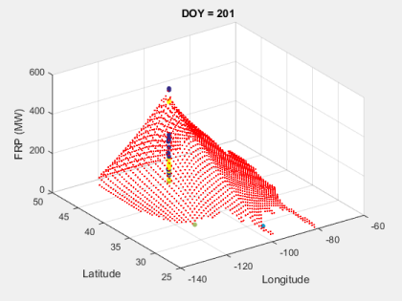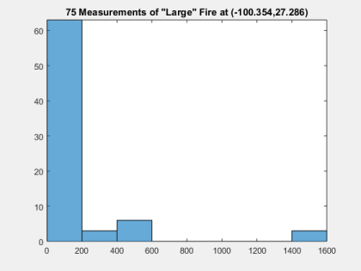5
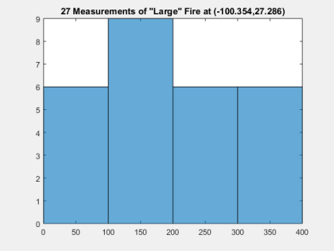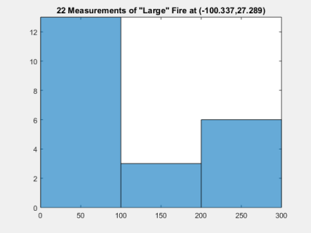6
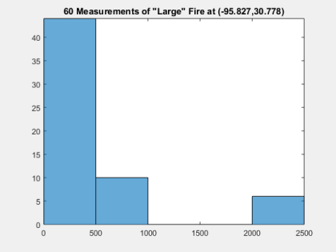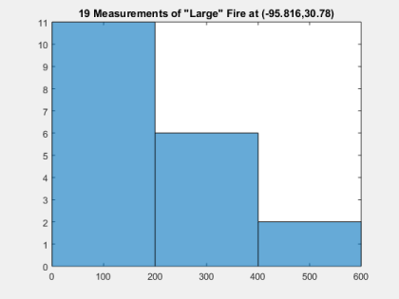7
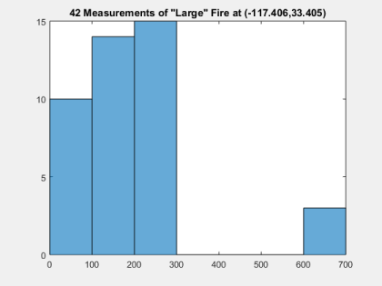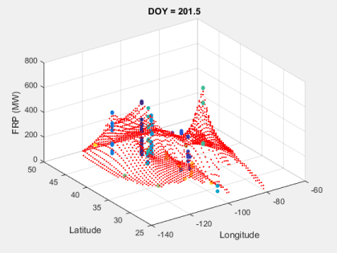8
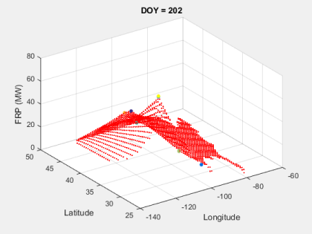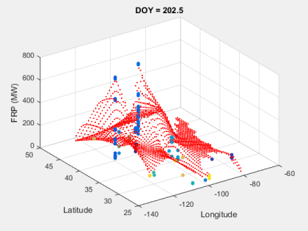9
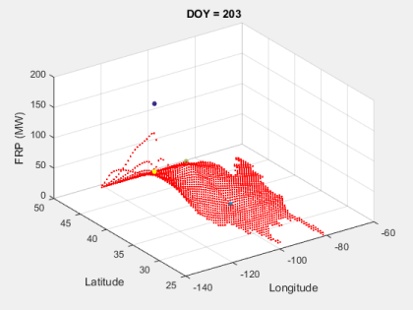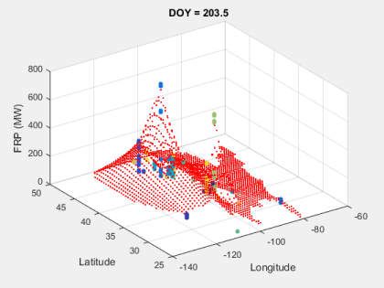10
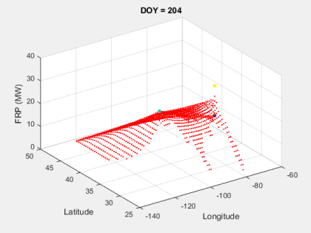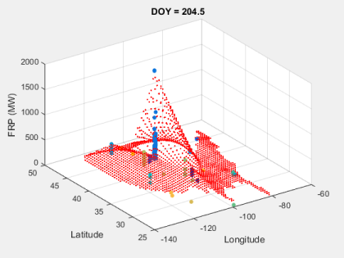11
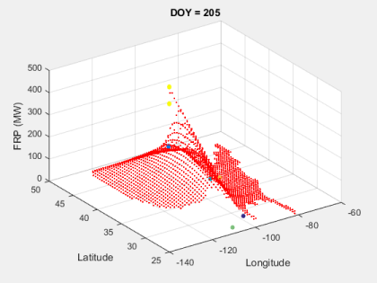12
13
14
15
16
Published with MATLAB® R2015a
17

