Comparative review of recent developments in archaeological predictive models and automatic structure detection
Mathias Bellat^{1,2,✉}, Amy Hatton^{3,4}, and Jordy Didier Orellana-Figueroa^{3,5}
March 5, 2026
Abstract
Prediction and detection of archaeological features have long been central topics in archaeological science. In recent years, artificial intelligence and machine learning have increasingly complemented (and in some cases replaced) traditional statistical approaches. This paper examines two distinct yet related subfields: automatic archaeological structure detection and archaeological predictive modelling. We reviewed 84 articles addressing these two topics using a rapid systematic protocol, published from 2005 to 2024, and highlighted a sharp rise in publications after 2021, particularly for structure detection studies. Our results reveal the growing predominance of deep learning methods in this area. At the same time, we explore the similarities between the two approaches, based on the corpus and an enlarged number of references, notably their reliance on similar theoretical backgrounds and remote sensing imagery as input data. We also identify key differences: predictive models often involve more complex theoretical frameworks and a broader variety of data types, while structure detection is dominated by convolutional neural network models. Finally, we outline potential future directions for both fields based on the trends observed in the reviewed literature.
¹ CRC 1070 “ResourceCultures”, University of Tübingen
² Department of Geosciences, Working Group of Soil Science and Geomorphology, University of Tübingen
³ Department of Geosciences, Working Group Early Prehistory and Quaternary Ecology, University of Tübingen
⁴ Max Planck Institute of Geoanthropology
⁵ High Performance and Cloud Computing Group, University of Tübingen
✉ Correspondence: Mathias Bellat <mathias.archaeology@gmail.com>
Keywords: machine learning; site detection; review; archaeological theory; archaeological modelling
Highlights: - 84 papers reviewed. - Massive development of machine learning for archaeological features detection and prediction approaches since 2021. - Asymmetry in publication numbers between automatic structure detection, which dominates, and archaeological predictive models. - Automatic structure detection approaches are more suited for modern analysis, given their “easier” interpretation.

1. Introduction
One of the central questions in archaeology lies in understanding the organisation of past societies (Renfrew and Bahn, 2020; Trigger, 1967), whether from an intra-site or inter-site perspective. Spatial organisation is a key driver of both present (Lévi-Strauss, 1936) and past human interactions (Bonnichsen, 1973). Consequently, the relationship between humans and space/place has been explored in depth by archaeologists since the mid-twentieth century (Chang, 1968; Hodder and Orton, 1976; Judge and Sebastian, 1988a; Kroll et al., 1991; Parsons, 1972; Phillips and Willey, 1953; Willey, 1953). These studies have not only addressed relationships between humans but also human-environment interactions and interdependencies, emphasising the concept of resilience (Keck and Sakdapolrak, 2013). The distribution of settlements and other perennial human structures has been a key indicator of these spatial dynamics within societies (Chapman, 1999; Willey, 1953). To investigate such patterns, statistical approaches have been developed to assess spatial dependencies between settlements and environmental factors (Kvamme, 1990; Trigger, 1967) or to detect distinctive site distributions that may reveal specific social behaviours (Hodder and Orton, 1976; Judge and Sebastian, 1988b; Kohler, 1988; Kroll et al., 1991).
In parallel, the past decade has witnessed a “data deluge” in archaeology (Bevan, 2015), evident across subfields such as GIS and remote sensing (Argyrou and Agapiou, 2022; Davis and Douglass, 2020), text-based records (Brandsen, 2023), and reflected also in the increasing frequency of machine learning applications in the field (Bellat et al., 2025). This expansion has been particularly transformative in remote sensing, where airborne laser scanning (ALS or LiDAR) has produced high-resolution imagery capable of penetrating dense vegetation (Bennett et al., 2025), and the availability of diverse satellite datasets has greatly increased (Cracknell, 2018). Advances in automated detection and segmentation algorithms (Bonhage et al., 2021; Bundzel et al., 2020; Guyot et al., 2021), improved GIS training for younger generations of archaeologists (Argyrou and Agapiou, 2022), and the rise of open-science collaborations and networks (Batist and Roe, 2024) have further accelerated this trend.
Although the idea of reducing survey results to binary classifications - “site” or “non-site” - dates back to Willey (1953), the real beginnings of predictive modelling in archaeology emerged in the 1970s and 1980s (Judge and Sebastian, 1988a; Thomas, 1973), marking the rise of what has been termed “predictive archaeology” (Verhagen and Whitley, 2012, p. 51). This approach has been defined as an attempt to predict “the location of archaeological sites or materials in a region, based either on a sample of that region or on fundamental notions concerning human behaviour” (Kohler and Parker, 1986), under the “assumption that the location of archaeological remains in the landscape is not random, but is related to certain characteristics of the natural environment” (Verhagen, 2007, p. 13). If the definitions of “site” are often debated in archaeology (McCoy, 2020; Orton, 2000, pp. 67–68), we conceived it here as an: “anthropic perennial structure/installation”, with few exceptions (Benner et al., 2019; Carranza, 2018; Perry and O’Sullivan, 2018). Although somewhat restrictive, this definition accurately represents the object studies in most of the analysed records. The term settlement pattern is understood following and adaptation of Willey’s definition (1953, p. 1), as: “the way humans adapted themselves on the landscape on which they live”, to temper the original deterministic tone. With the development of GIS and enhanced computing capacity in the late 1980s (Allen et al., 1990; Djindjian, 2015; Verhagen, 2007, pp. 15–16), a new generation of archaeological predictive models (henceforth APMs) emerged, designed to map site probabilities (Altschul, 1984; Kohler, 1988; Kvamme, 1990; Moon, 1993; Warren, 1990). These gave rise to two distinct approaches: inductive (data-driven) models and deductive (theory-driven) ones (Kamermans and Wansleeben, 1999; Wheatley and Gillings, 2013). The former are constructed from observed variables, such as environmental or anthropogenic factors (Carrer, 2013; Croce et al., 2025; Ebert, 2000; Yaworsky et al., 2020), while the latter rely on expert-defined parameters (Canning, 2005). Yet theory-driven models have remained underdeveloped, often criticised as overly simplistic or “unsophisticated” (Verhagen and Whitley, 2012). They also bear strong affinities with agent-based modelling (Lake, 2015), another computational approach in archaeology. The opposition between inductive and deductive methods, rooted in debates of the 1970s, is now increasingly regarded as outdated. Both insiders (Kvamme, 2006; Verhagen and Whitley, 2012) and external commentators (Salmon, 1976) view it as more of a historical and epistemological distinction than a current methodological divide.
Following the development of APMs, new approaches with automatic structure detection (henceforth ASD) emerged (Menze et al., 2006), supported by the spread of high-resolution satellite imagery, particularly digital elevation model (DEM) from the shuttle radar topographic mission (SRTM) in 2000 (Farr et al., 2007). This innovative use of learning (henceforth ML) for the semi-automated detection of archaeological structures was aimed at tells, which are mounds formed from repeated human use, using SRTM data at a resolution of 90 m (Menze et al., 2006). Despite the early use of ML for site detection, the more dramatic uptake of this method has only taken place since 2018 (Bellat et al., 2025), thanks to technological innovation and improvements in satellite imagery quality, combined with the increase in open-access satellite datasets such as Sentinel and Landsat (Zhu et al., 2019). Most archaeological structures are smaller than tells and require very-high-resolution satellite data (< 1 m), in order to be detected. The decreasing cost of drones has also allowed them to be adopted by archaeologists for site documentation, which can generate centimetre and even millimetre resolution imagery. Along with all of the improvements in data availability and quality, ML methods saw significant advances in the late 2000s and 2010s, with the development of fast Graphics Processing Units (GPU’s) which allowed for renewed interest and development in Deep Learning (LeCun et al., 2015) and Neural Networks aimed at analysing sparse data (Ronneberger et al., 2015), which archaeological data usually is.
There have been criticisms of ASD, in the same way as how APMs were dismissed as lacking in theory. These criticisms are, however, enhanced for ML in archaeology due to the black box nature of many machine learning models, and concerns over accuracy and contextualisation of the results (Casana, 2014; Opitz and Herrmann, 2018). While these debates are important, and will lead to improvements in how ML for automatic structure detection is approached, binary questions such as whether a site is present or not in a location can lend themselves to automated approaches, especially when results are properly contextualised and interpreted by relevant experts. The original aim of Menze et al. (2006), to create: “A comprehensive and accurate listing of these sites”, is still one of the goals of many applications of automatic structure detection. It is a non-destructive tool that allows for archaeological sites to be identified on a far larger scale than would be possible by fieldwork or manual survey of satellite imagery, while also increasing consistency and allowing for documentation of the entire process. It also allows for the detection of sites that have already been destroyed, through the use of historical imagery (Bulawka et al., 2024), the detection of sites in areas that are remote or difficult to access due to e.g. political instability (Rayne et al., 2020), and country-wide detection of sites (Berganzo-Besga et al., 2021).
Recent years have seen a rapid expansion of machine-learning applications in archaeology (Bellat et al., 2025; Bickler, 2021), driven in large part by the growing availability of large, heterogeneous datasets (Bevan, 2015). Archaeological predictive modelling and automated structure detection, while often treated as distinct methodological traditions, share a common theoretical background rooted in spatial analysis and assumptions about non-random patterning in the archaeological record. At the same time, both approaches are confronted with similar external pressures (Klehm, 2023), including the need to manage growing data volumes and to integrate increasingly complex machine-learning techniques. In this context, it becomes timely to examine how these approaches, despite their shared conceptual foundations, adapted to the current challenges in archaeology (Huggett, 2020; Moscati, 2021), which are reshaping the discipline (Bellat et al., 2025).
Based on the above elements, this paper addresses the following research question: (1) What methodological trends have characterised archaeological predictive modelling and automated structure detection in recent development? (2)To what extent do these approaches converge in their use of machine-learning methods, and which methodological or conceptual features remain specific to each?

2. Methodology

2.1 Article selection
We conducted a rapid systematic review (Jesson et al., 2012) in accordance with the Preferred Reporting Items for Systematic Reviews and Meta-Analyses (PRISMA) guidelines (Page et al., 2021). This approach was chosen because it combines a relatively short scoping process along with methodological transparency (Haby et al., 2016). Our previous work (Bellat et al., 2025) served as the starting point for this review, to which we added records published in 2023 and 2024. To ensure consistency between the collected items we followed the exact same protocol as presented in Bellat et al. (2024) and Bellat et al. (2025). The protocol comprised queries derived from a set of archaeological and machine learning “keywords” (Box 1), tested across six online databases: Web of Science, PubMed, Tübingen University Library, German Archaeological Institute, German National Library, and Google Scholar. These generalised databases ensured wide coverage of scientific publications without including overly specific grey literature records. Records published up to 2022 (n = 730) were taken from Bellat et al. (2024), while an additional 278 records were collected for 2023 and 2024, resulting in a total dataset of 1,006 records (Figure 1).
The screening process followed two inclusion criteria (Dekkers et al., 2022, pp. 202–208). First, only peer-reviewed records in academic journals were retained to ensure methodological consistency. Second, only English-language publications were included, also for consistency. Both criteria combined resulted in the exclusion of 213 records (Figure 1). Following this first inclusion criteria, a retrieval based on the words within the article was performed. It was done within the R environment relying on the selection of keywords (Box 1) included inside the abstract or title of the records as explained in detail in Bellat et al. (2025). In total from the newly collected data, 44 records were assessed as eligible, while 699 did not pass the retrieval process. From the Bellat et al. (2024) dataset, we only selected studies focusing on archaeological predictive modelling or automatic structure detection. For 2023 and 2024 papers, we read all abstracts and titles and manually selected publications that mentioned either of these two approaches.
We then applied two exclusion criteria (Dekkers et al., 2022, pp. 208–209) to refine the dataset. First, we restricted the sample to papers applying machine learning methods, excluding studies based solely on statistical approaches (e.g. regression-based methods, hard voting classifiers, and data transformation techniques), in line with related literature (Bellat et al., 2025; Bzdok et al., 2018; Eleftheriadou et al., 2025). While statistical methods focus on identifying relationships within datasets, machine learning aims to improve predictions for new data based on prior training (Alpaydin, 2014). Second, we excluded theory-based and review papers, as these do not provide an actual application of the ML methods.
In total, our review protocol yielded 84 included articles: 47 from Bellat et al. (2025) and 37 newly collected from 2023 and 2024.
Box 1: Search query used for the protocol search
Topic = machine learning | deep learning | artificial intelligence | archaeological | archeological | archaeology | archeology | archaeo | archeo
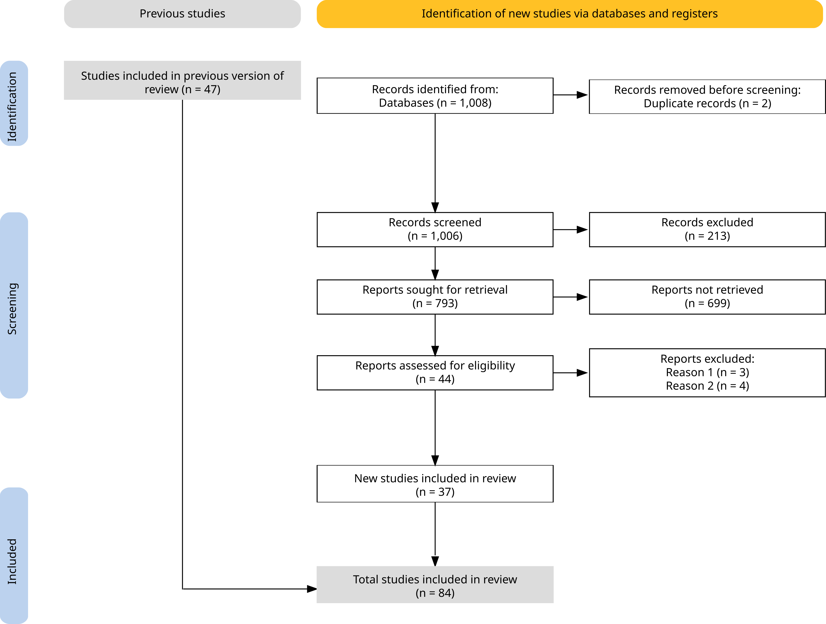
Figure 1: Review process from source selection to analysis. Inspired by the PRISMA 2020 flow diagram Haddaway et al. (2022). Reason 1 = Theory or review paper; Reason 2 = Does not involve machine learning techniques or algorithms. Figure created using PRIMA2020 R package and Inkscape.

2.2 Data collection
From the reviewed records, we extracted 13 variables, both numerical and categorical (Table 1). The classification of model families followed Alpaydin (2014), and Bellat et al. (2025), and Eleftheriadou et al. (2025), while the evaluation methods were grouped into three categories: classification, regression, and clustering (Alpaydin, 2014, pp. 5–13). These “Model”, “Best model”, “Family”, and “Evaluation”, features serve as a basis for our latter reflection on new application of machine learning models of both ASD and APM approaches. The archaeological subfield of each study was assigned according to the framework established in previous work (Bellat et al., 2025; Kelly and Thomas, 2017), this helped in distinguishing specific patterns of application for both approaches. Study outcomes were classified as successful, unsuccessful, mixed, or undefined, based on the authors’ own assessment and goals; we also evaluated whether any article had important methodological issues. This feature also collected in Bellat et al. (2025) is not discussed in the later text but can be referred to as a qualitative assessment of the methodology used in a study.
Feature | Number of categories
Year | 16
Model | 36
Best model | 13
Family | 8
Subfield | 5
Input data | 4
Evaluation | 3
Result | 5
Pre-training | 4
Country of study area | -
Size of the study area | -
Size of structures | 5
Data availability | 3
Code availability | 2
Table 1: The fourteen features collected systematically from the review along with how many categories they were comprised of.
Additional details were recorded for pre-training procedures and input data classes, which were also later integrated in the interpretation of the different methodological workflows and practices. We collected the country and the size of the study area - in case of several areas both were collected - and integrated it into our discussion as these features presented distinct patterns for both approaches. For the APM records, we also extracted the number of covariates used in the study and the type of feature selection executed, if any. This feature reflected methodological choice and difference between some studies. Furthermore, for the ASD study cases, the size of the structures detected was also collected. We extracted the type of performance metrics reported in each study, as well as their associated values (Figure 4). Since many publications did not provide complete performance metrics, we computed additional values where possible (e.g. from correlation matrices) to enable greater comparability across studies. Specifically, we calculated recall, precision, accuracy, and the F1-score (Equations 1-4), based on the true or false positives and negatives (TP, TN, FP and FN). In cases where multiple models or study areas were presented, only the highest reported score was retained. This choice was made to reflect the outcome of the model design by the researchers. Full definitions of all metric acronyms are provided in the glossary. Finally, we also recorded the availability of code and data from the screened records. These last two features, along with those mentioned above, can serve as a catalogue of datasets for future studies, including replication studies. Researchers can therefore enhance their own training data with additional data available in the list, compare their study with others sharing regional or size similarities, apply transfer learning from a previously trained model to their own data, and attempt the replication of publishes studies.
$$Recall=\frac{TP}{TP+FP}$$
$$Precision=\frac{TP}{TP+FN}$$
$$Accuracy=\frac{TP+TN}{TP+TN+FP+FN}$$
$$F1−score=2⋅\frac{recall⋅precision}{recall+precision}$$

3. Results
From the 84 records analysed, 15 addressed APM approaches and 69 focused on ASD techniques (Figure 2). One study applied two distinct ASD methods, and another used two different APM approaches; these were therefore counted as separate study cases (Agapiou et al., 2021; Li et al., 2024). A clear trend is visible from 2018 onwards, with at least one publication per year in each application area. This pattern intensified after 2020, with around 75% of all papers (n = 62) published in 2021 or later. The rapid growth of machine learning applications in archaeology since 2018, and particularly from 2020 and 2021, has also been noted by Bickler (2021), Eleftheriadou et al. (2025, fig. 1), and in our previous work (Bellat et al., 2025, fig. 2).
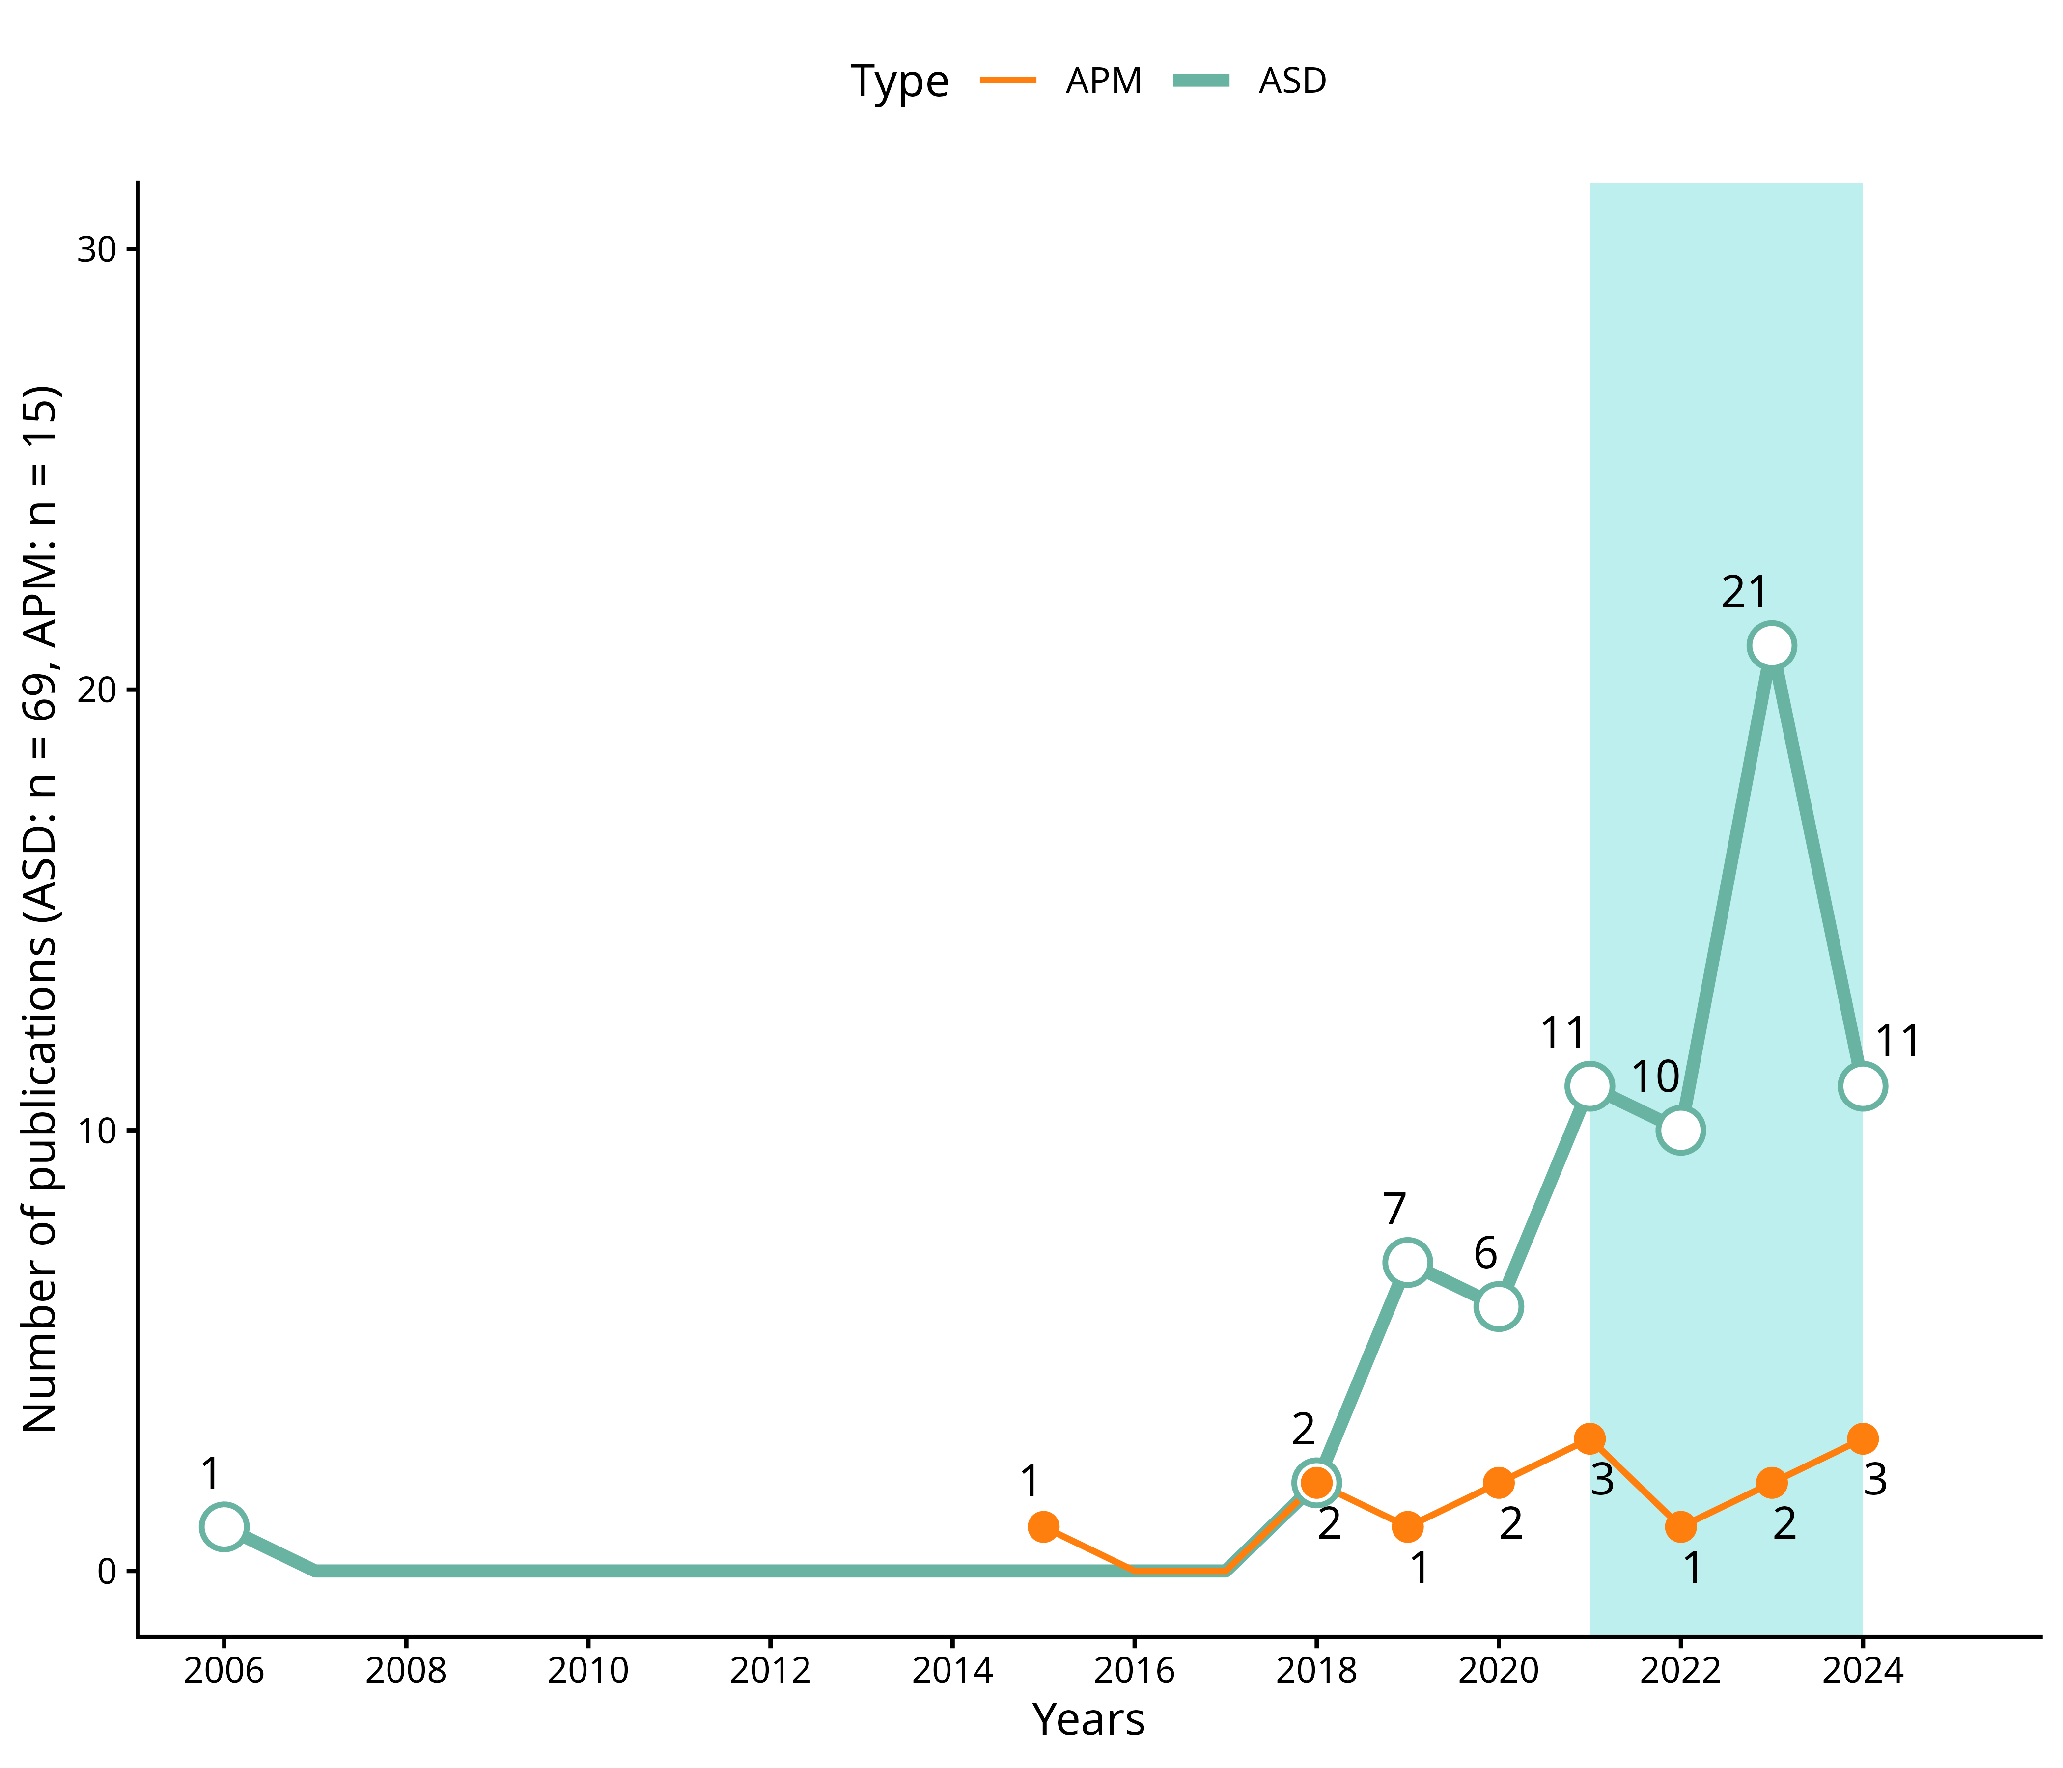
Figure 2: Number of publications per year between 2006 and 2024, split between ASDs and APMs (n = 84). In light blue, the articles published after 2021 accounted for more than 75% of the publications. Figure generated with R 4.5.0.
Regarding the type of algorithms used, deep learning methods and artificial neural networks (ANNs) are the most represented, with 65 uses (Figure 3), followed by ensemble learning models (n = 33), in particular, random forest (RF), which is the most prominent model with 28 applications. All other families of machine learning models, Bayesian classifiers, linear classifiers, unsupervised learning and clustering, decision trees and rule induction, nearest neighbour classifiers and polynomial classifiers, are more or less, equally represented (Figure 3). The rise of ANNs can be seen from 2020 and 2021 onwards (see supplementary file) and follow the general trend of all reviewed publications (Figure 2). There is a high diversity of models used, with 39 different algorithms but only half of them were used more than once. This number could have also been affected by the level of granularity we used for the classification of the methods, as no inter-rater reliability analyses were performed due to expediency. Furthermore, we counted two applications of statistical methods, used in parallel of other machine learning models, one linear regression (Fuentes-Carbajal et al., 2023) and one k-means clustering (Ben-Romdhane et al., 2023).
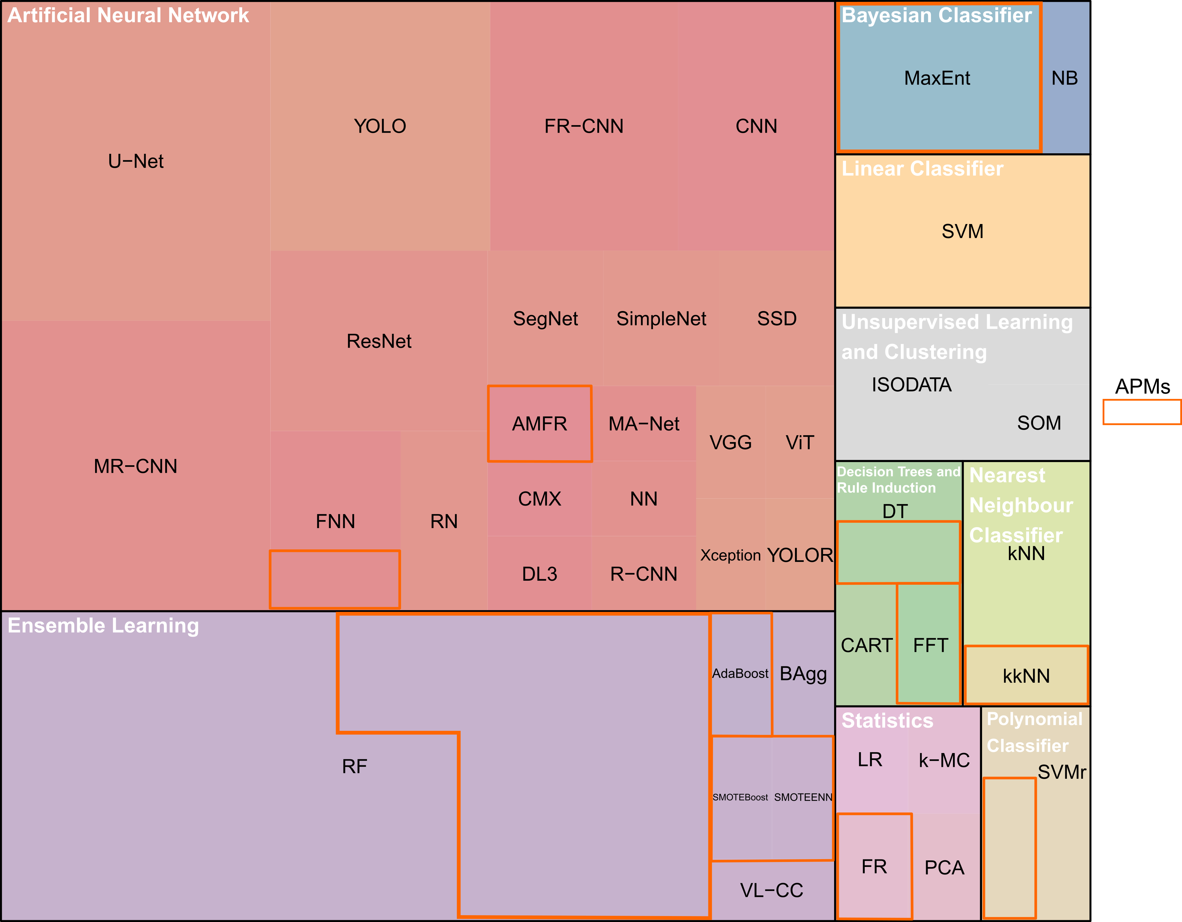
Figure 3: Tree map of the different models used and their related family/group (n = 128). APM papers are highlighted by an orange rectangle. Figure generated with R 4.5.0 and modified with Inkscape.
From the collected performance metrics, we identified 20 unique measures (Figure 5), though only nine appeared in more than one study. In total twelve records of ASD application did not present any evaluation measurement, while this was the case in five for the APMs. Among ASD applications, recall, precision, and F1-score were reported in 65% of cases (n = 45), with accuracy additionally included in 25 of these. Intersection over Union (IoU) was used in nine studies, mainly in segmentation tasks. For APMs, 66% (n = 8) reported Area Under the Curve (AUC), while only four relied soly on alternative metrics.
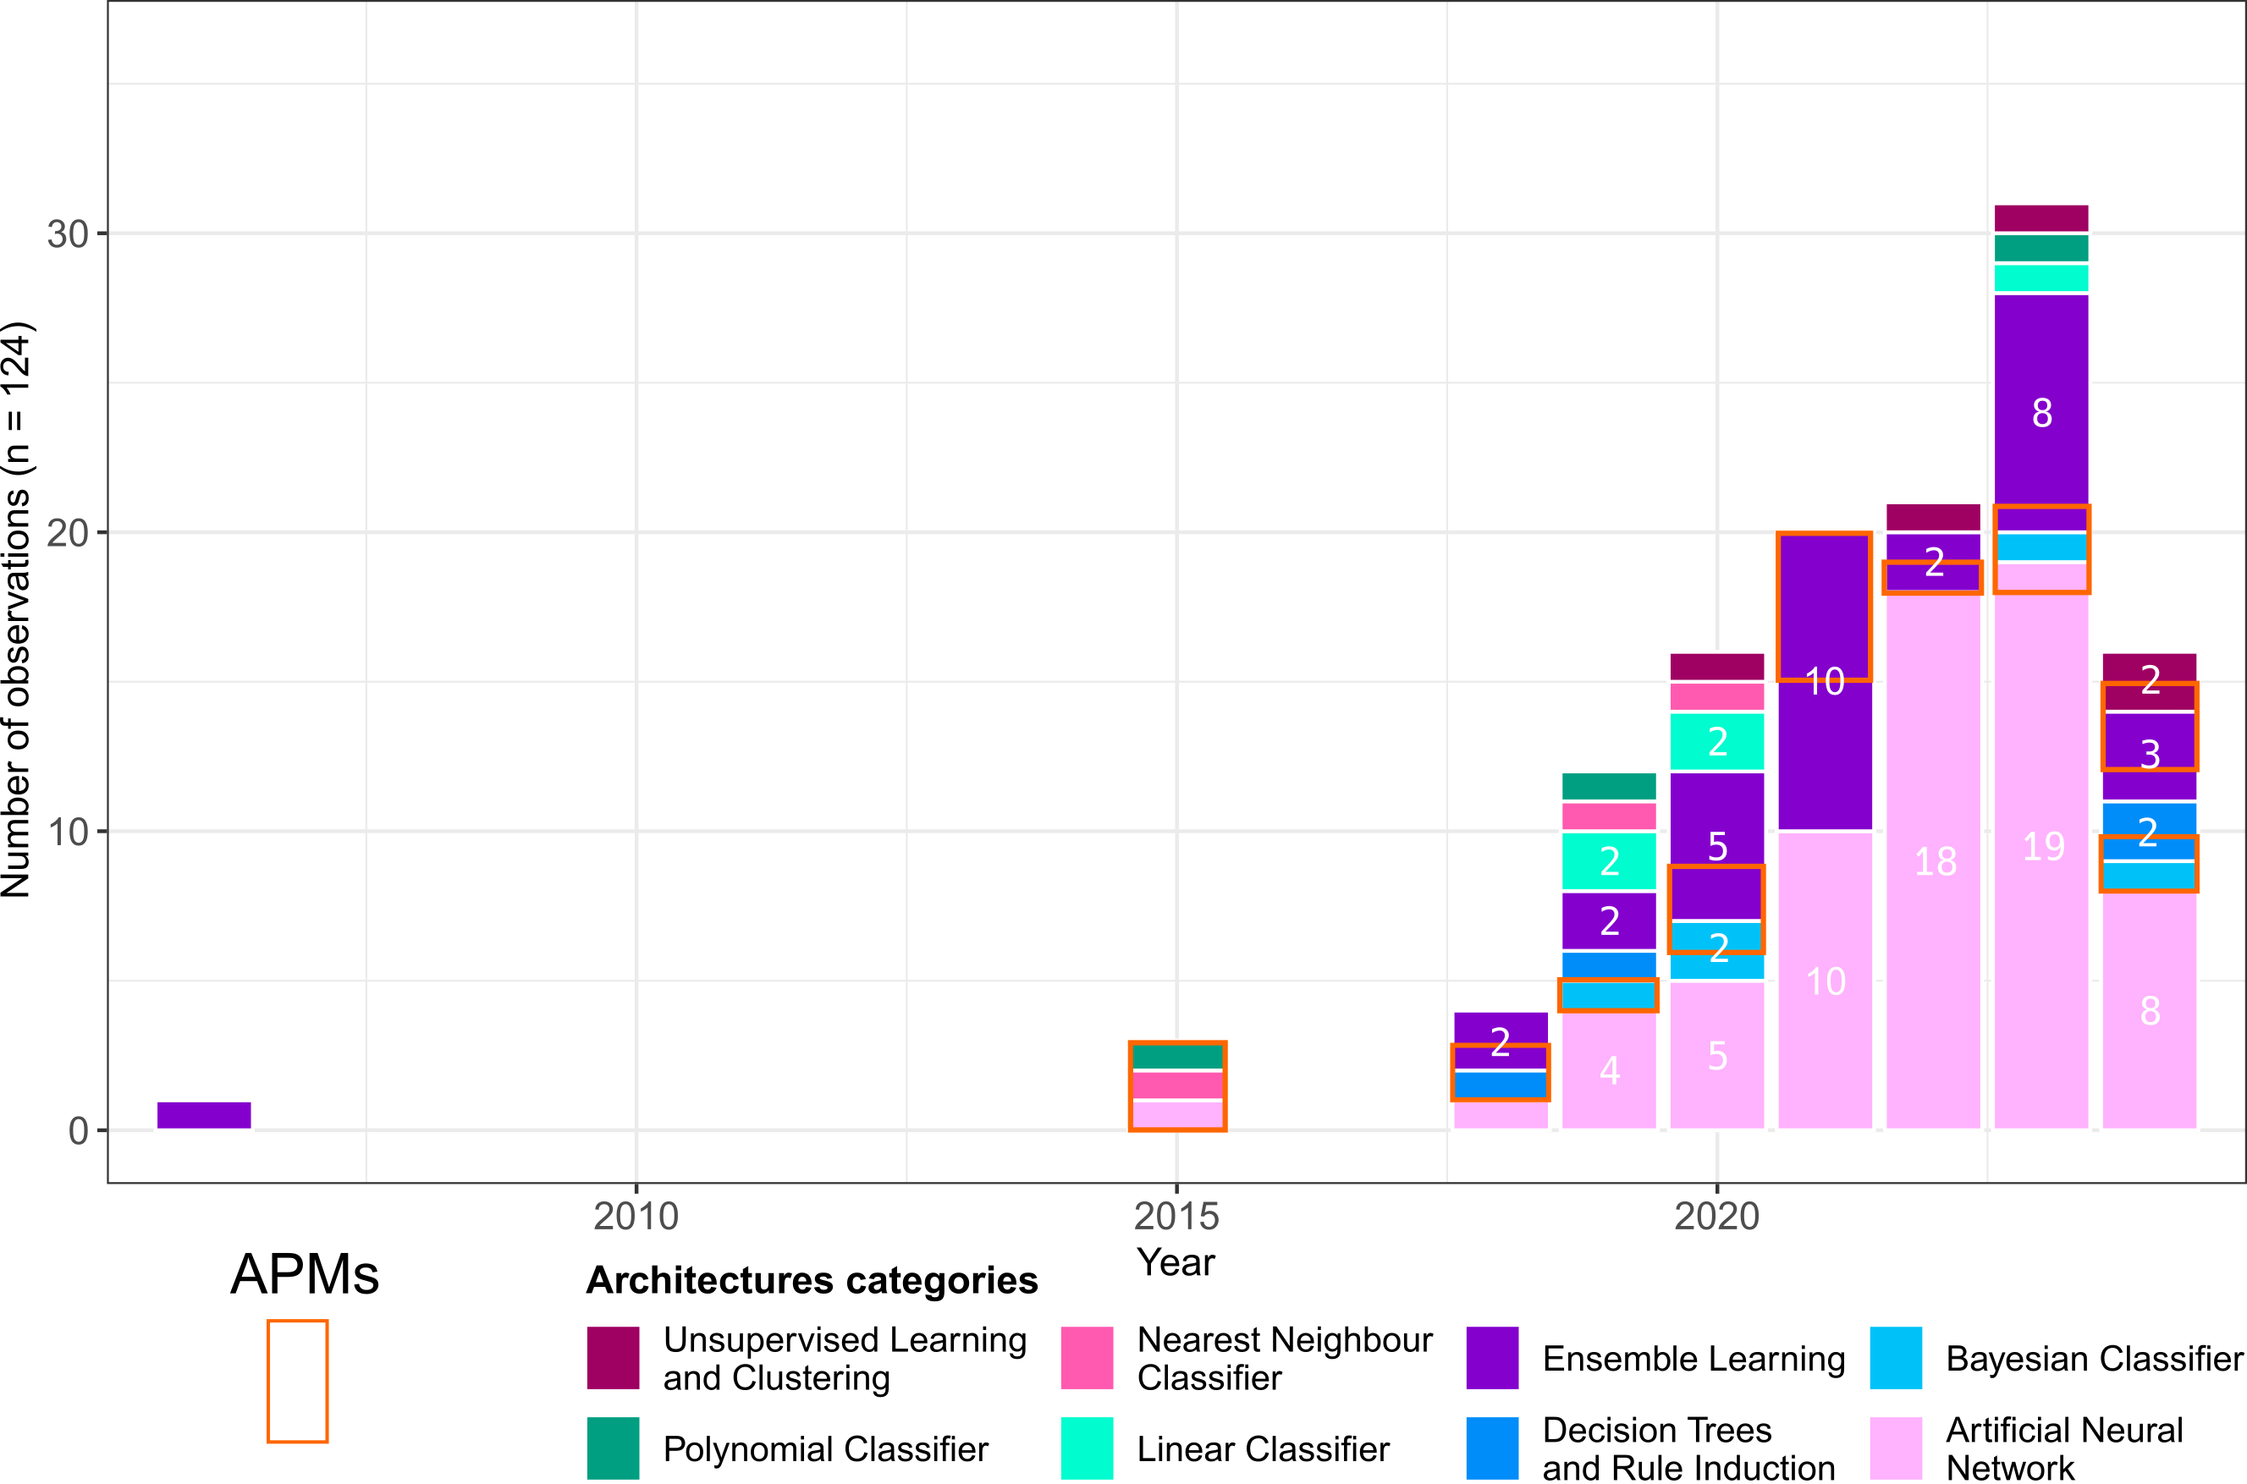
Figure 4: Bar plot of the number of each use of a model family/group per year (n = 124). APM papers are highlighted by an orange rectangle. Figure generated with R 4.5.0 and modified with Inkscape.
We also examined model performance scores by plotting precision against recall for ASD models, including F1-score and accuracy when available (Figure 6). The median F1-score was 0.76, while the median accuracy reached 0.86. Precision tended to be slightly higher (median = 0.86) than recall (median = 0.74). However, a subset of studies reported very low precision, which reduced the mean values of both precision and recall to 0.74.
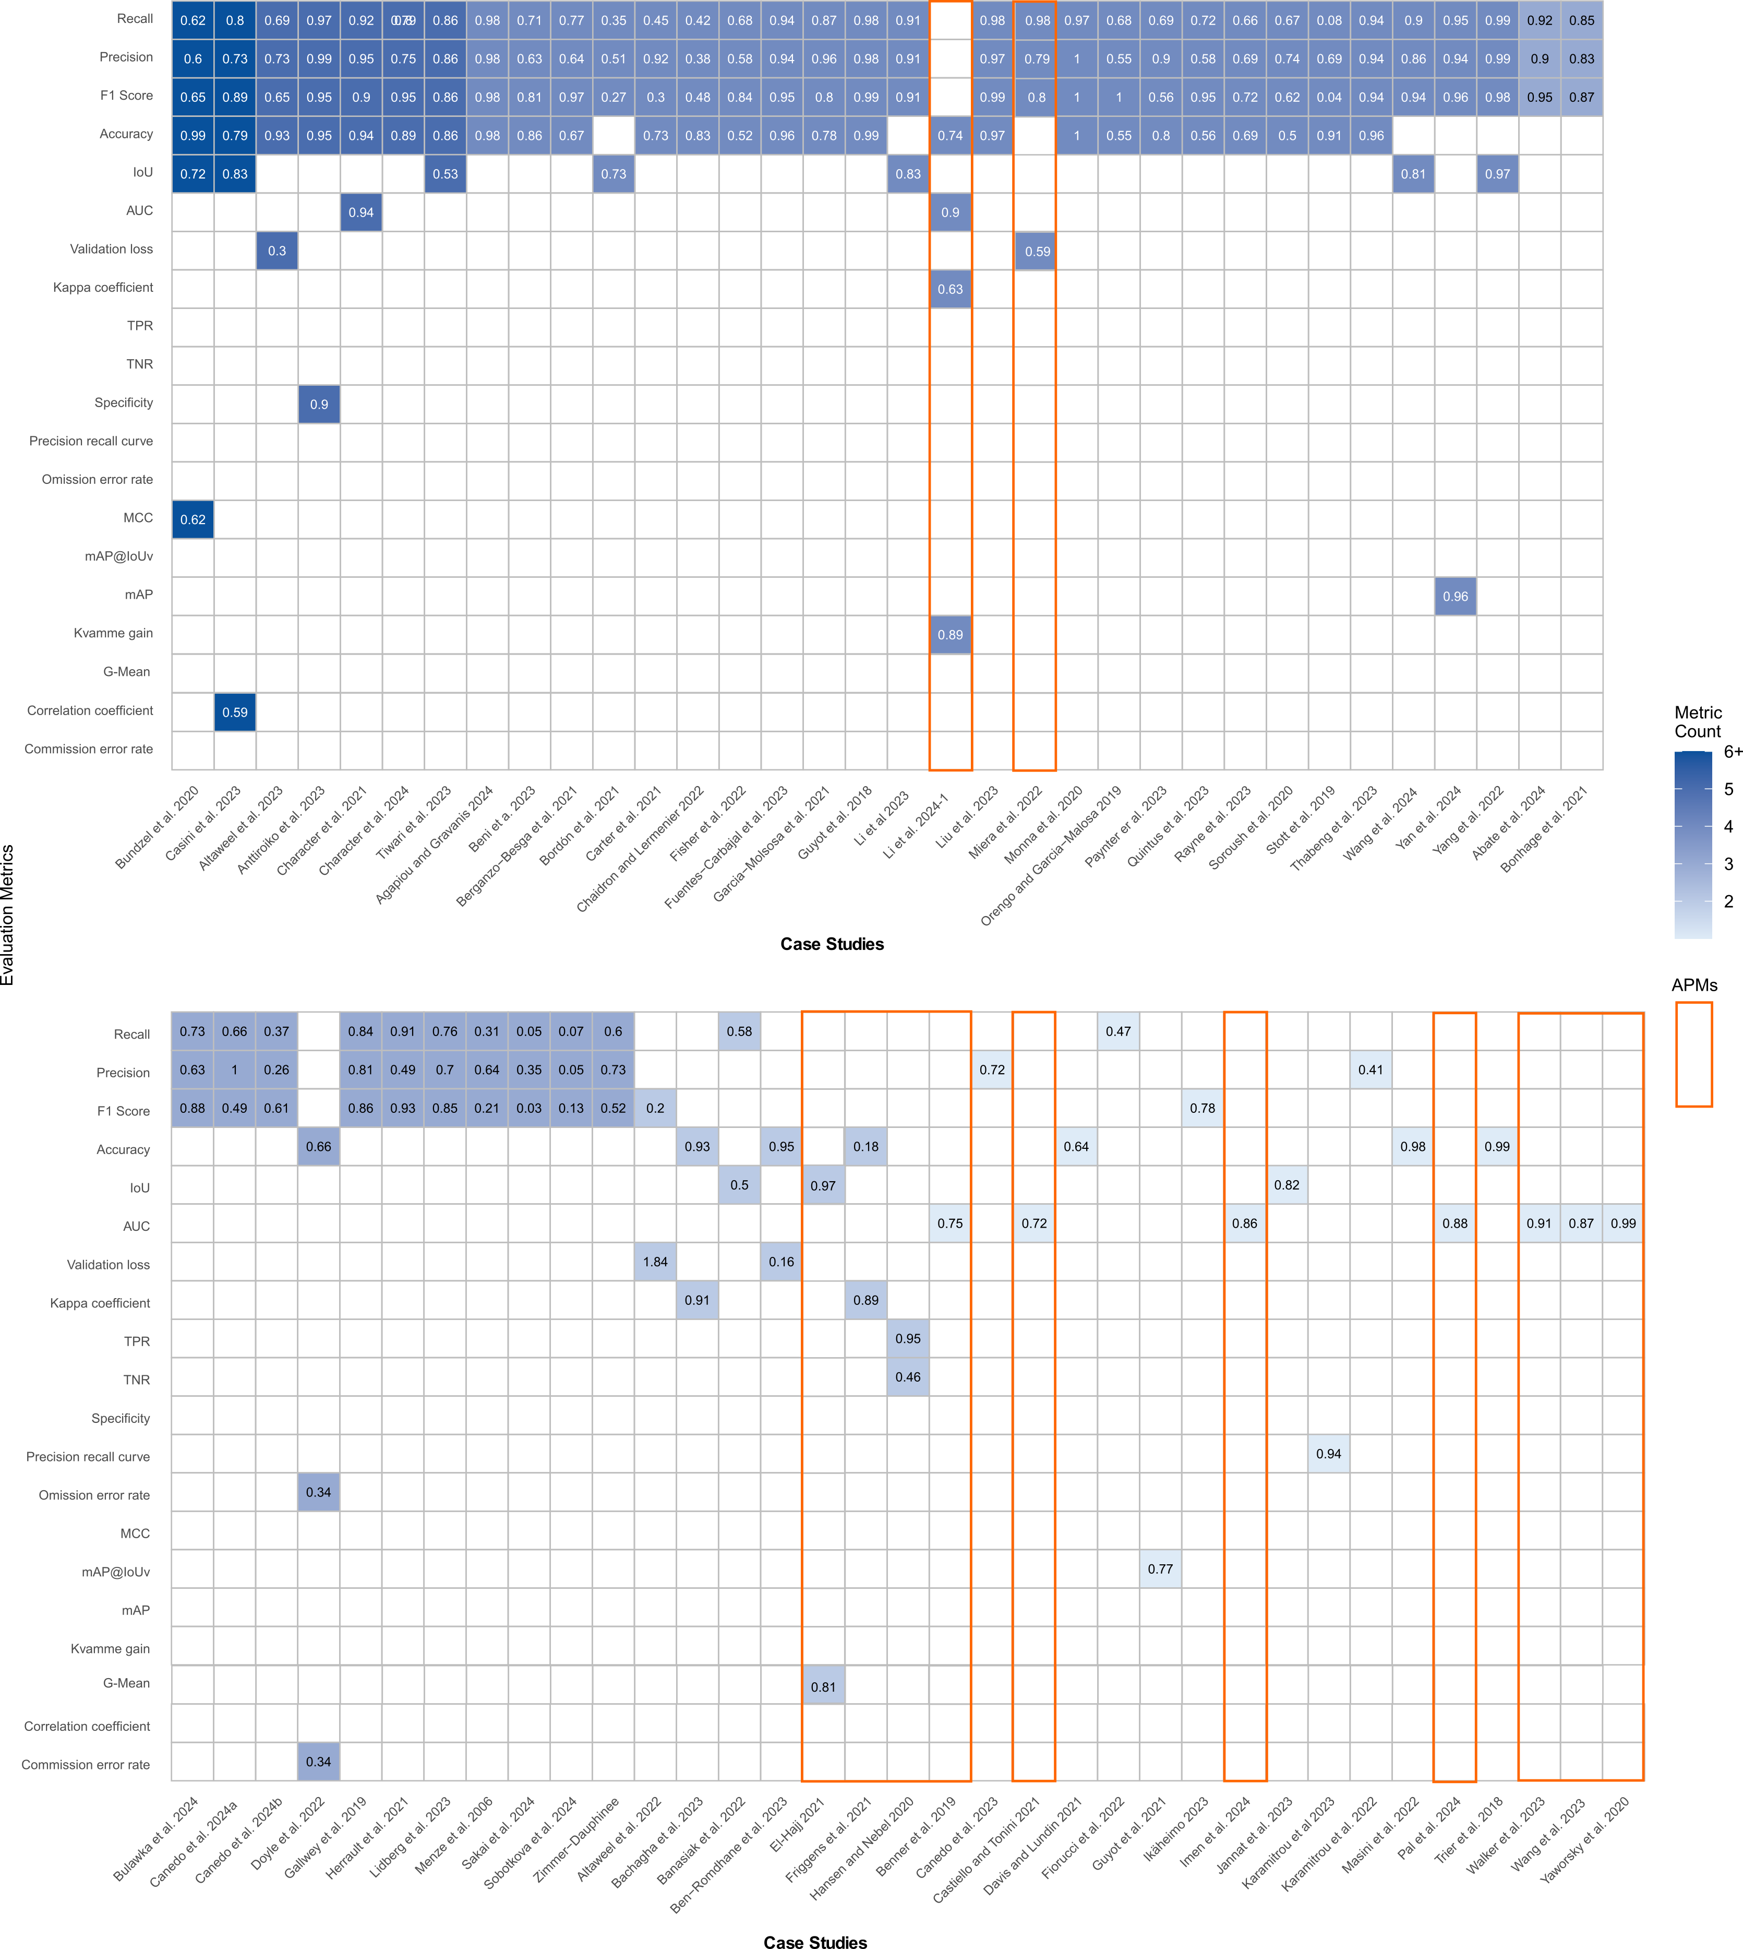
Figure 5: Number of metrics and metrics scores presented in the reviewed papers (n = 69). Some papers did not present any metrics. The different metrics are represented on the left, and the case study citation note is at the bottom. The blue gradient indicates the number of metrics used for one case study, with a minimum of 1 (pale blue) and a maximum of 6 (strong blue). APM papers are highlighted by an orange rectangle. Figure generated with R 4.5.0 and modified with Inkscape, inspired by Eleftheriadou et al. (2025).

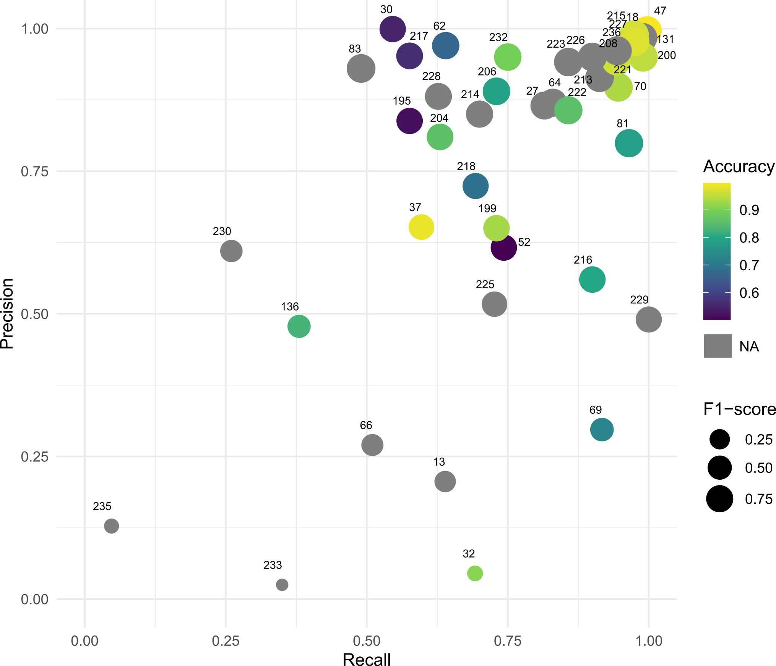
Figure 6: Scatter plot of the recall and precision scores for the ASD records (n = 45), numbered according to the ID number of the study in our table. F1-score is represented by the area of the point, and accuracy is shown with a gradient colour when available. Figure generated with R 4.5.0 and modified with Inkscape.
The spatial distribution of study areas indicates a broadly global coverage, although notable regional disparities remain (Figure 7). While case studies are represented across most continents, Africa, and Central Asia, appear in comparison underrepresented. Conversely, regions that have traditionally received less attention in archaeology, such as Oceania, are well represented through studies conducted in American Sāmoa, the Republic of the Marshall Islands, and Australia (Karamitrou et al., 2023; Quintus et al., 2023). Southwestern Asia and South America also account for a substantial number of case studies, particularly in Iraq (Altabrawee et al., 2019; Altaweel et al., 2022; Menze et al., 2006; Soroush et al., 2020) and Peru (Payntar, 2023; Sakai et al., 2023; Zimmer-Dauphinee et al., 2024). Despite this broad geographic distribution, a clear imbalance remains between hemispheres. The Northern hemisphere concentrates approximately 84% of the recorded studies (Figure 7), reflecting a continued dominance in research production. At the national scale, China, Iraq, the United States and Peru lead in the number of applications of ASD and APM approaches, with eight, seven and six case studies respectively.
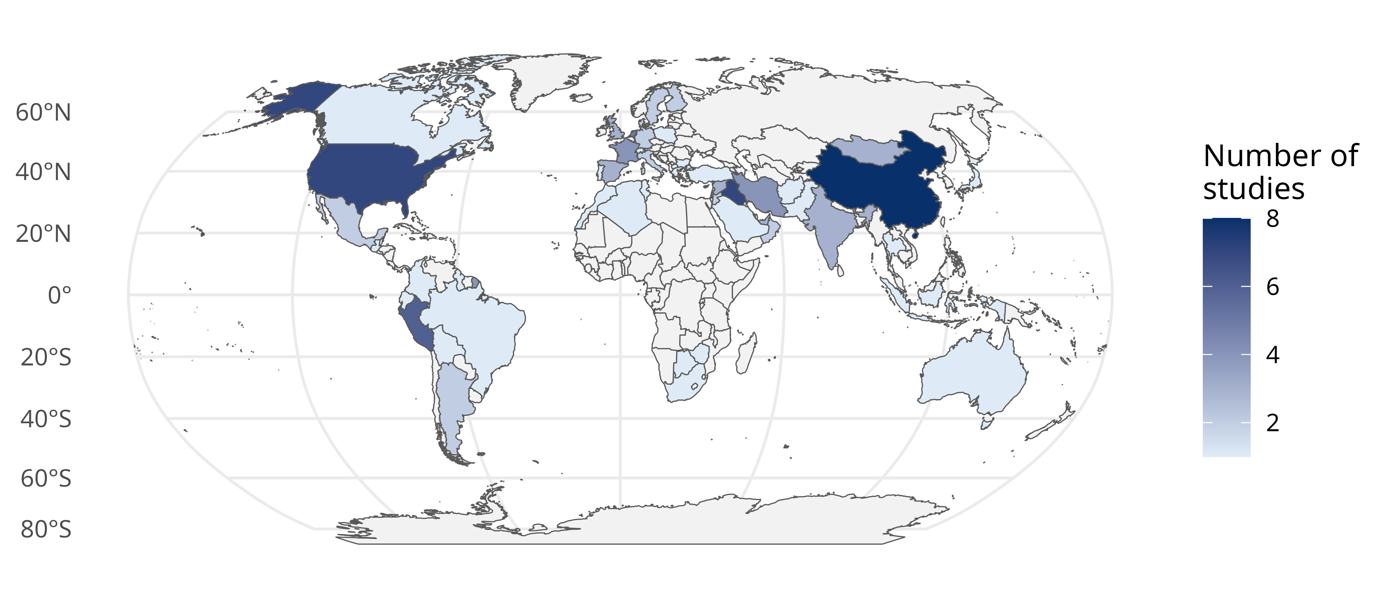
Figure 7: Map of the countries where the studies were conducted (n = 115). Figure generated with R 4.5.0.
We also considered the size of the studied areas (Figure 8A) and, for ASD records only, the size of the detected structures (Figure 8B). The smallest areas of interest (AOIs) corresponded to fields as small as 25 m$²$ (Agapiou and Gravanis, 2024), whereas the largest AOIs in APM studies cover entire continents, such as the model developed by Walker et al. (2023), of approximately 8,000,000 km$²$. Overall, the size of APM study areas tended to be substantially larger, with a median of 6,305 km$²$, compared to ASD AOIs, which had a median of 475.50 km$²$. Focusing specifically on automatic structure detection, the size of the detected structures is mostly concentrated between 5 m and 200 m, representing about 80% of all structures (Figure 8B). Structures at the layer or site level each account for approximately 8% of the corpus.
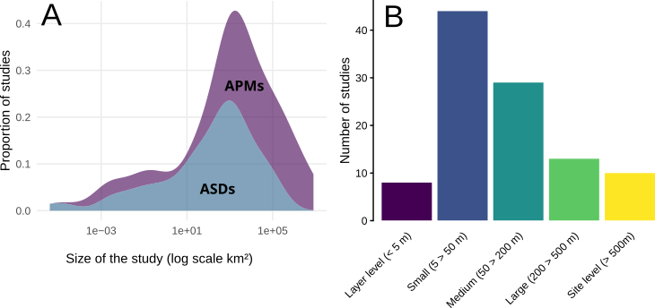
Figure 8: A: Density plot of the area of interest size - transformed in log10 - for both APMs and ASDs records (n = 91). B: Bar plot of the size of structures of the ASDs records (n = 104). Figure generated with R 4.5.0.

4. Discussion

4.1 Common elements
From a theoretical perspective, both archaeological predictive models and archaeological structure detection share a common conceptual background. At their core lies the notion of site probability (Gillies et al., 2016; Hodder and Orton, 1976; Willey, 1953), rooted in the fundamental archaeological question of why “populations located sites where they did” (Kvamme, 2020, p. 213). Both approaches address this question by attempting to predict site locations. Judge and Lynne defined prediction as “the ability to foretell on the basis of observation, experience, or scientific reason” (Judge and Sebastian, 1988b, p. 2). This predictive dimension was explicitly present in the early stages of APMs (Verhagen and Whitley, 2012), and is even reflected in their name, but it is less immediately visible in the terminology of ASD. Nevertheless, one of the earliest works to apply predictive modelling for archaeological structure detection in remote sensing imagery - Menze et al. (2006) on Syrian tells - explicitly framed the task as the need for “a comprehensive and accurate listing of these sites” effectively operationalising presence/absence prediction in a way analogous to APMs.
Another key similarity between APMs and ASDs lies in their reliance on remote sensing data, whether derived from UAVs (e.g. Monna et al., 2020; Orengo and Garcia-Molsosa, 2019; Sakai et al., 2024) , aircraft (e.g. Bonhage et al., 2021; Guyot et al., 2021; Lidberg et al., 2024), or satellites (e.g. Caspari and Crespo, 2019; Castiello and Tonini, 2021; Karamitrou et al., 2023). The rise of both applications is closely tied to the broader expansion of remote sensing in archaeology (Argyrou and Agapiou, 2022), itself driven by the rapid increase in Earth observation satellites since 2015 (Figure 9). This growth has also been fuelled by greater accessibility to satellite and LiDAR datasets, as well as by major improvements in image resolution, particularly from modern airborne laser scanning (ALS) platforms (0.5 - 1 m resolution) and UAVs. Future developments in remote sensing are likely to further enhance archaeological applications, not only through sensor advances but also through computational methods such as super-resolution techniques (Liu et al., 2025; Wang et al., 2022).
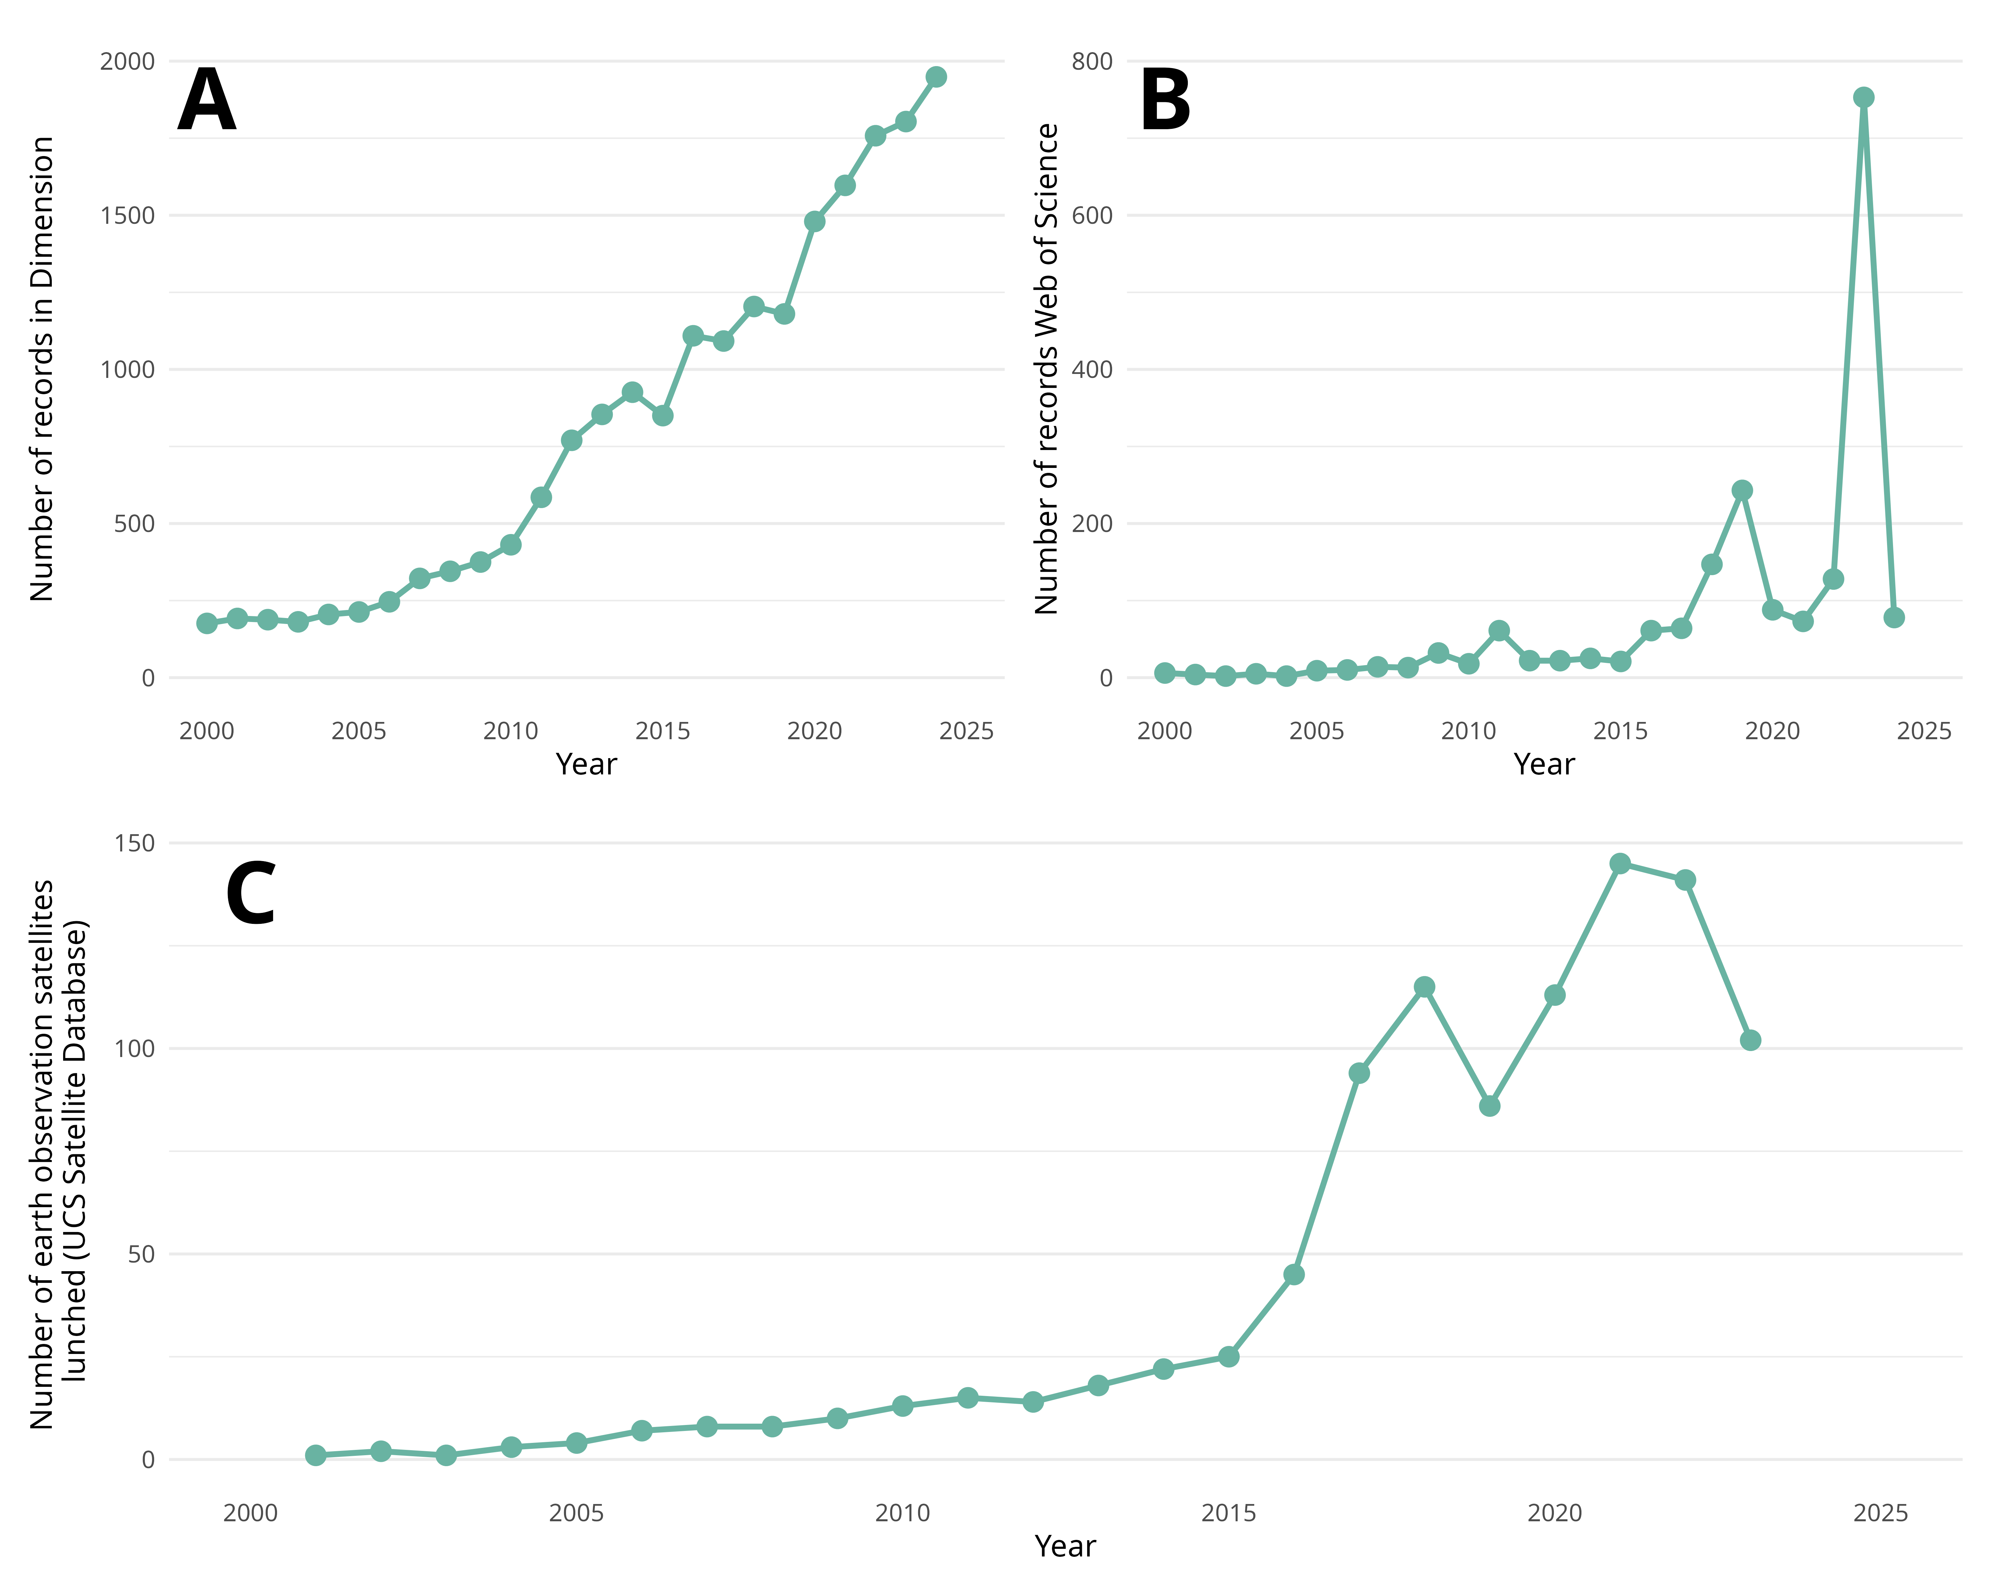
Figure 9: A: Number of records in the archaeological field mentioning remote sensing in the Dimension database. B: Number of records in the archaeological field mentioning remote sensing in the Web of Science database. C: Number of satellites dedicated to earth observation launched per year, according to the USC database, we did not take military satellites into account. Figure generated with R 4.5.0.
Despite differences in the types of models employed in APMs and ASDs, both fields show a strong reliance on the RF algorithm. In ASD tasks, RF accounts for nearly 20% of applications (n = 18), while in APMs it represents 41% (n = 10). The prominence of RF in archaeological machine learning is unsurprising: the method is relatively straightforward to implement and can be applied flexibly to both classification and prediction problems (Breiman, 2001).
Another common theme is the broadly worldwide representation of both APMs and ASD study cases (Figure 7). Concerning these trends, the underrepresentation of African case studies likely reflects the only recent development of archaeological research in the continent (Davis and Douglass, 2020). Limited access to funding and lack of large-scale remote sensing datasets are likely to also contribute to this imbalance. In the post-Soviet sphere, lower representation might come from a historical tendency toward relative scientific isolation within Russia and some affiliated countries. Between 1993 and 2017, Russia accounted for only approximately 0.33% of global publication in humanities, on average (Gilyarevskii et al., 2019, Table 3). This structural separation from mainstream international research networks has probably intensified following the Russian aggressions against Ukraine from 2014 and 2022 onwards, further limiting scientific collaboration and visibility (Jack, 2024). Conversely, the comparatively high representation of ASD applications in Iraq and Peru may be explained by favourable environmental and archaeological conditions. Large parts of Iraq and neighbouring regions of the Arabian Peninsula are characterised by relatively flat topography and sparse vegetation cover, conditions that enhance the performance of satellite-based remote sensing (Casana, 2020). In addition, characteristic settlement forms such as tells - artificial mounds formed by long-term occupation - are particularly well suited to aerial and satellite detection methods (Menze et al., 2006), though the centuries-old interest in the region for its well-renowned history and archaeology is undoubtedly a contributing factor. Comparable environmental advantages are also found in parts of coastal and arid Peru, where low vegetation density and clear surface visibility support remote sensing approaches (Sakai et al., 2024; Sakai et al., 2023; Zimmer-Dauphinee et al., 2024).

4.2 Differences in approaches
While APMs and ASDs share several similarities, important differences explain why they have followed distinct research trajectories. From a theoretical standpoint, APMs benefit from a more established background built over more than 40 years of practice (Judge and Sebastian, 1988a; Kvamme, 2020). They have also faced criticism, particularly for their perceived deterministic nature (Kamermans et al., 2004; Kvamme, 2006), reflecting their strong roots in ecological science (Yaworsky et al., 2024). By contrast, ASDs have been less subject to such criticism, as they are more data-driven and object-focused. Their main limitations concern their ability to connect with broader archaeological questions and engage a wider audience (Davis, 2021, 2020, 2019). However, the past five years have seen growing interest in ASDs (Bennett et al., 2025). The OpenAI to Z Challenge is one example of bridging a niche method with public engagement, aiming to locate archaeological sites in the Amazon using large language models and computer vision tools with OpenAI o3/o4 mini and GPT-4.1 (https://openai.com/openai-to-z-challenge).
Differences are also evident in the use of machine learning methods. ASD studies frequently employ artificial neural networks (ANNs; n = 57), particularly U-Net (e.g. Anttiroiko et al., 2023; Bundzel et al., 2020; Garcia-Molsosa et al., 2021), convolutional neural networks (CNNs Gallwey et al., 2019; Ikäheimo, 2023; Soroush et al., 2020), and their region-based or mask-based variants (e.g. Bonhage et al., 2021; Quintus et al., 2023; Verschoof-van der Vaart and Lambers, 2019). In contrast, our review found only two APM studies using ANNs (Oonk and Spijker, 2015; Wang et al., 2023). Bayesian classifiers also show divergent use: MaxEnt appears exclusively in APMs (e.g. Benner et al., 2019; Imen et al., 2024; Wang et al., 2023), given its suitability for handling pseudo-absence data (Yaworsky et al., 2020).
Another major difference lies in the input data. ASD typically relies on single-image datasets (LiDAR, UAV, or satellite imagery, Altaweel et al., 2022; Guyot et al., 2021). This choice is partly due to the finer resolution of such imagery (< 10 m), suited to detecting small structures, and partly to the suitability of deep learning models for image recognition. By contrast, APMs often integrate multiband datasets - including DEMs, spectral information, and soil chemistry - with more than ten covariates commonly included (Castiello and Tonini, 2021; Oonk and Spijker, 2015). The number of covariates is less limited as the process does not need recognition, but prediction based on pixel values. Feature selection, a method to reduce of the number of input data variables (Figure 10), is often applied to simplify the model and increase transposability, either through expert-driven choices (Friggens et al., 2021; Hansen and Nebel, 2020) or statistical methods (Oonk and Spijker, 2015; Wang et al., 2023; Yaworsky et al., 2020).
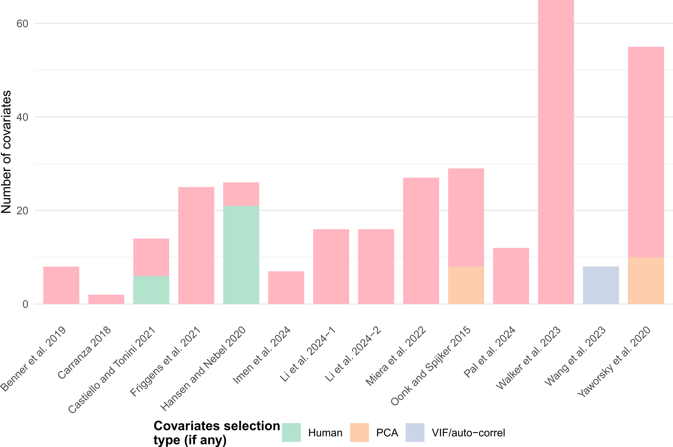
Figure 10: Number of covariates used in the APMs papers reviewed and the type of feature selection selected (n = 14). Figure generated with R 4.5.0.
Interpretability also differs markedly. ASD, especially when based on deep learning, is often considered a “black box” because the contribution of individual features is unclear (Bickler, 2021). Recent progress in explainable AI (XAI) has improved transparency, for example, through saliency maps that highlight which areas of an image drive predictions Rudin (2019). However, XAI remains relatively uncommon in ASD. In contrast, APMs naturally lend themselves to interpretation, as the influence of each covariate can be quantified and visualised (Li et al., 2024).
When examining the size of the AOIs, another difference was a broader spatial extent observed in APM studies (Figure 8A). It can largely be explained by the environmental scope and conceptual framework underlying these models (Kvamme, 2020). Predictive modelling aims to capture landscape-scale patterns, which requires accounting for spatially dispersed and sometimes distant environmental variables. Moreover, APMs frequently rely on survey datasets or institutional records (Castiello and Tonini, 2021; Imen et al., 2024; Miera et al., 2022), which typically cover extensive geographic regions. In contrast, automatic structure detection applications tend to provide detailed analyses of localized phenomena. These studies are often constrained to relatively small regions (Guyot et al., 2018; Sakai et al., 2023; Trier et al., 2018) or rely on high-resolution UAV imagery covering individual fields or restricted surfaces (Monna et al., 2020; Orengo and Garcia-Molsosa, 2019).
Regarding the size of the detected structures in ASD records, the predominance of features ranging between 5 m and 200 m (Figure 8B) reflects the primary archaeological targets of these studies. Most applications focus on domestic structures (Bundzel et al., 2020; Zimmer-Dauphinee et al., 2024), individual constructions (Davis and Lundin, 2021; Gallwey et al., 2019), or funerary features (Guyot et al., 2018; Trier et al., 2018). Only a limited proportion of studies address large-scale fortifications (Canedo et al., 2024; Stott et al., 2019), collective architectural complexes (Soroush et al., 2020), or entire archaeological sites (Garcia-Molsosa et al., 2021; Menze et al., 2006; Orengo et al., 2020). On the other hand, APM approaches only focus on site-scale prediction and detection.
Finally, APMs generally follow a well-established and relatively lightweight workflow requiring limited computational resources, reflecting their long-standing use in archaeology. By contrast, ASD research is less standardised, employing a wide range of models and metrics (Figure 3; Figure 5; Figure 6). This diversity is unsurprising given its recent and rapidly evolving development, combined with the variety of models used. Over time, ASD workflows may become more structured as the field matures. However, they remain computationally demanding, requiring substantial time and resources despite the accessibility of cloud platforms such as Google Colab.

4.3 Limitation of the study
Several limitations of our study should be acknowledged. First, our screening strategy (see Section 2.2) involved the review of some articles by a single author, while records from Bellat et al. (2025) were reviewed by two authors. This element might have introduced subjectivity when assessing certain objective criteria (e.g. subfield classification), although the collected items largely consist of fixed categories (Table 1). Our strategy also excluded non-peer-reviewed publications and non-English language records. Inclusion of diverse sources, such as book chapters or conference proceedings, might have altered some results. However, trends observed in non-peer-reviewed materials - as observed by the authors of this publication - were largely consistent with those reported here. Additionally, our decision to report only the highest evaluation scores prevents comparisons across the full range of scores where various models were applied but only the best performing reported, which could have otherwise provided a more nuanced assessment of model performance. Due to concerns about reproducibility and inter-rater reliability, we therefore relied on a single metric per record. Interpretation of archaeological research questions based on model results was consistently guided by the best-performing model.
Regarding the corpus itself, the diversity of regions and periods explored introduces further limitations in comparing models. As noted above, some global regions remain underrepresented, primarily due to research biases linked to funding and economic constraints (Allik et al., 2020). While the country of the primary affiliation of the first authors of the reviewed publications may be skewed towards wealthier countries (see Bellat et al., 2025), this bias appears less pronounced at the level of research areas (Figure 7). Open access to data and code remains a critical issue: only 31% of records provided full or partial access to data, or shared their original code, or both (Table 2). Replicability is a fundamental principle of science (Popper and Popper, 2005) and has been highlighted as crucial for archaeology by Marwick et al. (2017), Marwick (2025) and Queffelec (2026). The lack of accessible data or code thus represents a notable limitation of the corpus. Finally, other biases may affect interpretation, including publication bias favoring positive results (Song et al., 2013) and the FUTON effect privileging open-access publications (Wentz, 2002). Beside code and data the lack of transparency was also presents in the results, 1/3 of the ASD record did not presented metrics results (Figure 5). Similar observation were made by Eleftheriadou et al. (2025) were they had to look in figures and graphs in detail for evaluation results, which should have been explicitly presented in the text.
Availability | No. of articles | References
Data fully available | 10 | Anttiroiko et al. (2023); Bachagha et al. (2023); Karamitrou et al. (2023); Oonk and Spijker (2015); Orengo et al. (2020); Perry and O’Sullivan (2018); Stott et al. (2019); Trotter et al. (2022); Verschoof-van der Vaart and Lambers (2019); Yaworsky et al. (2020)
Data partially available (API or platform) | 16 | Altaweel et al. (2024, 2022); Bulawka et al. (2024); Carter et al. (2021); Casini et al. (2023); Davis et al. (2021); Fisher et al. (2022); Ikäheimo (2023); Li et al. (2024); Lidberg et al. (2024); Miera et al. (2022); Quintus et al. (2023); Rayne et al. (2023); Sobotkova et al. (2024); Walker et al. (2023); Zimmer-Dauphinee et al. (2024)
Code available | 26 | Agapiou et al. (2021); Altaweel et al. (2024, 2022); Berganzo-Besga et al. (2021); Bulawka et al. (2024); Carter et al. (2021); Casini et al. (2023); Davis et al. (2021); Fiorucci et al. (2022); Fisher et al. (2022); Gallwey et al. (2019); Ikäheimo (2023); Li et al. (2024); Lidberg et al. (2024); Liu et al. (2023); Orengo and Garcia-Molsosa (2019); Orengo et al. (2020); Perry and O’Sullivan (2018); Quintus et al. (2023); Rayne et al. (2023); Sobotkova et al. (2024); Stott et al. (2019); Trotter et al. (2022); Walker et al. (2023); Yaworsky et al. (2020); Zimmer-Dauphinee et al. (2024)
Table 2: Available material and code from the reviewed studies (n = 84).

5. Conclusion
This review has examined recent developments and trends of the use of machine learning in two different approaches in archaeology: archaeological structure detection (ASD) and archaeological predictive models (APMs). Our survey, based on a reproducible methodology, covers studies published from the mid-2000s to 2024. As in other subfields of AI in archaeology, ASD has attracted growing interest since 2020, while APM has not yet fully embraced the AI transition, with relatively few studies adopting such methods.
The dominance of artificial neural networks in ASD reflects the suitability of deep learning for image recognition. Convolutional neural networks, and particularly MR-CNNs, have proven highly effective for detecting archaeological features and are now widely used. By contrast, APMs continue to rely on more established approaches, such as Bayesian classifiers (e.g., MaxEnt) and ensemble learning with random forest. Progress in explainable AI is argued by to be able to improve the interpretability of deep learning, which could particularly benefit ASD applications (Labba et al., 2023). However, this positivist vision of AI progress is not shared by all (Gattiglia, 2025; Tenzer et al., 2024).
Another critical point concerns the perspective of both approaches within the development of machine learning techniques and “big data” in general. As established in the introduction, the “inductive vs. deductive” distinction is probably a matter of the past, but questions remain regarding how this new area of computational approaches is transforming archaeology. The current opposition lies between theory-driven and data-driven approaches (Huggett, 2020), and whether big data could: “abolish models, theories, and hypotheses” (Gattiglia, 2015). While some technology pundits might be tempted to advocate for a data revolution - as expressed in Clive Humby’s 2006 statement “Data is the new oil” (Farronato, 2025) - or for an AI-driven one (Suleyman, 2023), this remains far from certain. Both practices will undoubtedly change methodologies, processes, and the quantity or type of data analysed. However, the fundamental archaeological question remains unchanged: “is there an archaeological site at this location?”. From this perspective, theory has not evolved despite technological breakthroughs, and archaeologists remain in control of the theoretical and modelling process - as they must, in an analytical perspective (Bellat et al., 2025; Chanteau, 2013; Orton, 1980, p. 5).
Our comparison has highlighted both theoretical and methodological differences (Table 3). APMs build on a long-standing research tradition and tend to employ more standardised workflows, while ASD remains less structured and more experimental. The diversity of input data also distinguishes the two approaches: APMs integrate multiple covariates (e.g., digital elevation models, spectral data, climate variables), providing a broader picture of past landscapes, whereas ASD focuses mainly on single-band imagery (LiDAR, aerial or satellite data). ASD tasks also demand greater computational resources in terms of time and processing power.
Element | Archaeological predictive models | Automatic structure detection
Theoretical background and foundations | Strong, with developed literature | Limited, growing community and common practices but recent
Access to the input data | High, worldwide covering on open-access platforms | Reduce access to input data, depending of national policies
Number of input data | Exhaustive, all possible landscape features | Often limited to a single type of image source (monochrome or RGB)
Pre-treatment | Mixed, feature selection and sampling selection can occur | Limited, data augmentation in a few cases
Model complexity | Low. Ensemble learning and Bayesian classifier models | High. Neural network models with millions of parameters
Time needed | Low. Limited time needed for local and regional-based model | High. Large amount of time needed for deep learning computation model.
Cost | Low cost | Low to high cost in case of high compute power needed for model training needing GPU capacities
Model interpretability | High, with each feature’s influence on the model | Low, with neural network models acting as “black boxes”
Metrics | Few of the metrics available | Numerous metrics available depending on the segmentation task
Result interpretability | Limited. Prediction maps and binary maps can be computed when needed | Easy to read results
Adaptability | Limited to a type of landscape | Limited to the type of structure studied
Table 3: Summary of various aspects of ASD and APM approaches.
From this review, several future directions can be identified:
- The availability of larger datasets will encourage further applications in APMs. For ASD, given that imaging resolution has already reached near-critical levels, the most promising developments lie in open-access data, FAIR principles, and shared databases (Casillo et al., 2025).
- More standardised and collaborative workflows, supported by platforms such as GitHub or Google Colab (Batist and Roe, 2024), will enhance reproducibility and strengthen the scientific foundations of both approaches (Marwick, 2025).
- ASD offers a clear binary outcome, “site or not”. APMs provide probabilistic predictions, yet remain limited by the challenge of defining true absence data (Kamermans et al., 2004; McDonald, 2015).
- Commercial applications are also likely to diverge. ASD is increasingly applied in practice, with dedicated workflows such as the ADAF model (Čož et al., 2025, 2024). By contrast, APMs have long sought but rarely secured a consistent role in cultural heritage management (Deeben et al., 1997; Espa et al., 2006), due to both methodological challenges and administrative constraints (Kamermans, 2008; Kamermans and Wansleeben, 1999; Verhagen, 2007).
Finally, both ASD and APM will inevitably need to address broader concerns surrounding the ethical use and development of artificial intelligence (Tenzer et al., 2024). As these methods mature, balancing technological innovation with responsible practice will remain a central challenge for the future of AI in archaeology.
An interactive version of this manuscript, with code and internal links, is accessible online.
Author contributions: M.B. and A.H., conceived the idea for the manuscript and initiated and designed the research. M.B., A.H. and J.D.O.F., collected data and selected the articles. M.B. and A.H., performed the statistical analysis and interpreted the results. M.B., A.H. and J.D.O.F., wrote the manuscript, with critical input from all co-authors. M.B., A.H. and J.D.O.F., reviewed the manuscript.
Acknowledgements: We would like to thank the organizers of the CAA2025 Session 46: Advances in Computational Archaeology, L. Fischer and J. Glover, as well as the three reviewers who provided many comments that greatly helped in improving the manuscript.
Fundings: This work has received funding from the Deutsche Forshungemeischaft (DFG) Collaborative Research Center (CRC) 1070 “ResourceCultures”, grant agreement n°215859406.
Conflict of interest statement: The authors declare no conflict of interest.
Data availability statement: The data used in this study are openly available on the Zenodo repository at https://doi.org/10.5281/zenodo.17095617.
Declaration of Generative AI and AI-assisted technologies in the writing process: During the preparation of this work, the authors used ChatGPT 4.5 (Brown et al., 2020) in order to generate part of the R code and improve spelling and diction in already-written text. After using this tool, the authors reviewed and edited the content as needed and take full responsibility for the content of the publication.

6. Annexes
[1] "/home/mathias/Bureau/CAA_procedings/CAA2025/analysis/paper"
Approach | Family | Description | model | value | value.best
Machine learning | Artificial Neural Network | U-Net | U-Net | 11 | 3
 |  | Mask Region-based Convolutional Neural Network | MR-CNN | 10 | 1
 |  | You Only Look Once | YOLO | 7 | 0
 |  | Faster Region based Convolutional Neural Network | FR-CNN | 6 | 0
 |  | Convolutional Neural Network | CNN | 5 | 0
 |  | ResNet | ResNet | 5 | 0
 |  | Feedforward Neural Network | FNN | 3 | 0
 |  | RetinaNet | RN | 2 | 0
 |  | Semantic Segmentation Model | SegNet | 2 | 0
 |  | SimpleNet | SimpleNet | 2 | 0
 |  | Single Shot MultiBox Detector | SSD | 2 | 0
 |  | Visual Geometry Group | VGG | 1 | 0
 |  | Multi-scale Attention Network | MA-Net | 1 | 0
 |  | Xception U-Net | Xception | 1 | 0
 |  | You Only Learn One Representation | YOLOR | 1 | 0
 |  | DeepLabv3+ | DL3 | 1 | 0
 |  | Vision Transformer | ViT | 1 | 0
 |  | Region-Based CNN | R-CNN | 1 | 0
 |  | Attention Mechanism and Frequency Ratio | AMFR | 1 | 0
 |  | Semantic Segmentation with Transformer | CMX | 1 | 0
 |  | Neural Network | NN | 1 | 1
 | Bayesian Classifier | Maximum Entropy | MaxEnt | 4 | 1
 |  | Naïve Bayes | NB | 1 | 0
 | Decision Trees and Rule Induction | Decision Tree/Classification Tree | DT | 2 | 0
 |  | Classification And Regression Tree (CART) | CART | 1 | 0
 |  | Fast and Frugal Tree | FFT | 1 | 0
 | Ensemble Learning | Random Forest | RF | 28 | 6
 |  | Adaptative Boost | AdaBoost | 1 | 0
 |  | Bootstrap Agreggating | BAgg | 1 | 0
 |  | SMOTE Boost | SMOTEBoost | 1 | 0
 |  | Synthetic Minority Oversampling Technique + Edited Nearest Neighbour Rule | SMOTEENN | 1 | 0
 |  | Viola-Jones Cascade Classifier | VL-CC | 1 | 0
 | Linear Classifier | Support Vector Machine | SVM | 5 | 0
 | Nearest Neighbour Classifier | k-Nearest Neighbors | kNN | 3 | 0
 |  | Weighted k-nearest neighbors | kkNN | 1 | 0
 | Polynomial Classifier | Support Vector Machine with Radial Basis Function Kernel | SVMr | 3 | 1
 | Unsupervised Learning and Clustering | Iterative Self-Organizing Data Analysis | ISODATA | 3 | 0
 |  | Nearest Centroid | NC | 1 | 0
 |  | Self-Organizing Map | SOM | 1 | 0
Statistics | Dimensionality Reduction | k-Mean Clustering | k-MC | 1 | 0
 |  | Principal Component Analysis | PCA | 1 | 0
 | Linear Regression | Linear Regression | LR | 1 | 0
 | Probability | Frequency Ratio | FR | 1 | 0
Annexes 1 : List of algorithms used in the papers under review organized by the approach and family of analysis, along with their abbreviations and number of use. In the case the model was compared to others, we highlighted the number of time he performed as the best model.

7. References
Agapiou, A., Gravanis, E., 2024. A Machine-Learning-Assisted Classification Algorithm for the Detection of Archaeological Proxies (Cropmarks) Based on Reflectance Signatures. Remote Sensing 16. https://doi.org/10.3390/rs16101705
Agapiou, A., Vionis, A., Papantoniou, G., 2021. Detection of Archaeological Surface Ceramics Using Deep Learning Image-Based Methods and Very High-Resolution UAV Imageries. Land 10. https://doi.org/10.3390/land10121365
Allen, K.M.S., Green, S.W., Zubrow, E.B.W. (Eds.), 1990. Interpreting space: GIS and archaeology, Applications of geographic information systems. Taylor & Francis, London ; New York.
Allik, J., Lauk, K., Realo, A., 2020. Factors Predicting the Scientific Wealth of Nations. Cross-Cultural Research 54, 364–397. https://doi.org/10.1177/1069397120910982
Alpaydin, E., 2014. Introduction to machine learning, Third edition. ed, Adaptive computation and machine learning. The MIT Press, Cambridge, Massachusetts.
Altabrawee, H., Ali, O.A.J., Ajmi, S.Q., 2019. Predicting Students’ Performance Using Machine Learning Techniques. Journal of University of Babylon for Pure and Applied Sciences 27, 194–205. https://doi.org/10.29196/jubpas.v27i1.2108
Altaweel, M., Khelifi, A., Li, Z., Squitieri, A., Basmaji, T., Ghazal, M., 2022. Automated Archaeological Feature Detection Using Deep Learning on Optical UAV Imagery: Preliminary Results. Remote Sensing 14. https://doi.org/10.3390/rs14030553
Altaweel, M., Khelifi, A., Shana’ah, M., 2024. Monitoring Looting at Cultural Heritage Sites: Applying Deep Learning on Optical Unmanned Aerial Vehicles Data as a Solution. Social Science Computer Review 42, 480–495. https://doi.org/10.1177/08944393231188471
Altschul, J.H., 1984. Models of Prehistoric Site Location near Pinyon Canyon, Colorado, in: Condie, C.J. (Ed.), Papers of the Philmont Conference On the Archeology of Northeastern New Mexico. Albuquerque.
Anttiroiko, N., Groesz, F., Ikäheimo, J., Kelloniemi, A., Nurmi, R., Rostad, S., Seitsonen, O., 2023. Detecting the Archaeological Traces of Tar Production Kilns in the Northern Boreal Forests Based on Airborne Laser Scanning and Deep Learning. Remote sensing 15. https://doi.org/10.3390/rs15071799
Argyrou, A., Agapiou, A., 2022. A Review of Artificial Intelligence and Remote Sensing for Archaeological Research. Remote Sensing 14. https://doi.org/10.3390/rs14236000
Bachagha, N., Elnashar, A., Tababi, M., Souei, F., Xu, W., 2023. The Use of Machine Learning and Satellite Imagery to Detect Roman Fortified Sites: The Case Study of Blad Talh (Tunisia Section). Applied Sciences-Basel 13. https://doi.org/10.3390/app13042613
Barredo Arrieta, A., Díaz-Rodríguez, N., Del Ser, J., Bennetot, A., Tabik, S., Barbado, A., Garcia, S., Gil-Lopez, S., Molina, D., Benjamins, R., Chatila, R., Herrera, F., 2020. Explainable Artificial Intelligence (XAI): Concepts, taxonomies, opportunities and challenges toward responsible AI. Information Fusion 58, 82–115. https://doi.org/10.1016/j.inffus.2019.12.012
Batist, Z., Roe, J., 2024. Open Archaeology, Open Source? Collaborative practices in an emerging community of archaeological software engineers. Internet Archaeology 67. https://doi.org/10.11141/ia.67.13
Bellat, M., Figueroa, J.D.O., Reeves, J.S., Taghizadeh-Mehrjardi, R., Tennie, C., Scholten, T., 2025. Machine Learning Applications in Archaeological Practices: A Review. Journal of Computer Applications in Archaeology 8. https://doi.org/10.5334/jcaa.201
Bellat, M., Tennie, C., Reeves, J.S., Figueroa, J.D.O., Scholten, T., Taghizadeh-Mehrjardi, R., 2024. Supplementary Information for Machine Learning Applications in Archaeological Practices: A Review. https://doi.org/10.17605/OSF.IO/RUPGY
Benner, J., Knudby, A., Nielsen, J., Krawchuk, M., Lertzman, K., 2019. Combining data from field surveys and archaeological records to predict the distribution of culturally important trees. Diversity and Distributions 25, 1375–1387. https://doi.org/10.1111/ddi.12947
Bennett, R., Cowley, D., Gaffney, C., Opitz, R., Rášová, A.B., Zerboni, A., Corns, A., Russell, A., Villarejo, A.J.O., Mann, B., Collaro, C., Novák, D., Mlekuž Vrhovnik, D., Rensink, E., fovet, elise, Fontana, G., Kramer, I., Herzog, I., Streatfeild-James, J., Eogan, J., Zachar, J., Kort, J.W. de, Waagen, J., Lambers, K., Challis, K., Teale, K., Killoran, L., Banaszek, Ł., Meyer-Heß, M.F., Rybska, M., Kostamovaara, M., Oakey, M., Doneus, M., Kecheva, N., Crabb, N., Anttiroiko, N., Trier, Ø.D., Risbøl, O., Crow, P., O’Keeffe, P., Evans, S., Popović, S., Crutchley, S., Davis, S., Zoldoske, T., Driver, T., Fildes, T., Verschoof-van der Vaart, W.B., Kokalj, Ž., 2025. Guidelines for the use of Airborne Laser Scanning (Lidar) in Archaeology (EAC Guidelines 10). European Archaeological Council. https://doi.org/10.5281/ZENODO.14609210
Ben-Romdhane, H., Francis, D., Cherif, C., Pavlopoulos, K., Ghedira, H., Griffiths, S., 2023. Detecting and Predicting Archaeological Sites Using Remote Sensing and Machine Learning-Application to the Saruq Al-Hadid Site, Dubai, UAE. Geosciences 13. https://doi.org/10.3390/geosciences13060179
Berganzo-Besga, I., Orengo, H.A., Lumbreras, F., Carrero-Pazos, M., Fonte, J., Vilas-Estevez, B., 2021. Hybrid MSRM-Based Deep Learning and Multitemporal Sentinel 2-Based Machine Learning Algorithm Detects Near 10k Archaeological Tumuli in North-Western Iberia. Remote Sensing 13, 4181. https://doi.org/10.3390/rs13204181
Bevan, A., 2015. The data deluge. Antiquity 89, 1473–1484. https://doi.org/10.15184/aqy.2015.102
Bickler, S.H., 2021. Machine Learning Arrives in Archaeology. Advances in Archaeological Practice 9, 186–191. https://doi.org/10.1017/aap.2021.6
Bonhage, A., Eltaher, M., Raab, T., Breuss, M., Raab, A., Schneider, A., 2021. A modified Mask region-based convolutional neural network approach for the automated detection of archaeological sites on high-resolution light detection and ranging-derived digital elevation models in the North German Lowland. Archaeological Prospection 28, 177–186. https://doi.org/10.1002/arp.1806
Bonnichsen, R., 1973. Millie’s Camp: An experiment in archaeology. World Archaeology.
Brandsen, A., 2023. Information Extraction and Machine Learning for Archaeological Texts, in: Gonzalez-Perez, C., Martin-Rodilla, P., Pereira-Fariña, M. (Eds.), Discourse and Argumentation in Archaeology: Conceptual and Computational Approaches, Quantitative Archaeology and Archaeological Modelling. Springer International Publishing, Cham, pp. 229–261. https://doi.org/10.1007/978-3-031-37156-1_11
Breiman, L., 2001. Random forests. Machine Learning 45, 5–32. https://doi.org/10.1023/A:1010933404324
Brown, T.B., Mann, B., Ryder, N., Subbiah, M., Kaplan, J., Dhariwal, P., Neelakantan, A., Shyam, P., Sastry, G., Askell, A., Agarwal, S., Herbert-Voss, A., Krueger, G., Henighan, T., Child, R., Ramesh, A., Ziegler, D.M., Wu, J., Winter, C., Hesse, C., Chen, M., Sigler, E., Litwin, M., Gray, S., Chess, B., Clark, J., Berner, C., McCandlish, S., Radford, A., Sutskever, I., Amodei, D., 2020. Language Models are Few-Shot Learners. https://doi.org/10.48550/arXiv.2005.14165
Bulawka, N., Orengo, H., Berganzo-Besga, I., 2024. Deep learning-based detection of qanat underground water distribution systems using HEXAGON spy satellite imagery. Journal of archaeological science 171. https://doi.org/10.1016/j.jas.2024.106053
Bundzel, M., Jascur, M., Kovac, M., Lieskovsky, T., Sincak, P., Tkacik, T., 2020. Semantic Segmentation of Airborne LiDAR Data in Maya Archaeology. Remote Sensing 12, 3685. https://doi.org/10.3390/rs12223685
Bzdok, D., Altman, N., Krzywinski, M., 2018. Statistics versus machine learning. Nature Methods 15, 233–234. https://doi.org/10.1038/nmeth.4642
Canedo, D., Fonte, J., Dias, R., Pereiro, T. do, Gonçalves-Seco, L., Vázquez, M., Georgieva, P., Neves, A., 2024. Automated Detection of Hillforts in Remote Sensing Imagery With Deep Multimodal Segmentation. Archaeological Prospection. https://doi.org/10.1002/arp.1958
Canning, S., 2005. “Belief” in the past: Dempster-Shafer theory, GIS and archaeological predictive modelling. Australian Archaeology 60, 6–15. https://doi.org/10.1080/03122417.2005.11681799
Carranza, E., 2018. The study of lithic assemblages on deflation surfaces: The case study of Arroyo Verde, Northern Patagonia coast, Argentina. Journal of Lithic Studies 5. https://doi.org/10.2218/jls.3030
Carrer, F., 2013. An ethnoarchaeological inductive model for predicting archaeological site location: A case-study of pastoral settlement patterns in the Val di Fiemme and Val di Sole (Trentino, Italian Alps). Journal of Anthropological Archaeology 32, 54–62. https://doi.org/10.1016/j.jaa.2012.10.001
Carter, B., Blackadar, J., Conner, W., 2021. When Computers Dream of Charcoal Using Deep Learning, Open Tools, and Open Data to Identify Relict Charcoal Hearths in and around State Game Lands in Pennsylvania. Advances in Archaeological Practice 9, 257–271. https://doi.org/10.1017/aap.2021.17
Casana, J., 2020. Global-Scale Archaeological Prospection using CORONA Satellite Imagery: Automated, Crowd-Sourced, and Expert-led Approaches. Journal of Field Archaeology 45, S89–S100. https://doi.org/10.1080/00934690.2020.1713285
Casana, J., 2014. Regional-Scale Archaeological Remote Sensing in the Age of Big Data: Automated Site Discovery vs. Brute Force Methods. Advances in Archaeological Practice 2, 222–233. https://doi.org/10.7183/2326-3768.2.3.222
Casillo, M., Colace, F., Gaeta, R., Lorusso, A., Pellegrino, M., 2025. Artificial Intelligence in Archaeological Site Conservation: Trends, Challenges, and Future Directions. Journal of Computer Applications in Archaeology 8. https://doi.org/10.5334/jcaa.207
Casini, L., Marchetti, N., Montanucci, A., Orrù, V., Roccetti, M., 2023. A human–AI collaboration workflow for archaeological sites detection. Scientific Reports 13, 8699. https://doi.org/10.1038/s41598-023-36015-5
Caspari, G., Crespo, P., 2019. Convolutional neural networks for archaeological site detection – Finding “princely” tombs. Journal of Archaeological Science 110, 104998. https://doi.org/10.1016/j.jas.2019.104998
Castiello, M.E., Tonini, M., 2021. An Explorative Application of Random Forest Algorithm for Archaeological Predictive Modeling. A Swiss Case Study. Journal of Computer Applications in Archaeology 4, 110–125. https://doi.org/10.5334/jcaa.71
Chang, K., 1968. Settlement archaeology. National Press Books, Palo Alto, Calif.
Chanteau, J., 2013. L’archéologie virtuelle. Médium 35, 95. https://doi.org/10.3917/mediu.035.0095
Chapman, J., 1999. Settlement archaeology, theory. Archaeological Method and Theory An Encyclopedia. https://doi.org/10.4324/9780203801567
Čož, N., Kokalj, Ž., Curran, S., Corns, A., Kocev, D., Kostovska, A., Davis, S., O’Keeffe, J., 2025. Advancing Landscape Archaeology with AI-driven insights from Airborne Laser Scanning data. https://doi.org/10.5194/egusphere-egu25-9968
Čož, N., Kokalj, Ž., Kostovska, A., 2024. EarthObservation/adaf.
Cracknell, A.P., 2018. The development of remote sensing in the last 40 years. International Journal of Remote Sensing 39, 8387–8427. https://doi.org/10.1080/01431161.2018.1550919
Croce, E., Carrer, F., Angelucci, D.E., 2025. Ethnoarchaeological Inductive Predictive Model: A Field Test in the Italian Alps. Journal of Archaeological Method and Theory 32, 43. https://doi.org/10.1007/s10816-025-09712-w
Davis, D., 2021. Theoretical Repositioning of Automated Remote Sensing Archaeology: Shifting from Features to Ephemeral Landscapes. Journal of Computer Applications in Archaeology 4, 94. https://doi.org/10.5334/jcaa.72
Davis, D., 2020. Defining what we study: The contribution of machine automation in archaeological research. Digital Applications in Archaeology and Cultural Heritage 18, e00152. https://doi.org/10.1016/j.daach.2020.e00152
Davis, D., 2019. Object-based image analysis: A review of developments and future directions of automated feature detection in landscape archaeology. Archaeological Prospection 26, 155–163. https://doi.org/10.1002/arp.1730
Davis, D., Caspari, G., Lipo, C., Sanger, M., 2021. Deep learning reveals extent of Archaic Native American shell-ring building practices. Journal of Archaeological Science 132. https://doi.org/10.1016/j.jas.2021.105433
Davis, D., Douglass, K., 2020. Aerial and Spaceborne Remote Sensing in African Archaeology: A Review of Current Research and Potential Future Avenues. African Archaeological Review 37, 9–24. https://doi.org/10.1007/s10437-020-09373-y
Davis, D., Lundin, J., 2021. Locating Charcoal Production Sites in Sweden Using LiDAR, Hydrological Algorithms, and Deep Learning. Remote Sensing 13. https://doi.org/10.3390/rs13183680
Deeben, J., Hallewas, D., Kolen, J., Wiemer, R., 1997. Beyond the crystal ball : Predictive modelling as a tool in archaeological heritage management and occupation history., in: Willems, W.J.H., Kars, H., Hallewas, D. (Eds.), Archaeological Heritage Management in the Netherlands : Fifty Years State Service for Archaeological Investigations. Van Gorcum, Assen :, pp. 76–118.
Dekkers, R., Carey, L., Langhorne, P., 2022. Setting Inclusion and Exclusion Criteria, in: Dekkers, R., Carey, L., Langhorne, P. (Eds.), Making Literature Reviews Work: A Multidisciplinary Guide to Systematic Approaches. Springer International Publishing, Cham, pp. 201–233. https://doi.org/10.1007/978-3-030-90025-0_6
Djindjian, F., 2015. A Short History of the Beginnings of Mathematics in Archaeology, in: Barceló, J.A., Bogdanovic, I. (Eds.), Mathematics and Archaeology. CRC Press, Boco Raton, FL, pp. 65–85.
Ebert, D., 2000. The State of the Art in "Inductive" Predictive Modeling: Seven Big Mistakes (and Lots of Smaller Ones), in: Practical Applications of GIS for Archaeologists. CRC Press, pp. 129–134.
Eleftheriadou, A., McPherron, S.P., Marreiros, J., 2025. Machine Learning Applications in Use-Wear Analysis: A Critical Review. Journal of Computer Applications in Archaeology 8. https://doi.org/10.5334/jcaa.190
Espa, G., Benedetti, R., De Meo, A., Ricci, U., Espa, S., 2006. GIS based models and estimation methods for the probability of archaeological site location. Journal of Cultural Heritage 7, 147–155. https://doi.org/10.1016/j.culher.2006.06.001
Farr, T.G., Rosen, P.A., Caro, E., Crippen, R., Duren, R., Hensley, S., Kobrick, M., Paller, M., Rodriguez, E., Roth, L., Seal, D., Shaffer, S., Shimada, J., Umland, J., Werner, M., Oskin, M., Burbank, D., Alsdorf, D., 2007. The Shuttle Radar Topography Mission. Reviews of Geophysics 45, 2005RG000183. https://doi.org/10.1029/2005RG000183
Farronato, C., 2025. Data as the New Oil: Parallels, Challenges, and Regulatory Implications.
Fiorucci, M., Verschoof-van der Vaart, W.B., Soleni, P., Le Saux, B., Traviglia, A., 2022. Deep Learning for Archaeological Object Detection on LiDAR: New Evaluation Measures and Insights. Remote Sensing 14, 1694. https://doi.org/10.3390/rs14071694
Fisher, M.T., Jurkenas, D., Jambajantsan, A., Jamsranjav, B., Nasan-Ochir, E.-O., Gelegdorj, E., Chuluunbat, M., Petraglia, M., Boivin, N., 2022. Multidisciplinary digital methodologies for documentation and preservation of immovable Archaeological heritage in the Khovd River Valley, Western Mongolia. F1000Research 11.
Friggens, M.M., Loehman, R.A., Constan, C.I., Kneifel, R.R., 2021. Predicting wildfire impacts on the prehistoric archaeological record of the Jemez Mountains, New Mexico, USA. Fire Ecology 17, 18. https://doi.org/10.1186/s42408-021-00103-6
Fuentes-Carbajal, J., Carrasco-Ochoa, J., Martínez-Trinidad, J., Flores-López, J., 2023. Machine Learning and Image-Processing-Based Method for the Detection of Archaeological Structures in Areas with Large Amounts of Vegetation Using Satellite Images. Applied Sciences-Basel 13. https://doi.org/10.3390/app13116663
Gallwey, J., Eyre, M., Tonkins, M., Coggan, J., 2019. Bringing Lunar LiDAR Back Down to Earth: Mapping Our Industrial Heritage through Deep Transfer Learning. Remote Sensing 11. https://doi.org/10.3390/rs11171994
Garcia-Molsosa, A., Orengo, H., Lawrence, D., Philip, G., Hopper, K., Petrie, C., 2021. Potential of deep learning segmentation for the extraction of archaeological features from historical map series. Archaeological Prospection 28, 187–199. https://doi.org/10.1002/arp.1807
Gattiglia, G., 2025. Managing Artificial Intelligence in Archeology. An overview. Journal of Cultural Heritage 71, 225–233. https://doi.org/10.1016/j.culher.2024.11.020
Gattiglia, G., 2015. Think big about data: Archaeology and the Big Data challenge. Archäologische Informationen 38. https://doi.org/10.11588/AI.2015.1.26155
Gillies, M., Fiebrink, R., Tanaka, A., Garcia, J., Bevilacqua, F., Heloir, A., Nunnari, F., Mackay, W., Amershi, S., Lee, B., d’Alessandro, N., Tilmanne, J., Kulesza, T., Caramiaux, B., 2016. Human-Centred Machine Learning, in: Proceedings of the 2016 CHI Conference Extended Abstracts on Human Factors in Computing Systems. ACM, San Jose California USA, pp. 3558–3565. https://doi.org/10.1145/2851581.2856492
Gilyarevskii, R.S., Libkind, A.N., Markusova, V.A., 2019. Dynamics of Russia’s Publication Activity in 1993–2017 Based on Web of Science Data. Automatic Documentation and Mathematical Linguistics 53, 51–63. https://doi.org/10.3103/S0005105519020031
Guyot, A., Hubert-Moy, L., Lorho, T., 2018. Detecting Neolithic Burial Mounds from LiDAR-Derived Elevation Data Using a Multi-Scale Approach and Machine Learning Techniques. Remote Sensing 10, 225. https://doi.org/10.3390/rs10020225
Guyot, A., Lennon, M., Lorho, T., Hubert-Moy, L., 2021. Combined Detection and Segmentation of Archeological Structures from LiDAR Data Using a Deep Learning Approach. Journal of Computer Applications in Archaeology 4, 1. https://doi.org/10.5334/jcaa.64
Haby, M.M., Chapman, E., Clark, R., Barreto, J., Reveiz, L., Lavis, J.N., 2016. What are the best methodologies for rapid reviews of the research evidence for evidence-informed decision making in health policy and practice: A rapid review. Health Research Policy and Systems 14, 83. https://doi.org/10.1186/s12961-016-0155-7
Haddaway, N.R., Page, M.J., Pritchard, C.C., McGuinness, L.A., 2022. PRISMA2020: An R package and Shiny app for producing PRISMA 2020‐compliant flow diagrams, with interactivity for optimised digital transparency and Open Synthesis. Campbell Systematic Reviews 18. https://doi.org/10.1002/cl2.1230
Hansen, J., Nebel, M., 2020. Prioritizing Archaeological Inventory and Protection with Predictive Probability Models at Glen Canyon National Recreation Area, USA. Kiva-Journal of Southwestern Anthropology and History 86, 1–23. https://doi.org/10.1080/00231940.2019.1684003
Hodder, I., Orton, C., 1976. Spatial analysis in archaeology, New studies in archaeology. Cambridge university press, Cambridge London New York.
Huggett, J., 2020. Is Big Digital Data Different? Towards a New Archaeological Paradigm. Journal of Field Archaeology 45, S8–S17. https://doi.org/10.1080/00934690.2020.1713281
Ikäheimo, J., 2023. Detecting pitfall systems in the Suomenselka watershed, Finland, with airborne laser scanning and artificial intelligence. Journal of Archaeological Science-Reports 51. https://doi.org/10.1016/j.jasrep.2023.104216
Imen, G., Halima, G., Ayoub, K., Djamel, A., 2024. Utilizing the MaxEnt machine learning model to forecast urban heritage sites in the desert regions of southwestern Algeria: A case study in the Saoura region. Archaeological Prospection 31, 23–35. https://doi.org/10.1002/arp.1923
Jack, P., 2024. Russian research “increasingly isolated” amid Ukraine war. Times Higher Education.
Jesson, J.K., Matheson, L., Lacey, F.M., 2012. Doing your literature review: Traditional and systematic techniques, Repr. ed. Sage, Los Angeles, Calif.
Judge, J., Sebastian, L., 1988a. Predicting the past: Correlation, explanation, And the use of archaeological models, in: Judge, J., Sebastian, L. (Eds.), Quantifying the Present and Predicting the Past : Theory, Method, and Application of Archaeological Predictive Modeling. U.S. Department of the Interior, Bureau of Land Management Service Center., Denver, pp. 1–18.
Judge, J., Sebastian, L., 1988b. Quantifying the present and predicting the past : Theory, method, and application of archaeological predictive modeling, U.S. Department of the Interior, Bureau of Land Management Service Center. ed. U.S. Department of the Interior, Bureau of Land Management Service Center., Denver.
Kamermans, H., 2008. Smashing the Crystal Ball. A Critical Evaluation of the Dutch National Archaeological Predictive Model (ikaw). International Journal of Humanities and Arts Computing 1, 71–84. https://doi.org/10.3366/E1753854808000116
Kamermans, H., Deeban, J., Hallewas, D., Leusen, M. van, Verhagen, P., Zoetbrood, P., 2004. Deconstructing the crystal ball: CAA 2003 : Computer Applications and Quantitative Methods in Archaeology : Proceedings of the 31st conference, in: The E-Way into the Four Dimensions of Cultural Heritage, BAR International Series. Archaeopress, Vienna, Austria.
Kamermans, H., Wansleeben, M., 1999. Predictive modelling in Dutch archaeology, joining forces, in: Barceló, J.A., Briz, I., Vila, A. (Eds.), New Techniques for Old Times—CAA98. BAR, pp. 225–230.
Karamitrou, A., Sturt, F., Bogiatzis, P., 2023. Identification of Black Reef Shipwreck Sites Using AI and Satellite Multispectral Imagery. Remote Sensing 15. https://doi.org/10.3390/rs15082030
Keck, M., Sakdapolrak, P., 2013. What is social resilience? Lessons learned and ways forward. Erdkunde 67, 5–19. https://doi.org/10.3112/erdkunde.2013.01.02
Kelly, R.L., Thomas, D.H., 2017. Archaeology, Seventh edition. ed. Cengage Learning, Boston, MA.
Klehm, C., 2023. The Use and Challenges of Spatial Data in Archaeology. Advances in Archaeological Practice 11, 104–110. https://doi.org/10.1017/aap.2022.38
Kohler, T.A., 1988. Predictive locational modeling: History and current practice, in: Judge, J., Sebastian, L. (Eds.), Quantifying the Present and Predicting the Past : Theory, Method, and Application of Archaeological Predictive Modeling. U.S. Department of the Interior, Bureau of Land Management Service Center., Denver, pp. 19–59.
Kohler, T.A., Parker, S.C., 1986. Predictive Models for Archaeological Resource Location. Advances in Archaeological Method and Theory 9, 397–452.
Kroll, E.M., Price, T.D., Jochim, M. (Eds.), 1991. The Interpretation of Archaeological Spatial Patterning, Interdisciplinary Contributions to Archaeology. Springer US, Boston, MA. https://doi.org/10.1007/978-1-4899-2602-9
Kvamme, K.L., 2020. Analysing Regional Environmental Relationships, in: Gillings, M., Hacigüzeller, P., Lock, G.R. (Eds.), Archaeological Spatial Analysis: A Methodological Guide. Routledge, New York, pp. 212–230.
Kvamme, K.L., 2006. There and Back Again: Revisiting Archaeologial Locational Modeling, in: Mehrer, M., Wescott, K. (Eds.), GIS and Archaeological Site Location Modeling. Taylor & Francis, Boca Raton, FL, pp. 3–38.
Kvamme, K.L., 1990. One-Sample Tests in Regional Archaeological Analysis: New Possibilities through Computer Technology. American Antiquity 55, 367–381. https://doi.org/10.2307/281655
Labba, C., Alcouffe, A., Crubézy, E., Boyer, A., IEEE, 2023. IArch : An AI Tool for Digging Deeper into Archaeological Data, in: Universite de Lorraine. pp. 22–29. https://doi.org/10.1109/ICTAI59109.2023.00012
Lake, M.W., 2015. Explaining the Past with ABM: On Modelling Philosophy, in: Reschreiter, H., Wurzer, G., Kowarik, K. (Eds.), Agent-Based Modeling and Simulation in Archaeology, Advances in Geographic Information Science. Springer International Publishing, Cham, pp. 3–37. https://doi.org/10.1007/978-3-319-00008-4
LeCun, Y., Bengio, Y., Hinton, G., 2015. Deep learning. Nature 521, 436–444. https://doi.org/10.1038/nature14539
Lévi-Strauss, C., 1936. Contribution à l’étude de l’organisation sociale des Indiens Bororo. Journal de la société des américanistes 28, 269–304. https://doi.org/10.3406/jsa.1936.1942
Li, G., Dong, J., Che, M., Wang, X., Fan, J., Dong, G., 2024. GIS and Machine Learning Models Target Dynamic Settlement Patterns and Their Driving Mechanisms from the Neolithic to Bronze Age in the Northeastern Tibetan Plateau. Remote Sensing 16. https://doi.org/10.3390/rs16081454
Lidberg, W., Westphal, F., Brax, C., Sandström, C., Östlund, L., 2024. Detection of Hunting Pits using Airborne Laser Scanning and Deep Learning. Journal of Field Archaeology 49, 395–405. https://doi.org/10.1080/00934690.2024.2364428
Liu, D., Zhong, L., Wu, H., Li, S., Li, Y., 2025. Remote sensing image Super-resolution reconstruction by fusing multi-scale receptive fields and hybrid transformer. Scientific Reports 15, 2140. https://doi.org/10.1038/s41598-025-86446-5
Liu, Y., Hu, Q., Wang, S., Zou, F., Ai, M., Zhao, P., 2023. Discovering the Ancient Tomb under the Forest Using Machine Learning with Timing-Series Features of Sentinel Images: Taking Baling Mountain in Jingzhou as an Example. Remote Sensing 15. https://doi.org/10.3390/rs15030554
Marwick, B., 2025. Is archaeology a science? Insights and imperatives from 10,000 articles and a year of reproducibility reviews. Journal of Archaeological Science 180, 106281. https://doi.org/10.1016/j.jas.2025.106281
Marwick, B., Barton, C.M., Bates, L., Bollwerk, E., Bocinsky, K., Carter, A.K., Conrad, C., Costa, S., Crema, E.R., Davies, B., Drake, L., Dye, T.S., Giusti, D., Graham, S., Hawks, J., Huffer, D., Madsen, M.E., Neiman, F.D., Opitz, R., Riel-Salvatore, J., Riris, P., Romanowska, I., Ullah, I., Wren, C.D., 2017. Open Science in Archaeology. https://doi.org/10.31235/osf.io/72n8g
McCoy, M.D., 2020. The Site Problem: A Critical Review of the Site Concept in Archaeology in the Digital Age. Journal of Field Archaeology 45, S18–S26. https://doi.org/10.1080/00934690.2020.1713283
McDonald, P.R., 2015. Site-Based and Nonsite Archaeological Survey: A Comparison of Two Survey Methods in the City of Rocks, Idaho (PhD thesis). Utah State University.
Menze, B.H., Ur, J.A., Sherratt, A.G., 2006. Detection of Ancient Settlement Mounds. Photogrammetric Engineering & Remote Sensing 72, 321–327. https://doi.org/10.14358/PERS.72.3.321
Miera, J.J., Schmidt, K., Suchodoletz, H. von, Ulrich, M., Werther, L., Zielhofer, C., Ettel, P., Veit, U., 2022. Large-scale investigations of Neolithic settlement dynamics in Central Germany based on machine learning analysis: A case study from the Weiße Elster river catchment. PloS one 17, e0265835. https://doi.org/10.1371/journal.pone.0265835
Monna, F., Magail, J., Rolland, T., Navarro, N., Wilczek, J., Gantulga, J.-O., Esin, Y., Granjon, L., Allard, A.-C., Chateau-Smith, C., 2020. Machine learning for rapid mapping of archaeological structures made of dry stones - Example of burial monuments from the Khirgisuur culture, Mongolia -. Journal of Cultural Heritage 43, 118–128. https://doi.org/10.1016/j.culher.2020.01.002
Moon, H., 1993. Archaeological predictive modelling: An assessment (Discusssion document No. 016). The Earth Sciences Task Force Resources Inventory Committee, Victoria, Canada.
Moscati, P., 2021. How Big Is Big Data?, in: Moscati, P., Djindjian, F. (Eds.), Big Data and Archaeology, Proceedings of the XVIII UISPP World Congress (4-9 June 2018, Paris, France) Volume 15, Session III-1. Archaeopress, pp. 8–22. https://doi.org/10.2307/jj.15136030.7
Oonk, S., Spijker, J., 2015. A supervised machine-learning approach towards geochemical predictive modelling in archaeology. Journal of Archaeological Science 59, 80–88. https://doi.org/10.1016/j.jas.2015.04.002
Opitz, R., Herrmann, J., 2018. Recent Trends and Long-standing Problems in Archaeological Remote Sensing. Journal of Computer Applications in Archaeology 1, 19–41. https://doi.org/10.5334/jcaa.11
Orengo, H.A., Conesa, F.C., Garcia-Molsosa, A., Lobo, A., Green, A.S., Madella, M., Petrie, C.A., 2020. Automated detection of archaeological mounds using machine-learning classification of multisensor and multitemporal satellite data. Proceedings of the National Academy of Sciences of the United States of America 117, 18240–18250. https://doi.org/10.1073/pnas.2005583117
Orengo, H.A., Garcia-Molsosa, A., 2019. A brave new world for archaeological survey: Automated machine learning-based potsherd detection using high-resolution drone imagery. Journal of Archaeological Science 112, 105013. https://doi.org/10.1016/j.jas.2019.105013
Orton, C. (Ed.), 2000. Covering the ground, in: Sampling in Archaeology, Cambridge Manuals in Archaeology. Cambridge University Press, Cambridge, pp. 67–111. https://doi.org/10.1017/CBO9781139163996.004
Orton, C., 1980. Mathematics in archaeology, Collins archaeology. Collins, London.
Page, M.J., McKenzie, J.E., Bossuyt, P.M., Boutron, I., Hoffmann, T.C., Mulrow, C.D., Shamseer, L., Tetzlaff, J.M., Akl, E.A., Brennan, S.E., Chou, R., Glanville, J., Grimshaw, J.M., Hróbjartsson, A., Lalu, M.M., Li, T., Loder, E.W., Mayo-Wilson, E., McDonald, S., McGuinness, L.A., Stewart, L.A., Thomas, J., Tricco, A.C., Welch, V.A., Whiting, P., Moher, D., 2021. The PRISMA 2020 statement: An updated guideline for reporting systematic reviews. BMJ n71. https://doi.org/10.1136/bmj.n71
Parsons, J.R., 1972. Archaeological Settlement Patterns. Annual Review of Anthropology 1, 127–150. https://doi.org/10.1146/annurev.an.01.100172.001015
Payntar, N., 2023. A Multi-Temporal Analysis of Archaeological Site Destruction using Landsat Satellite Data and Machine Learning, Moche Valley, Peru. Acm journal on computing and cultural heritage 16. https://doi.org/10.1145/3586079
Perry, G., O’Sullivan, D., 2018. Identifying Narrative Descriptions in Agent-Based Models Representing Past Human-Environment Interactions. Journal of Archaeological Method and Theory 25, 795–817. https://doi.org/10.1007/s10816-017-9355-x
Phillips, P., Willey, G.R., 1953. Method and Theory in American Archeology: An Operational Basis for Culture-Historical Integration. American Anthropologist 55, 615–633.
Popper, K., Popper, K., 2005. The Logic of Scientific Discovery, 2nd ed. Routledge, London. https://doi.org/10.4324/9780203994627
Queffelec, A., 2026. Replication report for Marwick (2025) "Is archaeology a science?", including new data from OpenAlex. https://doi.org/10.5281/zenodo.18348294
Quintus, S., Davis, D., Cochrane, E., 2023. Evaluating Mask R-CNN models to extract terracing across oceanic high islands: A case study from Samoa. Archaeological Prospection 30, 477–492. https://doi.org/10.1002/arp.1909
Rayne, L., Brandolini, F., Makovics, J.L., Hayes-Rich, E., Levy, J., Irvine, H., Assi, L., Bokbot, Y., 2023. Detecting desertification in the ancient oases of southern Morocco. Scientific reports 13, 19424. https://doi.org/10.1038/s41598-023-46319-1
Rayne, L., Gatto, M.C., Abdulaati, L., Al-Haddad, M., Sterry, M., Sheldrick, N., Mattingly, D., 2020. Detecting Change at Archaeological Sites in North Africa Using Open-Source Satellite Imagery. Remote Sensing 12, 3694. https://doi.org/10.3390/rs12223694
Renfrew, C., Bahn, P.G., 2020. Archaeology: Theories, methods and practice, Eight edition, revised & updated. ed. Thames & Hudson, London.
Ronneberger, O., Fischer, P., Brox, T., 2015. U-Net: Convolutional Networks for Biomedical Image Segmentation. https://doi.org/10.48550/arXiv.1505.04597
Rudin, C., 2019. Stop explaining black box machine learning models for high stakes decisions and use interpretable models instead. Nature Machine Intelligence 1, 206–215. https://doi.org/10.1038/s42256-019-0048-x
Sakai, M., Lai, Y., Canales, J., Hayashi, M., Nomura, K., 2023. Accelerating the discovery of new Nasca geoglyphs using deep learning. Journal of archaeological science 155. https://doi.org/10.1016/j.jas.2023.105777
Sakai, M., Sakurai, A., Lu, S., Olano, J., Albrecht, C.M., Hamann, H.F., Freitag, M., 2024. AI-accelerated Nazca survey nearly doubles the number of known figurative geoglyphs and sheds light on their purpose. Proceedings of the National Academy of Sciences of the United States of America 121, e2407652121. https://doi.org/10.1073/pnas.2407652121
Salmon, M.H., 1976. “Deductive” versus “Inductive” Archaeology. American Antiquity 41, 376–381. https://doi.org/10.2307/279528
Sobotkova, A., Kristensen-Mclachlan, R., Mallon, O., Ross, S., 2024. Validating predictions of burial mounds with field data: The promise and reality of machine learning. Journal of Documentation 80, 1167–1189. https://doi.org/10.1108/JD-05-2022-0096
Song, F., Hooper, L., Loke, Y.K., 2013. Publication bias: What is it? How do we measure it? How do we avoid it? Open Access Journal of Clinical Trials 5, 71–81. https://doi.org/10.2147/OAJCT.S34419
Soroush, M., Mehrtash, A., Khazraee, E., Ur, J., 2020. Deep Learning in Archaeological Remote Sensing: Automated Qanat Detection in the Kurdistan Region of Iraq. Remote Sensing 12. https://doi.org/10.3390/rs12030500
Stott, D., Kristiansen, S.M., Sindbaek, S.M., 2019. Searching for Viking Age Fortresses with Automatic Landscape Classification and Feature Detection. Remote Sensing 11, 1881. https://doi.org/10.3390/rs11161881
Suleyman, M., 2023. How the AI Revolution Will Reshape the World. TIME.
Tenzer, M., Pistilli, G., Bransden, A., Shenfield, A., 2024. Debating AI in Archaeology: Applications, implications, and ethical considerations. Internet Archaeology 67. https://doi.org/10.11141/ia.67.8
Thomas, D.H., 1973. An Empirical Test for Steward’s Model of Great Basin Settlement Patterns. American Antiquity 38, 155–176. https://doi.org/10.2307/279362
Trier, O., Cowley, D., Waldeland, A., 2018. Using deep neural networks on airborne laser scanning data: Results from a case study of semi-automatic mapping of archaeological topography on Arran, Scotland. Archaeological prospection 26, 165–175. https://doi.org/10.1002/arp.1731
Trigger, B.G., 1967. Settlement Archaeology. Its Goals and Promise. American Antiquity 32, 149–160. https://doi.org/10.2307/277900
Trotter, E.F.L., Fernandes, A.C.M., Fibaek, C.S., Kessler, C., 2022. Machine learning for automatic detection of historic stone walls using LiDAR data. International Journal of Remote Sensing 43, 2185–2211. https://doi.org/10.1080/01431161.2022.2057206
Verhagen, P., 2007. Case studies in archaeological predictive modelling, Archaeological studies Leiden University. Leiden University Press, Leiden.
Verhagen, P., Whitley, T.G., 2012. Integrating Archaeological Theory and Predictive Modeling: A Live Report from the Scene. Journal of Archaeological Method and Theory 19, 49–100. https://doi.org/10.1007/s10816-011-9102-7
Verschoof-van der Vaart, W., Lambers, K., 2019. Learning to Look at LiDAR: The Use of R-CNN in the Automated Detection of Archaeological Objects in LiDAR Data from the Netherlands. Journal of Computer Applications in Archaeology 2, 31–40. https://doi.org/10.5334/jcaa.32
Walker, R.S., Ferguson, J.R., Olmeda, A., Hamilton, M.J., Elghammer, J., Buchanan, B., 2023. Predicting the geographic distribution of ancient Amazonian archaeological sites with machine learning. PeerJ 11, e15137. https://doi.org/10.7717/peerj.15137
Wang, P., Bayram, B., Sertel, E., 2022. A comprehensive review on deep learning based remote sensing image super-resolution methods. Earth-Science Reviews 232, 104110. https://doi.org/10.1016/j.earscirev.2022.104110
Wang, Y., Shi, X., Oguchi, T., 2023. Archaeological Predictive Modeling Using Machine Learning and Statistical Methods for Japan and China. Isprs International Journal of Geo-Information 12. https://doi.org/10.3390/ijgi12060238
Warren, R.E., 1990. Predictive Modelling in Archaeology: A Primer, in: Allen, K.M.S., Green, S.W., Zubrow, E.B.W. (Eds.), Interpreting Space: GIS and Archaeology, Applications of Geographic Information Systems. Taylor & Francis, London ; New York, pp. 90–111.
Wentz, R., 2002. Visibility of research: FUTON bias. The Lancet 360, 1256. https://doi.org/10.1016/S0140-6736(02)11264-5
Wheatley, D., Gillings, M., 2013. Spatial Technology and Archaeology: The Archaeological Applications of GIS. CRC Press, London. https://doi.org/10.1201/b12806
Willey, G.R., 1953. Prehistoric settlement patterns in the Virú; Valley, Peru. Bureau of American Ethnology Bulletin 155.
Xu, F., Uszkoreit, H., Du, Y., Fan, W., Zhao, D., Zhu, J., 2019. Explainable AI: A Brief Survey on History, Research Areas, Approaches and Challenges, in: Tang, J., Kan, M.-Y., Zhao, D., Li, S., Zan, H. (Eds.), Natural Language Processing and Chinese Computing. Springer International Publishing, Cham, pp. 563–574. https://doi.org/10.1007/978-3-030-32236-6_51
Yaworsky, P.M., Nielsen, E.S., Nielsen, T.K., 2024. The Neanderthal niche space of Western Eurasia 145 ka to 30 ka ago. Scientific Reports 14, 7788. https://doi.org/10.1038/s41598-024-57490-4
Yaworsky, P.M., Vernon, K.B., Spangler, J.D., Brewer, S.C., Codding, B.F., 2020. Advancing predictive modeling in archaeology: An evaluation of regression and machine learning methods on the Grand Staircase-Escalante National Monument. Plos One 15, e0239424. https://doi.org/10.1371/journal.pone.0239424
Zhu, Z., Wulder, M.A., Roy, D.P., Woodcock, C.E., Hansen, M.C., Radeloff, V.C., Healey, S.P., Schaaf, C., Hostert, P., Strobl, P., Pekel, J.-F., Lymburner, L., Pahlevan, N., Scambos, T.A., 2019. Benefits of the free and open Landsat data policy. Remote Sensing of Environment 224, 382–385. https://doi.org/10.1016/j.rse.2019.02.016
Zimmer-Dauphinee, J., Vanvalkenburgh, P., Wernke, S., 2024. Eyes of the machine: AI-assisted satellite archaeological survey in the Andes. Antiquity 98, 245–259. https://doi.org/10.15184/aqy.2023.175

