APA 254

Data Structures

Lecture 7.1 (Hashing)

Dept. of Information System Hanyang University

# Dictionary

* A dictionary is a collection of elements
* Each element has a field called **key**
  + (key, value)
* Every key is usually distinct
* Typical dictionary operations are:
  + **Determine** whether or not the dictionary is **empty**
  + **Determine** the dictionary **size** (i.e., # of pairs)
  + **Insert** a pair into the dictionary
  + **Search** the pair with a specified key
  + **Delete** the pair with a specified key

# Accessing Dictionary Elements

* Random Access
  + Any element in the dictionary can be retrieved by simply performing a search on its key
* Sequential Access
  + Elements are retrieved one by one in ascending order of the key field
  + Sequential Access Operations:
    - Begin – retrieves the element with smallest key
    - Next – retrieves the next element

# Application of Dictionary

* Collection of student records in a class
  + (key, value) =

(student-number, a list of assignment and exam marks)

* + All keys are distinct
* Read Examples 10.1, 10.2 & 10.3
* Exercise: Give other real-world applications of

**dictionaries** and/or **dictionaries with duplicates**

# Dictionary as an Ordered Linear List

* L = (e1, e2, e3, …, en)
* Each ei is a pair (key, value)
* Array or chain representation
  + unsorted array: O(*n*) search time
  + sorted array: O(log*n*) search time
  + unsorted chain: O(*n*) search time
  + sorted chain: O(*n*) search time
* See Program 10.2 (find), 10.3 (insert), 10.4 (erase) of the class sortedChain

# Hash Table

* A **hash table** is an alternative method for representing a dictionary
* In a hash table, a **hash function** is used to map keys into positions in a table. This act is called **hashing**
* The ideal hashing case: if a pair *p* has the key *k* and *f* is the hash function, then *p* is stored in position *f(k)* of the table
* Hash table is used in many real world applications!

# Hash Table

* Hash Table Operations
  + **Search**: compute f(k) and see if a pair exists
  + **Insert**: compute f(k) and place it in that position
  + **Delete**: compute f(k) and delete the pair in that position
* In ideal situation, hash table search, insert or delete takes (1)
* Read Examples 10.6 & 10.7

# Ideal Hashing Example

* Pairs are: (22,a),(33,c),(3,d),(72,e),(85,f)
* Hash table is ht[0:7], b = 8 (where b is the number of positions in the hash table)
* Hash function ***f* is key % b** = key % 8
* Where are the pairs stored?

|  |  |  |  |  |  |  |  |
| --- | --- | --- | --- | --- | --- | --- | --- |
|  |  |  |  |  |  |  |  |

|  |  |  |  |  |  |  |  |
| --- | --- | --- | --- | --- | --- | --- | --- |
| [0] | [1] | [2] | [3] | [4] | [5] | [6] | [7] |
| (72,e) | (33,c) |  | (3,d) |  | (85,f) | (22,a) |  |
| [0] | [1] | [2] | [3] | [4] | [5] | [6] | [7] |

# What Can Go Wrong? - Collision

|  |  |  |  |  |  |  |  |
| --- | --- | --- | --- | --- | --- | --- | --- |
| (72,e) | (33,c) |  | (3,d) |  | (85,f) | (22,a) |  |

[0] [1] [2] [3] [4] [5] [6] [7]

* Where does (25,g) go?
* The **home bucket** for (25,g) is already occupied by (33,c)

→ This situation is called **collision**

* Keys that have the same home bucket are called

## synonyms

* + 25 and 33 are synonyms with respect to the hash function that is in use

# What Can Go Wrong? - Overflow

|  |  |  |  |  |  |  |  |
| --- | --- | --- | --- | --- | --- | --- | --- |
| (72,e) | (33,c) |  | (3,d) |  | (85,f) | (22,a) |  |

[0] [1] [2] [3] [4] [5] [6] [7]

* A **collision** occurs when the home bucket for a new pair is occupied by a pair with different key
* An **overflow** occurs when there is **no space in the home bucket** for the new pair
* When a bucket can hold only one pair, collisions and overflows occur together
* Need a method to handle overflows

# Hash Table Issues

* The choice of hash function
* Overflow handling
* The size (number of buckets) of hash table

# Hash Functions

* Two parts

1. Convert key into an integer in case the key is not
2. Map an integer into a home bucket

– f(k) is an integer in the range [0,b-1],

where b is the number of buckets in the table

# Converting String to Integer

* Let us assume that each character is 2 bytes long
* Let us assume that an integer is 4 bytes long
* A 2 character string ***s*** may be converted into a unique 4 byte integer using the following code:

int answer = (int) s[0];

answer = (answer << 16) + (int) s[1];

* In this case, strings that are longer than 2 characters do not have a unique integer representation
* Read Example 10.8 and see Program 10.13: However, it’s also okay to skip.

<http://www.cs.ecu.edu/karl/3300/spr14/Notes/DataStructure/hashtable.html> https://research.cs.vt.edu/AVresearch/hashing/strings.php

C++ map

# Mapping Into a Home Bucket

* Most common method is by division

## homeBucket = k % divisor

* Divisor equals to the number of buckets b
* 0 <= homeBucket < divisor = b

# Overflow Handling

* Search the hash table in some systematic fashion for a bucket that is not full
  + Linear probing (linear open addressing)
  + Quadratic probing
  + Random probing
* Eliminate overflows by permitting each bucket to keep a list of all pairs for which it is home bucket
  + Array linear list
  + Chain

# Hashing with Linear Open Addressing

* If a collision occurs, insert the entry into the next available bucket regarding the table as circular
* Example
  + the size of hash table b = 11
  + f(k) = k % b
  + 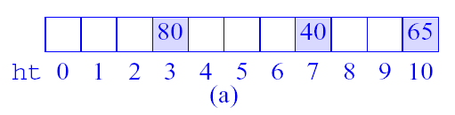after inserting the three keys 80, 40, and 65

# Linear Open Addressing

* Example
  + after inserting the two keys 58 (collision) and 24

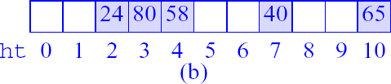

– after inserting the key 35 (collision)

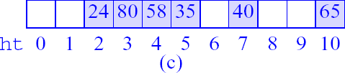

# Linear Open Addressing

* Search operation
  + The search begins at the home bucket *f(k)* of the key *k*
  + Continue the search by examining successive buckets in the table until one of the following happens:

**(c1) A bucket containing an element with key *k* is reached (c2) An empty bucket is reached**

**(c3) We return to the home bucket**

* + In the cases of (c2) and (c3), the table contains no element with key *k*

# Linear Open Addressing

* Delete operation
  + Perform the search operation to find the bucket for key *k*
  + Clear the bucket
  + Then do either one of the following:
* **Move zero or more elements to fill the empty bucket**
* **Introduce and use the NeverUsed field in each bucket**
* See Programs 10.16-10.19 for hashTable class definition and operations

# Performance of Linear Probing

|  |  |  |  |  |  |  |  |
| --- | --- | --- | --- | --- | --- | --- | --- |
| (72,e) | (33,c) |  | (3,d) |  | (85,f) | (22,a) |  |

[0] [1] [2] [3] [4] [5] [6] [7]

* The worst-case search/insert/delete time is (*n*), where n is the number of pairs in the table
* When does the worst-case happen?

→ When all n key values have the same home bucket

* For the worst case, the performance of hash table and linear list are the same
* However, for average performance, hashing is much better

# Expected (Average) Performance

|  |  |  |  |  |  |  |  |
| --- | --- | --- | --- | --- | --- | --- | --- |
| (72,e) | (33,c) |  | (3,d) |  | (85,f) | (22,a) |  |

[0] [1] [2] [3] [4] [5] [6] [7]

* **alpha** = loading factor = ***n / b***
* **Sn** = average number of buckets examined in a successful search
* **Un** = average number of buckets examined in an unsuccessful search
* Time to insert and delete is governed by **Un**.

# Expected Performance

* Sn ~ ½ (1 + 1/(1-alpha))
* Un ~ ½ (1+1/(1-alpha)2) Note that 0 <= alpha <= 1.

|  |  |  |
| --- | --- | --- |
| alpha | Sn  (buckets) | Un  (buckets) |
| 0.50 | 1.5 | 2.5 |
| 0.75 | 2.5 | 8.5 |
| 0.90 | 5.5 | 50.5 |

# Hash Table Design

* In practice, the choice of the divisor *D* (i.e., the number of buckets *b*) has a significant effect on the performance of hashing
* Best results are obtained **when D is either a prime number or has no prime factors less than 20**

## The key is how do we determine D (see the next slide)

* Read Example 10.12

# Methods for Determining *D*

**Method 1:**

* First, determine what constitutes acceptable performance.
* Use the formulas Un and Sn, determine the largest alpha that can be used.
* From the value of n and the computed value of alpha, obtain the smallest permissible value for b.

**Method 2:**

* Begin with the largest possible value for b as determined by the max. amount of space available.
* Then find the largest D no larger than this largest value that is either a prime or has no factors smaller than 20.

# Hashing with Chains

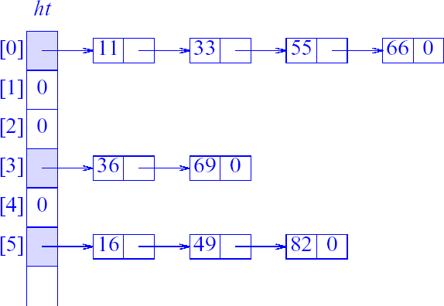

* Hash table can handle overflows using **chaining**
* Each bucket keeps a chain of all pairs for which it is the home bucket (see Figure 10.3)
* The chain may or may not be sorted by key
* See Program 10.20 for hashChains methods

# Hash Table with Sorted Chains

* 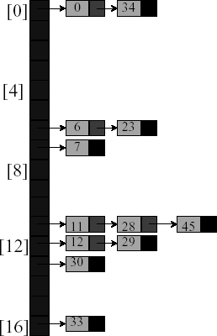Put in pairs whose keys are 6,12,34,29, 28,11,23,7,0, 33,30,45

|  |
| --- |
|  |
|  |
|  |
|  |
|  |
|  |
|  |
|  |
|  |
|  |
|  |
|  |
|  |
|  |
|  |
|  |
|  |

* Home bucket = key % 17.

# Exercise & Reading

* Exercise
  + Suppose we are hashing integers with a 7-bucket hash table using the hash function ***f(k) = k % 7*.**
  1. Show the hash table if 1, 8, 23, 40, 51, 69, 70 are to be inserted. Use the linear open addressing method to resolve collisions.
  2. Repeat part (a) using chaining to resolve collisions. Assume the chain is sorted.
* Read Chapter 10