**Fig. 11.24** Interior view of the 1.1- million hp (820-MW) turbine units on the Grand Coulee Dam of the Columbia River, showing the spiral case, the outer fixed vanes (“stay ring’’), and the inner adjustable vanes (“wicket gates’’). *(Courtesy of Allis-Chalmers Fluid Products Company*.*)*

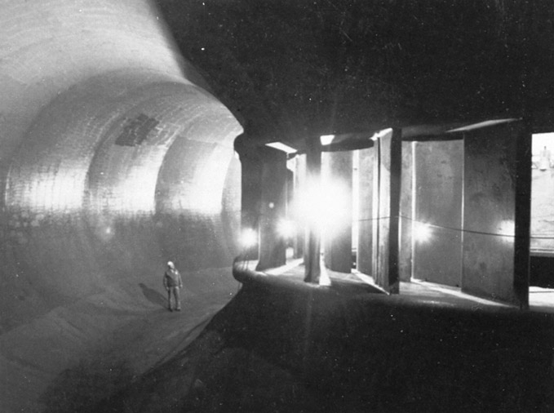

**Fig. 11.25** Impulse turbine: (*a*) side view of wheel and jet; (*b*) top view of bucket; (*c*) typical velocity diagram.

(*a*) (*c*)

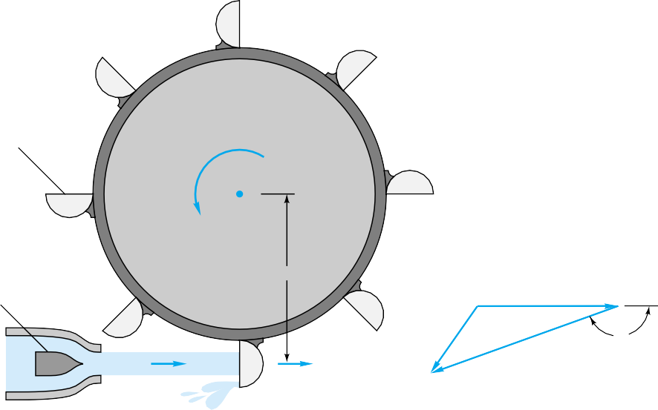

Split bucket

*Vj*

*n*,

  165˚

(*b*)

Needle valve

*r*

*u*

*w*





*Vj*

*u* = 2 *nr*

#### Figure 11.26 shows Eq. (11.41) plotted for an ideal turbine (*β* = 180°, *Cv* = 1.0) and for typical working conditions (*β* = 160°, *Cv* = 0.94). The latter case predicts

max = 85 percent at *ф* = 0.47, but the actual data for a 24-in Pelton wheel test are somewhat less efficient due to windage, mechanical friction, backsplashing, and nonuni-

1.0



0.8

0.6



0.4

**Fig. 11.26** Efficiency of an impulse turbine calculated from Eq. (11.41): solid curve = ideal, *β* = 180°,

*Cv* = 1.0; dashed curve = actual,

*β* = 160°, *Cv* = 0.94; open circles

0.2

0

0.2 0.4 0.6 0.8 1.0

= data, Pelton wheel, diameter =

2 ft.

 = *u*

(2*g*H)1/2

#### form bucket flow. For this test max = 80 percent, and, generally speaking, an impulse turbine is not quite as efficient as the Francis or propeller turbines at their BEPs.

Figure 11.27 shows the optimum efficiency of the three turbine types, and the im- portance of the power specific speed *Nsp* as a selection tool for the designer. These ef- ficiencies are optimum and are obtained in careful design of large machines.

#### The water power available to a turbine may vary due to either net-head or flow-rate changes, both of which are common in field installations such as hydroelectric plants. The demand for turbine power also varies from light to heavy, and the operating re- sponse is a change in the flow rate by adjustment of a gate valve or needle valve (Fig. 11.25*a*). As shown in Fig. 11.28, all three turbine types achieve fairly uniform effi- ciency as a function of the level of power being extracted. Especially effective is the adjustable-blade (Kaplan-type) propeller turbine, while the poorest is a fixed-blade pro- peller. The term *rated power* in Fig. 11.28 is the largest power delivery guaranteed by the manufacturer, as opposed to *normal power*, which is delivered at maximum effi- ciency.

For further details of design and operation of turbomachinery, the readable and in- teresting treatment in Ref. 33 is especially recommended. The feasibility of micro- hydropower is discussed in [26]. See also Refs. 27 and 28.

1.0

Propeller

Francis

Impulse

 0.9

**Fig. 11.27** Optimum efficiency of turbine designs.

0.8

1

10 100 1000

*Nsp*

1.0

Kaplan (adjustable blade)

Francis

Impulse

10

Fixed-blade propeller

20

0.9

0.8



0.7

0.6

**Fig. 11.28** Efficiency versus power level for various turbine designs at constant speed and head.

0.5

0

20 40 60 80 100

Rated power, percent

### EXAMPLE 11.9

Investigate the possibility of using (*a*) a Pelton wheel similar to Fig. 11.26 or (*b*) the Francis turbine family of Fig. 11.21*d* to deliver 30,000 bhp from a net head of 1200 ft.

### Part (a)

**Solution**

From Fig. 11.27, the most efficient Pelton wheel occurs at about

(r/min)(30,000 bhp)1/2

*N* ≈ 4.5 = ———

*sp* 1.25

(1200 ft)

or *n* = 183 r/min = 3.06 r/s

From Fig. 11.26 the best operating point is

*πD*(3.06 r/s)

≈ 1/2

*ф* 0.47 = ——

[2(32.2)(1200)]

or *D* = 13.6 ft *Ans. (a)*

This Pelton wheel is perhaps a little slow and a trifle large. You could reduce *D* and increase *n* by increasing *Nsp* to, say, 6 or 7 and accepting the slight reduction in efficiency. Or you could use a double-hung, two-wheel configuration, each delivering 15,000 bhp, which changes *D* and *n* by the factor 21/2:

Double wheel: *n* = (183)2

1/2

13.6

= 260 r/min *D* = —1/2 = 9.6 ft *Ans. (a)*

2

**Part (b)** The Francis wheel of Fig. 11.21*d* must have

(r/min)(30,000 bhp)1/2

*N* = 29 = ———

*sp* 1.25

(1200 ft)

or *n* = 1183 r/min = 19.7 r/s

Then the optimum power coefficient is

*P*

*CP\** = 2.70 = —3

30,000(550)

5 = ——3 5

*pn D* (1.94)(19.7) *D*

or *D*5 = 412 *D* = 3.33 ft = 40 in *Ans. (b)*

This is a faster speed than normal practice, and the casing would have to withstand 1200 ft of water or about 520 lbf/in2 internal pressure, but the 40-in size is extremely attractive. Francis turbines are now being operated at heads up to 1500 ft.

## Wind Turbines

#### Wind energy has long been used as a source of mechanical power. The familiar four- bladed windmills of Holland, England, and the Greek islands have been used for cen- turies to pump water, grind grain, and saw wood. Modern research concentrates on the ability of wind turbines to generate electric power. Koeppl [47] stresses the potential for propeller-type machines. Spera [49] gives a detailed discussion of the technical and economic feasibility of large-scale electric power generation by wind. See also Refs. 46, 48, and 50 to 52.

Some examples of wind turbine designs are shown in Fig. 11.29. The familiar Amer- ican multiblade farm windmill (Fig. 11.29*a*) is of low efficiency, but thousands are in use as a rugged, reliable, and inexpensive way to pump water. A more efficient design is the propeller mill in Fig. 11.29*b*, similar to the pioneering Smith-Putnam 1250-kW two-bladed system which operated on Grampa’s Knob, 12 mi west of Rutland, Ver- mont, from 1941 to 1945. The Smith-Putnam design broke because of inadequate blade strength, but it withstood winds up to 115 mi/h and its efficiency was amply demon- strated [47].

#### The Dutch, American multiblade, and propeller mills are examples of *horizontal- axis wind turbines* (HAWTs), which are efficient but somewhat awkward in that they require extensive bracing and gear systems when combined with an electric generator. Thus a competing family of *vertical-axis wind turbines* (VAWTs) has been proposed which simplifies gearing and strength requirements. Figure 11.29*c* shows the “egg- beater’’ VAWT invented by G. J. M. Darrieus in 1925, now used in several govern- ment-sponsored demonstration systems. To minimize centrifugal stresses, the twisted blades of the Darrieus turbine follow a *troposkien* curve formed by a chain anchored at two points on a spinning vertical rod.

An alternative VAWT, simpler to construct than the troposkien, is the straight-bladed Darrieus-type turbine in Fig. 11.29*d*. This design, proposed by Reading University in England, has blades which pivot due to centrifugal action as wind speeds increase, thus limiting bending stresses.

#### 

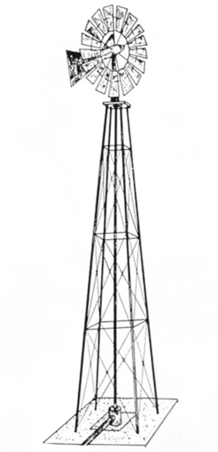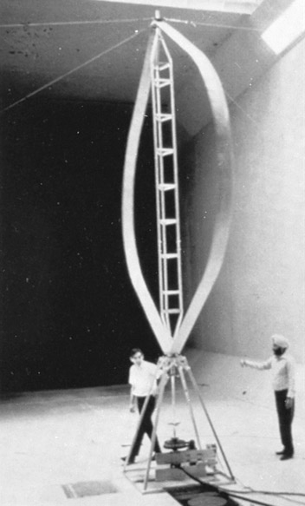

(*a*)

(*c*)

**Fig. 11.29** Wind turbine designs:

(*a*) the American multiblade farm HAWT; (*b*) propeller HAWT *(Courtesy of Grumman Aerospace Corp.)*; (*c*) the Darrieus VAWT *(Courtesy of National Research Council, Canada)*; (*d*) modified straight-blade Darrieus VAWT *(Courtesy of Reading University— Nat’l Wind Power Ltd.)*.

(*b*)

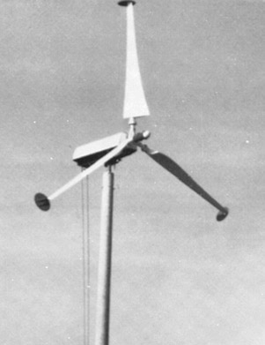

(*d*)

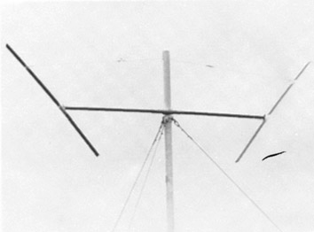

## Idealized Wind Turbine Theory

#### The ideal, frictionless efficiency of a propeller windmill was predicted by A. Betz in 1920, using the simulation shown in Fig. 11.30. The propeller is represented by an *ac- tuator disk* which creates across the propeller plane a pressure discontinuity of area *A* and local velocity *V*. The wind is represented by a streamtube of approach velocity *V*1 and a slower downstream wake velocity *V*2. The pressure rises to *pb* just before the disk and drops to *p*a just after, returning to free-stream pressure in the far wake. To hold the propeller rigid when it is extracting energy from the wind, there must be a leftward force *F* on its support, as shown.

A control-volume–horizontal-momentum relation applied between sections 1 and 2 gives

Σ *Fx* = —*F* = *m˙* (*V*2 — *V*1)

#### A similar relation for a control volume just before and after the disk gives

Σ*Fx* = —*F* + (*pb* — *pa*)*A* = *m˙* (*Va* — *Vb*) = 0 Equating these two yields the propeller force

*F* = (*pb* — *pa*)*A* = *m˙* (*V*1 — *V*2) (11.42)

#### Assuming ideal flow, the pressures can be found by applying the incompressible Bernoulli relation up to the disk

From 1 to *b*: *p∞* + —1—*pV* 2 = *p* + —1—*pV*2

2

1

*b*

2

From *a* to 2: *pa* + —1—*pV* 2 = *p* + —1—*pV* 2

2 *∞* 2 2

#### Subtracting these and noting that *m˙* = *pAV* through the propeller, we can substitute for

*pb* — *pa* in Eq. (11.42) to obtain

*pb* — *pa* = —1—*p*(*V* 2 — *V* 2) = *pV*(*V*1 — *V* )

2 1 2 2

or *V* = —1—(*V* + *V* ) (11.43)

2 1 2

Streamtube passing through propeller

*pb*

*pa*

*V*

Wind

*V*1, *p*

Wake

Swept area *A*

*V*2, *p*

*F*

**Fig. 11.30** Idealized actuator-disk and streamtube analysis of flow through a windmill.

*pb*

*p*  *p*

*p*

*pa*

0.6

0.5

0.4

*Cp* 0.3

0.2

Ideal Betz number

**Fig. 11.31** Estimated performance of various wind turbine designs as a function of blade-tip speed ratio. *(From Ref. 53.)*

0.1

0

1 2 3 4 5 6 7 8

Dutch, four-arm

Darrieus VAWT

Grumman windstream (Fig. 11.29*b*)

American multiblade

Savonius rotor

High-speed HAWT

Ideal, propeller type

Speed ratio *r*/*V*1

#### Continuity and momentum thus require that the velocity *V* through the disk equal the average of the wind and far-wake speeds.

Finally, the power extracted by the disk can be written in terms of *V*1 and *V*2 by combining Eqs. (11.42) and (11.43)

*P* = *FV* = *pAV* 2(*V*1 — *V*2) = —1—*pA*(*V* 2 — *V* 2)(*V*1 + *V*2) (11.44)

4 1 2

#### For a given wind speed *V*1, we can find the maximum possible power by differentiat- ing *P* with respect to *V*2 and setting equal to zero. The result is

*P* = *P*max = —8—*pAV* 3

at *V*

= —1—*V*

#### (11.45)

27 1 2 3 1

#### which corresponds to *V* = 2*V*1/3 through the disk.

The maximum available power to the propeller is the mass flow through the pro- peller times the total kinetic energy of the wind

*P*avail = —1—*m˙ V* 2 = —1—*pAV*3

2 1 2 1

#### Thus the maximum possible efficiency of an ideal frictionless wind turbine is usually stated in terms of the *power coefficient*

*P CP* = —

—1—*pAV* 3

#### (11.46)

2 1

#### Equation (11.45) states that the total power coefficient is

*Cp*,max = —16— = 0.593 (11.47)

27

#### This is called the *Betz number* and serves as an ideal with which to compare the ac- tual performance of real windmills.

Figure 11.31 shows the measured power coefficients of various wind turbine de- signs. The independent variable is not *V*2/*V*1 (which is artificial and convenient only in

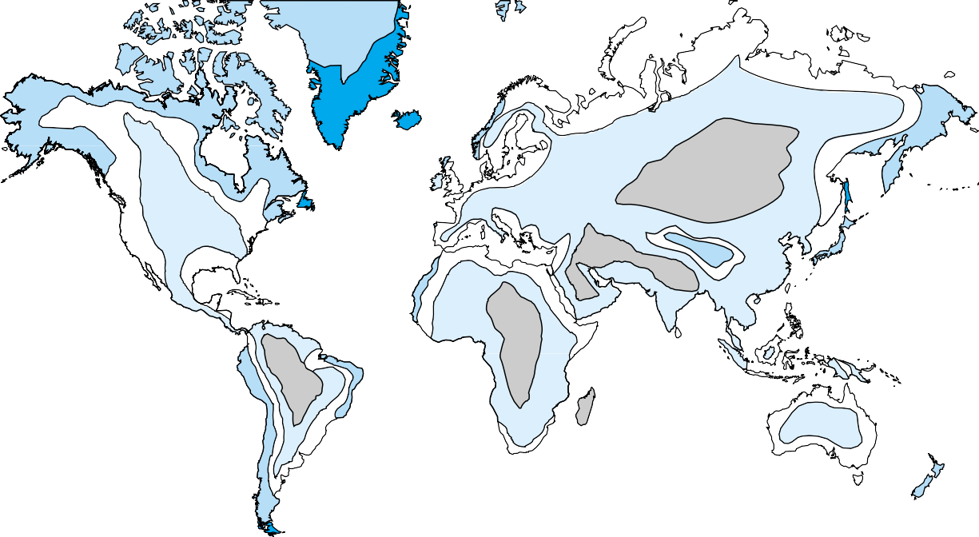

Under 750

**Fig. 11.32** World availability of land-based wind energy: estimated annual electric output in kWh/kW of a wind turbine rated at 11.2 m/s (25 mi/h). *(From Ref. 54*.*)*

750 – 2250

2250 – 3750

3750 – 5000

Over 5000

#### the ideal theory) but the ratio of blade-tip speed *ωr* to wind speed. Note that the tip can move much faster than the wind, a fact disturbing to the laity but familiar to en- gineers in the behavior of iceboats and sailing vessels. The Darrieus has the many ad- vantages of a vertical axis but has little torque at low speeds and also rotates more slowly at maximum power than a propeller, thus requiring a higher gear ratio for the generator. The Savonius rotor (Fig. 6.29*b*) has been suggested as a VAWT design be- cause it produces power at very low wind speeds, but it is inefficient and susceptible to storm damage because it cannot be feathered in high winds.

As shown in Fig. 11.32, there are many areas of the world where wind energy is an attractive alternative. Greenland, Newfoundland, Argentina, Chile, New Zealand, Ice- land, Ireland, and the United Kingdom have the highest prevailing winds, but Australia, e.g., with only moderate winds, has the potential to generate half its electricity with wind turbines [53]. In addition, since the ocean is generally even windier than the land, there are many island areas of high potential for wind power. There have also been proposals [47] for ocean-based floating windmill farms. The inexhaustible availability of the winds, coupled with improved low-cost turbine designs, indicates a bright fu- ture for this alternative.

# Summary

#### Turbomachinery design is perhaps the most practical and most active application of the principles of fluid mechanics. There are billions of pumps and turbines in use in the world, and thousands of companies are seeking improvements. This chapter discusses both positive-displacement devices and, more extensively, rotodynamic machines. With the centrifugal pump as an example, the basic concepts of torque, power, head, flow rate, and efficiency are developed for a turbomachine. Nondimensionalization leads to the pump similarity rules and some typical dimensionless performance curves for ax- ial and centrifugal machines. The single most useful pump parameter is found to be the specific speed, which delineates the type of design needed. An interesting design application is the theory of pumps combined in series and in parallel.

Turbines extract energy from flowing fluids and are of two types: impulse turbines, which convert the momentum of a high-speed stream, and reaction turbines, where the pressure drop occurs within the blade passages in an internal flow. By analogy with pumps, the power specific speed is important for turbines and is used to classify them into impulse, Francis, and propeller-type designs. A special case of reaction turbine with unconfined flow is the wind turbine. Several types of windmills are discussed and their relative performances compared.

# Problems

Most of the problems herein are fairly straightforward. More dif- ficult or open-ended assignments are labeled with an asterisk. Prob- lems labeled with an EES icon will benefit from the use of the En- gineering Equations Solver (EES), while problems labeled with a computer icon may require the use of a computer. The standard end-of-chapter problems 11.1 to 11.103 (categorized in the prob- lem list below) are followed by word problems W11.1 to W11.10, comprehensive problems C11.1 to C11.3, and design project D11.1.

**Problem distribution**

|  |  |  |
| --- | --- | --- |
| **Section** | **Topic** | **Problems** |
| 11.1 | Introduction and classification | 11.1–11.14 |
| 11.2 | Centrifugal pump theory | 11.15–11.21 |
| 11.3 | Pump performance and similarity rules | 11.22–11.41 |
| 11.3 | Net positive-suction head | 11.42–11.44 |
| 11.4 | Specific speed: Mixed- and axial-flow pumps | 11.45–11.62 |
| 11.5 | Matching pumps to system characteristics | 11.63–11.73 |
| 11.5 | Pumps in parallel or series | 11.74–11.81 |
| 11.5 | Pump instability | 11.82–11.83 |
| 11.6 | Reaction and impulse turbines | 11.84–11.99 |
| 11.6 | Wind turbines | 11.100–11.103 |

**P11.1** Describe the geometry and operation of a peristaltic pos- itive-displacement pump which occurs in nature.

**P11.2** What would be the technical classification of the fol- lowing turbomachines: (*a*) a household fan, (*b*) a wind- mill, (*c*) an aircraft propeller, (*d*) a fuel pump in a car,

(*e*) an eductor, ( *f* ) a fluid-coupling transmission, and (*g*) a power plant steam turbine?

**P11.3** A PDP can deliver almost any fluid, but there is always a limiting very high viscosity for which performance will deteriorate. Can you explain the probable reason?

**P11.4** Figure 11.2*c* shows a double-screw pump. Sketch a sin- gle-screw pump and explain its operation. How did Archimedes’ screw pump operate?

**P11.5** What type of pump is shown in Fig. P11.5? How does it operate?

##### P11.5

**P11.6** Figure P11.6 shows two points a half-period apart in the operation of a pump. What type of pump is this? How does it work? Sketch your best guess of flow rate versus time for a few cycles.

**P11.7** A piston PDP has a 5-in diameter and a 2-in stroke and operates at 750 r/min with 92 percent volumetric effi- ciency. (*a*) What is its delivery, in gal/min? (*b*) If the pump delivers SAE 10W oil at 20°C against a head of 50 ft, what horsepower is required when the overall efficiency is 84 percent?

##### P11.6



Flow out

*A B*

Flow in

Check valve

Flow out

*A B*

Flow in

in meters; and (*b*) the input power required at 75 percent efficiency.

**P11.13** A 20-hp pump delivers 400 gal/min of gasoline at 20°C with 75 percent efficiency. What head and pressure rise result across the pump?



**P11.14** A pump delivers gasoline at 20°C and 12 m3/h. At the inlet *p*1 = 100 kPa, *z*1 = 1 m, and *V*1 = 2 m/s. At the exit *p*2 = 500 kPa, *z*2 = 4 m, and *V*2 = 3 m/s. How much power is required if the motor efficiency is 75 percent?

**P11.15** A lawn sprinkler can be used as a simple turbine. As shown in Fig. P11.15, flow enters normal to the paper in the center and splits evenly into *Q*/2 and *V*rel leaving each nozzle. The arms rotate at angular velocity *ω* and do work on a shaft. Draw the velocity diagram for this turbine. Neglecting friction, find an expression for the power de- livered to the shaft. Find the rotation rate for which the power is a maximum.

**P11.8** A centrifugal pump delivers 550 gal/min of water at 20°C when the brake horsepower is 22 and the efficiency is 71 percent. (*a*) Estimate the head rise in ft and the pressure rise in lbf/in2. (*b*) Also estimate the head rise and horse- power if instead the delivery is 550 gal/min of gasoline at 20°C.

**P11.9** Figure P11.9 shows the measured performance of the Vickers model PVQ40 piston pump when delivering SAE 10W oil at 180°F (*p* ≈ 910 kg/m3). Make some general observations about these data vis-à-vis Fig. 11.2 and your intuition about the behavior of piston pumps.

**P11.10** Suppose that the piston pump of Fig. P11.9 is used to de- liver 15 gal/min of water at 20°C using 20 brake horse- power. Neglecting Reynolds-number effects, use the fig- ure to estimate (*a*) the speed in r/min and (*b*) the pressure rise in lbf/in2.

**P11.11** A pump delivers 1500 L/min of water at 20°C against a pressure rise of 270 kPa. Kinetic- and potential-energy changes are negligible. If the driving motor supplies 9 kW, what is the overall efficiency?

**P11.12** In a test of the centrifugal pump shown in Fig. P11.12, the following data are taken: *p*1 = 100 mmHg (vacuum) and *p*2 = 500 mmHg (gage). The pipe diameters are *D*1 = 12 cm and *D*2 = 5 cm. The flow rate is 180 gal/min of light oil (SG = 0.91). Estimate (*a*) the head developed,



EES



*Q* , *V*rel

2

*R*

*Q*

*R*

⬥

*Q* , *V*rel

2

##### P11.15

**P11.16** For the “sprinkler turbine’’ of Fig. P11.15, let *R* = 18 cm, with total flow rate of 14 m3/h of water at 20°C. If the noz- zle exit diameter is 8 mm, estimate (*a*) the maximum power delivered in W and (*b*) the appropriate rotation rate in r/min.

**P11.17** A centrifugal pump has *d*1 = 7 in, *d*2 = 13 in, *b*1 = 4 in,

*b*2 = 3 in, *β*1 = 25°, and *β*2 = 40° and rotates at 1160 r/min. If the fluid is gasoline at 20°C and the flow enters the blades radially, estimate the theoretical (*a*) flow rate in gal/min, (*b*) horsepower, and (*c*) head in ft.

**P11.18** A jet of velocity *V* strikes a vane which moves to the right at speed *Vc*, as in Fig. P11.18. The vane has a turning angle *θ*.

(2)



, *V*, *A*

❑

*Vc*

65 cm

##### P11.12

(1)

##### P11.18

100

210 bar

140 bar

70 bar

35 bar

210 bar - 3000 lb/in2

140 bar - 2000 lb/in2

70 bar - 1000 lb/in2

35 bar - 500 lb/in2

35 bar

70 bar

140 bar

210 bar

210 bar

140 bar

70 bar

35 bar

Pump displacement: 41 cm3/r

Volumetric efficiency, percent

80

60

40

100 20

80 0

Overall efficiency, percent

60

40

95

20

76

0

Delivery, L/min

57

38

19

60 0

Input power, kW

45

30

**Fig. P11.9** Performance of the

model PVQ40 piston pump deliv- 15

ering SAE 10W oil at 180°F.

*(Courtesy of Vickers Inc.,* 0

*PDN/PACE Division.)*

500

1000

Speed, r/min

1500

2000

Derive an expression for the power delivered to the vane by the jet. For what vane speed is the power maximum?

**P11.19** A centrifugal pump has *r*2 = 9 in, *b*2 = 2 in, and *β*2 =

35° and rotates at 1060 r/min. If it generates a head of 180 ft, determine the theoretical (*a*) flow rate in gal/min and (*b*) horsepower. Assume near-radial entry flow.

**P11.20** Suppose that Prob. 11.19 is reversed into a statement of the theoretical power *Pw* ≈ 153 hp. Can you then com- pute the theoretical (*a*) flow rate and (*b*) head? Explain and resolve the difficulty which arises.

**P11.21** The centrifugal pump of Fig. P11.21 develops a flow rate of 4200 gal/min of gasoline at 20°C with near-radial absolute

##### P11.21

2 in

30

1750 r/min

4 in

3 in



100 30

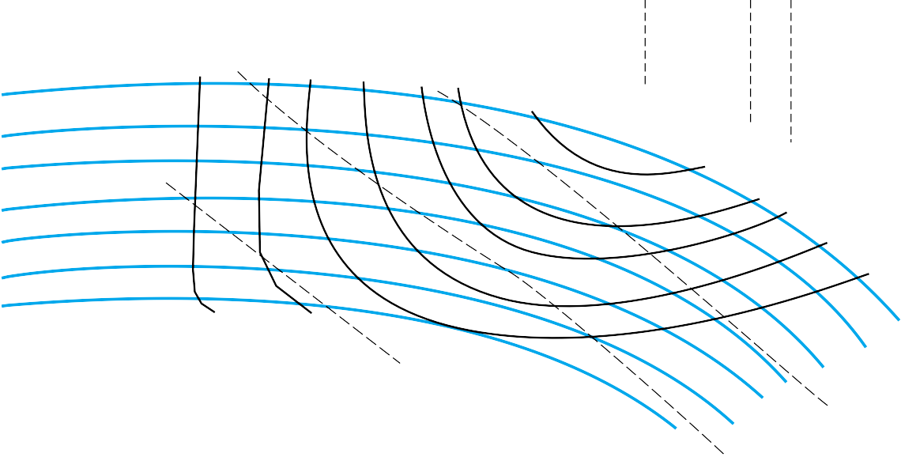

***aco***

5

**Model 4013**

**FM Series**

**1160 RPM Curve No. 806**

**Min. Imp. Dia. 10.0**

**Sizes 5 x 4 x13**

10

15

20

25

30

35

3 4

40

5

45 L/s 50

6

NPSH, ft

12.95 in

50% 60% 65% 70%

74% 76%

78% 79%

12.50 in

12.00 in

80%

11.50 in

11.00 in

10.50 in

10.00 in

79%

78%

76%

74%

70%

65%

60%

5 bhp

50%

10 bhp

Curves based on clear water with specific gravity of 1.0

7.5 bhp

80 25

20

60

Head, ft

15

40

10

20

5

0

0 100

200

300

400

Flow, gal/min

500

600

700

0

800

**Fig. P11.24** Performance data for a centrifugal pump. *(Courtesy of Taco, Inc., Cranston, Rhode Island.)*

inflow. Estimate the theoretical (*a*) horsepower, (*b*) head rise, and (*c*) appropriate blade angle at the inner radius.

**P11.22** A 37-cm-diameter centrifugal pump, running at 2140 r/min with water at 20°C, produces the following per- formance data:

|  |  |  |  |  |  |  |  |
| --- | --- | --- | --- | --- | --- | --- | --- |
| *Q,* m3/s | 0.0 | 0.05 | 0.10 | 0.15 | 0.20 | 0.25 | 0.30 |
| *H*, m | 105 | 104 | 102 | 100 | 95 | 85 | 67 |
| *P*, kW | 100 | 115 | 135 | 171 | 202 | 228 | 249 |

(*a*) Determine the best efficiency point. (*b*) Plot *CH* ver- sus *CQ*. (*c*) If we desire to use this same pump family to deliver 7000 gal/min of kerosine at 20°C at an input power of 400 kW, what pump speed (in r/min) and impeller size (in cm) are needed? What head will be developed?

**P11.23** If the 38-in-diameter pump of Fig. 11.7*b* is used to de- liver 20°C kerosine at 850 r/min and 22,000 gal/min, what

(*a*) head and (*b*) brake horsepower will result?

**P11.24** Figure P11.24 shows performance data for the Taco, Inc., model 4013 pump. Compute the ratios of measured shut- off head to the ideal value *U*2/*g* for all seven impeller sizes. Determine the average and standard deviation of this ratio and compare it to the average for the six im- pellers in Fig. 11.7.

**P11.25** At what speed in r/min should the 35-in-diameter pump of Fig. 11.7*b* be run to produce a head of 400 ft at a dis- charge of 20,000 gal/min? What brake horsepower will be required? *Hint:* Fit *H*(*Q*) to a formula.

**P11.26** Determine if the seven Taco, Inc., pump sizes in Fig. P11.24 can be collapsed into a single dimensionless chart

140

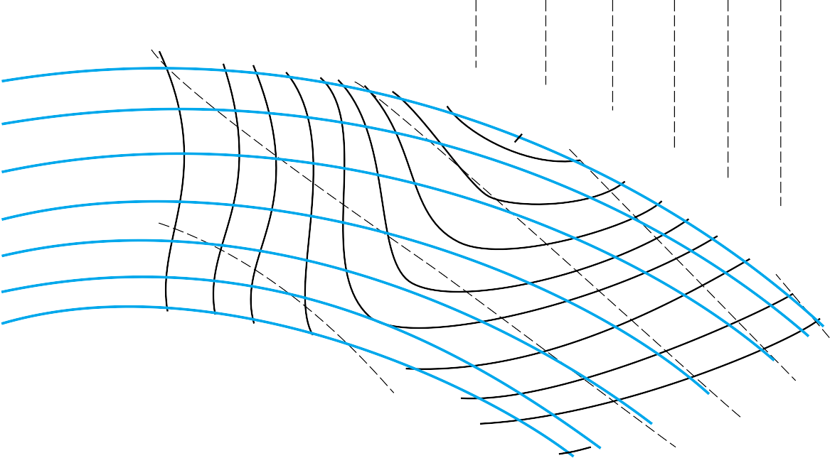

***aco***

10

20

**Model 4010**

**CM & FM Series**

30

10

NPSH, ft

**1760 RPM Curve No.756**

**Min. Imp. Dia. 7.70**

**Sizes 5 x 4 x10**

40

12

50

14

60

16

18

20

70 L/s

22

50%

10.40 in

60% 65% 70% 74%

78% 80%

10.00 in

82%

83%

9.50 in

82%

80%

9.00 in

78%

76%

8.50 in 74%

70%

8.00 in

7.70 in

65%

60%

30 bhp

25 bhp

Curves based on clear water with specific gravity of 1.0

10 bhp

20 bhp

50%

15 bhp

120

100

Head, ft

80

60

40

200

40

35

30

Head, m

25

20

15

10

125 250 375 500 625 750 875 1000 1125 1250

Flow, gal/min

**Fig. P11.31** Performance data for a family of centrifugal pump impellers. *(Courtesy of Taco, Inc., Cranston, Rhode Island*.*)*

of *CH*, *CP*, and versus *CQ*, as in Fig. 11.8. Comment on the results.

**P11.27** The 12-in pump of Fig. P11.24 is to be scaled up in size to provide a head of 90 ft and a flow rate of 1000 gal/min at BEP. Determine the correct (*a*) impeller diameter, (*b*) speed in r/min, and (*c*) horsepower required.



EES

**P11.28** Tests by the Byron Jackson Co. of a 14.62-in-diameter centrifugal water pump at 2134 r/min yield the follow- ing data:

|  |  |  |  |  |  |  |
| --- | --- | --- | --- | --- | --- | --- |
| *Q*, ft3/s | 0 | 2 | 4 | 6 | 8 | 10 |
| *H*, ft | 340 | 340 | 340 | 330 | 300 | 220 |
| bhp | 135 | 160 | 205 | 255 | 330 | 330 |

What is the BEP? What is the specific speed? Estimate the maximum discharge possible.

**P11.29** If the scaling laws are applied to the pump of Prob.

11.28 for the same impeller diameter, determine (*a*) the speed for which the shutoff head will be 280 ft, (*b*) the speed for which the BEP flow rate will be 8.0 ft3/s, and

(*c*) the speed for which the BEP conditions will require 80 hp.

**P11.30** A pump from the same family as Prob. 11.28 is built with *D* = 18 in and a BEP power of 250 hp for *gasoline* (not water). Using the scaling laws, estimate the resulting (*a*) speed in r/min, (*b*) flow rate at BEP, and (*c*) shutoff head.

**P11.31** Figure P11.31 shows performance data for the Taco, Inc., model 4010 pump. Compute the ratios of measured shut- off head to the ideal value *U*2/*g* for all seven impeller sizes. Determine the average and standard deviation of this ratio, and compare it to the average of 0.58 ± 0.02 for the seven impellers in Fig. P11.24. Comment on your results.

**P11.32** Determine if the seven Taco, Inc., impeller sizes in Fig. P11.31 can be collapsed into a single dimensionless chart of *CH*, *CP*, and versus *CQ*, as in Fig. 11.8. Comment on the results.

**P11.33** Clearly the maximum efficiencies of the pumps in Figs. P11.24 and P11.31 decrease with impeller size. Compare

max for these two pump families with both the Moody and the Anderson correlations, Eqs. (11.29). Use the cen- tral impeller size as a comparison point.

**P11.34** You are asked to consider a pump geometrically similar to the 9-in-diameter pump of Fig. P11.31 to deliver 1200 gal/min at 1500 r/min. Determine the appropriate (*a*) im- peller diameter, (*b*) BEP horsepower, (*c*) shutoff head, and (*d*) maximum efficiency. The fluid is kerosine, not water.

**P11.35** An 18-in-diameter centrifugal pump, running at 880 r/min with water at 20°C, generates the following per- formance data:

|  |  |  |  |  |  |  |
| --- | --- | --- | --- | --- | --- | --- |
| *Q*, gal/min | 0.0 | 2000 | 4000 | 6000 | 8000 | 10,000 |
| *H*, ft | 92 | 89 | 84 | 78 | 68 | 50 |
| *P*, hp | 100 | 112 | 130 | 143 | 156 | 163 |

Determine (*a*) the BEP, (*b*) the maximum efficiency, and

1. the specific speed. (*d*) Plot the required input power versus the flow rate.

**P11.36** Plot the dimensionless performance curves for the pump of Prob. 11.35 and compare with Fig. 11.8. Find the ap- propriate diameter in inches and speed in r/min for a geo- metrically similar pump to deliver 400 gal/min against a head of 200 ft. What brake horsepower would be re- quired?

**P11.37** The efficiency of a centrifugal pump can be approximated by the curve fit ≈ *aQ* — *bQ*3, where *a* and *b* are con- stants. For this approximation, (*a*) what is the ratio of *Q*\*

at BEP to *Q* ? If the maximum efficiency is 88 per-

14.0 to 18.0 lbf/in2 absolute using an 800-hp motor at 3550 r/min. What is the overall efficiency? What will the flow rate and Δ*p* be at 3000 r/min? Estimate the diame- ter of the impeller.

**P11.40** The specific speed *Ns*, as defined by Eqs. (11.30), does not contain the impeller diameter. How then should we size the pump for a given *Ns*? Logan [7] suggests a pa- rameter called the *specific diameter Ds*, which is a di- mensionless combination of *Q*, *gH*, and *D*. (*a*) If *Ds* is proportional to *D*, determine its form. (*b*) What is the re- lationship, if any, of *Ds* to *CQ*\*, *CH*\*, and *CP*\*? (*c*) Esti- mate *Ds* for the two pumps of Figs. 11.8 and 11.13.

**P11.41** It is desired to build a centrifugal pump geometrically similar to that of Prob. 11.28 to deliver 6500 gal/min of gasoline at 20°C at 1060 r/min. Estimate the resulting (*a*) impeller diameter, (*b*) head, (*c*) brake horsepower, and

1. maximum efficiency.

**P11.42** An 8-in model pump delivering 180°F water at 800 gal/min and 2400 r/min begins to cavitate when the inlet pressure and velocity are 12 lbf/in2 absolute and 20 ft/s, respectively. Find the required NPSH of a prototype which is 4 times larger and runs at 1000 r/min.

**P11.43** The 28-in-diameter pump in Fig. 11.7*a* at 1170 r/min is used to pump water at 20°C through a piping system at 14,000 gal/min. (*a*) Determine the required brake horsepower. The average friction factor is 0.018. (*b*) If there is 65 ft of 12-in- diameter pipe upstream of the pump, how far below the sur- face should the pump inlet be placed to avoid cavitation?

**P11.44** The pump of Prob. 11.28 is scaled up to an 18-in diam- eter, operating in water at best efficiency at 1760 r/min. The measured NPSH is 16 ft, and the friction loss be- tween the inlet and the pump is 22 ft. Will it be sufficient to avoid cavitation if the pump inlet is placed 9 ft below the surface of a sea-level reservoir?

**P11.45** Determine the specific speeds of the seven Taco, Inc., pump impellers in Fig. P11.24. Are they appropriate for

max

1 4 centrifugal designs? Are they approximately equal within

cent, what is the efficiency at (*b*) —3—*Q*max and (*c*) —3—*Q*\*?

**P11.38** A 6.85-in pump, running at 3500 r/min, has the follow- ing measured performance for water at 20°C:



EES

|  |  |  |  |  |  |  |  |  |  |
| --- | --- | --- | --- | --- | --- | --- | --- | --- | --- |
| *Q*, gal/min | 50 | 100 | 150 | 200 | 250 | 300 | 350 | 400 | 450 |
| *H*, ft | 201 | 200 | 198 | 194 | 189 | 181 | 169 | 156 | 139 |
| , % | 29 | 50 | 64 | 72 | 77 | 80 | 81 | 79 | 74 |

(*a*) Estimate the horsepower at BEP. If this pump is rescaled in water to provide 20 bhp at 3000 r/min, de- termine the appropriate (*b*) impeller diameter, (*c*) flow rate, and (*d*) efficiency for this new condition.

**P11.39** The Allis-Chalmers D30LR centrifugal compressor de- livers 33,000 ft3/min of SO2 with a pressure change from

experimental uncertainty? If not, why not?

**P11.46** The answer to Prob. 11.40 is that the dimensionless “spe- cific diameter” takes the form *Ds* = *D*(*gH*\*)1/4/*Q*\*1/2, evaluated at the BEP. Data collected by the author for 30 different pumps indicate, in Fig. P11.46, that *Ds* corre- lates well with specific speed *Ns*. Use this figure to esti- mate the appropriate impeller diameter for a pump which delivers 20,000 gal/min of water and a head of 400 ft when running at 1200 r/min. Suggest a curve-fit formula to the data. *Hint*: Use a hyperbolic formula.

**P11.47** A typical household basement sump pump provides a discharge of 5 gal/min against a head of 15 ft. Estimate

(*a*) the maximum efficiency and (*b*) the minimum horse- power required to drive such a pump at 1750 r/min.

20



|  |  |  |  |  |  |  |
| --- | --- | --- | --- | --- | --- | --- |
|  |  |  |  |  |  |  |
|  | Data from 30 different pump designs | | | | |  |
|  |  |  |  |  |  |  |
|  |  |  |  |  |  |  |
|  |  |  |  |  |  |  |
|  |  |  |  |  |  |  |
|  |  |  |  |  |  |  |
|  |  |  |  |  |  |  |
|  |  |  |  |  |  |  |
|  |  |  |  |  |  |  |

18

16

14

12

*Ds* 10

8

6

4

2

0

0

500

1000 1500 2000 2500 3000 3500

*Ns*

2

1.8

1.6

1.4

1.2

*C*\*

1

*P*

0.8

0.6

0.4

0.2

0

|  |  |  |  |  |  |  |
| --- | --- | --- | --- | --- | --- | --- |
|  |  |  |  |  |  |  |
|  | Data from 30 different pump designs | | | | |  |
|  |  |  |  |  |  |  |
|  |  |  |  |  |  |  |
|  |  |  |  |  |  |  |
|  |  |  |  |  |  |  |
|  |  |  |  |  |  |  |
|  |  |  |  |  |  |  |
|  |  |  |  |  |  |  |
|  |  |  |  |  |  |  |

0 500 1000 1500 2000 2500 3000 3500



*Ns*

**Fig. P11.46** Specific diameter at BEP for 30 commer- cial pumps.

**P11.48** Compute the specific speeds for the pumps in Probs. 11.28, 11.35, and 11.38 plus the median sizes in Figs. P11.24 and P11.31. Then determine if their maximum ef- ficiencies match the values predicted in Fig. 11.14.

**P11.49** Data collected by the author for flow coefficient at BEP for 30 different pumps are plotted versus specific speed in Fig. P11.49. Determine if the values of *C*\*Q for the five

pumps in Prob. 11.48 also fit on this correlation. If so,

suggest a curve-fitted formula for the data.



|  |  |
| --- | --- |
|  | 0.400 |
| 0.350 |
| 0.300 |
| 0.250 |
| *C*\*  *Q* | 0.200 |
|  | 0.150 |
|  | 0.100 |
|  | 0.050 |
|  | 0.000 |

|  |  |  |  |  |  |  |
| --- | --- | --- | --- | --- | --- | --- |
|  |  |  |  |  |  |  |
|  | Data from 30 different pump designs | | | | |  |
|  |  |  |  |  |  |  |
|  |  |  |  |  |  |  |
|  |  |  |  |  |  |  |
|  |  |  |  |  |  |  |
|  |  |  |  |  |  |  |
|  |  |  |  |  |  |  |

0 500 1000 1500 2000 2500 3000 3500

*NS*

**Fig. P11.49** Flow coefficient at BEP for 30 commercial pumps.

**P11.50** Data collected by the author for power coefficient at BEP for 30 different pumps are plotted versus specific speed in Fig. P11.50. Determine if the values of *C* \**P* for the five pumps in Prob. 11.48 also fit on this correlation. If so, suggest a curve-fitted formula for the data.

**P11.51** An axial-flow pump delivers 40 ft3/s of air which enters at 20°C and 1 atm. The flow passage has a 10-in outer radius and an 8-in inner radius. Blade angles are *α*1 = 60° and *β*2 = 70°, and the rotor runs at 1800 r/min. For the first stage compute (*a*) the head rise and (*b*) the power required.

**Fig. P11.50** Power coefficient at BEP for 30 commer- cial pumps.

**P11.52** An axial-flow fan operates in sea-level air at 1200 r/min and has a blade-tip diameter of 1 m and a root diameter of 80 cm. The inlet angles are *α*1 = 55° and *β*1 = 30°, while at the outlet *β*2 = 60°. Estimate the theoretical val- ues of the (*a*) flow rate, (*b*) horsepower, and (*c*) outlet angle *α*2.

**P11.53** If the axial-flow pump of Fig. 11.13 is used to deliver 70,000 gal/min of 20°C water at 1170 r/min, estimate (*a*) the proper impeller diameter, (*b*) the shutoff head, (*c*) the shutoff horsepower, and (*d*) Δ*p* at best efficiency.

**P11.54** The Colorado River Aqueduct uses Worthington Corp. pumps which deliver 200 ft3/s at 450 r/min against a head of 440 ft. What types of pump are these? Estimate the impeller diameter.

**P11.55** We want to pump 70°C water at 20,000 gal/min and 1800 r/min. Estimate the type of pump, the horsepower re- quired, and the impeller diameter if the required pressure rise for one stage is (*a*) 170 kPa and (*b*) 1350 kPa.

**P11.56** A pump is needed to deliver 40,000 gal/min of gasoline at 20°C against a head of 90 ft. Find the impeller size, speed, and brake horsepower needed to use the pump families of (*a*) Fig. 11.8 and (*b*) Fig. 11.13. Which is the better design?

**P11.57** Performance data for a 21-in-diameter air blower running at 3550 r/min are as follows:

|  |  |  |  |  |  |
| --- | --- | --- | --- | --- | --- |
| Δ*p*, inH2O | 29 | 30 | 28 | 21 | 10 |
| *Q*, ft3/min | 500 | 1000 | 2000 | 3000 | 4000 |
| bhp | 6 | 8 | 12 | 18 | 25 |

Note the fictitious expression of pressure rise in terms of water rather than air. What is the specific speed? How does the performance compare with Fig. 11.8? What are *CQ*\*, *CH*\*, and *C* \**P*?

**P11.58** The Worthington Corp. model A-12251 water pump, op- erating at maximum efficiency, produces 53 ft of head at



3500 r/min, 1.1 bhp at 3200 r/min, and 60 gal/min at 2940

r/min. What type of pump is this? What is its efficiency, 4 m

Pump

3 m

8 m

and how does this compare with Fig. 11.14? Estimate the impeller diameter.

**P11.59** Suppose it is desired to deliver 700 ft3/min of propane gas (molecular weight = 44.06) at 1 atm and 20°C with a single-stage pressure rise of 8.0 inH2O. Determine the

##### P11.66

20 m

12 m

appropriate size and speed for using the pump families of (*a*) Prob. 11.57 and (*b*) Fig. 11.13. Which is the bet- ter design?

**P11.60** A 45-hp pump is desired to generate a head of 200 ft when running at BEP with 20°C gasoline at 1200 r/min. Using the correlations in Figs. P11.49 and P11.50, de- termine the appropriate (*a*) specific speed, (*b*) flow rate, and (*c*) impeller diameter.

**P11.61** A mine ventilation fan, running at 295 r/min, delivers 500 m3/s of sea-level air with a pressure rise of 1100 Pa. Is this fan axial, centrifugal, or mixed? Estimate its diame- ter in ft. If the flow rate is increased 50 percent for the same diameter, by what percentage will the pressure rise change?

**P11.62** The actual mine ventilation fan discussed in Prob. 11.61 had a diameter of 20 ft [20, p. 339]. What would be the proper diameter for the pump family of Fig. 11.14 to pro- vide 500 m3/s at 295 r/min and BEP? What would be the resulting pressure rise in Pa?

**P11.63** The 36.75-in pump in Fig. 11.7*a* at 1170 r/min is used  to pump water at 60°F from a reservoir through 1000 ft of 12-in-ID galvanized-iron pipe to a point 200 ft above

the reservoir surface. What flow rate and brake horse- power will result? If there is 40 ft of pipe upstream of the pump, how far below the surface should the pump in- let be placed to avoid cavitation?

**P11.64** In Prob. 11.63 the operating point is off design at an ef- ficiency of only 77 percent. Is it possible, with the sim- ilarity rules, to change the pump rotation speed to deliver the water near BEP? Explain your results.

**P11.65** The 38-in pump of Fig. 11.7*a* is used in series to lift 20°C water 3000 ft through 4000 ft of 18-in-ID cast-iron pipe. For most efficient operation, how many pumps in series are needed if the rotation speed is (*a*) 710 r/min and (*b*) 1200 r/min?

**P11.66** It is proposed to run the pump of Prob. 11.35 at 880 r/min to pump water at 20°C through the system in Fig. P11.66. The pipe is 20-cm-diameter commercial steel. What flow rate in ft3/min will result? Is this an efficient application?

**P11.67** The pump of Prob. 11.35, running at 880 r/min, is to pump water at 20°C through 75 m of horizontal galva- nized-iron pipe. All other system losses are neglected.



EES

Determine the flow rate and input power for (*a*) pipe di- ameter = 20 cm and (*b*) the pipe diameter found to yield maximum pump efficiency.

**P11.68** A 24-in pump is homologous to the 32-in pump in Fig. 11.7*a*. At 1400 r/min this pump delivers 12,000 gal/min of water from one reservoir through a long pipe to an- other 50 ft higher. What will the flow rate be if the pump speed is increased to 1750 r/min? Assume no change in pipe friction factor or efficiency.

**P11.69** The pump of Prob. 11.38, running at 3500 r/min, is used to deliver water at 20°C through 600 ft of cast-iron pipe to an elevation 100 ft higher. Determine (*a*) the proper pipe diameter for BEP operation and (*b*) the flow rate which results if the pipe diameter is 3 in.

**P11.70** The pump of Prob. 11.28, operating at 2134 r/min, is used with 20°C water in the system of Fig. P11.70. (*a*) If it is operating at BEP, what is the proper elevation *z*2? (*b*) If *z*2 = 225 ft, what is the flow rate if *d* = 8 in.?

*z* 2



*z*1 = 100 ft

Pump

1500 ft of cast-iron pipe

##### P11.70

**P11.71** The pump of Prob. 11.38, running at 3500 r/min, deliv- ers water at 20°C through 7200 ft of horizontal 5-in-di- ameter commercial-steel pipe. There are a sharp entrance, sharp exit, four 90° elbows, and a gate valve. Estimate

1. the flow rate if the valve is wide open and (*b*) the valve closing percentage which causes the pump to op- erate at BEP. (*c*) If the latter condition holds continuously for 1 year, estimate the energy cost at 10 ¢/kWh.

**P11.72** Performance data for a small commercial pump are as follows:

*Q*, gal/min 0 10 20 30 40 50 60 70

*H*, ft

75 75 74 72 68 62 47 24