**User guide for MATLAB open-source program APAS (Adaptive Piston Angular Spectrum)**

29th of November 2024, Author Mathias Myrtveit Sæther

The APAS software is easy to use and the user only needs to consider two separate files:

**APAS_main.m**

**PropertiesParent.m**

APAS_main.m is the main file which is executed in MATLAB. (The software is developed in MATLAB version 2021a). Some examples of how to extract simulation results are given in PostprocessAPAS.m. In APAS_main.m there are 12, and in PropertiesParent.m there are 11 parameters which may be set by the user.

In Fig. A, the first codelines of APAS_main.m is shown. The parameters on the codelines 16-27 may be set by the user.

*f_vec* is the frequency, *z_vec* is the receiver-source distance. *r_vec* can have two meanings: either the lateral position of the pressure point which is to be calculated; or the radius of the receiving surface which gives the average pressure over the surface. *a_vec* is the source radius. Multiple values are set in vector format (e.g *f_vec =* [500e3:2e3:600e3];)

*wavePropSetup* has several possible settings. ‘transm’ and ‘echo’ are used when the plate is immersed in fluid and the transmitted and reflected pressure is calculated, respectively. ‘freefield’ is used when the plate is absent. ‘transm1’ is used to calculate the pressure wave traveling directly through the plate, without internal reflections within the plate resonating. ‘transm2’ is used to calculate the transmitted pressure wave which is reflected one time within the plate but without resonating effects. ‘echo1’ is used to calculate the pressure wave which is directly reflected by the plate, without internal reflections within the plate resonating. ‘echo2’ is used to calculate the reflected pressure wave which is reflected one time within the plate without resonating effects.

*recAndModelType* has several possible settings. ‘transducer’ is used to calculate the average pressure over a surface with radius *r_vec*. ‘hydrophone’ is used when calculating pressure in a point. ‘diffCorrTransducer’ and ‘diffCorrHydrophone’ are used to calculate the diffraction correction over a receiver and hydrophone, respectively. ‘planeWave’ is used to calculate a normally incident plane wave. ‘KinslerAndFrey’ can be used for analytical axial calculations of the free-field pressure.

*errTresh* is the absolute local error tolerance (in Pascal) for in the numerical integration (typical value is 0.01). When eta step is less than *etaStepBreak*, the algorithm search for a nearby singularity (typical value 1e-8). etaStepInit is the initial stepsize (typical value 0.01), *integrationBoundaryDeltaAbove_h_f* set the upper integration limit above the fluid wavenumber (typical value 200, which means that the upper integration limit is h_f+200 rad/m).

*filonMethodStarts_OscPeriodCutOff_or_EtaCutoff* determines when the Filon method is used (typical value 0.1-0.2). For a value set in the range <0,10>, a low value: Filon method is executed at a low *η*, where *η* is the integration variable. For a value set outside <0,10>, Filon method is executed at the set value *η.* For *filonMethodStarts_OscPeriodCutOff_or_EtaCutoff* set to inf, the Gauss is always used, for 0, Filon is always used.

Figure A: Shows the first codelines for APAS_main.m.

In Fig. B, the first codelines of PropertiesParent.m is shown. The parameters on the codelines 4-14 may be set by the user. *rho_f* is the fluid density, v0 is the piston particle velocity, *K_f_real* is the real part fluid bulk modulus, *mu_p_real* is the real part plate shear modulus, *K_p_real* is the real part plate bulk modulus, *rho_p* is the plate density, *d* is the plate thickness, *z1* is the plate distance to piston source, *loss_K_f*, *loss_K_p*, and *loss_mu_p* set the Q value of the fluid and plate bulk moduli and the plate shear modulus, where ‘inf’ is the value to be set. ‘inf’ indicates zero loss. It the future more loss models may be implemented.

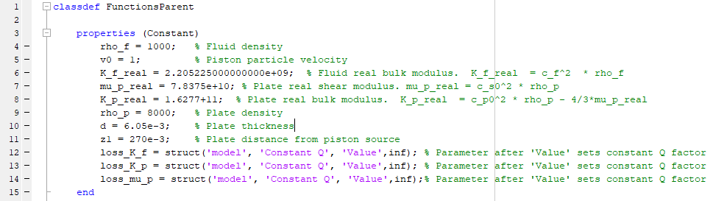

Figure B: Shows the first codelines for PropertiesParent.m.