MATHIAS EL TRIBE SUPREME COURT
OFFICE OF THE CHIEF JUSTICE & TRUSTEE

Case No. MET-SC-2025-007
(Non-Interference & Land/People Protective Judgment)

IN RE: Final Non-Interference Judgment & Protective Order
Pursuant to Treaty Authority, Tribal Constitution, International Law, and Sovereign Jurisdiction

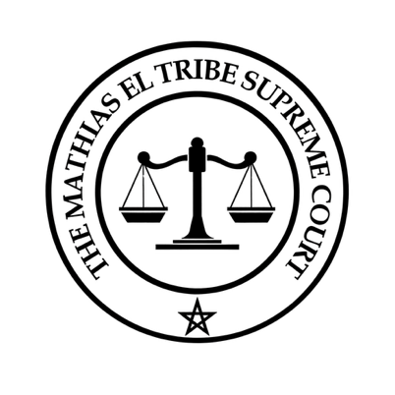
SUPPLEMENTAL PROVISIONS – TAX NON-INTERFERENCE ORDER

Incorporated into and carrying the binding force of Case No. MET-SC-2025-007, this Supplemental Order applies to taxation matters and is enforceable against:
- Internal Revenue Service (IRS)
- California Franchise Tax Board (FTB)
- Any California county or municipal tax agency

I. Findings of Law
- Taxation Bars under Treaty and Constitution
The Treaty of Dancing Rabbit Creek (1830, Article 14) is supreme per the U.S. Constitution (Art. VI, cl. 2) and prohibits taxation without tribal consent. U.S. Constitution (Art. I, § 2; 14th Amendment) historically reserves “Indians not taxed,” refusing taxation without representation.
- Property Tax Exemption under California Law
As per CA Board of Equalization Annotation 525.0010: “Land and improvements held by the government in trust for Indians are not subject to property taxation, and Indians residing thereupon are similarly not subject to such taxation.”
- Federal Protections & General Welfare Doctrine
Tribal programs for the general welfare—such as housing, social support, or healthcare—are excluded from taxable income under 26 U.S.C. § 139E and recognized by IRS guidance (Publication 519).
- Interpretive Rule Favoring Tribal Rights
Federal statutes and regulations must be construed in favor of tribal sovereignty per the Indian Canons of Construction (Montana v. Blackfeet Tribe, 471 U.S. 759 (1985)).

II. Declaratory Order

It is DECLARED that:
- IRS, FTB, and any state/local tax authority are enjoined from assessing, levying, or enforcing property, payroll, or income tax on the Mathias El Tribe, its lands, trust property, or citizens acting in official tribal capacities, absent express tribal authorization.
- Any action to the contrary is void ab initio as unlawful alienation, unenforceable under treaty, constitutional, and federal law.

III. Enforcement and Reservations
- 25 U.S.C. § 175 mandates the U.S. Attorney General’s duty to enforce tribal protections.
- This Order does not waive sovereign immunity, nor does it consent to litigation; all enumerated rights and jurisdiction remain expressly reserved under Case No. MET-SC-2025-007.

IT IS SO ORDERED AND DECREED

Dated: August 23, 2025

Chief Mathias El
Chief Justice & Trustee
Mathias El Tribe Supreme Court

CERTIFICATE OF SERVICE

Case No. MET-SC-2025-007
(Supplemental Tax Non-Interference Order)

I, Chief Mathias El, Chief Justice and Trustee of the Mathias El Tribe Supreme Court, hereby certify that on this 23rd day of August, 2025, true and correct copies of the Supplemental Tax Non-Interference Order were duly served by certified mail and electronic transmission, postage prepaid, upon the following parties:
- U.S. Department of Justice – Tax Division
Office of the Assistant Attorney General
950 Pennsylvania Avenue, NW
Washington, D.C. 20530
Email: tax.enforcement@usdoj.gov
- Internal Revenue Service – Office of Chief Counsel
Attn: Associate Chief Counsel (Procedure & Administration)
1111 Constitution Ave., NW
Washington, D.C. 20224
Email: chief.counsel@irs.gov
- Internal Revenue Service – Taxpayer Advocate Service (National Office)
1111 Constitution Ave., NW
Washington, D.C. 20224
Email: taxpayeradvocate@irs.gov
- California Franchise Tax Board – Legal Division
Attn: Chief Counsel
P.O. Box 1720
Rancho Cordova, CA 95741-1720
Email: FTB.LegalOffice@ftb.ca.gov
- California State Controller – Property Tax Post-Audit & Exemptions
300 Capitol Mall, Suite 1850
Sacramento, CA 95814
Email: sco.propertytax@controller.ca.gov

Statement of Service

Service of this instrument constitutes lawful notice and due process under tribal, federal, and constitutional law. All recipients are bound by treaty protections, the Supremacy Clause, 25 U.S.C. § 175 (Attorney General duty to represent tribes), and California BOE Annotation 525.0010, which prohibits taxation of trust lands and improvements. Any attempt to impose property, employment, or income taxation on the Tribe, its members, or its trust property absent express tribal authorization is void ab initio and subject to enforcement under this Court’s protective jurisdiction.

