NICAR 2021: Using data to report on climate change

Peter Aldhous

# Learning to love gridded climate data

The [slides](https://docs.google.com/presentation/d/1-8zQVF0kwo7uZLNuh4PqyRaoomcCzyImWu9B92Sf9qM/edit?usp=sharing) for this session introduce the concept of gridded climate data and the [widely used](https://www.unidata.ucar.edu/software/netcdf/usage.html) Network Common Data Form or [netCDF](https://www.unidata.ucar.edu/software/netcdf/) data format. Gridded data means that a geographical area has been divided into a regular grid, and then values have been assigned to each cell in that grid. Often the data has a time-series element, with a separate grid layer for each of multiple periods of time.

In the session I’ll also attempt a live demo, working with NASA’s [**Panoply**](https://www.giss.nasa.gov/tools/panoply/) software to view a netCDF file and to show how to make customized maps and animations from data like this.

## An introduction to the R raster package for working with gridded climate data

If you are willing to learn some simple code, the R [**raster**](https://rspatial.org/raster/pkg/index.html) package is very powerful, allowing you to work with gridded data in flexible ways. Below are some code examples to give you a flavor of the possibilities. You can download the data used from [here](https://paldhous.github.io/NICAR/2021/data.zip).

### Processing NASA’s GISTEMP global temperature analysis

NASA’s [GISTEMP](https://data.giss.nasa.gov/gistemp/) surface temperature analysis contains monthly temperature records from 1880 onward for a global grid with cells of 2 degrees latitude by 2 degrees longitude. The values in each cell are the difference between average temperature for that time period compared to the average for a reference period from 1951 to 1980.

The code below processes [this netCDF data](https://data.giss.nasa.gov/pub/gistemp/gistemp1200_GHCNv4_ERSSTv5.nc.gz) to the data files used to make this interactive:

An earlier version of this map first appeared in this [Apr. 22, 2019 BuzzFeed News post](https://www.buzzfeednews.com/article/peteraldhous/climate-change-maps-ice-sea-level-rise).

#### Setting up

# load required packages  
library(raster)  
library(rgdal)  
  
# load data from netCDF file as raster brick object  
temperature_monthly <- brick("data/gistemp1200_GHCNv4_ERSSTv5.nc")

In addition to **raster**, I loaded the [**rdgal**](https://rgdal.r-forge.r-project.org/) package, which connects to the [Geospatial Data Abstraction Library](https://gdal.org/). GDAL allows you to read, write, and process geodata. You may already be familiar with it if you have worked with [QGIS](https://qgis.org/en/site/).

NetCDF files often contain multiple gridded data layers, one for each time interval – in this case a layer for each month. Using the [**brick**](http://finzi.psych.upenn.edu/library/raster/html/brick.html) function, such netCDF data files can be loaded as [RasterBrick](https://rspatial.org/raster/pkg/2-classes.html" \l "rasterstack-and-rasterbrick) objects, which hold multiple data layers.

#### Making new layers for years, rather than months

The following code uses the [**stackApply**](https://search.r-project.org/library/raster/html/stackApply.html) function to run some calculations on the data to create one layer for each year, rather than each month:

# create vector to serve as index for calculating annual values  
# we need an index with 12 repeats of an index number for each of the 141 years in the data  
num_years <- rep(1:141, each = 12)  
  
# calculate annual averages, giving 141 layers one for each year 1880-2020 in the data  
temperature_annual <- stackApply(temperature_monthly, indices = num_years, fun = mean)

#### Convert to a spatial polygons data frame, then write to GeoJSON

# convert to spatial polygons data frame  
temperature_annual_df <- as(temperature_annual,"SpatialPolygonsDataFrame")  
# name the variables in the data frame as years  
names(temperature_annual_df@data) <- c(as.character(1880:2020))  
  
# write to GeoJSON  
writeOGR(temperature_annual_df, "data/temperature_annual.geojson",  
layer = "temperature", driver = "GeoJSON")

#### Make the map overlay

The code below first subsets the annual data to isolate the most recent decade, and then uses the **[calc](https://rspatial.org/raster/spatial/8-rastermanip.html?" \l "calc)** function to calculate the average temperature differences for this decade from the 1951-1980 reference period.

temperature_diff <- subset(temperature_annual, 132:141)  
temperature_diff <- calc(temperature_diff, mean, na.rm = TRUE)

#### Interpolate the data to a higher resolution and write to a GeoTIFF

We saw that the Panoply software can apply an interpolation to smooth the data so is doesn’t display as an obvious grid. We can apply a similar effect using the [**resample**](http://search.r-project.org/library/raster/html/resample.html) function. Be cautious with such interpolations: I was comfortable doing this to provide a less jarring appearance for the map overlay, but I would not have done this for the data displayed on the charts.

# create a raster object with the same extent but higher resolution   
r <- raster(nrow = 1800, ncol = 3600, extent(c(-180, 180, -90, 90)))   
# resample the data using this raster   
temperature_diff <- resample(temperature_diff, r, method = "bilinear")  
  
# write to GeoTIFF  
writeRaster(temperature_diff, filename="data/temperature_diff.tif", format = "GTiff", overwrite = TRUE)

I styled the GeoTIFF in QGIS and imported to [Mapbox](https://www.mapbox.com/) as a raster [tileset](https://docs.mapbox.com/studio-manual/reference/tilesets/). The GeoJSON was imported to Mapbox as a vector tileset.

The interactive map and chart was made with [Mapbox GL](https://docs.mapbox.com/mapbox-gl-js/api/) and [Highcharts](https://www.highcharts.com/). The vector tileset is queried on a map click or location search to yield the data displayed in the chart.

### Making gridded data on burn frequency from CAL FIRE’s historical fire footprints data.

For a student project at UC Berkeley J-School, we wanted to look at the distribution of rare plant species in relation to historical burn frequencies. The California Department of Forestry and Fire Protection, or CAL FIRE, maintains a geodatabase of [historical fire footprints](https://frap.fire.ca.gov/media/10969/fire19_1.zip), currently complete until 2019. The following code takes a shapefile processed from this geodatabase for a century of fires from 1920 to 2019 and uses the [**rasterize**](http://search.r-project.org/library/raster/html/rasterize.html) function to calculate the number of overlapping polygons at the center of each cell for a grid of 0.005 degrees latitude by 0.005 degrees longitude drawn across the entire state. Using “count” to summarize any variable in the data simply counts the number of polygons; other summary functions are available.

# load data from shapefile  
fire_perimeters <- shapefile("data/fire_perimeters/fire_perimeters.shp")  
  
# review variables in the data  
dplyr::glimpse(fire_perimeters@data)

## Rows: 19,336  
## Columns: 18  
## $ YEAR_ <chr> "2007", "2007", "2007", "2007", "2007", "2007", "2007", "2007…  
## $ STATE <chr> "CA", "CA", "CA", "CA", "CA", "CA", "CA", "CA", "CA", "CA", "…  
## $ AGENCY <chr> "CCO", "CCO", "USF", "CCO", "CCO", "CCO", "CCO", "CCO", "CCO"…  
## $ UNIT_ID <chr> "LAC", "LAC", "ANF", "LAC", "LAC", "LAC", "LAC", "LAC", "LAC"…  
## $ FIRE_NA <chr> "OCTOBER", "MAGIC", "RANCH", "EMMA", "CORRAL", "GORMAN", "WES…  
## $ INC_NUM <chr> "00246393", "00233077", "00000166", "00201384", "00259483", "…  
## $ ALARM_D <chr> "2007/10/21", "2007/10/22", "2007/10/20", "2007/09/11", "2007…  
## $ CONT_DA <chr> "2007/10/23", "2007/10/25", "2007/11/15", "2007/09/11", "2007…  
## $ CAUSE <int> 14, 14, 2, 14, 14, 14, 14, 14, 14, 14, 14, 14, 4, 14, 7, 2, 1…  
## $ COMMENT <chr> NA, NA, NA, NA, NA, NA, NA, NA, NA, NA, NA, NA, NA, NA, NA, N…  
## $ REPORT_ <dbl> NA, NA, 54716.00, NA, NA, NA, NA, NA, NA, NA, NA, NA, 837.00,…  
## $ GIS_ACR <dbl> 25.73671, 2824.87720, 58410.33594, 172.21495, 4707.99707, 237…  
## $ C_METHO <int> 8, 8, 7, 8, 8, 8, 8, 8, 8, 8, 8, NA, 7, 7, 2, 2, 1, 1, 1, 7, …  
## $ OBJECTI <int> 1, 1, 1, 1, 1, 1, 1, 1, 1, 1, 1, 1, 1, 1, 1, 1, 1, 1, 1, 1, 1…  
## $ FIRE_NU <chr> "00233414", "00233077", "00000166", "00201384", "00259483", "…  
## $ Shp_Lng <dbl> 1902.439, 20407.966, 169150.716, 6117.777, 22907.182, 19693.2…  
## $ Shap_Ar <dbl> 104152.78, 11431872.51, 236378245.17, 696929.17, 19052588.51,…  
## $ year <int> 2007, 2007, 2007, 2007, 2007, 2007, 2007, 2007, 2007, 2007, 2…

# raster template of grid 0.005 degrees lat and lon for bounding box around CA  
r <- raster(ncol = 2400, nrow = 2000, extent(c(-126, -113, 32, 42)))  
  
# create raster layer with number of overlapping fire footprints the center of each cell in that grid  
burn_freq <- rasterize(fire_perimeters, r, field = "Shp_Lng", fun = "count")  
  
# write to GeoTIFF   
writeRaster(burn_freq, "data/burn_frequency.geotiff", format = "GTiff", overwrite = TRUE)

#### Here is the original data displayed in QGIS showing 100 years of fire footprints around Los Angeles:

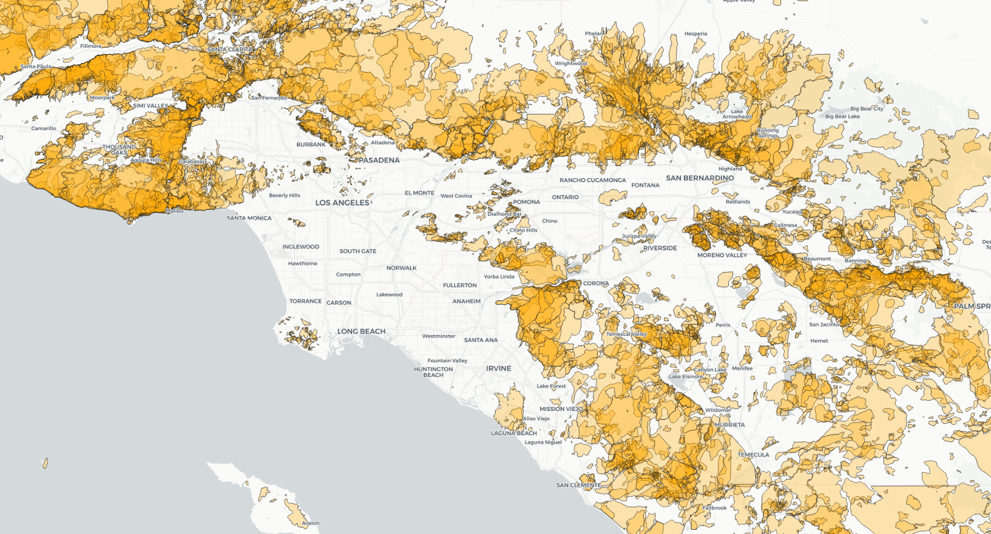

#### Here is the gridded data layer showing relative burn frequencies over the past 100 years:

