**SED Command:**

* SED command in UNIX stands for stream editor
* It can perform lots of function on file like, searching, find and replace, insertion or deletion.
* The most common use of SED command in UNIX is for substitution or for find and replace.

**Using ‘S’:**

* In the below shown screenshot, First we are viewing the content of a text file using ‘cat’ command
* Secondly, we are substituting (s) the word “unix” with “linux” using the below command
* ***sed ‘s/unix/linux/’ sample.txt***

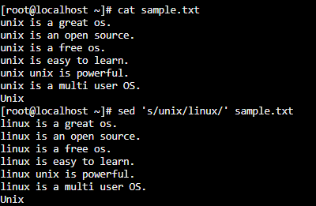

**Replacing ‘n’ the occurrence in a file:**

In the below shown screenshot, we are trying to replace the “3rd” occurrence of unix with linux in a single line.

* ***sed ‘s/unix/linux/3’ sample.txt***

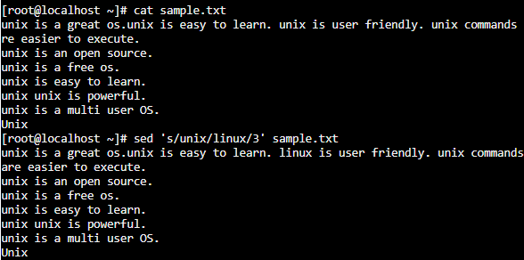

**Replacing all the occurrence of the pattern in a line:**

This can be done either by using “s” command shown in the first screen shot or like below as well.

* *sed ‘s/unix/linux/g’ sample.txt*

Here, “g” represents global replacement.

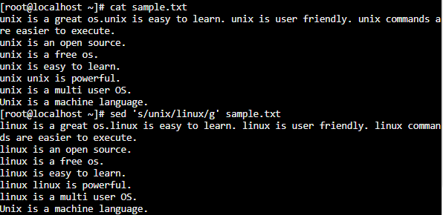

**Replacing from nth occurrence to all occurrences in a line:**

The below command replaces all the occurrences post the second occurrence.

sed ‘s/unix/linux/2g

The above command is not working properly in the simulator that i use.

**To replace the string in a particular line**

The below command replaces the occurrences in the second line only.

sed ‘2s/unix/linux/’ sample.txt

