1. **gzip command –** Command to compress the file. The file will be sufficed by .gz post compressing.

* ls –lh display all the files/directories with its size present in a parent directory
* In the below, file “speciality.txt” has a size of 803 B, when we do a gzip the file gets compressed to 75 B, with its name sufficed with .gz “speciality.txt.gz”.

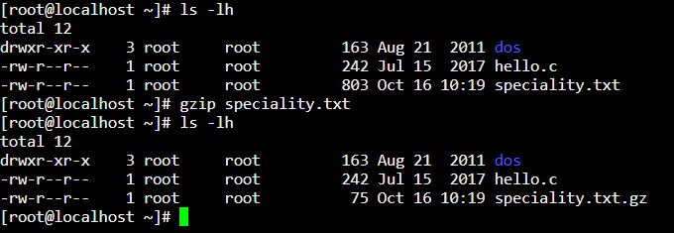

1. **zcat -** Command to view the content of the compressed file.

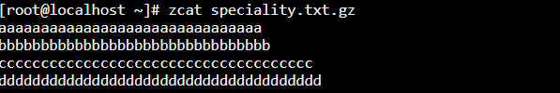

1. **gunzip –** command for uncompressing the compressed file.

In the below, the command has uncompressed the “speciality.txt.gz” to “specialty.txt” with file size back to 803 B.

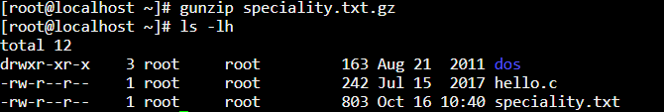

1. **tar –** command that archives an entire directory into a single file.

* **cvf** mentioned along with tar command mentions the below.
* **c** tells tar to create a new archive
* **v** tells tar to be verbose and print messages over the screen
* **f** tells tar to create given .tar file
* **/root –** Place/directory to store the .tar file

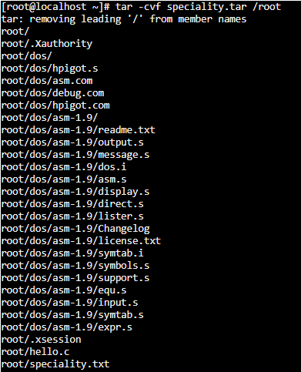

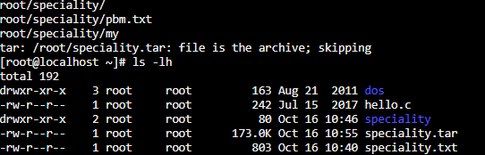

1. **Unix Pipes : Pipes are used to send an output of one command as an input to another command**

**Ex:** ls | tail -2

In the above, ls command lists all the files of the directory, piping it with tail -2 displays the last two files from the bottom

1. **tee –** command view the output and store the output in a file (using Pipe, that is mentioned above)

The below command displays output in the screen and writes the same out to a file that you mention

* ls | tee filename

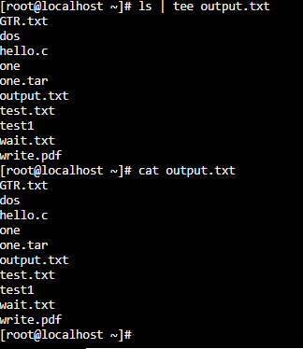

1. **grep** command - The “grep” filter searches a file for a particular pattern of characters, and displays all lines that contain that pattern.

The below is the displayed result when you do a “cat” to the file “hello.c”

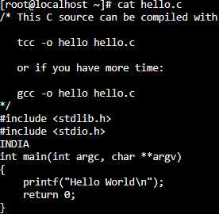

1. case insensitive search: grep –I “in” hello.c

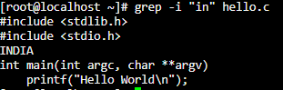

1. Displays the count of matches : grep –c “in” hello.c can find the number of lines that matches the given string/pattern

