1. **To view the running processes -**ps

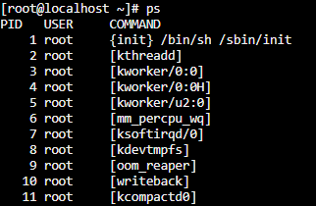

1. **Sort command**

* The below mentioned command sorts the content in ascending order

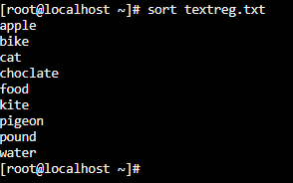

* Sort –r textreg.txt sorts the same in reverse order

1. **Escaping regular Expression characters (\, *)**

The below command prints all the lines

grep ‘$’ /root/textreg.txt

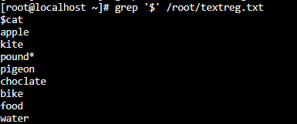

Adding a backslash (\) escapes the regular expression characters and prints the line that has only $.



1. **Line Anchors** – Commands to force a regular expression to match the start or end of a line

The below command prints all the line which has “at” present anywhere in the pattern

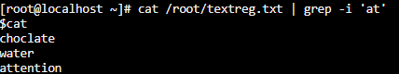

When introducing line anchors to the command, it prints the pattern that has “at” at it’s start

