**df:**

Command “df” mention us the space left in the system

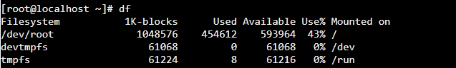

**history**

Command “history” shows you the lastly performed activites/commands:

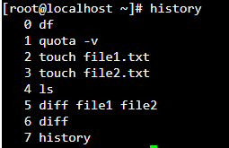

**Using wildcards (*)**

**Command :** ls file*

The above command displays all the files that starts with name file.



**Command : ls *txt**

The above command displays all the files that ends with txt.



**Appending to a file:**

The below command helps us to append the details of two files into a single file

cat file1.txt file2.txt > file3.txt

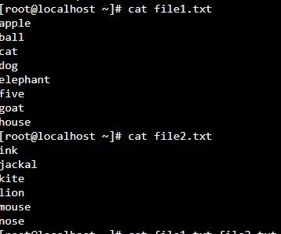

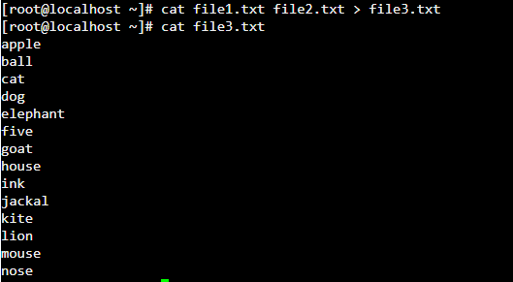

**To rename a file:**

In the below, we are trying to rename file1.txt to file4.txt

mv file1.txt file4.txt

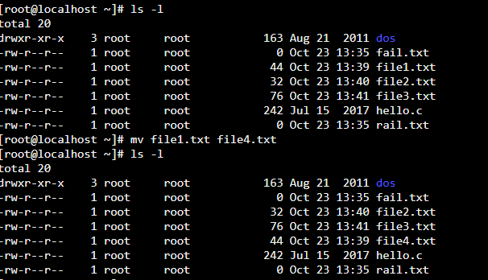

**Important Commands:**

The below are a list of some useful commands. Some of the commands may be shell dependent and may not work as expected in the current simulator that we use.

|  |  |
| --- | --- |
| **Command** | **Description** |
| ls | Lists all files and directories in the present working directory |
| ls - R | Lists files in sub-directories as well |
| ls - a | Lists hidden files as well |
| ls - al | Lists files and directories with detailed information like permissions, size, owner, etc. |
| cat > filename | Creates a new file |
| cat filename | Displays the file content |
| cat file file2 > file3 | Joins two files (file1, file2) and stores the output in a new file (file3) |
| mv  file "new file path" | Moves the files to the new location |
| mv filename new_file_name | Renames the file to a new filename |
| sudo | Allows regular users to run programs with the security privileges of the superuser or root |
| rm filename | Deletes a file |
| man | Gives help information on a command |
| history | Gives a list of all past commands typed in the current terminal session |
| clear | Clears the terminal |
| mkdir directoryname | Creates a new directory in the present working directory or a at the specified path |
| rmdir | Deletes a directory |
| mv | Renames a directory |
| pr -x | Divides the file into x columns |
| pr -h | Assigns a header to the file |
| pr -n | Denotes the file with Line Numbers |
| lp -nc  lpr c | Prints "c" copies of the File |
| lp -d lp -P | Specifies name of the printer |
| apt-get | Command used to install and update packages |
| mail -s 'subject' -c 'cc-address' -b 'bcc-address' 'to-address' | Command to send email |
| mail -s "Subject" to-address < Filename | Command to send email with attachment |