**The “AWK” :**

* Awk is a scripting language used within Unix/Linux for manipulating data and generating reports. The awk command programming language requires no compiling, and allows the user to use variables, numeric functions, string functions, and logical operators.
* Awk is abbreviated from the names of the developers – Aho, Weinberger, and Kernighan.
* By default AWK prints every line of the file.

1. The below command prints all the lines of the.txt file

awk ‘{print}’ employee.txt

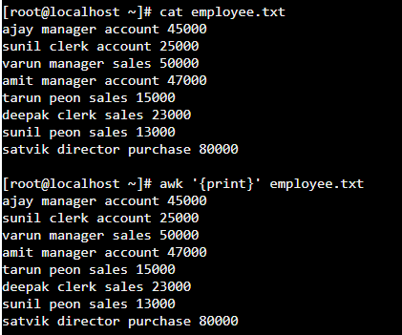

1. The below command prints the lines that matches the pattern that we search in the file.

awk ‘/manager/ {print}’ employee.txt

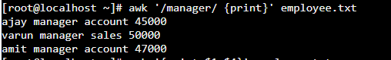

1. Splitting lines into fields.

“awk” command splits the record delimited by whitespace character by default and stores it in the $n variables.

awk ‘{print $1,$4}’ employee.txt

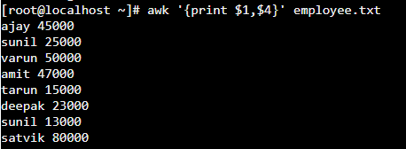

1. **Use of NR built-in variables (Displays the Line number):**

This below command is used to display line numbers along with the data.

awk ‘{print NR, $0}’ employee.txt

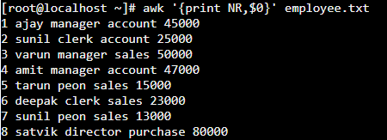

1. **Use of NF built in Variable (NF display the last field)**

awk ‘{print $1, $NF}’ employee.txt

