1. **pwd –** Displays your present working directory



1. **mkdir –** Create a new directory within a main directory



1. **ls –** To list all the files in a directory



1. **ls –l –** Displays the longlist of files (Displays the longlist of files under the root directory)

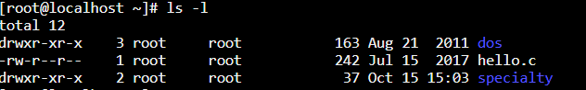

1. **rmdir –** deletes a directory from the parent directory (Directory “specialty” is deleted using command rmdir)



1. **cd –** command to change the directory (accessing directory “specialty” which is created inside the root directory)



1. **touch –** creates a new empty file (Creating “specialty.txt” inside the directory “specialty”)



1. Adding data to “speciality.txt”

a) Type vi specialty.txt and press ↵ Enter.

b) Type i to enter insert/editing mode.

c) Enter your text ("**This is a test file**").

d) Press Esc to enter command mode.

e) Type: wq and press ↵ Enter.

1. To view the content of “specialty.txt” file



1. Delete a file with an user’s confirmation prompt



* rm –f specialty.txt will forcefully delete the file without asking the user’s confirmation

1. Copy command – command to copy a file and its content

* In the below, we are copying the content of “specialty.txt” and re-creating a new file “memberservices.txt”
* Do an “ls”, it will now list two .txt files, named as above.
* Doing a “cat” command to “memberservices.txt”

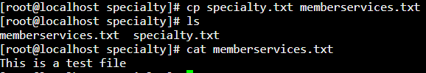

1. Move command – moving the file “specialty.txt” from directory “specialty” to “root” directory



* Change the directory from specialty to root
* Do a “ls” and you could find the file moved from directory “specialty” to “directory “root”

