Foo

**Mathieu Boudreau MSc1, Ives R. Levesque2, Nikola Stikov PhD3, G. Bruce Pike PhD1,6**

1Montreal Neurological Institute, McGill University, Montreal, Quebec, Canada

2Foo, Montreal, Quebec, Canada

3Ecole Polytechnique de Montreal, Montreal, Quebec, Canada

4Hospital for Sick Children, Toronto, Ontario, Canada

5Department of Medical Biophysics, University of Toronto, Ontario, Canada

6Hotchkiss Brain Institute and Department of Radiology, University of Calgary, Calgary, Alberta, Canada

**In submission to: Journal of Magnetic Resonance Imaging**

**Corresponding author**

Mathieu Boudreau

Room WB-325, McConnell Brain Imaging Centre

Montreal Neurological Institute

McGill University, Montreal

Quebec, Canada

H3A 2B4

E-mail: mathieu.boudreau2@mail.mcgill.ca

Phone: (438) 822-8747

**Grant support:** Funding for M.B. was provided by the National Sciences and Engineering Research Council of Canada with the Alexander Graham Bell Canada Graduate Scholarships-Doctoral program.

**Running title:** Foo

**Word count: 0 words**

**Title: Foo**

**Abstract**

**Purpose:** Foo

**Materials and Methods:** Foo

**Results:** Foo

**Conclusion:** Foo

**Keywords:** Foo1; foo2.

# INTRODUCTION

Foo (1)

Foo:

|  |  |
| --- | --- |
| $$B_{1}^{}≡\frac{α_{corr}}{α_{nom}}=\frac{\cos^{-1}\left(\frac{I_{2}}{{2I}_{1}}\right)}{α_{nom}}$$ | [1] |

Foo.

**qMTLab Tab1s**

qMTLab Tab1s (opTimizAtion for B1 inSensitivity)

It is an extension of qMTLab, a powerful, open source, scalable, easy to use and intuitive software for qMTI data simulation, fitting and analysis. The software consists of two parts: 1) a qMT data simulator 2) a qMT data fitting and visualization interface

The simulation part allows end users to easily simulate qMT data using the above described methods, evaluate how well these models perform under known parameters input, determine the most appropriate acquisition protocol and evaluate how fitting constraints impact the results. The data fitting part provides a simple interface to import real-world qMT data, fit them using the selected fitting procedure, and visualize the resulting parameters maps.

# MATERIALS AND METHODS

Foo.

**To-Do**

**Development Branch**

* Extend Sensitivity Calculation for B1 variations (constant T1)
* Add T1 signal generation
* Add T1 fitting
* Extend Sensitivity Calculation for B1 variations (VFA T1)

**Optimization Branch**

* Implement Sensitivity Analysis metrics calculations
* Write algorithm that takes a 2xN array argument (values, zSpectrumID; cell array) identifies the index of the largest (smallest?) value
* Write function that will take the index to be removed, store it in a list variable (to keep track when each point was removed),

**Analysis Branch**

* Create 2D Shepp-Logan phantom generator for specific tissue tags
* Convert extra high res shepp-logan phantom to imaging resolution, to investigate multi-tissue voxel impact
* Function that takes Shepp-Logan phantom and qMT protocol as args, and outputs the ideal qMT measured values.
* Function that takes ideal qMT Shepp-Logan set and noise level, and adds noise to images.
* qMT data fitting framework integration with qMTLab
* Script to investigate B1 errors varying homogeneously %-wise for scaled values (1%, 5%, 10%, 25%), or higher res?

Script to investigate Nominal Flip Angle assumption on qMT.

## Foo

Foo.

## Foo

Foo

# RESULTS

Foo.

# DISCUSSION

Foo.

# APPENDIX A – SENSITIVITY ANALYSIS EQUATIONS

Let’s assume that an experiment requires a set of N measurements *M*i,meas (i = 1, 2 ..., N). Fitting the data to a mathematical model, we intend that the algorithm will converge to a state where |*Mi,meas - Mi,fi*t| is minimized at each point, such that:

|  |  |  |
| --- | --- | --- |
|  | $$\left(\begin{matrix}M_{1,fit}\left(p_{1},…,p_{L}\right) \\ ⋮ \\ M_{N,fit}\left(p_{1},…,p_{L}\right)\end{matrix}\right)≅\left(\begin{matrix}M_{1,meas} \\ ⋮ \\ M_{N,meas}\end{matrix}\right)$$ | **[A1]** |

*Mi,fit* depends on a set of L model parameters $p_{k}$ (k = 1, 2, .., L). For a small error in an measured model parameter $Δp_{j,meas}$ (i.e. a calibration measurement, such as B1 in qMT), the change in each *Mi,fit* is approximated by a Taylor expansion:

|  |  |
| --- | --- |
| $${ M}_{i,fit}\left(p_{j,meas}+Δp_{j,meas}\right)=M_{i,fit}\left(p_{j,meas}\right)+\sum_{k=1}^{L}{\frac{∂M_{i,fit}}{∂p_{k}}Δp_{k}}+…$$ | **[A2]** |

The fitting algorithm will nonetheless aim at producing a good fit ([Eq. A1]), thus the following approximations can be reasonably expected:

|  |  |  |
| --- | --- | --- |
|  | $$M_{i,fit}\left(p_{j,meas}+Δp_{j,meas}\right)≅M_{i,meas}≡M_{i}$$ | **[A3]** |
|  | $$M_{i,fit}\left(p_{j,meas}\right)≅M_{i,meas}≡M_{i}$$ | **[A4]** |

A first order approximation of the Taylor series for small $Δp_{j,meas}$, condenses [Eq. A2] to:

|  |  |  |
| --- | --- | --- |
|  | $$M_{i}≅M_{i}+\sum_{k=1}^{L}{\frac{∂M_{i}}{∂p_{k}}Δp_{k}}$$ | **[A5]** |

Thus, any error caused by $Δp_{j,meas}$ must be compensated by errors propagated to the remaining fitting parameters $Δp$ for k ≠ j:

|  |  |  |
| --- | --- | --- |
|  | $$\sum_{\begin{aligned}k=1 \\ k≠j\end{aligned}}^{L}{\frac{∂M_{i}}{∂p_{k}}Δp_{k}}=-\frac{∂M_{i}}{∂p_{j,meas}}Δp_{j,meas}$$ | **[A6]** |

For the Sled & Pike model of qMT, the calibration measurement we are interested in as a possible source of error in this work is B1, and the explicitly fitted parameters are F, kf, T2f and T2r:

|  |  |
| --- | --- |
|  | **[A7]** |

The sensitivity of a measurement *Mi* relative to a model parameter *pk* is defined as (2):

|  |  |  |
| --- | --- | --- |
|  | $$S_{p_{k},i}≡\frac{∂M_{i}}{∂p_{k}}$$ | **[A8]** |

Until now, we have only dealt with a single measurement *i* of an experiment which may consist of multiple measurements. For a set of N measurements, [Eq. A7] and [Eq. A8] simplifies to matrix form:

|  |  |  |
| --- | --- | --- |
|  | $$\left(\begin{matrix}S_{F,1_{}} \\ S_{F,2_{}} \\ \begin{matrix}⋮ \\ S_{F,N_{}} \end{matrix}\end{matrix}\begin{matrix}S_{k_{f},1} \\ S_{k_{f},2} \\ \begin{matrix}⋮ \\ S_{k_{f},N}\end{matrix} \end{matrix}\begin{matrix}S_{T_{2,f},1 } \\ S_{T_{2,f},2} \\ \begin{matrix}⋮ \\ S_{T_{2,f},N}\end{matrix} \end{matrix}\begin{matrix}S_{T_{2,r},1} \\ S_{T_{2,r},2} \\ \begin{matrix}⋮ \\ S_{T_{2,r},N}\end{matrix}\end{matrix}\right)\left(\begin{matrix}ΔF \\ Δk_{f} \\ \begin{matrix}{ΔT}_{2f} \\ {ΔT}_{2r}\end{matrix}\end{matrix}\right)= -\left(\begin{matrix}S_{B_{1},1} \\ S_{B_{1},2} \\ \begin{matrix}⋮ \\ S_{B_{1},N}\end{matrix}\end{matrix}\right)ΔB_{1}$$ | **[A10]** |

For a given error in B1 (), [Eq. A10] could be minimized to estimate the errors in each fitting parameter ($ΔF$, $Δk_{f}$, ${ΔT}_{2f}$, ${ΔT}_{2r}$) having known sensitivity values, which can be calculated analytically or through numerical simulations. However, to simplify the analysis, we chose to compare each fitting parameter *pk* independently, and then estimate which parameter may accumulate less error ($Δp_{k})$ for a given $ΔB_{1}$ when comparing two sets of sensitivity values. For each fitting parameter-of-interest ($Δp)$, we set all other $Δp_{k}$ values to 0. [Eq. A10] now simplifies to a vector equation:

|  |  |  |
| --- | --- | --- |
|  | $$S_{p} Δp=-S_{B_{1}}ΔB_{1}$$ | **[A11]** |

where $S_{p}$ is the column vector for the parameter-of-interest *p* in [Eq. A10], similar to $S_{B_{1}}$. This equation can easily be solved for $Δp$ by doing the scalar product of $S_{p}$ on both sides of the equation, and separating the norm of the vectors and their unit vectors:

|  |  |  |
| --- | --- | --- |
|  |  | **[A12]** |

Thus for a given $ΔB_{1}$, $Δp$ is minimized (least sensitive) for a given measurement protocol (i.e. sensitivity vectors) if $min\left|\frac{\left\|{ S}_{B_{1}}\right\|}{\left\|S_{p}\right\|} \left({ {\hat{S}}_{p}∙\hat{S}}_{B_{1}}\right)\right|$, or most sensitive if $max\left|\frac{\left\|{ S}_{B_{1}}\right\|}{\left\|S_{p}\right\|} \left({ {\hat{S}}_{p}∙\hat{S}}_{B_{1}}\right)\right|$.

# REFERENCES

1. Levesque IR, Sled JG, Pike GB. Iterative optimization method for design of quantitative magnetization transfer imaging experiments. Magn Reson Med 2011;66(3):635-643.

2. Cruz JB. System sensitivity analysis: Dowden, Hutchinson & Ross; 1973.

Table . (UK using Legacy Code) qMT Z-spectra sensitivity comparison metrics between B1 (accounting for the B1-sensitivity of each T1 method, IR and VFA) and each fitted qMT parameter. $S_{B_{1}}^{IR}$ corresponds to the qMT sensitivity values relative to B1 assuming a B1-independent measure of T1, while considers a qMT protocol using a VFA T1 measurement which inherently is B1-dependent.

|  |  |  |  |  |  |  |
| --- | --- | --- | --- | --- | --- | --- |
|  |  | |  | |  | |
|  |  |  |  |  |  |  |
|  | 0.975 | 0.754 | 0.250 | 0.130 | 0.243 | 0.098 |
| $$S_{k_{f}}$$ | 0.815 | 0.951 | 23.9 | 12.4 | 19.5 | 11.8 |
| $$S_{T_{2,f}}$$ | 0.704 | 0.776 | 0.127 | 0.066 | 0.089 | 0.051 |
| $$S_{T_{2,r}}$$ | 0.482 | 0.552 | 0.338×10-4 | 0.176×10-4 | 0.163×10-4 | 0.097×10-4 |

Table . UK using qMTLab.

|  |  |  |  |  |  |  |
| --- | --- | --- | --- | --- | --- | --- |
|  |  | |  | |  | |
|  |  |  |  |  |  |  |
|  | **0.9518** | 0.8115 | 0.2606 | 0.1152 | 0.2480 | 0.0935 |
| $$S_{k_{f}}$$ | 0.8262 | **0.9554** | 26.615 | 11.770 | 21.990 | 11.245 |
| $$S_{T_{2,f}}$$ | 0.7174 | 0.7035 | 0.1007 | 0.0445 | 0.0722 | 0.0313 |
| $$S_{T_{2,r}}$$ | **0.4381** | **0.5153** | 3.762 x 10-5 | 1.664 x 10-5 | 1.611 x 10-5 | 0.857 x 10-5 |

Table . Ives Optimized using qMTLab.

|  |  |  |  |  |  |  |  |
| --- | --- | --- | --- | --- | --- | --- | --- |
|  |  |  | |  | |  | |
|  |  |  |  |  |  |  |  |
|  | TRshort | **0.9932** | 0.7858 | 0.2528 | 0.1142 | 0.2511 | 0.0897 |
| TRlong | 0.3315 | 0.1097 | 0.8562 | 0.4614 | 0.2838 | 0.0506 |
| Both | 0.5133 | 0.2985 | 0.5076 | 0.2663 | 0.02606 | 0.0795 |
| $$S_{k_{f}}$$ | TRshort | 0.8494 | **0.9980** | 24.508 | 11.077 | 20.8171 | 11.0548 |
| TRlong | 0.4521 | 0.0285 | 135.53 | 73.039 | 61.27 | 2.0816 |
| Both | 0.4815 | 0.3264 | 54.378 | 28.528 | 26.18 | 9.3115 |
| $$S_{T_{2,f}}$$ | TRshort | 0.8168 | 0.9623 | 0.1481 | 0.0669 | 0.1210 | 0.0644 |
| TRlong | 0.9852 | 0.9054 | 0.1685 | 0.0908 | 0.1660 | 0.0822 |
| Both | 0.9510 | 0.5850 | 0.1643 | 0.0862 | 0.1562 | 0.0914 |
| $$S_{T_{2,r}}$$ | TRshort | **0.4601** | **0.3786** | 2.23 x 10-5 | 1.01 x 10-5 | 1.026 x 10-5 | 0.38 x 10-5 |
| TRlong | 0.1842 | 0.0251 | 13.64 x 10-5 | 7.35 x 10-5 | 2.5 x 10-5 | 0.185 x 10-5 |
| Both | 0.2124 | 0.1212 | 5.02 x 10-5 | 2.63 x 10-5 | 1.066 x 10-5 | 0.319 x 10-5 |

# FIGURE LEGENDS

Figure 1. Percent difference in qMT F between DA B1 maps and the flat B1 = 1 maps using two qMT acquisition protocols (uniform and optimizedCRLB) for three different scale bar ranges (a-c).

Figure 2. Histogram of fitted qMT F error % between nominal and DA B1 map, when using IR qMTuniform (red), VFA with qMTuniform (blue), and VFA with qMToptimal (yellow).

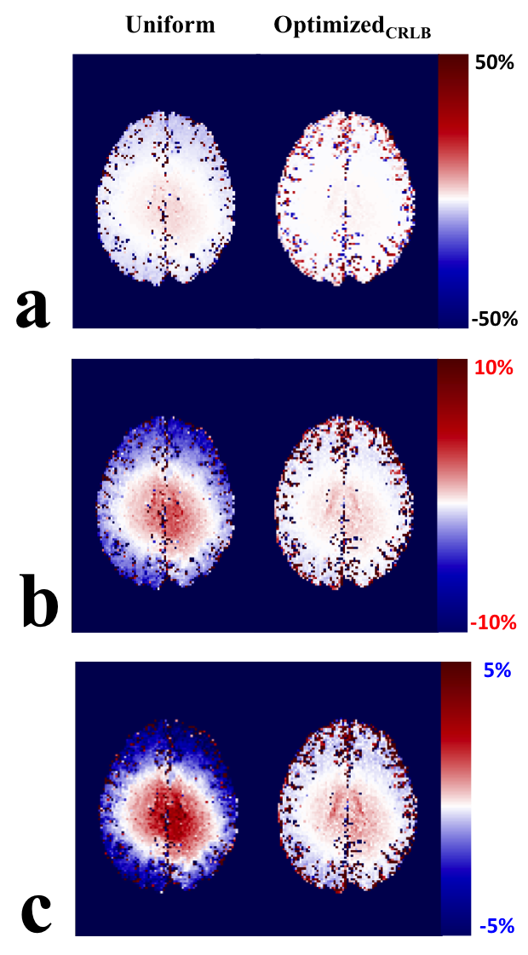

Figure . Percent difference in qMT F between DA B1 maps and the flat B1 = 1 maps using two qMT acquisition protocols (uniform and optimizedCRLB) for three different scale bar ranges (a-c).

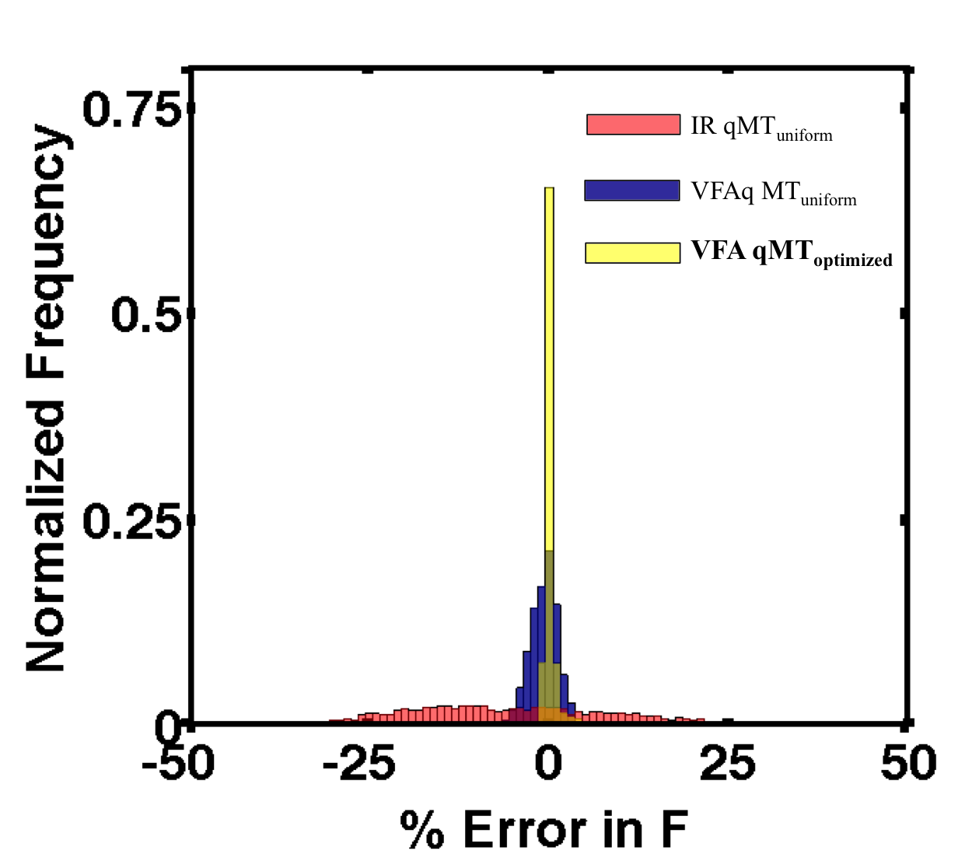

Figure . Histogram of fitted qMT F error % between nominal and DA B1 map, when using IR qMTuniform (red), VFA with qMTuniform (blue), and VFA with qMToptimal (yellow).