Sensitivity-Regularization of the Cramér-Rao Lower Bound to Minimize B1 Nonuniformity Effects in Quantitative Magnetization Transfer Imaging

**Mathieu Boudreau MSc1 and G. Bruce Pike PhD1,2**

1Montreal Neurological Institute, McGill University, Montreal, Quebec, Canada

2Hotchkiss Brain Institute and Department of Radiology, University of Calgary, Calgary, Alberta, Canada

**In submission to: Magnetic Resonance in Medicine**

**Corresponding author**

Mathieu Boudreau

Room WB-325, McConnell Brain Imaging Centre

Montreal Neurological Institute

McGill University, Montreal

Quebec, Canada

H3A 2B4

E-mail: mathieu.boudreau2@mail.mcgill.ca

Phone: (438) 822-8747

**Grant support:** Funding for M.B. was provided by the National Sciences and Engineering Research Council of Canada with the Alexander Graham Bell Canada Graduate Scholarships-Doctoral program. Funding to GBP from the Canadian Institutes of Health Research also supported this research.

**Running title:** B1-Sensitivity Regularization of the CRLB for qMT

**Word count: 4720**

**Title: Sensitivity-Regularization of the Cramér-Rao Lower Bound to Minimize B1 Nonuniformity Effects in Quantitative Magnetization Transfer Imaging**

**Abstract**

**Purpose:** To develop and validate a regularization approach of optimizing B1-insensitivity of the quantitative magnetization transfer (qMT) pool-size ratio (F).

**Theory and Methods:** An expression describing the impact of B1-inaccuracies on qMT fitting parameters was derived using a sensitivity analysis. To simultaneously optimize for robustness against noise and B1-inaccuracies, the optimization condition was defined as the Cramér-Rao lower bound (CRLB) regularized by the B1-sensitivity expression for the parameter-of-interest (F). qMT protocols were iteratively optimized from an initial search space, with and without B1-regularization. Three 10-point qMT protocols (Uniform, CRLB, CRLB+B1-regulatization) were compared using Monte Carlo simulations for a wide range of conditions (SNR, B1-inaccuracies, tissues).

**Results:** The B1-regularized CRLB optimization protocol resulted in the best robustness of F against B1-errors, for a wide range of SNR and for both white and grey matter tissues. For SNR = 100, this protocol resulted in errors of less than 1% in mean F values for B1-errors ranging between -10 to 20%, the range of B1 values typically observed in vivo in the human head at field strengths of 3 T and less. Both CRLB-optimized protocols resulted in the lowest σF values for all SNRs, and did not increase in the presence of B1-inaccuracies.

**Conclusion:** This work demonstrates a regularized optimization approach for improving the robustness of auxiliary measurements (e.g. B1) sensitivity of qMT parameters, particularly the pool-size ratio (F). Predicting substantially less B1-sensitivity using protocols optimized with this method, B1 mapping could even be omitted for qMT studies primarily interested in F.

**Keywords:** Magnetization Transfer, pool-size ratio, B1 mapping, Cramér-Rao lower bound, regularization, optimization, sensitivity analysis.

# INTRODUCTION

Quantitative magnetization transfer (qMT) imaging is a class of techniques that indirectly probe tissue macromolecular content, which is not directly observable using conventional MRI due to their inherently short T2*. Most qMT techniques quantify properties of macromolecular hydrogen (“restricted pool”) relative to nearby liquid water molecules (“free pool”) by solving the Bloch-McConnell equations, which describes the magnetization exchange between these two interacting pools (1). Particularly, the pool-size ratio F (ratio of equilibrium magnetization between both pools) is a qMT parameter that correlates strongly with myelin content (2,3). As such, the pool-size ratio has been proposed as a potential biomarker for lesion monitoring in multiple sclerosis (MS) patients (4,5), and has been shown to correlate with de- and remyelination in a mouse model of MS (6).

Several techniques have been developed to acquire and model qMT data. Most commonly, qMT data are acquired using pulsed off-resonance MT-prepared spoiled gradient echo (SPGR) pulse sequences (7), however techniques using inversion recovery (8) and balanced steady-state free precession have also been proposed (9). Analytically solving the Bloch-McConnell equations is challenging unless a long continuous-wave MT pulse is used (10), which is impractical for in vivo measurements. Several fitting models have been developed to estimate quantitative parameters from pulsed SPGR qMT data (7,11,12), each with unique sets of experimental assumptions and approximations. In addition, SPGR qMT techniques require several additional quantitative measurements, such as main field (B0) mapping, transmit radiofrequency (RF) field (B1) mapping, and longitudinal relaxation time (T1) mapping. In this context, B0 mapping is used to calibrate the off-resonance frequency values in the presence of main field inhomogeneity (13), B1 mapping to correct the RF field amplitude variations (14,15), and T1 mapping to constrain the magnetization transfer fitting parameters (7,10,16). These three measurements, in addition to the 10+ qMT measurements typically required to fit the full set of model parameters (17), makes it a challenge to acquire qMT data in a clinically feasible acquisition time.

Several strategies have been developed to shorten the SPGR qMT acquisition time, which originally consisted of over 60 qMT measurements (7) and limited the technique to single slice acquisitions. The first three-dimensional qMT brain scan was achieved using a “uniform” acquisition protocol by reducing the number of off-resonance frequencies (Δ) to 5 (uniformly ranging between 400 Hz and 20 kHz) and MT flip angles (FAMT) to 2 (high and low values), for a total of MT-weighted 10 measurements (18). Other studies went further, optimizing the protocol Δ and FAMT values using the Cramér-Rao lower bound (CRLB) as an optimization condition to minimize estimated parameter variances, using simulated annealing (19) or an iterative protocol reduction algorithm from an initial search space (17). Rapid k-space readout techniques such as echo planar imaging have also been proposed to improve acquisition times (20). The choice of B0/B1/T1 mapping techniques have evolved over time, with researchers typically choosing the most rapid and reliable technique available at their disposal. For example, the evolution from single-slice qMT imaging to whole-brain imaging required a switch from single-slice T1 mapping techniques (e.g. inversion recovery – IR, Look-Locker – LL) to 3D techniques (e.g. Variable Flip Angle – VFA). However, recent work has shown that this transition may impact the robustness of the fitting parameters, since IR is a B1-insensitive technique (21), whereas VFA is a B1-sensitive technique (22). For a uniform 10-pt SPGR qMT protocol, it has been demonstrated that the pool-size ratio F is much less sensitive to B1-inaccuracies if the qMT protocol uses VFA T1 mapping, relative to B1-insensitive T1 mapping techniques (23). Since that work used a fixed “uniform” qMT sampling protocol to demonstrate the benefit of using VFA T1 mapping for F, it raises an interesting question: is it possible to further improve the robustness of F against B1 inaccuracies by optimizing the qMT acquisition protocol itself for B1-insensitivity?

The aim of this work is to develop a method to incorporate B1-sensitivity considerations into the optimization of qMT data acquisition, by regularizing the CRLB optimization condition with a B1-sensitivity term. We first derived a B1-sensitivity expression that was used to regularize the CRLB condition. Using simulations, we then explored the B1-sensitivity of qMT for several different uniform sampling protocol configurations. The optimal regularization term for the pool-size ratio was determined, and a sample qMT protocol was iteratively optimized using the CRLB condition both with and without the regularization term. The robustness of three protocols (uniform, CRLB, CRLB + B1 regularization) were then investigated using Monte Carlo simulations for a range of signal-to-noise ratios (SNR), B1-inaccuracies, and tissue values. Lastly, the qMT optimization framework developed and presented here is released as an open-source package.

# THEORY

In the presence of a small inaccuracy of a measurement parameter, such as B1 in qMT, this error will propagate to the fitting parameters of the model. The behavior of how this propagated error will impact each fitting parameter can be explored through a sensitivity analysis, by expanding the fitted signal in the presence of a ΔB1 with a Taylor expansion (24). Assuming a small ΔB1 and a good fit (*M*(*B1*+ ΔB1) ≈ *M*(*B1*) ≈ *M*meas, where *M* is the signal generated by the fit), a first-order approximation of the Taylor expansion of the fitted signal results in the following matrix equation (23):

|  |  |  |
| --- | --- | --- |
|  |  | **[1]** |

where *p* are the model fitting parameters (e.g. for the Sled and Pike(1) model of qMT: F, kf, T2,f, T2,r), is the column vector of errors in fitted parameters [ΔF, Δkf, ΔT2,f, ΔT2,r]ʹ, and are matrices with sensitivities values elements relative to *pi* or *B*1 (columns) for each measurement *n* (rows). can also be interpreted as being the Jacobian of the measurement for the fitting parameters, which we’ll call the Jacobian sensitivity matrix.

Given a known ΔB1 value and Jacobian sensitivity matrices for *p* and *B*1, Eq. 1 can be solved for . However, since Eq. 1 is typically an overdetermined system of linear equations (), the optimal solution is found by minimizing the following 2-norm for :

|  |  |  |
| --- | --- | --- |
|  |  | **[2]** |

Although Eq. 2 provides an estimate of the error propagated to the fitting parameters by an error in B1, it alone is insufficient to be used for optimal protocol design. qMT protocols must also be designed for robustness against noise that naturally occurs in measured signals. For this purpose, the Cramér-Rao lower bound (CRLB) has been shown to be an adequate and sufficient estimate to minimize the variance in fitted qMT parameters due to experimental noise (19). Consider the Fisher information matrix (FIM) **J**, which has elements:

|  |  |  |
| --- | --- | --- |
|  |  | **[3]** |

where σ is the standard deviation of the noise, and **x***n* is the acquisition protocol for the *n*th measurement out of N unique measurements. The CRLB is defined as the diagonal elements of **J**-1, and the trace of this matrix provides an overall estimate of the minimum variance of a model. However, because the qMT fitting parameters differ largely in their order of magnitudes, the parameter-normalized CRLB (*V*) is defined instead (19):

|  |  |  |
| --- | --- | --- |
|  |  | **[4]** |

In this work, we propose a regularization approach to simultaneously optimize against both noise (Eq. 4) and B1-error propagation (Eq. 2), using an iterative optimization approach for the acquisition protocol design (17). Particularly, we are interested in minimizing the propagation of B1-error to the pool-size ratio *F* (Δ*F*) because of its demonstrated potential as a biomarker for myelin content. Thus, to optimally reduce an acquisition protocol of N unique measurements to N-1 measurements, each iteration evaluates:

|  |  |  |
| --- | --- | --- |
|  |  | **[5]** |

where λ is the regularization parameter constant, and **x**N-1 is the N-1 optimal qMT subset protocol of **x**N for a given iteration. The regularization parameter λ value controls the tradeoff between CRLB (noise) and *F* sensitivity to B1-inaccuracies during the optimization.

# METHODS

The core qMT functions and routines used in the simulations and fitting of this work are from qMRLab (http://github.com/neuropoly/qMRLab), an open-sourced quantitative MRI software packaged that evolved from qMTLab (25) and is written in MATLAB (MATLAB 2017a; MathWorks Inc., Natick, MA). The additional source code developed in this work, particularly for numerically estimating the Jacobians matrices of the system, the protocol optimization algorithms, and the Monte Carlo simulations, is released as its own open-source package (http://github.com/mathieuboudreau/qmt-optimization). The code was developed to wrap around the qMRLab code, so that it may also be easily adaptable with other qMT software packages or in-house code.

## Uniform Protocols

The regularization term in Eq. 5 proposed for optimizing qMT parameters against B1-inaccuracies was derived using a first-order approximation of a Taylor series. To test this approximation, **Δ*p*** values (ΔF, Δkf, ΔT2,f, ΔT2,r) were calculated by solving Eq. 2 for a range of ΔB1 typically observed in vivo (±30%, with an actual B1 = 1.0 n.u.), and were compared to values estimated by fitting the signal to the Bloch-McConnell equations (7). A “uniform” qMT measurement protocol was used, meaning a protocol with logarithmically uniform off-resonance frequencies for each MT flip-angle (αMT) preparation pulse. Jacobian sensitivity matrices calculations for Eq. 2 (and) were estimated from numerical partial derivatives (10-2 % relative increase in parameter values). Two different qMT cases were considered for : B1-independent T1 measurements (IR) and B1-dependent T1 measurements (VFA). Signal simulation details (protocol and tissue parameters) matched those described in full detail in a recent study (17).

Prior to protocol optimization, we were also interested in investigating values (from Eq. 2) for other uniform qMT protocols with different numbers of MT flip angles and off-resonance values. MT-prepared SPGR (TR = 25 ms, α = 7°) pulse sequence protocols using every combination of three αMT values (150°, 400°, 650°) were used (each unique αMT, each combination of two αMT values, and all three). Logarithmically-uniform offset frequencies for each αMT values ranged between 300 Hz and 20 kHz. To fairly assess all uniform protocols, the total number of acquisitions were limited between 8 and 30 by varying the number of offset values per αMT sets. For example, a single-αMT 10-point protocol would have 10 off-resonance frequencies, and a two-αMT 10-point protocol would have the same 5 off-resonance frequencies for both αMT. qMT signals were simulated for tissue values within the typical white matter range (Table 1). A 5% overestimation in B1 value (ΔB1 = +0.05 n.u.) relative to the expected value (B1 = 1 n.u.) was used for all protocols to solve Eq. 2 for , and a VFA T1 mapping method was assumed (TR = 15 ms, α = 3° and 20°).

## Protocol Optimization

qMT protocols were iteratively optimized (17) from a large initial search-space set of potential αMT and Δ protocol values, for fixed TR and α (25 ms and 7°). The most time-intensive component of the optimization algorithm is computing the Jacobian sensitivities ( and ). The Jacobian sensitivities were precomputed using parallel processing and cached for rapid access during the optimization algorithm execution. Note that both terms in Eq. 5 require element values from the Jacobian sensitivity matrices (through Eq. 4 and 3). The optimization search-space consisted of 312 points; each combination of 12 αMT values (ranging between 150° to 700°, in 50° increments) and 26 Δ values (ranging between 300 Hz and 20 kHz, with logarithmically uniform steps). A few (<5%) protocol points resulted in outlier numerical partial derivative values (non-smooth Jacobian sensitivity curve at those points), which may be due to signal simulation rounding errors or imprecise free-pool saturation fraction interpolations in the open-source software used. Those protocol points were replaced with the nearest-neighbor points calculated from a higher-resolution search-space (101 Δ values). The Jacobian sensitivity matrices were calculated for white matter tissue values (Table 1).

Prior to protocol optimization, an optimal value for the regularization parameter λ was determined. The iterative optimization algorithm using Eq. 5 was executed for a range of λ values (λ = 0, 0.01, 0.1, 0.5, 1, 2, 5), assuming ΔB1 = 0.05 and VFA T1 mapping (TR = 15ms, α = 3° and 15°). Since TR, TE, and α were fixed for all protocol points, the standard deviation of the noise in Eq. 3 (σ) was arbitrarily set to 1 during the optimization calculations. The ΔF values and variance-efficiency curves ([variance × # acq. points]-1/2, where the variance is interpreted to be the parameter-normalized CRLB *V*) were compared for each N during the iterative optimization procedure. Two sets of 10-point protocols were optimized by iteratively finding the N-1 protocol subset that minimized Eq. 5 for ΔB1 = 0.05 (assuming VFA for T1 mapping, as above) with and without regularization (CRLB and CRLBλ).

## Monte Carlo Simulations

Ideal (noiseless) MT-prepared SPGR signals were simulated for three 10-point protocols (Table 2: Uniform, CRLB, and CRLBλ) and two tissue types (Table 1: white matter, grey matter). Rician noise was added to each simulated MT signal and an MT-off signal, for normalization (*M*MT/*M*MT-off). Six different SNR levels were considered (SNR = 25, 50, 75, 100, 150, 200). Sets of 10,000 noisy MT signals were independently generated and compared for each combination of qMT protocols, tissues, and SNR. Each dataset was subsequently fitted for qMT parameters (F, kf , T2,f, and T2,r) considering a range of B1 errors (±30% in increments of 5%) and a two-FA VFA T1 mapping method (TR = 15ms, α = 3° and 15°).

# RESULTS

## Uniform Protocols

Figure 1 shows the simulated errors in each fitting parameter (ΔF, Δkf, ΔT2,f, ΔT2,r) estimated from the first-order approximation of the Taylor expansion in Eq. 2 (solid lines) and from the relative error in fit using the Sled and Pike model (dash line) in the presence of B1 errors (±30%). Data was simulated for a B1-independent T1 measure (IR, red) and a B1-dependent T1 measure (VFA, blue) separately. The overall trends in the error curves produced by model fits reproduced well similar simulations that were reported recently (23) (Boudreau et al 2017, Figure 3) even though they don’t share the same core qMT simulation and fitting software, establishing confidence in the use of this open-source qMTLab software (25) for this work.

For B1 errors within ±5%, the errors in all parameters calculated from Eq. 2 approximated well the fitted estimates. For VFA T1 mapping and ΔB1 = 0.05 n.u. (+5 %), the Δ*p* values (Eq. 2, Fit) were: ΔF = (-0.94 %, -1.06 %), Δkf = (14.77 %, 16.88 %), ΔT2,f = (-2.56 %, -1.97 %), and ΔT2,r = (-0.51 %, -0.65%). Both ΔF (for VFA) and ΔT2,r showed linear trends for the “Fit” case, which resulted in an overall better agreement with Eq. 2. Resulting from these analyses, a ΔB1 of 0.05 n.u. was selected for the iterative optimization calculation (Eq. 5) later in this work.

Figure 2 shows the simulated errors of fitting parameters for a 5% ΔB1 (assuming VFA T1), using a wide range of uniform qMT acquisition protocols varying in number of FAMT, number of off-resonance frequencies per FAMT, and total number of acquisitions points. While most curves (sets of FAMT combinations) trended asymptotically with increasing number of acquisition points, they did not trend towards 0% parameter error values (except for a few ΔT2,r cases, # FA > 1 protocols that contain 650°). For ΔF, the three # FA = 1 curves (dark blue, orange, yellow) resulted in the largest ΔF values overall, demonstrating the benefit of including at least two flip angles in your qMT protocol in the context of lower B1-sensitivity. The three # FA > 1 protocols that included FA=650° (green, light blue, red) resulted in ΔF curves that overlapped and intercepted ΔF = 0 % values near 10 and 15 acquisition points, but increased in error for larger # of acquisition points.

## Protocol Optimization

Figure 3 displays the values of the Jacobian sensitivity matrices (**a-d** are the columns of , **e** is , and **f** is ). Each plot represents the sensitivity of the Z-spectrum relative to each parameter-of-interest (i.e. the change in Z-spectrum signal value due to a small increase in each parameter). The magnitude of the sensitivity values is shown to simplify interpretations; the sign of the sensitivity curves represents the direction (increase/decrease) that the Z-spectrum changes for small variations of each parameters, while we are mainly concerned in how large of an overall change occurs. A peak of the sensitivity curve for F occurs at off-resonance frequencies an order of magnitude higher for high FAMT (>500°) than for low FAMT values (~150-300°). For all FAMT values, the peak sensitivity for kf remained near Δ = 1-2 kHz. The peak sensitivity of also remained constant near Δ = 1-2 kHz, which may explain why kf has the largest errors due to ΔB1 (Eq. 1) for the VFA case in Figure 1. The higher sensitivity of F at high off-resonance (>10kHz) values (Figure 3a), relative to (Figure 3f), likely contributes to the greater robustness against B1 observed in the previous section.

The optimal variance-efficiency and ΔF values (for ΔB1 = 5%) calculated at each iteration of the optimization algorithm using the 312-point initial search-space are shown in Figure 4 for a wide range of regularization parameter (λ) values. The highest-valued variance-efficiency curve occurs for λ=0 (i.e. unregularized parameter-normalized CRLB) and λ = 0.01. For these values, the magnitude of ΔF steadily increased to 1% as the protocol was iteratively reduced to ~150 acquisition points, and then proceeded to decrease to ~0.5% for N < 25. Increasing the regularization parameter by an order of magnitude (λ = 0.1) substantially reduced ΔF values for N > 25 by up to a factor of two, while keeping the variance-efficiency relatively unaffected. However, for this case, ΔF returned to ~-0.5% abruptly for N < 25. A regularization parameter of 0.5 was the lowest value tested which succeeded in ΔF achieving values near 0% for small protocols; for N = 10, λ = 0.5 resulted in ΔF = -0.04% compared to -0.53 % for λ = 0, a factor of 13 in relative improvement of the B1-insensitivity of F. A small reduction in variance-efficiency accompanied the improvement of ΔF for λ = 0.5; for N=10, the variance-efficiency decreased by 6.3% for λ = 0.5 relative to λ = 0. For higher λ values, the regularization term in Eq. 5 dominated early in the iterative optimization at the cost of lower variance-efficiencies, which never recover to their unregularized values. For intermediately-high λ values (λ = 1, 2), a second region where the regularization term in Eq. 5 dominates the iterative optimization can be seen near N = 60 and 120 respectively, substantially reducing the variance-efficiency. Overall, a λ value of 0.5 showed the best compromise between decreasing ΔF (insensitivity of F against B1 errors) and maximizing variance-efficiency.

The 10-point protocols optimized using λ = 0 (CRLB) and λ = 0.5 (CRLBλ=0.5) are shown in Figure 5, overlaid on the 312-point protocol search-space (displayed as line plots for better visibility of the optimized protocols). The details of these protocols are listed in Table 2. Overall, both optimized protocols share 7 out of 10 (Δ, FAMT) pairs, with only three acquisition points changing if the regularization term is included in Eq. 5 (λ = 0.5). Both protocols have coverage of low, medium, and high off-resonance values, as well as low and high FAMT values.

## Monte Carlo Simulations

Distributions statistics (mean, σ) of the Monte Carlo simulations of the fitted parameter-of-interest F are shown for a range of ΔB1 values (SNR = 100) in Figure 6 and a range of SNR values (ΔB1 = 0 and 15 %) in Figure 7, for the three protocols listed in Table 2. Figure 6 a and b displays the difference (%) in mean F relative to the mean F value for the ΔB1 = 0 case, whereas Figure 7 a and b displays the difference (%) in mean F relative to the ideal (noiseless) fitted F value.

For the CRLBλ=0.5 protocol, values were less than 1% (grey area) for ΔB1 between -10% and 20% (Figure 6, for both WM and GM). The same was true for ΔB1 between -5% and 10% for the CRLB protocol, and between -5% and 5% for the Uniform protocol. CRLB and CRLBλ=0.5 protocols resulted in standard deviations of fitted F substantially lower (by a factor of ~1.75) than the Uniform protocol. Although CRLBλ=0.5 σF values were slightly different than the CRLB values (6.7% higher), both curves nearly overlapped for all ΔB1 values.

In the absence of B1 errors (ΔB1 = 0), values for both optimized protocols (CRLB and CRLBλ=0.5) were below 1% for datasets with SNR values greater than 75 (Figure 7, WM and GM). The Uniform protocol needed a minimum SNR of 100 to result in values below 1%. In the presence of a 15% overestimation of B1, the vs. SNR curve for CRLBλ=0.5 remained largely unchanged for WM. For GM, the values for CRLBλ=0.5 resulted in slight increase, although remained within 1% for SNR > 100. In contrast, even at high SNR values (>100), values for the CRLB and Uniform protocols resulted in greater bias (>1%) for the ΔB1 = 15% case. The σF curves increased rapidly for SNR values lower than 75 for all protocols. For all cases, σF did not vary substantially between both ΔB1 values evaluated (0% and 15%). For CRLB and CRLBλ=0.5, no substantial differences in their σF vs. SNR curves were observed, and both had lower standard deviations relative to the Uniform protocol.

# DISCUSSION

This work describes a qMT protocol optimization methodology for reduced B1-sensitivity of the pool-size ratio F by regularizing the CRLB with a first-order sensitivity analysis. Using Monte Carlo simulations we found that, for a protocol optimized using regularized CRLBλ=0.5, errors propagated to fitted F were below 1% for B1-errors ranging between -10 and 20%, consistent with the B1 values typically observed in the human brain at 3T (26). Both regularized and conventional CRLB optimization resulted in an improvement of pool-size ratio B1-insensitivity relative to a two-FAMT uniform protocol. Sensitivity analyses of uniform protocols suggested that, if using VFA T1 mapping, acquiring data at both small and large MT flip angle acquisitions (at mid and high off-resonance frequencies) may be an important contributing factor in designing a B1-insensitive acquisition protocol, where F likely has a higher robustness against B1 errors. These simulations demonstrate for a range of SNRs, B1-inaccuracies, and brain tissues, the effectiveness of a regularized approach of designing qMT for B1-insensitivity. This work suggests that if the pool-size ratio is the primary parameter-of-interest, it may be possible to design a qMT protocol robust enough to omit B1 map acquisition altogether, without substantially biasing estimates of F.

Our study considered a specific qMT fitting model (Sled and Pike(7)) that fitted quantitative MT data for four parameters of the Bloch-McConnell equations (F, kf, T2,f, T2,r). Several other qMT fitting models for MT-prepared SPGR data exist, such as Yarnykh’s model (11), which neglects direct saturation effects, and Ramani’s continuous wave power equivalent model (12). Each qMT fitting model makes different approximations or assumptions, and differ in fitting parameters. For example, Yarnykh’s model suggests acquiring data only at off-resonance frequencies greater than 1 kHz, and has a different set of fitting parameters (e.g. T2,f is neglected and their pool-size ratio parameter is defined as *f* = M0,r / (1+ M0,r), instead of Sled and Pike’s F = M0,r / M0,f parameter). The different range in off-resonance frequencies will reduce the available Jacobian sensitivity values during optimization, which may impact the optimization against auxiliary measurements (e.g. B1) errors. Different sets of fitting parameters between models could also change the fitting behavior in the presence of B1-error propagation, even if the same SPGR qMT acquisition protocols are used. The single-point qMT fitting model (27,28) may provide additional challenges for optimizing against auxiliary measurement error-sensitivity. This fitting model imposes several fitting parameter restraints, which would provide additional limitations when solving Eq. 2. The analysis of uniform protocols and Jacobian sensitivity matrices also suggests that B1-insensitivy of F may be a result of including both small and large MT flip angle acquisitions in a protocol at mid and high off-resonance frequencies, a configuration that cannot be done using single-point measurement protocol.

We proposed a regularization approach to add an auxiliary measurement (e.g. B1) error-sensitivity component to the CRLB in our optimization algorithm. An alternative approach could have been to do a formal statistical analysis of the error propagation using the CRLB instead as the optimization algorithm condition. Lankford and Does (29) recently presented such a treatment and applied it to study T2 mapping. Their statistical analysis of the error propagation from parameter constraints demonstrated that, under certain practical circumstances, it can be beneficial (in terms of variance and full mean-squared error of fitted T2) to include a B1 measurement for multi-echo T2 mapping. Their framework was presented to be generalizable to other quantitative techniques that require auxiliary measurements such as qMT; however, their analysis was only developed for a single-level of parameter constraints. Although this may be applicable for a B1-error propagation analysis of qMT when using a B1-independent T1 mapping method (e.g. IR), a B1-dependent T1 mapping method (e.g. VFA) complicates the error propagation analysis beyond what is presented in Lankford and Does, as there are two interacting constraints within the qMT model (e.g. qMT(B1, T1(B1)). In contrast, one benefit of the sensitivity-regularization approach we presented here is its conceptual simplicity and ease of implementation for optimization applications, particularly for this case. Nonetheless, a formal propagation of error analysis would likely be a good choice moving forward to compare the sensitivity to errors in constraints between different qMT fitting models, as discussed above.

Several limitations should be considered when interpreting this work. An iterative optimization approach was chosen to estimate optimal acquisition protocols from a larger initial search space, however this approach is not guaranteed to result in the global minima of the optimization condition. Global optimization using simulated annealing (19) could have been another valid approach to optimize our qMT protocol using Eq. 5. However, iterative optimization approaches benefit from an ease of implementation, rapid computation, and the flexibility to choose the number of measurements in the protocol after the optimization is complete. In contrast, simulated annealing approaches optimize for a fixed pre-determined number of protocol points. We also opted for Monte Carlo simulations instead of an in vivo study to validate the regularized approach to B1-sensitivity protocol optimization. This gave us the flexibility to accurately know and control the system conditions (e.g. tissue values, B1 error values, and noise level). In vivo evidence of the benefits of qMT protocol optimization using CRLB has already been reported in several studies (17,19,20). In addition, Eqs. 1 and 2 (used to establish the regularization term) were developed from a recent comprehensive B1-sensitivity analysis of qMT study (23) that compared and validated simulations with in vivo measurements of F in the absence of B1 maps (for a uniform protocol). Lastly, the optimization algorithm investigated here only considered a single tissue type (WM) during the protocol optimization procedure. Although the resulting protocol was also evaluated for another tissue type in the Monte Carlo simulations (GM) and both were restricted to errors below 1%, even though the B1-sensitivity of F in GM varied more than for WM. If desired, the optimization condition (Eq. 5) could be adapted to consider multiple tissue types in a similar manner as proposed by Cercignani et al (19), by instead minimizing for the tissue which results in the maximum value of Eq. 5 at each iteration.

Overall, this work presents a framework for designing qMT acquisition protocols optimized for robustness against inaccuracies of auxiliary measurements (e.g. B1) by regularizing the Cramér-Rao lower bound with fitting parameter-sensitivity information. We demonstrated this methodology by optimizing a qMT protocol for robustness of the pool-size ratio (F) against B1-inaccuracies, and studied simulations using this protocol for a wide range of signal-to-noise ratios, B1-inaccuracies, and tissue types. These findings imply that B1 mapping possibly be omitted from such a qMT optimized acquisition protocol with minimal impact to the fitted pool-size ratio (< 1% error). Potential future work may include optimizing protocols for reduced sensitivity of other or multiple auxiliary measurements, and compare this optimization between other qMT fitting models. Another interesting approach could be to combine Z-spectrum compressed sensing (30) with this optimization technique, to maximize the auxiliary measurement insensitivity by increasing the number of measurements while reducing the total acquisition time.

# REFERENCES

1. Sled JG, Pike GB. Quantitative interpretation of magnetization transfer in spoiled gradient echo MRI sequences. Journal of Magnetic Resonance 2000;145(1):24-36.

2. Schmierer K, Tozer DJ, Scaravilli F, Altmann DR, Barker GJ, Tofts PS, Miller DH. Quantitative magnetization transfer imaging in postmortem multiple sclerosis brain. J Magn Reson Imaging 2007;26(1):41-51.

3. Schmierer K, Wheeler-Kingshott CAM, Tozer DJ, Boulby PA, Parkes HG, Yousry TA, Scaravilli F, Barker GJ, Tofts PS, Miller DH. Quantitative magnetic resonance of postmortem multiple sclerosis brain before and after fixation. Magnetic Resonance in Medicine 2008;59(2):268-277.

4. Levesque IR, Giacomini PS, Narayanan S, Ribeiro LT, Sled JG, Arnold DL, Pike GB. Quantitative magnetization transfer and myelin water imaging of the evolution of acute multiple sclerosis lesions. Magn Reson Med 2010;63(3):633-640.

5. Davies GR, Tozer DJ, Cercignani M, Ramani A, Dalton CM, Thompson AJ, Barker GJ, Tofts PS, Miller DH. Estimation of the macromolecular proton fraction and bound pool T2 in multiple sclerosis. Mult Scler 2004;10(6):607-613.

6. Turati L, Moscatelli M, Mastropietro A, Dowell NG, Zucca I, Erbetta A, Cordiglieri C, Brenna G, Bianchi B, Mantegazza R, Cercignani M, Baggi F, Minati L. In vivo quantitative magnetization transfer imaging correlates with histology during de- and remyelination in cuprizone-treated mice. NMR Biomed 2015;28(3):327-337.

7. Sled JG, Pike GB. Quantitative imaging of magnetization transfer exchange and relaxation properties in vivo using MRI. Magn Reson Med 2001;46(5):923-931.

8. Dortch RD, Li K, Gochberg DF, Welch EB, Dula AN, Tamhane AA, Gore JC, Smith SA. Quantitative magnetization transfer imaging in human brain at 3 T via selective inversion recovery. Magn Reson Med 2011;66(5):1346-1352.

9. Gloor M, Scheffler K, Bieri O. Quantitative magnetization transfer imaging using balanced SSFP. Magn Reson Med 2008;60(3):691-700.

10. Henkelman RM, Huang X, Xiang QS, Stanisz GJ, Swanson SD, Bronskill MJ. Quantitative interpretation of magnetization transfer. Magn Reson Med 1993;29(6):759-766.

11. Yarnykh VL. Pulsed Z-spectroscopic imaging of cross-relaxation parameters in tissues for human MRI: theory and clinical applications. Magn Reson Med 2002;47(5):929-939.

12. Ramani A, Dalton C, Miller DH, Tofts PS, Barker GJ. Precise estimate of fundamental in-vivo MT parameters in human brain in clinically feasible times. Magn Reson Imaging 2002;20(10):721-731.

13. Skinner TE, Glover GH. An extended two-point Dixon algorithm for calculating separate water, fat, and B0 images. Magn Reson Med 1997;37(4):628-630.

14. Jin J, Chen J. On the SAR and field inhomogeneity of birdcage coils loaded with the human head. Magn Reson Med 1997;38(6):953-963.

15. Wiggins GC, Triantafyllou C, Potthast A, Reykowski A, Nittka M, Wald LL. 32-channel 3 Tesla receive-only phased-array head coil with soccer-ball element geometry. Magn Reson Med 2006;56(1):216-223.

16. Caines GH, Schleich T, Rydzewski JM. Incorporation of magnetization transfer into the formalism for rotating-frame spin-lattice proton NMR relaxation in the presence of an off-resonance-irradiation field. Journal of Magnetic Resonance (1969) 1991;95(3):558-566.

17. Levesque IR, Sled JG, Pike GB. Iterative optimization method for design of quantitative magnetization transfer imaging experiments. Magn Reson Med 2011;66(3):635-643.

18. Cercignani M, Symms MR, Schmierer K, Boulby PA, Tozer DJ, Ron M, Tofts PS, Barker GJ. Three-dimensional quantitative magnetisation transfer imaging of the human brain. NeuroImage 2005;27(2):436-441.

19. Cercignani M, Alexander DC. Optimal acquisition schemes for in vivo quantitative magnetization transfer MRI. Magn Reson Med 2006;56(4):803-810.

20. Battiston M, Grussu F, Ianus A, Schneider T, Prados F, Fairney J, Ourselin S, Alexander DC, Cercignani M, Gandini Wheeler-Kingshott CAM, Samson RS. An optimized framework for quantitative magnetization transfer imaging of the cervical spinal cord in vivo. Magn Reson Med 2017.

21. Barral JK, Gudmundson E, Stikov N, Etezadi-Amoli M, Stoica P, Nishimura DG. A robust methodology for in vivo T1 mapping. Magn Reson Med 2010;64(4):1057-1067.

22. Liberman G, Louzoun Y, Ben Bashat D. T(1) mapping using variable flip angle SPGR data with flip angle correction. J Magn Reson Imaging 2014;40(1):171-180.

23. Boudreau M, Stikov N, Pike GB. B1 -sensitivity analysis of quantitative magnetization transfer imaging. Magn Reson Med 2017.

24. Cruz JB. System sensitivity analysis: Dowden, Hutchinson & Ross; 1973.

25. Cabana J-F, Gu Y, Boudreau M, Levesque IR, Atchia Y, Sled JG, Narayanan S, Arnold DL, Pike GB, Cohen-Adad J, Duval T, Vuong M-T, Stikov N. Quantitative magnetization transfer imaging made easy with qMTLab: Software for data simulation, analysis, and visualization. Concepts in Magnetic Resonance Part A 2016:n/a-n/a.

26. Boudreau M, Tardif CL, Stikov N, Sled JG, Lee W, Pike GB. B1 mapping for bias-correction in quantitative T1 imaging of the brain at 3T using standard pulse sequences. J Magn Reson Imaging 2017.

27. Underhill HR, Rostomily RC, Mikheev AM, Yuan C, Yarnykh VL. Fast bound pool fraction imaging of the in vivo rat brain: association with myelin content and validation in the C6 glioma model. NeuroImage 2011;54(3):2052-2065.

28. Yarnykh VL. Fast macromolecular proton fraction mapping from a single off-resonance magnetization transfer measurement. Magn Reson Med 2012;68(1):166-178.

29. Lankford CL, Does MD. Propagation of error from parameter constraints in quantitative MRI: Example application of multiple spin echo T2 mapping. Magn Reson Med 2017.

30. Mclean M, MacDonald ME, Lebel RM, Boudreau M, Pike B. Accelerated z-Spectrum Imaging. In: Proceedings of the 25th Annual Meeting of ISMRM 2017;25.

Table 1. qMT tissue parameters used to simulate white matter and grey matter tissue values in the Monte Carlo simulations. The parameter definitions are: F ­ pool-size ratio, kf  – exchange rate constant, T1,f – longitudinal relaxation time of the free pool, T1,r – longitudinal relaxation time of the restricted pool, T2,f – transverse relaxation time of the free pool, T2,r – transverse relaxation time of the restricted pool. The fitting parameters for qMT are F, kf, T2,f, and T2,r; T1,f is calculated from the observed T1 and the fitting parameters, and T1,r is conventionally fixed to 1 s.

|  |  |  |
| --- | --- | --- |
| Parameter | White Matter | Grey Matter |
| F | 0.15 n.u. | 0.075 n.u. |
| kf | 4.0 s-1 | 2.5 s-1 |
| T1,f | 0.9 s | 1.3 s |
| T1,r | 1.0 s | 1.0 s |
| T2,f | 30 ms | 55 ms |
| T2,r | 12 μs | 11 μs |

Table 2. qMT protocols used in the Monte Carlo simulations. The repetition times, excitation flip angles, and number of acquisitions were matched for all protocols. The Uniform protocol is a two MT flip-angle with logarithmically uniform off-resonance frequencies. The CRLB protocol was optimized using Eq. 5 with the regularization parameter set to 0, and CRLBλ=0.5 was optimized using a regularization parameter of 0.5.

|  |  |  |  |  |  |  |  |  |  |
| --- | --- | --- | --- | --- | --- | --- | --- | --- | --- |
|  | Uniform | | | CRLB | | | CRLBλ=0.5 | | |
| Acq. # | TR/α | αMT | Δ (Hz) | TR/α | αMT | Δ (Hz) | TR/α | αMT | Δ (Hz) |
| 1 | 25ms/7° | 142° | 432.9 | 25ms/7° | 200.0 | 300.0 | 25ms/7° | 200.0 | 300.0 |
| 2 | 1 087.5 | 250.0 | 1 903.9 | 200.0 | 1609.5 |
| 3 | 2 731.6 | 700.0 | 1 609.5 | 700.0 | 1609.5 |
| 4 | 6 861.6 | 700.0 | 12 083.6 | 700.0 | 12 083.6 |
| 5 | 17 235.5 | 700.0 | 1 903.9 | 700.0 | 2 252.2 |
| 6 | 426° | 432.9 | 250.0 | 2 252.2 | 200.0 | 1 903.9 |
| 7 | 1 087.5 | 150.0 | 300.0 | 650.0 | 300.0 |
| 8 | 2 731.6 | 700.0 | 1 360.6 | 200.0 | 1 360.6 |
| 9 | 6 861.6 | 200.0 | 1 609.5 | 700.0 | 1 903.9 |
| 10 | 17 235.5 | 700.0 | 2 252.2 | 150.0 | 300.0 |

# FIGURE LEGEND

Figure 1. Simulated qMT parameter errors due to B1-inaccuracies (-30% < ΔB1 < 30%) considering a B1-independent T1 measurement (red: IR – inversion recovery) and a B1-dependent T1-measurement (blue: VFA – variable flip angle). Solid lines are parameter errors calculated from minimizing Eq. 2 (first-order approximation of the Taylor expansion), and dashed lines are parameter errors calculated from fitting the qMT signal according to the Sled & Pike model. The tissue parameters (white matter) and qMT protocol (uniform) were matched to those presented in Boudreau et al. 2017 (see Fig. 3 of the paper).

Figure 2. Simulated qMT parameter errors estimated from Eq. 2 for ΔB1=0.05 for a wide range of logarithmically-uniform (offsets) qMT protocols. Single (blue, orange, yellow), dual (purple, green, light blue), and triple (red) flip angle combinations of 150°, 400°, and 600° were compared. The number of offset frequencies were uniformly distributed between 300 Hz and 20 kHz, and matched for the total number of acquisition points (# offsets × # flip angles).

Figure 3. Sensitivity values (magnitudes) for each qMT fitting parameters (F, kf, T2,f, T2,r) and B1 measurement values considering a B1-independent T1 measure (IR – inversion recovery) and a B1-dependent T1 measure (VFA – variable flip angle). The 312-point protocol shown (12 flip angles x 26 offset frequencies) represents the initial search-space used for protocol optimization. The sets of sensitivity values for each fitting parameter (a–d) consists of the matrix columns of the Jacobian sensitivity matrix (S*p* in Eq. 2 and 5).

Figure 4. Variance-efficiency (a) and ΔF (b) (Eq. 2, ΔB1 = 5%) values during the iterative optimization of the sensitivity-regularized Cramer-Rao Lower-Bound equation (Eq. 5). Variance-efficiency is defined here as (variance × # acq. points)-1/2, where the variance is interpreted to be the parameter-normalized Cramer-Rao Lower Bound (*V*, Eq. 3).

Figure 5. Comparison between the 10-point protocols iteratively optimized from a 312-point search space using solely the parameter-normalized CRLB (λ = 0) and regularized CRLBλ=0.5. The different flip angle Z-spectrums of the initial optimization search-space are displayed in blue to emphasize the 10-point protocols. The flip angle Z-spectrums (150° to 700°, in 50° increments) range from the highest MT-signal values curve (150°) to lowest (700°).

Figure 6. Means (a, b) and standard deviations (c, d) of the distribution of pool-size ratios (F) for sets of Monte Carlo simulations (10,000 runs, SNR = 100) fitted using a range of B1 errors (ΔB1 = ±30%, B1 = 1 n.u.) and for two sets of qMT parameters (white matter – a,c; grey matter – b, d). Mean F values (% error) shown here were compared relative to the accurate B1 value case (ΔB1 = 0), and the grey region represents the region of ±1% relative error. Simulated signal values were generated and fitted for three different 10-point qMT protocols: Uniform (blue) – two-FA protocol with logarithmically-uniform off-resonance frequency values, CRLB (red) – protocol optimized by iteratively minimizing the increase in the parameter-normalized Cramer-Rao Lower-Bound of the system, and CRLBλ=0.5 (yellow) – protocol optimized similar to CRLB, regularized by the estimated error of F (ΔF) in the presence of a B1 error (Eq. 5).

Figure 7. Means (a, b) and standard deviations (c, d) of the distribution of pool-size ratio values (F) for sets of Monte Carlo simulations (10,000 runs) fitted using a range of SNR values (25, 50, 75, 100, 150, and 200) and for two sets of qMT parameters (white matter – a,c; grey matter – b, d). Mean F values (% error) shown here were compared relative to data fitted for an ideal SNR case (noiseless), and the grey region represents the region of ±1% relative error. Data was fitted assuming ideal B1 values (B1 = 1 n.u., solid lines) and a 15% overestimation in B1 (B1 = 1.15 n.u., dotted lines). Simulated signal values were generated and fitted for three different 10-point qMT protocols: Uniform (blue) – two-FA protocol with logarithmically-uniform off-resonance frequency values, CRLB (red) – protocol optimized by iteratively minimizing the increase in the parameter-normalized Cramer-Rao Lower-Bound of the system, CRLBλ=0.5 (yellow) – protocol optimized similar to CRLB, regularized by the estimated error of F (ΔF) in the presence of a B1 error (Eq. 5).

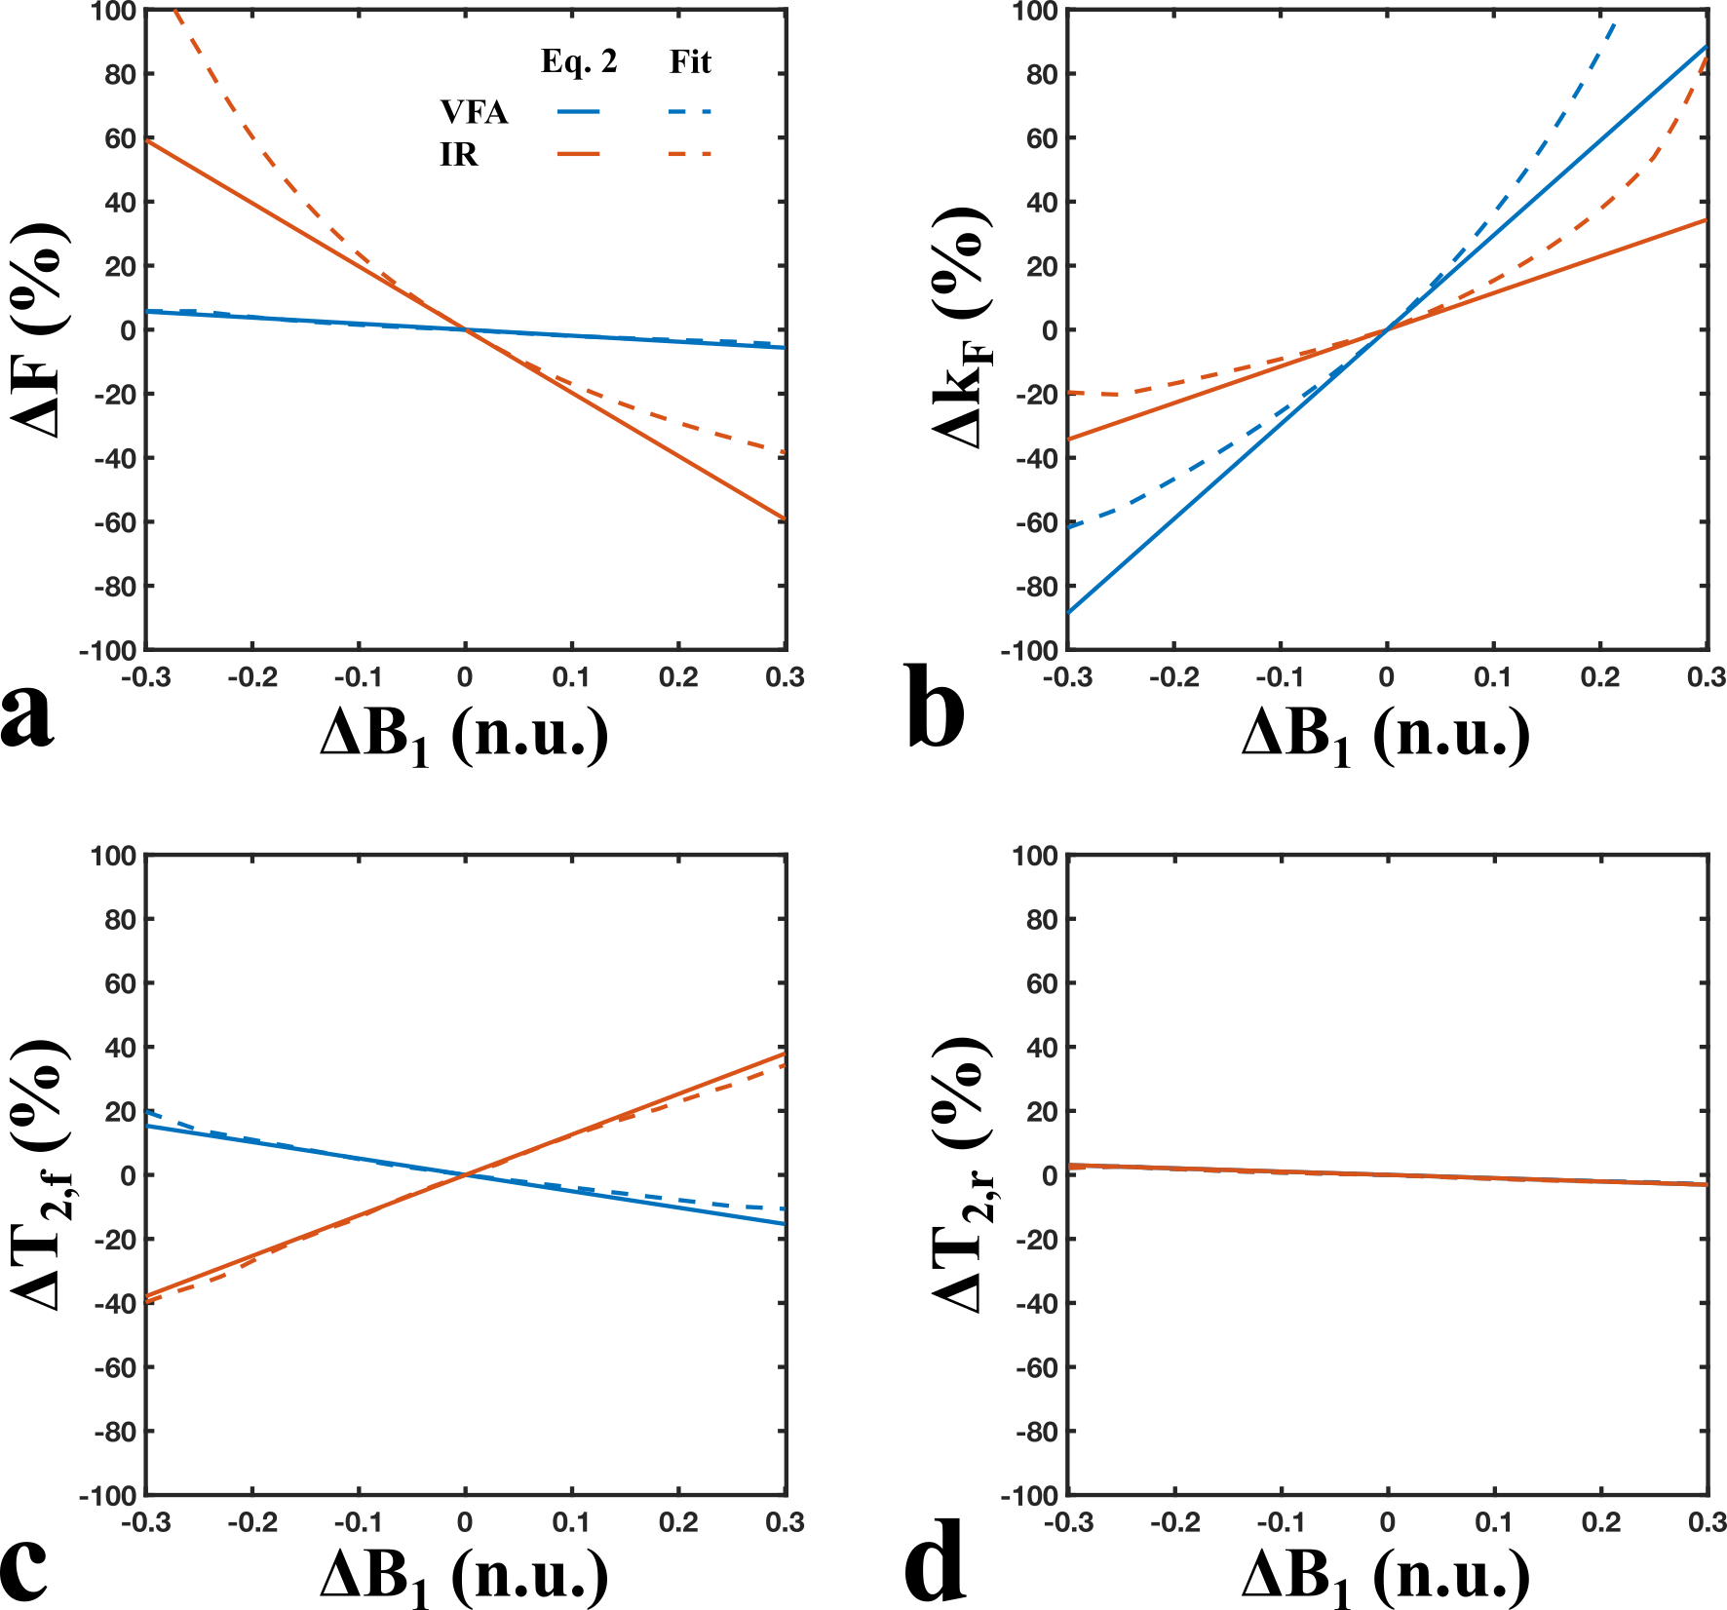

Figure 1. Simulated qMT parameter errors due to B1-inaccuracies (-30% < ΔB1 < 30%) considering a B1-independent T1 measurement (red: IR – inversion recovery) and a B1-dependent T1-measurement (blue: VFA – variable flip angle). Solid lines are parameter errors calculated from minimizing Eq. 2 (first-order approximation of the Taylor expansion), and dashed lines are parameter errors calculated from fitting the qMT signal according to the Sled & Pike model. The tissue parameters (white matter) and qMT protocol (uniform) were matched to those presented in Boudreau et al. 2017 (see Fig. 3 of the paper).

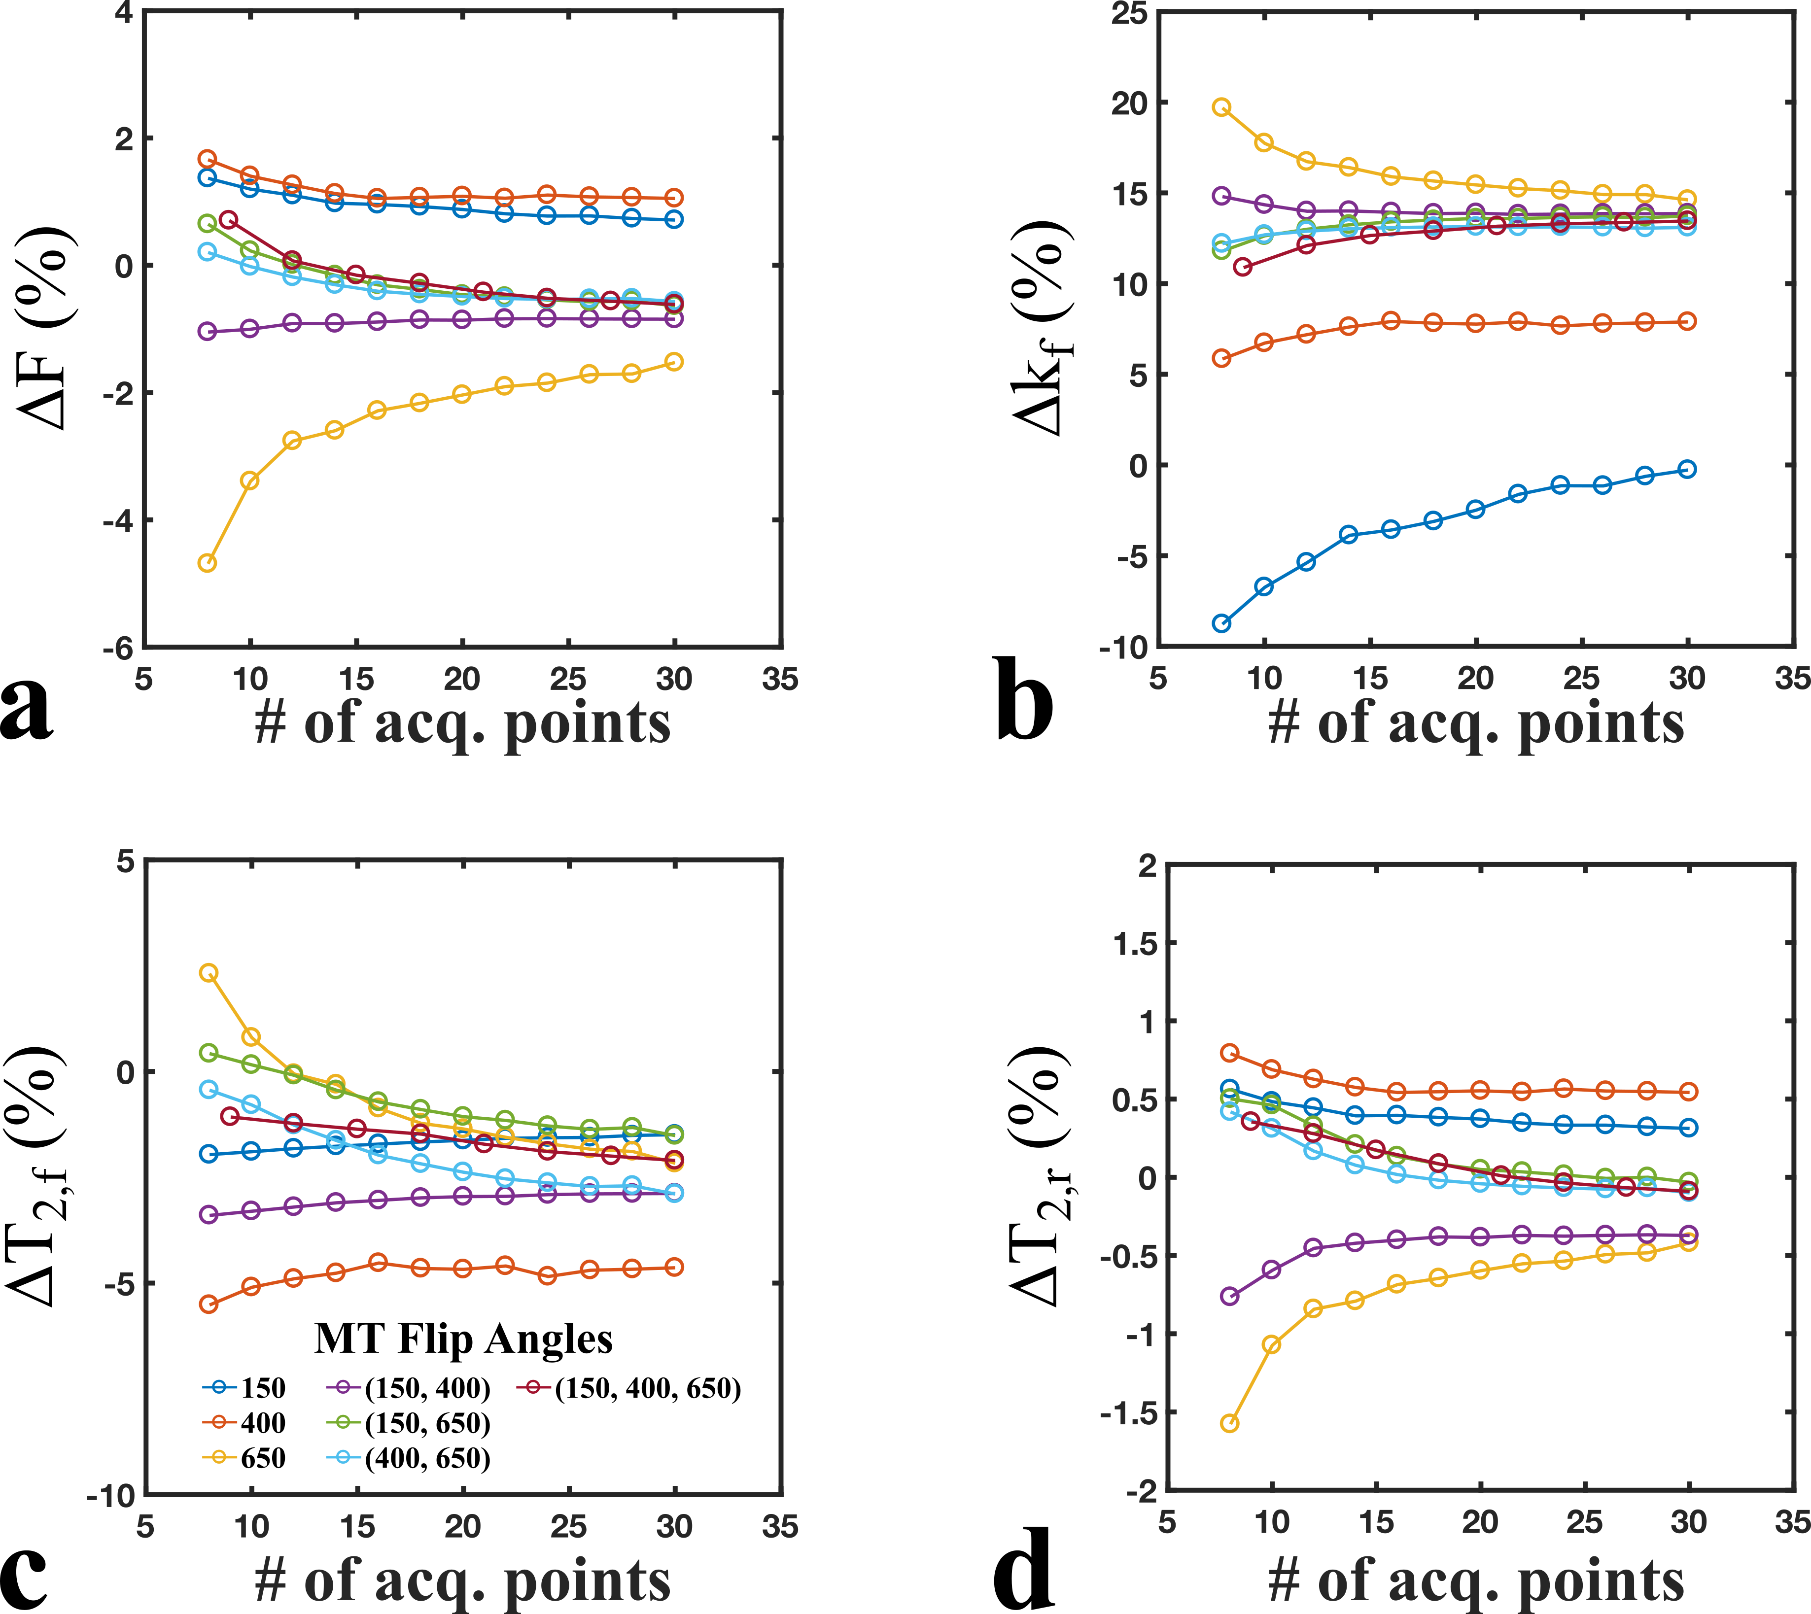

Figure 2. Simulated qMT parameter errors estimated from Eq. 2 for ΔB1=0.05 for a wide range of logarithmically-uniform (offsets) qMT protocols. Single (blue, orange, yellow), dual (purple, green, light blue), and triple (red) flip angle combinations of 150°, 400°, and 600° were compared. The number of offset frequencies were uniformly distributed between 300 Hz and 20 kHz, and matched for the total number of acquisition points (# offsets × # flip angles).

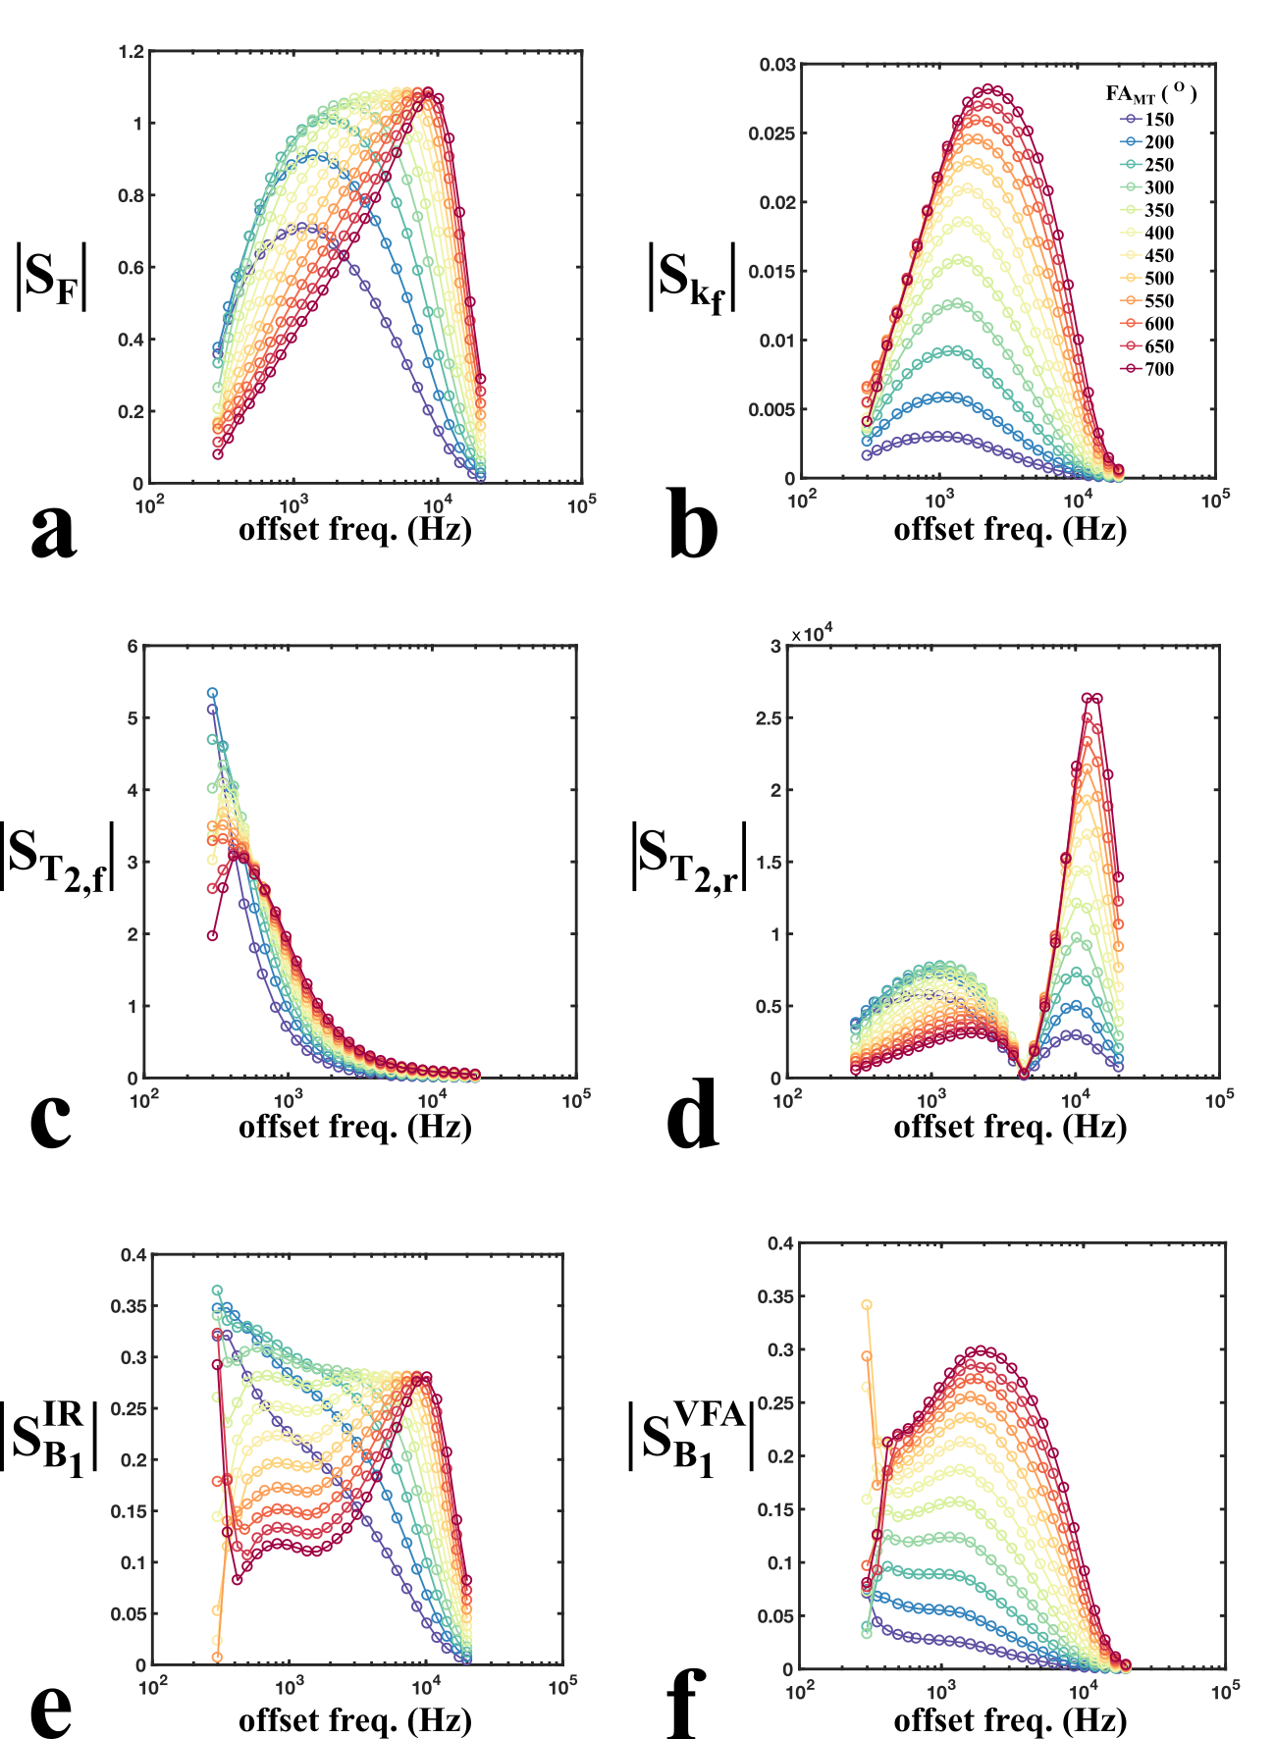

Figure 3. Sensitivity values (magnitudes) for each qMT fitting parameters (F, kf, T2,f, T2,r) and B1 measurement values considering a B1-independent T1 measure (IR – inversion recovery) and a B1-dependent T1 measure (VFA – variable flip angle). The 312-point protocol shown (12 flip angles x 26 offset frequencies) represents the initial search-space used for protocol optimization. The sets of sensitivity values for each fitting parameter (a–d) consists of the matrix columns of the Jacobian sensitivity matrix (S*p* in Eq. 2 and 5).

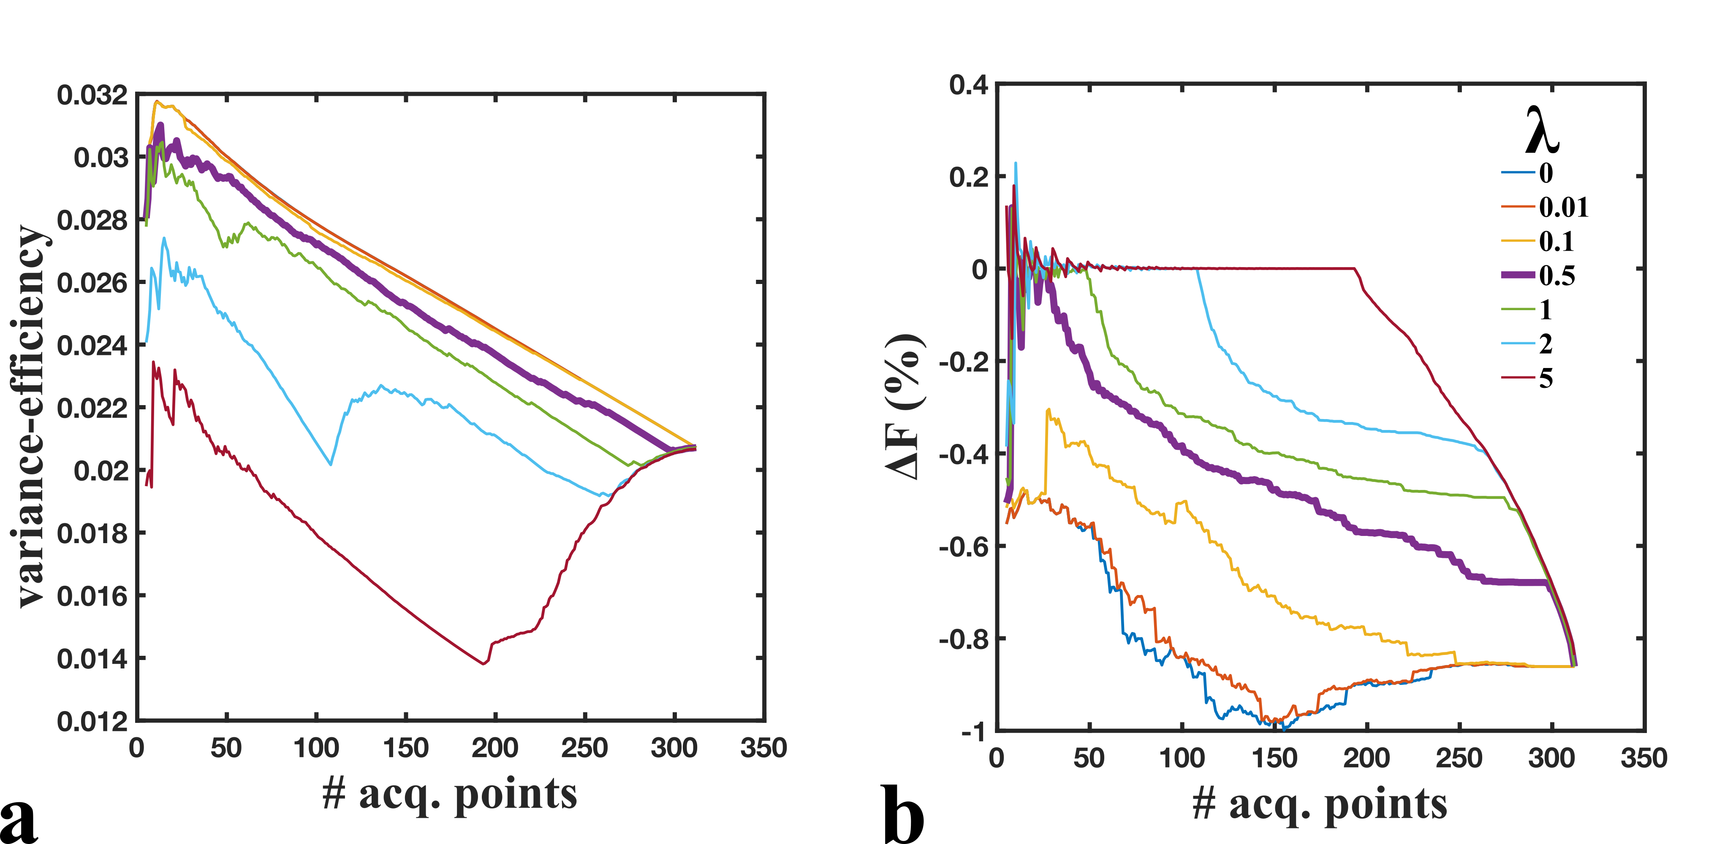

Figure 4. Variance-efficiency (a) and ΔF (b) (Eq. 2, ΔB1 = 5%) values during the iterative optimization of the sensitivity-regularized Cramer-Rao Lower-Bound equation (Eq. 5). Variance-efficiency is defined here as (variance × # acq. points)-1/2, where the variance is interpreted to be the parameter-normalized Cramer-Rao Lower Bound (*V*, Eq. 3).

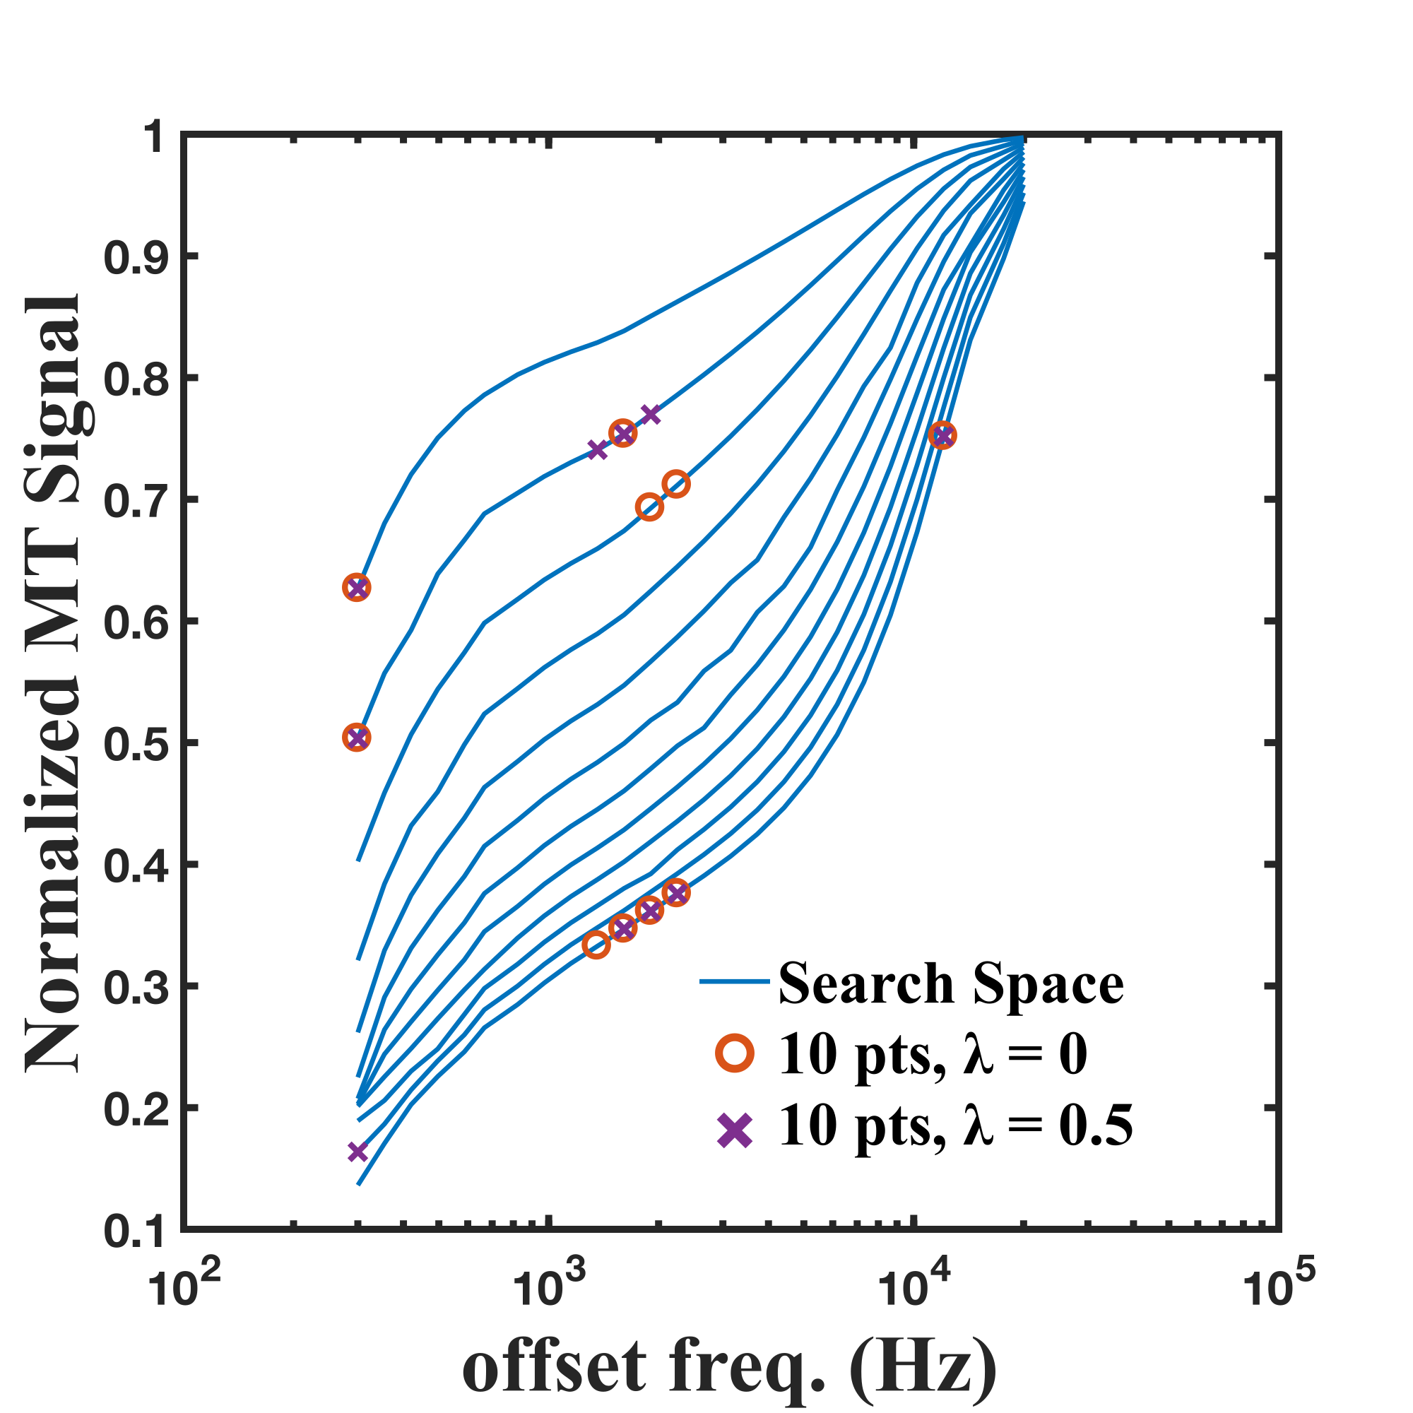

Figure 5. Comparison between the 10-point protocols iteratively optimized from a 312-point search space using solely the parameter-normalized CRLB (λ = 0) and regularized CRLBλ=0.5. The different flip angle Z-spectrums of the initial optimization search-space are displayed in blue to emphasize the 10-point protocols. The flip angle Z-spectrums (150° to 700°, in 50° increments) range from the highest MT-signal values curve (150°) to lowest (700°).

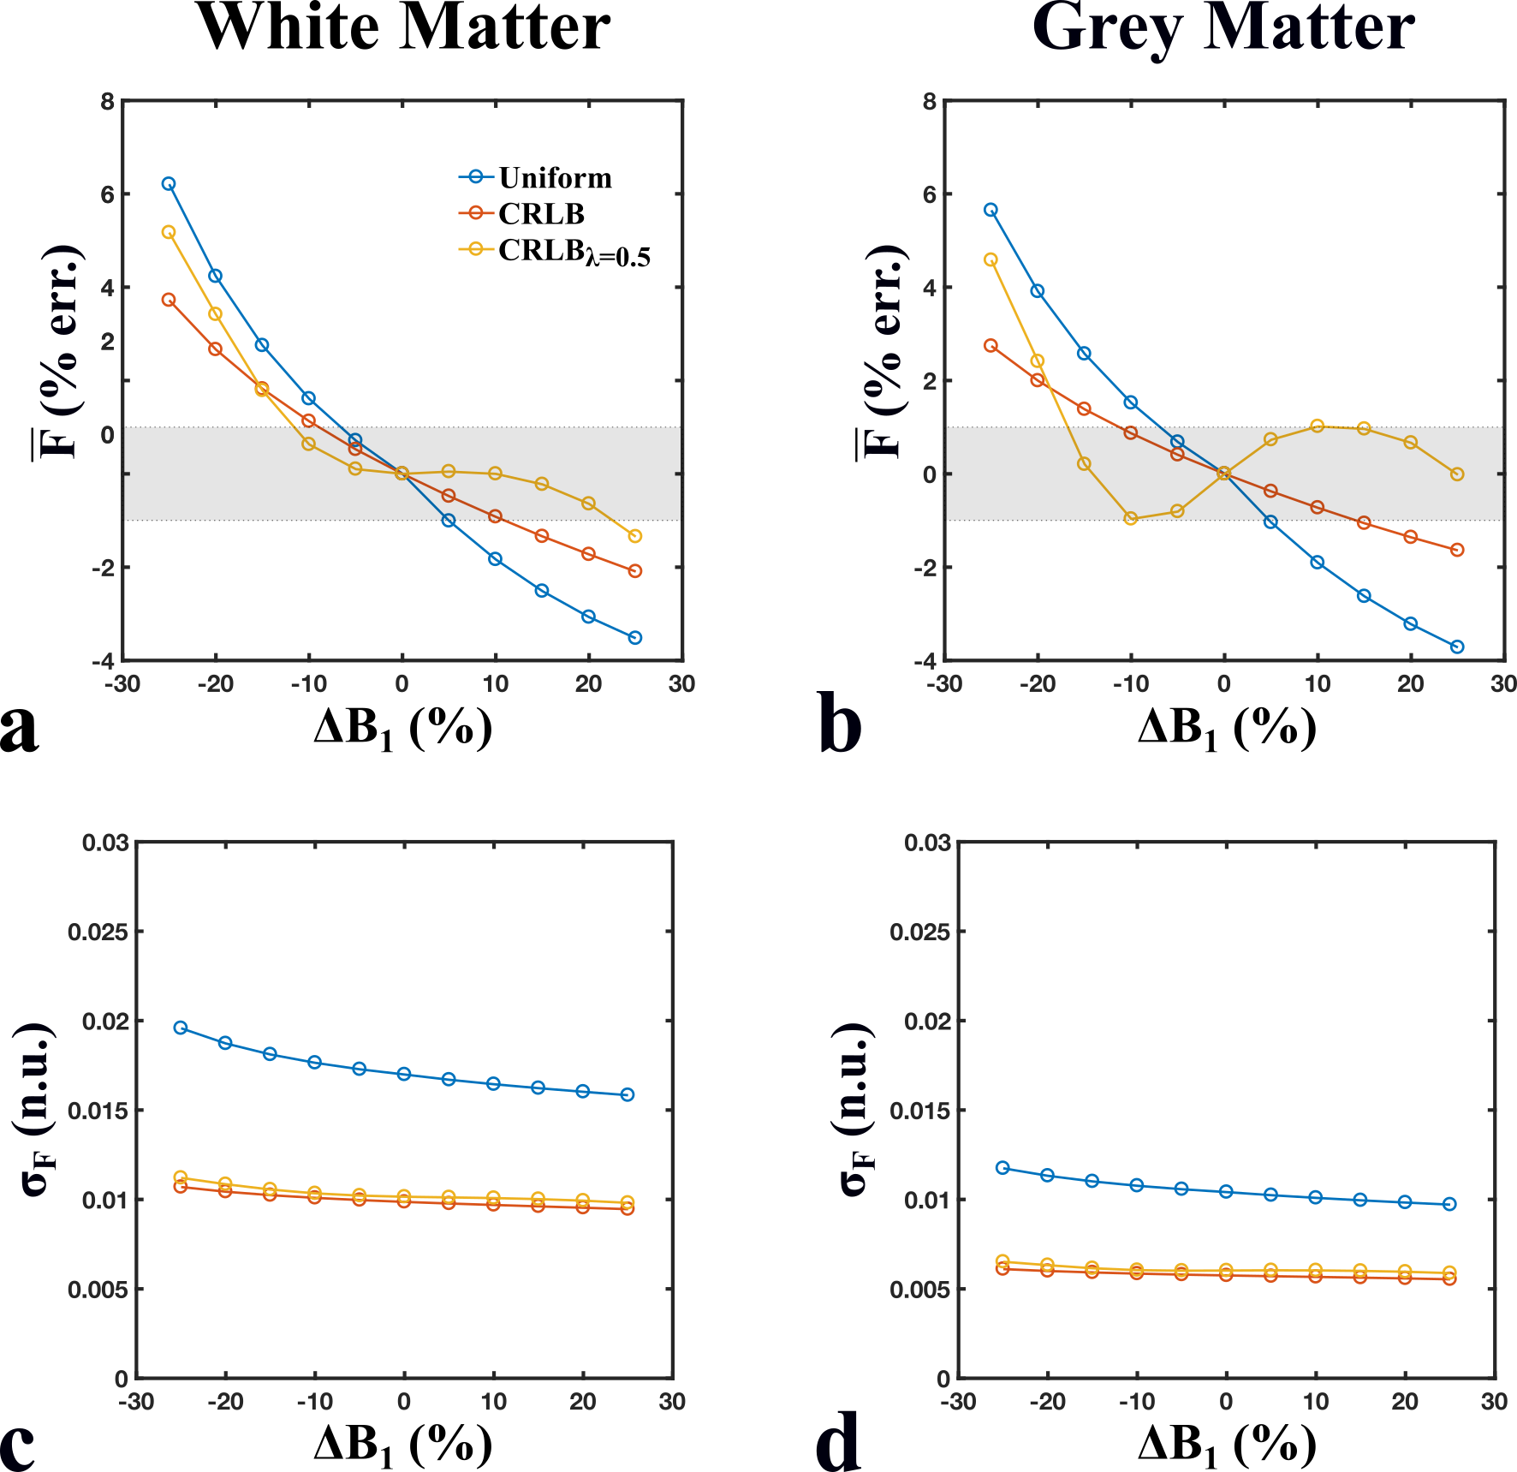

Figure 6. Means (a, b) and standard deviations (c, d) of the distribution of pool-size ratios (F) for sets of Monte Carlo simulations (10,000 runs, SNR = 100) fitted using a range of B1 errors (ΔB1 = ±30%, B1 = 1 n.u.) and for two sets of qMT parameters (white matter – a,c; grey matter – b, d). Mean F values (% error) shown here were compared relative to the accurate B1 value case (ΔB1 = 0), and the grey region represents the region of ±1% relative error. Simulated signal values were generated and fitted for three different 10-point qMT protocols: Uniform (blue) – two-FA protocol with logarithmically-uniform off-resonance frequency values, CRLB (red) – protocol optimized by iteratively minimizing the increase in the parameter-normalized Cramer-Rao Lower-Bound of the system, and CRLBλ=0.5 (yellow) – protocol optimized similar to CRLB, regularized by the estimated error of F (ΔF) in the presence of a B1 error (Eq. 5).

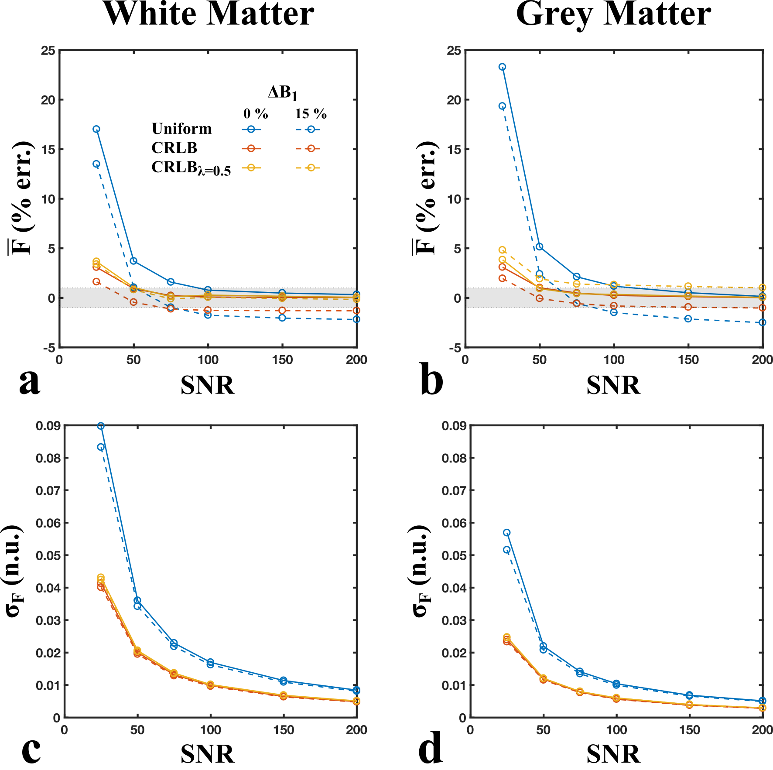

Figure 7. Means (a, b) and standard deviations (c, d) of the distribution of pool-size ratio values (F) for sets of Monte Carlo simulations (10,000 runs) fitted using a range of SNR values (25, 50, 75, 100, 150, and 200) and for two sets of qMT parameters (white matter – a,c; grey matter – b, d). Mean F values (% error) shown here were compared relative to data fitted for an ideal SNR case (noiseless), and the grey region represents the region of ±1% relative error. Data was fitted assuming ideal B1 values (B1 = 1 n.u., solid lines) and a 15% overestimation in B1 (B1 = 1.15 n.u., dotted lines). Simulated signal values were generated and fitted for three different 10-point qMT protocols: Uniform (blue) – two-FA protocol with logarithmically-uniform off-resonance frequency values, CRLB (red) – protocol optimized by iteratively minimizing the increase in the parameter-normalized Cramer-Rao Lower-Bound of the system, CRLBλ=0.5 (yellow) – protocol optimized similar to CRLB, regularized by the estimated error of F (ΔF) in the presence of a B1 error (Eq. 5).