Development of Multimodal Quantitative MRI Techniques to Assess Microstructure in Multiple Sclerosis

Mathieu Boudreau, M.Sc.

Department of Biomedical Engineering

McGill University, Montreal, Canada

October 15, 2017

A thesis submitted to McGill University in partial fulfillment of the

requirements for the Degree of Philosophy

© Mathieu Boudreau, 2017

Contents

Contents 2

List of Figures 5

List of Tables 6

Acknowledgements 7

Preface 8

Contribution of Authors 9

Other Publications 10

Abstract 12

Résumé 13

Original Contributions 14

Chapter 1 *Introduction* 15

1.1 Motivation 15

1.2 Objectives 15

1.3 Thesis Outline 15

Chapter 2 *Background* 16

2.1 Radio Frequency Pulses in MR 16

2.1.1 Pulse Generation and Measurement 16

2.1.2 Conventional B1 Mapping Methods 16

2.1.3 Practical Applications of B1 Maps 16

2.2 Relaxometry 16

2.2.1 Relaxation Mechanisms 16

2.2.2 T2 Mapping 16

2.3 Magnetization Transfer Imaging 16

2.3.1 Two-Pool Model of MT 16

2.3.2 Pulsed Quantitative Magnetization Transfer Imaging 16

2.3.3 Novel Magnetization Transfer Imaging Methods 17

2.3.4 MTR and MTsat 17

2.4 Multiple Sclerosis 17

2.4.1 Neuropathology of MS 17

2.4.2 Role of MRI in MS 17

2.4.3 Quantitative MRI in MS 17

Chapter 3 *B1 Mapping for Bias-Correction in Quantitative T1 Imaging of the Brain at 3T Using Standard Pulse Sequences* 18

3.1 Preface 18

3.2 Abstract 20

3.3 Introduction 20

3.4 Materials and Methods 22

3.4.1 Measurements 22

3.4.2 B1 Mapping 24

3.4.3 T1 Mapping 26

3.4.4 Data Analysis 26

3.5 Results 27

3.6 Discussion 32

3.7 Acknowledgments 36

Chapter 4 *B1-Sensitivity Analysis of Quantiative Magnetization Transfer Imaging* 37

4.1 Preface 37

4.2 Abstract 39

4.3 Introduction 39

Chapter 5 *Last paper* 40

5.1 Preface 40

Chapter 6 *Conclusion* 41

6.1 Preface 41

Bibliography 42

List of Figures

Figure 3‑1.Tissue classification maps (black = 0%, gray = 100%) of a healthy subject calculated from INSECT [24] using MP-RAGE T1w data (1 × 1 × 1mm3) and resampled to 2 × 2 × 5mm3. Tissue percentages were estimated by calculating the ratio of INSECT tissue-classified voxels (1mm3) for a given tissue type (WM, GM, CSF) that were located inside the corresponding low-resolution voxels (2 × 2 × 5mm3), for which the quantitative maps (B1, T1) were acquired. 24

Figure 3‑2. Normalized histograms of single-slice unfiltered B1 (a) and T1 (b) map values masked for WM in six healthy subjects. The abbreviation “n.u.” stands for normalized units. 28

Figure 3‑3. a: Acquisition images for each acquired B1 method: Ref. DA (reference single-slice double angle), AFI (actual flip angle imaging), BS (Bloch-Siegert shift), and EPI-DA (double-angle using an interleaved multislice EPI acquisition). b: Unfiltered single-slice B1 maps, and corresponding WM-masked VFA T1 maps fitted using flip-angles scaled voxelwise using each B1 map. The “Nominal” column represents VFA T1 fitting using no B1 correction (B1 = 1 n.u.). 28

Figure 3‑4. Unfiltered (a) and Gaussian filtered (b) B1 maps of a single subject. (c) Relative differences between unfiltered and filtered maps shown as percent difference maps. 31

Figure 3‑5. Whole-brain coverage of axial MP-RAGE T1w slices, unfiltered AFI B1 maps, and unfiltered EPI-DA B1 maps in one subject. 32

List of Tables

Table 3‑1. Linear Regression Analysis of the Pooled WM-Masked B1 and T1 Values (Six Subjects) for Each Rapid B1 Method Relative to the Ref. DA Method 29

Table 3‑2. Mean and Standard Deviations of Voxelwise Percent Differences (%) of B1 and T1 Values in WM Relative to the Ref. DA Method for All Subjects 30

Acknowledgements

Preface

Contribution of Authors

Other Publications

The following list of peer-reviewed articles and conference presentations were also produced over the course of this PhD degree, but are not included in the thesis:

* J.S.W. Campbell, I.R. Leppert, S. Narayanan, **Mathieu Boudreau**, T. Duval, J. Cohen-Adad, G.B. Pike, N. Stikov, *“Promise and pitfalls of g-ratio estimation with MRI”*, Submitted to: Neuroimage (2017)
* M. Mclean, M.E. MacDonald, R.M. Lebel, **M. Boudreau**, B. Pike, *“Accelerated z-Spectrum Imaging”*, Oral, International Society for Magnetic Resonance in Medicine Meeting (2017)
* J. Campbell, I.R. Leppert, **M. Boudreau**, S. Narayanan, T. Duval, J. Cohen-Adad, G.B. Pike, N. Stikov, *“Myelin g-ratio imaging: promises and pitfalls”*, Poster, International Society for Magnetic Resonance in Medicine Meeting (2016)
* J.-F. Cabana, Y. Gu, **M. Boudreau**, I.R. Levesque, Y. Atchia, J.G. Sled, S. Narayanan, D.L. Arnold, G.B. Pike, J. Cohen-Adad, N. Stikov, *“Quantitative Magnetization Transfer Imaging Made Easy with qMTLab: a Software for Data Simulation, Analysis and Visualisation”*, Concepts in Magnetic Resonance Part A, 44A: 263–277 (2016)
* N. Stikov, J.S.W. Campbell, T. Stroh, M. Lavalée, S. Frey, J. Novek, S. Nuara, M.-K. Ho, B.J. Bedell, R.F. Dougherty, I.R. Leppert, **M. Boudreau**, S. Narayanan, T. Duval, J. Cohen-Adad, P.-A. Picard, A. Gasecka, D. Côté, G.B. Pike, *“In vivo histology of the myelin g-ratio with magnetic resonance imaging”*, NeuroImage, 118:397-405 (2015)
* N. Stikov, J.S.W. Campbell, T. Stroh, M. Lavalée, St. Frey, J. Novek, S. Nuara, M.-K. Ho, B.J. Bedell, R.F. Dougherty, I.R. Leppert, **M. Boudreau**, S. Narayanan, T. Duval, J. Cohen-Adad, P.-A. Picard, A. Gasecka, D. Côté, G.B. Pike, *“Quantitative analysis of the myelin g-ratio from electron microscopy images of the macaque corpus callosum”*, Data in Brief, 4:368-373 (2015)
* N. Stikov, **M. Boudreau**, I.R. Levesque, C.L. Tardif, J. Barral, G.B. Pike, “*On the Accuracy of T1 Mapping: Searching for Common Ground.*” Magnetic Resonance in Medicine, 73:514-522 (2015)
* N. Stikov, J. Campbell, **M. Boudreau**, S. Narayanan, T. Stroh, S. Nuara, J. Novek, S. Frey, M.-K. Ho, B. Bedell, G.B. Pike, “*In vivo histology of the myelin g-ratio”*, Poster, OHBM Annual Meeting (2014)

Abstract

Résumé

Original Contributions

# *Introduction*

## Motivation

## Objectives

## Thesis Outline

# *Background*

## Radio Frequency Pulses in MR

### Pulse Generation and Measurement

This is a test body.

### Conventional B1 Mapping Methods

### Practical Applications of B1 Maps

## Relaxometry

### Relaxation Mechanisms

### T2 Mapping

## Magnetization Transfer Imaging

### Two-Pool Model of MT

### Pulsed Quantitative Magnetization Transfer Imaging

### Novel Magnetization Transfer Imaging Methods

### MTR and MTsat

## Multiple Sclerosis

### Neuropathology of MS

### Role of MRI in MS

### Quantitative MRI in MS

# *B1 Mapping for Bias-Correction in Quantitative T1 Imaging of the Brain at 3T Using Standard Pulse Sequences*

## Preface

Foo

**B1 Mapping for Bias-Correction in Quantitative T1 Imaging of the Brain at 3T Using Standard Pulse Sequences**

*Mathieu Boudreau, Christine L. Tardif, Nikola Stikov, John G. Sled, Wayne Lee, G. Bruce Pike*

McConnell Brain Imaging Centre, Montreal Neurological Institute 3801 University Street, McGill University  
Quebec, Canada, H3A 2B4

**Journal of Magnetic Resonance Imaging, DOI: 10.1002/jmri.25692, 2017**

## Abstract

**Purpose:** B1 mapping is important for many quantitative imaging protocols, particularly those that include whole-brain T1 mapping using the variable flip angle (VFA) technique. However, B1 mapping sequences are not typically available on many magnetic resonance imaging (MRI) scanners. The aim of this work was to demonstrate that B1 mapping implemented using standard scanner product pulse sequences can produce B1 (and VFA T1) maps comparable in quality and acquisition time to advanced techniques.

## Introduction

Radiofrequency transmit field (B1+) maps, typically termed “B1 maps” for brevity, are necessary in several quantitative magnetic resonance imaging (MRI) applications, such as specific absorption rate (SAR) estimation, magnetization transfer (MT) imaging, and quantitative T1 mapping. Electrical properties tomography (EPT) relies on quantitative B1 maps to calculate the conductivity (*σ*) and permittivity (*ε*) of tissue in vivo [1], and is an essential step in the estimation of local SAR [2]. MT techniques probe the macromolecular content of tissue, and are often used as an index of myelination in diseases such as multiple sclerosis [3]. Unaccounted B1 inhomogeneity in certain MT experiments can be an important source of error. For example, B1-correction has been shown to improve the quality of MT ratio (MTR) maps [4], due to the sensitivity of MTR to the MT preparation RF pulse power. The longitudinal relaxation time (T1), one of the fundamental quantities in MRI, is an important input for several other data processing pipelines, such as dynamic contrast enhancement (DCE) imaging [5,6] and quantitative MT [7]. Although some whole-brain T1 mapping methods boast first-order insensitivity to RF field inhomogeneities [8], others—notably the variable flip angle (VFA) method [9]—are inherently sensitive to inaccuracies in the excitation flip angles (FA). B1 maps can greatly benefit the accuracy and precision of VFA T1 maps at high clinical field strengths, (eg, 3T), where large B1 amplitude variations are typical in loaded coils [10] (eg, ±30% for the human brain). The broad range of B1 applications highlights the need for accurate B1 mapping techniques, while also balancing other competing interests such as acquisition speed and ease of implementation, particularly in the context of multisite studies.

Substantial efforts have been made to develop rapid whole-brain B1 mapping techniques in the last decade. Previously, conventional B1 mapping was done using some variations of the double angle (DA) method, which consists of two separate gradient-echo or spin-echo measurements with longitudinal magnetization recovery in which the second measurement is performed with double the excitation pulse flip angle [11]. However, conventional DA requires very long repetition times, and was mostly used for single-slice imaging. Advanced pulse sequences have been developed to accommodate whole-brain B1 mapping. Two of the most popular techniques are actual flip angle imaging (AFI) [12] and Bloch-Siegert shift (BS) mapping [13]. AFI is a steady-state 3D spoiled gradient echo (SPGR) B1 mapping method based on a dual-TR acquisition (TR2 = N*TR1, where N is typically an integer on the order of 5), and has been shown to be T1-insensitive for most tissues. BS is a phase-sensitive slice-selective B1 mapping method using a modified SPGR sequence; a high amplitude off-resonance RF pulse between the excitation and readout events induces a phase-shift proportional to the B1 amplitude. Currently, an important limitation of these methods is their lack of widespread availability as a standard product sequence on clinical scanners. These pulse sequences are typically implemented onsite, a time-consuming process that require pulse sequence programming expertise, and is susceptible to site-specific implementation issues.

The lack of a readily available whole-brain B1 mapping pulse sequence is a challenge to many researchers, particularly in the context of multi-center studies, resulting in the omission of B1 mapping in quantitative imaging protocols that would significantly benefit from its inclusion. One such quantitative MRI method is VFA T1 mapping, which estimates T1 by fitting the gradient echo images to a function of flip angles, making it inherently sensitive to B1 inaccuracies. For example, using a VFA sequence with a 15 msec TR and two flip angles (3° and 20°) [14], an underestimation of the nominal flip angles by 1/5/10/20% results in an overestimation of the fitted T1 by 2/11/24/57%. Thus, errors in B1 induce at least twice as large errors in T1, and the error increases nonlinearly. Notably, DCE imaging protocols that use VFA T1 mapping often omit B1 correction [5,15], even though B1 maps have been shown to substantially improve the accuracy of DCE [6,16]. Citing the unavailability of advanced B1 mapping sequences at their site, other researchers have developed techniques to simulate B1 maps by normalizing the VFA T1 image [17] using postprocessing image analysis algorithms [18]. However, a systemic bias in B1 values (of unknown size) could still be present using this type of image analysis approximation, so measuring B1 directly should improve the accuracy of the T1 maps.

The purpose of this work was to evaluate the quality of a fast and simple whole-brain B1 mapping protocol implemented using a standard EPI pulse sequence. An interleaved multislice spin-echo EPI readout standard product pulse sequence was used to map B1 with the DA method (EPI-DA) [19-21] in a group of healthy human subjects. EPI-DA has not gained as much attraction in comparison to AFI and BS, due to their demonstrated robustness against specific characteristics (eg, large T1 values, B0 inhomogeneity) and their compatibility with higher fields systems that use parallel transmit coils. Yet the ease of implementation of EPI-DA or other similar techniques (eg, fast spin-echo DA [22]) may make them a good alternative to advanced B1 methods, which require custom implementations and pulse sequence programming expertise.

## Materials and Methods

All measurements were performed on a 3.0T whole-body MRI scanner (Magnetom TIM TRIO, Siemens, Erlangen, Germany) using a 32-channel phased-array receive-only head coil and whole-body transmit coil.

### Measurements

Healthy adult volunteers were scanned in compliance with the guidelines of the Institutional Ethics Committee, and gave written informed consent prior to being scanned for this study. Six healthy adult volunteers were scanned (three females, three males, 29 ± 3 years old). Axial slices were acquired (for 2D measurements) or extracted (from 3D/multislice measurements, with orientations matching the single-slice 2D measurements) parallel to the anterior and posterior commissure (AC-PC) plane, superior to the corpus callosum.

Quantitative analyses of the B1 and T1 maps were limited to voxels comprised of white matter (WM), consistent with previous work [22,23]. Two reasons factored into this decision. First, as B1 maps are typically acquired at low resolution, partial volume effects occur near cortical gray matter (GM) regions and areas adjacent to ventricles. Therefore, there is an insufficient number of voxels that contain pure GM. Second, the partial volume effects in regions containing cerebrospinal fluid (CSF) result in substantially longer mean T1 values (2–5 sec), so T1-sensitive artifacts will vary in severity between B1 methods that have different intrinsic sensitivity to long T1 and CSF flow. Adequately comparing B1 methods in GM and CSF is a specialized topic that requires higher resolution and/or longer scan-times, which is beyond the scope of this work.

Whole-brain T1-weighted magnetization-prepared rapid gradient-echo (MP-RAGE) 3D volumes (1 × 1 × 1mm3) were acquired: repetition time (TR) = 2300 msec, echo time (TE) = 3.32 msec, inversion time (TI) = 900 msec, iPAT factor = 2 (GRAPPA), bandwidth (BW) 5230 Hz/Px, 5 min 30 sec scan time. Tissue classification maps (WM, GM, CSF) were obtained via Intensity Normalized Stereotaxic Environment for the Classification of Tissue (INSECT)24 using the MP-RAGE data with the ICBM-152 atlas. All necessary preprocessing steps (nonuniformity correction, skull-stripping, etc.) were done using the standard pipeline of the MINC Tool Kit (v. 1.9.11, McConnell Brain Imaging Center, Montreal Neurological Institute, Montreal, Canada). Tissue percentage maps (WM, GM, CSF), at the low resolution (2 × 2 × 5mm3) for which the quantitative maps (B1, T1) were acquired, were estimated by calculating the ratio of high-resolution INSECT tissue-classified voxels (1mm3) that had the center of their voxels located within the corresponding 2 × 2 × 5mm3 voxels. using a majority voting analysis (75% threshold). Figure 3‑1 shows a tissue classification maps of WM, GM, and CSF for a healthy subject. The classification maps show that for a 2 × 2 × 5mm3 resolution, very few voxels consisted of single-tissue GM or CSF, reaffirming our reasoning to exclude these areas in our study. To generate the WM masks for each subject, a >75% binary threshold was applied to the tissue percentage maps; since there can be 20 high-resolution voxels (1mm3) that have their centers located in a low-resolution voxels (2 × 2 × 5mm3), a >75% threshold represents the case that no more than four non-WM INSECT tissue classified voxels (out of 20) are located within a voxel of the WM mask. Lastly, note that the WM mask were only used to mask-out non-WM voxels after the B1 maps were calculated, and are not required to calculate any of the B1 maps described in the following section.

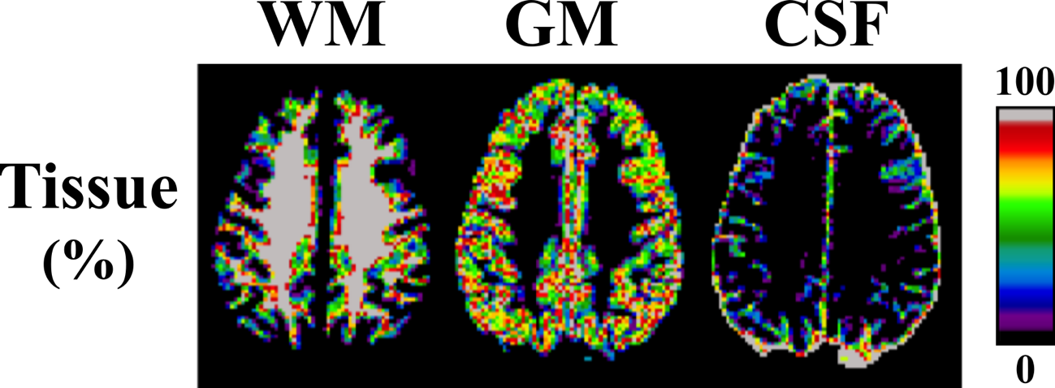

Figure ‑.Tissue classification maps (black = 0%, gray = 100%) of a healthy subject calculated from INSECT [24] using MP-RAGE T1w data (1 × 1 × 1mm3) and resampled to 2 × 2 × 5mm3. Tissue percentages were estimated by calculating the ratio of INSECT tissue-classified voxels (1mm3) for a given tissue type (WM, GM, CSF) that were located inside the corresponding low-resolution voxels (2 × 2 × 5mm3), for which the quantitative maps (B1, T1) were acquired.

### B1 Mapping

Three rapid B1 mapping techniques (Bloch-Siegert shift, BS; actual flip angle imaging, AFI; echo planar imaging double angle, EPI-DA) were acquired with acquisition protocols that matched their original publications values as closely as possible. A single-slice double angle B1 map was acquired as a reference (Red. DA), as is typical [13,25]. Lastly, a uniform B1 map of value 1 normalized units (n.u.), noted in short-hand as “Nominal,” was generated to represent the case when VFA T1 values are fitted using the nominal flip angles of its acquisition protocol.

*BLOCH-SIEGERT (BS).* Single-slice BS B1 maps [13] were acquired using an in-house-developed pulse sequence: TE/TR = 15/100 msec, excitation flip angle (*α*) = 25°, field-of-view (FOV) = 25.6 × 17.6 cm2, 2 × 2mm2 in-plane resolution, 128 × 88 matrix (readout/phase), 5mm slice thickness, 1 slice, 8 msec Fermi Pulse of 500° at 64 kHz off-resonance and phase-shift constant KBS = 74.01 rad/G2, 19 sec scan time.

*ACTUAL FLIP ANGLE IMAGING (AFI).* AFI B1 maps were acquired using an in-house-written slab-selective 3D AFI pulse sequence with optimal RF and gradient spoiling [12,26]: TE/TR1/TR2 3.53/20/100 msec, *α* = 60°, BW = 260 Hz/pixel, FOV = 25.6 × 17.6 × 16.0 cm3, 2 × 2 × 5mm3 resolution, 128 × 88 × 32 matrix (readout/phase/3D), spoiling gradient moment (AG) = 450 mT∙ms/m and RF phase increment (*ψ*) = 39°, 5 min 38 sec scan time.

*EPI DOUBLE ANGLE (EPI-DA).* Interleaved multislice spin-echo EPI-DA B1 maps with whole-brain coverage were acquired using a standard product EPI pulse sequence with a protocol similar to that of Wang et al [19], except with 180° refocusing pulses (the scanner default for this sequence). Since our sequence used (*α*, 180°) and (2*α*, 180°) excitation-refocusing pulses, instead of (*α*, 2*α*) and (2*α*, 4*α*) in the original article, the equation used to calculate EPI-DA B1 was [11,22]:

|  |  |
| --- | --- |
|  | **(3-1)** |

where *α* is the nominal flip angle (double for the second measurement), *α*corr is the true flip angle experienced by the tissue at that voxel location, *I1* and *I2* are the image voxels magnitudes for *α* and 2*α* acquisition, respectively. The EPI-DA acquisition protocol was: TE/TR = 46/4000 msec, *α*/2*α* = 60°/120°, FOV = 25.6 × 25.6 cm2, 2 × 2mm2 in-plane resolution, 128 × 128 matrix (readout/phase), 5mm slice thickness, 27 slices, EPI factor = 9 (15 shots of 9 k-space readout line acquisitions), echo spacing = 4.18 msec, fat saturation on, BW = 250 Hz/px, 2 min 16 sec scan time. Standard automated shimming was performed as with all other sequences (shim currents adjusted using a 3D phase map); no additional adjustments of the static or gradient fields were necessary.

Fast EPI sequences, such as the widely used single-shot implementations, can be susceptible to a wide range of artifacts that lead to a degradation of image quality. Several strategies are incorporated in this protocol to mitigate these artifacts, while still using a readily available scanner sequence and maintaining rapid overall acquisition. A segmented multishot EPI approach increases the effective BW in the phase-encode direction, which reduces distortion artifacts that are typically prevalent in areas of high B0 inhomogeneity such as near the sinuses. Blurring is also reduced, due to decreased T2* modulation in each acquired echo train. Acquiring the B1 map at a low in-plane resolution (2 × 2mm2) also means smaller readout gradient amplitudes are used, reducing potential eddy current artifacts (eg, ghosting). Other fast imaging techniques, such as fast spin-echo, have also been adapted for whole-brain double angle B1 mapping [22]. These methods could offer different imaging benefits as alternatives to EPI; however, such a comparison is outside the scope of the present work.

*REFERENCE DOUBLE ANGLE (REF. DA).* Single-slice double angle B1 maps were acquired using a spin-echo sequence as a reference measurement for the other B1 mapping techniques: TE/TR 12/1550 msec, *α* = 60°/120°, FOV = 25.6 × 17.6 cm2, 2 × 2mm2 in-plane resolution, 128 × 88 matrix (readout/phase), 5mm slice thickness, 1 slice, slice-selective excitation and 180° refocusing pulses, and BW = 130 Hz/pixel, 4 min 28 sec scan time. The flip angles were chosen to match the EPI-DA sequence. As Ref. DA is the most time costly of all the compared methods (4 min 38 sec), a shorter TR was chosen to reduce the acquisition time of the entire protocol while maintaining sufficient accuracy in WM [14]. The TR is sufficiently long to allow almost complete relaxation of the WM signal, which we are evaluating.

Overall, each pulse sequence had the following effective acquisition time per slice: Ref. DA: 4 min 38 sec/slice, BS: 19 sec/ slice, AFI: 11 sec/slice (3D measurement), EPI-DA: 5 sec/slice (interleaved multislice sequence produced 27 slices in 68 sec per flip angle acquisition).

### T1 Mapping

VFA is a widely used T1 mapping technique; spoiled gradient echo images are acquired using multiple (usually 2–5) excitation flip angles, each using the same TR. VFA T1 maps were acquired using a standard product spoiled 3D gradient echo pulse sequence: 2 × 2 × 5mm3 resolution, 128 × 88 × 32 matrix (readout/phase/3D), TE/TR 2.89/15 msec, *α* = 3°/20°, BW = 390 Hz/pixel, default manufacturer slab-selection and RF spoiling modes, 1 min 28 sec scan time.

### Data Analysis

B1 and T1 maps were processed from the MRI data using custom MATLAB code (MathWorks, Natick, MA). Each B1 map was used to scale the VFA nominal flip angles voxelwise prior to fitting for T1. T1 maps were estimated from linear least square fitting to the SPGR equation [14].

The B1 amplitude is expected to be a smooth slowly varying function, particularly in the brain [18]. As such, B1 maps are commonly filtered to reduce noise and minor artifacts [12,25]. Subjective assessment of the images was performed by two of the coauthors (coauthors #3 and #6) who were blinded to the acquisition method used for each dataset. They provided a brief subjective evaluation of any artifacts they observed. A consensus opinion was then formed via discussion between all coauthors. In addition to comparing unfiltered (raw) B1 maps (as well as in the VFA T1 analysis), we repeated the data analysis using filtered B1 maps. Single slice B1 maps were filtered (prior to WM masking) using the MATLAB function *roifilt2* and skull-stripped brain masks (all tissues). A Gaussian kernel (*fspecial*) was used with a full-width-half-maximum of 10 × 10mm2 (sigma = 4.2466) and a 7 × 7 voxel kernel matrix.

The voxelwise WM B1 and T1 data for each method (Ref. DA, BS, AFI, EPI-DA) and the nominal flip angle case (Nominal) were pooled together (all subjects) for data analysis. Histograms of the unfiltered B1 maps and accompanying fitted T1 values were calculated to investigate the presence of potential systemic biases or spreading between methods [14,22]. Linear regression analysis of B1 and T1 (Pearson correlation and linear fit values) was performed for each B1 method relative to the Ref. DA B1 values. The linear regression analysis was performed using both the unfiltered and the Gaussian filtered B1 data.

## Results

Pooled-subject histograms of unfiltered B1 map values from WM regions are shown in Figure 3‑2a. There is an overlap between the different B1 histograms; the differences in statistical modes (ΔMode) for each method relative to Ref. DA were 3.6/1.5/3.8% (BS/AFI/EPI-DA). EPI-DA is the only method for which a small B1 histogram shift is qualitatively observable, which suggests the presence of a small systemic bias. The unfiltered B1 maps for a single subject are shown in Figure 3‑3b, along with their accompanying acquisition images in Figure 3‑3a. The signal-to-noise ratio (SNR) in a region-of-interest of WM was estimated across all subjects to be 240 ± 45 for Ref. DA, 98 ± 11 for BS, 170 ± 35 for AFI, and 130 ± 30 for EPI-DA. Linear regression statistics computed using the pooled voxelwise data for each unfiltered B1 map (BS, AFI, EPI-DA) relative to the Ref. DA measurement is presented in Table 3‑1. EPI-DA had the highest Pearson correlation coefficient relative to Ref. DA (*ρ* = 0.96) and a near-unity slope (*β* = 0.99); the BS B1 maps had the lowest correlation out of the three (*ρ* = 0.88). Table 3‑2 lists the mean and SD of voxelwise differences (%) in WM for each B1 method relative to Ref. DA. Overall, EPI-DA had a lower voxelwise percent differences SD than other methods for all subjects, except subject #6, where BS had a lower value.

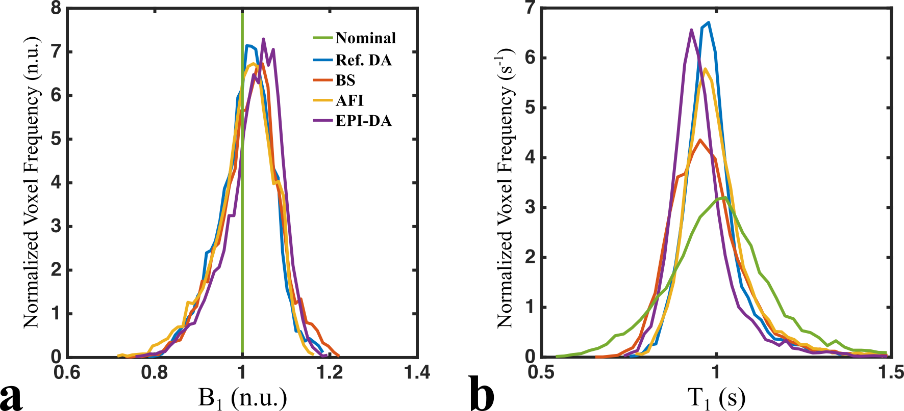

Figure ‑. Normalized histograms of single-slice unfiltered B1 (a) and T1 (b) map values masked for WM in six healthy subjects. The abbreviation “n.u.” stands for normalized units.

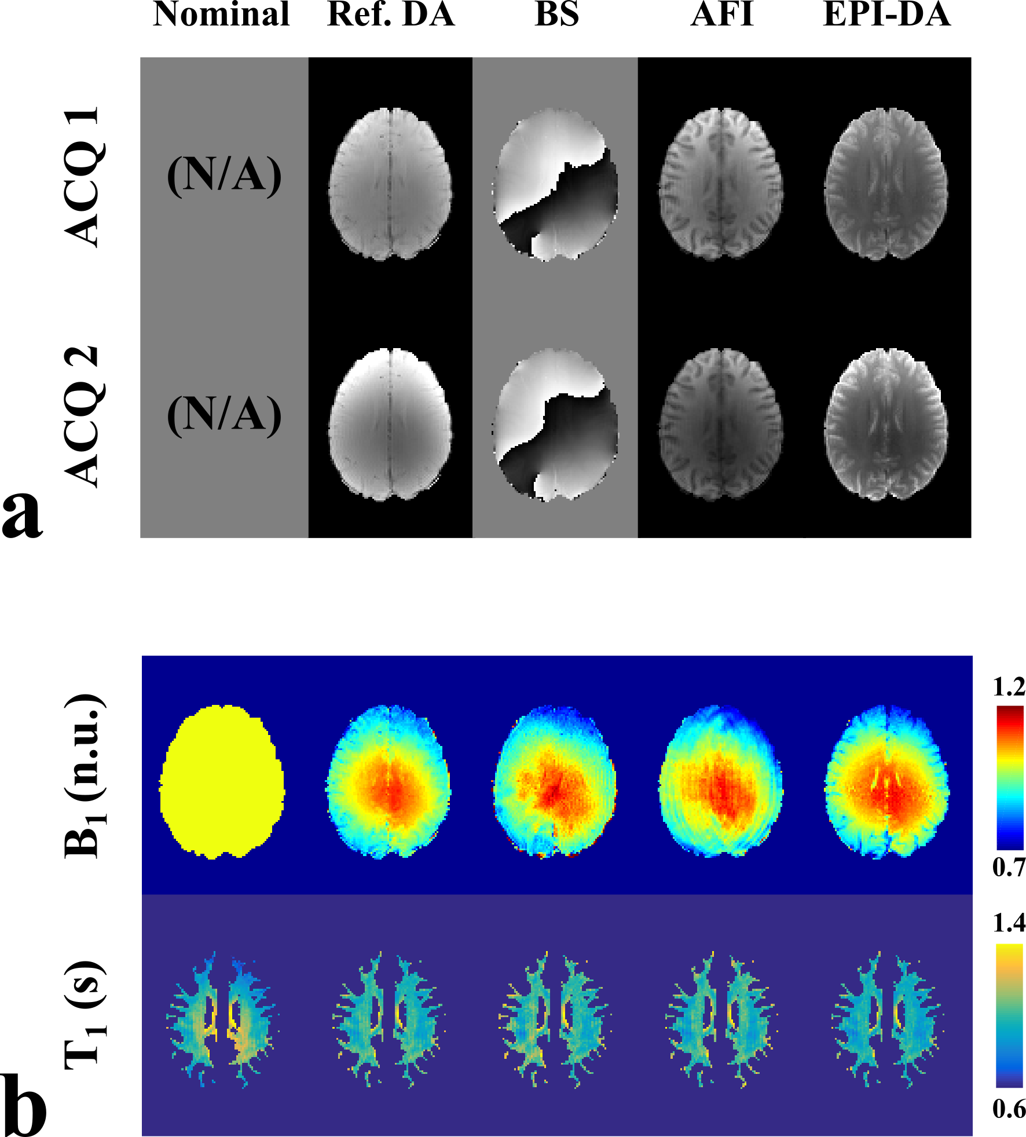

Figure ‑. a: Acquisition images for each acquired B1 method: Ref. DA (reference single-slice double angle), AFI (actual flip angle imaging), BS (Bloch-Siegert shift), and EPI-DA (double-angle using an interleaved multislice EPI acquisition). b: Unfiltered single-slice B1 maps, and corresponding WM-masked VFA T1 maps fitted using flip-angles scaled voxelwise using each B1 map. The “Nominal” column represents VFA T1 fitting using no B1 correction (B1 = 1 n.u.).

The pooled-subject histogram analysis of WM T1 values is shown in Figure 3‑2b. Each measured B1 map resulted in narrower WM T1 histograms than for the Nominal case. The differences in statistical modes (ΔMode) for WM T1 between Ref. DA and BS/AFI/EPI-DA/Nominal were 2.5/ 1.0/5.0/5.0%, respectively. The width of the WM T1 distributions had more relative variation between methods than observed for the B1 histograms. EPI-DA had the largest ΔMode value (5%), but did not experience noticeable broadening relative to Ref. DA. However, BS clearly did suffer from broadening, yet much less severe than the Nominal case. The small reduction in EPI-DA WM T1 histogram statistical mode (Figure 3‑2b) is attributed to the small increase in the corresponding B1 histogram statistical mode (Figure 3‑2a). T1 correlations were lower relative to their respective B1 correlations, which was to be expected due to the B1-sensitivity of the VFA technique. Overall, EPI-DA T1 maps had the highest correlation relative to Ref. DA (*ρ* = 0.92), which was substantially better than for the Nominal case (*ρ* = 0.53). WM-masked T1 maps are shown for a single subject in Figure 3‑3. Large overestimations of T1 at the center of the slice are clearly seen for the Nominal case, unlike those using each measured B1 map.

Table ‑. Linear Regression Analysis of the Pooled WM-Masked B1 and T1 Values (Six Subjects) for Each Rapid B1 Method Relative to the Ref. DA Method

|  |  |  |  |  |  |  |  |  |  |
| --- | --- | --- | --- | --- | --- | --- | --- | --- | --- |
|  |  |  |  | Unfiltered B1 Maps | | | Gaussian Filtered B1 Maps | | |
|  |  | Ref. DA | Nominal | BS | AFI | EPI-DA | BS | AFI | EPI-DA |
| B1 | **Pearson *ρ*** | --------- | N/A | **0.88** | **0.92** | **0.96** | **0.92** | **0.95** | **0.98** |
| Slope *β* | --------- | N/A | 0.97 | 1.01 | 0.99 | 0.96 | 0.99 | 1.01 |
| Intercept *y0* | --------- | N/A | 0.04 | -0.01 | 0.03 | 0.05 | 0.00 | 0.01 |
| T1 | **Pearson *ρ*** | --------- | **0.53** | **0.79** | **0.81** | **0.92** | **0.86** | **0.88** | **0.96** |
| Slope *β* | --------- | 0.95 | 0.99 | 0.89 | 0.94 | 0.97 | 0.92 | 0.98 |
| Intercept *y0* | --------- | 0.07 | 0.00 | 0.12 | 0.02 | 0.00 | 0.09 | -0.02 |

Artifacts in the unfiltered B1 maps differ between methods due to their differing acquisition pulse sequences (Figure 3‑3b). The sulci are visible in the B1 maps of both DA methods (Ref. DA and EPI-DA), unlike BS and AFI. In the ventricles, lower B1 values are present for Ref. DA and EPIDA relative to the other methods (Figure 3‑3b, Figure 3‑5). An open-ended fringe line (pole) was present in the Bloch-Siegert phase maps (Figure 3‑3a), due to out-of-phase multichannel image recombination [27], and may have caused some inhomogeneity in the Bloch-Siegert B1 maps in

Table ‑. Mean and Standard Deviations of Voxelwise Percent Differences (%) of B1 and T1 Values in WM Relative to the Ref. DA Method for All Subjects

|  |  |  |  |  |  |  |
| --- | --- | --- | --- | --- | --- | --- |
| Mean ± SD Voxel-wise Percent Differences (%) in White Matter | | | | | | |
|  | Subject # | Ref. DA | Nominal | BS | AFI | EPI-DA |
| B1 | 1 | --------- | N/A | 0.31 ± 3.47 | 0.47 ± 1.83 | 1.67 ± 1.43 |
| 2 | --------- | N/A | 3.34 ± 2.46 | -1.46 ± 2.40 | 2.41 ± 1.32 |
| 3 | --------- | N/A | 0.95 ± 2.24 | -0.44 ± 2.22 | 1.87 ± 1.49 |
| 4 | --------- | N/A | 1.57 ± 2.43 | -1.28 ± 3.12 | 0.15 ± 1.66 |
| 5 | --------- | N/A | -0.01 ± 3.61 | 0.63 ± 2.09 | 2.37 ± 1.45 |
| 6 | --------- | N/A | 2.07 ± -0.69 | -0.69 ± 3.07 | 1.76 ± 2.08 |
| T1 | 1 | --------- | -2.11 ± 12.12 | -0.30 ± 6.83 | -0.85 ± 3.78 | -3.27 ± 2.70 |
| 2 | --------- | 2.86 ± 10.96 | -6.25 ± 4.67 | 3.17 ± 5.07 | -4.64 ± 2.50 |
| 3 | --------- | 0.46 ± 10.64 | 2.10 ± 4.69 | 1.03 ± 4.66 | -3.72 ± 2.59 |
| 4 | --------- | 10.27 ± 14.19 | -3.01 ± 4.84 | 2.69 ± 6.60 | -0.54 ± 2.60 |
| 5 | --------- | 3.40 ± 11.01 | 0.32 ± 7.02 | -1.09 ± 4.16 | -4.53 ± 2.72 |
| 6 | --------- | -2.70 ± 10.54 | -3.86 ± 4.93 | 1.56 ± 6.70 | -3.39 ± 4.36 |

the posterior left hemisphere (Figure 3‑3b). This phase image artifact was present in all subjects. For BS, the inhomogeneities near the phase pole along with noisier B1 maps were likely contributing factors in the broadening of the WM T1 distribution (Figure 3‑2b). A ringing artifact affected the AFI B1 maps (Figure 3‑3b), although it is not easily seen in the raw AFI acquisition images themselves (Figure 3‑3a). However, by carefully adjusting the window/level (not shown), a small ringing artifact is present in both AFI MRI images. We observed this ringing in both the raw data and B1 maps of all subjects. If the ringing between both images is out-of-phase, the resulting B1 artifact may be amplified due to the nature of the AFI calculation, which requires a division of the two images. The original AFI work only presents their B1 maps postfiltering (8 × 8 × 16mm3 median filter); however, ringing can also be seen in their axial and coronal TR1 images (fig. 10a in Ref. [12]). Overall, these artifacts and noise in the unfiltered B1 maps likely contributed to lower correlations of B1 and T1 relative to the reference maps.

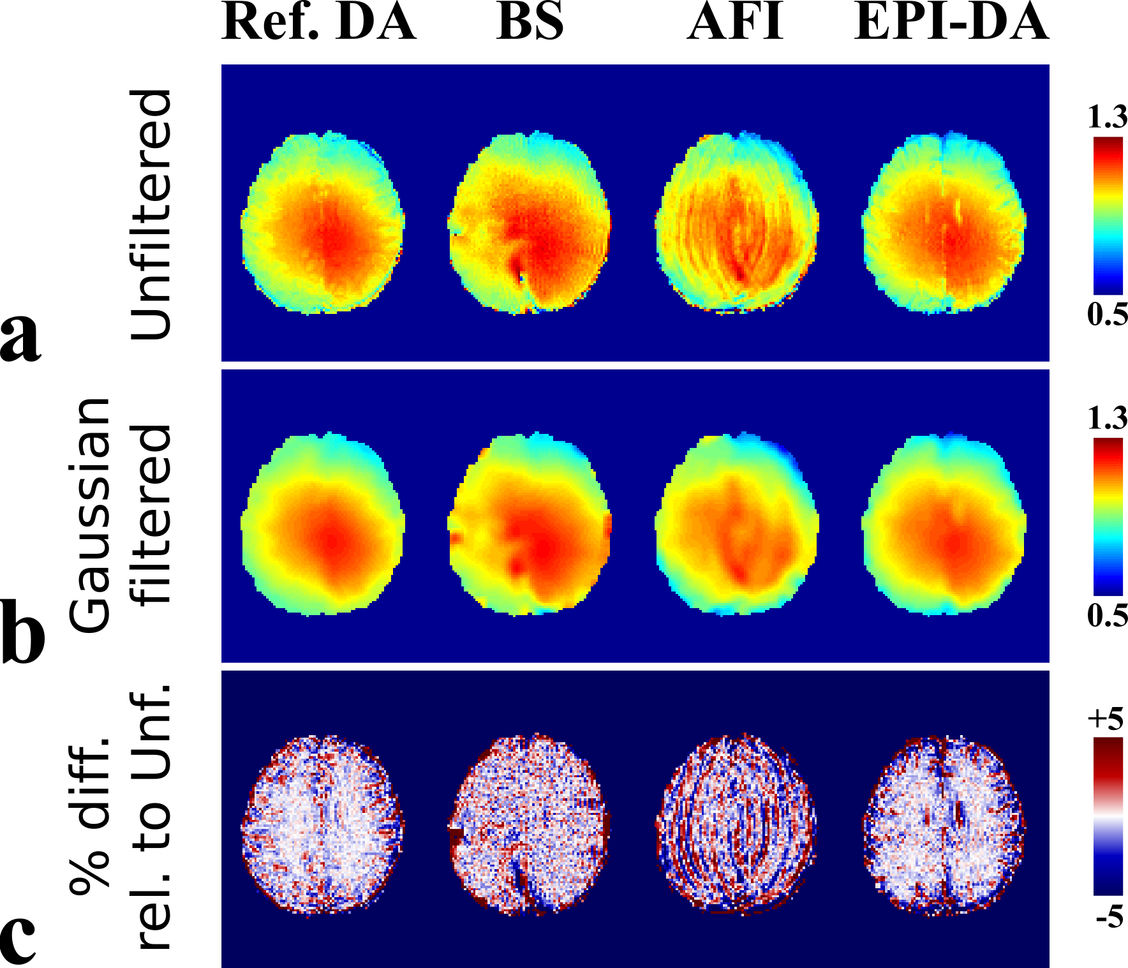

Figure ‑. Unfiltered (a) and Gaussian filtered (b) B1 maps of a single subject. (c) Relative differences between unfiltered and filtered maps shown as percent difference maps.

The unfiltered and Gaussian filtered B1 maps are shown for a subject in Figure 3‑4a,b, and the relative difference (%) between the two is shown in Figure 3‑4c. The Gaussian filter was effective at reducing noise in the maps, as well as in attenuating minor artifacts (eg, sulci in DA maps, “ringing” in AFI). The correlations and linear regression analysis of B1 (and VFA T1) relative to the reference (Ref. DA) were recalculated using the filtered B1 maps (Table 3‑1). The correlations improved postfiltering; for BS/AFI/EPI-DA, B1 correlations (*ρ*) were 0.92/0.95/0.98, and for T1 they were 0.86/0.88/0.96. The 95th percentiles of the absolute relative differences between the reference B1 map and BS/AFI/EPIDA (in WM) were equal or lower than 5% (5/4/3%, respectively), while the nominal flip-angle case had a relative difference (to Ref. DA) 95th percentile of 13%.

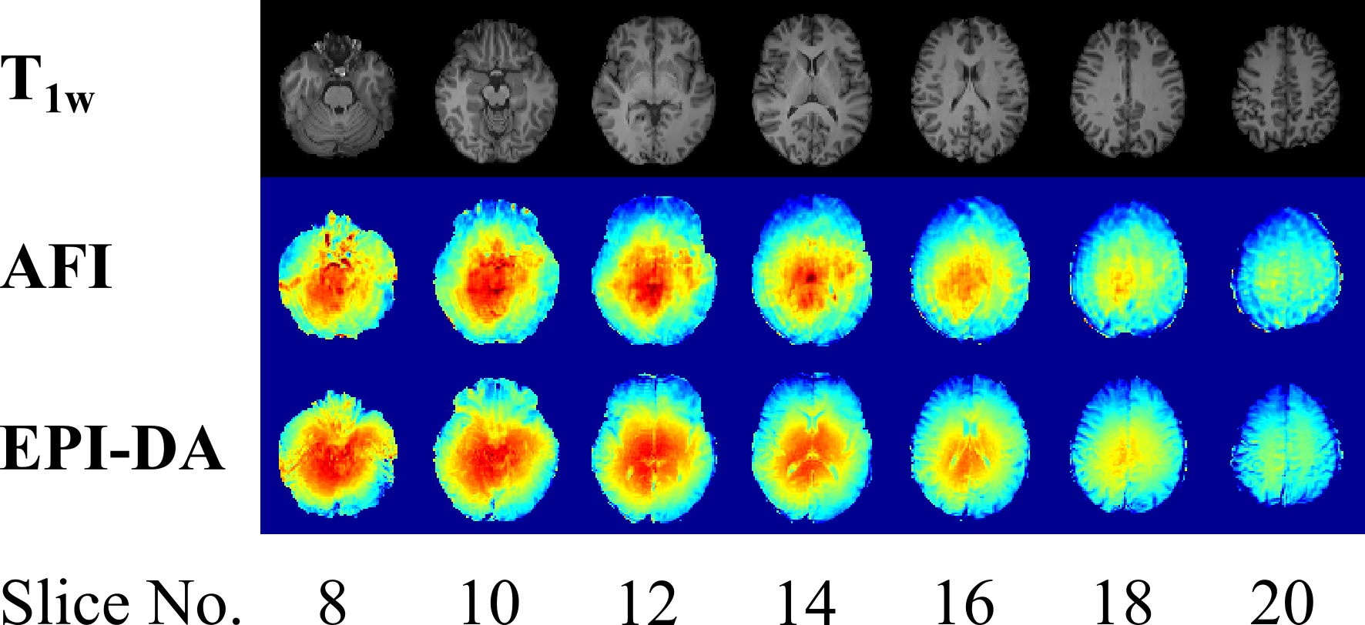

Figure ‑. Whole-brain coverage of axial MP-RAGE T1w slices, unfiltered AFI B1 maps, and unfiltered EPI-DA B1 maps in one subject.

The raw images used to calculate an EPI-DA B1 map for a subject are shown in Figure 3‑3a. The image quality of the EPI images is comparable to the Ref. DA method, and no observable distortions or ghosting were present in the brain for either the acquisition images or the B1 map. This observation was consistent in all subjects for the slice used in the data analysis. In addition to the single-slice measurements, two of the B1 mapping protocols were acquired with whole-brain coverage (AFI and EPI-DA). Axial slices for both B1 methods are shown in Figure 3‑5. EPI-DA B1 maps throughout the brain were free of severe susceptibility-induced distortions. However, the ventricles can be clearly identified in the EPI-DA maps (lower values) unlike for AFI, as AFI is well known to be very robust for a wide range of T1 values [12].

## Discussion

Our findings demonstrate that B1 mapping implemented using a standard product EPI pulse sequence (EPI-DA) can provide quality whole-brain B1 maps with a short acquisition time (~2min). The B1 maps were comparable or superior in WM to other well-regarded rapid acquisition B1 methods (AFI and BS) at 3T. Unfiltered B1 maps correlated with our reference single-slice measurement (Ref. DA), and we observed an improvement in those correlations after applying a Gaussian filter to the images to reduce noise and attenuate small artifacts. Pooled-subject voxelwise B1 correlation values (relative to Ref. DA) ranged between 0.88 ≤ *ρ* ≤ 0.96 for unfiltered maps, and 0.92 ≤ *ρ* ≤ 0.98 for filtered maps. The 95th percentile of the relative errors of filtered B1 maps (compared to Ref. DA) were ≤ 5%, nearly three times lower than for the nominal flip-angle case (13%). VFA T1 maps using Gaussian filtered B1 maps correlated with those using Ref. DA (0.88 ≤ *ρ* ≤ 0.96,), unlike for the case using uncorrected (nominal) flip-angles (*ρ* = 0.53). The peak of the WM T1 histograms varied slightly between methods (1 to 5%), much less than the differences reported between different T1 [14] mapping techniques themselves (20–30%). Our results demonstrate that double angle B1 mapping using a standard product EPI sequences can produce whole-brain B1 maps comparable in quality to rapid techniques (eg, AFI and BS) in a clinically acceptable scan time (~2min). While our work was based on a multishot EPI protocol [19], double angle imaging using other fast k-space acquisition strategies could also be considered (eg, double angle using a fast spin-echo readout [22]). Implementing standard product pulse sequence protocols for B1 mapping avoids time-consuming on-site pulse sequence programming (sequences similar to the one used in our study are commonly offered by other manufacturers [19]), improves accessibility of whole-brain B1 mapping to researchers without access to custom pulse sequences, and could facilitate protocol standardization between sites.

Other groups have also presented comparison studies of existing B1 methods. Lutti et al [25] optimized and compared the following methods at 3.0T: AFI, a 3D stimulated-echo B1 mapping method with EPI readouts, a 2D stimulated echo acquisition mode (STEAM) B1 mapping method, and single-slice DA as a reference. The two stimulated-echo-based methods required additional quantitative pulse sequences for calibration: the 3D stimulated-echo with single-shot EPI B1 mapping technique used B0 maps to correct for distortions, and the 2D STEAM method was calibrated against AFI using a separate measurement on a gel phantom to correct for nonlinearities of the slice-selective pulse. Each method demonstrated good reproducibility, and the largest deviation relative to the reference (DA) was observed with the stimulated-echo EPI method (4%), which is in the range of deviation we observed with our standard product EPI-DA pulse sequence (5% relative to Ref. DA for WM). Despite the benefits of these optimized rapid B1 methods, wide-scale use is limited, as all methods require pulse sequence programming expertise and additional quantitative measurements. Another important source of B1 inaccuracies, noise, has been characterized for different B1 methods (Ref. DA, AFI, and BS) using Monte Carlo simulations and phantoms [28,29]. The authors demonstrated that SNRs as low as 50 can be sufficient for accurate flip angle estimation for the range observed in the brain at 3T, and all of the methods compared in our work had SNRs above this threshold in WM.

Optimal flip angles for VFA are in the low FA range (1–30°) due to short TRs required for whole-brain VFA T1 mapping.21 All B1 methods compared in this work used larger flip angles to map the B1 intensity (Ref. DA and EPIDA: 60°/120°; AFI: 60°; BS: 25° and 500°), consistent with the published values in the original articles. Thus, RF amplifier nonlinearities could result in inaccurate low FA estimations. RF amplifier nonlinearity can vary substantially between scanner hardware manufacturers, which may lead to a bias of the corrected low flip angles used for VFA [30]. VFA pulse sequence optimization techniques have been proposed to minimize the impact of RF nonlinearity on T1 mapping [31]. A modified DA B1 method has also been proposed to map low flip angles accurately [30], which could possibly be adapted to use fast k-space readout acquisition pulse sequences, such as EPI or fast spin-echo.

For the purpose of our study, a simple single-slice DA method measurement was considered to be our “reference” method, as is often the case in B1 mapping studies. The Ref. DA acquisition is itself sensitive to sources of inaccuracies, as the typical pulse sequence protocols for Ref. DA render the B1 maps sensitive to long T1, particularly in voxels containing CSF. The TR used for this pulse sequence was shorter than conventional implementations; however, it was validated against another robust DA method [32] using a TR = 3000 msec and demonstrated very high voxelwise correlation in WM (*ρ* = 0.98, y = 0.99x + 0.03). Longer TRs could be used for improved accuracy; however, such a protocol requires 20+ min for a single slice scan [13], and motion would become an increasing concern with longer TRs. Slice-select RF pulse profiles may also impact B1 map accuracy, as nonrectangular RF profiles result in a range of flip angles within a slice (and voxel), particularly for large flip angles. Some techniques have been developed to correct for slice profile effects [33]; however, they add additional complexity in postprocessing and require RF pulse waveform information, which may not always be accessible from the scanner. Single-slice DA imaging can mitigate slice profile inaccuracies by using nonselective excitation pulses [32] or refocusing pulses, yet undesired signal from outside the slice can be a problem if incompletely crushed [34]. All B1 methods compared in this work used pulse sequences that differ greatly in their mechanism and analysis (saturation recovery: DA; steady-state: AFI; phase: BS), yet still produced voxelwise B1 values highly correlated with the reference measurement (Ref. DA). Each B1 method, even considering their imperfections, produced much better T1 maps than for the case of omitting B1 correction altogether (Nominal).

Smoothing or blurring filters are typically applied to B1 maps [12,25,35], as the B1 variation in the brain is expected to be smooth and spatially slowly varying [18]. There is no well-established consensus on which filter is ideal for B1 maps. The types of filters used in the literature are numerous: Gaussian convolution, median filters, spline interpolation, etc. In addition, the size of the blurring kernel used varies widely between studies; ranging from 3mm [12] to 10 mm [35]. Although filtering the B1 map is often considered a good practice when used in subsequent B1-correction applications, unfiltered B1 maps should also be reported when using, developing, or comparing new B1 methods. B1 methods are often only compared postblurring [12,25], thus not all artifacts (or noise level) may be clearly identifiable, only those not fully attenuated by the filters. Unfiltered B1 maps display valuable information about scanner and pulse sequence artifacts, which is particularly useful when developing or evaluating new methods. For example, even though the ringing artifact in our AFI measurements can be attenuated in the B1 maps using filtering methods, it may be preferable to use preprocessing techniques to eliminate the ringing in the acquisition images before the B1 map is calculated [36]. Although blurring B1 maps can attenuate local artifacts, it can also spread inaccuracies (eg, ventricles in our EPI-DA maps). If tissue masks are available, specific tissues known to produce inaccurate B1 values (eg, for the multislice EPI-DA case, cerebrospinal fluid) could be masked, and B1 values could be interpolated in these regions to approximate the missing values.

The specific scope of this work is limited to applications at clinical field strengths. B1 mapping at ultrahigh field strengths must be robust against more B0 inhomogeneity, longer T1 values, and faces additional hardware challenges, such as parallel transmit [37]. Accelerating B1 mapping methods using an EPI-based acquisition scheme can be prone to significant susceptibility distortions and signal dropouts at ultrahigh fields [38]. However, Bloch-Siegert at 7T requires additional acceleration techniques like EPI due to its high SAR RF pulses [39]. Supplementary scans (eg, B0 map) can be used in EPI-based B1 mapping to correct the distortions [40], but at the cost of a longer total scan time. Investigating structural characteristics of the cortex is also a topic of great interest in high-field MRI, due to its capability to image at very high resolutions (≤1mm3). High-resolution VFA T1 mapping of the cortex must use B1 maps acquired using a method that has a good robustness against the long T1 of CSF that neighbors the cortical regions [41], such as AFI, BS, or other advanced B1 mapping techniques.

This study had some limitations. The decision to use single-slice B1 for a reference limited the quantitative comparison between methods to a single slice of the brain. Although using a single-slice DA B1 map as a reference is common for validating whole-brain methods [13,25], one solution could be to acquire two more slices in perpendicular planes. Another limitation was that the low resolution of the reference scan restricted the quantitative assessment of B1 and T1 values to WM. To quantitatively compare B1 maps in the cortex, a faster reference acquisition allowing for higher resolution (~1mm3) is needed.

In conclusion, we report that B1 mapping at 3T implemented using standard product pulse sequences (eg, interleaved multislice EPI double angle) can serve as a sufficient alternative to advanced B1 methods (eg, actual flip angle imaging, Bloch-Siegert), which are not readily available on most MRI systems. The EPI double angle protocol produced whole-brain B1 maps in a clinically acceptable scan time (~2min), shorter than the AFI and BS’s protocols that were compared (although these methods can be further accelerated by implementing fast acquisition strategies, eg, EPI, fast spin-echo, or spiral). All investigated B1 mapping methods correlated well with a reference measurement, and produced substantially better VFA T1 maps than in the absence of B1 correction. The agreement between B1 maps and resulting T1 maps were improved by filtering the B1 maps to reduce noise and minor artifacts. B1 mapping implemented with standard product pulse sequences can provide an excellent alternative for researchers without custom rapid whole-brain B1 methods and is much preferred to omitting B1 correction altogether.

## Acknowledgments

Contract grant sponsor: National Sciences and Engineering Research Council of Canada with the Alexander Graham Bell Canada Graduate Scholarships-Doctoral program (to M.B.); Contract grant sponsor: CIHR and Campus Alberta Innovates grants (to G.B.P.)

# *B1-Sensitivity Analysis of Quantiative Magnetization Transfer Imaging*

## Preface

**B1-Sensitivity Analysis of Quantitative Magnetization Transfer Imaging**

*Mathieu Boudreau, Nikola Stikov, G. Bruce Pike*

McConnell Brain Imaging Centre, Montreal Neurological Institute 3801 University Street, McGill University  
Quebec, Canada, H3A 2B4

**Magnetic Resonance in Medicine, 10.1002/mrm.26673, 2017**

## Abstract

**Purpose:** To evaluate the sensitivity of quantitative magnetization transfer (qMT) fitted parameters to B1 inaccuracies, focusing on the difference between two categories of T1 mapping techniques: B1-independent and B1-dependent.

**Methods:** The B1-sensitivity of qMT was investigated and compared using two T1 measurement methods: inversion recovery (IR) (B1-independent) and variable flip angle (VFA), B1-dependent). The study was separated into four stages: 1) numerical simulations, 2) sensitivity analysis of the Z-spectra, 3) healthy subjects at 3T, and 4) comparison using three different B1 imaging techniques.

**Results:** For typical B1 variations in the brain at 3T (±30%), the simulations resulted in errors of the pool-size ratio (F) ranging from -3% to 7% for VFA, and -40% to>100% for IR, agreeing with the Z-spectra sensitivity analysis. In healthy subjects, pooled whole-brain Pearson correlation coefficients for F (comparing measured double angle and nominal flip angle B1 maps) were *ρ* = 0.97/0.81 for VFA/IR.

**Conclusion:** This work describes the B1-sensitivity characteristics of qMT, demonstrating that it varies substantially on the B1-dependency of the T1 mapping method. Particularly, the pool-size ratio is more robust against B1 inaccuracies if VFA T1 mapping is used, so much so that B1 mapping could be omitted without substantially biasing F.

## Introduction

Quantitative magnetization transfer (qMT) imaging is a powerful MRI technique used to investigate macromolecular content not typically detectable with conventional MRI. MR properties of macromolecular hydrogen are measured with qMT by indirect means: the magnetization of the macromolecular pool is saturated, and energy is exchanged with nearby water molecules via cross-relaxation processes and chemical exchange [42,43]. In imaging brain white matter (WM), the pool-size ratio (F), the ratio between the equilibrium magnetization of hydrogen in macromolecules versus hydrogen in water, has been shown to be a good marker of myelin density [3,44]. In particular, the pool-size ratio has been used to study multiple sclerosis lesions [45-47]. Several methods have been developed to estimate qMT parameters from the mathematical model that describes the exchange processes [48-52].

Commonly, off-resonance qMT imaging uses a magnetization transfer (MT)-prepared spoiled gradient (SPGR) echo pulse sequence [53]. It is a standard SPGR sequence preceded by an off-resonance radiofrequency (RF) pulse that varies in amplitude and frequency offset between measurements; 10 measurements or more are generally required to fit this Z-spectrum (normalized MT signal vs. off-resonance frequencies) [54], and one additional measurement without the MT-preparation for signal normalization. These qMT techniques also require three additional measurements: B0, B1, and T1. In postprocessing, B0 maps calibrate the off-resonance frequency of the MT pulse in each voxel. B1 maps are used to scale the SPGR excitation flip angle and MT-pulse saturation power. A T1 map is necessary to constrain certain fitting parameters of the two-pool MT fitting model [43]. For a given voxel, the measured T1 (T1,meas) is a function of the T1 of the water molecules (T1,f, “f” is for “free pool”) and of the T1 of the macromolecules (T1,r, “r” is for “restricted pool”), and two other parameters (F, ratio of the two pool sizes in the voxel, and kf, the exchange rate constant). The large number of measurements required to sample the Z-spectrum and additional quantitative maps make qMT a time-costly technique.

Increasingly, whole-brain qMT imaging has been achieved via a reduction in qMT measurements [55,56] and new rapid techniques to measure the required quantitative calibration maps [12,13,26]. However, integrating new methods into quantitative imaging studies can introduce unintended effects. For example, transitioning from single-slice T1 mapping techniques (i.e., inversion recovery [IR]) to three-dimensional [3D] techniques, variable flip angle [VFA]) also results in transitioning from B1-insensitive [14,57] to B1-sensitive [17] T1 mapping. If VFA is used in the qMT imaging protocol, inaccuracies in B1 will propagate into fitted qMT parameters through two pathways instead of just one (Fig. 1): from errors induced in T1, used to restrict the fitting parameters, and from errors in scaling the MT saturation powers with the B1 maps. The potential effect of B1-uncorrected qMT on the fitted parameters has been noted in previous work [7,58]; however, these were limited in scope to B1-insensitive T1 techniques. To our knowledge, no comprehensive characterization of the B1- sensitivity of qMT (and notably, comparing different T1 mapping methods) has previously been performed.

This work focuses on answering the following three questions: 1) How sensitive is each qMT parameter to B1-inaccuracies? 2) How does the B1-sensitivity of qMT parameters differ between protocols using B1-independent (IR) and B1-dependent (VFA) T1 mapping methods?; and 3) Which T1 mapping method results in the most robust measure of the pool-size ratio in the presence of B1-inaccuracies? To explore these questions, we first focused on simulations under ideal measurement conditions for a single tissue type, and then used this framework to perform a sensitivity analysis of the signal curves. We then measured qMT maps in healthy human volunteers using both T1 mapping methods (IR and VFA), and compared measured B1 maps with fictitious maps generated to have a large range of potential inaccuracies. Finally, we compared the relative agreement of qMT fits between three different B1 mapping methods (double angle, actual flip angle imaging, Bloch-Siegert) using both T1 mapping methods (IR and VFA).

## Methods

All measurements were performed with a 3.0T whole-body MRI scanner (Magnetom TIM TRIO; Siemens, Erlangen, Germany) using a 32-channel phased-array receive-only head coil and whole-body transmit coil. Healthy volunteers were scanned after providing informed consent, in compliance with and approved by the institutional ethics committee. The total scan time for the entire acquisition protocol described in the B1-Sensitivity of qMT in Healthy Subjects and B1 Method Comparison sections was 28 minutes and 58 seconds.

### Simulations

The coupled Bloch-McConnell differential equations describing two-pool magnetization exchange were solved numerically (MATLAB 2011a; MathWorks Inc., Natick, MA) for a pulsed MT-prepared SPGR pulse sequence using the Sled and Pike model [7,59]. The pulse sequence was decomposed into event blocks of instantaneous saturation of the free pool, constant irradiation of the restricted pool, and free precession. Prior to simulating exchange, the fractional saturation of the longitudinal magnetization induced by direct saturation was computed numerically in the absence of exchange and T1 recovery. The steady-state solution was approximated analytically using the assumption that the magnetization at an arbitrary time t should be equal to that of time *t*+prepetition time (TR), as described in detail in the appendix of Sled and Pike [50]. The signal was simulated with the following pulse sequence parameters [54,55]: TR = 25 ms, excitation flip angle (FA) = 7º, MT pulse flip angle = 142 º and 426 º, MT pulse duration = 10 ms, 10 offresonance frequencies ranging between 423.9Hz and 17.2354 kHz in logarithmic steps. The envelope of the MT-preparation RF pulse was a Gaussian-Hanning function, and a super-Lorentzian lineshape function was used for the transition rate of the restricted pool to approximate the behavior observed in tissues [59]. qMT tissue parameters for all simulations were set to healthy white matter values measured in a previous scan: F = 0.122 n.u. (normalized units), magnetization exchange rate (kf) = 3.97 s-1, free-pool longitudinal relaxation rate (R1,f = 1/T1,f) = 1.12 s-1, restricted-pool longitudinal relaxation rate (R1,r = 1/T1,r) = 1.00 s-1, free-pool transverse relaxation time (T2,f) = 27.2 ms, restricted-pool transverse relaxation time (T2,r) = 10.96ms.

SPGR qMT experiments require three additional quantitative measures: B0, B1, and T1. B0 measurement methods typically do not require B1 or T1 calibration; thus, ideal B0 homogeneity was used in the simulations. MT signal values were simulated using B1 (to scale the MT saturation powers and excitation flip angles) and T1,meas (to constrain the fitting parameters) that were fixed to their ideal values (1 n.u. and 0.9 s respectively). The MT signal was subsequently fitted using the Sled and Pike method [7]. As per convention, R1,r was fixed to 1 s-1. R1,f was calculated during the fitting algorithm from an analytical expression of F, kf, R1,r, and T1,meas. To investigate the effect of inaccuracies in B1 and T1,meas on the fitted qMT parameters, the simulated MT signal values were fitted using a large range of B1 and T1,meas values. Four qMT parameters (F, kf, T2,f, T2,r) were explicitly fitted for each pair of 100 B1 and 100 T1,meas values (10,000 combinations). The set of B1 values varied linearly from 0.5 to 2 n.u., and T1,meas varied from 0.1 s to 4 s. For this stage, B1 and T1,meas varied independently of each other. We investigated the qMT parameter sensitivities due to B1 inaccuracies for two T1 mapping techniques: IR, approximately B1 independent [14], and VFA, inherently B1-dependent [17]. The IR case was interpreted to be a linear subset of the B1-T1 combination discussed above by a fixed T1 (T1,IR = 0.9 s, constant). The VFA signals from a two flip angle experiment were calculated for T1 = T1,true =0.9 s from the analytical steady-state SPGR equation (TR = 25 ms, FA = 3º and 20 º). T1,VFA values were subsequently estimated by linear least-square fitting of the VFA data with flip angle calibration [60] using the set of 100 B1 values (0.5 to 2 n.u.). The fitted VFA T1,meas values were then used in conjunction with their respective B1 values to fit the qMT parameters to the simulated MT signal.

### Sensitivity Analysis

To provide further insight into the behavior of fitted parameters in the presence of B1 inaccuracy, a sensitivity analysis of the qMT signal was performed [61]. For each qMT parameter, the following definition of sensitivity was used (cf. Appendix A):

|  |  |
| --- | --- |
|  | **(4-1)** |

where the index *i* describes a specific qMT acquisition point, *Mi* is the normalized signal of the ith qMT measurement, and *Sp,i* is the sensitivity of the MT signal with respect to *p* for the *i*th qMT acquisition. The sensitivity *Sp,i* represents the change in normalized MT signal induced by a slight change in fitting parameter value or model input value (e.g., B1). A large absolute *Sp,i* value signifies that, to a linear approximation, a large change in MT signal will occur (at that Z-spectrum value) for a small variation of *p*. In the context of fitting data to measurements using an inaccurate B1 value, the following relationship can be shown (cf. Appendix A):

|  |  |
| --- | --- |
|  | **(4-2)** |

Thus, the sensitivity values can provide an insight as to why certain fitting parameters are more likely to have large errors due to inaccurate B1 values. When comparing two measurement protocols, the following metrics can be expected to provide insight into which fitting parameters *p* are more/less sensitive to B1 inaccuracies (cf. Appendix A):

|  |  |
| --- | --- |
|  | **(4-3)** |
|  | **(4-4)** |

where ***S*** is the vector of sensitivity values for a set of N measurements, is its norm, and is its unit vector. If the sensitivity values of a parameter *p* and B1 have very similar curves (Eq. (4-3) ≈ 1), then *p* is likely to be most sensitive to B1 inaccuracies compared to other parameters. The relative error of *p* will then be proportional to the ratio in Eq. (4-4).

The qMT measurement protocol and tissue parameters from the Simulations section were used to simulate normalized MT signal values. Partial derivatives with respect to qMT parameters (and B1) of the MT signal were evaluated at each point of the Z-spectrum [62]. B1 sensitivity values were calculated for two cases: T1,meas independent of B1 (which for consistency with the other sections we designate as IR), and T1,meas with VFA B1-dependency. As T1,meas is primarily used to constrain R1,f, R1,f was modified in addition to B1 accordingly for the VFA case. The derivative steps were fixed to a 10-5% relative increase of the parameter denominator value, sufficient for the convergence of the partial derivative at each Z-spectrum point of our qMT protocol.

### B1-Sensitivity of qMT in Healthy Subjects

Three healthy adult volunteers were scanned (two males, one female, 30 ± 4 years old). All quantitative imaging sequences were acquired at a resolution of 2 × 2mm2 in-plane × 5mm slice thickness. Single slices were acquired parallel to the anterior commissure–posterior commissure (AC-PC) line, superior to the corpus callosum.

*T1 Maps:* VFA T1 maps were acquired using a spoiled 3D gradient echo sequence [26]: echo time (TE) = 2.89 ms, TR = 15 ms, FA = 3º and 20 º, spoiler gradient moment (AG) = 280 mT ∙ ms/m, RF phase increment (*φ*) = 169º, 1 m 28 s scan time. Prior to fitting the data for T1, the nominal flip angles were scaled voxel-wise with each B1 map. The VFA T1 values were then estimated from linear least-square fitting. Inversion recovery T1 data were collected from a four-inversion-time (TI) spin-echo sequence [14]: TE/TR = 11/1550 ms, TI = 30, 530, 1030, 1530 ms, 9 m 16 s scan time. An open-source software package for robust inversion recovery fitting was used to fit the IR T1 maps [57].

*qMT Maps:*

# *Last paper*

## Preface

# *Conclusion*

## Preface

Bibliography

1. Liu J, Zhang X, Schmitter S, Van de Moortele PF, He B. Gradient-based electrical properties tomography (gEPT): A robust method for mapping electrical properties of biological tissues in vivo using magnetic resonance imaging. Magn Reson Med 2015;74(3):634-646.

2. Katscher U, Voigt T, Findeklee C, Vernickel P, Nehrke K, Dossel O. Determination of electric conductivity and local SAR via B1 mapping. IEEE Trans Med Imaging 2009;28(9):1365-1374.

3. Schmierer K, Tozer DJ, Scaravilli F, Altmann DR, Barker GJ, Tofts PS, Miller DH. Quantitative magnetization transfer imaging in postmortem multiple sclerosis brain. J Magn Reson Imaging 2007;26(1):41-51.

4. Ropele S, Filippi M, Valsasina P, Korteweg T, Barkhof F, Tofts PS, Samson R, Miller DH, Fazekas F. Assessment and correction of B1-induced errors in magnetization transfer ratio measurements. Magn Reson Med 2005;53(1):134-140.

5. Yuan J, Chow SK, Yeung DK, Ahuja AT, King AD. Quantitative evaluation of dual-flip-angle T1 mapping on DCE-MRI kinetic parameter estimation in head and neck. Quant Imaging Med Surg 2012;2(4):245-253.

6. Sung K, Daniel BL, Hargreaves BA. Transmit B1+ field inhomogeneity and T1 estimation errors in breast DCE-MRI at 3 tesla. J Magn Reson Imaging 2013;38(2):454-459.

7. Sled JG, Pike GB. Quantitative imaging of magnetization transfer exchange and relaxation properties in vivo using MRI. Magn Reson Med 2001;46(5):923-931.

8. Marques JP, Kober T, Krueger G, van der Zwaag W, Van de Moortele PF, Gruetter R. MP2RAGE, a self bias-field corrected sequence for improved segmentation and T1-mapping at high field. Neuroimage 2010;49(2):1271-1281.

9. Gupta RK. New Look at Method of Variable Nutation Angle for Measurement of Spin-Lattice Relaxation-Times Using Fourier-Transform Nmr. Journal of Magnetic Resonance 1977;25(1):231-235.

10. Sled JG, Pike GB. Standing-wave and RF penetration artifacts caused by elliptic geometry: an electrodynamic analysis of MRI. IEEE Trans Med Imaging 1998;17(4):653-662.

11. Insko EK, Bolinger L. Mapping of the Radiofrequency Field. Journal of Magnetic Resonance Series A 1993;103(1):82-85.

12. Yarnykh VL. Actual flip-angle imaging in the pulsed steady state: a method for rapid three-dimensional mapping of the transmitted radiofrequency field. Magn Reson Med 2007;57(1):192-200.

13. Sacolick LI, Wiesinger F, Hancu I, Vogel MW. B1 mapping by Bloch-Siegert shift. Magn Reson Med 2010;63(5):1315-1322.

14. Stikov N, Boudreau M, Levesque IR, Tardif CL, Barral JK, Pike GB. On the accuracy of T1 mapping: searching for common ground. Magn Reson Med 2015;73(2):514-522.

15. Leppert IR, Narayanan S, Araujo D, Giacomini PS, Lapierre Y, Arnold DL, Pike GB. Interpreting therapeutic effect in multiple sclerosis via MRI contrast enhancing lesions: now you see them, now you don't. J Neurol 2014;261(4):809-816.

16. Di Giovanni P, Azlan CA, Ahearn TS, Semple SI, Gilbert FJ, Redpath TW. The accuracy of pharmacokinetic parameter measurement in DCE-MRI of the breast at 3 T. Physics in Medicine & Biology 2010;55(1):121-132.

17. Liberman G, Louzoun Y, Ben Bashat D. T(1) mapping using variable flip angle SPGR data with flip angle correction. J Magn Reson Imaging 2014;40(1):171-180.

18. Sled JG, Zijdenbos AP, Evans AC. A nonparametric method for automatic correction of intensity nonuniformity in MRI data. IEEE Trans Med Imaging 1998;17(1):87-97.

19. Wang J, Qiu M, Constable RT. In vivo method for correcting transmit/receive nonuniformities with phased array coils. Magn Reson Med 2005;53(3):666-674.

20. Wang J, Qiu M, Kim H, Constable RT. T1 measurements incorporating flip angle calibration and correction in vivo. J Magn Reson 2006;182(2):283-292.

21. Cheng HL, Wright GA. Rapid high-resolution T(1) mapping by variable flip angles: accurate and precise measurements in the presence of radiofrequency field inhomogeneity. Magn Reson Med 2006;55(3):566-574.

22. Samson RS, Wheeler-Kingshott CA, Symms MR, Tozer DJ, Tofts PS. A simple correction for B1 field errors in magnetization transfer ratio measurements. Magn Reson Imaging 2006;24(3):255-263.

23. Stikov N, Campbell JS, Stroh T, Lavelee M, Frey S, Novek J, Nuara S, Ho MK, Bedell BJ, Dougherty RF, Leppert IR, Boudreau M, Narayanan S, Duval T, Cohen-Adad J, Picard PA, Gasecka A, Cote D, Pike GB. In vivo histology of the myelin g-ratio with magnetic resonance imaging. Neuroimage 2015;118:397-405.

24. Collins DL, Zijdenbos A, Baaré WC, Evans A. ANIMAL+INSECT: Improved Cortical Structure Segmentation. In: Kuba A, Šáamal M, Todd-Pokropek A, editors. Information Processing in Medical Imaging. Volume 1613, Lecture Notes in Computer Science: Springer Berlin Heidelberg; 1999. p 210-223.

25. Lutti A, Hutton C, Finsterbusch J, Helms G, Weiskopf N. Optimization and validation of methods for mapping of the radiofrequency transmit field at 3T. Magn Reson Med 2010;64(1):229-238.

26. Yarnykh VL. Optimal radiofrequency and gradient spoiling for improved accuracy of T1 and B1 measurements using fast steady-state techniques. Magn Reson Med 2010;63(6):1610-1626.

27. Liu T, Wisnieff C, Lou M, Chen W, Spincemaille P, Wang Y. Nonlinear formulation of the magnetic field to source relationship for robust quantitative susceptibility mapping. Magn Reson Med 2013;69(2):467-476.

28. Morrell GR, Schabel MC. An analysis of the accuracy of magnetic resonance flip angle measurement methods. Physics in Medicine & Biology 2010;55(20):6157-6174.

29. Park DJ, Bangerter NK, Javed A, Kaggie J, Khalighi MM, Morrell GR. A statistical analysis of the Bloch-Siegert B1 mapping technique. Physics in Medicine & Biology 2013;58(16):5673-5691.

30. Balezeau F, Eliat PA, Cayamo AB, Saint-Jalmes H. Mapping of low flip angles in magnetic resonance. Physics in Medicine & Biology 2011;56(20):6635-6647.

31. Lutti A, Weiskopf N. Optimizing the accuracy of T1 mapping accounting for RF non-linearities and spoiling characteristics in FLASH imaging. abstract 2478; 2014; Milan. (abstract 2478).

32. Sled JG, Pike GB. Correction for B1 and B0 variations in quantitative T2 measurements using MRI. Magnetic Resonance in Medicine 2000;43(4):589-593.

33. Parker GJ, Barker GJ, Tofts PS. Accurate multislice gradient echo T(1) measurement in the presence of non-ideal RF pulse shape and RF field nonuniformity. Magn Reson Med 2001;45(5):838-845.

34. Mitsouras D, Mulkern RV, Rybicki FJ. Strategies for inner volume 3D fast spin echo magnetic resonance imaging using nonselective refocusing radio frequency pulses. Med Phys 2006;33(1):173-186.

35. Helms G, Finsterbusch J, Weiskopf N, Dechent P. Rapid radiofrequency field mapping in vivo using single-shot STEAM MRI. Magn Reson Med 2008;60(3):739-743.

36. Kellner E, Dhital B, Kiselev VG, Reisert M. Gibbs-ringing artifact removal based on local subvoxel-shifts. Magn Reson Med 2016;76(5):1574-1581.

37. Nehrke K, Bornert P. Eigenmode analysis of transmit coil array for tailored B1 mapping. Magn Reson Med 2010;63(3):754-764.

38. Pohmann R, Scheffler K. A theoretical and experimental comparison of different techniques for B(1) mapping at very high fields. NMR Biomed 2013;26(3):265-275.

39. Saranathan M, Khalighi MM, Glover GH, Pandit P, Rutt BK. Efficient Bloch-Siegert B1 (+) mapping using spiral and echo-planar readouts. Magn Reson Med 2013;70(6):1669-1673.

40. Lutti A, Stadler J, Josephs O, Windischberger C, Speck O, Bernarding J, Hutton C, Weiskopf N. Robust and fast whole brain mapping of the RF transmit field B1 at 7T. PLoS One 2012;7(3):e32379.

41. Lutti A, Dick F, Sereno MI, Weiskopf N. Using high-resolution quantitative mapping of R1 as an index of cortical myelination. NeuroImage 2014;93, Part 2:176-188.

42. Wolff SD, Balaban RS. Magnetization transfer contrast (MTC) and tissue water proton relaxation in vivo. Magn Reson Med 1989;10(1):135-144.

43. Henkelman RM, Huang X, Xiang QS, Stanisz GJ, Swanson SD, Bronskill MJ. Quantitative interpretation of magnetization transfer. Magn Reson Med 1993;29(6):759-766.

44. Schmierer K, Wheeler-Kingshott CAM, Tozer DJ, Boulby PA, Parkes HG, Yousry TA, Scaravilli F, Barker GJ, Tofts PS, Miller DH. Quantitative magnetic resonance of postmortem multiple sclerosis brain before and after fixation. Magnetic Resonance in Medicine 2008;59(2):268-277.

45. Tozer D, Ramani A, Barker GJ, Davies GR, Miller DH, Tofts PS. Quantitative magnetization transfer mapping of bound protons in multiple sclerosis. Magn Reson Med 2003;50(1):83-91.

46. Davies GR, Tozer DJ, Cercignani M, Ramani A, Dalton CM, Thompson AJ, Barker GJ, Tofts PS, Miller DH. Estimation of the macromolecular proton fraction and bound pool T2 in multiple sclerosis. Mult Scler 2004;10(6):607-613.

47. Levesque IR, Giacomini PS, Narayanan S, Ribeiro LT, Sled JG, Arnold DL, Pike GB. Quantitative magnetization transfer and myelin water imaging of the evolution of acute multiple sclerosis lesions. Magn Reson Med 2010;63(3):633-640.

48. Gloor M, Scheffler K, Bieri O. Quantitative magnetization transfer imaging using balanced SSFP. Magn Reson Med 2008;60(3):691-700.

49. Dortch RD, Li K, Gochberg DF, Welch EB, Dula AN, Tamhane AA, Gore JC, Smith SA. Quantitative magnetization transfer imaging in human brain at 3 T via selective inversion recovery. Magn Reson Med 2011;66(5):1346-1352.

50. Sled JG, Pike GB. Quantitative interpretation of magnetization transfer in spoiled gradient echo MRI sequences. Journal of Magnetic Resonance 2000;145(1):24-36.

51. Yarnykh VL. Pulsed Z-spectroscopic imaging of cross-relaxation parameters in tissues for human MRI: theory and clinical applications. Magn Reson Med 2002;47(5):929-939.

52. Ramani A, Dalton C, Miller DH, Tofts PS, Barker GJ. Precise estimate of fundamental in-vivo MT parameters in human brain in clinically feasible times. Magn Reson Imaging 2002;20(10):721-731.

53. Pike GB. Pulsed magnetization transfer contrast in gradient echo imaging: a two-pool analytic description of signal response. Magn Reson Med 1996;36(1):95-103.

54. Levesque IR, Sled JG, Pike GB. Iterative optimization method for design of quantitative magnetization transfer imaging experiments. Magn Reson Med 2011;66(3):635-643.

55. Cercignani M, Symms MR, Schmierer K, Boulby PA, Tozer DJ, Ron M, Tofts PS, Barker GJ. Three-dimensional quantitative magnetisation transfer imaging of the human brain. NeuroImage 2005;27(2):436-441.

56. Underhil HR, Yuan C, Yarnykh VL. Direct quantitative comparison between cross-relaxation imaging and diffusion tensor imaging of the human brain at 3.0 T. NeuroImage 2009;47(4):1568-1578.

57. Barral JK, Gudmundson E, Stikov N, Etezadi-Amoli M, Stoica P, Nishimura DG. A robust methodology for in vivo T1 mapping. Magn Reson Med 2010;64(4):1057-1067.

58. Levesque IR, Chia CL, Pike GB. Reproducibility of in vivo magnetic resonance imaging-based measurement of myelin water. J Magn Reson Imaging 2010;32(1):60-68.

59. Portnoy S, Stanisz GJ. Modeling pulsed magnetization transfer. Magn Reson Med 2007;58(1):144-155.

60. Fram EK, Herfkens RJ, Johnson GA, Glover GH, Karis JP, Shimakawa A, Perkins TG, Pelc NJ. Rapid Calculation of T1 Using Variable Flip Angle Gradient Refocused Imaging. Magnetic Resonance Imaging 1987;5(3):201-208.

61. Cruz JB. System sensitivity analysis: Dowden, Hutchinson & Ross; 1973.

62. Grad J, Mendelson D, Hyder F, Bryant RG. Applications of nuclear magnetic cross-relaxation spectroscopy to tissues. Magn Reson Med 1991;17(2):452-459.