Response to Referee #2

We would like to thank the Referee for his/her constructive comments. We have taken into account all the points that were raised and we document the changes below.

Major comment :

1) Like the rest of the paper, the introduction is thorough and well-written. I think it could do a better job of emphasising the novelty of the paper a little more strongly, particularly with regard to the vertical coordinate/nested domain and thorough analysis/breakdown of the barotropic vorticity equation.

We have slightly modified the abstract (l.4-7) and introduction (l. 61-65) to further emphasize the main novelty of the study.

2) The model run is relatively short, although page 3 does discuss the spinup. Whilst this is probably sufficient to equilibrate the barotropic mode, there is a link to the baroclinic mode via the JEBAR term. Is the baroclinic mode properly spunup? If it isn’t, the authors should discuss any impact this might have on their argument.

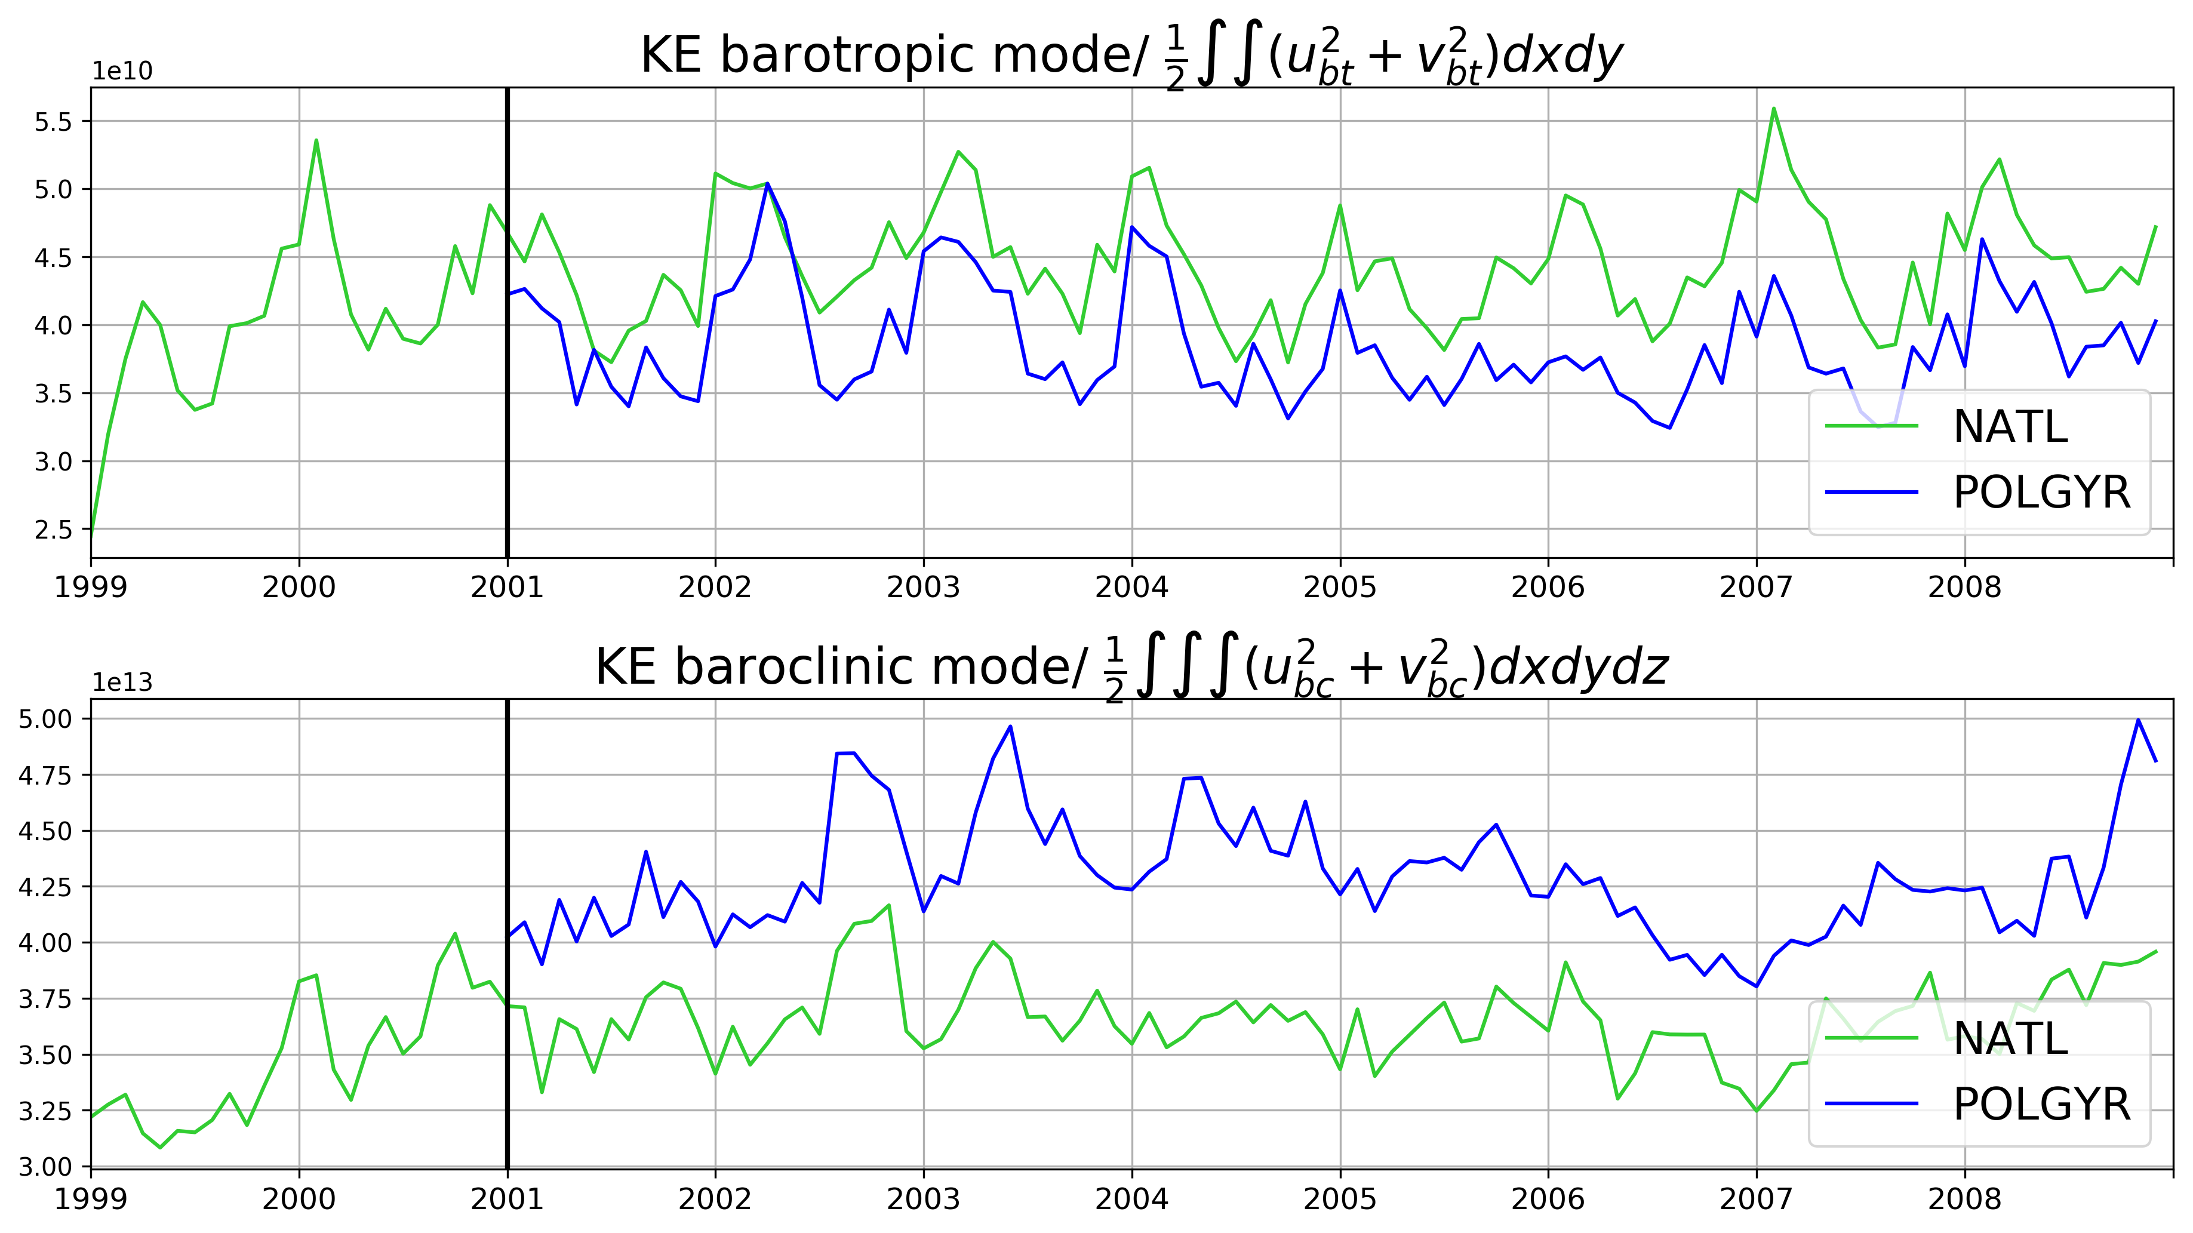
To evaluate the equilibration of the model, we show the time series of the barotropic (top) and baroclinic energies (bottom) for NATL (green) and POLGYR (blue). The area of integration is the same and corresponds to the entire POLGYR domain. We can see that the amount of energy in the barotropic mode reaches a statistical equilibrium pretty fast, over about a year. By 2001, the baroclinic mode is also close to equilibration in NATL. One additional year of spin up for the POLGYR nest from 2001 to 2002 allows the dynamics to adjust to the increase in resolution . The text has been modified to refer to both barotropic and baroclinic energies (l.96)

Minor comments :

Typos issues as in line 3- 18- 132- 303- 317- Fig13 were corrected

lines 9-10 : "the topographic Sverdrup balance cannot describe the dynamics in the interior". which it probably shouldn’t. I’d expect the flat bottomed Sverdrup balance to dominate here.

We changed « topographic Sverdrup balance » to «Sverdrup balance » in the abstract (l.10)

line 31 : It would also be appropriate to mention bottom friction and Stommel (1948) here, as bottom friction is discussed later, e.g. Fig. 7e.

In addition to viscous effects, bottom friction was added along with a reference to Stommel (1948) (l.31-32)

Section 2 : No mention of horizontal viscosity or diffusivity, although the rest of the section is very thorough.

We have added the following in the model description : « We use no explicit horizontal viscosity or diffusivity and rely on third-order upwind-biased advection schemes, which include an implicit hyperdiffusivity at the grid scale. » (l.105-106)

line 235 & 243 : There’s really only a few locations where the BDC is large. It seems largely the case that betaV balances the residual of the NL and BPT terms.

l.235 : We have added a sentence to make this more explicit in the text (l .248 in the revised version of the manuscript) : « More precisely, the $\beta$V term balances the sum over most of the domain, while the BDC locally plays a role in the shallow areas. »

l.243 : The sentence has been modified to avoid any misunderstanding (l.255)

line 292-297 : This goes past a little too quickly for me. Without further reading, or a more in depth description, I find it difficult to make the link between the gradient of the bottom pressure and the nature of the flow’s driving force.

We have modified this part and removed the explanation based on the coordinate change to make the interpretation clearer. (l.310-316)

